

BA (Hons) Leadership and Management Skills for the Workplace

Student Name: Daciana Bont
Student Number:
Module Name and Code: Developing Emotional Intelligence Skills LCLM 5006
Assignment Type: C1- Individual Poster Presentation
Assignment Title: Building emotional intelligence in the academic domain
Lecturer Name:
Session:

Table of Contents
Slide 1: Cover Page 3
Slide 2: Poster 4
References 7

Slide 1: Cover Page
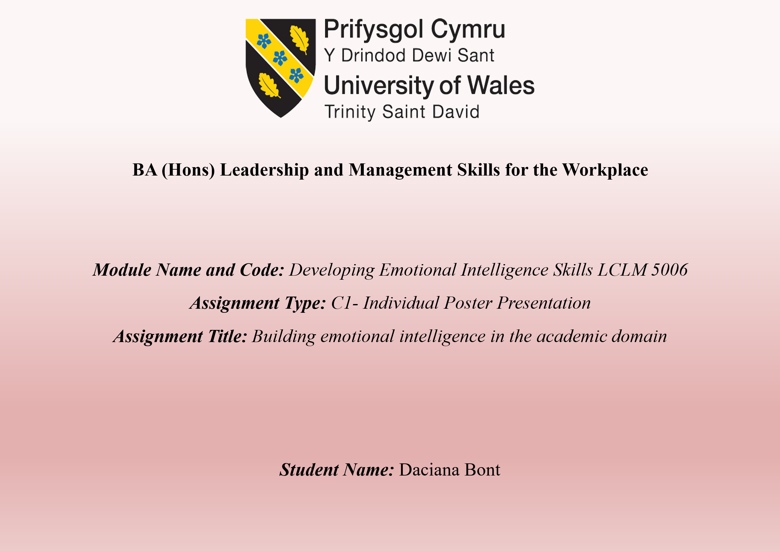

Slide 2: Poster
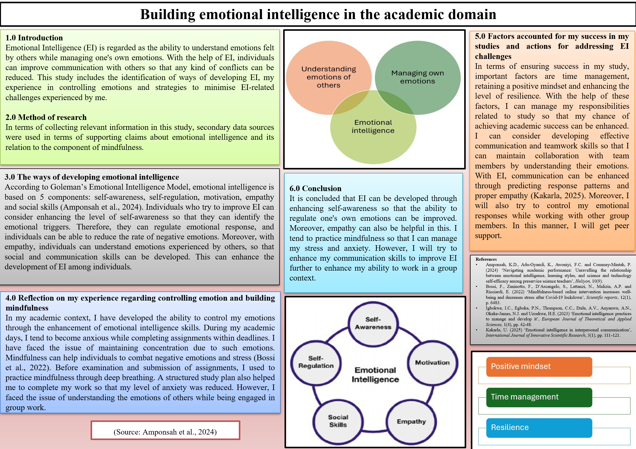
Speaker Notes
Introduction
Emotional intelligence, or EI, is important in the academic domain to regulate one's own emotions and feelings. This is regarded as the capability of identifying the emotions of others while controlling one's own emotional responses. This study is based on the analysis of the ways of building EI, along with my own experience related to EI and the regulation of emotional responses. The factors of academic success and actions to reduce EI challenges are also incorporated in this study.
Method of research
The development of this work, including relevant data and information, was dependent on the secondary data sources. Regarding this, academic sources such as journal articles were considered as appropriate data sources in terms of gaining knowledge about different aspects of EI in relation to academic study, so that the point of academic success can be ensured.
The ways of developing emotional intelligence
Goleman’s Emotional Intelligence Model can guide individuals to develop a high level of EI through several components, such as self-awareness, self-regulation, motivation, empathy, and social skills. With building the high level of self-awareness, individuals can be able to have control their own emotions in both positive and negative terms. In this manner, individuals can be able to regulate their emotional responses so that their social relationships can be enhanced. The development of empathy can help individuals to apprehend emotions felt by others. In this manner, individuals can gain the ability to maintain collaboration with others and group dynamics in the academic domain can be maintained. By gaining expertise in social skills, one can minimise conflicts by ensuring clarity in emotional responses so that relationships can be improved.
Reflection on my experience regarding controlling emotion and building mindfulness
As per my personal experience, I can say that I am vulnerable to experiencing stress and anxiety while meeting the deadline of an assignment and facing an examination. Due to high stress, my level of concentration tends to be affected negatively. Regarding this. I tried to manage my stress level of negative emotions by managing my emotional responses. Mindfulness practices such as deep breathing helped me maintain my calmness, and I became more aware of thoughts and emotions without reacting negatively to them. In this manner, I have developed the ability to reduce the experience of negative emotions through EI. However, while working in a group in the presence of others, I tend to face problems of understanding the emotions of others due to my lack of empathy and communication skills. In the future, I will try to improve these areas.
Factors accounted for my success in my studies and actions for addressing EI challenges.
In terms of achieving my academic success, several factors helped me throughout my studies in terms of maintaining my emotional calmness. Such factors are efficiency in time management, a positive mindset and a high level of resilience. Time management enabled me to maintain compliance with my study schedule, and I have submitted my work on time. A positive mindset helped me to maintain motivation to achieve academic success by overcoming academic obstacles.
I want to develop communication and teamwork skills to minimise my challenges related to EI. In this manner, I will ensure group dynamics and a collaborative environment while working in a group in the presence of other members.
Conclusion
It is concluded that academic and personal development can be guided with proper EI. Self-awareness, self-regulation and motivation can enhance the level of EI within individuals. I tend to practice mindfulness in terms of regulating my emotional responses. My academic success is ensured through a positive mindset, time management and resilience.

References
Amponsah, K.D., Adu-Gyamfi, K., Awoniyi, F.C. and Commey-Mintah, P. (2024) ‘Navigating academic performance: Unravelling the relationship between emotional intelligence, learning styles, and science and technology self-efficacy among preservice science teachers’, Heliyon, 10(9).
Bossi, F., Zaninotto, F., D’Arcangelo, S., Lattanzi, N., Malizia, A.P. and Ricciardi, E. (2022) ‘Mindfulness-based online intervention increases well-being and decreases stress after Covid-19 lockdown’, Scientific Reports, 12(1), p. 6483.
Igbokwe, I.C., Egboka, P.N., Thompson, C.C., Etele, A.V., Anyanwu, A.N., Okeke-James, N.J. and Uzoekwe, H.E. (2023) ‘Emotional intelligence: practices to manage and develop it’, European Journal of Theoretical and Applied Sciences, 1(4), pp. 42-48.
Kakarla, U. (2025) ‘Emotional intelligence in interpersonal communication’, International Journal of Innovative Scientific Research, 3(1), pp. 111-121.

