Act 6 t2
LLMNR and NBT-NS are known as Link-Local Multicast Name Resolution and NetBIOS Name Service, respectively. Both are used for name resolution on a network, as different forms of DNS providing systems with several forms of unique identification. LLMNR is the successor to NBT-NS, which was made in the 1980’s, and has been used for Windows systems for its suitability to modern standards.
In the attack, the attacker sends out broadcasting queries to the internal network without any integrity checks. Using that vulnerability, it can track a user’s contact with a given server, to the point of disclosing user credentials when compromised. A user can use the correct credentials on a server, and access will not be granted. When programs like Responder are capturing, it discloses the hash that includes the credentials used in that attempt. The hash can then be converted, fully showing the password.
I have successfully managed to extract the hashed credentials from the system, after using responder to poison the network surrounding it, many requests were sent, and the credentials appeared on responder as an attempt to access the shared file system. After recovering the hashes from the responder logs, it was then time to extract the passwords from those hashes. The most simplified method revolves around using John the Ripper.
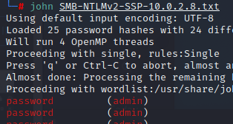
My process involved going into the responder logs on the terminal, then initiating “john”, alongside the set filename for the hashes made from responder. As seen above, the username is admin, and the password is password.
Although John the ripper provides a much simpler method of cracking hash files, there is another application, which is shown to be the fastest in this field. It is known as Hashcat, and it supports many different functions, such as attacking the files differently, and supporting a wide range of Hash algorithms, such as MD5 or the SHA variants. Specifically, to crack the file again with hashcat, I will need to investigate the algorithm the file uses. It is evident in the file name that it uses NTMLv2, so using the –help function to search for its corresponding number, 5600.
A wordlist is also being used as an assistive measure for the process, as the wordlists contain information about many passwords, so hashcat could use the information as a reference as to what the translated data may become and speed the process along.
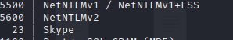
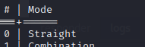
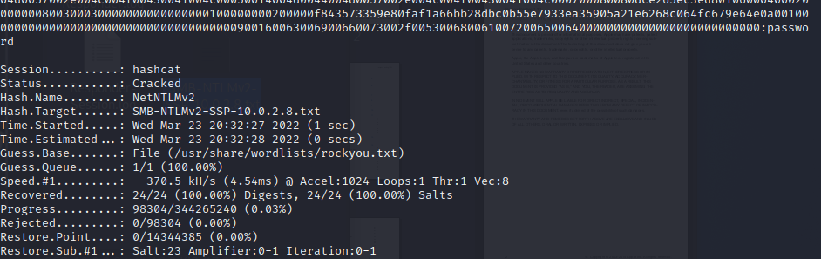
As seen at the last screenshot, the end of each cracked hash provides the password itself, “password”, providing a much more detailed insight into the txt file being cracked, such as the amount and percentage of passwords that could be deciphered.

