ACDB4002 / ACDA4006 14th May 2021
Electrical & Electronic Principles Berian Rhys Griffiths
Level 4 Exam Student ID: 2013049
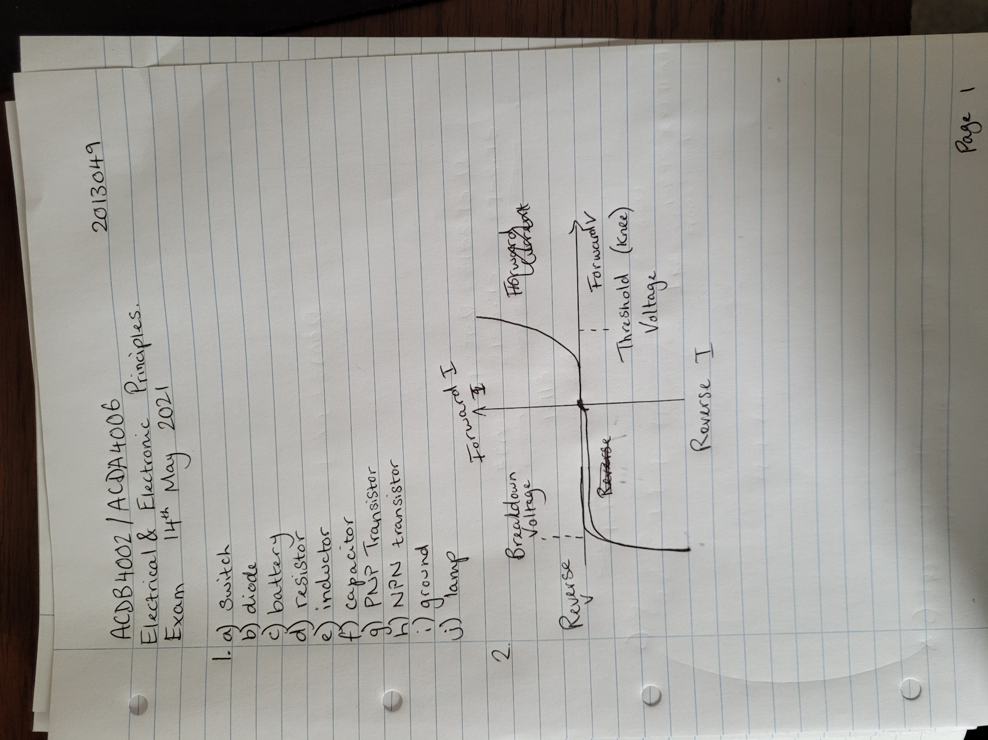
Please find below photographs of my exam workings out.



