Globally Responsible Business
IKEA

Module
Globally Responsible Business.

Christine Joy 2009194
BMSP6001

Executive Summary

IKEA is one of the biggest furniture retailers in the world, offering high-quality pieces at competitive prices. They base many of their furniture designs on Scandinavian aesthetics. Amazon, Wayfair, and Walmart are IKEA's main international rivals. The top rivals of IKEA in the UK include DFS, Argos, Wren, B&Q, John Lewis, Dreams, Furniture Village, and Next.

Flemming (2021) notes how IKEA is dedicated to sustainability through circular economy design and thinking, which incorporates issues like forestry control, transportation, and retailing to safeguard future generations. The author also mentions IKEA's investments in renewable energy across all their logistical and retail operations, with a target of transitioning to entirely electric vehicles by 2025 and becoming climate positive by 2030. IKEA has also launched initiatives that emphasise long-lasting, high-quality products that are climate neutral, recyclable, or reusable; ensuring nothing goes to waste. In addition, they have entered the sharing economy by offering products for lease and sale that have already been used (Bouhia, 2022, pp. 212-233). These significant initiatives are covered within IKEA's sustainability report, which also describes how they are one of the first companies to disclose outdoor air pollution across the value chain, their on-going investment in renewable energy and commitments to ensuring equality within the workforce and supply chain (IKEA, 2023a, p.23). In addition, IKEA are focused on changing consumer attitudes towards sharing, recycling, nature, and eco-design, which has seen increased consumption of their plant-based foods and innovations that extend product lifespan (IKEA, 2023a, p.23).

IKEA (2023a, p.23) note, more than 98% of the wood used within products is either FSC-certified or recycled, achieving IKEA’s goal of using more sustainable sources. IKEA have reduced the amount of food waste from their restaurants by 50% in 2022, food waste reduction strategies are in place in 91% of stores (Ettinger, 2022; IKEA, 2023a, p.23). To advance their transformation to a circular economy, IKEA has also created key circular customer offerings and updated customer information in-store and online to educate their consumers regarding sustainable living and the circular economy. These range from small, reasonably priced, and energy-efficient products to bigger items like solar panels and water conservation tools. Included within their consumer engagement, IKEA have launched their circular services that enable repair, removal, and buy-back programmes; second-hand digital and physical touchpoints that will allow customers to donate any unwanted items; and care and repair that will allow customers to upgrade, maintain, and refurbish products to increase their lifespan (Seidel, 2018; Elf et al., 2021, pp. 1037-1050; IKEA, 2023a, p.23).

Contents

Title 1
Executive Summary 1
Contents 3
Introduction (69) 4
Circular Economy (486) 5
Biomimicry (263) 9
IKEA (781) 10
Challenges (468) 15
Strengths 16
Weaknesses 17
Opportunities 17
Threats 17
Recommendations (466) 17
Conclusion (150) 21
References 22

Introduction

The paper will explore how the foundations of sustainable business are supported by circular economy and biomimicry. The report will investigate how the world's largest home furnishings retailer, IKEA, incorporates the concepts of the circular economy and biomimicry into its business model. The paper will examine the challenges IKEA is facing and suggest short, medium, and long-term objectives that will ensure IKEA ‘s viability for the future.

Circular Economy

“The goal of the circular economy paradigm is to minimize waste through cycles of reduction, reuse, and recycling with limited leakage and minor environmental impact”

MacArthur (2013, pp. 23-44)

Sørensen (2018, pp. 71-87) describes our current economic model as take, make, use, and lose, where resources are used to make products, which once they have served their purpose are discarded as waste, frequently ending up in landfill. This is known as the linear economy, prioritising profit regardless of product life and impact to earth (Neves & Marques, 2022; Sundar, 2023). Contrarily, in circular economy, waste generation is avoided altogether, by focusing on sustainability, where waste becomes the new raw material. In addition to preserving raw materials, promoting environmental protection, tackling biodiversity loss, and lowering CO₂ emissions, the circular economy fosters innovation, resilience and enhances prosperity, creating new business concepts, and employment opportunities while addressing important social needs (Geissdoerfer et al., 2017, pp. 757-768).

Ellen MacArthur Foundation (2023) describes the circular economy built on a framework for systems-level problem-solving guided by three core values: lowering waste and pollution, reusing products and materials, and restoring the environment. However, Fraint et al., (2020, p. 161) notes how both business and policymakers are utilising circular economy business models to ensure sustainable and resilient futures. De Giovanni (2022) claims there is a lack of knowledge surrounding circular economy advantages and further research is required to identify the full benefits and limitations of the model, ensuring business leaders of the future are well informed.

Benites & Osmond (2021, pp. 25-39) states that key planetary ecological boundaries have been overstepped because of unchallenged linear economies, arguing that a move towards regenerative and circular economies and societies requires disruptive change. Figure 1 illustrates the circular economy, a design ideology that aims to reduce waste and pollution, reuse products and materials, and regenerate natural resources.

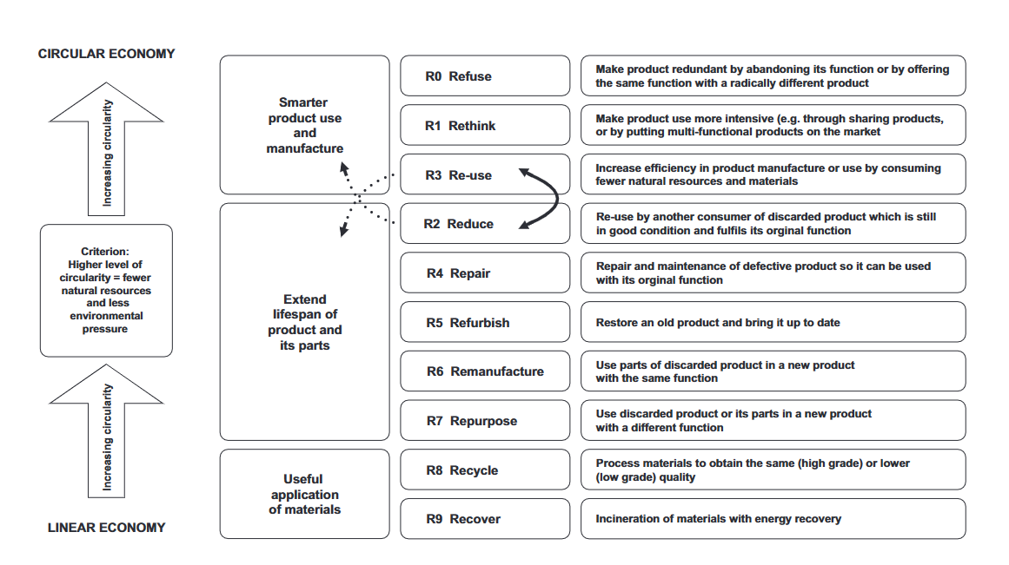Fig 1, Image displaying circular economy (Lehmann & Hinske, 2022, p. 32)

Holistic approaches such as regenerative design and systems thinking underpin responsible business practises of the circular economy, linking the human population with ecological system dynamics (De Souza et al., 2019, pp. 145-156; Parida et al., 2019, pp. 715-725; Künkel, & Ragnarsdottir, 2022). Fig 2 displays doughnut economics within two concentric rings: an ecological ceiling and social foundation, highlights how the economy is embedded and dependent upon society and the living world, visualising this connection between people and planet.

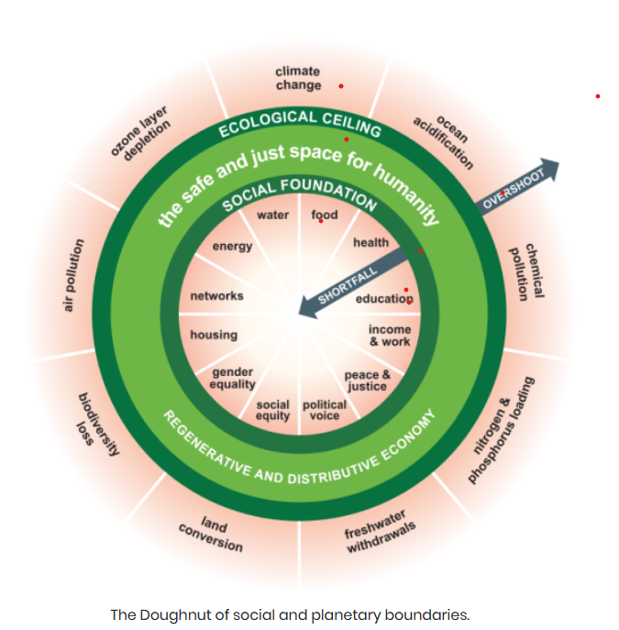
Fig 2, Doughnut Economics image, showing the social and planetary boundaries, (Doughnut Economics Action Lab, 2023)
Fig 3 visualises key levels of development and concepts that will enable the transition from the linear economy to the circular economy, however, Larsson expresses concern that if the principles of the circular economy are not followed throughout the supply chain and society, it will not be possible to develop circular economies (Larsson, 2018, p. 47).

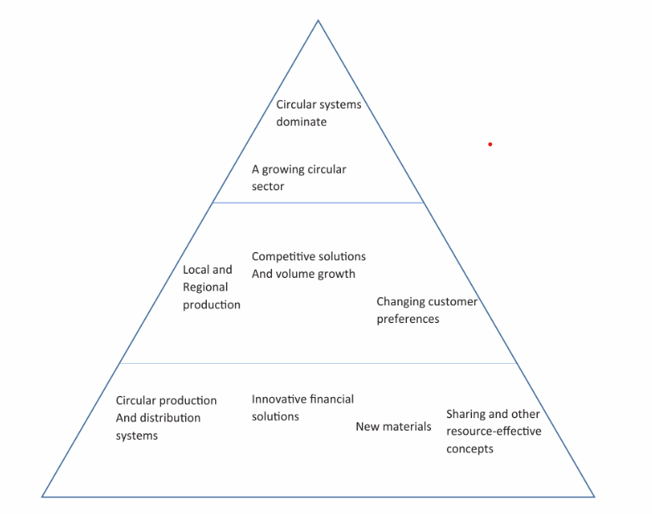
Fig 3, key principles to enable change from a linear to a circular economy (Larsson, 2018, p. 47).

Biomimicry

The term "biomimicry" derives from the Greek word's "bio" for life and "mimesis" for imitation. It refers to the use of innovation and environmentally friendly design that mimics nature to solve human problems (Jamei & Vrcelj, 2021, p. 7514). Bio-inspiration uses biological principles within its design, to create bio-architectural innovations, e.g., aeroplanes modelled after birds and Velcro's hook-and-eye structure modelled after hairy seeds (Kulkarni & Saraf, 2019, pp. 1-6; Primrose, 2020; Hapsari et al., 2022, p. 12057). However, Chayaamor-Heil (2023, pp. 202-223) notes gaps within the understanding of biological principles, which is key to bio-inspiration within design to create sustainable products. These views are supported by Tate et al., (2019, pp. 115-129) who state that “biomimicry is an essential aspect in generating value for the economy, environment, and society”, and believe that interconnected, circular ecosystems as opposed to linear models could achieve business sustainability.

Biomimicry innovation could improve sustainability by emulating the natural world in eco-design, switching from a business-driven to a design-driven business model (Fernhaber & Stark, 2019). As a result, production costs may be reduced, product quality and design may be enhanced, product lifespan may be extended, and disposal, carbon storage, recycling, and resource usage may all benefit (Bumgardner & Nicholls, 2020, p. 1277). In fig. 4, the Japanese Bullet Train imitates the Kingfisher’s beak, which allows it to dive into the water with little splash, by redesigning the front of the bullet train to mimic the beak, allowed the train to run 10% faster and consume 15% less energy.
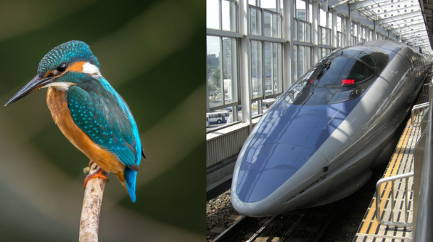
Fig 4, Image of the bullet train, inspired by the kingfisher (Moore, 2018)

IKEA

IKEA has three main codes of conduct: ‘I-Conduct,’ aimed at franchisee business requirements; ‘Inter Code of Conduct,’ aimed at all co-workers within the IKEA group; and ‘IWAY,’ aimed at socially responsible procurement within their supply chain (Laurin & Fantazy, 2017, pp. 309-318). IWAY seeks to ensure that all products, services, resources, and parts are sourced ethically and is applied to all suppliers and providers of goods and services to IKEA. IWAY lays out guidelines and procedures for addressing issues pertaining to animal welfare, social and labour standards, and the environment (IKEA, 2023g, pp. 48-50). The IWAY FY22 Audit found no instances of child labour, either confirmed or suspected. However, recognised detrimental effects on children working in the lower supply chain in 2021, and as a result created a pilot project within the natural fibres supply chain to better understand the dangers and effects children face (IKEA, 2023h, p. 43). Fig 5 displays a high-level overview of the IWAY audit of the IKEA group of suppliers, during FY22 IKEA phased out nine suppliers who failed to meet satisfactory compliance (IKEA, 2023g, pp. 48-50).

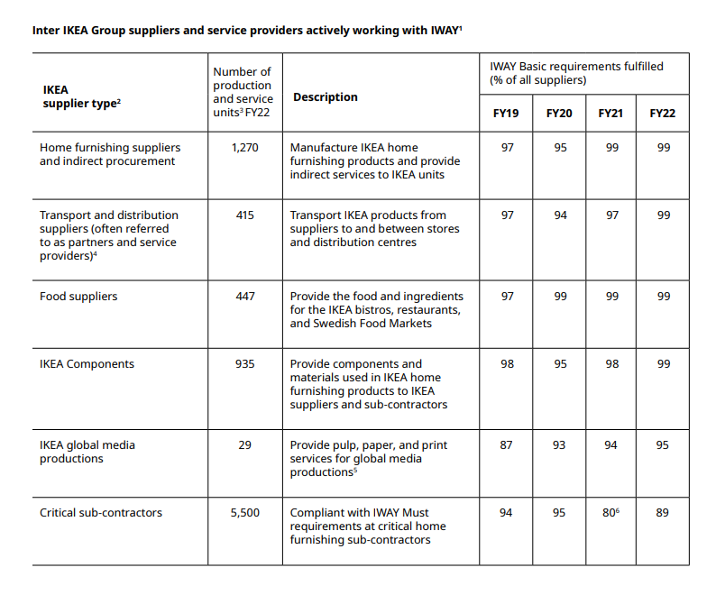Fig 5, high-level overview of the IKEA group suppliers and service providers IWAY ratings (Ikea, 2023g, pp. 48-50).

Fig 6, IKEA recognised that their use of raw materials during the product design and production process represented their biggest opportunity to reduce their carbon footprint (IKEA, 2018; IKEA, 2021c). As such, IKEA has enhanced their product design to ensure that they achieve circular capabilities, reduce material usage, and switch to more sustainable materials (IKEA, 2023c). IKEA no longer sell non-rechargeable alkaline batteries, converted all their lighting range to energy-efficient LEDs and phased out single-use plastic products such as; straws, plates, and freezer bags, which will significantly reduce waste and extend product life (IKEA, 2023e). Furthermore, 5% of IKEA’s carbon footprint was caused by the glue it used to assemble products. IKEA is switching to glues developed through biomimicry and emerging technologies, but due to compatibility issues, this will require a more extensive technological redesign, as well as an update of the equipment and materials used in manufacturing (IKEA, 2023c).

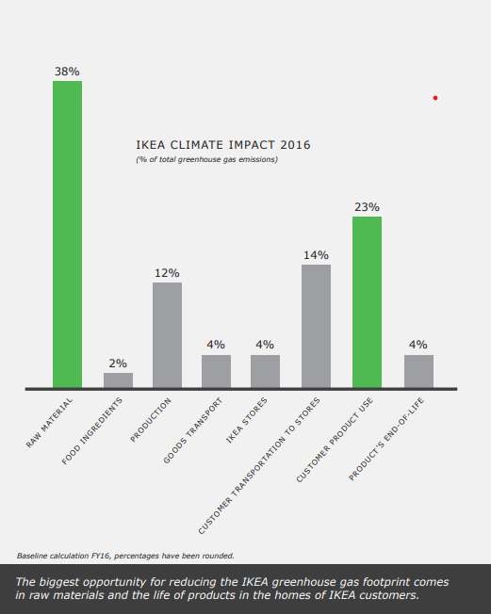
Fig 6, IKEA’s climate impact review 2016 (IKEA, 2018)

Fig 7, the Rönninge extendable table uses less wood in production by using hollow leg technology (IKEA, 2023i, pp. 14-18). The Grönsta chair was enhanced, by replacing the non-recyclable glass fibre that was previously used and utilising alternative material derived from post-industrial waste, while ensuring recyclable capabilities of the product are met (IKEA, 2023i, pp. 14-18). Similarly, one of IKEA’s most popular items, the Billy bookcase was also redesigned to improve its circular capabilities, the redesign has reduced plastic, snap fittings instead of nails and made from renewable resources which make the product easier to assemble, dismantle, repair, and recycle (IKEA, 2023i pp. 14-18).
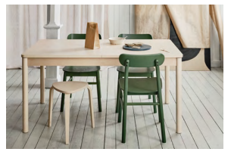
Fig 7, image of Rönninge table (IKEA, 2023i, pp. 14-18)
Fig 8, IKEA have also addressed products such as their foam mattresses which previously ended up in landfill, they have developed a renewable foam range which seeks to have a minimum of 20% of materials coming from recycled and renewable sources within all their foam mattresses by 2025 (IKEA, 2023i, pp. 14-18).
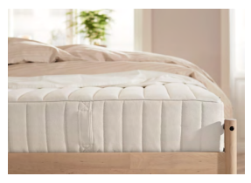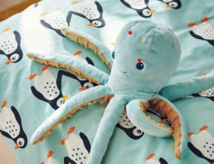
Fig 8, Image of foam mattresses (IKEA, 2023i, pp. 14-18) Fig 9, Image of octopus from the Blåvingad range (IKEA, 2023i, pp. 14-18)
IKEA has also concentrated on its soft furnishings, including soft toys, cushion fillings, rugs, and several items made of recycled polyester, made from ocean-based plastics (OBP). A recycled polyester octopus from the Blåvingad children's collection can be seen in Fig. 9. IKEA have also reviewed the design of larger furniture pieces to minimise the number of parts, such as sofa frames, where in some cases the number of assembly parts was reduced from 122 to 13 saving resources such as water, energy, and packaging, as well as cutting down on transportation costs and emissions (IKEA, 2023c).
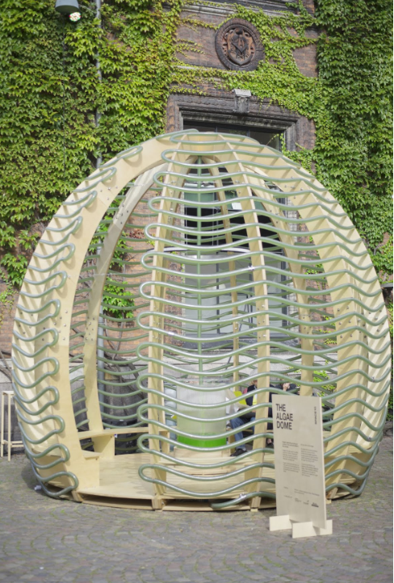
Fig 10, Image of IKEA’s Algae Done (Agritecture, 2022)

Figure 10 illustrates IKEA's innovative algae dome, a 13-foot-tall "food producing architecture pavilion" that uses a photobioreactor system to grow microalgae and create phototropic microorganisms (Agritecture, 2022). According to Raheem et al., (2018, pp. 42-59) and Nagappan et al., (2021, pp. 1-20), the production of algae could replace the production of maize and soybeans, which are primarily used as animal feed and are one of the major factors in deforestation, in addition, microalgae is used within micro-energy, a key source for sustainable biofuel. With numerous applications microalgae also helps in the reduction of CO2 and other greenhouse gases and for industrial wastewater treatment (Wang, 2017; Elmeligy & Elhassan, 2019). IKEA’s sustainability expansion has led to collaboration between bioengineers and architects to create innovative and sustainable designs (Ayoubi, 2017).

Challenges

Fig 11, Image of IKEA’S SWOT analysis, created using Canva, by Canva Inc. (Joy, 2023).

Strengths

Figure 11 displays a SWOT for IKEA demonstrating key aspects within IKEA's business model, such as providing low priced products at high quality coupled with customer knowledge, gives them competitive advantage (Mo et al., 2016). The regular introduction of new products, combining innovative designs with smarter use of raw materials and technologies aid to drive sustainability and continue their growth within the circular economy (Kadar & Kadar, 2020, pp. 1-6; Shahzadi, 2022). With a diverse product portfolio designed for easy transport and assembly that meets the needs of consumers everywhere, help to build brand awareness. The competitiveness of IKEA is increased by direct delivery, bulk purchasing, and sourcing materials close to the supply chain, all of which result in cost savings (IKEA, 2022). IKEA integrates suppliers into its supply chain using IWAY corporate social responsibility, which encourages long-term partnerships to increase social and environmental responsibility. By matching customer needs to products IKEA delivers a profitable business plan, without this knowledge the company may struggle to maintain a competitive advantage (Jurevicius, 2023).

Weaknesses

Government lobbying, employee treatment, and company advertising have all drawn criticism (IKEA, 2023). Unfavourable press can damage a brand's reputation and customer loyalty by exposing issues like child labour exploitation, poor design, and illegal business practises (Filatotchev & Stahl, 2015, pp. 121–129; Earthsight, 2020; Kennedy, 2020; Glover, 2021). If IKEA cannot strike a balance between price and green quality, its products and services may suffer (Heydari et al., 2021). While IKEA's product standardisation helps keep prices low, failing to satisfy customer demand for higher-quality, more customised options give rivals an advantage, because fewer customers want standardised products (Zhang et al., 2019, pp. 227-235; Wang et al., 2022, p. 243).

Opportunities

IKEA operates in majority developed economies, however, only China within developing economies, expanding into emerging markets offers revenue growth opportunities, made more successful by utilising adaptive strategies (Samiee & Chirapanda, 2019, pp. 20-37). IKEA may benefit from digitalisation, growing online sales and lowering overhead costs (Stackpole, 2021). IKEA could expand upon its partnership with uber eats to enable procurement of its grocery items, thus expanding upon its market share and increasing consumer demand (Rai, 2023, p. 134). Continuous expansion into the circular economy, greener products, renewable energy, recycling, and reuse can support IKEA’s sustainability agenda (Bouhia, 2022, pp. 212-233).

Threats

Due to Walmart, ASDA, and Tesco entering homeware markets, these large retailers can easily take market share from IKEA due to their low costs, well-managed supply chains, and huge market presence (Hulten, 2012, pp. 273-289; Hughes, 2023). Economic changes affecting consumer disposable incomes could compound this, and lead to high competition in the low-cost homeware markets (Greenacre & Akbar, 2019, pp. 87-93; Mao et al., 2023, p. 71).

Recommendations

Fig 12, Image of IKEA’S Challenges & Solutions, short medium- and long-term goals, created using Canva, by Canva Inc. (Joy, 2023).

Figure 12 displays three significant challenges IKEA face; unsustainable consumption, climate change, and inequality, which could impact upon their sustainability goals. Grouped by focus areas and sectioned into short-, medium- and long-term goals of commitment to fulfil potential outcomes. Value safeguarding and maintenance are common and inherent to circular business models (CBMs), therefore, protecting and improving natural capital, such as maximising resource yields, and promoting system effectiveness are the principles that direct value creation and capture (De Angelis, 2022, pp. 2245-2255).
In recent years, many of IKEA’s products and business practises revolve around the end-of-life recovery of product materials, parts, and components (Catalan, 2022; Bouhia, 2022, pp. 212-233). IKEA is committed to operating in a circular manner by 2030 and have pledged to create all products with circular functionality by only using recycled or renewable materials and providing customers new ways to extend the life of products and materials (IKEA, 2023 p.6). IKEA's in-store design and marketing, according to recent studies, are a major factor in driving experiential consumption, impulse buying, and compulsive buying, which could be seen as barriers to achieving the objective of fostering a sustainable positive consumer consumption (Nagadeepa & Shirahatti, 2021; Gupta, 2022; Oishi et al., 2023).

IKEA might investigate biomimicry design further to improve some of their current products. Applying some of these concepts to their product line could improve their sustainable product design and increase circular design because the materials used are fully recyclable and fully biodegradable at the end of their product usefulness. These solutions have strong connections to biological processes found in nature. Additionally, these products could support the three challenges depicted in figure 12 and help with SDGs (Sustainable Development Goals). Figure 13 and 14 below displays examples of sensitive walls, that offer a green noise barrier, sunshade, and air filtration, created with inspiration from concave-eared torrent frogs, mimosa leaves, and desert snails. This design could be easily incorporated into homes to improve wellbeing, and even investigate a specialised market for sensory aids (The Biomimicry Institute, 2021c).

Fig 13 & 14 Examples of sensitive walls (Green Wall, 2022)
Figure 15 displays bottle bricks, this interlocking bottle system can be used in place of brick to create garden designs by imitating the triangular corrugated shape of Saharan silver ant hairs, still air trapped within silk cocoons, and the interlocking structure of nacre known as mother of pearl (The Biomimicry Institute, 2021b).

Fig 15, Bottle bricks (The Biomimicry Insitute, 2020d)

Pranavayu is an air filtration system that uses electrostatically charged metal meshes to mimic the slender shape of floral stamens as well as the structural and electrical characteristics of a spiderweb (Ajayi, 2021)

Fig 16, Pranavayu (The Biomimicry Insitute, 2023e)

Conclusion (150)

The report investigated the global giant IKEA, highlighting key tenets of its circular economy business model, which seeks to lessen waste and pollution, reuse goods and materials, and regenerate natural resources, all crucial for boosting prosperity and building resilience. Key products were researched which support raw material preservation and environmental protection, combating biodiversity loss, and reducing CO2 emissions. A SWOT analysis was used to uncover issues with the IKEA business model and present them with potential solutions ranked in terms of short-, medium-, and long-term objectives. Additionally, suggestions were made that could enhance IKEA's use of biological principles in design to produce design ideologies and bio-architectural innovations that are environmentally friendly in design and imitate nature to address human problems.

References

Agritecture. (2022). IKEA’s space10 develops the algae dome, a prototype for food-producing architecture. Agritecture.com. Retrieved March 28, 2023, from https://www.agritecture.com/blog/2017/10/30/ikeas-space10-develops-the-algae-dome-a-prototype-for-food-producing-architecture.

Ajayi, T. O. (2021). NATURE INSPIRED INNOVATIONS, THE PANACEA FOR OUR AILING AND DISTRESSED PLANET EARTH. LAGOS, NIGERIA, 67.

Ayoubi, A. (2017). IKEA’s Future-Living Lab Creates the Algae Dome. Architect Magazine. Date accessed April 26, 2023, from https://www.architectmagazine.com/technology/ikeas-future-living-lab-creates-the-algae-dome_o#:~:text=IKEA%20%27s%20external%20future-living%20lab%20Space10%20%E2%80%94whose%20mission,growing%20microalgae%E2%80%94one%20of%20the%20world%27s%20fastest-growing%20photosynthetic%20organisms.

Benites, & Osmond, P. (2021). Bioconnections as Enablers of Regenerative Circularity for the Built Environment. Urban Planning, 6(4), 25–39. https://doi.org/10.17645/up.v6i4.4373.

Bouhia, G. (2022). Applying the circular economy concept to a sustainable business model for large retailers: the case of IKEA. International Journal of Competitiveness, 2(3), 212-233.

Bumgardner, & Nicholls, D. L. (2020). Sustainable Practices in Furniture Design: A Literature Study on Customization, Biomimicry, Competitiveness, and Product Communication. Forests, 11(12), 1277–. https://doi.org/10.3390/f11121277.

Catalan, M. L. P. (2022). IKEA’s Supply Chain: Growth on Sustainability.

Chayaamor-Heil, N. (2023). From Bioinspiration to Biomimicry in Architecture: Opportunities and Challenges. Encyclopedia, 3(1), 202-223.

De Angelis, R. (2022). Circular economy business models as resilient complex adaptive systems. Business Strategy and the Environment, 31(5), 2245-2255.

De Giovanni. (2022). Cases on Circular Economy in Practice. IGI Global.

De Souza, Bloemhof-Ruwaard, J., & Borsato, M. (2019). Towards Regenerative Supply Networks: A design framework proposal. Journal of Cleaner Production, 221, 145–156. https://doi.org/10.1016/j.jclepro.2019.02.178.

Doughnut Economics Action Lab. (2023). About Doughnut Economics. Doughnut Economics. Date accessed, March 21, 2023, from https://doughnuteconomics.org/about-doughnut-economics.

Earthsight. (2020). Ikea’s response to its illegal timber scandal is a sham. Date accessed April 26, 2023, from https://www.earthsight.org.uk/news/blog-ikea-response-illegal-timber-scandal-is-a-sham-heres-why.

Ellen MacArthur Foundation. (2023). Circular economy introduction. Ellen Macarthur Foundation. Date accessed March 8, 2023, from https://ellenmacarthurfoundation.org/topics/circular-economy-introduction/overview?gclid=Cj0KCQiAgaGgBhC8ARIsAAAyLfFaynsxtK72WWXKRpfqS0yN6p_6OVLdqffTmg2MbEn_DU36opEFe9UaAoUtEALw_wcB.

Elf, P., Isham, A., & Gatersleben, B. (2021). Above and beyond? How businesses can drive sustainable development by promoting lasting pro‐environmental behaviour change: An examination of the IKEA Live Lagom project. Business Strategy and the Environment, 30(2), 1037-1050.

Elmeligy, D., & Elhassan, Z. (2019). The Bio-adaptive algae contribution for sustainable architecture. In IOP Conference Series: Earth and Environmental Science (Vol. 397, No. 1, p. 012007). IOP Publishing.

Ettinger, J. (2022). Ikea Ups Its Sustainability Efforts With a Plant-Based Food Hall. Green Queen. Retrieved March 24, 2023, from https://www.greenqueen.com.hk/ikea-sustainability-efforts-plant-based-food-hall/

Fernhaber, & Stark, A. Y. (2019). Biomimicry: New insights for entrepreneurship scholarship. Journal of Business Venturing Insights, 12, e00137–. https://doi.org/10.1016/j.jbvi.2019.e00137.

Fleming, S. (2021). IKEA fits in a world that wants to buy less, says Ingka Group’s CEO. We Forum. Date accessed, March 22, 2023, from https://www.weforum.org/agenda/2021/01/jesper-brodin-ikea-circular-economy/.

Filatotchev, I., & Stahl, G. K. (2015). Towards transnational CSR. Corporate social responsibility approaches and governance solutions for multinational corporations. Organizational Dynamics, 44(2), 121-129.

Friant, M. C., Vermeulen, W. J., & Salomone, R. (2020). A typology of circular economy discourses: Navigating the diverse visions of a contested paradigm. Resources, Conservation and Recycling, 161, 104917. https://doi.org/10.1016/j.resconrec.2020.104917.

Geissdoerfer, M., Savaget, P., Bocken, N. M., & Hultink, E. J. (2017). The Circular Economy–A new sustainability paradigm?. Journal of cleaner production, 143, 757-768.

Glover, S. (2021). IKEA makes pledge to act on child labour. Ecotextile News. Date accessed April 26, 2023, from https://www.ecotextile.com/2021040727619/fashion-retail-news/ikea-makes-pledge-to-act-on-child-labour.html.

Greenacre, L., & Akbar, S. (2019). The impact of payment method on shopping behaviour among low income consumers. Journal of Retailing and Consumer Services, 47, 87-93.

Gupta, A. D. (2022). Factors influencing Impulse Buying Behavior.

Hapsari, Purwaningsih, R., Azzahra, F., & Sari, D. P. (2022). Velcro Product Design with Biomimicry Approaches. IOP Conference Series. Earth and Environmental Science, 1111(1), 12057–. https://doi.org/10.1088/1755-1315/1111/1/012057.

Heydari, J., Govindan, K., & Basiri, Z. (2021). Balancing price and green quality in presence of consumer environmental awareness: A green supply chain coordination approach. International Journal of Production Research, 59(7), 1957-1975.

Hughes, J. (2023). Ikea Competitors Analysis : How Does It Stand Out? Business Chronicler. Date accessed April 26, 2023, from https://businesschronicler.com/competitors/ikea-competitors-analysis/.

Hulten. (2012). Sensory cues and shoppers’ touching behaviour: the case of IKEA. International Journal of Retail & Distribution Management, 40(4), 273–289. https://doi.org/10.1108/09590551211211774.

IKEA. (2018). People & Planet Positive. Retrieved March 24, 2023, from https://www.ikea.com/gb/en/files/pdf/7e/58/7e58334c/ikea_sustainability_strategy_people_planet_positive_v3.pdf

IKEA. (2022). IKEA continues to grow in a challenging business environment. Date accessed April 26, 2023, from https://about.ikea.com/en/newsroom/2022/10/13/ikea-continues-to-grow-in-a-challenging-business-environment#:~:text=The%20pandemic%20limited%20growth%20in,quantities%20have%20not%20kept%20up.

IKEA. (2023). A new compass. IKEA Museum. Date accessed April 26, 2023, from https://ikeamuseum.com/en/digital/the-story-of-ikea/a-new-compass/.

IKEA. (2023a). Creating a sustainable IKEA value chain with IWAY. Date accessed March 23, 2023, from https://about.ikea.com/en/sustainability/building-a-better-business-with-iway.

IKEA. (2023b). Designing for circularity and our future. Retrieved March 24, 2023, from https://about.ikea.com/en/about-us/our-view-on/designing-for-circularity-and-our-future.

Ikea. (2023c). Fewer parts make a big difference. Retrieved March 24, 2023, from https://www.ikea.com/au/en/this-is-ikea/about-us/were-all-in-this-together-pubc8331c51#:~:text=This%20means%20designing%20all%20products,as%20little%20waste%20as%20possible.

IKEA. (2023d). IKEA launches new 2030 forest agenda to push for improved forest management and biodiversity globally. Date accessed March 23, 2023, from https://about.ikea.com/en/newsroom/2021/01/25/ikea-launches-new-2030-forest-agenda-to-push-for-improved-forest-management-and-biodiversity-globally

IKEA. (2021e). IKEA releases circular product design tool to inspire and accelerate the circular movement. Retrieved March 24, 2023, from https://about.ikea.com/en/newsroom/2021/09/01/ikea-circular-open-source-blueprint

IKEA. (2023f, p.23). IKEA Sustainability and Climate Reports FY22: Reduced climate footprint and significant increase of renewable energy. Date accessed March 22, 2023, from https://about.ikea.com/en/newsroom/2023/02/15/ikea-sustainability-and-climate-reports-fy22-reduced-climate-footprint-increase-of-renewable-energy

IKEA. (2023g, pp. 48-50). IKEA Sustainability and Climate Reports FY22: Reduced climate footprint and significant increase of renewable energy. Date accessed March 22, 2023, from https://about.ikea.com/en/newsroom/2023/02/15/ikea-sustainability-and-climate-reports-fy22-reduced-climate-footprint-increase-of-renewable-energy

IKEA. (2023h, p.43). IKEA Sustainability and Climate Reports FY22: Reduced climate footprint and significant increase of renewable energy. Date accessed March 22, 2023, from https://about.ikea.com/en/newsroom/2023/02/15/ikea-sustainability-and-climate-reports-fy22-reduced-climate-footprint-increase-of-renewable-energy

IKEA. (2023i, pp. 14-18). IKEA Sustainability and Climate Reports FY22: Reduced climate footprint and significant increase of renewable energy. Date accessed March 22, 2023, from https://about.ikea.com/en/newsroom/2023/02/15/ikea-sustainability-and-climate-reports-fy22-reduced-climate-footprint-increase-of-renewable-energy

IKEA. (2023j). The IKEA Forest Positive Agenda. Date accessed March 23, 2023, from https://about.ikea.com/en/sustainability/wood-forestry/forestry-beyond-our-business/ikea-forest-positive-agenda

Jamei, & Vrcelj, Z. (2021). Biomimicry and the Built Environment, Learning from Nature’s Solutions. Applied Sciences, 11(16), 7514–. https://doi.org/10.3390/app11167514.

Joy, C. (2023) Image of IKEA’S SWOT analysis, created using Canva, by Canva Inc. Colorful SWOT Analisys - Graph (canva.com)

Joy, C. (2023) Image of IKEA’S Challenges & Solutions, short medium- and long-term goals, created using Canva, by Canva Inc. Ikea challenges - Graph (canva.com)

Jurevicius, O. (2023). IKEA SWOT analysis 2023. Strategic Management Insight. Date accessed April 26, 2023, from https://strategicmanagementinsight.com/swot-analyses/ikea-swot-analysis/.

Kadar, T., & Kadar, M. (2020). Sustainability Is Not Enough: Towards AI Supported Regenerative Design. In 2020 IEEE International Conference on Engineering, Technology and Innovation (ICE/ITMC) (pp. 1-6). IEEE.

Kennedy, M. (2020). Ikea Reaches $46 Million Settlement Over Death Of Toddler Killed By Dresser Tip-Over. NPR. Date accessed April 26, 2023, from https://www.npr.org/2020/01/07/794281632/ikea-reaches-46-million-settlement-over-death-of-toddler-killed-by-dresser-tip-o#:~:text=At%20least%20eight%20children%20are,may%20still%20be%20in%20use.

Kulkarni, A., & Saraf, C. (2019, December). Learning from Nature: Applications of Biomimicry in Technology. In 2019 IEEE Pune Section International Conference (PuneCon) (pp. 1-6). IEEE.

Künkel, & Ragnarsdottir, K. V. (2022). Transformation Literacy: Pathways to Regenerative Civilizations. Springer Nature. https://doi.org/10.1007/978-3-030-93254-1.

Larsson. (2018). Circular Business Models Developing a Sustainable Future (1st ed. 2018.). Springer International Publishing, 47, https://doi.org/10.1007/978-3-319-71791-3.

Laurin, F. and Fantazy, K., 2017. Sustainable supply chain management: a case study at IKEA. Transnational Corporations Review, 9(4), pp.309-318.

Lehmann, & Hinske, C. (2022). Impossibilities of the Circular Economy. Taylor & Francis. 32.

Live Wall. (2022). Green wall. Date accessed June 17, 2023, from https://livewall.com/faq-items/how-do-green-walls-reduce-noise/

MacArthur, E. (2013). Towards the circular economy. Journal of Industrial Ecology, 2(1), 23-44.

Mao, Z., Duan, Y., & Liu, W. (2023). Consumers’ choice of private label considering reference price and moderating effect. Journal of Retailing and Consumer Services, 71, 103216.

Mo, C., Chen, M., & Meinecke, A. (2016). SWOT analysis and sustainable business planning. An IKEA case study. Prezi. Date accessed April 25, 2023, from https://prezi.com/pf_lgveu6zrj/swot-analysis-and-sustainable-business-planning-an-ikea-ca/.

Moore, C. (2018). Biomimicry: Design Inspired by Nature. Linkedin. Date accessed, March 26, 2023, from https://www.linkedin.com/pulse/biomimicry-design-inspired-nature-clare-moore/.

Nagadeepa, C., & Shirahatti, M. D. (2021). Impulse buying: concepts, frameworks and consumer Insights. Shanlax Publications.

Nagappan, Das, P., AbdulQuadir, M., Thaher, M., Khan, S., Mahata, C., Al-Jabri, H., Vatland, A. K., & Kumar, G. (2021). Potential of microalgae as a sustainable feed ingredient for aquaculture. Journal of Biotechnology, 341, 1–20. https://doi.org/10.1016/j.jbiotec.2021.09.003.

Neves, & Marques, A. C. (2022). Drivers and barriers in the transition from a linear economy to a circular economy. Journal of Cleaner Production, 341, 130865–. https://doi.org/10.1016/j.jclepro.2022.130865.

Oishi, H., Nakazawa, K., Takahashi, T., Kyutoku, Y., & Dan, I. (2023). Visualizing the IKEA effect: experiential consumption assessed with fNIRS-based neuroimaging. Frontiers in Neuroergonomics, 4, 1129582.

Parida, Burström, T., Visnjic, I., & Wincent, J. (2019). Orchestrating industrial ecosystem in circular economy: A two-stage transformation model for large manufacturing companies. Journal of Business Research, 101, 715–725. https://doi.org/10.1016/j.jbusres.2019.01.006.

Primrose, S. B. (2020). Biomimetics: nature-inspired design and innovation. John Wiley & Sons.

Raheem, Prinsen, P., Vuppaladadiyam, A. K., Zhao, M., & Luque, R. (2018). A review on sustainable microalgae based biofuel and bioenergy production: Recent developments. Journal of Cleaner Production, 181, 42–59. https://doi.org/10.1016/j.jclepro.2018.01.125.

Rai, H. B. (2023). Implications for Urban Logistics. The Routledge Handbook of Urban Logistics, 134.

Samiee, S., & Chirapanda, S. (2019). International marketing strategy in emerging-market exporting firms. Journal of International Marketing, 27(1), 20-37.

Seidel, A. (2018). Closing the Loop: Exploring IKEA’s Transition to the Circular Economy.

Shahzadi, A. (2022). Sustainability (definition, examples, pillars, sustainable development).Masters Thesis, Universitat Jaume, Departament d’Economia.

Sørensen, P.B., 2018. From the Linear Economy to the Circular Economy: A Basic Model. Finanz - Archiv : Zeitschrift für das Gesamte Finanzwesen, 74(1), pp. 71-87.

Stackpole, T. (2021). Inside IKEA’s Digital Transformation. Harvard Business Review. Date accessed April 26, 2023, from https://hbr.org/2021/06/inside-ikeas-digital-transformation.

Sundar, Mathiyazhagan, K., Agarwal, V., Janardhanan, M., & Appolloni, A. (2023). From linear to a circular economy in the e‐waste management sector: Experience from the transition barriers in the United Kingdom. Business Strategy and the Environment. https://doi.org/10.1002/bse.3365

Tate, Bals, L., Bals, C., & Foerstl, K. (2019). Seeing the forest and not the trees: Learning from nature’s circular economy. Resources, Conservation and Recycling, 149, 115–129. https://doi.org/10.1016/j.resconrec.2019.05.023.

The Biomimicry Institute. (2020a). Air Filter Inspired by Floral Stamens and Spiderwebs Pranavayu. Ask Nature. Date accessed June 17, 2023, from https://asknature.org/innovation/air-filter-inspired-by-floral-stamens-and-spiderwebs/

The Biomimicry Institute. (2020b). Bottle Bricks. Ask Nature. Date accessed June 17, 2023, from 2020 Launchpad Virtual Portfolio – Biomimicry Institute

The Biomimicry Institute. (2021c). Green Noise Barrier and Sunshade Inspired by Torrent Frogs, Mimosa Leaves, and Desert Snails A Sensitive Wall. Ask Nature. Date accessed June 17, 2023, from https://asknature.org/innovation/solutionsgallgreen-noise-barrier-and-sunshade-inspired-by-torrent-frogs-mimosa-leaves-and-desert-snails/.

The Biomimicry Institute. (2021d). Temporary Housing Insulation Inspired by Saharan Silver Ants and Nacre BottleBricks. Ask Nature. Date accessed June 17, 2023, from https://asknature.org/innovation/temporary-housing-insulation-inspired-by-saharan-silver-ants-and-nacre/.

The Biomimicry Institute. (2023e). Pranavayu. Biomimicry. Date accessed June 17, 2023, from https://biomimicry.org/2020-launchpad-virtual-portfolio/

Wang, L. (2017). Incredible Algae Dome absorbs sun and CO2 to produce superfood and oxygen. Inhabitat. Date accessed April 26, 2023, from https://inhabitat.com/incredible-algae-dome-absorbs-sunshine-and-co2-to-produce-superfood-and-oxygen/

Wang, J. X., Burke, H., & Zhang, A. (2022). Overcoming barriers to circular product design. International Journal of Production Economics, 243, 108346.

Zhang, M., Guo, H., Huo, B., Zhao, X., & Huang, J. (2019). Linking supply chain quality integration with mass customization and product modularity. International journal of production economics, 207, 227-235.

