

Module: Electrical Machines

Module Code: M6X00373

Module Tutor: Dr. Steve Mosey

Stator Modelling Part 1

Supervisors: Dr. Steve Mosey

Joseph Landeg – 1708387

07/03/2019

Contents
Abstract 4
Chapter 1 – Introduction 5
1.1 – DC Motors 5
1.2 – Information on Magnetics 7
1.3 – Information on Finite Element Methods (FEM) 9
1.4 – Information on Specific Problem 9
Chapter 2 – Method 10
Chapter 3 – Results 12
3.1 – Total Flux 12
3.2 – Flux vs Angle 13
3.3 – Flux Leakage Factor (FLF) 15
Chapter 4 – Discussion 16
Chapter 5 – Conclusions 17
References 18

Figure.1 - Left-Hand Rule [4] 5
Figure.2 - Stator - Permanent Magnets/Electromagnetic Windings [5] 6
Figure 3 - Commutator and Brush contact [6] 6
Figure 4 - Magnetic Field [7] 7
Figure 5 - Magnetic attraction/repulsion[3] 7
Figure 6 - Magnetic Domains [11] 8
Figure.7 - DC Motor Stator Circuit 10
Figure.8 - Circuit with mesh density 10
Figure.9 - DC Stator Circuit Analysis 11
Figure 10 - Total Flux 12
Figure 11 - Flux vs Angle 13
Figure.12 - Flux vs Angle results 13
Figure 13 - Flux Density vs Angle 14
Figure 14 - Flux Density vs Angle over 360° 14

Abstract

Throughout this task, a 2D model of a DC Motor Stator circuit will be produced in order to analyze the behaviour of a magnetic field within a motor and to analyse data for flux density, flux leakage factor and flux density against the coil angle of a motor.
The task has enabled me to understand the principles of an electrical machine and how to analyze different parts of a motor in regards to flux density. It shows that flux density can be given from a model created using FEMM 4.2 and can be transformed into hard data using excel spreadsheet.

Chapter 1 – Introduction

– DC Motors

A DC motor is an electrical machine which converts electrical energy into mechanical energy [1]. The working principle of a DC motor is:

“whenever a current carrying conductor is placed into a magnetic field, it experiences a mechanical force” [1].

The direction of this force can be explained through the left-hand rule as shown in fig.1 where the index finger indicates the magnetic field, the second finger is the direction of current and the mechanical force is represented by the thumb [1].
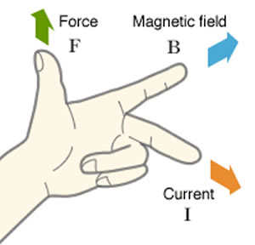
Figure.1 - Left-Hand Rule [7]

The force can be calculated as F= BIL, where B = Flux Density, I Current and L = Length of conductor within magnetic field [1]. The higher the flux density, the greater the force to turn motor.

A brushed DC motor consists of 4 main components; rotor (or armature), stator, brushes and a commutator.
The stator is a fixed component surrounding the rotor, generating a magnetic field around it. The magnetic field can be generated using electromagnetic windings or permanent magnets [2].

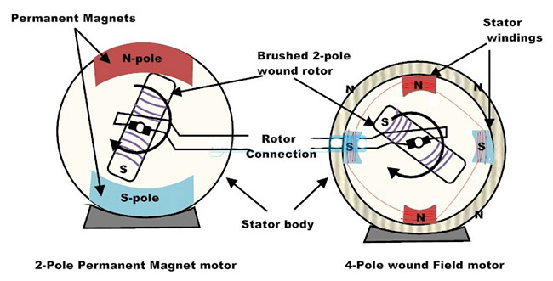
Figure.2 - Stator - Permanent Magnets/Electromagnetic Windings [8]

The rotor, known as the armature, is positioned inside the stator, is made up of windings which when energized, produces a magnetic field. The magnetic field produced in the windings gets attracted to the magnetic field produced in the stator, causing the rotor to turn, producing a rotating magnetic field as per figure.2.
The commutator and brushes work together, the commutator being a copper sleeve fitted onto the axle of the rotor, connecting to the two windings. So the commutator has two parts separated by a small gap. The carbon brushes are fitted so as the motor turns, they make contact with the commutator generating a magnetic field inside the motor when voltage is applied.
As the brushes make contact with the commutator segment, the polarity of the segment will match the winding the brush is connected to, ensuring the motor continually turns. As the brushes reach the gap in the commutator, the polarity switches.

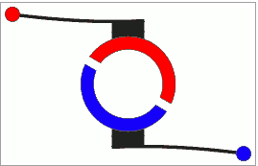
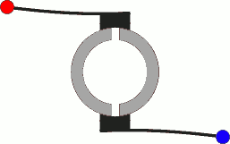

Figure 3 - Commutator and Brush contact [9]

– Information on Magnetics

A magnet is an object which produces a magnetic field around itself, which enables them to stick to each other and other materials [3]. A magnet will be attracted to another when equal but opposite “poles” come in close proximity of each other.
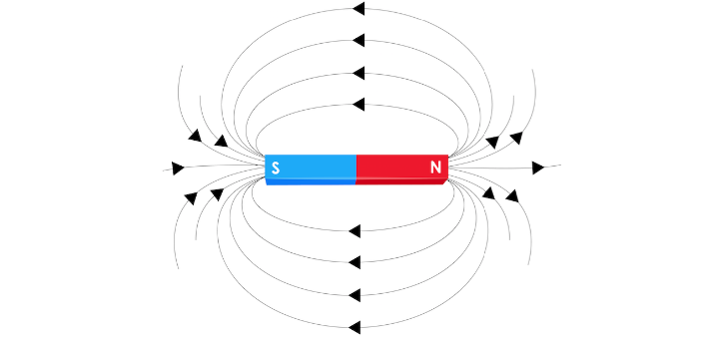
Figure 4 - Magnetic Field [7]

Poles on a magnet refer to the two ends which are North and South. Every magnet has north and south poles. A magnetic field is produced whenever an electrical charge is present.

“The rule to remember is that opposites attract” - [3]

Magnets stick to ferromagnetic materials, which includes iron and materials containing iron, such as steel [3]. Magnets are attracted to nickel, cobalt and other rare materials.
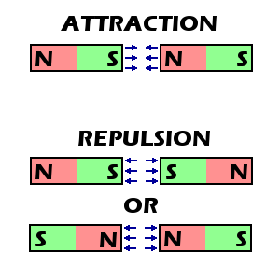
Figure 5 - Magnetic attraction/repulsion[3]

In a ferromagnetic material, the magnetic properties are present in small regions of a material known as magnetic domains.
In each domain, the atomic dipoles are paired together in a preferential direction and developed as solidification takes place. The magnetic field is intense in each domain. However, in a solid object each domain may cancel each other out, making the material demagnetized.
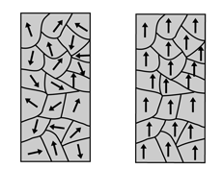

Figure 6 - Magnetic Domains [11]

When an external magnetic field is applied to a bulk material such as iron, each domain becomes magnetized in the same direction as the magnetic field that is applied. This means that the iron can attract to either pole of the magnet when magnetized.

– Information on Finite Element Methods (FEM)

The Finite Element Method was developed for the aircraft industry where stiffness analysis of an airplane was carried out [4]. It is a numerical method for solving engineering and mathematical physic problems such as heat transfer, fluid flow, electromagnetic potential etc. [5].
A software that can be used is FEMM 4.2 which solves 2D planar and axisymmetric problems in low frequency magnetic and electrostatics [6].

– Information on Specific Problem

A finite element simulation will be created to analyse the flux density (measured in Weber, Wb) within a DC Motor Stator circuit. Using the software package FEMM 4.2, a 2D circuit will be produced in order for the software to perform an analysis on the following:

- Total Magnetic Flux
- Flux Leakage Factor
- Flux as a function of the coil angle

Chapter 2 – Method

FEMM 4.2 was used to produce the circuit in fig.7 using the node, line, curve functions and using the specification given to produce co-ordinates to create the circuit.
Block labels will be used to create the air gap, coil properties and the stator material properties.
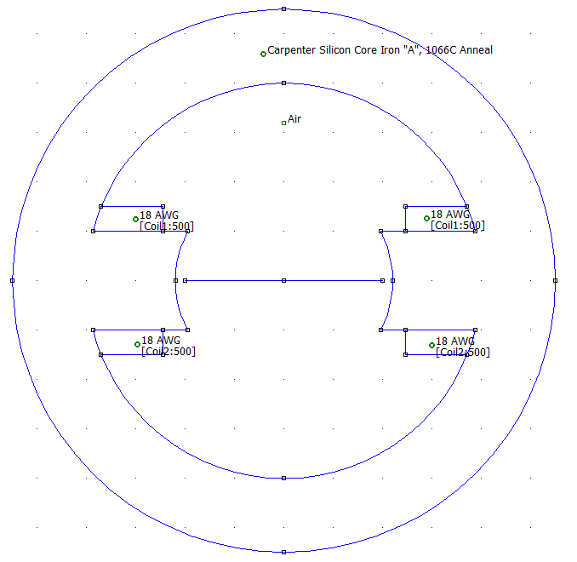

Figure.7 - DC Motor Stator Circuit
A boundary was created around the stator circuit in order to produce a mesh which shows the mesh density as in figure.8. This was done by using the mesh tool on the software.
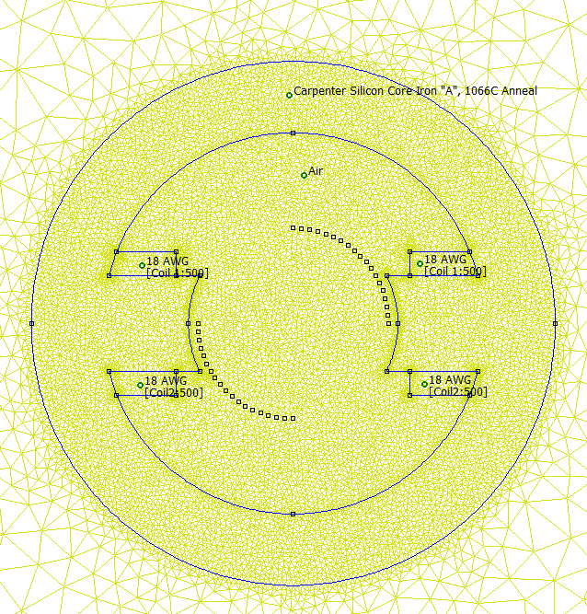
Figure.8 - Circuit with mesh density

In order to analyse the model, the “turn the crank” and the glasses icon was used. This brought up the model showing the magnetic flux and its most dense areas.

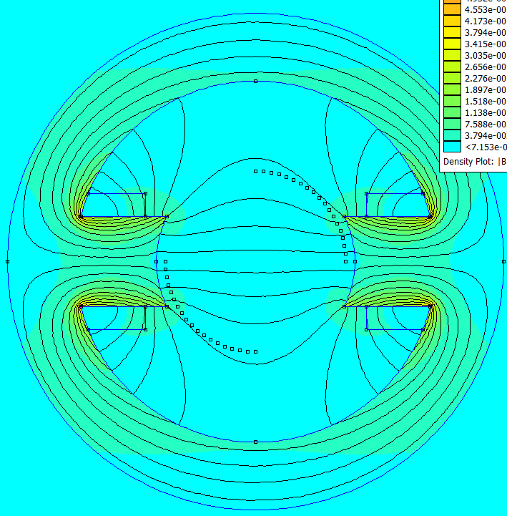
Figure.9 - DC Stator Circuit Analysis

Once complete, total flux, flux leakage factor and flux vs angle was determined.
The total flux was determined by creating a line vertically over the width of the armature and using the equation tool to obtain a total flux value.
The flux vs angle was found by placing nodes within the rotor around 90° with a spacing of 5° between nodes in the top and bottom half of the rotor.
A line was connected between each of the corresponding angles to obtain a flux density value against the angle of the rotor.
The flux leakage factor was obtained by the following equation:

FLF = Total Flux–Useful Flux/Total Flux

Where useful flux is the highest flux density value of a given angle over 90°.

Chapter 3 – Results

3.1 – Total Flux

After analysing the model, and using a vertical line over the width of one of the armatures (as fig.10), the total flux of the model was 238.6E-6 Wb.

Figure 10 - Total Flux

3.2 – Flux vs Angle

Using the method stated, the results obtained for the flux vs angle for the flux cutting the rotor coil as a function of the coil angle are:
Figure 11 - Flux vs Angle

By using the line for each angle up to 90°, the following results were obtained:
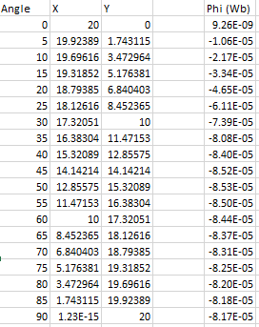
Figure.12 - Flux vs Angle results

It is worth noting from the results that the angle with the highest flux density is 50° having a density of -8.53E-5. The minus sign shows the direction of the magnetic field.

Figure 13 - Flux Density vs Angle
The results can also be shown over 360° to show that the magnetic field changes its polarity as the values change from a minus to a plus.

Figure 14 - Flux Density vs Angle over 360°
It is interesting to see that the graph over 360° is just a representation of the 90° results which have a different polarity after 180°.

3.3 – Flux Leakage Factor (FLF)

After completing previous task, using the highest value for flux density over 90°, the flux leakage factor, given as a percentage is:

FLF = (238.6E-6) – (8.53E-5) / (238.6E-6) x100
FLF = 64.22%

This value shows how much leakage there is.

Chapter 4 – Discussion

Based on evidence shown from the results, the estimated total flux density of the DC Motor Stator circuit model is 238.6E-6 which is a relatively high flux density, however if a finer mesh was used in the FEMM software, the flux density would increase significantly.
From the flux density vs angle results, the graph over 360° shows consistent flux density throughout which indicates that the magnetic field through the rotor is stable over its rotation.
Finally, the flux leakage factor of 64.22% is relatively high. By altering properties of the motor, the flux leakage factor could be improved through experimentation of the armature width, stator diameter etc.

Chapter 5 – Conclusions

Throughout these tasks I have learned how to not only draw a model using nodes, segments, arc and block labels using the FEMM 4.2 software but to utilise the package in order to assign materials to components within a model, create a magnetic field using a mesh and to also analyse the data that can be extracted from the model within the software such as:
- Flux Density
- Flux Leakage Factor
- Flux Density in respect of the coil angle
It has also given me the ability use the information from the model and create hard evidence via excel to create graphs of the flux density changing its magnitude and also the magnetic field changing its polarity.
The task completed has enabled me to demonstrate the understanding of the operation and design of an electrical machine.

References

[1] | “How a DC Motor Works?,” [Online]. Available: https://www.electricaleasy.com/2014/01/basic-working-of-dc-motor.html. [Accessed 07 March 2019].
[2] | “Brushed DC Motor Basics,” Microchip.
[3] | “Magnet Basics,” [Online]. Available: https://www.kjmagnetics.com/blog.asp?p=magnet-basics. [Accessed 12 March 2019].
[4] | “Finite Element Method,” [Online]. Available: https://www.sciencedirect.com/topics/engineering/finite-element-method. [Accessed 12 March 2019].
[5] | “Finite Element Method,” [Online]. Available: https://en.wikipedia.org/wiki/Finite_element_method#cite_note--1. [Accessed 12 March 2019].
[6] | “FEMM 4.2 Magnetostatic Tutorial,” [Online]. Available: http://www.femm.info/wiki/MagneticsTutorial. [Accessed 12 March 2019].
[7] | “Difference Between Left Hand Rule and Right Hand Rule,” [Online]. Available: http://www.differencebetween.info/difference-between-left-hand-rule-and-right-hand-rule. [Accessed 7th March 2019].
[8] | “Advantages & Disadvantages of DC,” [Online]. Available: http://www.dolin.com.vn/en/news/Economics-news/advantages-disadvantages-of-dc-79.html. [Accessed 11 March 2019].
[9] | “How Dc Motors are made and how they work,” [Online]. Available: http://www.pcbheaven.com/wikipages/How_DC_Motors_Work/. [Accessed 11 March 2019].
[10] | “Magnetic Field Polarity,” [Online]. Available: https://www.drpawluk.com/education/magnetic-science/magnetic-field-polarity/. [Accessed 12 March 2019].
[11] | “Ferrormagnetism,” [Online]. Available: http://hyperphysics.phy-astr.gsu.edu/hbase/Solids/ferro.html. [Accessed 12 March 2019].

