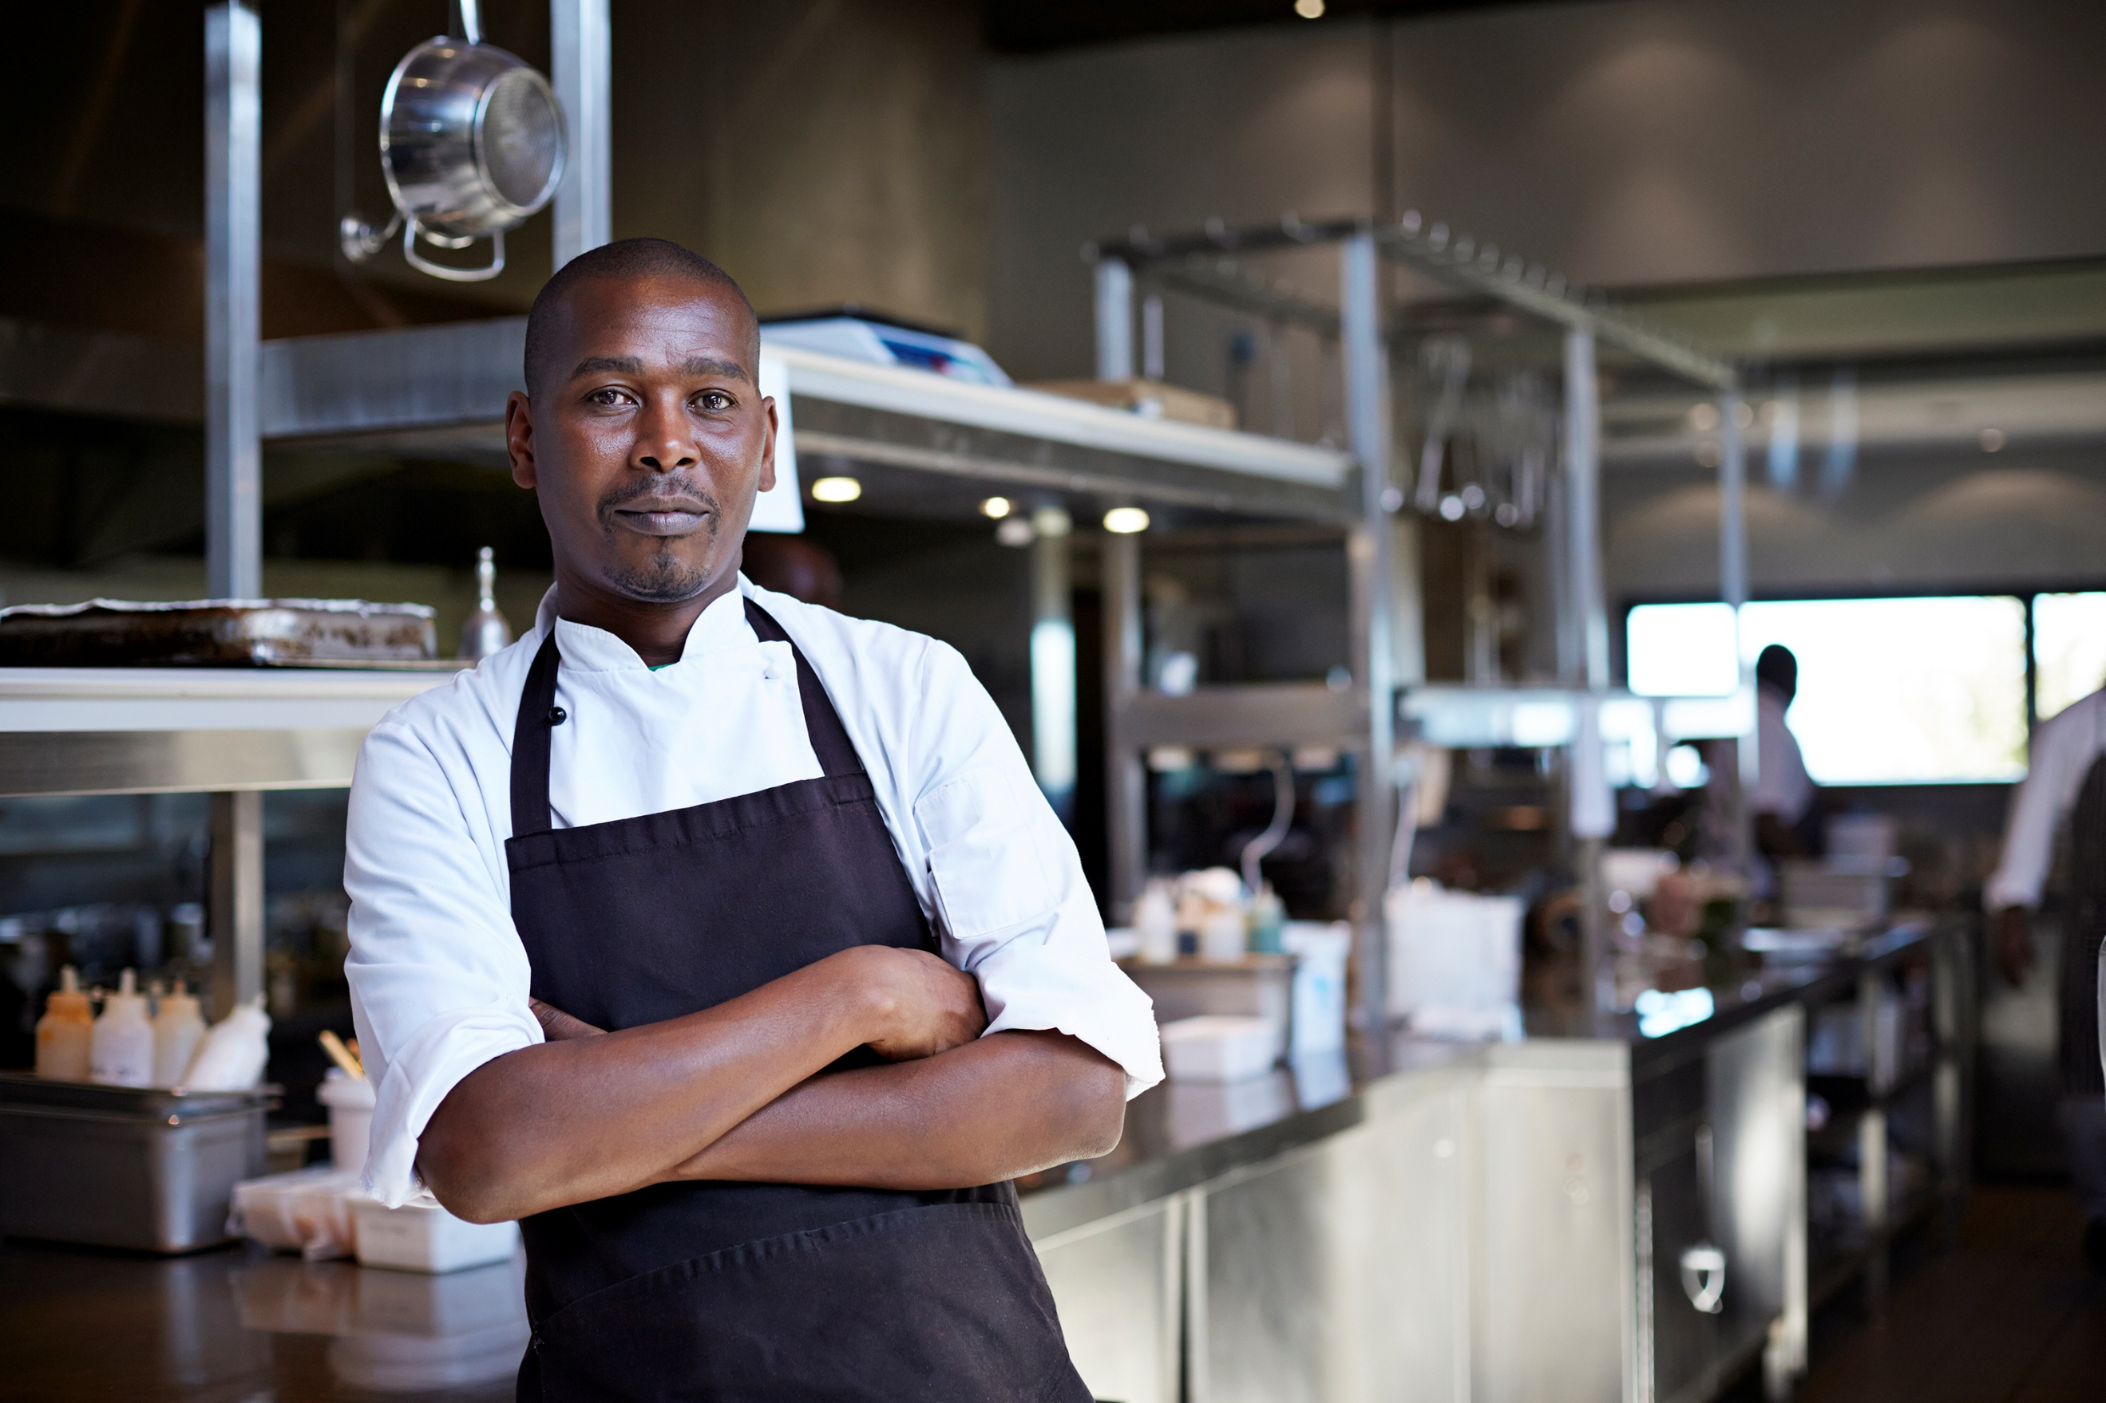  Student Learning Log: Food and Bevarage | Student Name: Anat Dranciuc Georgescu  Student Number: 2125394  Module: Managing Food & Beverage Operations  Module code: BMIH6002  Lecturer: Lisa Bassler  Word Count: 1246

I acknowledge the use of Grammarly (https://www.grammarly.com/) on 10 February
2024 to check my work using the prompt(s):
1. Please check the following text for readability, grammar and syntax.
I confirm that I have not presented any AI-generated text as my own work. I confirm I
have copies of my drafts, notes, and other resources I used before, and after the use of
AI tools which I may be asked to provide in evidence.

Contents
Introduction 3
Reflection on Experience and Personal Development 3
Reporting 4
Responding: 4
Relating: 5
Reasoning: 5
Conclusion and Action Plan 5
Reconstructing: 5
Reference List: 6

Introduction
The Food and Beverage department with Hilton Garden Inn in Doncaster has its operations based on two factors: one is the Hilton (2025) rules and policies that the staff must follow as well as some internal rules of their own.
This is a daily and weekly operation breakthrough as well as services that the F and B offer (Pell, 2025):
“(Breakfast, Lunch, Dinner, Room Service)
- 06:00-10:00 Breakfast Monday –Friday,
- 07:00 – 11:00 (Breakfast weekend)
- Lunch 12:00 – 17:00
- Dinner 17:00-21:00
Staff within the department: F&B Manager – F&B Assistant Manager, 2 Supervisors, 2 Shift Leaders.
Rota – Will look at the forecast and see how many guests we have for the week. Plan my rota with forecasted numbers with formulas for staffing levels. Rota – 1 week ahead, I will send it out. I will then review the Rota Day by day to see if the forecasted rooms have changed.
Manage Staff - Staff welfare, checking in on staff, making sure they are doing the correct job, and supporting any concerns that they might have.
Manager tasks – Pay Roll, Stock ordering (Alcohol, Linen, Dispo, Receipts) Training up to date (Hilton training & all health and safety) Risk assessments – All up to date and signed by every staff member) – Purchase orders, increase sales – Via open table – Push offers on there.”
The main learning objectives within the food and beverage department were:
- How the department works:
- What preparations must be put in place before service starts.
- What time service start.
- What happens during service time and what activities need to be done during service.
- What is allowed and not allowed in front of the customer.
- What and when break time is available for employees.
- What jobs need to be done after service time has finished
- How and when does upselling take place
- When does restocking happen
- How and when is the rota made for the day.
Reflection on Experience and Personal Development
For this part of the learning log, I will be using the 5R framework for Reflection, The University of Edinburgh (2024 cited Bain et al.,2002) explains the benefits of the 5R framework for Reflection, this framework breaks down the whole analysis into 5 steps: reporting, responding, relating, reasoning, and reconstructing making the whole process much easier to complete. As well as highlighting the Hilton Garden Inn F and B operations guide-EMEA, this was confirmed by Steward (2025).
Reporting:
While shadowing my F and B manager, supervisor, and team leader during my placement, I noticed that Mondays and Tuesdays are less busy, allowing the manager to handle office tasks like refreshing stock and making weekly rotas. Saturdays, however, are busy for everyone.
Breakfast service starts at 07:00, with customers arriving early. From 06:00, we have a 10-minute meeting to assign jobs, give feedback, and discuss handovers. Food and beverage items have a 3-day shelf life, so deep cleaning and rotation are crucial.
We double-check time sheets for jobs left from previous shifts and ensure customers receive clean, polished cutlery and glasses. Management, supervisors, and team leaders also register fridge temperatures to maintain optimal conditions for quality goods.
According to Andersen Veslemoy (2023, c. 2, p.5), Food safety is defined by the Codex Alimentarius Commission as ensuring that food does not cause adverse health effects when prepared and consumed according to its intended use. This definition highlights several key points:
- Adverse health effects: Distinguishes food safety from food suitability, which refers to quality aspects that make food unfit for consumption without being dangerous to health.
- Assurance: Food safety relies on the conditions of production and preparation rather than just end-product testing. This is referred to as “food hygiene.”
- Preparation and/or use: Food is safe if it is prepared and used as intended, with manufacturers considering this in product design and information provided to consumers. By ensuring these conditions, food safety aims to protect consumer health effectively.
Responding:
Being part of the Hilton franchise and the Racecourse group (Doncaster Racecourse, 2025), the team must adhere to both in-house and external standards, ensuring compliance with Hilton's presentation guidelines. The Hilton Garden Inn
Doncaster (Hilton Garden Inn, 2025) must follow Hilton F and B Operations Guidelines while supporting Racecourse events as needed.
As a team member, I had the opportunity to perform various tasks and interact with customers to ensure they received pleasant service. Initially, I lacked confidence in my communication and serving abilities, fearing unprofessional behaviour might upset customers and affect the business. However, with encouragement from the manager and the department, I gained confidence and interacted more with customers, knowing I could always ask for help if needed.
I didn't serve drinks or coffee from the bar but interacted with customers, assuring them that any issues would be resolved promptly.
Relating: Some F and B team members assigned me tasks that weren’t always aligned with my learning journey, but I completed most of the jobs. I signed and shared my daily work reports with the team. There were minor issues regarding break times and food access after service, but I eventually gathered all the necessary information to avoid repeating these mistakes.
Reasoning: After all, Haag, E (step 8 subsection 8.5 p. 161, 2012), points out that many degree programs recognize the skills students gain during placements, but further development is often neglected due to timing. This can cause feelings of distancing and affect motivation. Identifying and sharing gained competencies with lecturers and peers is beneficial, as each placement experience is unique and educational in its own way and form.
I can understand why there are rules set in place for everything from when and how employees can take their breaks, why there is only a 3-day life span for certain food and drinks provided as well as the way that the hotel is minimizing their food waste and recycle food where they can.
Conclusion and Action Plan
Reconstructing:
My future action plan includes applying the skills I learned from the F and B team. Providing high-quality service is essential and maintaining a polite and kind attitude makes communication easier. Every job is important in delivering excellent customer service.
Staying proactive and preventing issues is crucial. Assessing future events and predicting staffing needs can be challenging, especially in a restaurant without a booking system. However, with the hotel's booking system, predicting staffing needs becomes more manageable, ensuring smooth operations.
Finding solutions to food waste within the hospitality industry is one of my future career goals, currently, Hilton Garden Inn in Doncaster is recycling food, Ellgia (2025) offers businesses the opportunity to turn their food waste into biogas and biofertilizer.
Doncaster-Food Bank together with Trussell (2025) is requesting help from businesses in the area in the form of money or food products, currently with only 3 places used as food banks and a warehouse, this is quite limited for the big city of Doncaster.
Another issue is that businesses refuse to get involved in donating food since most of them have the food already prepared and it does not comply with health and safety regulations to donate food that already has been cooked, customers who do leave the Hilton Inn Garden Doncaster premises with food have to sign a form that states that they agree with any risks that come with overcooking the food that they have taken or have not stored properly after departure, I promise to myself to find suitable solutions to this rules while continuing the journey within the hospitality industry.

Reference List:
Andersen Veslemoy (p.1-p.1160, 2023) Food Safety Management: A Practical Guide for the Food Industry. [Online] Available at: https://www-vlebooks-com.ezproxy.uwtsd.ac.uk/Product/Index/3113628?page=0&startBookmarkId=-1 (Accessed: 6 March 2025).
Doncaster-Food Bank together with Trussell (2025). Donate food. [Online] Available at: https://doncaster.foodbank.org.uk/give-help/donate-food/ (Accessed: 6 March 2025).
Doncaster Racecourse (2025) Restaurants and Hospitality. [Online] Available at: https://www.doncaster-racecourse.co.uk/restaurants-and-hospitality (Accessed: 6 March 2025).
Ellgia-Waste Management-Recycling Solutions-Skip Hire (2025). Food recycling. [Online] Available at: https://www.ellgia.co.uk/commercial-waste/food-recycling/ (Accessed: 6 March 2025).
Haag, E (step 8 subsection 8.5, 2012) Internship Guide: Work Placements Step by Step, Eleven International Publishing, Hague. [Online] Available from: https://ebookcentral.proquest.com/lib/trinity/reader.action?docID=3015612&ppg=163 (Accessed: 6 March 2025). step 8 subsection 8.5 p. 161
Hilton (2025) Hotels by Hilton - Book the Best Rates Across All Brands. [Online] Available at: https://www.hilton.com/en/ (Accessed: 6 March 2025).
Hilton Garden Inn (2025) Hilton Garden Inn Doncaster Racecourse. [Online] Available at: https://www.hilton.com/en/hotels/dsadrgi-hilton-garden-inn-doncaster-racecourse/?SEO_id=GMB-EMEA-GI-DSADRGI (Accessed: 6 March 2025).
Gmail: Pell C. (2025) Gmail/ Email to Anat Dranciuc, 11 February
Gmail: Stewart Perkins (2025) Gmail/Email to Anat Dranciuc 06 March
The University of Edinburg (2024) The 5R framework for reflection [Online] Available at: https://reflection.ed.ac.uk/reflectors-toolkit/reflecting-on-experience/5r-framework (Accessed: 06 March 2025).

