
\

Student name: Elisabete Nobrega
Student ID: 2336792

Module name: Changemakers: Building your personal Brand for Sustainable Employment.
Module code: BMHP5015
Lecturer name: Christopheer Mafuva

Component 1 – Online Portfolio

Module Title – Changemakers – Building Your Personal Brand for Sustainable Employment
Module Code – BMHP5015
Program – BSc (Hons) Health and Social Care

Table of Contents
Introduction 3
Unit 1 – ‘Brand You’ 3
Unit 2 – ‘It’s a Small World’ 5
Unit 3 – Opportunity Knox 7
Unit 4 – The Pursuit of Happiness 9
Conclusion 10
References 11

Introduction
This project provides a reflective portfolio from my learning experience from the module ‘Changemakers – Building Your Personal Brand for Sustainable Employment’. During the module, we focused on improving major personal and professional skills required for employment in health and social care. Employability skills and personal branding are essential due to their help to individuals. In this way, it helps them show better their skills and values to companies they apply for (Tomlinson, 2017).
In the portfolio, I will show reflection on four units discussed in the module. These units consist of personal branding, global connections, recognising opportunities, and wellbeing. Moreover, all the units helped better understand how to improve my skills and be well-prepared for my future career. According to Gibbs (1988), reflection helps individuals learn and understand from experience and increase their work.
Also, this project will connect my learning to academic theories like networking, emotional intelligence, and goal setting. These theories are very important in health and social care due to their support for efficient communication, teamwork, and professional growth (Jackson, 2019).
In general, this portfolio illustrates how I am improving my professional identity and helping myself to be better employed in the future in the health and social care sector.

Unit 1 – ‘Brand You’
During Unit 1 ‘Brand You’, I explored important things about personal branding. Also, I learned that it is very important for my future career in health and social care. The main topics discussed were ambition, motivation, and boundaryless careers. These ideas helped me realise how to improve myself and equip myself with the necessary skills for future employment as a health care assistant.
Firstly, I understood that ambition is crucial. In addition, it will help me form real goals for my future. Before, I was not very concerned about my long-term career. Yet, I know that setting clear goals will help me be more organised and concentrated. For instance, I know that I should finish my studies successfully and gain real-life experience. Tomlinson (2017) states that employability heavily relies on how well individuals understand and represent their skills to the employers. This concept helped me understand that I should be responsible for my own development and future career.
Secondly, I analysed the idea of encouragement and what actually motivates me. In addition, I realised that my major motivation is assisting other people and making a positive difference in their lives. In health and social care environments, this is essential because staff must be compassionate and supportive to patients. Moreover, I realised that motivation can increase job satisfaction and improve performance (Ryan and Deci, 2020). This helped my reflection on personal values and how they relate to my future role as a healthcare assistant. Now, I feel sure about my career choice.
The boundaryless careers were major concepts that I also learned during Unit 1. This is related to people that do not remain on one job for their whole life. In addition, they acquire new skills and move between different roles. I understood that I have to be more flexible and seek new opportunities. This is very crucial for health and social care environment, because it is changing and developing rapidly (Inkson, 2019). For instance, I can begin as a Health Care Assistant but later advance a higher role, requiring further education and training.

Screenshot 1 – Boundaryless Career
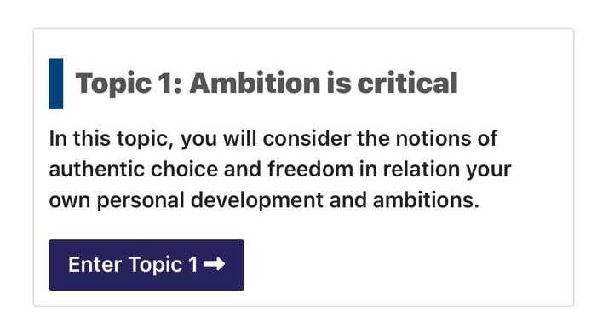
This screenshot is related to the topic ‘Ambition is critical’. During this activity, I analysed deeply my future goals and focused on the importance of setting career objectives.

Screenshot 2 – What Drives You?
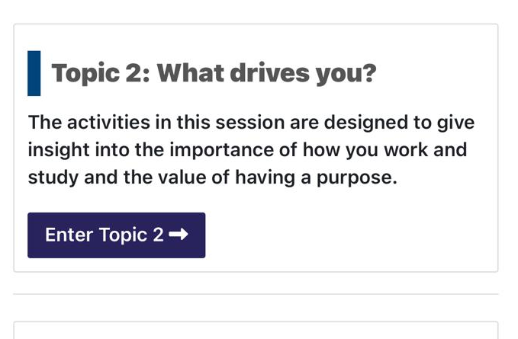
The topic ‘What drives you?’, helped me reflect on my personal motivation and realise what motivates me to work in health and social care.

Screenshot 3 Boundaryless Career
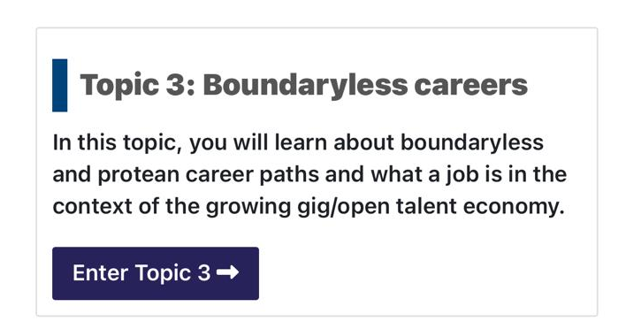
This screenshots illustrates the ‘Boundaryless careers’. In addition, it helped me realise that careers can be flexible and demand people to continuously learn and thrive for development.

Unit 2 – ‘It’s a Small World’
During the Unit 2 discussion, I have learnt about important issues like networking, diversity, and global connections. Moreover, the unit helped me better understand how companies and people are related in contemporary society. Also, it showed important factors why this connection is crucial in health and social care settings.
First, I understood that networking is a recommended skill for professional and personal growth. Before, I knew that networking is when you meet new people. Now, I understand that networking is aligned with saying your ideas, creating new relationships, and asking others for support. In health and social care environments, professionals have to work together to ensure that they provide efficient care for patients. According to Jackson (2019), networking helps people refine their employability and see new options. Therefore, I realised that creating relationships would better support my future career.
Moreover, I analysed the concept of diversity. I understood that people in big companies often come from different cultural, social, and personal backgrounds. So, this issue is crucial in health and social care environments. Also, professionals work with a large volume of patients. I learned that I should respect different norms, traditions, and values. In addition, cultural competence is about understanding and reacting well to the differences in working environments (Papadopoulos, 2018). So, I reflected better on my behaviour. Also, this helped me refine my communication abilities when working with individuals with different backgrounds.
In addition, during this unit I understood the main idea of a network society. This is aligned with how people are connected globally with the power of technology and communication strategies. Moreover, I realised that health and social care are influenced by global concerns like technology, migration, and public health concerns. Van Dijk (2020) states that contemporary society relies heavily on digital and social networks. These networks create the pattern of how people interact. This helped me realise that I should understand global changes due to their direct influence on service delivery and patient care.

Screenshot 4 – No one is an Island
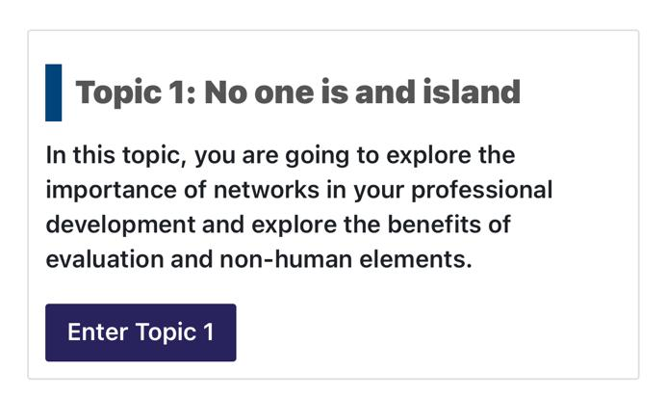
This screenshot shows the topic ‘No one is an island’. In this unit, I analysed the importance of social and professional networks.

Screenshot 5 Variety of the spice of life
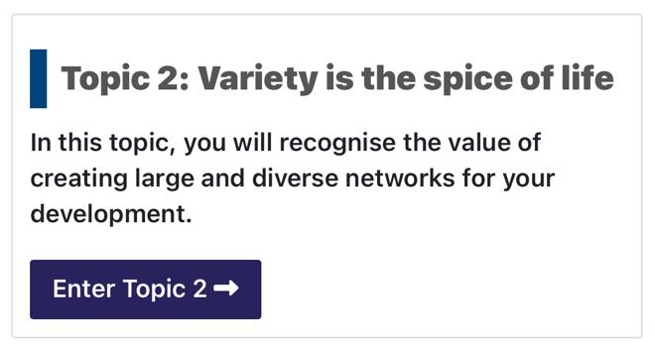
The following screenshot shows my work in ‘Variety of the spice of life’. Here focused on my reflection on cultural awareness and diversity.
Screenshot 6 Network Society
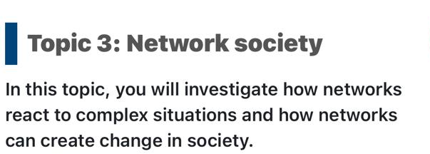
This screenshot shows the concept ‘Network society’. It helped me realise how global connections impact health and social care settings and create change in the society.

Unit 3 – Opportunity Knox
Unit 3 helped me learn about identifying and applying opportunities for personal and professional development. Also, this lesson improved my understanding of how to be more responsible for my future career and decide better in health and social care. The major topics were seeing opportunities, goal setting, and personal growth.
In addition, I realised the opportunities cannot always be in front of me, and I should actively see and take them. Before, I thought that opportunities come naturally, like chances. Still, I understand that proactivity is a skill that is very important. In addition, an individual must be initiative and should make decisions to improve the situation. Clarke (2018) analyses employability as it heavily relies on an individual’s ability to see and apply new opportunities efficiently. This also helped me understand that I should be more initiative in improving my career.
Moreover, I analysed the importance of goal setting. I understood that making specific and clear goals will help me manage my future actions. In addition, goal setting improves individuals in being more focused and concentrated. Moreover, I realised that I should plan my short-term and long-term goals cautiously. According to Locke and Latham (2019), clear goals help individuals improve motivation and overall performance. This helped me reflect better on planning my studies and career.
Another crucial idea developed in this unit was personal growth. I understood that continuous learning is important for being successful in health and social care. I understood that I have to improve new skills and refine current abilities. Kolb (2015) states that learning from experience helps people improve their professional practice and development. This helped me realise that experience and reflection are inevitable parts of my career development.
Screenshot 8
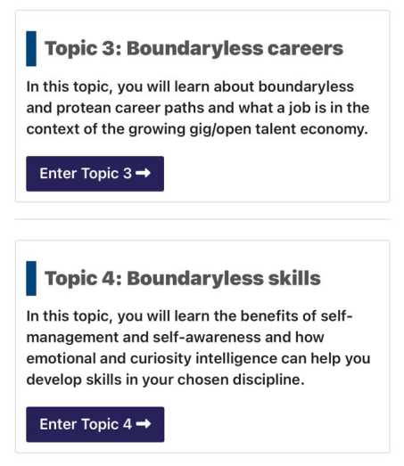
This screenshot shows how I analysed career opportunities and that I must be more flexible in my choices. In addition, this requires continuous learning and improvement over time.
Overall, Unit 3 helped me realise the essence of seeing new opportunities, setting clear goals, and improving my skills continuously. Now, I am more confident in making better plans for my future and being more responsible for my personal and professional development in the health and social care sector.

Unit 4 – The Pursuit of Happiness
Unit 4, ‘The Pursuit of Happiness’, helped me understand wellbeing, emotional intelligence, and self-management. Also, it improved my understanding of how to create a healthy balance between my personal life and future career in health and social care settings. It focused on the importance of keeping my emotions and improving self-awareness.
In addition, I understood that wellbeing is important for both personal and professional success. Before, I thought that stress and mental health could not directly impact on my performance. Now, I realise that keeping good wellbeing will help me stay productive and focused and provide better care to patients. The World Health Organisation (2021) shows that mental wellbeing is crucial for maintaining efficient functioning in daily life. This helped me understand that I should be more responsible for my mental health to support others excellently.
Moreover, I analysed the idea of emotional intelligence. This means that I have to work on the ability to understand and manage my own emotions, as well as see the emotions of others. In health and social care settings, this is crucial for professionals because they work closely with patients who are stressed or vulnerable.
In addition, emotional intelligence is crucial for ensuring effective communication and creating relationships in the workplace. Also, it helps people understand and handle emotions (Goleman, 2020). This unit helped me create reflection on my reactions and refine my interaction with other people. Moreover, I realised that self-management is crucial for achieving personal goals. It consists of managing time, emotions, and duties. I also understood that I must be more organised in my curriculum and then my future career. CIPD (2023) indicates that self-management helps individuals with their career growth and achieving long-term success. These concepts helped me be more focused on my behaviour and personal professional skills in health and social care.
Screenshot 7
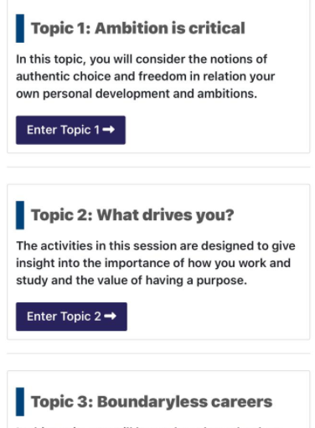
This screenshot outlines the points I reflected on my personal values and motivation. Also, it helped me realise the various aspects and improve my emotional awareness.

Conclusion
To conclude, this portfolio has helped me reflect on my learning from the module ‘Changemakers – Building Your Personal Brand for Sustainable Employment’. The four units – ‘Brand You’, ‘It’s a Small World’, ‘Opportunity Knox’, and ‘The Pursuit of Happiness' – helped me improve essential skills and knowledge required for my future career in health and social care. I also learned that personal branding, global connections, recognising opportunities, and wellbeing are important for following a career in healthcare.
During Unit 1, I understood my goals, motivation, and career direction better. Then, Unit 2 helped me identify the essentials of networking and respecting diversity when working with people with different backgrounds. Unit 3 helped me learn how to see opportunities and set real goals for my personal and professional growth. In the last Unit, 4, I understood the importance of wellbeing, emotional intelligence, and self-management. In this way, I learnt how to maintain a healthy work-life balance.
Lastly, the module helped me become more self-aware and sure in my capabilities. Now, I already know how to improve my skills and be prepared for future employment. The lessons helped me provide better and efficient service in health and social care settings. For further development, I will use these skills to improve my professional growth and reach my career objectives

References
CIPD (2023) Developing self-management skills. London: Chartered Institute of Personnel and Development.
Clarke, M. (2018) ‘Rethinking graduate employability: The role of capital, individual attributes and context’, Studies in Higher Education, 43(11), pp. 1923–1937.
Gibbs, G. (1988) Learning by Doing: A Guide to Teaching and Learning Methods. Oxford: Oxford Polytechnic.
Goleman, D. (2020) Emotional Intelligence. London: Bloomsbury Publishing.
Inkson, K. (2019) Understanding Careers. 3rd edn. London: Sage Publications.
Jackson, D. (2019) ‘Employability skill development in work-integrated learning: Barriers and best practice’, Studies in Higher Education, 44(3), pp. 1–15.
Kolb, D.A. (2015) Experiential Learning: Experience as the Source of Learning and Development. 2nd edn. New Jersey: Pearson Education.
Locke, E.A. and Latham, G.P. (2019) New Developments in Goal Setting and Task Performance. New York: Routledge.
Papadopoulos, I. (2018) Culturally Competent Compassion: A Guide for Healthcare Students. London: Routledge.
Ryan, R.M. and Deci, E.L. (2020) Intrinsic and Extrinsic Motivation from a Self-Determination Theory Perspective. New York: Guilford Press.
Tomlinson, M. (2017) ‘Forms of graduate capital and their relationship to graduate employability’, Education + Training, 59(4), pp. 338–352.
Van Dijk, J. (2020) The Network Society. 4th edn. London: Sage Publications.
World Health Organization (2021) Mental health and wellbeing. Available at: https://www.who.int (Accessed: 27 March 2026).

