Danielle Harding (2517154)
2517154@student.uwtsd.ac.uk

Introduction to Web and Database Concepts
Design and Implementation of a Relational Database System

Contents
Introduction to Web and Database Concepts 0
Design and Implementation of a Relational Database System 0
TABLE OF FIGURES 2
Introduction 3
Scenario Analysis 3
Entity-Relationship Diagram (ERD) 6
Data structure Development 7
Normalization Compliance 8
Sample Data Population 9
Query Development 10
Validation and Testing 11
Conclusion 12
References 13

TABLE OF FIGURES
Figure 1: Entity Relationship Diagram (ERD) 3
Figure 2: Bike table created in Microsoft Access 4
Figure 3: Maintenance table created in Microsoft Access 4
Figure 4: Database Relationship showing one to many cardinality and primary and foreign keys 5
Figure 5: Entity-Relationship Diagram (ERD) showing entities, primary keys, and one to many relationships 6
Figure 6: Bike table design showing the primary key and data type used to uniquely identify records in Microsoft Access 7
Figure 7: Referential integrity enforced between the Bike and Rental tables in Microsoft Access. 7
Figure 8: Database normalization stages (1NF–3NF) [8] 8
Figure 9: Relationships diagram for the Eco_Ride database (3NF compliant design) 8
Figure 10: Sample data populated in the Station table in Microsoft Access 9
Figure 11: Sample data populated in the Maintenance table in Microsoft Access 9
Figure 12: MaintenanceDue query design view in Microsoft Access 10
Figure 13: MaintenanceDue query results showing overdue maintenance records 10
Figure 14: How buttons were created in Microsoft Access 11
Figure 15: Buttons created in Microsoft Access 11
Figure 16: Validation error shown for email in Microsoft Access 11
Figure 17: Lookup dropdown box used for StationID in the Bike table in Microsoft Access 12

Introduction
This report presents the design and implementation of a database system for Eco_Ride, a local authority–run electric bike rental service aimed at promoting environmentally sustainable transport. It explains how the system meets the functional requirements of the scheme, including the storage and management of bike information, maintenance records, and staff and rider details. The report also demonstrates how a structured database solution can improve efficiency and help streamline the scheme’s operations.
The report supports Task 1 of the assignment by outlining the process of designing and implementing a database using Microsoft Access. This includes identifying key entities, defining relationships, and applying database design principles in practice.
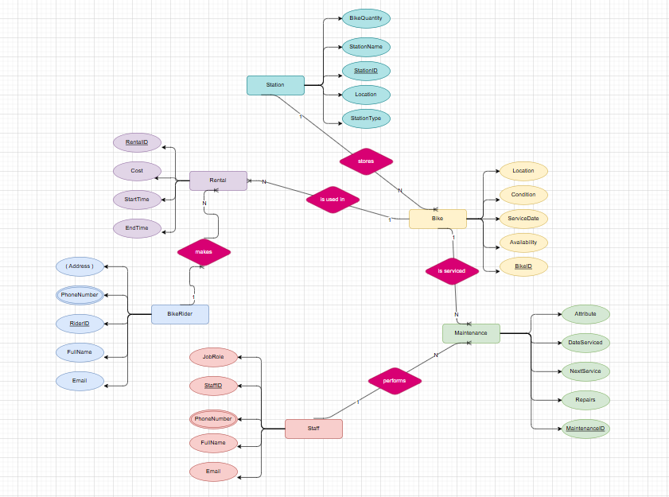
Figure 1: Entity Relationship Diagram (ERD)

Scenario Analysis
Eco_Ride is a local authority–run electric bike rental service designed to promote environmentally sustainable transport. Bike riders can scan their ID at rental locations situated across several public areas, such as train stations, university campuses, and parks. Riders can collect a bike from one station and return it to any other Eco_Ride station.
The current system relies on a combination of paper records and basic spreadsheets. Maintenance activities are tracked informally, which has resulted in issues such as double bookings and bikes not being returned to stations. As a result, it has become challenging to generate accurate summaries and gain a clear understanding of overall service usage.
This database system aims to replace manual processes by introducing a structured and centralised solution that improves accuracy, efficiency, and data visibility.

Identification of Entities
These entities represent the main components of the Eco_Ride system. Based on the scenario, the following entities were identified and are presented in the same order as shown in the Entity-Relationship Diagram to maintain consistency between the diagram and the written explanation.
- Station – identifies the locations where bikes can be collected and returned
- Bike – stores details about each electric bike in the system
- BikeRider – stores information about riders who rent bikes
- Rental – records individual bike rental transactions
- Staff – stores details of staff responsible for servicing and inspections
- Maintenance – records servicing and repair activities carried out on bikes

Entity Attributes
Each entity contains attributes that store detailed information to support accurate data storage within the Eco_Ride system. Primary keys are used to uniquely identify records, while foreign keys support relationships between entities.
The following screenshots show examples of the Design View for the database tables, highlighting the attributes, data types, and primary keys used within the system.
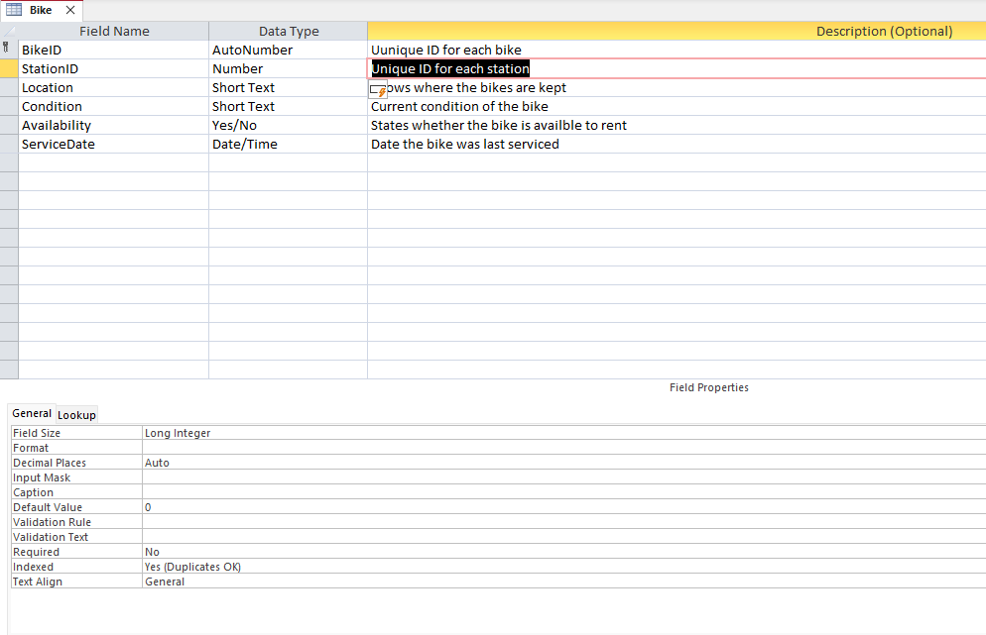

Figure 2: Bike table created in Microsoft Access
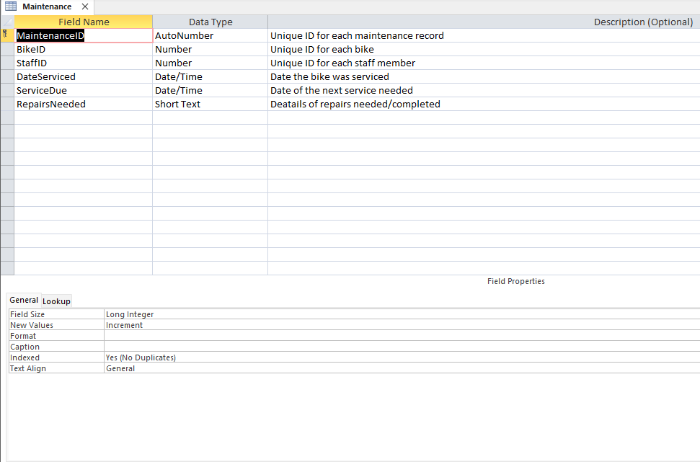

Figure 3: Maintenance table created in Microsoft Access

- Station: StationID (PK), StationName, Location, StationType
- Bike: BikeID (PK), Condition, Availability, ServiceDate
- BikeRider: RiderID (PK), FullName, ContactNumber, EmailAddress, IDNumber
- Rental: RentalID (PK), RentalDate, ReturnDate, Duration, Cost
- Staff: StaffID (PK), FullName, JobRole, ContactDetails
- Maintenance: MaintenanceID (PK), DateServiced, RepairsNeeded, NextServiceDate

Entity Relationships
Relationships are used to link entities using one-to-many (1:N) cardinality. This helps prevent duplicate data and supports accurate tracking of bike availability, maintenance history, and rentals.
As shown in figure 4 below, the relationships created between the database tables in Microsoft Access.
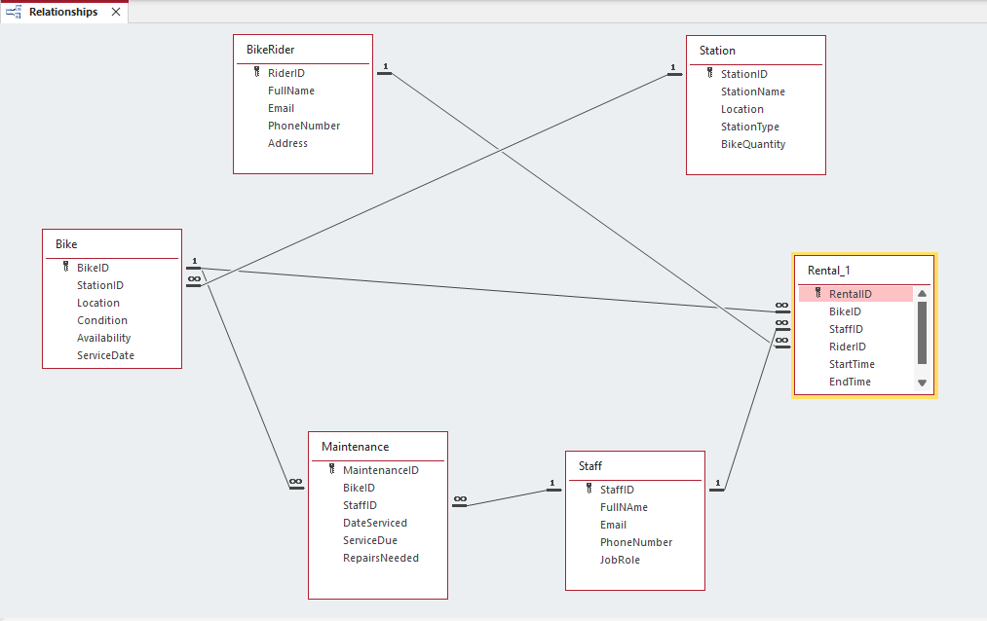

Figure 4: Database Relationship showing one to many cardinality and primary and foreign keys

- One Station can store many Bikes (one-to-many)
- One Bike can be involved in many Rentals over time (one-to-many)
- One BikeRider can make many Rentals (one-to-many)
- One Bike can have many Maintenance records (one-to-many)
- One Staff member can carry out many Maintenance tasks (one-to-many)

Entity-Relationship Diagram (ERD)
This ERD models the data structure of a Bike Rental Management System, including stations, bikes, riders, rentals, staff, and maintenance records.
An Entity–Relationship Diagram (ERD) illustrates the structure of a database by identifying entities, their attributes, primary keys, and the relationships between them with appropriate cardinality. ERDs are used during database design to visualise data structures and identify potential issues before implementation.
In the 1970s, Peter Chen introduced the Entity–Relationship (ER) model, and since then several ERD notations have been developed to support different modelling needs. These include Chen notation, which represents entities and cardinality using symbols and connecting lines, while later styles such as Crow’s Foot, Bachman, IDEF1X, and Barker provide alternative representations of entities, attributes, and relationship cardinality [1].
This ERD represents relationships at a conceptual level, while the Microsoft Access implementation enforces these relationships using numeric primary and foreign key fields to maintain referential integrity.
The Entity–Relationship Diagram shows the following relationships:
- One Station can store many Bikes (1:N)
- One Bike can be involved in many Rentals over time (1:N)
- One BikeRider can make many Rentals (1:N)
- One Bike can have many Maintenance records (1:N)
- One Staff member can perform many Maintenance tasks (1:N)
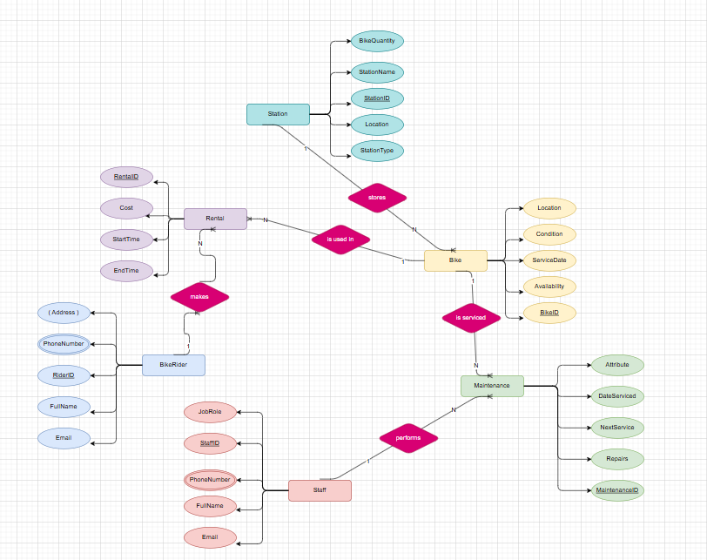
Figure 5: Entity-Relationship Diagram (ERD) showing entities, primary keys, and one to many relationships

Data structure Development
The Eco_Ride database was implemented in Microsoft Access using the Entity–Relationship (ER) model, with a separate table created for each entity. Primary keys, typically defined as AutoNumber fields, were used to uniquely identify records, and entities such as Station, Bike, BikeRider, Rental, Staff, and Maintenance were defined based on system requirements.
Figure 6 shows the Bike table design, including the primary key and data type used to uniquely identify records.
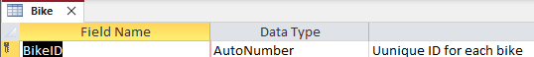

Figure 6: Bike table design showing the primary key and data type used to uniquely identify records in Microsoft Access

Database integrity is a fundamental principle in database systems, ensuring that stored data remains valid, accurate, and consistent over time. Integrity is maintained using constraints, which restrict invalid data entry and enforce correct relationships between related records [2].
Referential integrity is a database rule that ensures a value entered in a foreign key field matches an existing value in the related table’s primary key. In Microsoft Access, referential integrity is enforced through table relationships to prevent invalid or orphan records.
In the Eco_Ride database, a Rental record cannot exist unless the associated Bike and BikeRider records already exist. Access enforces this by preventing a Rental from being created with a BikeID or RiderID that does not exist in the Bike or BikeRider tables.
Figure 7 demonstrates referential integrity enforced between the Bike and Rental tables.
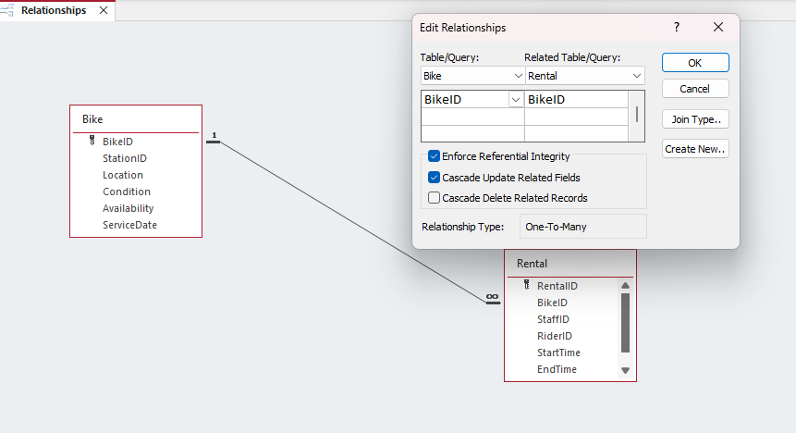
Figure 7: Referential integrity enforced between the Bike and Rental tables in Microsoft Access.

Some relationship issues were encountered in Microsoft Access and were resolved by ensuring consistent key fields and data types.

Normalization Compliance
The Eco_Ride database design follows Third Normal Form (3NF). Normalization is the process of organising a database so that each item of data is stored only once, reducing redundancy and ensuring clear relationships between tables [7].
Figure 8 illustrates the progression from First Normal Form (1NF) to Third Normal Form (3NF), highlighting the removal of partial and transitive dependencies in relational databases [8].
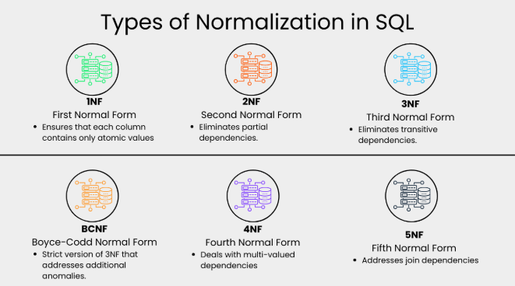
Figure 8: Database normalization stages (1NF–3NF) [8]

The database complies with First Normal Form (1NF) as all tables have a primary key and each field stores a single, atomic value. Identifiers such as BikeID, RiderID, and StaffID store one value per record, while attributes such as StartTime and ServiceDue are stored in separate fields.
Second Normal Form (2NF) is satisfied because all non-key attributes depend on the full primary key. Most tables use single field primary keys, such as RentalID and BikeID, which prevents partial dependencies.
The database design meets Third Normal Form (3NF) by removing transitive dependencies. Related data is stored in separate tables, with the Rental table linking to the Bike, BikeRider, and Staff tables using foreign keys instead of repeating the same information. Maintenance and Station details are also stored in their own tables and connected through relationships. Figure 9 shows the normalized relationships in the Eco_Ride database, confirming that the design follows Third Normal Form (3NF).
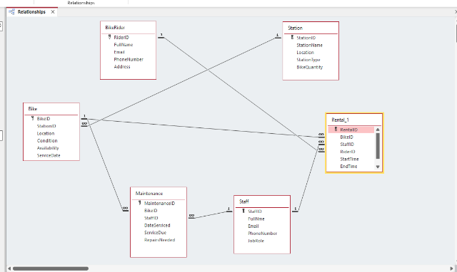

Figure 9: Relationships diagram for the Eco_Ride database (3NF compliant design)

Overall, each table has a clear purpose and stores only data that relates directly to its primary key. This structure reduces duplication, helps maintain data consistency, and makes the database easier to maintain and update in the future.

Sample Data Population
The Eco_Ride database was populated with sample data to demonstrate realistic system usage and to confirm that tables and relationships function correctly. Five records were added to each table, representing typical Eco_Ride operations such as station management and maintenance activities, while maintaining referential integrity between related tables. As shown in Figures 10 and 11, the data is correctly stored and linked within Microsoft Access.
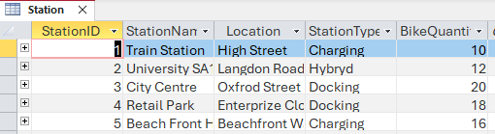
Figure 10: Sample data populated in the Station table in Microsoft Access

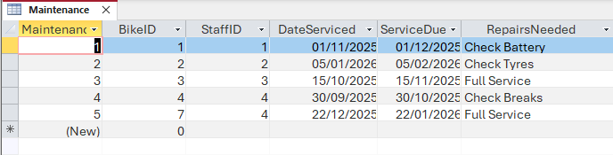
Figure 11: Sample data populated in the Maintenance table in Microsoft Access

Query Development
Queries were created in Microsoft Access to demonstrate how the Eco_Ride database can be efficiently retrieved and analyse data. In Access, queries allow data to be extracted, filtered, and combined from related tables using either Query Design View or SQL View. Queries play an important role in converting stored data into useful information that supports both operational tasks and decision-making [3].
A range of practical queries was developed to meet system requirements, including checking bike availability, identifying bikes currently out on rental, and listing bikes due for maintenance. These queries make use of the relationships defined in the database and apply selection criteria and joins between tables, which are key features of relational database querying [4].
Additional queries were created to analyse rider activity, such as viewing rental records for individual BikeRiders and identifying frequently used bikes. Figures 12 and 13 show the design and results of these queries in Microsoft Access. These queries combine data from multiple tables to provide clear insights into system usage, maintenance requirements, and overall service performance.
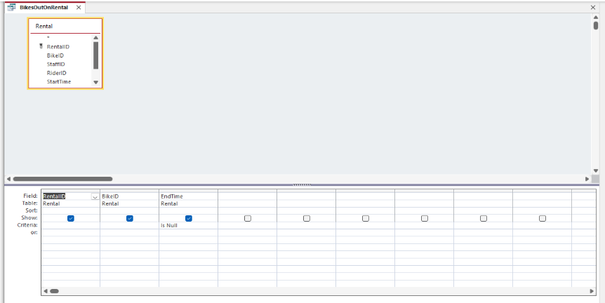

Figure 12: MaintenanceDue query design view in Microsoft Access

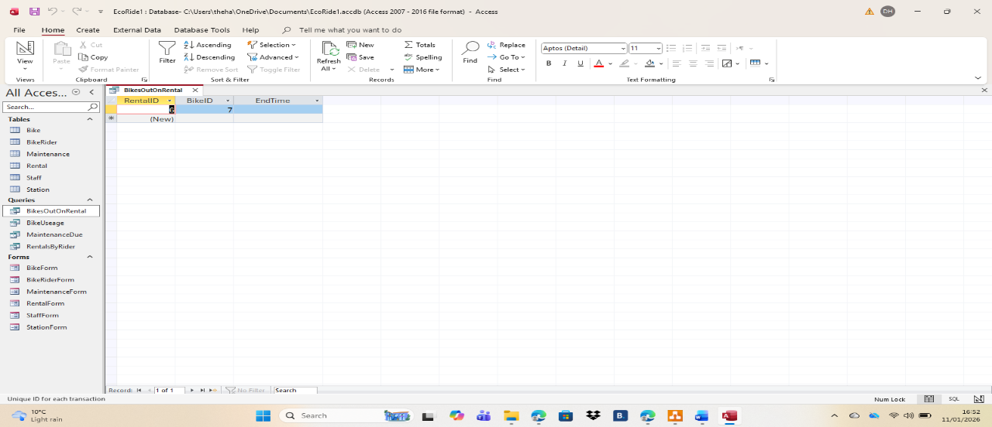

Figure 13: MaintenanceDue query results showing overdue maintenance records

Validation and Testing
To meet user requirements, the Eco-Ride database system was validated and tested to ensure that it operates correctly and reliably.
As shown in Figures 14 and 15, buttons were created and tested to allow users to easily manage records within the database. The Add Record button enables users to create a new data entry, while the Save Record button stores the new record in the database. The Delete button removes the selected record after user confirmation. Testing confirmed that each button performed its intended function correctly.
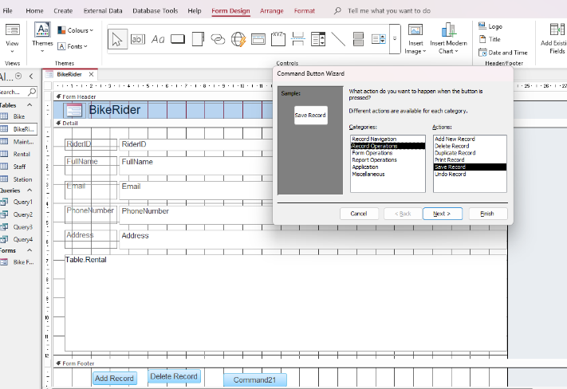
Figure 14: How buttons were created in Microsoft Access
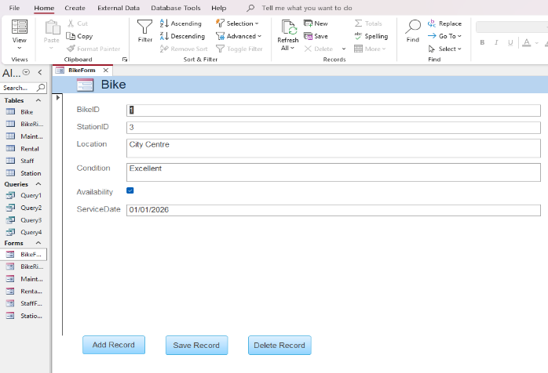
Figure 15: Buttons created in Microsoft Access

To ensure that only valid email addresses are stored in the database, a field-level validation rule was applied to the Email field in the BikeRider table. As shown in Figure 16, an invalid email address was rejected during testing due to the absence of the @ symbol. This confirms that the validation rule works correctly and helps maintain data accuracy and integrity within the database.
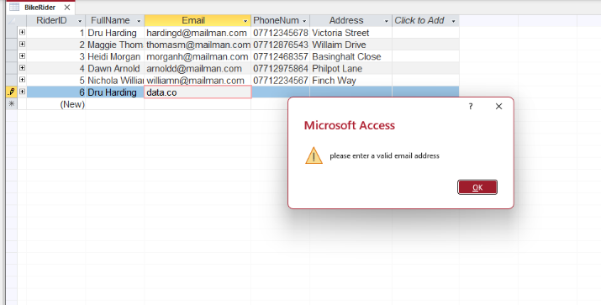

Figure 16: Validation error shown for email in Microsoft Access

A lookup was created for the StationID field in the Bike table to improve data accuracy. The lookup displays a dropdown list from the related table, making data entry more efficient and reducing input errors. As seen below this demonstrates that lookup validation works correctly and helps maintain data integrity.
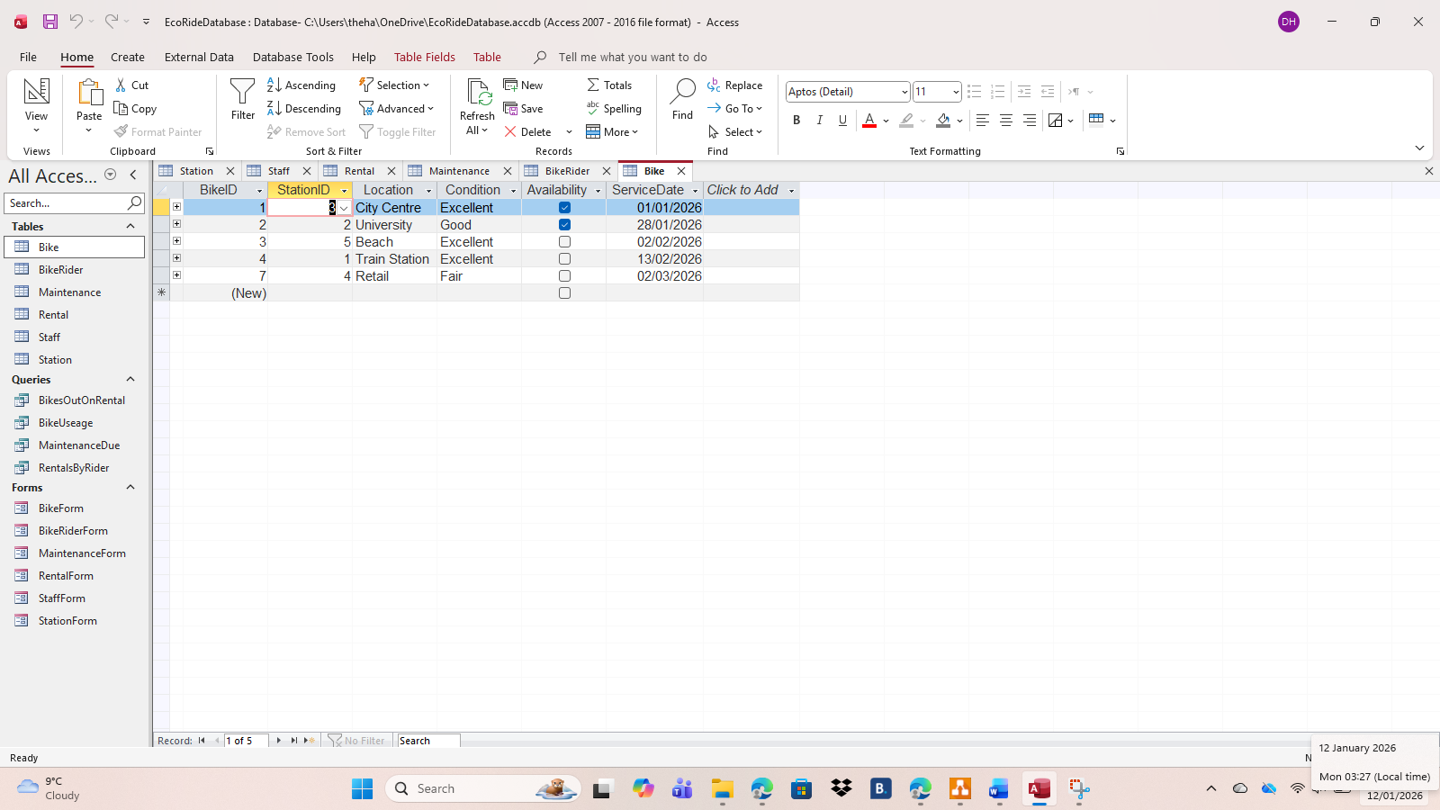
Figure 17: Lookup dropdown box used for StationID in the Bike table in Microsoft Access

Conclusion
This database was designed to effectively manage information about bikes, riders, rentals, maintenance, staff, and stations.
The report demonstrates the successful design and implementation of the Eco_Ride database using Microsoft Access. Key database principles, including primary and foreign keys, referential integrity, and Third Normal Form (3NF), were applied to ensure accurate data storage and reduce duplication.
Queries were used to analyse system usage and identify maintenance requirements. Validation and testing confirmed that the system operates correctly, with lookup fields, validation rules, and buttons improving data integrity and ease of use.
Overall, the Eco_Ride database provides a more efficient and reliable solution than the previous manual system.

References
[1] IBM, “Entity-relationship diagram (ERD),” IBM Think, 2024. [Online].
Available: https://www.ibm.com/think/topics/entity-relationship-diagram
[2] T. M. Connolly and C. E. Begg, Database Systems : a practical approach to design, implementation, and management, Sixth, Global edition. Boston: Pearson, 2015.
[3] T. Connolly and C. Begg, Database Systems: A Practical Approach to Design, Implementation, and Management, 6th ed. Harlow, U.K.: Pearson, 2015.
[4] K. Gorman, Learn SQL Database Programming: Query and Manipulate Databases from Popular Relational Database Servers Using SQL. Birmingham, U.K.: Packt Publishing, 2018.
[5] J. Eckstein and B. R. Schultz, Introductory Relational Database Design for Business, with Microsoft Access. Hoboken, NJ, USA: John Wiley & Sons, 2018.
[6] DataCamp, “Normalization in SQL: A Guide to First, Second, and Third Normal Form,” DataCamp, 2023. [Online]. Available: https://www.datacamp.com/tutorial/normalization-in-sql. [Accessed: 11-Jan-2026].

