Poster &Written Pitch: Creativity and Value Creation

Name: Modinat Bashorun
Student No: 2421037
Course Code: BMHP5014
Instructor’s Name: Zarah Ahmed
Date: 19/07/26

Poster
MindConnect Platform
“Mental health support, anytime, anywhere.”
Mission Statement: To improve access to timely, person-centred mental health support for young adults in the UK through an integrated digital platform.
TARGET DEMOGRAPHIC & IMPACT
Who benefits?
- Young adults aged 16–25
- University students
- Individuals with anxiety, depression, or stress
- Underserved or rural populations
Impact:
- Improved early access to mental health support
- Reduced stigma through private digital access
- Increased wellbeing and self-management
Reducing Inequalities:
- Supports individuals who avoid face-to-face services due to stigma (Edbrooke-Childs and Deighton, 2020)
- Reaches those in remote or underserved areas
- Promotes equitable access to mental health care
Communication Strategies:
- Social media campaigns (Instagram, TikTok)
- University outreach programmes
- NHS referral pathways
- Digital awareness campaigns

TECHNOLOGY INTEGRATION
- Mobile & Web App Access for flexibility
- Artificial Intelligence (AI) for mood tracking and personalised suggestions (Erku et al., 2023)
- Secure Cloud Systems for data protection and storage
- Digital Triage Algorithms for service navigation
- Online Peer Forums for social support
- Data Analytics to monitor usage and improve services
Safety & Compliance:
- GDPR (NHS Digital, 2022)
- NHS Digital Safety Standards
- Clinical governance protocols
- Safeguarding policies for vulnerable users
KEY VALUE STATEMENT
The MindConnect Platform creates healthcare value by:
- Improving outcomes through early intervention
- Reducing NHS workload and waiting times
- Supporting NHS Long Term Plan priorities (digital transformation & prevention (NHS England, 2024).

CONTEXT & PROBLEM IDENTIFICATION
Mental health conditions are a major public health concern in the UK.
- 1 in 6 adults experience a common mental health disorder weekly (Public Health England, 2018)
- 75% of mental health conditions develop before age 24
- Rising demand has increased waiting times and pressure on NHS services (NHS England, 2024)
- Many young people face stigma, delayed access, and lack of early intervention
Key Issue: There is a gap between mental health demand and accessible, timely support.
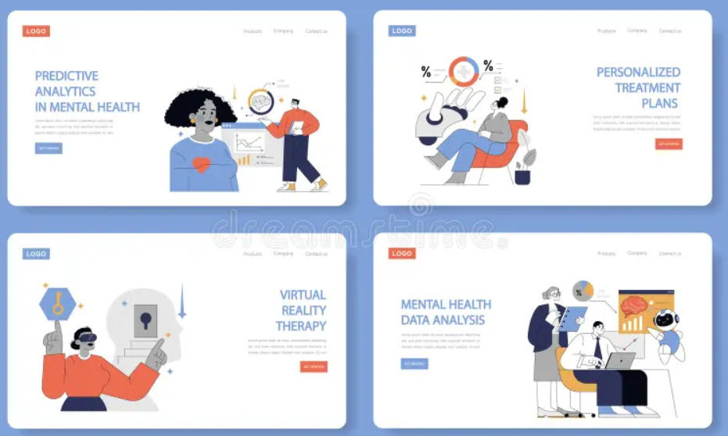
INNOVATION: MINDCONNECT PLATFORM
A digital mental health app + web platform offering 24/7 integrated support.
What it includes:
- Virtual Counselling: On-demand or booked therapy sessions
- AI Wellbeing Check-ins: Mood tracking + personalised support tips
- Self-Help Library: Evidence-based mental health resources
- Peer Support Communities: Moderated safe online groups
- Digital Triage System: Directs users to NHS or crisis services
Purpose:
- Improve early intervention
- Reduce waiting times
- Increase accessibility and confidentiality
- Reduce pressure on NHS services
Partnerships:
- NHS Talking Therapies
- Mind (mental health charity)
- Universities & schools
- Local authorities

Written Pitch

Introduction: Issue and Innovation Overview
I am proposing a digital innovation to help increase access to mental health support for young adults in the UK health and social care system called the MindConnect Platform. It is estimated that 1 in 6 adults have a common mental health disorder in the UK every week, and 3/4 mental health problems occur before the age of 24 (Public Health England, 2018). There are still a lot of young people who have difficulties getting support when needed due to stigma, confidentiality concerns, long waiting lists for the NHS, and the lack of support. These issues often result in delayed intervention, worsening mental health, and burden on emergency or crisis services (Edbrooke-Childs and Deighton, 2020). I am introducing MindConnect Platform, a creative and tech-driven solution that will help to make mental health support attainable, timely, and customized.

Key Components and How the Innovation Works
The MindConnect Platform is a mobile and web-based, continuous, and 24/7 digital mental health system that will provide young people with access to mental health support as needed. It is structured around a few interwoven components designed to provide a holistic and person-centered service. Virtual counselling service is one of the key services: Users can book or access virtual counselling services with qualified mental health professionals (Haleem et al., 2021). In addition, the platform offers AI-powered wellbeing check-ins, allowing users to monitor their emotional state and get tailored coping strategies and self-care strategies based on their mood.
In addition to therapeutic support, the platform offers a library of self-help resources such as evidence-based materials on anxiety, depression, stress, and other topics, and tools for emotional regulation. This provides the opportunity for users to have knowledge and tools to help them support their own wellbeing (Löchner et al., 2025). Peer-support communities provide a safe, online-moderated space to share experiences, reduce isolation, and help bring a sense of belonging, particularly important for youth who may feel disconnected from traditional services (Bravata et al., 2023).

Expected Impact and Relevance
MindConnect Platform is expected to have an impact on individual and system level. It enhances accessibility, confidentiality, and autonomy for youth adults, so they can access services without risk of judgment or stigma (Austin et al., 2024).
The platform also alleviates pressure on over-stretched services, as cases are filtered appropriately, thus decreasing unnecessary GP appointments and emergency department attendance, for the wider NHS, and therefore reducing emergency department costs (Philippe et al., 2021). This helps to optimize allocation of resources and efficiency of services.
In today's context the innovation is relevant because of growing demand for mental health services, lack of a workforce, and due to long waiting time throughout the NHS mental health pathways (NHS England, 2024). It is also timely and relevant to national priorities of digital transformation, prevention, and reducing health inequalities.

Implementation Plan

Phase 1: Design and Co-Production
- Engage young people, clinicians, and digital developers
- Conduct focus groups and user testing to ensure that the platform is technically successful and person centered, culturally accessible, and clinically appropriate (McGovern et al., 2025)
- Develop initial prototype

Phase 2: Pilot Testing
- Pilot in selected NHS Trusts and universities
- Evaluate usability, safety, engagement, and outcomes
- Collect feedback for improvement

Phase 3: Full Rollout
- Expand across Integrated Care Systems (ICS)
- Integrate with NHS digital infrastructure
- Launch national awareness campaign to raise awareness and promote uptake among young people (Knight and Burdett, 2020)

Timeline
- Months 1–3: Co-design and planning
- Months 4–8: Development and prototype testing
- Months 9–12: Pilot implementation
- Year 2 onwards: National rollout and scaling
The key stakeholders are NHS England, Integrated Care Boards, mental health charities (such as Mind), local authorities, educational providers, safeguarding teams, and digital developers. The resources required include NHS innovation funding, skilled software developers, clinical knowledge, safeguarding oversight, and good digital infrastructure. The implementation will be strictly followed to maintain the safety, legality, and public confidence with GDPR, Data Protection Act 2018, NHS Digital Safety Standards, safeguarding policies, and clinical governance regulations (NHS Digital, 2022).

Value, Feasibility & Recommendations
The MindConnect Platform adds value to healthcare while also fitting well within a value-based care model, which focuses on providing better healthcare results with efficient use of resources (Teisberg et al., 2020). This view underpins the innovation value as a means of improving allocative value by minimizing the unnecessary use of primary and emergency care services to support the use of digital interventions at an early stage and appropriate signposting. It also enhances the technical value by making it easier to access mental health services, eliminate wait times, and boost efficiency of mental health services via digital delivery (Erku et al., 2023). Additionally, it provides personalized value, allowing them to access counselling services whenever and wherever they need, as well as AI-assisted wellbeing check-ins and self-help resources tailored to their individual needs.
The innovation is deemed to be highly achievable, with the NHS continuing to progress towards digital health, and the introduction of integrated care systems (NHS England, 2023). However, there are some potential challenges which I am aware that could hinder implementation. These encompass digital exclusions (some individuals may have no access to devices or a reliable internet connection), concerns about privacy regarding data security, and digital tool resistance among healthcare practitioners and service users.
To overcome these drawbacks, I would adopt a variety of practical and accessible approaches. These include low data and offline features, as well as multilingual support and accessibility features to create an inclusive design for disabled users. I would also pay attention to informing users of data security and GDPR compliance to ensure their trust (Conduah et al., 2025). Additionally, there is a need for formal training for health care providers to facilitate the program's implementation and integration into the current services. The innovation is in line with the NHS Long Term Plan which focuses on prevention, early intervention, and digital transformation (NHS England, 2024).

Conclusion and Call to Action
To summarize, I suggest that the MindConnect Platform is an innovative and creative piece of technology that could help increase access to mental health services for young adults. It improves early intervention, decreases service burden, and increases equity in service access. I urge NHS leaders, policy makers, Integrated Care Boards, and mental health stakeholders to help develop, fund, and pilot this platform.

Reference List
Austin, L.J., Browne, R.K., Carreiro, M., Larson, A.G., Khreizat, I., DeJonckheere, M. and Sarah (2024). ‘It Makes Them Want to Suffer in Silence Rather Than Risk Facing Ridicule’: Youth Perspectives on Mental Health Stigma. Youth & Society. doi: https://doi.org/10.1177/0044118x241237236. (Assessed 15th of July 2026)
Bravata, D.M., Kim, J., Russell, D.W., Goldman, R. and Pace, E. (2023). Digitally Enabled Peer Support Intervention to Address Loneliness and Mental Health: Prospective Cohort Analysis. JMIR formative research, 7, pp.e48864–e48864. doi: https://doi.org/10.2196/48864. (Assessed 16th of July 2026)
Conduah, A.K., Ofoe, S. and Siaw-Marfo, D. (2025). Data privacy in healthcare: Global challenges and solutions. Digital Health, 11(20552076251343959). doi: https://doi.org/10.1177/20552076251343959. (Assessed 15th of July 2026)
Edbrooke-Childs, J. and Deighton, J. (2020). Problem Severity and Waiting Times for Young People Accessing Mental Health Services. BJPsych Open, [online] 6(6). doi: https://doi.org/10.1192/bjo.2020.103. (Assessed 28th of June 2026)
Erku, D., Khatri, R., Endalamaw, A., Wolka, E., Nigatu, F., Zewdie, A. and Assefa, Y. (2023). Digital Health Interventions to Improve Access to and Quality of Primary Health Care Services: A Scoping Review. International Journal of Environmental Research and Public Health, [online] 20(19), p.6854. doi: https://doi.org/10.3390/ijerph20196854. (Assessed 8th of July 2026)
Haleem, A., Javaid, M., Singh, R., and Suman, R. (2021). Telemedicine for healthcare: Capabilities, features, barriers, and Applications. Sensors International, 2(2), pp. 100–117. doi: https://doi.org/10.1016/j.sintl.2021.100117. (Assessed 29th of June 2026)
Knight, A., and Burdett, T. (2020). Achieving integrated care: the need for digital empowerment. Perspectives in Public Health, 141(1), p. 175791392092142. doi: https://doi.org/10.1177/1757913920921422. (Assessed 30th 0f June 2026)
Löchner, J., Carlbring, P., Schuller, B., Torous, J. and Sander, L. (2025). Digital interventions in mental health: An overview and future perspectives. Internet Interventions, [online] 40(100824), p.100824. doi: https://doi.org/10.1016/j.invent.2025.100824. (Assessed 30th of June 2026)
McGovern, Ó., Glennon, S., Walsh, I., Gallagher, P. and McCashin, D. (2025). The use of co-design with young people for digital mental health support development: A systematic review. Internet Interventions, 41, p.100835. doi: https://doi.org/10.1016/j.invent.2025.100835. (Assessed 25th of June 2026)
NHS Digital (2022). General Data Protection Regulation (GDPR) - Information. [online] NHS Digital. Available at: https://digital.nhs.uk/data-and-information/keeping-data-safe-and-benefitting-the-public/gdpr. (Assessed 26th June 2026)
NHS England (2023). Inclusive digital healthcare: a framework for NHS action on digital inclusion. [online] NHS England. Available at: https://www.england.nhs.uk/long-read/inclusive-digital-healthcare-a-framework-for-nhs-action-on-digital-inclusion/. (Assessed 21st of June 2026)
NHS England (2024). NHS England - NHS Long Term Workforce Plan. [online] NHS England. Available at: https://www.england.nhs.uk/long-read/nhs-long-term-workforce-plan-2/. (Assessed 17th of July 2026)
Philippe, T.J., Sikder, N., Jackson, A., Koblanski, M.E., Liow, E., Pilarinos, A. and Vasarhelyi, K. (2021). Digital Health Interventions for Delivery of Mental Health Care: Systematic and Comprehensive Meta-Review (Preprint). JMIR Mental Health, [online] 9(5). doi: https://doi.org/10.2196/35159. (Assessed 19th of June 2026)
Public Health England (2018). Health matters: reducing health inequalities in mental illness. [online] GOV.UK. Available at: https://www.gov.uk/government/publications/health-matters-reducing-health-inequalities-in-mental-illness. (Assessed 22nd of June 2026)
Teisberg, E., Wallace, S. and O’Hara, S. (2020). Defining and Implementing value-based Health Care. Academic Medicine, 95(5), pp.682–685. doi: https://doi.org/10.1097/acm.0000000000003122. Assessed 10th July 2026)

