Foreign Languages and Cultural Awareness
BMIH5003

Module leader: Giulia Chifari
Student id: 2126985
Student name: Alexandru Vlad Matei
Word count: 2000

Table of Contents
Component 1. Professional reflection 3
Introduction 3
Concrete Experience 3
Reflective Observation 3
Abstract Conceptualization 4
Active Experimentation 4
Component 2. Training plan 4
Objective 4
Component 3. Student self-reflection 6
Concrete experience 6
Reflective Observation 7
Abstract Conceptualization 7
Active experimentation 7
Conclusion 8
Component 4 . Presentation 8
References 13

Component 1. Professional reflection

Introduction
During my time volunteering at the Premier Inn Tamworth Central hotel, I saw a major cultural misunderstanding between a Japanese visitor and a British server during dinner service. The mistake happened when the waiter, intending to greet the guest, patted him on the back while directing him to his table. Physical touch from strangers is frequently regarded impolite and intrusive in Japanese society, in stark contrast to the more casual and tactile attitude commonly tolerated in British hospitality contexts. This incident demonstrated the vital role of cultural awareness in the hospitality sector. Using Kolb's Experiential Learning Cycle, I will reflect on this experience to better understand the skills and behaviours required to avoid similar misconceptions in the future.

Concrete Experience
I watched an instance in which a British waiter, with good intentions, patted a Japanese visitor on the back. The guest seemed uneasy and uncertain, apparently influenced by the sudden personal touch. This scenario shows a cultural conflict in which a gesture considered as pleasant and welcome in one culture is interpreted as improper and invasive in another. This experience demonstrated the importance of cultural variations in visitor relations and the possibility of misunderstandings.

Reflective Observation
Looking back on the situation, I realised that what appeared to be a modest gesture had a significant influence on the guest's comfort and assessment of the service. The waiter's ignorance of Japanese culture standards created an unpleasant scenario for the guest, which might have been easily avoided with more cultural knowledge. This discovery is consistent with Hofstede's cultural dimensions theory, which emphasises how cultural practices and perceptions influence interpersonal relationships (Hofstede, Hofstede, and Minkov, 2010). Deresky (2017) also emphasises the need of cultural awareness among hospitality workers in order to give high-quality service.

Abstract Conceptualization
This experience taught me the need of acquiring a thorough understanding of diverse cultural norms and customs. According to Maheshkar and Sharma (2018), extensive cultural education and training are required for hospitality professionals to modify their behaviours to match the demands of a varied visitor population. This entails not just comprehending cultural etiquette, but also identifying and honouring nonverbal communication patterns. For example, in Japanese culture, maintaining personal space and avoiding unwanted physical touch are critical to guaranteeing visitor comfort and happiness. By incorporating these principles into staff training programmes, hospitality businesses may better educate their personnel to handle cross-cultural encounters.

Active Experimentation
To utilise these insights and avoid such cultural misconceptions in the future, I want to engage in ongoing cultural education and training. This involves attending workshops and training sessions on cultural competency, as well as using resources like scholarly literature on cross-cultural management. Improving my language abilities, even at a basic level, can help me overcome communication barriers and show respect for visitors' cultural origins. By actively seeking out chances to learn about and appreciate diverse cultures, I can change my behaviour and deliver more inclusive and courteous service. This strategy will improve the client experience while also contributing to a more culturally sensitive and conscious hospitality environment.

Component 2. Training plan

Objective
The major goal of this training plan is to provide all personnel with the skills and information needed to properly handle cultural exchanges and avoid misunderstandings like the one that occurred between the Japanese visitor and the British waiter. This strategy seeks to increase cultural awareness, communication skills, and provide a friendly atmosphere for all guests.

Training type | Content | Method | Duration | Outcome
Cultural awareness | An introduction to essential cultural conventions and etiquette for significant visitor populations who visit the hotel, such as Asian, European, and American cultures. | Interactive training sessions with role-playing situations, guest speakers from various cultural backgrounds, and group discussions to promote a better awareness of cultural differences. | 3 hours | Staff will get a basic grasp of cultural differences and how to successfully handle them in interactions with visitors (Deresky, 2017).
Nonverbal communication | Understanding body language, gestures, and facial expressions in different cultures. A particular focus on how nonverbal clues might be received differently in different cultural situations (Makeshar and Sharma, 2018). | Training with visual aids, practice sessions, and real-life case studies. | 2 hours | Employees will learn to perceive and respond effectively to nonverbal cues, lowering the possibility of misunderstanding (Abramson and Moran, 2018).
Language basics | Basic words and greetings in the most often spoken languages among hotel visitors, including Japanese, French, and Spanish. | An online language learning platform that includes practical tasks and quizzes to encourage learning. | 1 hour every week for 6 weeks. | Staff will be able to express fundamental manners in several languages, displaying respect and consideration for visitors' cultural origins.
Scenario based learning | Content includes case studies and real-world examples of cultural misconceptions in the hospitality sector. Group exercises to analyse these circumstances and devise solutions for managing and avoiding similar situations. | Group talks, problem-solving exercises, and feedback sessions. | 1.5 hours | Staff will learn critical thinking skills and techniques for managing cultural exchanges successfully, resulting in a more inclusive and inviting atmosphere for guests.
Feedback and continuous improvement | Regular feedback meetings allow employees to discuss their experiences, issues, and recommendations for development. | Hold monthly meetings to exchange comments, evaluate current instances, and update training materials as appropriate. | 1 hour every month | A flexible and adaptable training programme that adapts to worker feedback and changing cultural trends.

Component 3. Student self-reflection

Concrete experience
During my internship at the Premier Inn Tamworth Central hotel, I observed a cultural misunderstanding between a Japanese visitor and a British server. The server, trying to greet the guest warmly, patted him on the back, a gesture considered pleasant in British society but unacceptable in Japanese. This experience made me realise how important cultural understanding, or lack thereof, can be for client pleasure and overall service quality in the hospitality sector.

Reflective Observation
After this encounter, I realised my prior concept of cultural awareness was shallow. I assumed that learning a few cultural conventions and being courteous would enough. However, seeing the guest's distress demonstrated that cultural sensitivity requires a deeper understanding of nonverbal communication and cultural conventions. According to Hofstede's cultural dimensions theory, cultures differ greatly in terms of personal space and nonverbal communication, and these distinctions must be respected to promote excellent visitor experiences (Hofstede, Hofstede, and Minkov, 2010).

Abstract Conceptualization
This encounter motivated me to explore the theoretical foundations of cultural awareness. I discovered that cultural competency in hospitality goes beyond superficial norms to include a grasp of fundamental cultural values and communication techniques. Deresky (2017) emphasises that cross-cultural management necessitates ongoing learning and adaptation in order to effectively traverse the intricacies of cultural relationships. Maheshkar and Sharma (2018) emphasise the value of comprehensive cultural education and training for hospitality professionals. These ideas prompted me to see cultural awareness as a dynamic and continuing process rather than a static set of information.

Active experimentation
I aimed to enhance my cultural competency by active experimentation after gaining fresh insights. I attended cultural awareness classes and began learning basic phrases and greetings in several languages. In addition, I made an intentional effort to study and learn from my interactions with visitors from all backgrounds. For example, I learnt to recognise nonverbal indicators that indicated discomfort and altered my behaviour appropriately, such as keeping a proper distance and avoiding needless physical touch. This proactive attitude not only improved my encounters with guests, but also their whole stay at the hotel.
Conclusion
After reflecting on Kolb's Experiential Learning Cycle, I gained a deeper appreciation of the significance of cultural awareness in the hospitality sector. Initially, I had a narrow perspective on cultural sensitivity, but through observation, learning, and practical application, I realised that genuine cultural competency necessitates a complete and continuing effort to understand and respect varied cultural norms and communication methods. This experience underlined the importance of ongoing cultural education and deliberate adaptation in professional practice. This event has taught me that cultural knowledge is essential for giving excellent service in a globalised environment. By creating an inclusive and courteous workplace, hospitality workers may improve client satisfaction, establish positive connections, and contribute to the organization's overall success. Moving forward, I am dedicated to constant learning and adaptation, ensuring that I am culturally competent and sensitive in all of my professional relationships.

Component 4 . Presentation


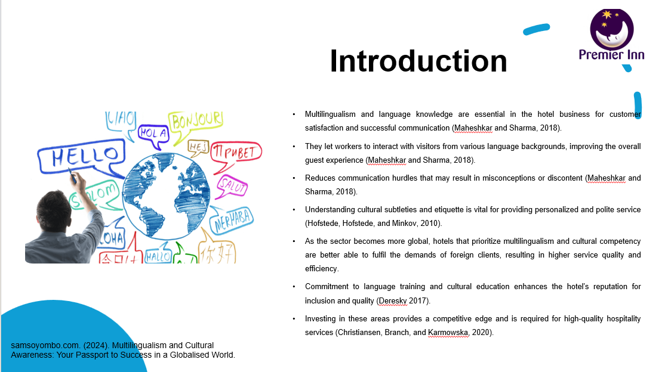
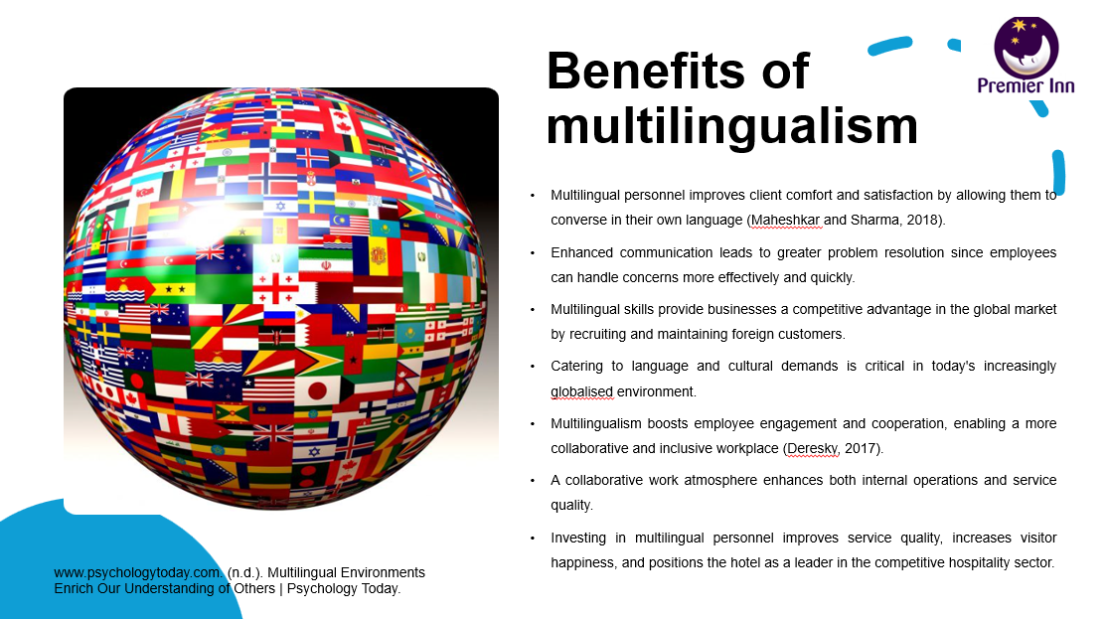
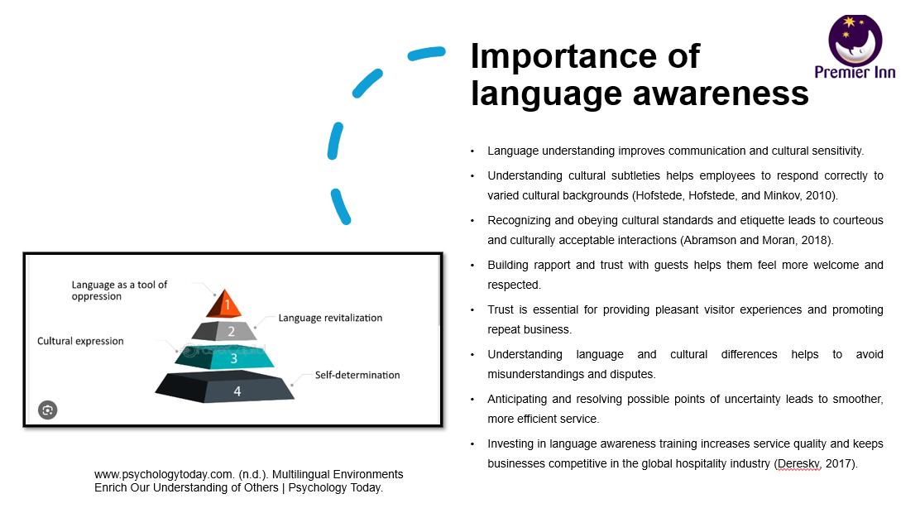
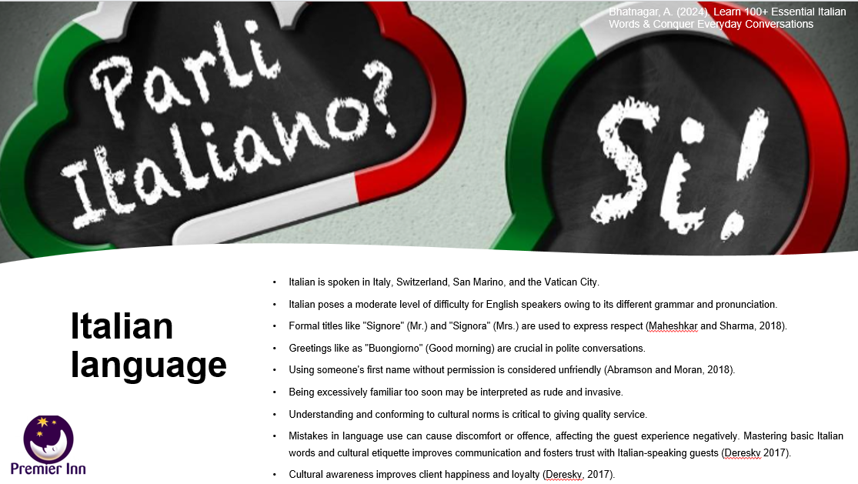

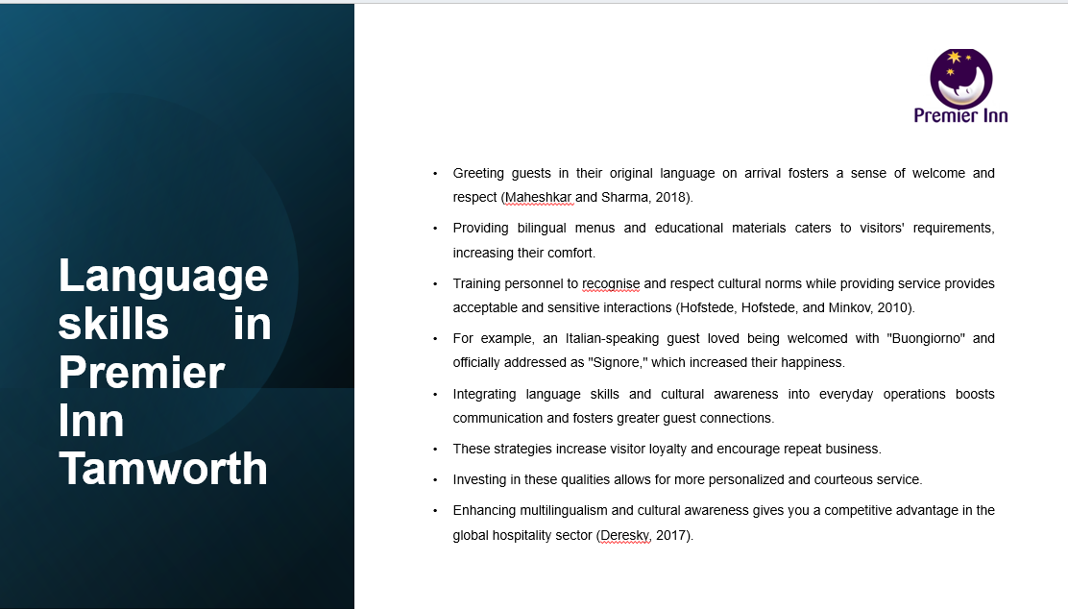
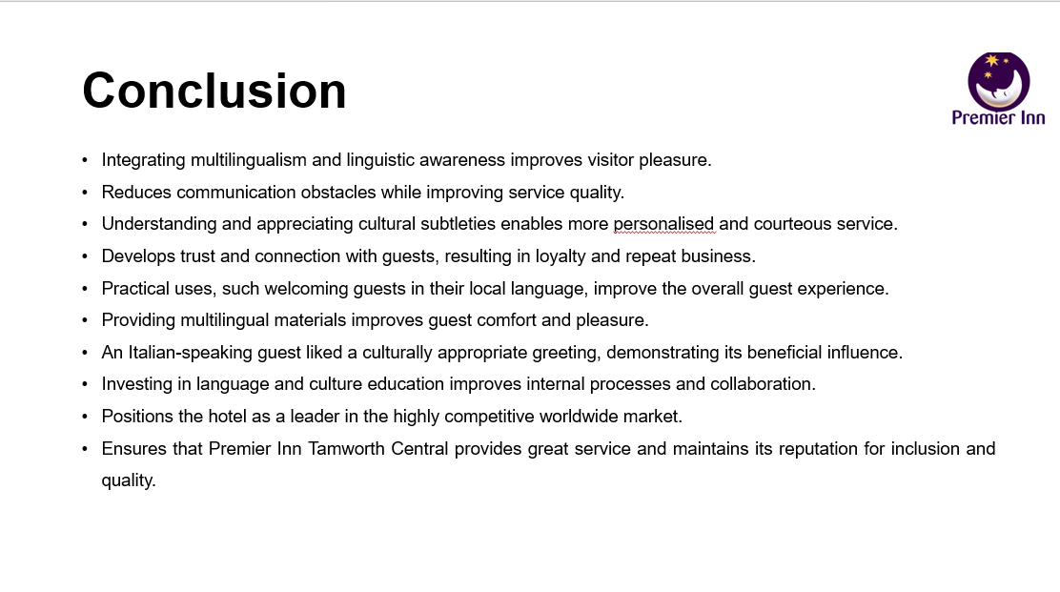
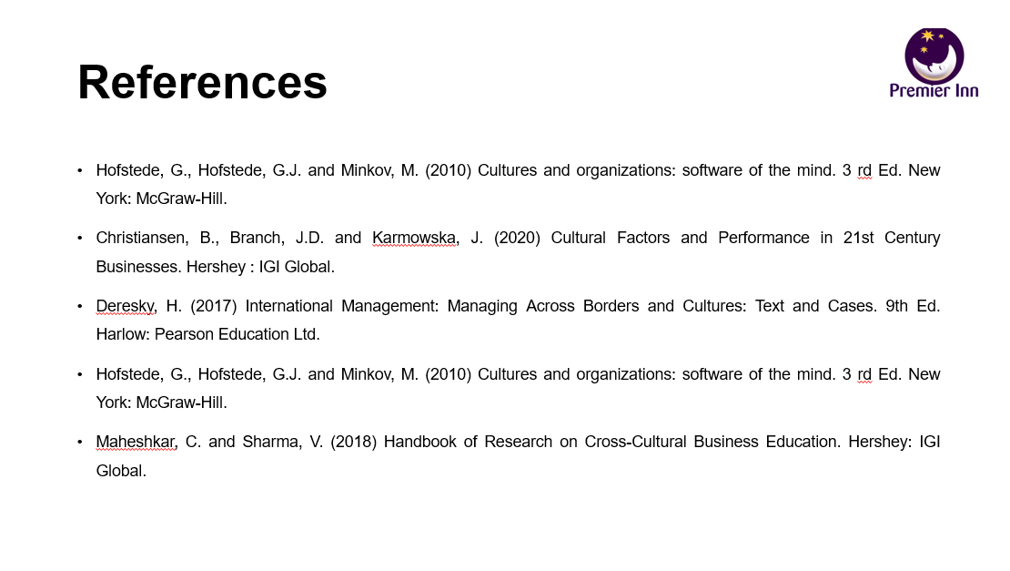

References

Abramson, N.R. and Moran, R. (2018) Managing Cultural Differences: Global Leadership for the 21st Century. 10th Ed. Abingdon: Routledge.
Christiansen, B., Branch, J.D. and Karmowska, J. (2020) Cultural Factors and Performance in 21st Century Businesses. Hershey : IGI Global
Deresky, H. (2017) International Management: Managing Across Borders and Cultures: Text and Cases. 9th Ed. Harlow: Pearson Education Ltd.
Hofstede, G., Hofstede, G.J. and Minkov, M. (2010) Cultures and organizations: software of the mind. 3 rd Ed. New York: McGraw-Hill.
Maheshkar, C. and Sharma, V. (2018) Handbook of Research on Cross-Cultural Business Education. Hershey: IGI Global.

