
Professional Career Development

Module Code: BMSK4005
Name: Abdallah Sekimwanyi
ID: 1806580
Module Lecturer: Navami Sudarsan

Contents
Introduction 3
A brief overview of my career 4
The skills and competencies that have contributed towards working effectively and for employability 4
Self-evaluation 6
Application of self-motivation quiz 6
Learning style analysis 9
Application of learning style to develop and improve my competencies 11
Personal SWOT Analysis 12
The Johari Window Model 13
Expectations and requirements of the world of employment and self-employment 15
Personal development plan 17
Areas of improvement 17
Action plan 18
Conclusion 21
References 22

Introduction
According to Skoyles, (2019) professional career development refers to a lifelong process of assessing skills, qualities, and competencies in line with the career goals and ambitions. It requires a SMART goal (specific, measurable, attainable, realistic, and time-bound) and practices accordingly to improve and develop competencies to explore the goal. Career goals provide a set of integrated instructions, an understanding of the steps that are required to explore the goal and ensure potential efforts to explore the goal. Career goals and objectives can be in different forms including a doctor, engineers, teachers, research, government service officer, banker, entrepreneur, accountant, etc. But all of these professions require some specific and differentiated skills and competencies. Whatever the career goals are we need to have a clear set of directions and activities. So the emergence of professional career development has come from the ultimate requirements of our career development objectives. Thus an effective career development plan should incorporate a clear understanding of the existing knowledge and skills level, self-motivation level, learning style, and the areas of improvement in consideration of the career objectives and recruitment. To explore the career goals, we need to classify our goals into short term and long term section. Short term goals will help to explore the long term goals. Different levels of goals focus on the different levels of skills, education, values, creativity, and vision of career development.
I am a customer service officer at Asda and dreaming to start my own restaurant business. In consideration of my career objectives, this report is going to provide a clear set of actions that are required to explore my career objectives.

A brief overview of my career
Here is Abdullah Isa a customer service officer at Asda. I have started my journey at Asda on 1st February 2016 as a customer service representative. After a year of the journey, I was promoted customer service representative to the customer service officer in April 2017. From then I am working at Asda with patience, commitment, and loyalty. Now I am dreaming to start a new restaurant business at Enfield, London. I enjoy independence and freedom, like to be my boss, desire to create employment for others, and want to earn more. It is also my aim of life from the very beginning of my student life. From then I have started to accumulate skills and competencies that are required for successful business management. To start my business I further need to develop and improve some skills and competencies for long-run sustainable success as an entrepreneur and it is the core concern of this professional career development report.

The skills and competencies that have contributed towards working effectively and for employability
Ohlsson, (2010) described the job of customer service officer as dynamic and challenging. A customer service officer needs to communicate with a diversified range of customers, understand their perceptions and demands, giving information on relevant products and services considering their demands, solve customer problems, listen to their complaints and feedback, and take actions accordingly. According to Tarae, (2019) cultural differences, behavioral aspects of the customers and situational factors make the duty of a customer service officer more complex. Thus a customer service officer should have the following skills and competencies for working effectively and employability:
Sherfield, (2009) described empathy as the most important competency of a customer service officer. From the very beginning of my career at Asda, I am trying to imagine myself in the position of the customers to explore their perceptions and demands. Sherfield, (2009) also described empathy as one of the most crucial competencies of successful leaders and managers.
According to Breckman, (2017) effective communication skills play the most crucial role in the success of a customer service representative. He also described it as the ultimate skills for success in the workplace as well as in personal life. I have also focused on the improvement of communication skills throughout my journey at Asda. It also plays a very big role in my success at Asda.
Products and services knowledge increases the efficiency of a customer service officer (Sherfield, 2009). Asda offers hundreds of varieties of products. A customer can demand a single item from the whole product portfolio. Thus I need to have clear products' knowledge regarding nutrition, price, weight, and features.
The modern workplace is all about taking challenges and solving barriers. Thus effective problem-solving skills are required for effective and efficient functioning in the workplace (Ohlsson, 2010). As a customer service officer, I also have to be competent in this area for a quick response to the changing behavior, perceptions, values, and culture of the customers.
Patience & Positive attitude increase emotional intelligence in the workplace. The job of customer service requires a higher level of patience and a positive attitude to explore value from the customers and make them long run valued customers (Skoyles, 2019). I have also tried to improve my competencies in this area. Improvement of patience and positive attitude has directly contributed to my success as a successful customer service officer.
Positivity is the ultimate desirable thing in human life (Ohlsson, 2010). Besides, we also need to be very aware of the non-verbal issues of communication to communicate with a diversified range of customers from all around the world. To ensure my success and secure my position in Asda I need to focus on positive language, eye contact, body movement, gestures, voice tone, and attention. Thus it is also considered as the crucial competencies for employment and self-employment.
Luka, (2019) added some other competencies including listening skills, confidence, tenacity, and authenticity as the factors that contribute to work effectively and secure sustainable success in the workplace. I have also found these competencies as the factors of success in my workplace as well.
Professionalism refers to the knowledge of professional rules, standards, and regulations, ethical issues, duties to the clients, duties to the employers, and duties to the stakeholders (Ohlsson, 2010). The customer service professionals are customer-focused. It requires understanding the changing perceptions, values, behavioral aspects, attitudes, and ethical issues while serving the stakeholders including the customers.
Luka, (2019) added some other competencies including attentiveness, creatively, and quick response as the significant competencies to the portfolio of employability skills that increase effectiveness and efficiency in the workplace. I always have to be very attentive to my customers and priorities their interests first. Their demanding Products and services may be or may not be available in our outlet but I need to offer a quick response to this. Even I am suggested to provide alternative products and services in case of situations where the perceived products and services are not available. I have found that it often makes customers satisfied and they even buy alternative products as well.
According to Tarae, (2019) effective time management skills are the ultimate academic and employability skills. Time is always limited and thus we need to ensure the best use of every minute. To increase my effectiveness in the area of time management I always classify my task-based on the importance and urgency. I like to delegate an urgent but less important task to my friends and colleagues. It helps proper and timely completion of the task and raises efficiency in the workplace.

Self-evaluation
According to Skoyles, (2019) self-evaluation refers to the understanding of strengths, weaknesses, self-motivation level, learning styles, attitudes, and behavior. There are different tools available for self-evaluation. As a part of self-evaluation, I have used self-motivation quiz to understand my self-motivation level, VAK learning style tools to explore my learning style, SWOT analysis to explore my strengths, weaknesses, opportunities, and threats, and Johari Windows to explore and improve my team working skills. Application of these tools and techniques are as follows:

Application of self-motivation quiz
According to Shafty, (2019) self-motivation refers to the forces that pushing us to go on. He described it as the internal driver to develop, produce, achieve, and keep moving forward. It is also the driver of career growth. Here I want to be an entrepreneur and desire to establish my restaurant business. Thus I have used the self-motivation quiz offered by MindTools to explore my self-motivation level. The self-motivation quiz is a systematic approach to explore self-motivation levels. It uses 12 integrated questionnaires to explore the self-motivation level. Thus the findings of my self-motivation quiz are as follows:

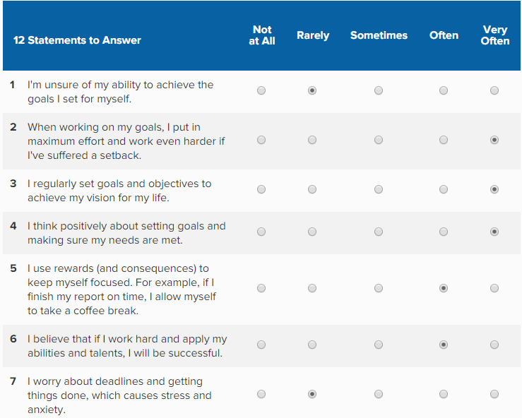
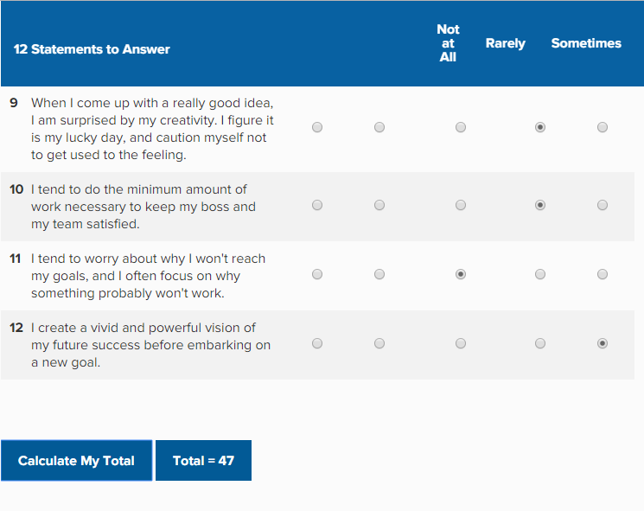
Figure: Application of self-motivation quiz
Source: MindTools (2019).

Findings and analysis
It is very pleasant to me that I have scored 47 in the self-motivation quiz. It belongs to the highest tier of the self-motivation level as offered by MindTools. The score refers to that I like to get things done and I don't let anything stand in my way. Besides, I also make a continuous effort to stay self-motivated. I also spend significant time and effort in setting objectives and exploring these objectives. Thus the goal of starting my new business is quite relevant and material issue to me. If I become successful in this area, I might inspire and motivate my friends and colleagues to be self-employed as well. Thus I have to focus on some factors that have a potential impact on self-motivation as self-motivation is a very complex issue. According to Skoyles, (2019) to keep me stay in the highest level of self-motivation I need to focus on strong goals and objectives, self-confidence, self-efficacy, positive thinking about the future, and motivating environment. Continual awareness in these areas will keep me in the highest level of self-motivation for a longer period.

Learning style analysis
According to Shafty, (2019) learning style refers to a guideline about how a person learns something. We need to improve our competencies in different areas but we don't learn and improve all the areas in the same way. We like to learn something by simply watching or hearing. Again we prefer to learn something by physical experience. Thus we need to understand our learning style to explore how we learn different things. In this regard, the VAK learning style is a systematic approach to explore personal learning style. Application of VAK learning style
The VAK learning style model was developed by psychologists in the 1920s to shape and classify the most common learning style that people learn. To explore the learning style, the VAK model uses 30 integrated questionnaires. The model has described the three most common learning styles including visual learning style, auditory learning style, and kinesthetic learning styles. But in reality personal learning style is a mixture of different learning styles (TEACH 2019). Thus the application of the model on me is as follows:
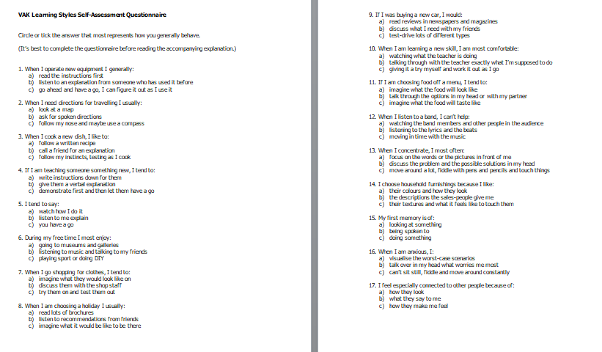

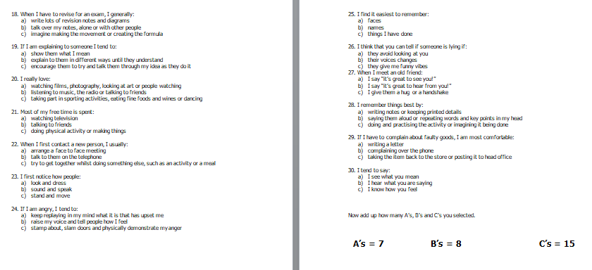
Figure: Learning style analysis
Source: MindTools (2019).
Findings and analysis
I have scored significantly higher in the kinesthetic learning style section. I have answered C 15 times in the questionnaire of the learning style analysis. It refers to that I am mostly a kinesthetic learner and I prefer to learn something by physical experience including touching, doing, holding, feeling, and practical hands-on experience. I like to do a task by going ahead and trying it out.
I have the second-highest score in the auditory section and it is 8. It refers to that I also prefer spoken words and sounds while learning something. It also refers to that I prefer active listening as well. Giving Instructions might be an effective approach to my learning.
I have also scored 7 in the area of the visual learning style section. It refers to that I also prefer exploring something by watching and observing things including pictures, diagrams, displays, flip-chart, handouts, etc. It also refers to that I like to perform a new task after reading the instructions or watching someone else doing it first and prefer written instructions as well.
Now I have explored my learning style and it is required to understand what things I like to learn in which way. For this, I need to apply my learning style to develop and improve my competencies.

Application of learning style to develop and improve my competencies
Areas of learning | Learning style | Reflection
Communication | Auditory, Visual, and Kinesthetic | To improve communication skills I need to practice it continually. Besides, I need to listen carefully to my partner and watch the non-verbal issues for effective communication skills.
Time management | Kinesthetic | Learning effective time management requires lots of practice in every step of my daily life.
Ethics | Auditory and Visual | I think improving ethics requires active listening, observation, and practice.
Conflict resolution | Auditory, Visual, and Kinesthetic | To improve conflict management I need to practice and practice different forms of personal and workplace conflicts continuously. Besides, active listening and observation will increase the quality of conflict management.
Leadership | Auditory, Visual, and Kinesthetic | To learn effective leadership practices of different types of leadership styles would be very productive for me. Besides, for a clear understanding of the employees, I would require active listening and observation as well.
Team building | Kinesthetic | I think practicing effective team-building strategies considering the team goals and required competencies might make me efficient in this area.
Written skills | Kinesthetic | Improvement in written skills requires lots of practice of academic writing considering sentence constructions, grammatical issues, word choice, referencing, etc.
Problem-solving skills | Kinesthetic | To improve problem-solving skills I need to practice and practice different forms of concurrent problems regarding the business issues continuously
Motivation | Auditory, Visual | A clear sense of understanding of personal needs is very crucial for intrinsic motivation. Thus active listening and observation of the needs might be a better option for me to improve motivation.
Networking | Auditory, Visual, and Kinesthetic | Building an effective network is a very complex and sensitive issue. So, I might need to practice, listen, and observe the factors of building effective networking to improve my professional network.

Personal SWOT Analysis
Personal SWOT analysis is a systematic approach to identify personal strengths and weaknesses to explore the opportunities and meet the threats/challenges (Career, 2019). I want to identify my strengths that will help me to develop and run my business. Besides, proper identification of the weaknesses will increase my self-awareness and self-regulation as well. It will also help me to develop my development plan for future success. Thus my SWOT analysis is as follows:
Strengths  Throughout my life, I have tried to improve my competencies that are crucial for self-employment and starting a new business. I have developed those competencies through academic learning and work experience. Thus I have strengths in the following areas:  - I am a good communicator. I have especially improved my listening and speaking skills through my job at Asda as a customer service officer.  - I am also competent in team working, stress management, problem-solving, and critical thinking.  - I also have a higher level of self-regulation, self-confidence, and a sense of direction.  - I further have compassion and passion for my jobs.  - I am also committed and loyal to my employers and customers. | Weaknesses  I don't get too much opportunity to go for higher education. Besides, skills development requires time, academic education, and experience. Thus I have weaknesses in the following areas:  - I have little knowledge of financial management techniques.  - Leadership and management skills are below the required level.  - Networking skills are a big area for improvement.  - Time management abilities are required to be improved  - Emotional intelligence, empathy, social skills, creative writing, presentation skills, and workplace ethics are required to be improved as well.
Opportunities  - I have the opportunity to develop and run my own business.  - I can further improve my stress management skills, communication skills, leadership skills, and time management skills at my workplace in Asda.  - I also have the opportunity to develop an online-based marketing platform as a part of affiliate marketing.  - The government is also rendering support to the young entrepreneurs and startups business. Besides, I can also explore the opportunities for online training courses to develop my financial management skills and computer application management skills. | Threats  - Starting a small business with insufficient capital in the competitive market place can be the biggest threat to me.  - Startup businesses are experiencing a very level of failure rate.  - Several large multinational companies are making local businesses more and more competitive.  - Market structure is also changing very rapidly and the Brexit issue may also add challenges in this area.

The Johari Window Model
Starting a new business requires a rage of the team working. To be an effective team member I need to improve self-regulation, self-awareness, social skills, and empathy. Thus Johari window model is a systematic approach to illustrating and improving self-awareness, self-regulation, and mutual understanding between team members within a group. The model was developed by psychologists Joseph Luft and Harrington Ingham in 1955 (Ohlsson, 2010). The model is also used to improve relationships among the team members as well. The model focuses on four sections considering open area, blind area, hidden area, and unknown area based on the factors known/ unknown to me and known/unknown to others. Application of the model is as follows:

 | Known to me | Unknown to me
Known to others | Open  Several things are known to me as well as known to others including acceptability, calmness, friendliness, modesty, kindness, empathy, rational behavior, etc. | Blind  There might have some personal characteristics that are known to others but unknown to me. This section may include my cheerfulness, confidence, responsiveness, self-assertiveness, extrovert attitudes, ingeniousness, etc.
Unknown to others | Secret  There might have some characteristics that are known to me but unknown to others including my shyness, nervousness, sensibility, trustworthiness, introvert behavior, etc. | Hidden  Some issues are unknown to me as well as unknown to others including my sentimental, power, maturity level, braveness, independency, ideology, complex behavior, etc.
Figure: Johari window model

Conclusion
I need to be aware of my unknown variables that might result in unwilling mistakes while working in an organization or running my business. Besides, I also need to focus on the factors that are unknown to others because that may cause unexpected disclosure and bring a challenge to me.

Expectations and requirements of the world of employment and self-employment
Competition in the world of employment is increasing very rapidly. World is experiencing an increase in technological advancements and world population (Skoyles, 2019). But the employment creation is not increasing at the same rate. Even there is a negative growth of employment creation in some areas of the world due to technological advancements and artificial intelligence of the computer system. Now I am working at Asda as a customer service officer but it is not my dream profession. I am keen on an entrepreneur in a restaurant business. Considering my knowledge and experience of real-world employment I have developed a basket of skills and competencies that are required to become successful in the workplace as well as in self-employment.
Financial management skills
Financial management skills are the driving force for real-world self-employment. Financial management skills are required to collect funds at the lowest cost of capital and investing the funds at the highest required rate of return. Thus financial management focuses on different alternative investments and analyses these investments using different tools and techniques including net present value, internal rate of return, payback period, profitability index, etc. Besides, it also helps to explore the expected cash follows from the investments, understand the project income statement, and minimize the costs of invested capital (Skoyles, 2019). In summary financial management ensures the best use of the invested capital to explore the wealth maximization objectives of the investors. So, financial management skills are the most dominant skills in the real world self-employment.
Leadership and management skills
An organization is a vehicle of differentiation groups of individuals (Tracy, 2019). If I establish my restaurant business, I would need to manage a diversified employee based. Thus effective leadership and management skills are required to increase the motivation, engagement, productivity, efficiency, effectiveness, and sustainable success of the business. It also reduces stress and turnover. Besides, proper knowledge of management ensures compliance of legal and regulatory requirements including the corporate social responsibilities.
Effective communication and interpersonal skills
Proper transformation of information is the ultimate factor for superior efficiency and effectiveness. It also reduces workplace conflicts and increases job satisfaction. Effective communication skills refer to effective listening, speaking, reading, and writing skills. To be an effective communicator we need to focus on verbal, non-verbal, and written communication systems (Tracy, 2019). It is also crucial for internal and external parties of an organization. Thus effective communication skills are the prerequisite of the world of competitive employment.
Marketing, sales, and customer service
Customers are the value creators of business. Customers are often compared to the heart in the modern era of business. The restaurant business is one step ahead in this value creation hypothesis because a loyal customer base if the most deals source of value of the restaurant. So, a proper understanding of the values, perceptions, demand, attitudes, and culture for making effective market segmentation and marketing strategies will play a key role in the success of my perceived business. It will help to generate growing sales revenue and ensure sustainable growth for a longer period.
Emotional intelligence
Skoyles, (2019) described Emotional intelligence as a function of self-awareness, social skills, self-regulation, empathy, and motivation. Emotional intelligence is a complete package of effective leadership and management. Current world of employment is focusing on the level of emotional intelligence while hiring employees in the top positions. So, it is also crucial for starting a new business as well. Emotional intelligence will increase patience, self-confidence, and execution excellence in the workplace.
Project management and planning skills
In the current century, the aspects of business management have changed. It is often found that the business is a combination of several small projects. Thus to start and run the existing business require effective project management and planning skills. Effective project management focuses on the required resource, allocation of resources, time management, and effective monitoring and controlling skills.
Delegation and time management skills
Effective Time management skills are required for almost every aspect of personal and business life. A day of 24 hours needs to be allocated effectively among the daily duties, responsibilities, and recreations (Tracy, 2019). But every task is not equally important to become successful in the workplace and life. It requires delegation and deletion of tasks. So, it becomes the urge requirements in the world of employment.
Problem-solving and innovative thinking
Business and workplace problems are often unique but there is a range of alternative solutions to these problems. Thus effective problem solving and creative thinking enable us to determine the best alternatives. Thus employers often seek employees with a higher level of problem-solving and innovative thinking skills.
Technological skills
Technology is changing 360 degrees every two years. It requires the help of technology from the production to the consumption stage. So, employers often ask for a good knowledge of technology including computer skills and software skills. Technological skills are also crucial for digital marketing, workplace management, and motivating employees. The incorporation of technology will also be very effective for my restaurant business as well (Tracy, 2019).
The world of employment also requires several skills including effective team working, collaboration, cultural knowledge, networking skills, etc. to become successful in the workplace and self-employment as well.

Personal development plan

Areas of improvement
Personal development is a continuous process. I want to establish and run my restaurant smoothly to secure sustainable success. Thus I need to improve my weaknesses to make me competent in the field of business management. According to Career, (2019) effective business management requires effective communication skills, time management skills, market and industry knowledge, financial management skills, networking skills, problem-solving skills, cultural knowledge, collaboration skills, effective leadership and management skills, and professional knowledge. Shafty, (2019) provided an integrated framework for personal development considering the areas of improvement, resource requirements, required activities, and time requirements.

Action plan
Considering the areas of improvement I have developed an integrated personal development plan to an entrepreneur of a restive business. My development plan is as follows:
Areas of improvement | Actions to achieve the objectives | Resource requirements | Success criteria | Time frame
Communication and interpersonal skills | I need to practice verbal, non-verbal, and written communication techniques continuously. | It requires communication partners, books, journals, and video supports. | An increase in confidence level while communicating would be the success criteria. | I will measure my improvement after each of three months period.
Financial management | I need to participate in a financial management course and practice financial management tools and techniques in real life. | I need an online financial management course fees with books and instruments. | 70% successful prediction would be the success criteria in the first stage and then 80%. | I will participate in a course of 3 months
Self-confidence and self-efficacy | I need to think about my achievement, understand my strengths, and focus on the achievable goals to increase self-confidence and efficacy. | I might require a mentor who may model my self-confidence, self-efficacy, skills, attributes, and competencies. | It is a subjective issue and increases in confidence level would be the success criteria. | I will practice it continually and measure the improvement after each of 2 weeks period.
Positive thinking | I need to be aware of my positive thinking, challenge the negative thinking, and development affirmation statements until I naturally think positively. | I would require a notebook where I would record my success and achievements. | An increase in the level of positive thinking would be the success criteria. | Same as I will do for self-confidence and efficacy.
Motivation | I need to focus on my achievements, challenging task, positive attitudes, and supportive behavior to improve motivation. | I would need supportive employers, colleagues, and friends with self-achievements. | It is also a subjective issue and increases motivation level would be the success criteria. | I will also practice it continually.
Emotional intelligence | I need to focus on my self-awareness, self-regulation, social skills, and empathy to improve emotional intelligence. I will practice it until I can overcome my weaknesses. | I would require mentor support and supportive human resources. | An increase in the level of emotional intelligence while making the decision would be the success criteria. | I will also practice it for six months.
Leadership and management | To improve my leadership and management skills I need to practice different types of duties, responsibilities, and techniques of leadership and management in different situations. | I would require supportive human resources to practice leadership and management. | An increase in the level of effective leadership and management would be the success criteria. | I will also practice it for one year.
Delegation and time management | I need to practice time management matrix considering the classification of tasks based on urgency and importance. | I would require a handbook to practice time management matrix. | Timely completion of the urgent and important tasks would be the success criteria. | I will also practice it lifelong.
Team working | To improve my team working skills I need to focus on effective team building, understanding the team roles and responsibilities, and the goals of an effective team. | I would require supportive team members with different books on it. | The proper exploration of team objectives would be the success criteria. | I will also practice it for the next 10 weeks.
Technological skills | I need to keep me update with the concurrent technology and conduct a course on the development of technical skills including computer skills, software skills, and hardware skills. | I would require the course fee, different hardware, and software with expert supports. | The efficient use of technological instruments including different application software would be the success criteria. | I will participate in an online course for three months and then focus on technological innovations.
Self-management | I need to increase my self-awareness, confidence, and self-regulations to improve my self-management skills. | I need different online personal development tools including mentoring service. | An increase in self-management level would be the success criteria. | I will practice it continuously.

Conclusion
Professional career development is a continuous process. We need to be patient and confident with our career objective to explore it. Analysis of my strengths and weaknesses has disclosed numerous areas for improvement. Besides, I have a very higher level of self-motivation that can be a positive signal in exploring my career objectives. Exploring the development in a proper learning style would be very fruitful for me. Thus raising self-confidence by focusing on my achievements and career success would be very helpful in exploring my career goal. Besides, an increase in self-awareness and self-regulation might play a very big role in success. Finally, the proper implementation of the career development plan will keep me on the track of sustainable success.

References
Breckman, B. (2017). Human Relationship Skills: Coaching and Self-Coaching - Fourth EditionHuman Relationship Skills: Coaching and Self-Coaching - Fourth Edition. Nursing Standard, 21(14), pp.30-30.
Career, C. (2019). Conduct a Personal SWOT Analysis to Improve Your Career. [online] Business News Daily. Available at: https://www.businessnewsdaily.com/5543-personal-swot-analysis.html [Accessed 31 Aug. 2019].
Luka, I. and Seniut, I. (2019). Developing Students’ Language Competence and Essential 21st Century Skills for Future Employability: The Case of Latvia and Lithuania. Acta Educationis Generalis, 9(2), pp.1-23.
MindTools (2019). How Self-Motivated Are You?:. [online] Mindtools.com. Available at: https://www.mindtools.com/pages/article/newLDR_57.htm [Accessed 31 Aug. 2019].
MindTools (2019). VAK Learning Styles: Understanding How Team Members Learn. [online] Mindtools.com. Available at: https://www.mindtools.com/pages/article/vak-learning-styles.htm [Accessed 2 Sep. 2019].
Ohlsson, H. and Borg, H. (2010). Career development. New York: Nova Science Publishers.
Shafty, S. (2019). 10 Tips for Career Development in Process Improvement. [online] Process Excellence Network. Available at: https://www.processexcellencenetwork.com/lean-six-sigma-business-performance/articles/top-10-tips-for-career-development-in-process-impr [Accessed 2 Sep. 2019].
Sherfield, R. and Moody, P. (2009). Solving the professional development puzzle. Upper Saddle River, N.J.: Pearson Prentice Hall.
Skoyles, A., Bullock, N. and Neville, K. (2019). Developing employability skills workshops for students’ Higher Education Achievement Reports. New Review of Academic Librarianship, pp.1-22.
Tarae, J. (2019). Employability in the 21st Century: The Global Graduate Skills Gaps and Mismatched Expectations - QS. [online] QS. Available at: https://www.qs.com/the-global-graduate-skills-gaps/ [Accessed 2 Sep. 2019].
TEACH (2019). Learning Styles. [online] Teach.com. Available at: https://teach.com/what/teachers-know/learning-styles/ [Accessed 31 Aug. 2019].
Tracy, B. (2019). Personal Development Plan: Examples & Templates for Success. [online] Briantracy.com. Available at: https://www.briantracy.com/blog/personal-success/personal-development-plan/ [Accessed 31 Aug. 2019].

