Postgraduate/Distance Learning
Assignment coversheet & feedback form

THIS SHEET MUST BE THE FIRST PAGE OF THE ASSIGNMENT YOU ARE SUBMITTING (DO NOT SEND AS A SEPARATE FILE)

For completion by the student:
Student Name:
Kathy Vinton
Module code: HPCA7015  Module title: Foundations in Cultural  Astronomy and Astrology | Student ID number:  2212888 |  |  | Educational support needs:  No
Module tutor: Dr. Nicholas Campion

Assignment due date: 1st December 2022
If your module has multiple submissions please indicate which piece of work this is.

1st 2nd 3rd 4th 5th 6th
I confirm that this is my original work and that I have adhered to the University policy on plagiarism.
Signed ……………………………………………………………
Email submission: if you are submitting this form via email, please tick this box □x
(as a substitute for your signature) to confirm that you agree to the above declaration.
Assignment Mark
Final Mark | WILL BE GIVEN ON TURNITIN

NB. All marks are provisional until confirmed by the Final Examination Board.

PLEASE NOTE: ALL COMMENTS WILL BE POSTED ON TURNITIN

For completion by Marker 1 :
Comments:

Marker’s signature: |  |  | Date:
For completion by Marker 2/Moderator:

Comments:

Marker’s Signature: |  | Date:
AGREED INTERNAL MARK (where necessary):

Comment on process of arriving at agreed mark:

External Examiner’s comments (if relevant)

External Examiner’s Signature: |  | Date:

Title: Essay based on a Sky Journal
Observations of the sky's relationship to a landscape, from entries recorded in a journal, and placed within the context of Alexandra Harris' statement, 'To think is to walk among clouds' from her book, Weatherland: Writers and artists under English skies
Word Count: 2086
Introduction:
This essay presents my observations of the sky's relationship to the landscape of The New Forest in Hampshire, whilst considering Alexandra Harris' statement, 'To think is to walk among clouds.' Excerpts are included from entries recorded each day for one month in a Sky Journal, together with some photographs which were taken at the same time.
In her book, Harris acknowledges that the association between clouds and inspiration is counter-intuitive but goes on to describe how clouds can be representative of the mind itself, from which thoughts and inspiration stem. During the course of the month, despite the seemingly simple task of observing the sky's relationship to a landscape, the concept of what it is to think became more significant, dominating the observation process. Using Plato's description of thinking, recorded in the dialogue between Theaetetus and Socrates, 'The soul . . . when it thinks, is merely conversing with itself, asking itself questions and answering', the analogy of thinking with walking in clouds was explored with the meaning of clouds remaining as close to its literal meaning as possible.
With regard to 'landscape', Tim Ingold refers to its 'customary' use as being 'formations of the land such as hills and valleys, mountains and plains . . .', and, being in The New Forest, this is the definition I used, although with the added intention of considering the atmosphere's link to the biosphere, as described in the Gaia Hypothesis proposed by James Lovelock and Lynn Margulis.
With no preconception of what the sky's relationship to a landscape might be, but anticipating that both the night sky and the day sky would have a relationship to a landscape, I initially kept both options open. In the late evening of Monday, 10th October, 2022, I started the diary and, courtesy of a clear night, I observed both the moon and Jupiter with many other stars, and was struck with awe but with no thought as to how this was aroused. Not only that, but the light from the moon was very bright, illuminating the trees in my garden, as dimly visible in Fig. 1, creating a very unfamiliar sight in a normally very familiar landscape (although later noting that it was a very familiar world to the owl which had just started calling).
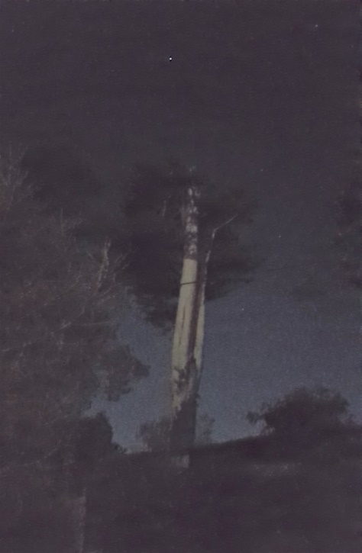
Figure 1 Tall Trees in moonlight in my garden
Neverthless, to make my decision as informed as possible, the next morning I walked along the track opposite my house. Quickly reaching a viewpoint, (Fig. 2), I noted the dramatic variation of colour and texture in the landscape which, as confirmed by Nadiia Oleksiichenko, Nadiia Gatalaska and Mariana Mavko, is mainly caused by the intensity of light and shade from the sky rather than any other factor. Not only seeing but also feeling the sun, through its warmth, the decision was made that the journal would be daytime-based and, at the same time each day between 10 am and 11 am, I walked the same track making entries either into a book or on my phone and taking photographs with my phone's camera.

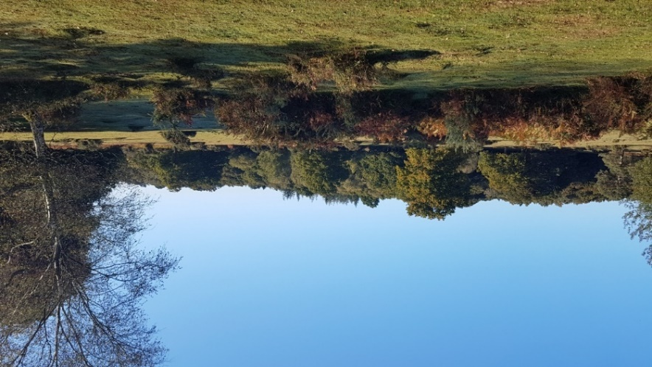
Figure 2 Heath and Forest to the left of the track
The first period of the Journal
Although, on each day of the first few days, the sky was for the most part blue, with warm air coming up from the south, and with no other reason to hurry, the early entries in the journal, in their brevity, reveal a resistance to the thought and concentration required to focus on the sky's relationship to the landscape, rather than gaze at the beauty of the sky, clouds, heath and horizon (Fig. 3). The diary entry notes, "Day 2. It's really lovely - blue sky and clouds taking turns to touch the landscape in the distance."

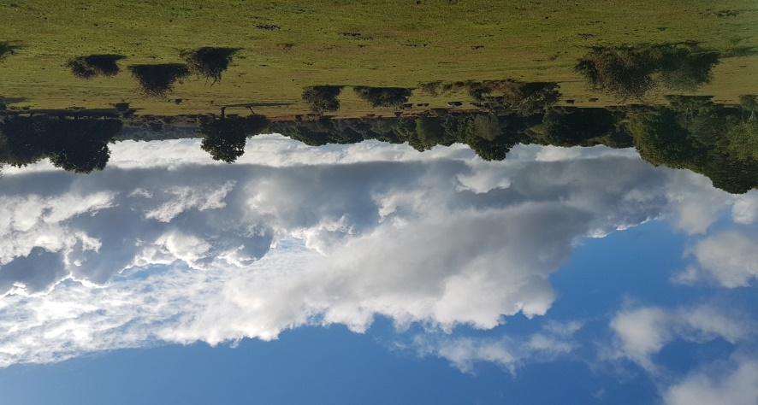
Figure 3 Horizon straight ahead from the track
Most of the allocated time was spent taking photographs in an attempt to capture aspects of the sky's relationship to the landscape. It was apparent that to think was to wander among clouds, not walk. With increased effort, observations progressed to include more detailed descriptions of how the sky's weather affected the landscape but which merely formed neat categories about the sky, listing whether it was cloudy or sunny, windy or still, warm or cold, and whether, as a direct consequence of the sky's relationship to the landscape, the trees were losing their leaves, the deep colour of the browning heathland was due to the dead bracken - or the dead and wet bracken (Fig. 4), and whether the blackberries were still able to ripen in the late season's warmth or were becoming mouldy (Fig. 5).

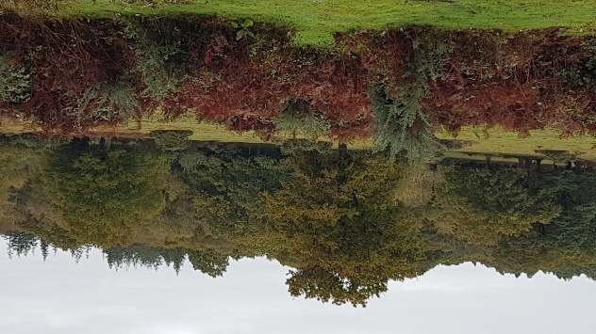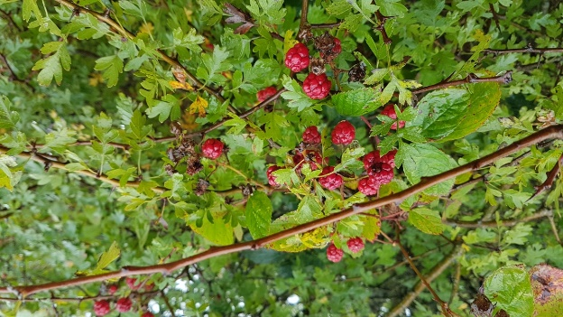
Figure 4 Ferns and Bracken turning brown Figure 5 Blackberries unable to ripen

However, as described by Ted Hughes in his poem, 'The Thought Fox' in which, having portrayed his (Hughes') mind as 'this midnight moment's forest', he describes his thought as '. . . something else is alive', I was also aware of some deeper thought hiding and an attempt to access this thought resulted in a different type of observation, which linking an imagined projection to the thought. The diary note on Day 8 reads, "Still mild, first windy day, noise from the leaves rustling, and blowing in small vortexes on the floor, wind builds up to a roar. Occurs to me that trees have the job of calming the strong effects of the sky, light, heavy rain and wind." Then, reflecting on the use of Victor Turner's concept of liminality, the entry continued, "Is this a liminal layer? Can liminal space be thought of as protective space?"
Observing landscape and sky gives rise to multiple ways of thinking about them. Different ways of describing and portraying different perceptions of landscape are discussed in Neal Alexander's paper, and he argues that some writers, describing ordinary landscapes, 'tend to employ a common set of quasi-religious tropes that imply a deeper network of associations linking ideas of landscape to the sacred, the mystical, and the extra-ordinary . . .'. Together with Tim Ingold's questioning, 'Is the sky a part of the landscape or is it not? . . . If it is not . . . is it all just an illusion?' again clouded the thinking process required to make valid observations.
By Day 10, biological descriptions were included in the entries, such as, "The sky controls the land as its light is required for photosynthesis, warmth for optimum enzyme action, rain for respiration." Even the wind, humourously described by the poet, Roger McGough, in his poem Sky in the Pie, as 'The whispering breeze is disturbing the peas, And making my chips go all cold' was vital in its role of seed and scent dispersal. That there was a reciprocal relationship between the sky and the landscape in a Gaia-like fashion was clear but nevertheless (from my notes) "impossible to accept as purely mechanistic".
Middle Days of the Journal
The entries reflected another change in thinking to include more questions than observations. Observing the distant horizon of hills and sky, I recorded that the distance ahead made me feel lonely and I was reluctant to think anymore. On Monday 24th October (Day 14), I wrote, "[I] feel part of something I won't ever know. That makes me sad." Dubious as to whether it was possible to carry on, the decision was made to make a final, different kind of effort and I began, in my mind, to speak to what I felt must be the original 'source' of the whole universe, before the point arrived when energy erupted out of nothing. I requested a sign, my own hierophany, as portrayed by Mircea Eliade.
One day later, on Tuesday, 25th October, full of exclamation marks, the entry reads, "Partial Eclipse!! Just when I'm looking!! Between 10 and 11!!!! Coincidence??!! Wow - I can't believe it!!" I had had no idea that there was going to be a partial eclipse until, already out on the track at 10 am, I opened my phone to take my customary first photo and noticed my daughter's text informing me. Although not advised, having retrieved some sunglasses, the moon was observed gradually moving in front of the sun. Watching, I wrote, "How incredible to see the little 'bite' taken out of the sun!!" I was incredulous that the partial eclipse was happening during my 'diary time' (Fig.6). Something had known that I would be moved by that coincidence. The eclipse did not happen because of me but, from somewhere had come, two weeks prior, my thought to focus between 10 am and 11 am each morning, then, two days prior, my thought to give things a last chance, and finally, five minutes prior, my daughter's text and my decision to read it at that moment. I wondered if, as this eclipse would have done, partial eclipses happened frequently without me knowing but I subsequently learnt that the next eclipse was not until 8th April 2024.

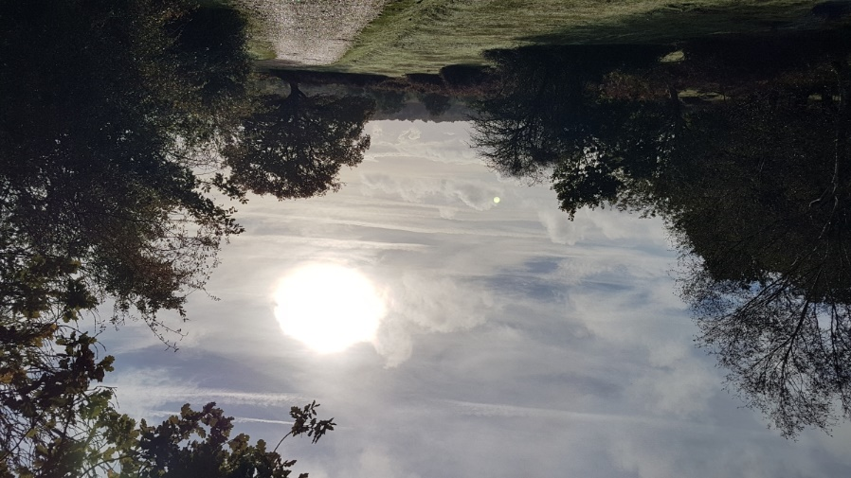
Figure 6 Sun during the eclipse but unfortunately unable to capture the moon on the phone camera

From this point, the journal entries reflected a new sense of enchantment and optimism. This event of synchronicity, similar to a situation Jung describes where the unusual appearance of a scarab beetle 'punctured the desired hole in her [the patient's] rationalism and broke the ice of her intellectual resistance', radically altered my feeling. On Day 18, I recorded, "I'm happy that something else is out here with me, the sky and the landscape." Nothing about this had felt strange and I agreed with Jung's comment that, 'Although meaningful coincidences are infinitely varied in their phenomenology, as acausal events, they nevertheless form an element that is part of the scientific picture of the world.'

Final Days of the Journal
On Day 25, I noted that "my feelings have changed the way I'm thinking out here so perhaps the clouds [in Harris's statement] are feelings" and further, that the tunnel-effect of the overlapping trees on my path now became "a liminal space where I have thirty seconds to transition from profane life of every day responsibilities to the 'real' world" (Fig. 7). Although referring to fantasy stories, Kristen McQuinn comments that, for characters who have crossed through liminal space, the ordinary world will not 'hold quite the same shine for them' and this was also the effect for me. Once through, the sky and landscape (although perfectly visible from both sides of the entrance tunnel) became embracing and I was accepted as part of their relationship. Similar to Edward Casey's perception of the space where he was camping in Maine changing, which he describes as noticing 'something else happening' and the place became 'unique' and 'the place I created', there was an evident change in the place where I had gone to every day.
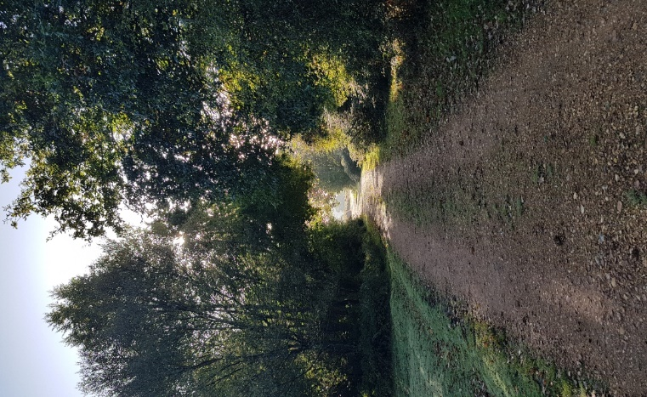
Figure 7 Liminal track to my viewpoints

The weather gradually became more wet and grey, but although from indoors it looked very uninviting, once out and through the tunnel, I saw the rain and clouds as comforting, taking care of the landscape. The forest - so dark and mysterious when the sun was fully out - became an enticing place of calm when it was windy. The exercise of going to the same place every day to observe the sky with the landscape had drawn me to feel part of it. The sentiment expressed in the last sentence of Belden Lane's book, 'To see the same place in a hundred different ways is much harder (and infinitely more rewarding) than visiting a hundred different places and never seeing any of them', summed up the final entries of the diary which recorded that I had become attuned to the connection between the sky and landscape, even noting the sky's reflection of light in tiny droplets on wild rosehips (Fig. 8).

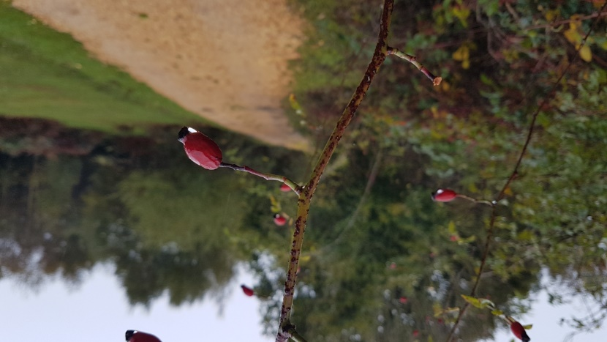
Figure 8 Sky reflected in a rosehip's raindrop
Conclusion
The dimension which was added to my sky and landscape observations by Harris's phrase regarding thinking gave rise to an unexpected journey through thought processes which significantly impacted the sky and landscape observations. Following my initial, instantaneous impressions (not thought) of the scale of the beauty shared between sky and landscape, it was challenging to make effort to push aside the cloud in order to concentrate, only to find the observations then strictly focusing on the biological relationship between sky and landscape. The dichotomy between the almost unbelievable complexity of their interraction, and the mechanistic explanation of it allowed the clouds to re-form, leaving just enough space for the question, 'Why'. Feelings of sadness and loneliness arrested all further thought processes until after the solar eclipse event, the impact of which felt like a personal communication, and I subsequently could think more freely, feeling part of the sky's relationship to the landscape. I concluded that the sentence 'To think is to walk among clouds' is accurate, as long as 'clouds' represent 'feeling' too, and just as the sky's relationship to the landscape is one of mutual reflection (Fig. 9), so is thinking's relationship to feeling.

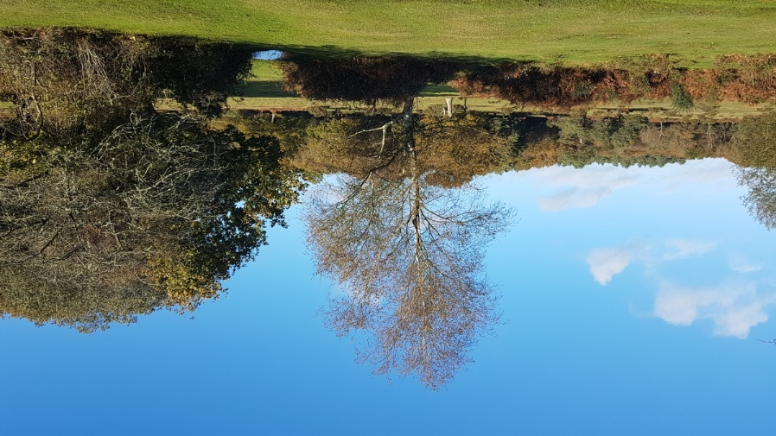
Figure 9 Deep Blue of the Sky captured in a Puddle

Bibliography
Alexander, Neil, 'Theologies Of The Wild: Contemporary Landscape Writing', Journal of Modern Literature , Vol. 38, No. 4, Spaces and Places (Summer 2015), pp. 1-19.

Casey, Edward S. 'Smooth And Rough-Edged Places: The Hidden History Of Place, The Review Of Metaphysics, Dec 1997; 51, 2; ProQuest Central, pp. 267-296.

Eliade, Mircea, The Sacred And The Profane The Nature Of Religion, (W.R. Trask, Trans.) (San Diego:Harcourt Brace Jovanovich, 1987).

Harris, Alexandra, Weatherland: Writers And Artists Under English Skies, (London: Thames and Hudson, 2015).

Hughes, Ted, 'The Thought Fox', The Hawk In The Rain, (London: Faber and Faber Ltd., 1957).
Ingold, Tim, Being Alive: Essays On Movement, Knowledge And Description (Abingdon, Oxon: Routledge, 2011).

Jung, C.G. and Roderick Main, 'Synchronicity', Jung On Synchronicity And The Paranormal, (Princeton: Princeton University Press, 1997), pp. 93-102. https://doi.org/10.2307/j.ctvzsmf3b.9.

Lane, Belden C. Landscapes of the Sacred Geography And Narrative In American Spirituality, (Baltimore: The John Hopkins University Press, 2002), pp. 238 - 255.
Lovelock, James and Lynn Margulis, 'Atmospheric Homeostasis By And For The Biosphere: The Gaia Hypothesis', Tellus, 1974, 26: pp. 2-10, (p. 2). DOI: 10.3402/tellusa.v26i1-2.9731.
McGough, Roger, 'Sky in the Pie', in Utterly Brilliant Poetry, edited by Brian Pattern (London: Penguin Group, 2000).
McQuinn, Kristen, 'Not at Home: Liminal Space And Personal Identity In The Hobbit And Coraline', Mallorn: The Journal of the Tolkien Society, No. 60 (Summer 2020), pp. 14-18. https://www.jstor.org/stable/48614899.

Oleksiichenko, Nadiia, Nadiia Gatalaska and Mariana Mavko, 'The Colour-Forming Components Of Park Landscape And The Factors That Influence The Human Perception Of The Landscape Colouring, Theoretical And Empirical Researches In Urban Management 13, no. 2 (2018): pp. 38–52. http://www.jstor.org/stable/26422068.

Plato, Theaetetus, 189e in Theaetetus. Sophist, trans. by Harold North Fowler, Loeb Classical Library 123 (Cambridge, MA: Harvard University Press, 1921).

Turner, Victor, 'Frame, Flow And Reflection: Ritual And Drama As Public Liminality', Japanese Journal Of Religious Studies, Vol. 6, No. 4 (Dec., 1979), pp. 465-499. https://www.jstor.org/stable/30233219.

Alexandra Harris, Weatherland: Writers And Artists Under English Skies, (London: Thames and Hudson, 2015), p. 247.
Harris, Weatherland, p. 247.
Harris, Weatherland, p. 246. ⁴ Plato, Theaetetus, 189e in Theaetetus. Sophist, trans. by Harold North Fowler, Loeb Classical Library 123 (Cambridge, MA: Harvard University Press, 1921) p. 179.
Tim Ingold, Being Alive: Essays on Movement, Knowledge and Description (Abingdon, Oxon: Routledge, 2011), p. 126.
James Lovelock and Lynn Margulis, 'Atmospheric Homeostasis By And For The Biosphere: The Gaia Hypothesis', Tellus, 1974, 26:1-2, pp. 2-10, (p.2). DOI: 10.3402/tellusa.v26i1-2.9731
Oleksiichenko, Nadiia, Nadiia Gatalaska and Mariana Mavko, 'The Colour-Forming Components Of Park Landscape And The Factors That Influence The Human Perception Of The Landscape Colouring, Theoretical And Empirical Researches In Urban Management 13, no. 2 (2018): 38–52, (p. 44). http://www.jstor.org/stable/26422068.
Ted Hughes, The Thought Fox in The Hawk In The Rain, (London: Faber and Faber Ltd., 1957) p. 7.
Victor Turner, 'Frame, Flow And Reflection: Ritual And Drama As Public Liminality', Japanese Journal Of Religious Studies, Vol. 6, No. 4 (Dec., 1979), pp. 465-499 (p. 465). https://www.jstor.org/stable/30233219 ¹⁰ Neil Alexander, 'Theologies Of The Wild: Contemporary Landscape Writing', Journal of Modern Literature , Vol. 38, No. 4, Spaces and Places (Summer 2015), pp. 1-19 (p.17). 1¹ Ingold, Being Alive, p. 127. ¹² Roger McGough, 'Sky In The Pie', Utterly Brilliant Poetry, ed. by Brian Pattern (London: Penguin Group, 2000) p. 52. ¹³ Mircea Eliade, The Sacred And The Profane The Nature Of Religion, (W.R. Trask, Trans.) (San Diego:Harcourt Brace Jovanovich, 1987), p. 11.
C.G. Jung and Roderick Main, 'Synchronicity', Jung On Synchronicity And The Paranormal, (Princeton: Princeton University Press, 1997), pp. 93-102, (p. 97). https://doi.org/10.2307/j.ctvzsmf3b.9.
Jung and Main, p. 101.
Kristen McQuinn, 'Not at Home: Liminal Space And Personal Identity In The Hobbit And Coraline', Mallorn: The Journal of the Tolkien Society, No. 60 (Summer 2020), pp. 14-18 (p.14). https://www.jstor.org/stable/48614899
Edward S. Casey, 'Smooth And Rough-Edged Places: The Hidden History Of Place, The Review Of Metaphysics, Dec 1997; 51, 2; ProQuest Central, pp. 267-296,(p. 270).
Belden C. Lane, Landscapes of the Sacred Geography And Narrative In American Spirituality, (Baltimore: The John Hopkins University Press, 2002) p. 255.

