

Data Security, Governance and Compliance
Module Code: ACCA7028
Module Lecturer: Dr Carlene Campbell
Student Name: Mohamad Wael Baghdadi
Student Number: 1708309
Due Date: 12/01/2021

Table of Contents
Table of Contents 1
List of Figures 2
List of Tables 2
Abstract 3
Introduction: 3
1. Literature Review 3
1.1 ISO 27000 3
1.1.1 History of ISO 27000: 3
1.1.2 ISO 27000 series 3
1.1.3 ISO 27001 4
1.2 COBIT 4
1.2.1 History of COBIT 4
1.2.2 COBIT 5 5
1.2.3 COBIT key facts 5
1.2.4 COBIT 5 Principles: 5
1.2.5 Advantages and Disadvantages: 6
1.3 ITIL 7
1.3.1 History 7
1.3.2 Why ITIL 7
1.3.3 ITIL Service lifecycle 7
1.3.4 ITIL Advantages 8
1.3.5 ITIL Weakness 8
1.4 ISO, COBIT and ITIL Comparison 8
1.4.1 Covering domain 8
1.4.2 Scope 9
1.4.3 Strengths and Weaknesses 9
2. ISMS Design and Implementation 9
2.1 Review 9
2.2 Risk assessment 10
2.3 Strategy & Policy 10
2.4 Vulnerability Management 10
2.5 Protecting the intellectual properties 10
2.6 Network 10
2.6.1 Network Segmentation 10
2.7 Access control 11
2.7.1 Password Control 11
2.8 Data 11
2.8.1 Using personal devices 11
2.9 Software 11
2.10 Exploratory review 11
2.11 Disaster Recovery 12
Conclusion 12
3. References: 13
4. Appendix 15
4.1 ISO 27000 Series current and planned: 15
4.2 ISO 27001 benefits in details: 15
4.3 ITIL Service lifecycle (Main Processes) 17
4.4 Resources 17

List of Figures
Figure 1: COBIT frameworks and components[15]. 5
Figure 2: COBIT Principles 6
Figure 3: IT infrastructure[19]. 7
Figure 4: ISMS Diagram. 9
Figure 5: Firewall Security Zone Segmentation[26]. 10

List of Tables
Table 1: ISO 27000 Series current and planned. 15

Abstract
Because the continuing risks associated with the increase of cyber-attacks and data breaches, information security has become a critical problem for all companies, it is assumed that an effective approach to help in the defence against both common external attacks and internal threats such as occasional violations of human error.

Introduction:
In this report, the author has highlighted briefly the security frameworks that commonly uses between the business such as ISO, COBIT and ITIL, starting with the history of each framework and why organization use them and which part they cover and what the strengths and weaknesses. After the research in the 3 frameworks, the author has included a section to critique and analyse between all of them compare and explain the differences.

Literature Review

1.1 ISO 27000

1.1.1 History of ISO 27000:
ISO is the International Organization for Standardization, which is an independent international non-governmental organization located in Geneva, Switzerland [1][2]. The ISO started after a meeting of 65 delegates from 25 countries to highlight the future of international standardization, and then ISO became official in 1947 with 67 technical committees, and now the ISO is an international standard-setting body made up of representatives from various national standards organizations and has 165 members around the world and their members are the most important standards organizations in their countries and there is only one member in each country, which each one of them represents the ISO in its country[2][3][4][5].

1.1.2 ISO 27000 series
The ISO 27000 family of information security management standards and considered as series reserved exclusively by ISO for information security matters. This aligns with a number of other topics such as Quality Management which included in ISO 9000 and Environmental Management in ISO 14000.
The ISO 2700 is a series of mutually supportive information security standards that can be combined to provide a globally recognized framework for the best - Information Security Management Practice[6].
One of the most widely cited and often discussed models of security is Information Technology - Code of Practice for Information Security Management, originally published as a British standard BS 7799, later published as ISO / IEC 17799, then ISO / IEC 27002
The aim of the standard according to iso.org was to provide a common basis for developing organizational security standards, effective security management practices and providing confidence in inter-organizational interactions.
The author has listed the current and planned series of the ISO 2700 in the index [4.1] and focused on the ISO 27001, which is considered as the mainstay of the series which defines the specification for the ISMS (Information Security Management System)[7].

1.1.3 ISO 27001
ISO 27001 is the international standard that provides specifications for an Information Security Management System or "ISMS", a structured approach consisting of people and technological processes that help protect and manage all of an organization's information through risk management, These standards help organizations maintain the security of their information assets by offering a set of codes of conduct, specifications, and guidelines for best practices to ensure robust information security management,
An ISMS in particular that complies with ISO 27001 can help organizations comply with a range of laws including the Network Regulations, the General High Level Data Protection Regulations (GDPR), and the Information Systems also known as the NIS Regulations.

1.1.3.1 Main aspects to protect:
Three main aspects of information that the ISO 27001 focuses on protecting are:
1- Confidentiality: The information is not available or disclosed to any unauthorized entities, groups, or person
2- Integrity: The information is accurate, complete, and protected from corruption
3- Availability: The information is available, accessible, and usable when requested by authorized people

1.1.3.2 ISO 27001 Advantages
More details are listed in appendix [4.1] [8]
- Information protection and security
- Increase attack resilience
- Data confidentiality and integrity protection
- Maximizing Security in Business Culture
- Reducing costs associated with information security
- Responding to evolving security threats

1.1.3.3 ISO 27001 Weakness
- It is primarily a management standard, not a security standard.
- Doesn't provide information risk management and security expertise to implement but it is provide only the framework to do[9].
- Insufficient guidance in their Compliance with or certified to ISO 27001 does not mean that all information is secure - It means the security is managed in line with the standard and to the level it believes is appropriate for the organization[9].
- Extra cost: overtime means extra cost[10].
- Personal resistance - some may view it as a waste of resources and offer resistance during the implementation and maintenance phases[10].
More details about ISO 27001 and its certifications are included in appendix[4.2] [11].

1.2 COBIT
COBIT is a framework for the governance and management of information and technology, targeting the entire organization.

1.2.1 History of COBIT
COBIT means Control Objectives for Information and Related Technology, and it is a framework for IT governance and management developed by the ISACA (Information Systems Audit and Control Association), first released in 1996, and it was created to assist companies to develop, organize and implement strategies around information management and governance and also to be a supportive tool for managers to bridge the critical gap between technical issues, business risks and control requirements.
COBIT is a globally recognized and comprehensive business-focused framework that can be implemented in organizations of all sizes across the commercial not-for-profit and public sector. COBIT ensures the quality, control and reliability of information systems in the organization, and is also the most important aspect of every modern business which by this framework it can help organizations create optimal value from their IT by maintaining a balance between realizing benefits and optimizing risk and resource usage[12][13].

1.2.2 COBIT 5
COBIT 5 was released in 2012 as the most recent iteration of the framework, It reinforced the COBIT 4.1 principles, IT risk frameworks, and Val IT 2.0. This release draws a reference from the Information Technology Assurance Framework (ITAF) of ISACA and BMIS (Business Model for Information Security). COBIT's business orientation involves linking business objectives to the IT infrastructure by providing different models and maturity metrics that measure achievement while identifying business responsibilities associated with IT operations.
COBIT is consists of a process reference model a series of governance and management practices and a set of enabler tolls to support the governance of an organization. in summary, this about providing guidance for making decisions concerning the use of information and technology to support and sustain organizational objectives, and also COBIT 5 enables IT to be governed and managed across the entire organization by considering the IT-related interests of internal and external stakeholders such as business users and management as well as outsourced service providers and regulator[13][14].
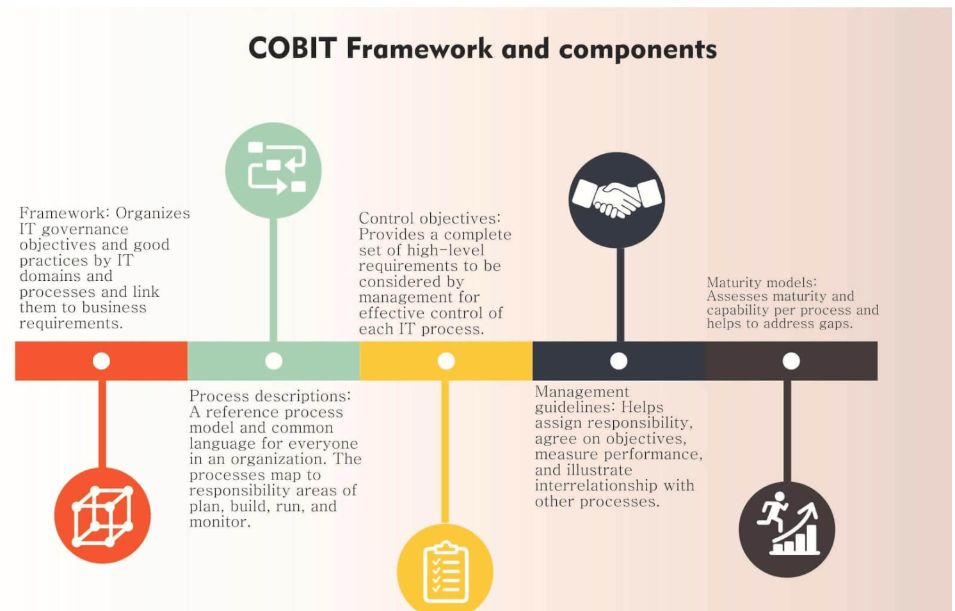
Figure 1: COBIT frameworks and components[15].

1.2.3 COBIT key facts
COBIT is not a complete description of the entire IT environment of the organization and it is not a framework for organizing business operations, nor is it a technical framework for managing all technologies nor making or describing any IT-related decisions.

1.2.4 COBIT 5 Principles:
COBIT 5 is based on five principles that enable the organization to build an effective governance and management framework that optimizes information and technology investments and the use of information technology[16]:
- Provide stakeholders value
- Holistic approach
- End to End governance system
- Apply one/single integrated framework
- Defining a holistic approach
- Separation of governance from management
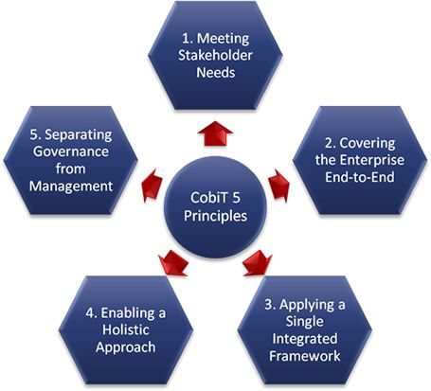
Figure 2: COBIT Principles

1.2.5 Advantages and Disadvantages:

1.2.5.1 COBIT Advantages
- Risk Minimization by helping companies to reduce service and infrastructure risks.
- Regulating the environment: The latest version of the COBIT framework allows for appropriate compliance and makes it easy for the company to demonstrate that it meets requirements.
- Size Independence: COBIT principles improve efficiency and effectiveness. It can be applied in every industry, regardless of business size or growth path.
- Efficiency and productivity: the models and principles in BOBIT are globally recognized. It helps in addressing the concerns in stakeholder, defining their roles, achieving strategic goals, and realizing business benefits, leading to enhanced efficiency and productivity in the business.
- Governance: The main benefit of COBIT is the application of an IT governance standard across an organization. It ensures that risks associated with information technology are mitigated and effective controls are in place to ensure that all processes are monitored[15][17].

1.2.5.2 COBIT Disadvantages
- It is not easy to implement. Because it needs a lot of skills and knowledge to use as a tool to provide IT governance support or evaluate the performance of an organization's IT department.
- Required an experienced analyst: Since it provides a general analysis for any given situation, it needs an experienced analyst to perform a reliable maturity assessment of an IT organization.
- Specifications for communications not provided: The framework lacks specifications regarding its links between the benefits of the activity and how to present it in a distinct maturity model[15][17][18].

1.3 ITIL

1.3.1 History
Information Technology Infrastructure Library is known as ITIL, it is a non-proprietary approach for managing information technology services, and developed when the level of IT service provided to the British Government was deemed insufficient at the end of 1980s by a branch of the British Government Office of Government Commerce (OGC) called the Central Computing and Telecommunications Agency (CCTA)[19][20].

1.3.2 Why ITIL
Since it includes detailed descriptions of many important IT practices, it can be designed for many IT organizations.
ITIL provides common terminology and best practice guides for how IT can deliver better value to a business that delivers optimum service provision at a justified cost, a few years ago the ITIL framework was redesigned from a process-based approach to a service life-cycle approach, and since the ITIL published best practices have been adopted in thousands of IT organizations around the world.
The information technology infrastructure library describes the lifecycle, processes, procedures, tasks, functions and checklists that are not organizations specific. Good materials and best practices collected and documented are based on years of experience by IT practitioners designed to model the provision of IT services, It is used by organizations to achieve integration with the company's vision and strategy, which focuses on providing services of value and importance while preserving costs and risks.
It allows an IT organization to create a baseline by which an IT organization can plan, implement, and measure its services for its clients and ensure continuous improvements. It also reduces the cost by taking advantage of efficiencies to improve staff productivity and information technology resources.
ITIL is considered as a philosophy around providing IT services which means that IT is a service provider and to keep clients productive and satisfied with the services that chosen to build a proven service model that includes many ITIL recommendations[19][20].
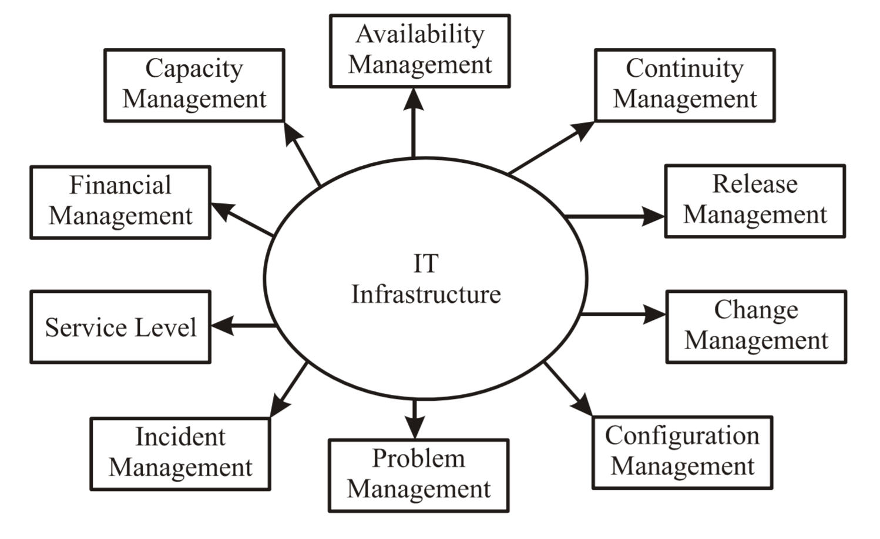
Figure 3: IT infrastructure[19].

1.3.3 ITIL Service lifecycle
There are 5 groups of books that are concerned with providing IT services and managing IT infrastructure, and the five volumes are listed below and the main processes for each one of them are listed in appendix [4.3][21]:
- ITIL Service Strategy: The service strategy defines the types of services to be provided to customers or markets.
- ITIL Service Design: Design service determines the service requirements and creates new service offers as well as changes and improvements to the current offerings.
- ITIL Service Transition: Builds service transfer and publishes new or modified.
- ITIL Service Operation: The service process carries out operational tasks.
- ITIL Continual Service Improvement: It is constantly working to improve the effectiveness and efficiency of the services and operations.

1.3.4 ITIL Advantages
The main advantages of using ITIL framework[21]:
- Reduced costs through improved use of resources: reducing information technology costs, increasing quality, and reducing risks around providing the department's services.
- Stronger alignment between IT and the business: provide clear and effective communication as a user of IT services ITIL can enable easy to understand communications from the IT department and a clear set of expectations of service levels for each service consumed
- Greater visibility into IT costs and assets and increase productivity: As an IT worker, you can help to become productive and effective in daily work by knowing which services are most important and most important to users.
- It can help management's ability to improve their strategic decisions. Visibility the total cost of ownership and benefit by evaluating the full life cycle of assets and services, not just the initial cost.
- Better management of business risks and service downtime or failure
- A more stable service environment to support continuous business change.

1.3.5 ITIL Weakness
- Not easy to use
- Special expertise required
- Expansive, requires specific IT budget
- Resources required to provide ongoing training and awareness

1.4 ISO, COBIT and ITIL Comparison
In this section the author has included the comparison between the frameworks that he mentioned in the literature review in terms of covering domain, scope and strength/weaknesses of each by using many different resources to obtain these results[22] [23] [24].

1.4.1 Covering domain
ISO: Provides specifications for an "ISMS" to help protect and manage all of an organization's information through risk management by offering a set of codes of conduct, specifications, and guidelines for best practices[23].
COBIT: The main function is to assist the company, and map its IT process followed by ISACA best practice standards. COBIT is usually chosen by the company performing the information system audit, whether it is a financial or general IT audit. In other word COBIT considered as a group of guidelines for any organization to develop, execute, monitor and progress technology management[22].
ITIL: framework for improving IT services for best practice, planning and directed selection to better meet the needs of the company, to defines the processes to be performed to provide and support IT services even like applications, with an emphasis on business especially IT clients[25]. and the philosophy of the ITIL is around the service bureau as a communications platform and Configuration Management Database (CMDB) [24].

1.4.2 Scope
ISO: is an International standard and is known Information Security framework, it has 10 domain in the area, and based on businesses characteristics location, assets and technology, and justification for an exclusion from scope[23].
COBIT: IT governance framework from ISACA, and concerned on the whole organization and its advises on issues related to IT and also understands that these issues are not limited to IT professionals which means COBIT is a complete enterprise[22].
ITIL: Best practice framework, and the bulk of ITIL's advice is focused to internal IT issues as it recognizes the primacy of business and emphasizes the presence of information technology to support the business[24].

1.4.3 Strengths and Weaknesses
ISO: In particular, the security controls are provided by ISO but there is no implementation guidance and does not specifically address how these processes fit into the overall IT management processes[23].
CBOIT: the main focuses are on controls and metrics, it has lack an element of security but at the same time provides a more global view of IT processes at the IT departments management principles[22].
ITIL: ITIL is strong in deliveries and processes' support. Describes how operational processes are structured but is weak in security controls and security operations as well[24].

ISMS Design and Implementation
The information security management system (ISMS) is a framework of policies and controls that manage security and risks systematically and across the entire organization
The design and implementation of this ISMS are going to be based on the requirements of the scenario (Caribbean coffee) which they using cloud services to deliver IT services to its staff and clients, and that case they require a framework and protection that considers the protection of their cloud activities and the data security for both staff and clients.

Figure 4: ISMS Diagram.

2.1 Review
CaribbeanCaffee should review what security they have already and how they secure their network, computing and their data to see and investigate the strengths and risks areas.

2.2 Risk assessment
Provide a list of all risks that the company may be exposed to, to determine the likelihood and severity of each of them, and the list should include the risks that occurred before and what are the potential risks in the future. This mitigation process can end with a plan for how best to deal with each risk and determine the risks that need to the highest level of observation. This process is closely related to the requirements of ISO 27001 6.1.3

2.3 Strategy & Policy
A comprehensive cloud security program should take into account ownership and liability (internal / external) of cloud security hazards, gaps in protection / compliance and define controls required to mature security and reach the desired end state.

2.4 Vulnerability Management
Because vulnerabilities can be from many different regions, regular vulnerability checks, security audits, and known vulnerabilities patches should be performed.

2.5 Protecting the intellectual properties
Because the information security is the main priority of the company and regarding their concerned about protecting the intellectual properties the compliance in the ISO 27001 A18 will be good to implement ta it, as the ISO 27001 covering the identification of the applicable legislations and contractual requirements such as Intellectual property rights, Protection of records which it will help the company to protect their right of the intellectual properties, and also the legislations in ISO 27001 can help and good for the privacy and protection of personally identifiable information, Regulation of cryptographic controls for Cloud Security, which it will be a good practice to protect the personal staff's data and client's data from any hackers.

2.6 Network
The tools that organizations can use to ensure the network in cloud computing more secure include enabling data loss prevention, installing multiple layers of firewalls, use of multi-factor authentication and encrypting data, and to do that, it will require a few steps such as:
- When deploying a VPN, a standard secure encapsulation protocols such as IPsec, SSH, and SSL should be used.
- Applications should use transport level end-to-end encryption.
- Network controls for traffic to and from their apps.
- Insulation between multiple areas must be ensured by using layers of protective walls.

2.6.1 Network Segmentation
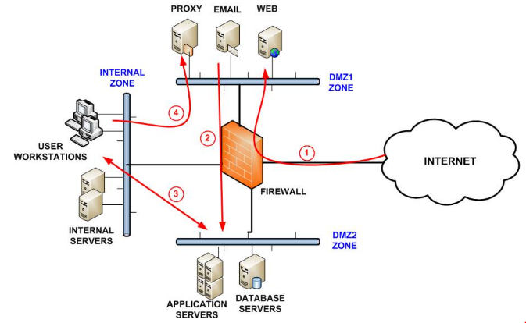
In multi-tenant environments, require what segmentation is in the area between resources and those of other clients, as well as between special cases. Take advantage of a zonal approach to isolate entire instances, containers, applications and systems from one another when possible, which the segmented network can lead a better network performance, reduced attack surface and Reduced compliance scope.
Figure 5: Firewall Security Zone Segmentation[26].

2.7 Access control
The impact of robust identity management and authentication processes should be taken in advantages to ensure only authorized users have access to the cloud, applications, and data. Force less privileged to restrict privileged access and power cloud resources.
Managing access controls are similar to (availability) which is to enable authorized users such as employees and customers to access information, and access controls protect data by allowing the organization to assign access lists to different assets, and by maintaining strict access control, it can help preserve valuable data from malicious insiders or hackers who have stolen credentials, and this process is closely similler to ISO 27001 A6 in accessing controls.

2.7.1 Password Control
Use strong passwords as most of the attacks are due to weak passwords, the shared passwords must not be used at all, and combine passwords with other authentication systems for sensitive areas. Ensure best practices for password management.

2.8 Data
Because the data is the most valuable in the company, the company should
- complete control over who has access to your sensitive data
- Monitor or secure data in transit within cloud applications
- Sensitive data must be is encrypted on the server before it is sent to the cloud. This prevents hackers who gain access to the firewall from editing, reading, copying, or deleting your files, and the data in the cloud should be always encrypted, at rest, and in transit
- Using Two-Factor Authentication to make obtaining unauthorized access more difficult, restrict data access using administrator levels to prevent mismanagement of data and incidents.
- Data protection: Data is vulnerable to corruption or deletion while in the cloud. so it must be backed up with two copies by using erase or replication

2.8.1 Using personal devices
An agreement for the employees and clients to avoid storing sensitive data such as copies of their IDs or important financial statements even the old copies. An agreement to avoid sharing personal information while using the cloud, and also the policy that provided by ISO 27001 that called BYOD under the organization of information security is seems quite good to implement in the company as well to provide the ability for the employees to bring and use their devices such as laptop, mobile phones and smart watches.

2.9 Software
Using some software can lead to a leak of information or data breaches so the company must ensure that the software is trusted and up to date to avoid to any attempted unauthorized access, external threats, and unusual access patterns.
- The devices must have an Anti-virus and anti-malware programs with an updated version all the time.
- Software application should be checked regularly and updated

2.10 Exploratory review
The entire security system should perform an annual review that can add up to a month, ensuring that the risks in the list are kept to a minimum, as the infrastructure will be the primary target for attackers.

2.11 Disaster Recovery
The organization should be aware of the data backup, retention and recovery policy, and operations of the cloud vendors if they meet the internal standards, and set up multiple backups of their valuable data in the event of any unexpected disaster for the company.

Conclusion
In this report, the author briefly explained what is the information security framework that provides three different frameworks ISO 27001, COBIT and ITIL and explains the process with its advantages and weaknesses and a comparison section to analyse the differences between them, and in the last step a section of the CaribbeanCaffee scenario was applied with operations which the author believes is most important.

References:
[1] C. N. Murphy and J. Yates, The International Organization for Standardization (ISO): Global governance through voluntary consensus. 2008.
[2] ISO, “ISO,” N.a., 2019. [Online]. Available: https://www.iso.org/about-us.html#3. [Accessed: 15-Dec-2020].
[3] T. Iso and S. Process, “II . A Brief History of ISO,” pp. 1–2, 2013.
[4] ISO, “ISO Members,” International Standards for Standardisation, 2017. [Online]. Available: https://www.iso.org/members.html. [Accessed: 15-Dec-2020].
[5] ISO Central Secretariat, “Recollections from ISO’s first fifty years,” 2015.
[6] “ISO 27000 Series of Standards | IT Governance UK.”
[7] I. 27000:2018, “Information technology-Security techniques-Information security management systems-Overview and vocabulary ISO/IEC 27000:2018(E) ii COPYRIGHT PROTECTED DOCUMENT,” vol. 2018, 2018.
[8] “ISO 27001 Benefits | IT Governance UK.” [Online]. Available: https://www.itgovernance.co.uk/iso27001-benefits. [Accessed: 16-Dec-2020].
[9] N. O’Connor, “Why ISO 27001 is not enough | BCS - The Chartered Institute for IT,” BCS, 2009. [Online]. Available: https://www.bcs.org/content-hub/why-iso-27001-is-not-enough/. [Accessed: 16-Dec-2020].
[10] “Advantages and disadvantages of certification against ISO 27001 standard.” [Online]. Available: https://community.advisera.com/topic/advantages-and-disadvantages-of-certification-against-iso-27001-standard/. [Accessed: 16-Dec-2020].
[11] Notice, “ISO/IEC 27001 certification standard,” ISO/IEC 27001, 2018. [Online]. Available: https://www.iso27001security.com/html/27001.html. [Accessed: 16-Dec-2020].
[12] R. R. Moeller, Executive’s Guide to IT Governance - Improving Systems Processes with Service Management, COBIT, and ITIL. 2013.
[13] S. De Haes, W. Van Grembergen, and R. S. Debreceny, “COBIT 5 and enterprise governance of information technology: Building blocks and research opportunities,” J. Inf. Syst., vol. 27, no. 1, pp. 307–324, 2013.
[14] W. H. Tsai, C. L. Hsieh, C. W. Wang, C. T. Chen, and W. H. Li, “The impact of IT management process of COBIT 5 on internal control, information quality, and business value,” in IEEE International Conference on Industrial Engineering and Engineering Management, 2016, vol. 2016-Janua, pp. 631–634.
[15] intellectsoft, “COBIT vs ITIL: Selecting The Right IT Governance Framework,” 2017. [Online]. Available: https://www.intellectsoft.net/blog/cobit-vs-itil/. [Accessed: 16-Dec-2020].
[16] Y. Ding, “Service Delivery Standards (ITIL, COBIT, ETOM, ISO/IEC 20000, Etc.),” in Wiley Encyclopedia of Management, John Wiley & Sons, Ltd, 2015, pp. 1–4.
[17] K. R. P. Harefa and N. Legowo, “The governance measurement of information system using framework cobit 5 in automotive company,” in Proceedings - 2017 International Conference on Applied Computer and Communication Technologies, ComCom 2017, 2017, vol. 2017-Janua, pp. 1–6.
[18] “Disadvantages of using COBIT to establish an IT management and governance | Course Hero.” [Online]. Available: https://www.coursehero.com/file/pfudb5/Disadvantages-of-using-COBIT-to-establish-an-IT-management-and-governance/. [Accessed: 16-Dec-2020].
[19] R. Das, J. Chandrakanta, B. Cet, J. Mishra, and S. Mishra, Bharati Vidyapeeth’s Institute of Computer Applications and Management (BVICAM). 2018.
[20] “The IT Service Management according to the ITIL framework applied to the enterprise value chain,” Int. J. Comput. Sci. Issues, vol. 8, no. 3, pp. 515–522, 2011.
[21] Glasspaper, ITIL® Foundation with Case Study. 2013.
[22] W. Bentley and P. T. Davis, Lean Six Sigma Secrets for the CIO. 2009.
[23] N. K. Gunawan, R. B. Hadiprakoso, and H. Kabetta, “Comparative study between the integration of ITIL and ISO / IEC 27001 with the integration of COBIT and ISO / IEC 27001,” in IOP Conference Series: Materials Science and Engineering, 2020, vol. 852, no. 1.
[24] ISACA. and J. W. Lainhart, COBIT 5: A business framework for the governance and management of enterprise IT COBIT 5, vol. 34, no. 1. 2012.
[25] Y. Ozdemir, H. Basligil, P. Alcan, and B. M. Kandemirli, “Evaluation and Comparison of Cobit , ITIL and ISO27K1 / 2 Standards Within the Framework of Information Security,” Int. J. Tech. Res. Appl., vol. 11, no. 11, pp. 22–24, 2014.
[26] V. Ramakrishnan, “Network Segmentation Best Practices to Improve Security,” Unmetric. p. 1, 2019.
[27] ISO/IEC 27001, “NEN-ISO/IEC 27001 Information Technology - Security Techniques - Information Security Managment Systmens - Requirements (ISO/IEC 27001:2013, IDT),” Int. Organ. Stand., vol. 27001, 2013.
[28] M. E. Whitman and H. J. Mattord, Principles of Information Security, Sixth Edition. 2018.
[29] M. E. Whitman, H. J. Mattord, and A. Green, Guide to Firewalls and VPNs. 2012.
[30] A. Chopra and M. Chaudhary, Implementing an Information Security Management System. 2020.
[31] D. Kim and M. G. Solomon, (Jones & Bartlett Learning information systems security & assurance series) Kim, David_ Solomon, Michael G-Fundamentals of information systems security-Jones & Bartlett Learning (2018).pdf. 2018.
[32] W. Stallings, Network Security Essentials 4th Edition. 2015.
[33] M. E. Whitman and H. J. Mattord, “MANAGEMENT OF Sixth Edition MANAGEMENT OF Sixth Edition,” p. 4,5,6, 2018.

Appendix

4.1 ISO 27000 Series current and planned:
27000:2016 | Series Overview and Terminology
27001:2013 | InfoSec Management System Specification
27002:2013 | Code of Practice for InfoSec Management
27003:2017 | InfoSec Management Systems Implementation Guidance
27004:2016 | InfoSec Measurements
27005:2011 | ISMS Risk Management
27006:2015 | Requirements for Bodies Providing Audit and Certification of an ISMS
27007:2011 | Guidelines for ISMS Auditing
27008:2011 | Guidelines for InfoSec Auditing
27010:2015 | Guidelines for Inter-sector and Inter-organizational Communications
27011:2016 | Guidelines for Telecomm orgs
27013:2015 | Guideline on the Integrated Implementation of ISO/IEC 20000-1 and ISO/IEC 27001
27014:2013 | InfoSec Governance Framework
27015:2012 | InfoSec Management Guidelines for Financial Services
27016: 2014 | InfoSec and Organizational Economics
27017:2015 | Code of practice for InfoSec controls for cloud computing services based on ISO/IEC 27002
27018:2014 | Code of practice for PII protection in public clouds acting as PII processors
27019:2013 | InfoSec Management guidelines for process control systems specific to the energy industry
27023:2015 | Mapping the revised editions of ISO/IEC 27001 and 27002
27031:2012 | Guidelines for info and communication technology readiness for business continuity
27032:2012 | Guidelines for cybersecurity
Table 1: ISO 27000 Series current and planned.

4.2 ISO 27001 benefits in details:
1- Information protection and security: protecting all forms of information, whether digital or paper stored in the cloud
2- Increase attack resilience: The implementation and maintenance of ISMS will greatly increase the organization's resilience in the face of cyber attacks
3- Data confidentiality and integrity protection: ISMS provides a set of policy measures and technical and physical controls to protect the confidentiality and integrity of information.
4- Maximizing Security in Business Culture: A comprehensive approach to standards covers the entire organization and not just the IT department so that employees can easily understand risks and adopt security controls as part of their daily work practices.
5- Reducing costs associated with information security: The Information Security Management System (ISMS) looks to assess and address the risks that can lead to maximizing the return on investment.
6- Responding to evolving security threats: ISMS continually adapts to changes both in the threat environment and within the organization and ensures that information security risks are managed effectively over time.

More in ISO 27001:
ISO 27001 controls there are 114 controls in annex a covering the breadth of information security management including areas such as:
- physical access control
- firewall policies
- security staff awareness programs
- procedures for monitoring threats
- incident management processes and encryption
the standard requires organizations to compare the measures they have implemented with the annex a control, they're then expected to implement the missing Controls or else provide and document a reason that those controls aren't applicable to them
How to get ISO 27001 certified:
once an organization has met the various requirements stipulated by ISO 27001 the next step is to seek certification certification is the procedure by which an external certification body provides written assurance that an organization's ISMS conforms to the requirements of ISO 27001,
Because certification to ISO 27001 is not mandatory not all organizations choose to achieve it, however there are many benefits to certification, as well as helping you protect your information and comply with relevant legislation ISO 27001 certification holds a distinct market value by providing clear externally validated proof of your organisation's willingness to meet internationally accepted information security standards,
the process involves going through a certification audit in which an expert from a certification body or visit your organization to examine your ISMS, if they're satisfied with what they see they will award a certificate[11][8]

4.3 ITIL Service lifecycle (Main Processes)
Service | Main processes
ITIL Service Strategy:  The service strategy defines the types of services to be provided to customers or markets | - Strategy Management for IT Services.  - Service Portfolio Management.  - Financial Management for IT Services.  - Demand Management.  - Business Relationship Management.
ITIL Service Design:  Design service determines the service requirements and creates new service offers as well as changes and improvements to the current offerings | - Design Coordination.  - Service Catalogue Management (SCM).  - Service Level Management (SLM).  - Risk Management.  - Capacity Management.  - Availability Management.  - IT Service Continuity Management (ITSCM).  - Information Security Management.  - Compliance Management.  - Architecture Management.  - Supplier Management.
ITIL Service Transition:  Builds service transfer and publishes new or modified services | - Change Management  - Change Evaluation  - Project Management (Transition Planning and Support)  - Application Development  - Release and Deployment Management  - Service Validation and Testing  - Service Asset and Configuration Management  - Knowledge Management
ITIL Service Operation:  The service process carries out operational tasks | - Event Management  - Incident Management  - Request Fulfilment  - Access Management  - Problem Management  - IT Operations Control  - Facilities Management  - Application Management  - Technical Management
ITIL Continual Service Improvement:  It is constantly working to improve the effectiveness and efficiency of the services and operations | - Service Review  - Process Evaluation  - Definition of CSI Initiatives  - Monitoring of CSI Initiatives

4.4 Resources
More resource has been used to implement this report [27], [28], [29], [30], [31], [32], [33].

