In an Age of Acceleration: How Graphic Design Visualises and Critiques the Fragmentation of Attention in Digital Culture

Keywords: Attention, Digital Interface, Visual Communication
Student name: Bingya Cui (Cassie)
Student Number: 2424395
BA course title: Graphic Design
Module: Research in Practice (ADAD5004)
Word count: 2817
Lecturer’s name: Donna Williams

Abstract
This proposal explores how graphic design can visualise and critique the fragmentation of attention in contemporary digital culture. With the rise of social media, mobile interfaces and algorithm-driven platforms, attention has become increasingly unstable and continuously interrupted. Rather than examining this issue solely from a sociological perspective, this research focuses on the role of visual communication in shaping and directing attention.
By analysing digital interfaces, experimental typography, and editorial design, the study investigates how distraction is constructed through visual strategies such as layout, hierarchy and repetition. The practical outcome will take the form of an experimental editorial publication that combines minimal design with moments of disruption to reflect the tension between focus and overload.
The project aims to demonstrate that graphic design is not only a tool for communication, but also a critical medium capable of revealing and questioning the conditions of attention in an accelerated digital age.

1. Introduction
1.1 Research Background
The rapid expansion of digital culture has significantly altered how individuals engage with and process information. In contemporary society, attention is increasingly mediated by visual environments shaped by mobile devices, social media platforms, and continuous streams of content. Within these conditions, sustained focus is no longer a given, but something that is often difficult to maintain.
1.2 Research Aim
While much existing research approaches attention from psychological or sociological perspectives, this study shifts the focus towards graphic design. It considers how visual language—particularly layout, typography, and interface structures—organises, redirects, and at times disrupts attention.
Rather than understanding distraction purely as a behavioural issue, this research frames it as a condition that is, to some extent, visually constructed. The aim is therefore to explore how graphic design can both visualise and critically reflect the fragmentation of attention in digital culture, ultimately informing a design-led response that translates this experience into a tangible visual form.
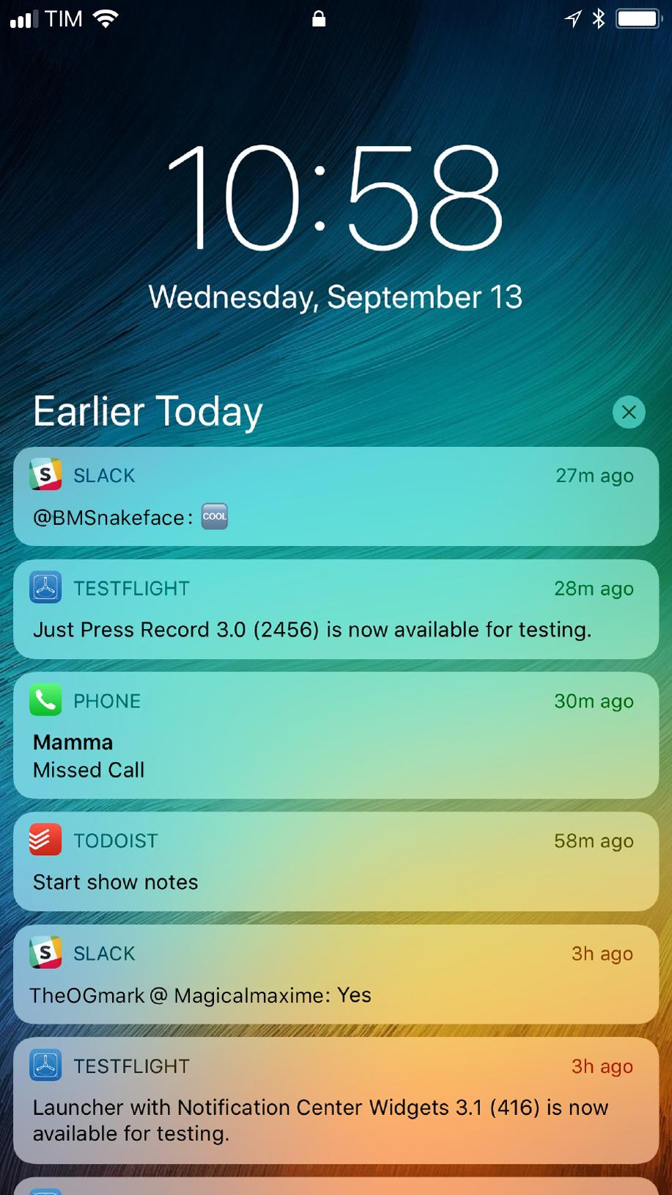
Figure 1: iPhone Notification

2. Context: Digital Culture and Attention Economy
2.1 Attention Economy
Digital platforms are intentionally structured to capture and retain user engagement through carefully designed visual and interactive systems. Features such as infinite scrolling, push notifications, and algorithm-driven feeds create ongoing cycles of interaction and interruption.
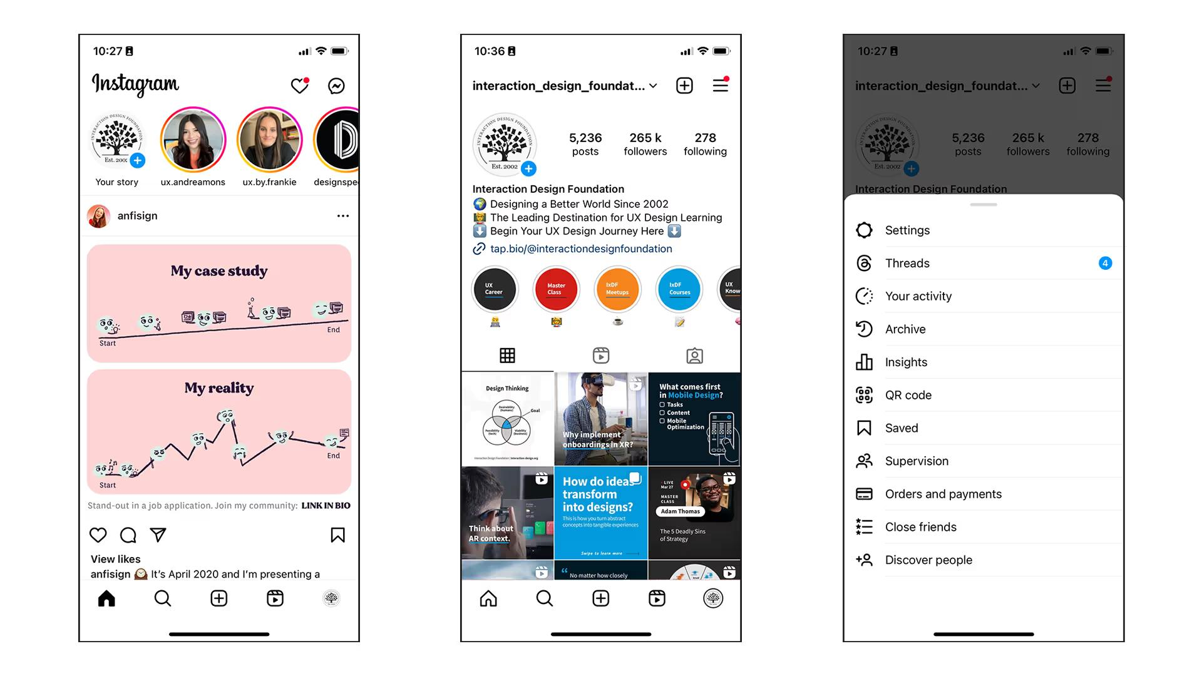
Figure 2: Instagram Interface

Another point to consider is how repetition plays a role in sustaining attention. Many digital platforms rely on repeating visual patterns, such as similar post formats or consistent interface structures. Over time, users become familiar with these patterns, which makes interaction faster but also more automatic.
Because of this, users may not actively process each piece of information. Instead, they move quickly through content, guided by familiarity rather than intention. This creates a passive form of engagement, where attention is present but not deeply focused.
Wu (2016) argues that attention has become a commodity within digital capitalism, while Carr (2010) suggests that prolonged exposure to fragmented information environments can weaken the capacity for deep and sustained thinking. This is particularly relevant in everyday digital experiences, where users are constantly navigating between multiple streams of information and competing visual stimuli.
2.2 Role of Graphic Design
Within this context, graphic design plays a central role in shaping how information is organised and experienced. Elements such as visual hierarchy, contrast, and interface layout guide user behaviour and subtly prioritise certain forms of engagement over others. As such, design operates not as a neutral medium but as an active force in directing attention.
2.3 Visual Stimulation and Interface Design
In addition to structural elements such as layout and hierarchy, digital interfaces also rely heavily on visual stimulation to sustain user engagement. Bright colours, motion graphics, and notification indicators are often strategically used to capture attention quickly. These visual cues operate at a sensory level, encouraging immediate responses rather than reflective interaction.
Manovich (2001) suggests that digital media is inherently modular and variable, allowing content to be constantly updated and reconfigured. This flexibility contributes to a visual environment that is never static, reinforcing a sense of urgency and continuous engagement. As a result, users are less likely to remain focused on a single piece of content for extended periods.
This is particularly evident in social media platforms, where visual intensity and rapid transitions between content create a rhythm of constant stimulation.

3. Keywords and Conceptual Framework
3.1 Attention
Attention can be understood as a limited cognitive resource that is constantly shaped within different visual environments. Hari (2022) suggests that the current crisis of attention is not simply an individual issue but is closely connected to broader structural conditions within digital systems.
It is also important to recognise that attention is not always stable, even outside digital environments. However, digital systems appear to intensify this instability by introducing continuous visual and informational interruptions.
Compared to more traditional forms of media, such as printed books, digital content is often consumed in shorter and less continuous segments. This shift not only changes how information is accessed but also affects how it is experienced over time. In this sense, attention can be seen not only as a cognitive function but also as something shaped by visual experience.
3.2 Digital Interface
Digital interfaces function as mediating structures between users and information. Norman (2013) highlights that design influences not only usability, but also perception and behaviour.
The organisation of visual elements within interfaces therefore plays an important role in shaping how attention is directed. Layout, hierarchy, and visual cues guide user interaction, often in subtle ways that are not immediately noticeable.
In everyday use, interfaces are designed to encourage continuous engagement. Elements such as notifications, scrolling systems, and visual prompts can quickly redirect attention, making interaction more automatic and less deliberate.
3.3 Visual Communication
Visual communication plays a central role in how information is structured and experienced. Rather than simply presenting content, it actively shapes how users interpret and respond to what they see.
Eyal (2014) explains how behavioural triggers are embedded within visual systems to repeatedly draw users back into interaction. This suggests that distraction is not always accidental but can be designed through visual strategies.
Flusser (2011) argues that technical images reshape human perception by mediating reality through visual codes. From this perspective, visual communication does not only convey meaning but also constructs experience.
This reinforces the idea that graphic design operates not only as a communicative tool but also as an experiential medium that influences how attention is distributed and understood.
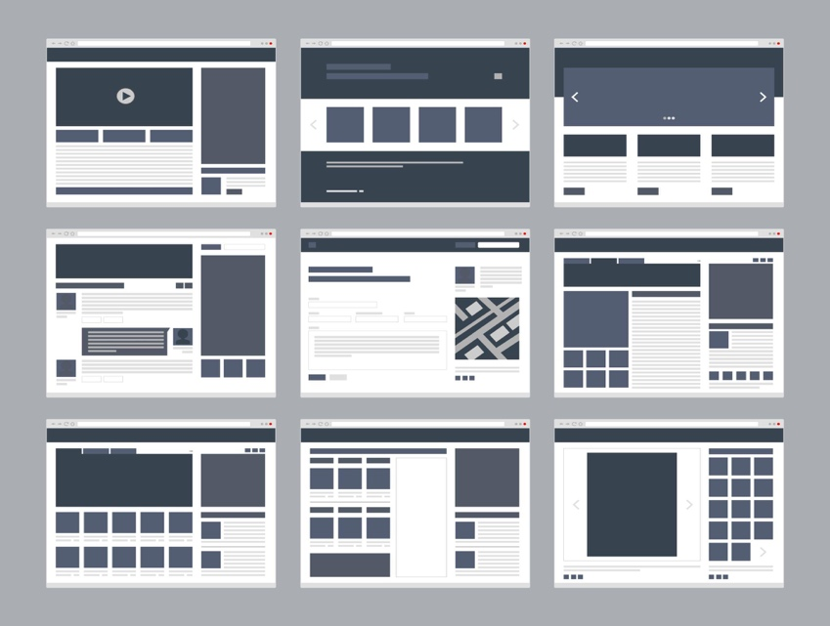
Figure 3: UI Wireframe

4. Theoretical Framework
4.1 Social Acceleration
Rosa (2013) describes contemporary society as defined by acceleration, where individuals are required to process increasing amounts of information within limited timeframes. This condition has a direct impact on perception and the experience of time.
4.2 Information Overload
Wurman (2001) introduces the concept of information anxiety, referring to the stress that arises when information exceeds an individual’s capacity to process it. Visually, this can be reflected through density, layering, and fragmented structures.
Together, these ideas suggest that visual communication is not only a means of conveying information but also a factor that shapes cognitive experience.
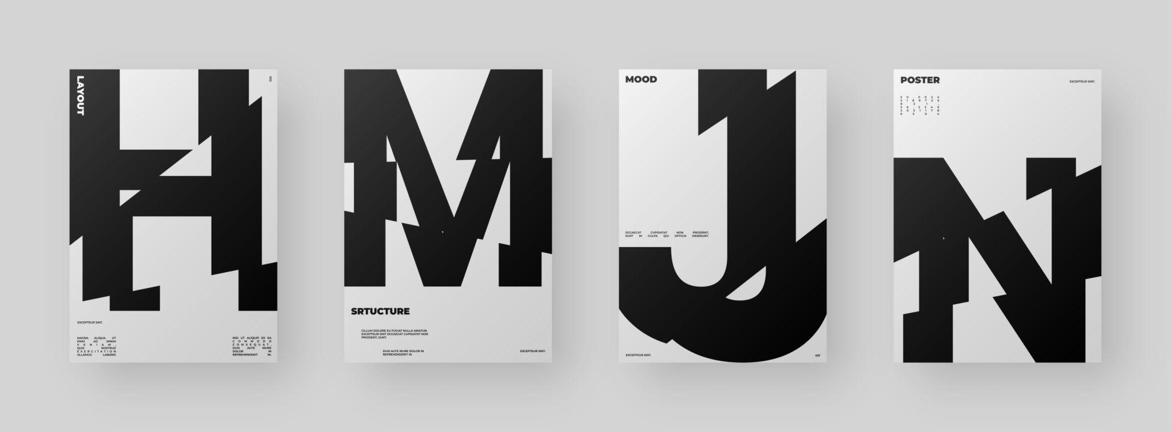
Figure 4: Glitch Typography

4.3 Temporal Experience and Design
The fragmentation of attention is closely linked to changes in how time is experienced within digital environments. Rapid transitions between content, short-form media, and continuous updates contribute to a sense of compressed time.
Rosa (2013) suggests that acceleration alters not only social structures but also individual perception. Within digital interfaces, time is often experienced as fragmented and non-linear, which directly affects how users process information.
From a design perspective, this raises important questions about pacing, rhythm, and duration. Graphic design can either reinforce this accelerated experience or attempt to slow it down through controlled visual structures.
4.4 Visual Hierarchy and Selective Attention
Another important aspect to consider is how visual hierarchy influences selective attention. In both digital and print design, hierarchy is used to guide the viewer’s eye towards certain elements while reducing the importance of others.
In digital environments, this process becomes more complex due to the presence of multiple competing elements. Users are often required to make quick decisions about where to look, which can lead to fragmented patterns of attention.
This suggests that attention is not only limited but also constantly being filtered. Design plays a key role in this process by highlighting certain information while allowing other elements to fade into the background.
From this perspective, visual hierarchy can be understood as both a tool for clarity and a mechanism that shapes how information is selectively experienced.

5. Case Studies and Visual Analysis
5.1 Fragmentation in Design
Contemporary graphic design increasingly reflects the fragmented nature of digital culture. Experimental typography and editorial practices often employ layering, distortion, and disruption to simulate the experience of distraction.
5.2 Minimalism as Resistance
In contrast, minimalist approaches emphasise clarity, hierarchy, and the use of white space. Lupton (2008) highlights how layout influences reading behaviour, while Tufte (2001) advocates for clarity and efficiency in visual communication.
These contrasting approaches suggest that design can either reinforce distraction or create conditions that support sustained attention.
In many contemporary designs, there is a noticeable shift towards layering and fragmentation. Text is often broken, repeated, or partially obscured, making it harder to read in a linear way.
While this might appear chaotic, it reflects the way information is encountered in digital environments. Rather than following a clear beginning and end, users often experience content as a series of interruptions.
This suggests that visual disorder is not always accidental but can be used intentionally to represent certain conditions of perception.
5.3 Design Tension: Order and Chaos
A key theme emerging from contemporary graphic design is the tension between order and chaos. While some designs intentionally disrupt readability through fragmentation, others aim to restore clarity through structured layouts.
This contrast highlights an important design dilemma: whether to reflect the chaotic nature of digital culture or to provide an alternative visual experience. Minimalist design can be seen as a response to overload, offering visual clarity and space for reflection.
At the same time, overly simplified design may fail to capture the complexity of contemporary media environments. Therefore, the balance between order and disruption becomes a central concern in this project.
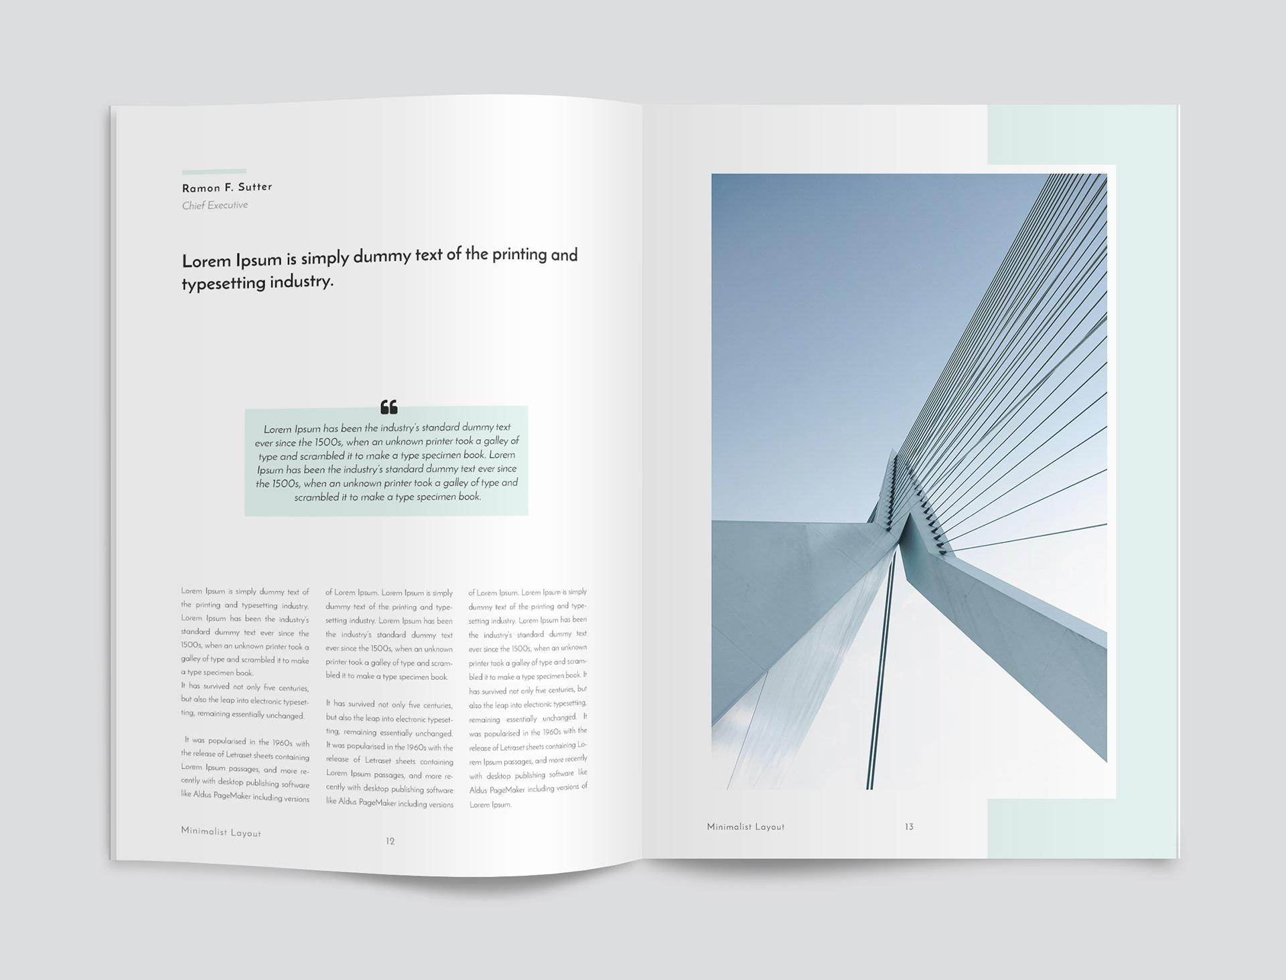
Figure 5: Experimental Editorial

6. Methodology and Practice
6.1 Design Approach
The practical outcome of this project will take the form of an experimental editorial publication. The design adopts a minimal visual approach, using structured grids, limited colour palettes, and controlled typography to establish a sense of order.
6.2 Visual Strategy
Moments of disruption are introduced through fragmented text, overlapping elements, and interrupted reading flows. While Munari (1966) suggests that design should simplify complexity, this project intentionally explores the tension between clarity and overload.
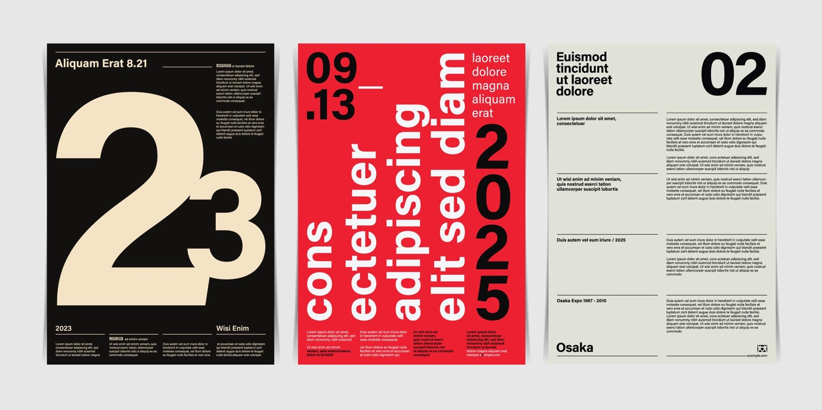
Figure 6: Swiss Minimal Layout

This approach reflects my intention to translate abstract cognitive experiences into a visual form that can be both observed and questioned.
6.3 Intended Outcome and Audience
The intended outcome of this project is not only to produce a visually engaging artefact, but also to create a reflective experience for the viewer. The editorial format allows for a sequential exploration of attention, guiding the reader through moments of clarity and disruption.
The target audience includes individuals who are familiar with digital media environments, particularly students and young adults who regularly engage with social media. By reflecting everyday visual experiences, the project aims to encourage awareness of how attention is shaped and influenced.
Ultimately, the design outcome seeks to bridge theory and practice, demonstrating how graphic design can function as both a critical and communicative tool.
Another important aspect of this project is the relationship between reading and visual pacing. In traditional printed formats, reading usually follows a clear and continuous structure. However, in digital environments, this process is often interrupted by visual elements that compete for attention.
In developing my design outcome, I am particularly interested in how pacing can be controlled through layout. For example, larger areas of empty space may slow the reader down, while dense compositions may encourage quicker scanning. By carefully adjusting these elements, it is possible to influence how information is experienced over time.
This approach allows the design to move beyond simply presenting content and instead shape the rhythm of attention itself.
6.4 Reflection on Design Decisions
Throughout the design process, it becomes clear that even small visual decisions can significantly affect how a piece is experienced. Choices such as spacing, alignment, and typography may appear subtle, but they influence how easily information can be followed.
In this project, I found that reducing visual elements does not necessarily simplify the experience. In some cases, minimal layouts can make disruptions more noticeable, as there are fewer elements to balance them.
This highlights the importance of experimentation within design practice. Rather than applying fixed rules, the process involves testing different visual approaches and observing how they affect attention.
By reflecting on these decisions, the project aims to better understand how design can shape perception in a more intentional way.
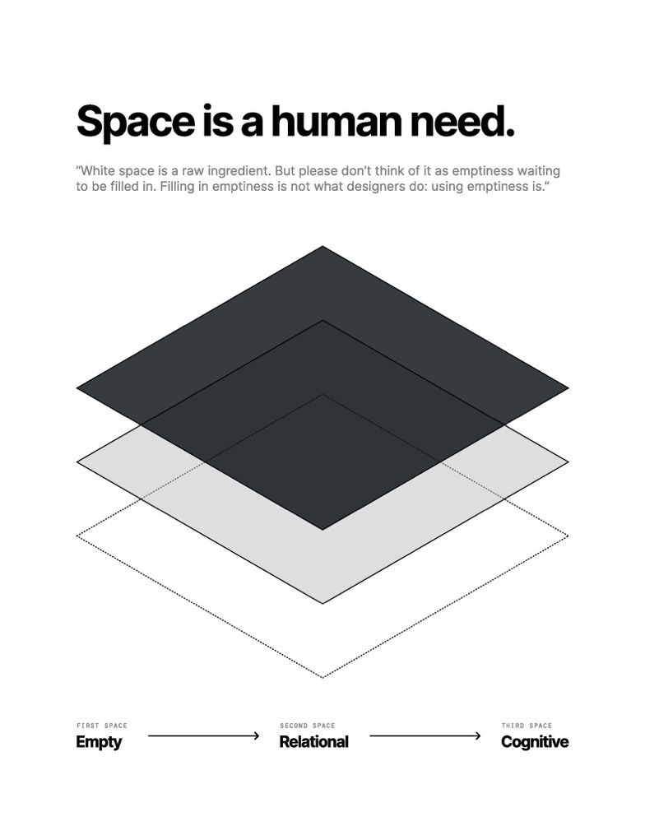
Figure 7: White Space

7. Conclusion
This proposal has explored how graphic design can visualise and critically engage with the fragmentation of attention in digital culture. By combining theoretical analysis with design practice, the study positions graphic design as both a participant in and a response to contemporary attention systems.
Looking at this topic more closely, it becomes clear that attention is not something that can be easily controlled or fixed. Instead, it is shaped by a combination of personal habits and external influences.
It is also worth considering how users adapt to these visual environments over time. As people become more familiar with fast-paced digital content, their expectations begin to change. Information is often expected to be immediate, visually engaging, and easy to navigate.
This shift can influence not only how design is created, but also how it is received. Designs that require slower reading or deeper engagement may feel unusual or even uncomfortable in comparison.
This raises an interesting question about whether design should follow these expectations or challenge them. In this project, I am more interested in using design to question these habits rather than reinforce them.
Digital design plays a significant role in this process, often without users being fully aware of it. This makes it important to not only analyse design but also question its impact on everyday behaviour. In this sense, graphic design can be seen as both part of the problem and a possible way of responding to it.
From a broader perspective, this topic highlights the close relationship between technology, behaviour, and visual culture. The way people see, read, and interact with information is no longer determined only by personal choice but also by the systems that surround them.
Graphic design exists within this system, but it also can reflect on it. By making attention visible, design can reveal patterns that might otherwise go unnoticed.
This makes design not only a practical discipline but also a critical one, capable of exploring and questioning contemporary conditions.
Overall, this project explores how an abstract cognitive condition might be translated into a more tangible visual experience, while encouraging reflection on how digital environments influence perception and behaviour.
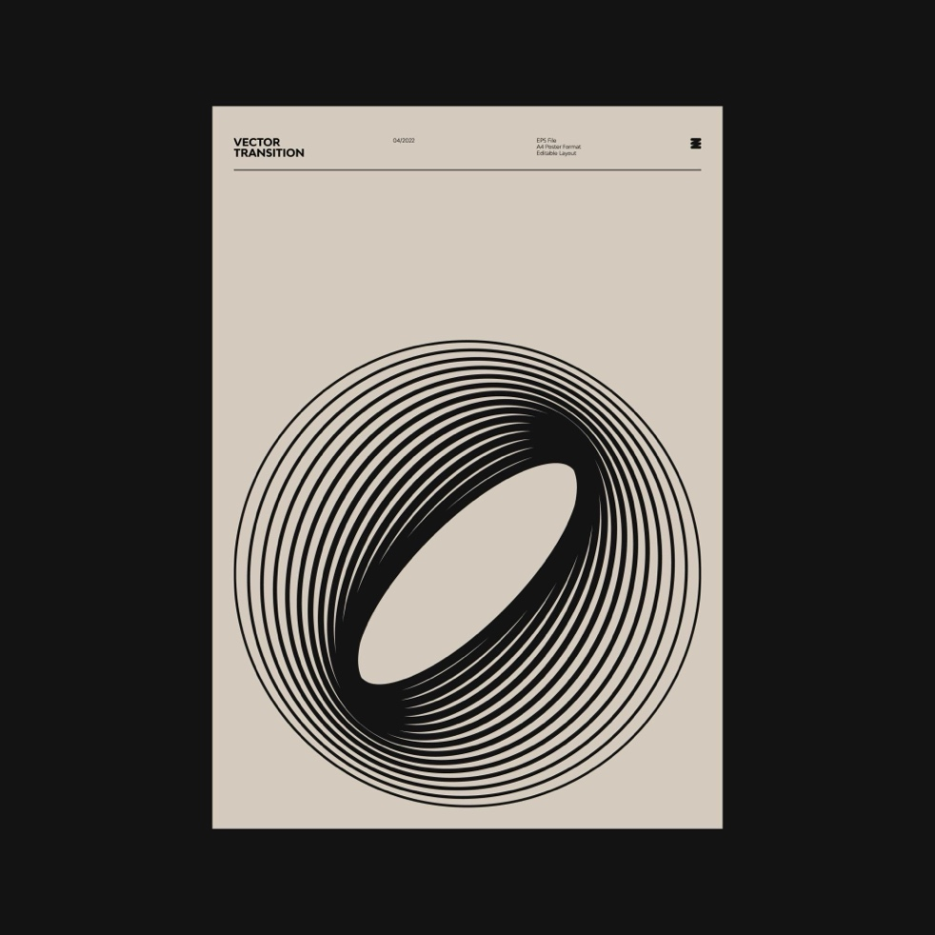
Figure 8: Visual Pause and the Absence of Information
References
Carr, N. (2010) The Shallows: What the Internet Is Doing to Our Brains. New York: W.W. Norton.

Eyal, N. (2014) Hooked: How to Build Habit-Forming Products. New York: Portfolio.

Hari, J. (2022) Stolen Focus: Why You Can't Pay Attention. London: Bloomsbury.

Lupton, E. (2008) Graphic Design: The New Basics. New York: Princeton Architectural Press.

Manovich, L. (2001) The Language of New Media. Cambridge, MA: MIT Press.

Munari, B. (1966) Design as Art. London: Penguin.

Norman, D. (2013) The Design of Everyday Things. Revised edn. New York: Basic Books.
Rosa, H. (2013) Social Acceleration: A New Theory of Modernity. New York: Columbia University Press.

Tufte, E. (2001) The Visual Display of Quantitative Information. Cheshire, CT: Graphics Press

Wurman, R. S. (2001) Information Anxiety 2. Indianapolis: Que.

Wu, T. (2016) The Attention Merchants: The Epic Scramble to Get Inside Our Heads. New York: Knopf.

Flusser, V. (2011) Into the Universe of Technical Images. Minneapolis: University of Minnesota Press.

List of Figures:

Figure 1: iPhone Notification Screen
Available at https://support.apple.com/en-gb/guide/iphone/iph7c3d96bab/ios (Accessed: 26 April 2026)

Figure 2: Instagram Interface
Available at: https://about.instagram.com/features (Accessed: 26 April 2026)

Figure 3: UI Wireframe Example
Available at: https://www.figma.com/community (Accessed: 26 April 2026)

Figure 4: Glitch Typography Poster
Available at: https://www.behance.net (Accessed: 26 April 2026)

Figure 5: Editorial Design Layout
Available at: https://www.itsnicethat.com (Accessed: 26 April 2026)

Figure 6: Swiss Design Layout
Available at https://www.moma.org/collection/ (Accessed: 26 April 2026)

Figure 7: Minimal White Space Poster
Available at: https://www.tate.org.uk/art (Accessed: 26 April 2026)
Figure 8: Minimalist Poster Design
Available at: https://www.tate.org.uk/art (Accessed: 26 April 2026)

