

Assessment 1 – Reading Task Template
PART 1: Upload your photo of your A3 in-class notes here:
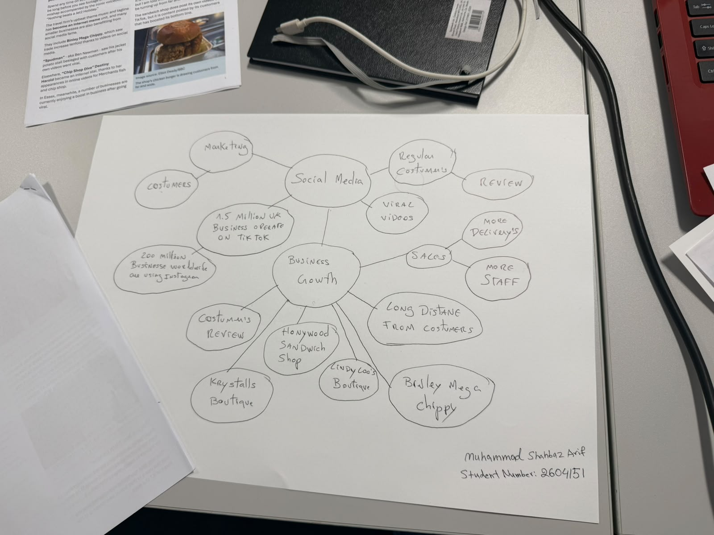

PART 2:
- Answer every question below in 1-3 full sentences.
- Use your own words. Do not use generative AI to answer these questions.
- Include a specific detail from the text when asked.
REMINDER
- The main idea is the overall message of the whole text.
- A key point helps to explain the main idea.
- A specific detail or example from the text shows that the key point is true.

- What is the main idea of the whole text?
The main idea of the article is to show that business are going online and posting to get new customers and clients and promote there business. But also customers posting is also beneficial.

- What is one key point that supports the main idea, and which specific example from the text shows this?
One main idea supporting this is in the article it states Binley mega chippy saw trade increase tenfold due to videos on social media.

- What is a different key point that supports the main idea, and which specific example from the text shows this?
Another example where social media has helped is honywood sandwich shop which seen business and popularity increase due to customers posting content online alongside the business.

- Which part of the text do you think is most important, and why?
I think the most import part is the examples as it shows the proof that social media works and helps increase business.

Reflection:
- What did you find difficult in this task (including in-class components), and why was it difficult?
I found using word difficult as it has been a long time since I have had to write assignments.

- What helped you with this difficulty, and how did it help you?
Asking questions and asking class mates and working in a team helped me overcome this issue which helped me finish this assignment

