For this task we were instructed to pitch an idea for an art exhibition based on the theory of sublime. For this assignment I have chosen the theme to be the Titanic. After looking at the idea of sublime I found that it was best that I base it on a topic that I am familiar with and after hearing what was needed as a criteria to made, I felt that the Titanic was appropriate as it touches on the idea of Romantic sublime, technological sublime, destructive sublime and cinema terror. Furthermore, I wanted to create an exhibit based on the titanic that was a memorial to the sinking of the ship and as the assignment was given 4 days before the anniversary of the sinking of the ship I wanted to create this exhibit with the anniversary in mind.
Once I knew the title I wanted to create, I began to think about what I would like to include in my exhibit. After discussing with my fellow peers on what they wanted display in their exhibit, I realised that many people had chosen to focus on photography as their medium alone. While I originally wanted to create an exhibit with photography also, I began to think about ways I could take to make my work stand out. I felt as though it was appropriate to look at my course of film and television as a medium and looked at film which connected with the main idea of titanic. I wanted to create a modern exhibit and one none like any other Titanic exhibit before.
In addition to that, I thought about adding a personal touch and add other interests of mine to the exhibit. I have a large interest in fashion and referring back to the film, the clothes worn were responsible for sparking an interest with period fashion and the want to research more into the topic testing my ability to identify the difference between eras through looking at the clothes and fashion at the time. When it come to my own exhibition experience, I was always drawn to visiting ones that offer more than a 2D surface such as paintings or photography hung on the wall. Because of this, I find art exhibits with mediums of sculptures that have more dimensions that are propped on exhibition boxes to have a more interactive feel that takes allows the individual to spend more time on appreciating the art and allow them to circle around and to take themselves around the piece.
Knowing the mediums I wanted to include, I then began thinking about the possible artists that I could use to make my planned exhibition into reality. After researching for a few days I gradually collected all my pieces and ensuring that I remained on track with my planned mediums.
As for choosing a three dimensional medium, I chose ceramics for two reasons. One reason for choosing ceramics as one of my mediums is because I had seen the plates that not only are being sold as merchandise based on the film but I have also seen the design on plates that were used in the titanic. While the designs on the plates were beautiful, the main reason is based on the character of Rose in the film, or rather the woman who partially inspired the character.

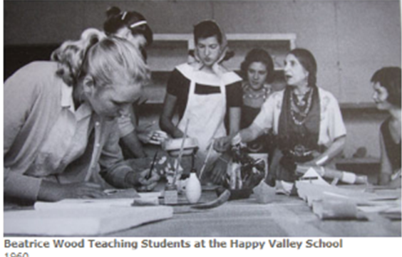
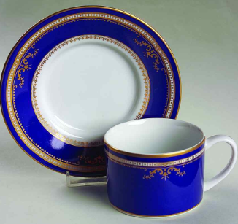
According to BeatriceWood.Com Beatrice Wood studied ceramics with Glen Lukens, a leading artist and teacher in the 1930s. I thought by including ceramics in the exhibition that would pay a tribute to Beatrice Wood as well have the opportunity to display beautiful designs that were on the ship in ceramic form.
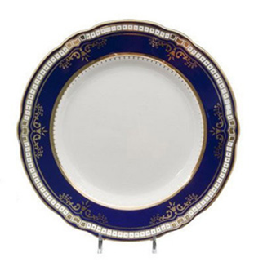
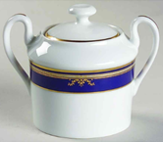

The blue theme with the first class dining sets stand out beautifully amongst the white but what stood out the most was the real gold details that would look amazing close up which an exhibition would allow people to see those details up close.
As these plates are replicas to those that were used in first class, as stated previously, it brought to my attention to the possibility that I could introduce the differences in the class systems but similarly to the ceramics, I wanted to focus on the upper class as aesthetically, it was more appropriate for the look that I wanted. One of the biggest signs of the class you were from heavily depended on the style of clothing you were dressed in. As mentioned previously, I have knowledge of period fashion to a certain degree but my greatest interest in fashion comes from modern runway designers.

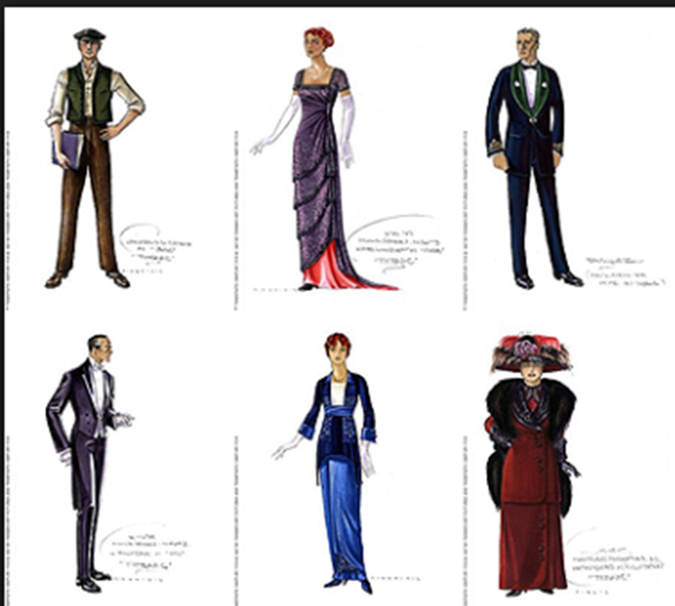

Director Jim Cameron wanted the clothes to as accurate as possible and in order to do this, a very talented and skilful costume designer would have needed to have been recruited. Costume designer Deborah Lynn Scott created beautiful Edwardian dresses for the character Rose and the intricate designs did not go unnoticed as Deborah received an Academy Award in 1998.
As displaying the clothes worn for the movie have been done before, I started to think about the ways in which I could continue to do what I had planned but add a twist. I didn’t want it to just be worn by mannequins in a glass container I wanted to add an edge as this is what I feel makes my exhibition standout the most from others.
I am grateful to this project for introducing me to some amazing work from different individuals but one of the best creator that this project has introduced me to is the works of Iris van Herpen. Herpen is a Dutch designer that created a dress piece modelled on splashing water. In collaboration with photographer Nick Knight, Herpen used the images from high speed cameras to capture black and clear water thrown at a model. The results were amazing and I wanted to attach these water splash pieces to the mannequins that some of the clothes are displayed on. It would add the water element from the story of the unsinkable ship sinking perfectly while being done in a striking way.
One designer that I knew of prior to this assignment was Hussein Chalayan. Chalayan is known for his experimental designs and he was brought to my attention a few years ago for his viral fashion show introduction in Paris fashion week in 2015 for the Spring Summer 2016 Collection Show. He started his fashion show with two ladies stood on podiums wearing simple white thigh length jackets that were showered with water from the ceiling. The jackets were actually water soluble and dissolved asway revealing his designs.

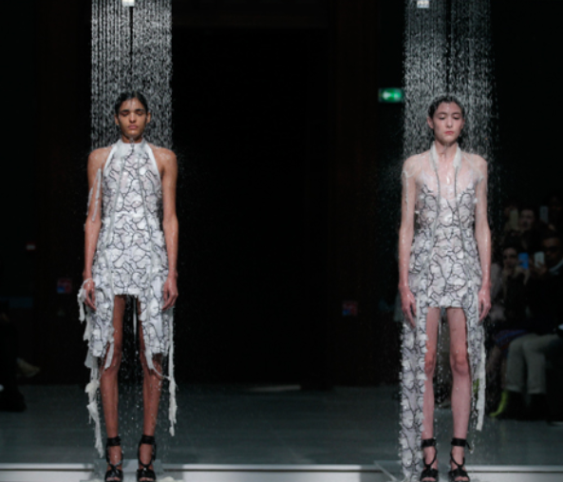
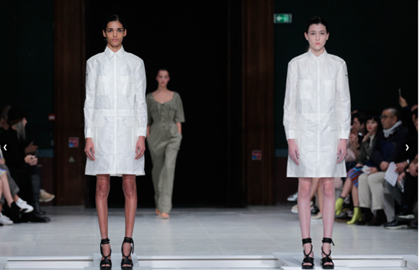
I wanted to take the idea of water showering down over some garements of clothes to my exhibition. I feel as though it would not only be vidually pleasing but as a pluviophile, a person who enjoys the sound of rain, I thought about the sounds of this exhibit piece and how it could be eqaully pleasing and is different to tohers by including more than sight but also hearing.
On the topic of having the audidence use more than just their sight, I wanted have a television screen displaying the behind the scenes footage as well as a few interviews of the cast and crew. As a film student, I am highly interested with finding out how movies are made as well as see the actors outside of their characters to see how different they are to ther genuine selves. I found a clip on youtube that would be played on loop towards the end of the of the exhbition.
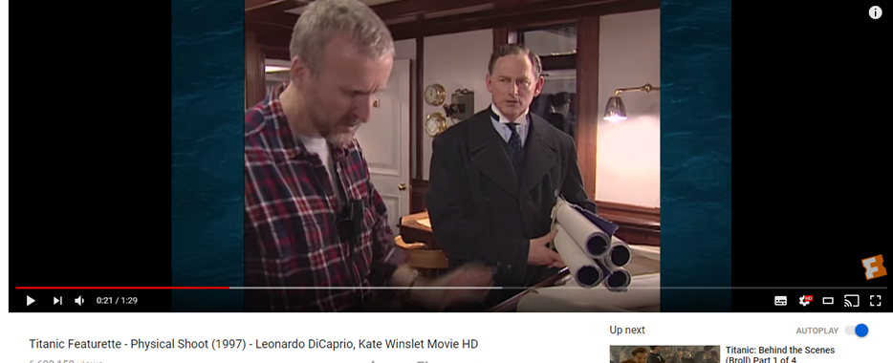
I feel as though it is important that people are introduced to what goes on behind the camera as I feel the auidence are able to see how much work is put in to create the final piece from the reaility such as prior to special effects.
For my final two pieces for my exhibitions, I refered to an artist that I truly respect. Perhaps more known for his 24 Hour Psycho video piece where he slowed down Alfred Hitchcock's famous 1960 film Psycho into a 24 hour duration, lengthening it out the horror until it is no longer suspenseful. Gordon said, “I am the one who provides the board, the pieces and the dice, but you are the one who has to play.” I was so fasinated by this piece that I wanted to do the same with the film Titanic but as it is not horror film, I wanted to do this to show more details of this intricute film that might have beeen missed prior and slow it down for that reason.
For my final piece I just wanted to stay with Gordon inspiration and create a looped clip or GIF as it refered to nowadays. The scene I wanted to choose particularly is the one where they are at the end of the boat felling as though they are soaring the sky.
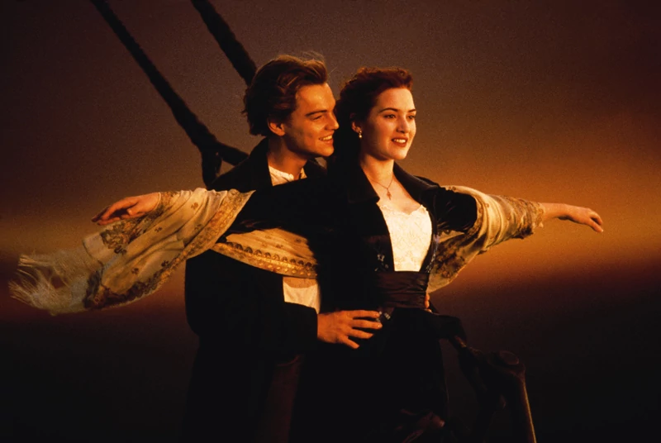

References:

Huffington Post - Titanic Sinking Anniversary (Updated Dec 06, 2017) Available at: https://www.huffingtonpost.com/entry/titanic-sinking-anniversary_n_3085121.html (Accessed: 1/5/2018)
Beatrice Wood Center for the Arts (no date) Available at: http://www.beatricewood.com/biography_3.html (Accessed at 1/5/2018)
The Titanic Store – 1st Class Diner Plate (no date) Available at: https://thetitanicstore.com/product/1st-class-dinner-plate/ (Accessed: 1/5/2018)
TITANIC' COSTUME DESIGNER ON WARDROBE DETAILS YOU MIGHT'VE MISSED FROM THE FILM (DEC 18, 2017) Available at: https://www.crfashionbook.com/culture/a14445164/titanic-costume-designer-deborah-lynn-scott/ (Accessed 1/5/2018)
Crystallisation Water Dress by Iris van Herpen (23/3/2018) Available at: https://www.dezeen.com/2013/03/23/crystallize-water-dress-by-iris-van-herpen-daphne-guinness-and-nick-knight/ (Accessed 2/5/2018)
Clothes dissolve on the catwalk during Hussein Chalayan's Spring Summer 2016 show ( 2 October 2015) Available at: https://www.dezeen.com/2015/10/02/clothes-disintegrate-on-catwalk-hussein-chalayans-spring-summer-2016-show-paris-fashion-week/ (Accessed: 2/5/2018)
Douglas Gordon Available at https://www.artsy.net/artist/douglas-gordon (Accessed at 3/5/2018)

