 | Pure Resistor | Pure Inductor | Pure Capacitor
Circuit | 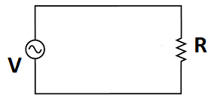 | 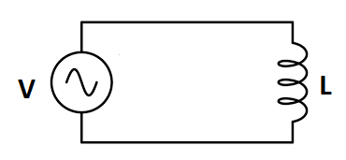 | 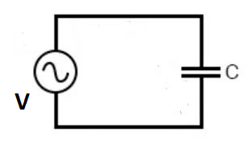
Voltage across Circuit | $$V=V_{m}sinωt$$ | $$V=V_{m}sinωt$$ | $V=V_{m}sinωt$
Current across circuit | $$I=I_{m}sinωt$$  $$I=\frac{V}{R}$$  $$I=\frac{V_{m}sinωt}{R}$$  $$I=\frac{V_{m}}{R}sinωt$$ | $$I=I_{m}sin(ωt-\frac{π}{2})$$  $$I=\frac{V_{m}}{ωL}sin(ωt-\frac{π}{2})$$ | $$I=I_{m}sin\left(ωt+\frac{π}{2}\right)$$  $$I=\frac{V_{m}}{1/{ωC}}sin\left(ωt+\frac{π}{2}\right)$$  $I=$ $\frac{V_{m}}{X_{C}}sin\left(ωt+\frac{π}{2}\right)$  $I=$ $I_{m}sin(ωt+\frac{π}{2})$  $$i=\frac{dq}{dt}$$
Peak current | $$I_{m}=\frac{V_{m}}{R}$$ | $I_{m}=\frac{V_{m}}{X_{L}}=\frac{V_{m}}{ωL}$ | $I_{m}=\frac{V_{m}}{X_{C}}=\frac{V_{m}}{1/{ωC}}$
Peak Voltage | $$V_{m}=I_{m}R$$ | $$V_{m}=I_{m}X_{L}$$ | $$V_{m}=I_{m}X_{C}$$
Phase | $$ϕ=0^{o}$$ | $$ϕ={-90}^{o}$$ | $$ϕ={+90}^{o}$$
Phasor Diagram | 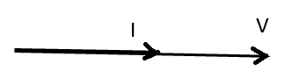 | 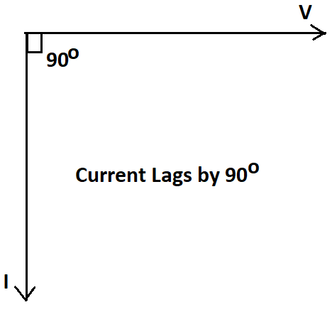 | 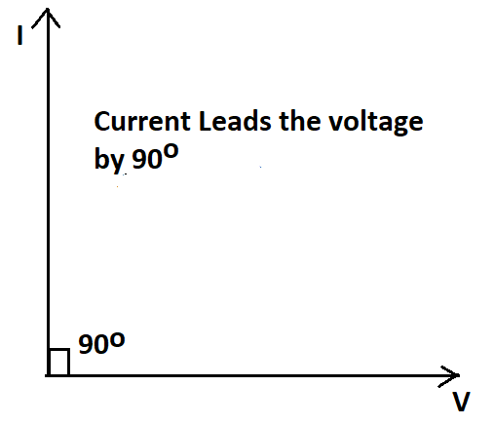
Waveform | 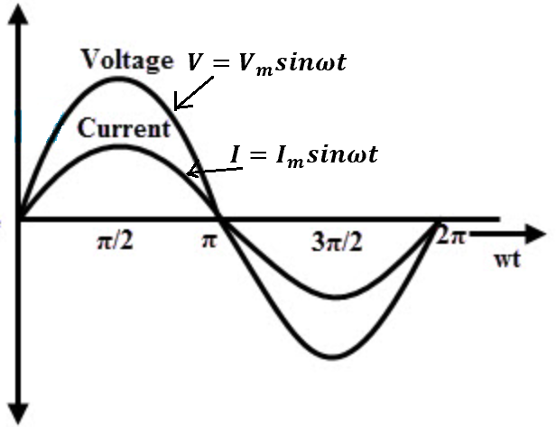 | 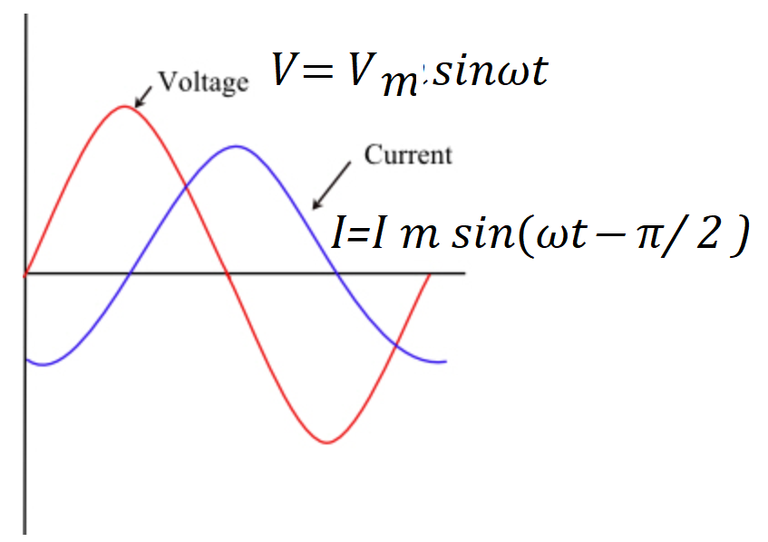 | 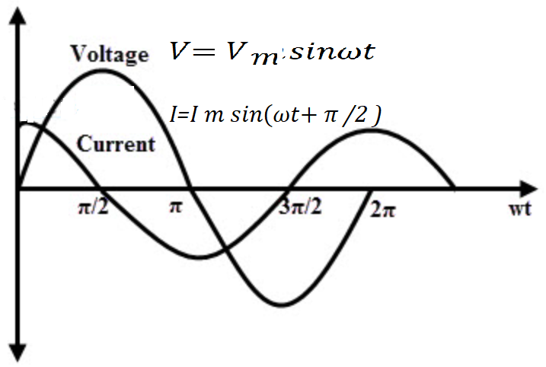
Instantaneous power | ${P=V×I=V}_{m}sinωt$× $I_{m}sinωt$  ${P=V}_{m}I_{m}\sin^{2}ωt$  If,$\text{ϴ}=ωt$  ${P=V}_{m}I_{m}\sin^{2}\text{ϴ}$ | ${P=V×I=V}_{m}sinωt$× $I_{m}sin⁡(ωt-\frac{π}{2})$  ${P=-V}_{m}I_{m}sinωt.cosωt$  $P=-\frac{V_{m}I_{m}}{2}sin2ωt$  If,$\text{ϴ}=ωt$  $P=-\frac{V_{m}I_{m}}{2}\text{sin2ϴ}$ | ${P=V×I=V}_{m}sinωt$× $I_{m}sin⁡(ωt+\frac{π}{2})$  ${P=V}_{m}I_{m}sinωt.cosωt$  $P=\frac{V_{m}I_{m}}{2}sin2ωt$  If,$\text{ϴ}=ωt$  $P=\frac{V_{m}I_{m}}{2}\text{sin2ϴ}$
Average Power | $$P_{avg}=V_{rms}I_{rms}=\frac{V_{m}}{\sqrt{2}}\frac{I_{m}}{\sqrt{2}}=\frac{V_{m}I_{m}}{2}$$ | $P_{avg}=0$ | $$P_{avg}=0$$
Power Factor | $Cosϕ=Cos0^{o}=1$ | $Cosϕ=Cos{90}^{o}=0$ | $Cosϕ=Cos{90}^{o}=0$
Impedance | $Z=\frac{V}{I}=\frac{V_{m}}{I_{m}}=R$ | $$Z=\frac{V}{I}=\frac{V_{m}}{I_{m}}=X_{L}$$  $$Z=ωL=2πfL=jX_{L}=jωL$$ | $$Z=\frac{V}{I}=\frac{V_{m}}{I_{m}}=\frac{1}{ωC}$$  $$Z{=X}_{C}=\frac{1}{2πfC}=-jX_{C}=-j\frac{1}{ωC}$$
Instantaneous Current | $I=\frac{V}{R}$ | $I=\frac{1}{L}\int{vdt}$ | $I=C\frac{dV}{dt}$
Instantaneous Voltage | $V=IR$ | $V=L\frac{di}{dt}$ | $V=\frac{1}{C}\int{Idt}$

RL, RC and RLC series circuit
 | RL Circuit | RC circuit | RLC circuit
Circuit | 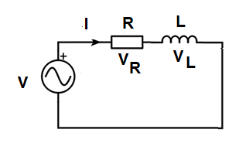 | 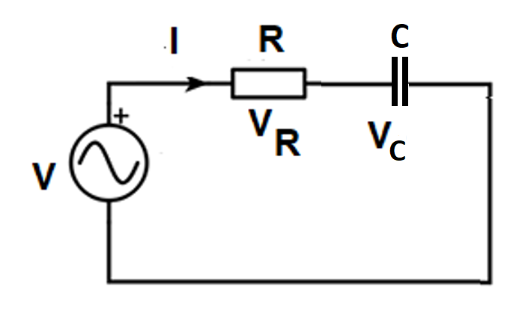 | 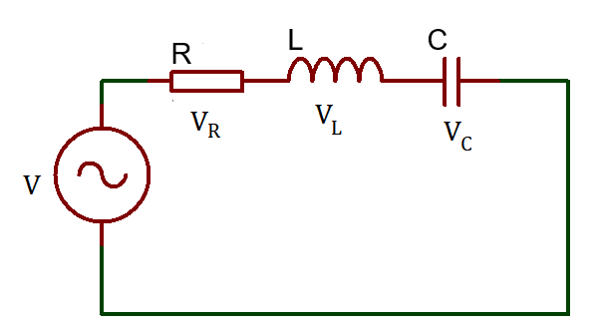
Voltage across the circuit | $$V=V_{m}sinωt$$  $V=\sqrt{{V_{R}}^{2}+{V_{L}}^{2}}$ | $V=V_{m}sinωt$  $$V=\sqrt{{V_{R}}^{2}+{V_{C}}^{2}}$$ | $$X_{L}>X_{C}$$  Voltage, $V^{2}=V_{R}^{2}+{(V_{L}-V_{C})}^{2}$  $$X_{C}>X_{L}$$  $V^{2}=V_{R}^{2}+{(V_{C}-V_{L})}^{2}$  $$X_{L}=X_{C}$$  $V_{L}=V_{C}$  $V=V_{R}$
Current across the circuit | $$I=I_{m}sin\left(ωt-ϕ\right)$$ | $$I=I_{m}sin\left(ωt+ϕ\right)$$ | $$I=I_{m}sin\left(ωt±ϕ\right)$$
Impedance | $Z=R+jX_{L}$  $Z=\sqrt{R^{2}+X_{L}^{2}}$  $Z=\frac{V}{I}$ | $Z=R-jX_{C}$  $Z=\sqrt{R^{2}+X_{C}^{2}}$  $Z=\frac{V}{I}$ | $X_{L}>X_{C}$  $$Z=\sqrt{R^{2}+{{(X}_{L}-X_{C})}^{2}}$$  $X_{C}>X_{L}$  $Z=\sqrt{R^{2}+{{(X}_{C}-X_{L})}^{2}}$  $$X_{L}=X_{C}$$  $$Z=R$$
Phasor diagram | 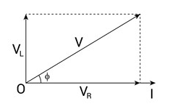 | 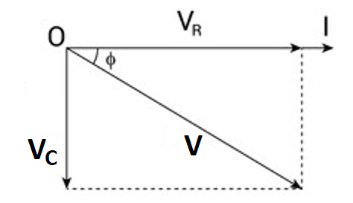 | $$X_{L}>X_{C}$$  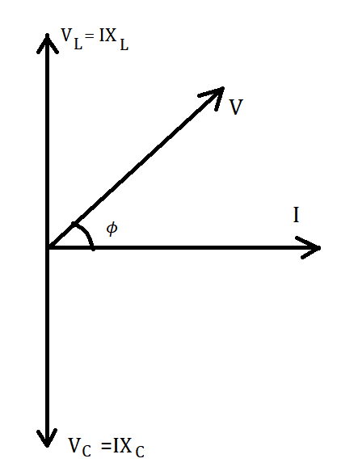  $$X_{C}>X_{L}$$  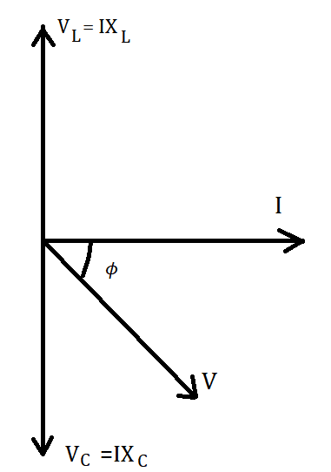  $$X_{L}=X_{C}$$  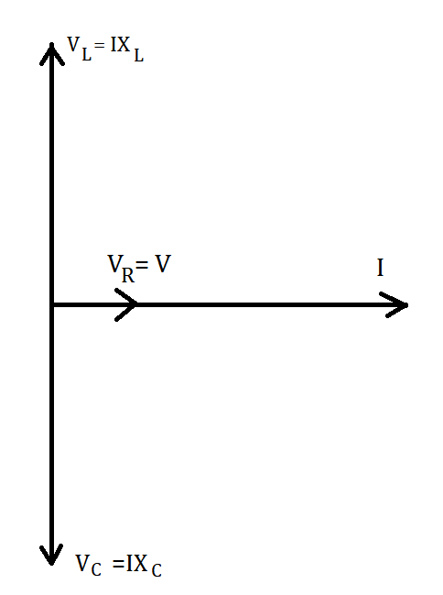
Waveform | 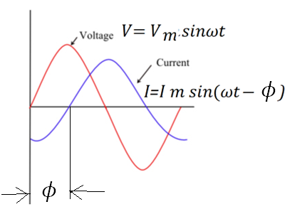 | 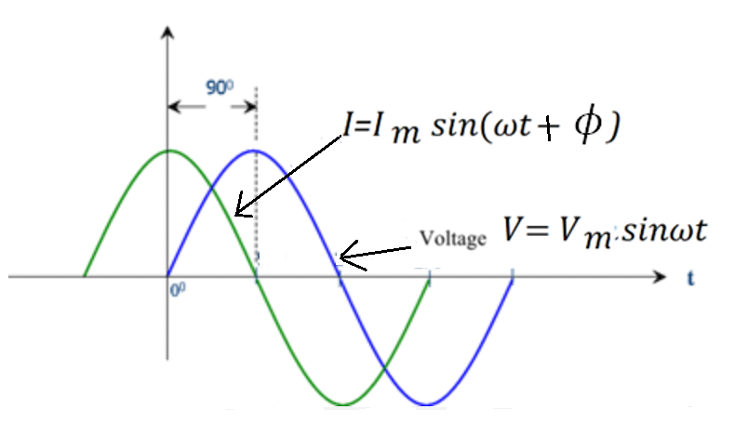
Average Power | $P_{avg}=V_{rms}I_{rms}cosϕ$  $P_{avg}=\frac{V_{m}I_{m}}{2}cosϕ$ Watt | $P_{avg}=V_{rms}I_{rms}cosϕ$  $P_{avg}=\frac{V_{m}I_{m}}{2}cosϕ$ Watt | $P_{avg}=V_{rms}I_{rms}cosϕ$  $P_{avg}=\frac{V_{m}I_{m}}{2}cosϕ$ Watt
Power Factor | $Power Factor=Cosϕ$ $=\frac{R}{Z}$ | $Power Factor=Cosϕ$ $=\frac{R}{Z}$ | $Power Factor=Cosϕ$ $=\frac{R}{Z}$
Phase Angle | $${ϕ=tan}^{-1}(\frac{X_{L}}{R})$$  $tanϕ$ $=\frac{V_{L}}{V_{R}}$  $Sinϕ$ $=\frac{X_{L}}{Z}$ | $${ϕ=tan}^{-1}(\frac{{-X}_{C}}{R})$$  $sinϕ=\frac{X_{C}}{Z}$  $tanϕ=\frac{V_{C}}{V_{R}}$ | $$X_{L}>X_{C}$$  $ϕ=\tan^{-1}(\frac{X_{L}-X_{C}}{R})$  $$X_{C}>X_{L}$$  $ϕ=\tan^{-1}(\frac{X_{C}-X_{L}}{R}$)

