MELISSA JAYNE ROBERTS
BA(HONS) SURFACE PATTERN DESIGN
UNIVERSITY OF WALES TRINITY SAINT DAVID, SWANSEA
DISSERTATION
ESSAY QUESTION-
What impact has William Morris’s wallpaper patterns had on inspiring contemporary designers, and why his legacy is significantly important to them?

TABLE OF CONTENTS-

NAME COURSE AND ESSAY QUESTION- PAGE 1

TABLE OF CONTENTS- PAGE 2

ESSAY QUESTION AND INTRODUCTION- PAGES 3-6

CHAPTER 1- The William Morris pattern and why we idolize his Legacy- PAGES 7-18

CHAPTER 2- How contemporary designers have taken forward Morris’s ideology? PAGES 19-28

CONCLUSION- PAGES 29-32

BIBLIOGRAPHY- PAGES 33-38

DISSERTATION QUESTION-
What impact has William Morris’s wallpaper patterns had on inspiring contemporary designers, and why his legacy is significantly important to them?

INTRODUCTION-

Being strongly influenced by interior design, and how we create patterns to fill our home with beauty. A well-known designer William Morris is someone who has always inspired me, especially focusing on his wallpaper designs in particular. He as a designer gives young designers so much inspiration to keep designing for the future. We look up to him as he has a very powerful, legacy behind him. I have been engaged to look further into his personal life, and what actually made him become so popular in the world on interior design.
My first chapter will be focusing on his legacy in particular, and what he has done that has made him so renown for interior design, how the impact of the arts and crafts movement has changed people’s opinion on designing. Taking into consideration how machinery printed designs, made a huge impact on mass-production and effected William Morris’s work, positively and negatively. Karl Marx is a theorist that I will be researching, and his beliefs on consumerism and mass-production, this will all then be relate back to how William Morris’s philosophy on quality before quantity. I want to find out exactly how? and why? Morris believed in wanting to create everything by hand, what inspired him to do so?.
In the second chapter, I will be introducing contemporary designers and how they credit William Morris for his work. I will be looking at how designers like Linda Florence, interpret patterns from William’s work and manipulates them to create new, edgy wallpaper designs, which are made using a diverse range, of mixed media from both traditional and new techniques. I will take into consideration how her work has a concept behind it, and also critically analyse, how her work is very bespoke, and not mass-produced, and why we have been adapted to designing one-off products. It makes us think about William Morris’s opinion on designing, how his legacy lives on through his work and how it has made an impact on designers back then and now.
Other contemporary designers who strongly influence me and I want to be discussing is designers like, Christopher Pearson and his Thermo chromic wallpaper, this technique, which has been newly introduced to us, and how it has made a huge impression, that we want to interact with it. I will look at a specific wallpaper design that grows with temperature change. How the idea of patterns are taken from William’s designs coming to life and that idea of why he thinks that “patterns to be a ‘visible symbol’ of nature” (Thompson, P 1993). Being strongly inspired by the book ‘the yellow wallpaper’, which is a story about a woman with an illness, and she describes how things come to life in her home. Especially, describing the movement in her wallpaper. Therefore, This would make a good reference for that idea of patterned, interactive wallpaper and someone describing exactly what it feels like.
Jessica Hemmings, not so pretty wallpaper is an article, which will also be introduced in this essay. An author that speaks out about different wallpaper designers and an interesting exhibition called “flock ‘n’roll” (Hemmings, J (2005). Which is an exhibition that invites people to take part in a design process and interact with the wallpaper, this ideology of using that idea of movement to create different forms and shaped patterns. I will relate this back to Morris’s pattern composition, which is also very interactive and also the philosophy behind his work. Morris has influenced people to engage with wallpapers, specifically, because of his floral motifs and how they flow and have movement.
To complete chapter two my studying will involve looking at the designers Timorous Beasties, who are a very popular interior design company who mass-produce wallpapers all over the world. Timorous Beasties did a collaboration taking elements from Morris’s work to create a fun, bright, and colourful wallpaper designs. The collection of wallpapers, have been described as “William Morris on acid” (Hemmings, J 2005). Which has really inspired me to look further into how the design processes are very different compared to the traditional printing techniques, asking myself the question, What would have William Morris thought about the new contemporary work today?, As it is going against his desire for handmade interiors.
From the research I intent to study, I want to find out exactly why William Morris’s patterns were so popular and how we still hugely admire them today. What was his legacy?, and why it has been such an important matter for interior designers of today.

CHAPTER 1-
The William Morris pattern and why we idolize his Legacy.

“Have nothing in your house that you do not know to be useful or believe to be beautiful”. (Waggoner, D. 2003)
This implies irony in the sense that William’s interior patterns are beautiful in every way. If it was not for his work and his philosophy we might not have had beautiful interiors then, and today.
His philosophy is being emphasised in this quote, “He looked to the past as inspiration for the present and for the future, and he discovered deep fulfilment in the daily work of craftsmanship and creation” (Waggoner, D 2003) We are inspired by his passion of craftsmanship, and his views on the arts and crafts movement. William Morris was a designer that believed that all art should be created by hand, as unique products are not mass-produced. Creating hand printed patterns, makes the functionality of them become precious and appreciate them more.

His ideas of creating a beautiful atmosphere in a home, inspires us all. The work that William created was, a beauty in itself. Floral and foliaged are often expressed as being lively and beautiful. He described his work as being “the embodiment of dreams in one form or another” (Naylor, G 1996) His strong philosophy is reflected here, this assumes that his patterns are something that we want, and need in our lives. He makes us think about nature, as being something that is vital to have inside the home.

His concept of bringing the organic patterns into an interior, creates not just a decorative sense but also feels as though his work comes to life inside. Almost like his patterns are growing through the walls. As described in the beauty of life book, his patterns are said to “poke or burst through” (Waggoner, D 2003) It highlights that idea of foliage growing on top of each other in all different directions, and seeing them form in natural arrangements. This creates a perception of energy and movement.
The word burst is an effective word, which engrosses us, we know that some of William’s patterns stand out boldly from the rest of the patterns, His structure and composition emphasises it could be a 3D design, which suggests elements of his work could be bursting through the surface.

This quote in particular strongly influences artists and designers “The need for ‘art’ within the home” (Hoskins, L. 2005).
Today, most homes either have wallpaper, or some sort of art decoration for interiors. William Morris is someone that we majorly honour, because of this philosophy, as he is emphasising that it is a necessity, that everyone must have. This quote has been taken forward by artists and designers of today, and is one of the reasons why we have so much gratification for William Morris.
We as designers understand how this expression needs to be applied when we are designing, he is almost dictating that art isn’t something that should be discontinued, and should always be there. It makes us think about why art was so important to William Morris? And how his philosophy keeps on inspiring us?. It engages contemporary designers to keep designing and creating new art. We credit William Morris for his legacy, which he has inspired us.

As emphasised in the papered wallpaper book, “Morris’s work represents something of a compromise between the extreme realism of pre-reformed floral patterns and more formalized designs.” (Hoskins, L. 2005 ) This specifically reveals, how William Morris uses the representation of naturalism. His work is inspired by natural forms but sometimes his work doesn’t look as structured or realistic as we may perceive them or how we expect it should look like. We recognize him for his distinctive style, his rich colours and mixed textures. That is what makes William Morris’s work so unique. He has a particular style that is of importance to us, because if we didn’t have inspiration there would be no designing.

The Victoria and Albert museum in London have an exhibition of Morris’s wallpaper designs. His name still remains a big part of the art and design world. Having to see his work first hand, gives much more of an authentic feel. It allows you to see original art work close up and empowers you to interact with it.
His passion for nature reflects strongly in his work, and as mentioned “Anything made by hand ‘must be either beautiful or ugly; beautiful if it is in accord nature, and helps her; ugly if it is discordant with nature” (Thompson, P 1993). His philosophy is being revealed in this quote. He almost emphasises that all art should involve nature of some sort as it is something which is highly desired. Floral and foliage is something, which is still very popular today, but it is getting slightly repetitive. We take a lot of credit from William Morris because of his concept, like mentioned previously, of trying to create the atmosphere of bringing the outside inside, which almost gives a sense of freedom. As stated in the book “He became one of the most respected art historians of his generation” (V&A. (2009) V&A pattern William Morris, London). This continues, to be a very powerful representation of William Morris, as his craftsmanship is sustained. We still respect him for his work now, his dominance has given us so much potential to design and develop work. His opinions on the arts and crafts movement, gives us the urge to want to draw all art by hand, it’s a way of us expressing our thoughts and feelings in a more creative sense.

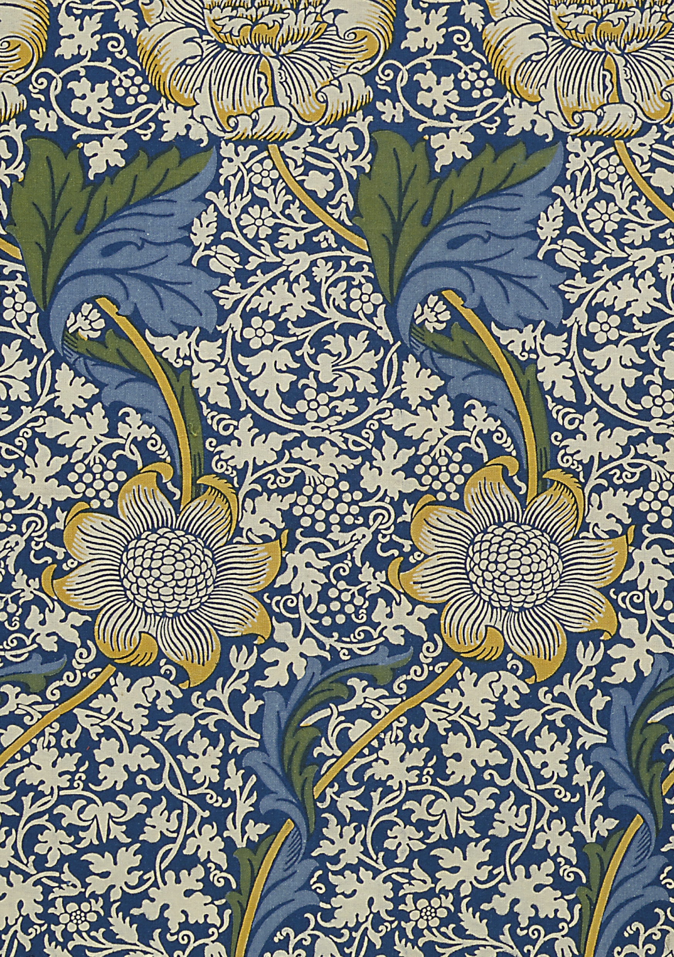

Image 1- Kennet textile V&A (2009). V&A Pattern William Morris. First edn. [CD-ROM]. South Kensington, London: V&A publishing.

This beautiful design is from the V&A pattern book, it is a great example of William Morris’s designs being brought to life. The layered patterns look as though they are floating, and this engages us. It makes us want to interact with it. As his work is being described in a book, “combination of fluid lines of nature with the rigid two dimensional demands of wallpaper patterns” (Well, 1996, 17). This quote gives a good portrayal of how we perceive this design, it emphasises how his work is flowing, and almost has a rhythm that we are immediately fascinated by. Going back to his patterns being previously described as bursting through, this image really defines and clarifies how his patterns feel as though they are coming out from the surface, and the juxtaposition of his large motifs feel as though they are exploding into small patterns fragments which surround them.

His use of rich colours and hand-finished surfaces form textured and risen surface where as today, most wallpapers are digitally printed, which look as though they are flat and the colours are stronger and more blocked, but don’t have that hand finished desire.

The majority of William’s work had been block printed back in the 1800’s. Block printing was a technique, which consisted on carving a desired design from wood or rubber and then printing with it. In William Morris’s case, using natural dyes. His work was all about discovering new things and being extremely creative with his work. An unintended but a successful process, “natural dyes which faded evenly and aged beautifully” (https://www.william-morris.co.uk/shop/fabric/) This reveals that the old natural colour creates a new contemporary design, it may have suggested that this was not desirable but we still admire him for his singularity and he achieved things which were not necessarily expected. As mentioned in the V&A book, “His research developed into an unusual depth of knowledge and, as a result, he become one of the most respected art historians of his generation” (V&A ,2009)
His philosophy for traditional printing techniques gives us, so much admiration as he was so committed and enthusiastic about making sure things were created in a certain way. We idolize him for his energy and drive, we want to work like him and be able to produce work, which is as successful as his.

As I just mentioned, William Morris was a very traditional designer who particularly liked the concept of using traditional techniques, to create his wallpaper patterns. He believed that “One must suppose that beauty is a marketable quality and that the better the work is all around, as works of art in its technique, the most likely it is to find favour with the public”. (Parry and Morris 2009, pre-face). This suggests how he believed that hand printed designs are the best, the most effective and most definitely the more successful. It emphasised how people prefer the idea of quality hand produced products that are original, and have had a lot more time spend them, rather than something, which has been machine produced, there’s no skill involved. We as designers, have more control of what we make by hand and we all have a particular style that is always different. People like the idea of being unique, and that is what designers of today are trying to achieve, to attract the contemporary market.

Karl Marx a theorist also back in the 1800’s, he had a strong perception on consumerism, which is very relevant and relates to William Morris’s concept on designing. Karl believed that ‘The labor process was divided into separate tasks, laborers became estranged from the products of their labor, destroying the pride in craftsmanship they had experienced in the artisan system” (http://science.jrank.org/pages/8818/Consumerism-Consumerism-Mass-Production.html) This quote strongly emphasises how that idea of digital is taking over the handmade. The word destroying is a very powerful word, and it summarizes how tradition was slowly being taken away, and how people are being mislead by the real meaning of art.
William Morris believed that we should not own products that haven’t been made through the true quality of craftsmanship.
As said in the book of arts and crafts movement “mechanical ‘progress’ in terms of human misery and degradation” ( Naylor, G. 1980) . This point gives a forceful explanation on how much of an impact machinery had, and that it almost destroyed, what the skill of hand produced artwork. It makes us think if we did not have machinery to create wallpaper, would all of our wallpapers be hand printed/ block printed today?, We love William Morris because his work was being so successful, we honour him for his skill and hand printed quality, which we rarely see as much today.
As William Morris said, he “hated the proliferation of cheap shoddy goods turned out by acute divisions of labour, whether by machine or by hand.” (Waggoner, D & Kirkham, P 2003) . William Morris had spent years on creating things by hand and finding out new processes, which were all environmentally friendly. Bringing in machinery to create new art must have felt very despairing considering all the effort he had made researching and designing.
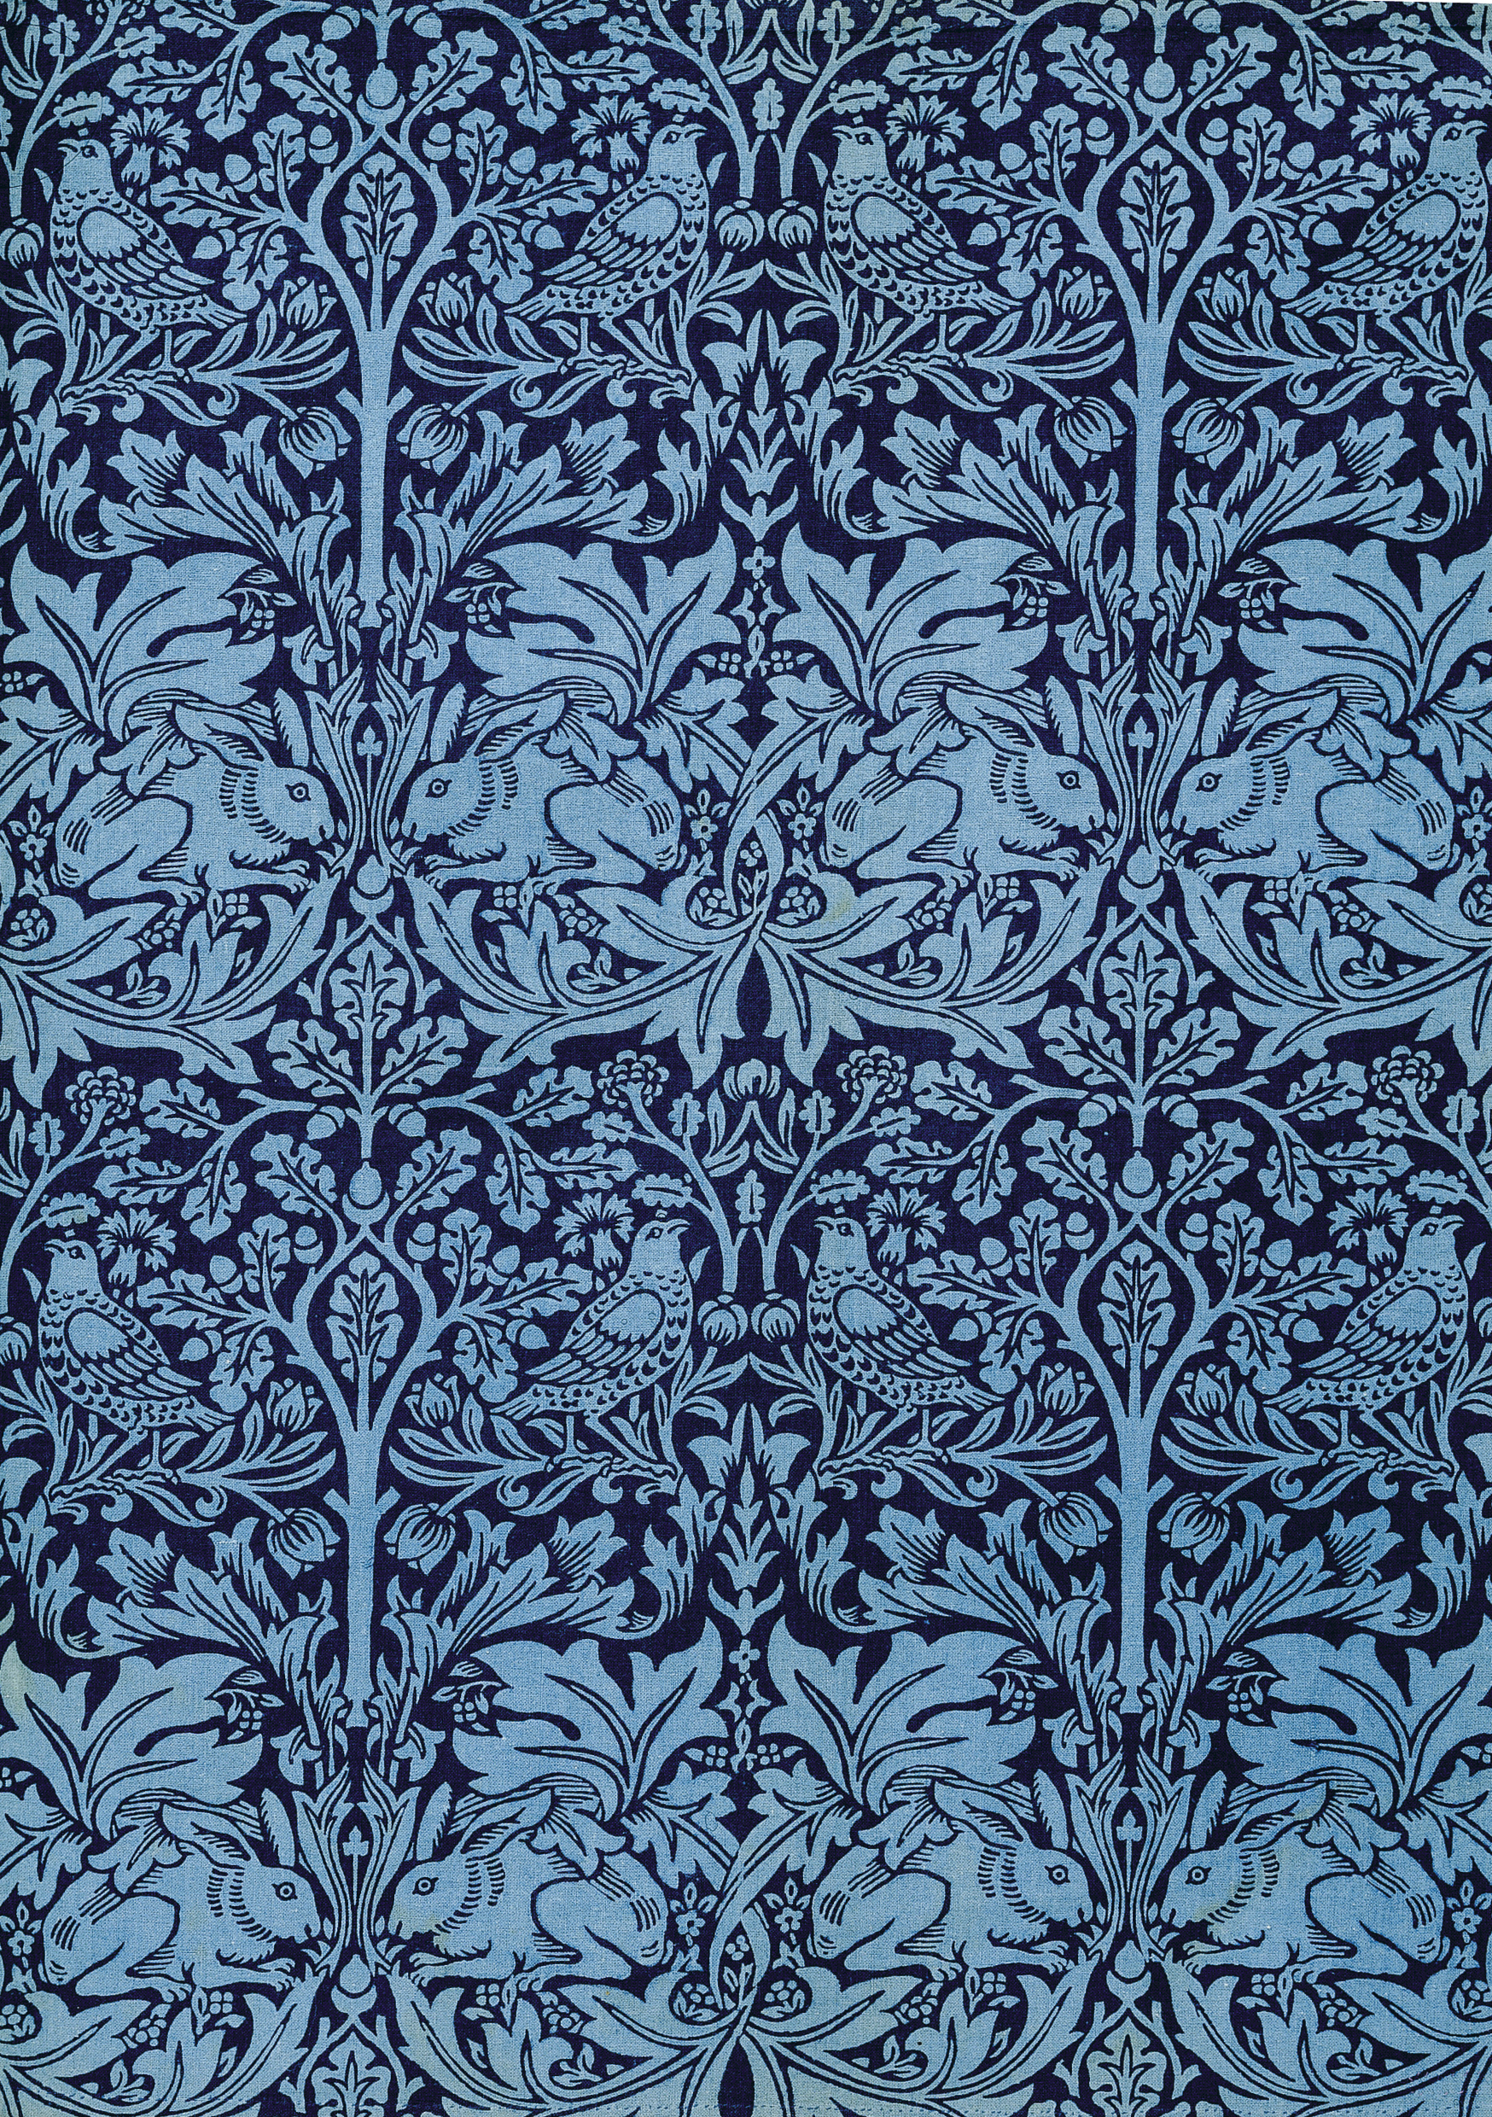

Image 2- (Brother Rabbit textile. V&A (2009). V&A Pattern William Morris. First edn. [CD-ROM]. South Kensington, London: V&A publishing.)

This design in particular stands out a lot from the rest of Morris’s work. His use of two-toned blue shades gives a flavourful contrast and strongly reflects on his use of juxtaposition. This design is very symmetrical, its mirror-imaged design makes the wallpaper look well-structured. An immensely detailed design like this has taken a lot of time to achieve and this is why we understand how much craftsmanship has gone into this, and why we are inspired to work in a similar way. As I mentioned previously, we respect him for his drawing skills and how he prefers to do everything by hand.

Contemporary designers are attempting to create new innovative designs, inspired by William’s pattern designs. Because his work is known to be so popular and he has a distinctive style to his pattern making. New designers want use similar patterns but in a more contemporary way that will attract the new generation.

As Mentioned in an article. “Elements of the Morris pattern” (http://www.contemporaryartsociety.org/artist-members/david-mabb/). The words Morris pattern emphasise that we know exactly what is being implied, we as designers recognize his style, so we automatically know exactly what to visualize when someone speaks of his name. William Morris is an extremely powerful name and when, it is mentioned by contemporary designers, we immediately get inspired and his legacy is still living on through his pattern designs.

David Mabb is a contemporary designer that interprets parts of William Morris’s patterns throughout his work.
As mentioned in the Kitsch’s archive, it is emphasised how we are becoming inundated with William Morris. He believed that because his work has become so popular over the years, that some people just feel as though, there needs to be something different about Morris’s work that would now to suit the more contemporary home. I disagree with this, we pay a lot of money to own something, which has been produced by Morris, his name is so big that we still encouraged to purchase his work. Most people desire to want top designer work in our homes, but his work is aimed at the higher end market.

Designers like David Mabb are “influenced by Morris but where a Morris design is not identifiable”. (Mabb,D. (2009). Textile: The journal of cloth & culture. Vol. 7 issue 3, p314-327, 14p). This highlights how we recognize his work, and it is almost like his patterns reveal his identity. It implies how his patterns are timeless, everlasting and how they can simply be re-formed into new contemporary patterns.
Contemporary designers value the work of famous designers, we all take inspiration and interpret them in different ways to produce new invigorating patterns. We love to see how work changes over time, and how designers of the future aspire to have a legacy for themselves just like William Morris.

CHAPTER 2-
How contemporary designers have taken forward Morris’s ideology?

Wallpaper designer Linda Florence, strongly influenced by Morris’s wallpaper patterns, interprets his work very visually and conceptually. As stated in an interview with Linda Florence “I try to mix different scales together with large space invaders layers with Morris inspired damask patterns and small maps” (Steed, J & Stevenson, F, 2012). This emphasises how she attempts to manipulate his patterns into a unique, new contemporary style. The word damask really highlights that idea of something being hidden, and slightly revealed.

This image from the ultimate wallpaper guide is a perfect example of how Linda explains her work. She uses a digitally printed design, which is very contemporary, and then almost transforms it into a traditional feel by using screen-printing, with designs inspired by William Morris. She uses motifs from his curled leaf pattern, which is how he is well known. When she uses the idea of layering in her work, it makes it look very reflective, ironic in the way that she is using motifs and printing processes from the past.

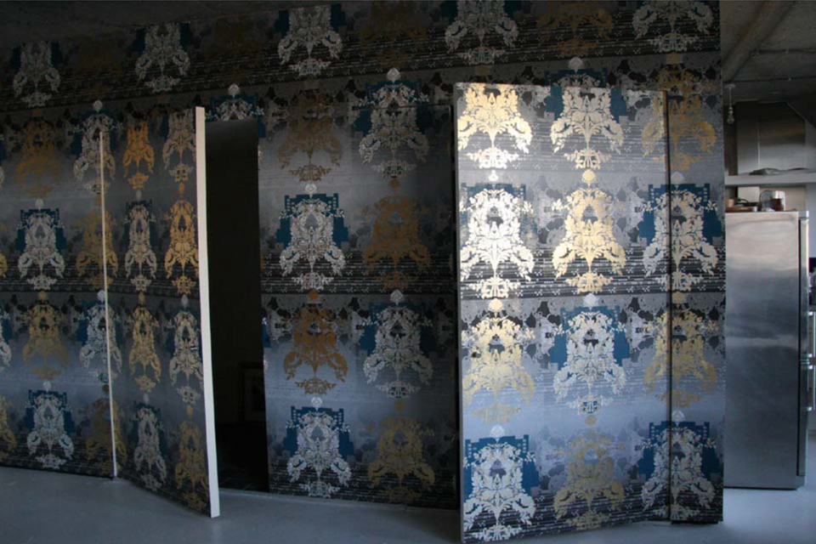

Image 3-
“Touch me exhibition” Linda Florence (2005)
http://www.lindaflorence.co.uk/wallpapers-and-lighting.html

Her work is very complex, and has detailed motifs. Her textured metallic foil sits on the surface and has a raised effect, which makes us want to interact with it. It makes her work look as though it is floating and it makes a design much more playful and attractive. The concept of interactive wallpaper has come from William Morris and how his patterns flow through the walls.
Linda’s patterns are often described as “growing in complexity” (Blackley, L 2006). The term growing emphasises how it is coming to life, almost how William Morris’s patterns are brought to life by his style of “intertwining” patterns and his “curvilinear lines” (Hoskins, L 2005).
As a designer, I am particularly interested in Linda Florence’s concept. That idea of creating the old and the new. She uses a combination of processes from a digitally printed layers and then a screen-printed layer on the top. Her screen-printed patterns look as though they are floating on the surface giving a 3D effect that makes us want to interact with it. As Linda mentions her patterns “build up in different ways and layers” (Blackley, L 2006) We see similarities in William Morris’s work, the idea of layering and combining patterns. Their composition of mirror imaged, floral patterns are very identical.

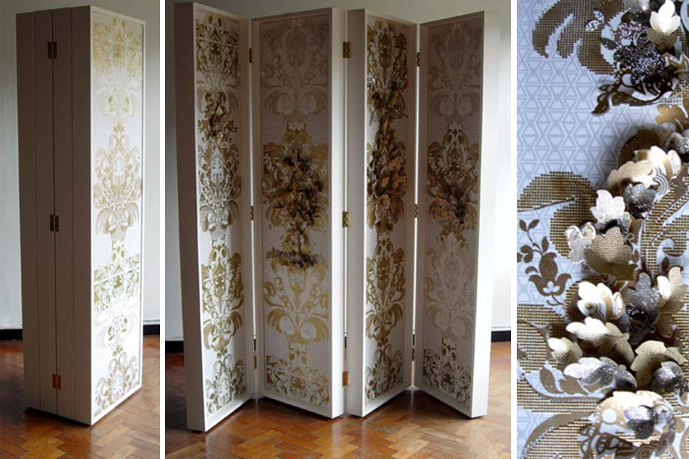

Image 4-
Linda Florence Swarovski crystal and gold studs. (2016)
http://www.lindaflorence.co.uk/wallpapers-and-lighting.html

This design by Linda Florence was commissioned for a Swarovski exhibition. This is such a beautiful design, which was inspired by William Morris’s curly leaf patterns. Being particularly inspired by her 3D forms which are raised from the surface. Almost like a growing flower, which has fully opened. Her screens have been screen-printed first, and then worked into by hand with crystals and offcuts. Linda has taken William Morris’s ideas further, and has created something, which attracts people with its shiny reflective surface. It feels as though it’s growing up the wall, like the walls are coming to life.
We see this idea in contemporary designer Christopher Pearson’s wallpaper designs. His work is all about being environmentally sensitive, and how a design changes with a change of temperature, and UV exposure.
As mentioned, the design looks as though it is “delicately animated” (Blackley, L 2006) It looks as though the walls are coming alive and as though they are emulating nature. How they naturally form upwards into different shapes and movements, the idea being hidden and revealed like reflected in Linda Florence’s work, it emphasises a very playful concept. His work is also described as being very “unpredictable” (Blackley, L 2006). This suggests how we are unsure of what is expected to happen, we are in the unknown. It engages us because, it sounds interesting, and we don’t actually know what different patterns, it is going to create. Having wallpaper designs like this, brings distinctiveness to contemporary art. People want to see change and different things happening to interiors. We are engaged by the idea of interactive wallpapers, and this concept is much more visually appealing and easy on the eye.
As mentioned in an online journal, “Pearson also used the Morris pattern in his digital wallpaper “ (Sinclair, M 2006). Personally, his working concept is taking designs from William Morris, and the idea of it changing with heat temperature, and growing up the walls is almost like a reference of time. As though the patterns are evolving, like William has started it and it continues to grow and change over time. This is irony in the sense that this is where all of the designs have started from and over time they are gradually been evolving and William Morris’s philosophy and legacy lives on throughout his work.

Below is a series of images, which shows what changes are made when the wallpaper is exposed to UV light. It gradually increases with the more exposure that is placed on it. It almost develops and blooms into extreme detail, which is virtually like formations of trees growing and flowing with the wind.
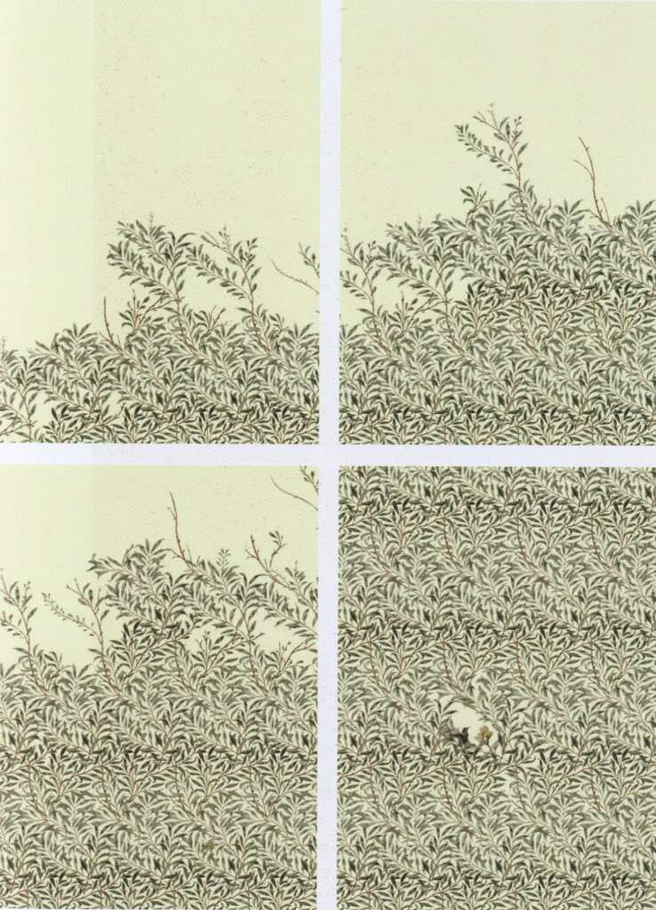

Image 5- Christopher Pearson, wallpaper installation, Royal college of art. (2005) (https://nnnancymitchell.wordpress.com/2011/03/25/digital-wallpaper/)

The yellow wallpaper book by Charlotte Perkins Gilman was a very interesting read, and this relates in a way when it comes to how we interact with wallpapers. It talks about a woman who suffers from a mental illness and how everything comes to life in her house. Being strongly inspired by her descriptions of her wallpapers and how she says that, “there are things in that paper that nobody knows but me, or ever will.” (Gillman, P, C 2011) It’s almost like how we all have different opinions on wallpaper designs, and how we perceive different things. Almost similar to how contemporary designers take inspiration from William Morris’s work and interpret his work in different style. She describes how things are growing up the wall, “there are always new shoots on the fungus” “I cannot count them, though I have tried conscientiously” (Gillman, P, C 2011) it’s something, which is continuous and keeps growing and changing. This relates back to Christopher Pearson’s work and how his William Morris inspired patterns transform with heat. The yellow wallpaper describes how a person is interacting with a wallpaper, it’s like how we as the audience, want to have the satisfaction of interacting with William Morris’s wallpaper designs as we know how special, and unique they are.
Looking at how we are made to interact with wallpaper patterns, Flock and roll is a company that “invites consumers to take part in the design process” This is very intriguing as it allows people to get a feel for what designers are offering. It is said that it is an “opportunity for self-expression, creativity and fun” ( Hemmings, J 2005) This is exactly what people expect from interactive wallpapers. William Morris’s interactive wallpaper have a different concept in the way that we can’t physically touch it but we can see it and our imagination explores what he is trying to propose.

This quote is very influential “colour and pattern can do much to trick the eye and enhance the sense of three dimensionality” (Hemmings, J 2005) this quote by Jessica Hemmings emphasises how we all perceive things differently, and how different colours can make our brains think that we are seeing something else. Popular designers Timorous beasties created a wallpaper design that was said to have been, “William Morris on acid” (Hemmings, J 2005). This design is one of the most inspiring William Morris design re-imagined.
This work is so bold, bright and vibrant, exactly what it’s trying to emphasise in the quote. It’s very different to what we would expect it to look like. This collaboration was made using digitally printed design, which would have been William Morris’s worse apprehension, but it has turned out to be very successful and very popular. These patterns are layered and give that sense of hovering the surface. It makes us want to feel the design as it looks very lively and realistic.

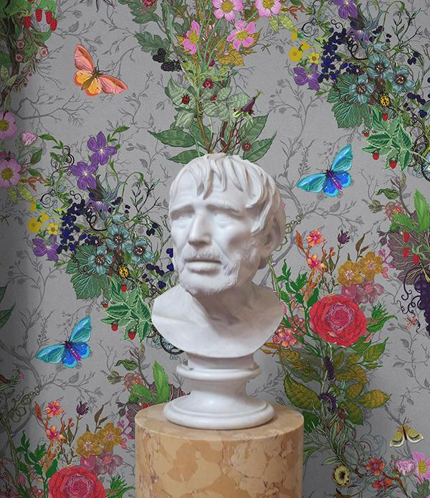
Image 6- Timorous Beasties
(https://www.selvedge.org/blogs/selvedge/timorous-beasties-in-debt-to-william-morris)
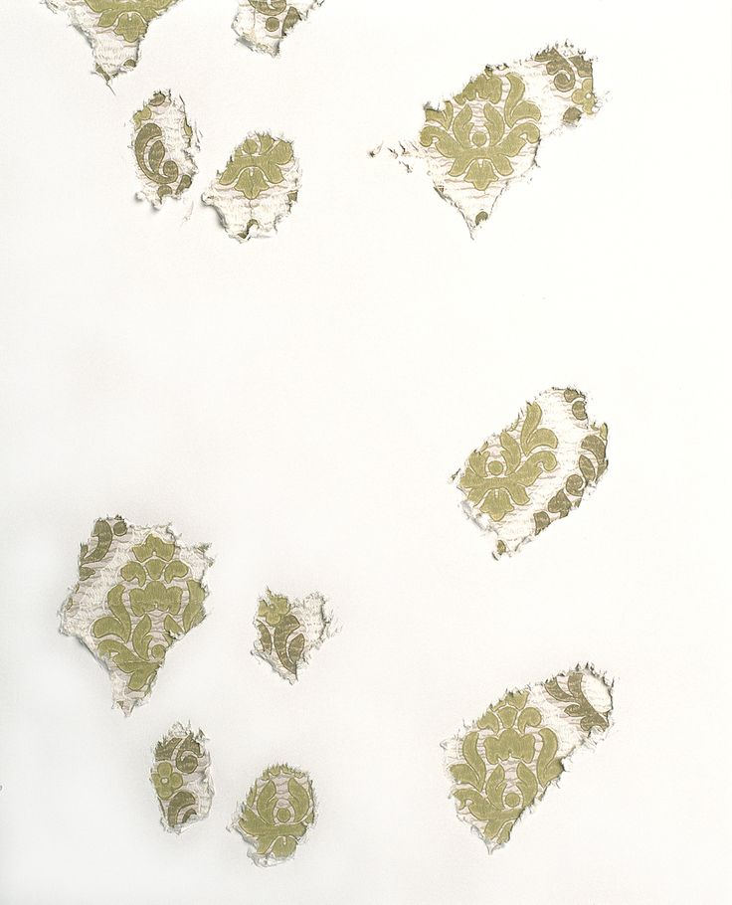

Image 7- (Blackley, L 2006)
The concept behind this wallpaper design is truly inspiring, It was created by four graduates. Another unintended wallpaper design, which has become extremely popular. This design was gnawed by a rat and created patterns, which were unintended. This natural idea of layering patterns, being hidden and revealed.
The background layered wallpaper patterns were originally inspired by William Morris’s work. This idea is pealing back and revealing the past and creating a new contemporary style. Some of us see this design as something tedious and has not got a create edge, but actually it has a lot more meaning behind it.
Going back to the quote about how we perceive things differently, the colours in this image are very bold and rich and it does make the wallpaper look as though it has a 3dimentionality.

CONCLUSION-

As a final conclusion for this dissertation, William Morris’s legacy has been a large part of inspiring myself, and after researching that he has also inspired many contemporary designers. We ask the question why contemporary designers find William Morris’s legacy significantly inspiring? Well, his opinions and quotes have lived on through his work, and this is why we honour him so much. The arts and crafts movement, made a huge impact on how we see him as a designer. As his work was all environmentally friendly, and the way he worked really had a uniqueness, which has inspired us to want to work like him.
Going back to the arts and crafts movement and William Morris’s views on mass- produced wallpapers. We love his views on quality, before quantity and made it clear that art should always be hand made, and not machine produced.
We respect William Morris for saying that it is a necessity to have art in our homes. If it was not for his work making a huge impact in interiors maybe we would have any of it today. His style in particular is very distinctive, and this is how we recognize his name from his patterns. He has so much love for nature and natural form and we can see his passion being revealed throughout his work.
Throughout this essay, I have discussed a lot about interactive wallpaper designs and why we have the desire to want to interact with them. What impact has Morris’s patterns had on contemporary designers?. All of William Morris’s pattern’s are very flowing and have a rhythm to them, as I mentioned which makes them look as though they have movement. His composition is extremely detailed, and we know that his designs, had taken along time to produce, we credit him for this.
Morris’s legacy lives on throughout the archives in the V&A museum. People from all over the world visit the museum every year and sometimes only go to see a particular piece of art. William Morris’s original work is there so people love to see his work first hand. His name is never forgotten and he is always going to be a huge interior icon, for the future ahead.
After looking at designers like David Mabb who takes elements from Morris’s work it is his philosophy that had inspired David to design in a particular way. He believed that we needed change, something different away from William’s original work. He believed that we were seeing too much of it and people were getting fed up. I disagreed with his statement as I believe that you can not change its originality, he’s always been known for designing in a style that we all recognize. His social philosophy has made such an impact over the years that it’s never going to be unrecognized.
The fact that Morris had used all traditional and natural techniques to make his work has made us love him even more. We know that he wanted to work in an environmentally friendly manor, so this had made a big impression on people opinions when taking inspiration from his work. Therefore this shows that he was very experimental and imaginative so we look up to him as a role model.
Going back to the arts and crafts movement and how William Morris has fused the idea inspired many of the contemporary designers to design in a similar way, bespoke and one-off products.
Karl Marx a theorist who I looked and his theory on consumerism. I felt as though he was relevant to look at because of his strong opinions on how technology is taking over the man-made, William Morris’s thoughts on this were very negative because of these changes, as he believed that everything should be hand made. We idolized his social philosophy about this, and I think that this is one of the main reasons why we still like work with hand printed processes today. The contemporary designers that I have researched continue to use a combinations on digital and hand printed processes which are sold at high prices as they are very bespoke and they’ve been considered and well thought about before, they are sold to the higher end market.
All of the contemporary designers that I have looked at are inspired by William Morris’s theory of creating one-off products, which are made to order. They all design for the high-end market, which was Morris’s target market back in the 1800’s.
William Morris will always be a well known designer and his legacy will continue through his inspiring quotes and his beautiful art work.

5349 WORDS

BIBLIOGRAPHY-

BOOKS-
(Waggoner, D. (2003) The beauty of life: William Morris & The art of design. UK: Thames & Hudson)

(Hoskins, L. (2005) The papered wall: The history, patterns and techniques of wallpaper. London : Thames & Hudson ltd.

(Hoskins, L. (2005) The papered wall: The history, patterns and techniques of wallpaper. London : Thames & Hudson ltd. )

(V&A. (2009) V&A pattern William Morris, London)

(V&A. (2009) V&A pattern William Morris, London) INTRODUCTION

(Thompson, P (1993) The work of William Morris: Oxford ; Oxford university press) PG 236.

(WELL. N, M (1996). The life, times & work of the world’s greatest artists. William Morris. UK : Blockhamption Press.)

(Parry, L & Morris, W (2009). V&A Patterns William Morris. South Kensington, London: V&A publishing)

(Naylor, G (1980) The arts and crafts movement, Great Britain : studio vista)

(Naylor, G (1996) William Morris by himself: designs and writings, great Britain: Little, Brown and company)

(Steed, J & Stevenson, F (2012) Basics textile design 01 : Sourcing ideas : Ava publishing SA)

(Blackley, L (2006) Wallpaper, London: Laurence King publishing LTD) 58-59

(Blackley, L (2006) Wallpaper, London: Laurence King publishing LTD) PG, 58-59

(Waggoner, D & & Kirkham, P (2003) The beauty of life: William Morris & The art of design. UK: Thames & Hudson)

(Blackley, L (2006) Wallpaper, London: Laurence King publishing LTD) PG 109-111

(Thompson, P. (1993) The work of William Morris: Oxford: Oxford university press).

(Blackley, L (2006) Wallpaper, London: Laurence King publishing LTD) PG 109-111

(Gilman, C, P. (2011) The yellow wallpaper, UK: Simon&Brown)

(Abrahams, C. (2009). The ultimate guide wallpaper, London: Quadrille publishing ltd)

INTERNET-

(http://www.morrissociety.org/about/WilliamMorrisSocietyUSBrochure.pdf)

(http://www.contemporaryartsociety.org/artist-members/david-mabb/)

http://science.jrank.org/pages/8818/Consumerism-Consumerism-Mass-Production.html

(https://www.william-morris.co.uk/shop/fabric/)

ARTICLES-

(Mabb,D. (2009). Textile: The journal of cloth & culture. Vol. 7 issue 3, p314-327, 14p)

(Sinclair, M (2006). Flock it. Vol. 26 issue 10, p34)

(Hemmings, J. (2005). Fiberarts 32 no 3)

(Hemmings, J. (2005). Fiberarts 32 no 3)

(Hemmings, J. (2005). Fiberarts 32 no 3)

CD-

V&A (2009). V&A Pattern William Morris. First edn. [CD-ROM]. South Kensington, London: V&A publishing.

IMAGES-
Image 1- Kennet textile V&A (2009). V&A Pattern William Morris. First edn. [CD-ROM]. South Kensington, London: V&A publishing.

Image 2- (Brother Rabbit textile. V&A (2009). V&A Pattern William Morris. First edn. [CD-ROM]. South Kensington, London: V&A publishing.)

Image 3-
“Touch me exhibition” Linda Florence (2005)
http://www.lindaflorence.co.uk/wallpapers-and-lighting.html

Image 4-
Linda Florence Swarovski crystal and gold studs. (2016)
http://www.lindaflorence.co.uk/wallpapers-and-lighting.html

Image 5- Christopher Pearson, wallpaper installation, Royal college of art. (2005) (https://nnnancymitchell.wordpress.com/2011/03/25/digital-wallpaper/)

Image 6- Timorous Beasties
(https://www.selvedge.org/blogs/selvedge/timorous-beasties-in-debt-to-william-morris)

Image 7- (Blackley, L 2006)

