Tyler John Rowland
P149838

A Critical Analysis of the Impact of Withdrawing from Social Media Marketing: A Study of Wetherspoons Swansea



Submitted in partial fulfilment of the requirements on the degree of BA (Hons) Business Management
UWTSD SWANSEA
2019
DECLARATION 1
This work has not previously been accepted in substance for any degree and is not being concurrently submitted in candidature for any degree.
Signed................................................... Date......................................................
STATEMENT 1
This dissertation is being submitted in partial fulfilment of the requirements for the degree of BA (Hons) Business Management.
Signed.................................................... Date......................................................
STATEMENT 2
This dissertation is the result of my own independent work/investigation, except where otherwise stated. Other sources are acknowledged by footnotes giving explicit references. A bibliography is appended.
Signed................................................... Date......................................................
STATEMENT 3
I hereby give consent for my dissertation, if accepted, to be available for photocopying and for interlibrary loan, and for the title and summary to be made available to outside organisations.
Signed...................................................... Date.........................................................
STATEMENT 4
I hereby give consent for my dissertation, if accepted, to be available on the university’s IT system to those who have consented to use the system.
Signed...................................................... Date.........................................................

Acknowledgements
Firstly, I would like to thank my friends and family for their outstanding support throughout the process of completing this research. It was clear that there were times throughout this journey that were very difficult, and I cannot express enough the importance of all of your support.
I would also like to acknowledge my dissertation supervisor; Will Fleming for his continuous support as well as pushing me to complete the dissertation study. Finally, I was also like to acknowledge the support from my partner Rhea Pittaway who has pushed me every step of the way and without her support, I couldn’t have done it without her.

Table of Contents

Table of Figures 5
1. Introduction 7
1.1 Rationale 7
1.2 Background 7
1.3 JD Wetherspoons 8
1.4 Aims and Objectives 8
2. Literature review 9
2.1 Traditional Marketing 9
2.2 Limitations of Traditional Marketing 10
2.3 Defining Social Media Marketing 11
2.4 The Impact of Social Media 12
2.5 Consumer Engagement 14
2.6 Impact of Social Media Marketing on Consumer Engagement 15
2.7 Conclusion 17
3. Methodology 18
3.1 Defining Research and the Research Onion 18
3.2 Philosophy 19
3.2.1 Interpretivism 19
3.2.2 Positivism 20
3.3 Research Approach 20
3.4 Research Strategy 21
3.5 Data Collection 22
3.5.1 Interview Technique 22
3.5.2 Questionnaires 22
3.5.3 Triangulation Research Design 23
3.5.4 Sample 23
3.6 Research Limitations and Ethical Considerations 23
3.6.1 Resource limitations 23
3.6.2 Research Ethics 23
3.7 Reliability and Validity 24
4. Data Analysis 25
4.1 Introduction 25
4.2Main Findings 26
4.2.1 Induvial Interview Analysis 26
4.2.1.1 Wetherspoons Social media Presence and Usage 26
4.2.1.2 Impact of Social Media 27
4.2.2 Questionnaire Analysis 28
4.2.2.1 Usage of Social Media 28
4.2.2.2 The Impact of Social Media 31
4.2.2.3 Considered Variables 34
5. Conclusion 35
5.1 Areas of Further Research 36
5.2 Recommendations 37
5.2.1 Recommendation 1 37
5.2.2 Recommendation 2 37
5.2.3 Recommendation 3 37
6. Bibliography 38
7. Appendices 42
Appendix 1 – Ethics Form 42
Appendix 2 – Qualitative result to question 15 of survey 53
Appendix 3- Questionnaire template 55
Appendix 4- Expert Interview Template 59
Appendix 5- Completed Interview with Transcript 61
Appendix 6- Sample participant information sheet 63

Table of Figures

Figure 1 – The Four P’s of the Traditional Marketing Mix 10
Figure 2 – Chaffey’s Seven P’s of the Digital Marketing Mix 11
Figure 3 – List of the Most Popular Social Media Platforms 13
Figure 4 – Key Statistical Indicators for the Worlds Social Media Users 14
Figure 5 – Social Customer Relationship Management Model 16
Figure 6 – The Research Onion 18
Figure 7 - Components of Research Approach 20
Figure 8- The Process of deductive Research 21
Figure 9 – Graph indicating the percentage of social media users 29
Figure 10 - Graph showing social media usage: male versus female 29
Figure 11 – Graph indicating the reasons for social media usage 30
Figure 12 – Graph showing the following of Wetherspoons Swansea through social media 30
Figure 13 – Graph indicating the importance of social media reviews 31
Figure 14 – Graph showing the response to how beneficial social media is for organisations 32
Figure 15 – Graph indicating the type of content consumers engage with more 32
Figure 16 – Word cloud indicating the most used words to describe companies that do not engage with social media 33
Figure 17 – Graph indicating the engagement with companies online versus in person 33

Abstract

This research study was undertaken in part achievement in the accordance to an undergraduate degree in Business Management, the rationale behind the research was to critically analyse the impact of withdrawal from social media in the case of Wetherspoons Swansea. However, more apparent themes such as the impact of social media marketing as a marketing tool, the effectiveness of social media versus traditional forms of marketing as well as social media effectiveness as an engagement tool were all analysis to determine the overall effects of withdrawing from social media.

An extensive literature review surrounds the topics of social media usage, its effects on consumers, benefits and downfalls as well as the comparison to that of traditional marketing methods were used in order to develop upon existing theories to best satisfy the research objectives.

The findings from the literature as well as the design of a suitable research methodology were used in order to critically evaluate the current digital environment alongside primary research concluding an extensive expert interview and survey questionnaire consisting of 106 participants enabled the researcher the ability to assess the full impacts of social media withdrawal.

Some of the main findings from the data analysis included; that social media is a very powerful tool which enables companies to promote a positive brand image and maintain a strong presence. However, for the case of Wetherspoons, their current marketing strategy didn’t allow for much flexibility to the use of social media due to there being little to no impact on its consumer base. It could be suggested that Wetherspoons targets local customers as they are located in towns, therefore, social media has little effect. Furthermore, results also indicate that as Wetherspoons is already successful and establish the organisation, many of its consumers already know what promotion and events that they are marketing simply by word of mouth.

The impact of withdrawal from social media marketing was clearly outlined within this research, however, it was intriguing that the positive effects of withdrawal for social media became very prominent through the data analysis. It was suggested that social media is closely linked with negative publicity to which was the main reason to Wetherspoons decision to withdraw from social media. Additionally, it was concluded through the findings that social media doesn’t perform well as an engagement tool with most participants. Therefore, this also suggests another reason for Wetherspoons to continue to implement more traditional forms of marketing over social media marketing.

Introduction

1.1 Rationale

Social media marketing is best defined as the utilization of social media technologies, channels and software to create, communicate, deliver and exchange offerings that have value to the organisation’s stakeholders (Solomon & Tuten, 2017). As advancements in technology have helped develop new marketing techniques it can be argued that social media marketing can be considered the most effective and vital marketing channel. However, it can also be suggested that social media marketing may have little or no effect on the consumer buying behaviour and that it is a waste of time (Vries, et al 2012). This is evident in ‘Wetherspoons’ decision to cancel all social media activities and accounts despite having over 140,000 followers according to (Christie, 2018) Therefore, the proposed research will focus to critically analyse the importance of social media marketing and its effects on consumer behaviour in the case of Wetherspoons due to the recent closure of its social media marketing campaigns as well the inherent lack of literature surrounding the direct relationship between social media marketing and its true effects on consumers.

The proposed research will also build upon current theoretical framework and conclusions that surround the importance of social media marketing to organisations as well as the effects on consumer buying behaviour by conducting and collecting vital research which will be analysed and correlated. For this research, an evaluation of the effectiveness of Weatherspoon’s social media marketing campaign will be evaluated.

1.2 Background

Social media marketing can be one of the most powerful tools of the modern marketer, while it may seem overwhelming, its importance cannot be overstated. “It’s so important that 97% of marketers are using social media and 78% of salespeople outsell their peers by using social media for their business” (Dukart, 2018). It can be argued that organisations that do not deploy a social media marketing campaign lose competitive advantaged to organisations that do adopt this approach. (Nelson, 2018) argues that if you are not applying this profitable source, you are missing out an incredible marketing opportunity, as it makes it easy to spread the word about your product and mission.
Therefore, this suggests that it is also necessary for organisations to have some sort of online presences. However, Wetherspoons argue that the use of social media marketing isn’t vitally important and that there are many drawbacks to the deployment of social media marketing. Wetherspoons suggests that social media marketing did little to no effect on their business and that it was counterproductive (BBC, 2018).

There has been extensive research into social media marketing and its importance within large and small businesses, it is collaboratively accepted amongst academics and industry leaders that social media marketing has a hugely positive impact to all types of businesses in many industries (Mangold, 2009). Therefore, the decision for Wetherspoons to go against this advice is unexpected which in turn demands more research into the effects and importance of social media marketing on consumers.

1.3 JD Wetherspoons

JD Wetherspoons is a chain of very successful restaurants and breweries located in the UK. The first Wetherspoons opened in 1979 in Colney Hatch Lane, Muswell Hill, north London and was founded by Tim Martin. It was originally named Martin’s Free House but was later renamed to Wetherspoons. Wetherspoons is now known for converting unconventional yet very attractive venues located mainly in town centres as its unique restaurants (Wetherspoons, 2018).

Their award-winning restaurants argue that they are the very best customer experience with superb quality choice and value in both food and drink. Wetherspoons supports a large variety of brewers across the UK and Ireland in order to satisfy their customer's needs. Additionally, Wetherspoons employs almost 37,000 people across the UK in its restaurants and head office, to which they aim to be a highly regarded employer through their investment in their staff (Wetherspoons, 2019).

1.4 Aims and Objectives

The predominant aim of this dissertation is to critically analyse the importance of social media marketing and its effects on consumer behaviour as well as further investigate the impact of Wetherspoons decision to withdraw from social media marketing. To successfully reconcile this aim, this dissertation thought extensive research surrounding the subject will aim to achieve the following objectives:

- To conduct research on the importance and impact of social media marketing on consumers in the food and beverage industry in the case of Wetherspoons.
- Investigate the impact of Wetherspoons decision to withdraw from their social media marketing campaigns and its effect on organisational performance.
- To conduct primary research in the form of interviews and questionnaires to identify the importance of social media marketing and its effects on consumer behaviour as opposed to traditional forms of marketing.
- Provide recommendations on the importance of social media marketing, the continued use of social media marketing and the impact of withdrawal from social media marketing.

Literature review

In this chapter, the dissertation study aims to meet the objective of conducting research into the development of social media marketing and its importance as well as its effects on consumers. Furthermore, research will be conducted to evaluate the effectiveness of social media marketing and its fundamental development as the most popular form of marketing to achieve an overall in-depth understanding of the pre-existing literature surrounding the dissertation study topic.

Traditional Marketing

Traditional Marketing can be defined as the science and art of exploring, creating, and delivering value to satisfy the needs of a target market at a profit (Kolter, et al., 2008). However, traditional marketing can also be defined as meeting the needs of your customer at a profit (kotler, 1967). Both definitions of marketing describe the relationship between adding value to the customer as well as meeting their needs. However, Kotler’s earlier definitions of marketing focus on the needs of the customers rather than the overall experience of the consumers. It can be suggested that this is due to earlier traditional forms of marketing didn’t allow for much consumer input which is now reflected in forms such as social media and digital marketing. It can be argued that a traditional marketing mix consists primarily of print advertisements, billboards, flyers or pamphlets, TV, newspaper and radio (Rai, 2018). Therefore, it can be suggested that traditional marketing heavily relies on physical forms such as newspapers and flyers.

Wroblewski (2018) deliberates that forms of traditional marketing often inherent traits such as effective credibility and mass communication. It is argued that traditional forms of marketing as still very successful in a modern day marketing mix due to the inherent advantages such as high credibility. A suggested cause of this advantage could be the fact that advertisements in already highly credible newspapers affect the credibility of the advert and furthermore the company or product that the advertisement is promoting. Another suggested reason to which why traditional marketing is still very popular is its ability to reach a large target audience (Trusov, et al., 2009). This study conducted by Trusov focuses heavily on the effectiveness of traditional marketing, specifically its capabilities of reaching a large audience. It is concluded in the study that word of mouth is still a very popular approach to marketing.

Rai (2018) concludes that traditional marketing refers to any type of promotion, advertising or campaign that has been in use by companies for years, and that has a proven success rate. Additionally, Buckland (2018) argues that traditional Marketing is a huge sized category which includes all forms of advertising and marketing, it is the most known type of marketing, encompassing the advertisements that we hear and see daily. Widjaya (2017) identifies that traditional marketing has major inherent advantages over more contemporary forms of marketing specifically if the target audience is local to the organisation. Widjaya (2017) adds that radio is one of the most effective marketing tools for a local target audience as it is a quick and effective way of reaching your customers. It is also clear from the evidence provided by Widjaya (2017) that traditional marketing also benefits from the recyclability of marketing materials that can be used for another marketing campaign. Finally, it is also clear that traditional marketing has a high and proven success rate to that of a contemporary form of marketing which is a suggested reason for its continued use throughout the business environment.

2.2 Limitations of Traditional Marketing

It is argued that the main limitation of traditional forms of marketing is the cost ineffectiveness, traditional media forms are usually more expensive than newer forms of advertising such as social media and digital marketing (Ashe-Edmunds, 2016). This suggests that TV and radio adverts inherently cost more to produce in turn leads to larger costs incurred by the organisation. Therefore, it is argued that larger organisations tend to adopt a more traditional marketing mix due to their size and wealth compared to smaller organisations preferring the use of other forms such as social media marketing where the cost is lower (Constantinides, 2006).

Figure 1 – The Four P’s of the Traditional Marketing Mix

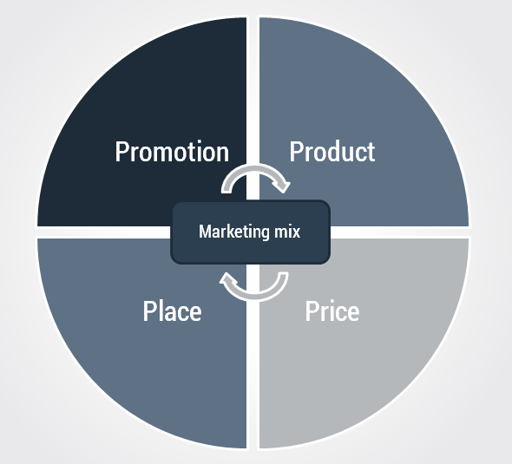

Source: (McCarthy, 1975)

An extensive and critical review of the limitations of traditional budgeting and its comparison to modern day methods was conducted by Constantinides (2006) in a study titled ‘The Marketing Mix Revisited: Towards the 21st Century Marketing’. This study was heavily influenced by the four P’s of the marketing mix which is also depicted in figure 1 as the framework surrounding the research into the limitations of traditional forms of marketing in the modern era. The study also indicates limitations to the marketing mix model and argues that the model lacks internal orientations and a lack of personality (Constantinides, 2006). However, as this research study focuses on the four P’s of marketing framework, most modern marketers and academics argue that the model is outdated and inaccurate compared to the seven P’s of the marketing model. This suggests that the framework surrounding the study may be inaccurate thus, makes the findings for the study also inaccurate and irrelevant. However, form this study and research, it can be argued that traditional forms of marketing have many inherent advantages that organisations still utilise as their main form of marketing. However, the research suggests that traditional marketing also occurs many limitations including higher costs and a lack of consumer engagement.

Figure 2 – Chaffey’s Seven P’s of the Digital Marketing Mix
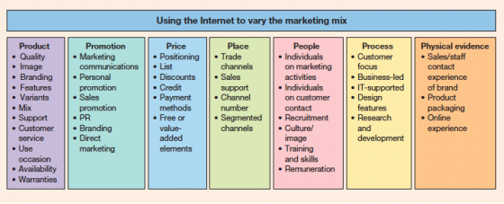

Source: (Chaffey, 2012, p. 34)

Figure 2 refers to the application of the seven P’s of the marketing mix to digital marketing forms such as social media marketing. Hanlon (2018) argues that this model was refreshed and applied to online channels to give a practical approach which works well for multichannel businesses. Therefore, it can be argued traditional marketing lacks the complexity of modern marketing and focuses heavily on factors that aren’t currently relevant.

Harris & Rae (2009) identify a further limitation of traditional marketing as a lack of personalisation and information. Findings from the highly researched and credible study suggest that the future of marketing consists of open collaboration between consumers and organisations and is not focused on the control in which traditional marketing heavily relies on (Harris & Rae, 2009). From further research conducted, it can be argued that traditional budgeting has many limitations however, it is still a very popular approach to marketing for many companies due to its inherent high credibility and allows for a much greater target audience. On the other hand, researches such as Harris & Rae (2006) and Constantinides (2006) both argue that softer forms such as digital marketing and social media marketing are the way in which organisations create better consumer relationships and overall better performance from their campaigns.

2.3 Defining Social Media Marketing

Vera (2018) deliberates that the concept of Social Media Marketing (SMM) in the business environment is interpreted as the use of social media resources to raise the presence of a business on the Internet. Furthermore, Felix, et al., (2017) also defines social media marketing as a form of internet-based marketing via the use of social media platforms in which organisations promote their brand, products and services. It can be argued that the main goal of social media marketing is to produce engaging content that users will share with their social media network in order to increase brand exposure and consumer engagement (Rouse, 2018). It is evident that the use of social media marketing as a main form of marketing is becoming vastly more popular to that of conventional marketing, Felix, et al., (2017) argues that social media marketing is an integral element of the 21st-century business. However, the literature on social media marketing remains fragmented and is focused on isolated issues, such as tactics for effective communication.

Social media marketing can be viewed as a new field and a new business practice involved with the marketing of goods, services, information and ideas via the online social media. It is argued that social media marketing can be viewed as an extension of traditional marketing rather than a completely new field of marketing (Dahil, et al., 2014). However, Hausman (2012) argues that there are many differences between social media marketing and traditional marketing, some of which are; its focus on consumer engagement and open systems compared to limited consumer engagement that of traditional marketing. Furthermore, It can be concluded from this research that social media marketing is regarded as the most viable source of marketing for any organisation.

Tuten & Ashley (2014) identifies one of the main elements and focuses of social media marketing is consumer engagement. Furthermore, it is argued that consumer engagement is the overall overriding factor to the success of social media marketing over traditional marketing as it allows for two way communication. It is evident that this element helps create a relationship between the organisation and the consumer through the use of direct communication through sites such as Facebook or indirect communication such as blogs. Research carried out by Tuten & Ashley to critically analyses the social media marketing mix concluded that the importance of frequent updates and incentives for participation is vital to the successfulness of social media marketing. However, it is evident that there is a lack of research into the negative effects of social media marketing techniques and whether adopting to withdraw from social media activities would have an adverse effect on an organisation.

2.4 The Impact of Social Media

Jolly (2019) argues that the rise in popularity of social media marketing is its cost-effectiveness, it is clear that social media marketing campaigns cost considerably less to produce than traditional forms of marketing such as TV advertising. A study into the cost-effectiveness and measurement of social media marketing was conducted in 2011, primarily focusing on its impact on small to medium-sized businesses conducted by Michaelidou, et al. (2011) concluded that SMM is vital to SME’s as flexibility and affordability is one of the main influencing factors of a marketing budget. Implementing a social media marketing campaign on any platform incurs a little cost as well as great flexibility.

It is argued that SMM has had a major impact on the way in which organisations approach their marketing campaigns. It is evident that SMM is the most popular form of marketing for SME’s, however, it is currently debated which social media platform is better for marketing (Bilbruck, 2016).

However, Adams-Mott (2019), argues that social media has some inherent disadvantages that can be very impactful on an organisation. It is clear that backlash is an important factor when implementing social media marketing, negative feedback from poor service or poor employment can have a major impact on the way the organisation is view online, furthermore, the organisation has no ability to control the situation if it becomes too hostile. This may suggest why many organisations also adapt traditional marketing tools over social media as it may have a negative impact. Adams-mott (2019) also indicates that social media must always be seen as one channel of marketing and to be used in conjunction with other forms of marketing. This is due to the fact that if an organisation is to focus on social media marketing on platforms such as Facebook, future changes to the social media platform may have a major negative impact on the organisation.

Figure 3 – List of the Most Popular Social Media Platforms

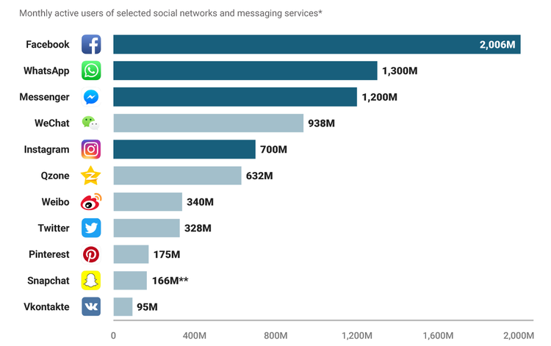

Source: (Dunn, 2017)

As depicted in figure 3, It is argued amongst social media marketers that Facebook is the most beneficial platform due to it having the largest user base. However, research conducted by Standberry (2017) indicates that the platform in which a business implements should align with their target audience. For example, the use of Intsatagram is mostly popular with consumers aged between 18-24 which engage with visual entertainment.The research also concludes that platforms such as Instagram may have a completely different demographic to that of WhatsApp. Furthermore, the research also indicates that the content in which an organisation publishes on different platforms can be more engaging than others.

Figure 4 – Key Statistical Indicators for the Worlds Social Media Users

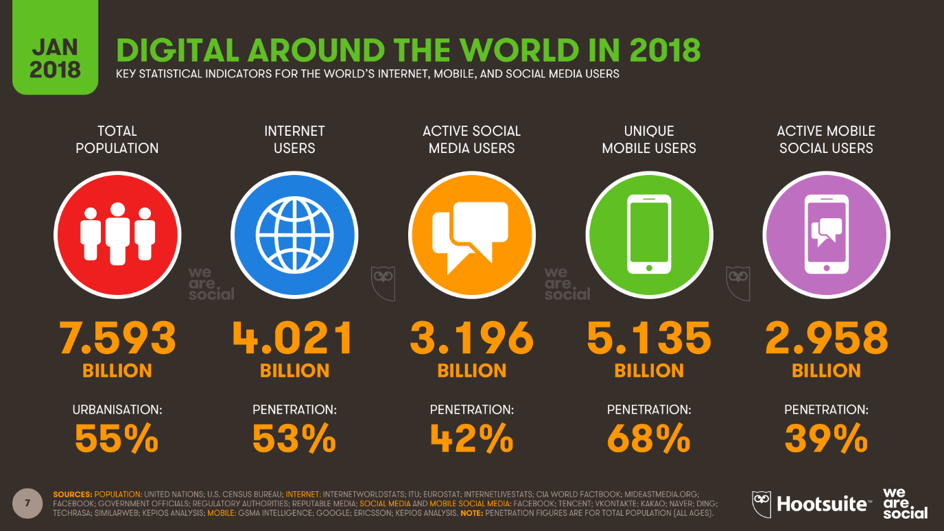

Source: (Hootsuite, 2018)

Newberry (2018) argues that organisations that are not taking advantage of social media are missing out on a fast, inexpensive, and effective way to reach almost half the world’s population. As depicted above, it is clear that almost 3.2 Billion potential customers are using social media daily with an average 42% penetration rate. This can suggest that almost half of also social media users interact with businesses in some form through the use of social media. However, many still suggest that social media isn’t vital to sustaining a competitive advantage over organisations that do use social media as a marketing tool. Newberry (2018) also identifies benefits to the use of social media such as increased brand awareness, consumer engagement and consumer loyalty.

2.5 Consumer Engagement

It is identified that there are limited definitions to consumer engagement by authors in the context of digital marketing, however, Patterson (2006) defines consumer engagement as the level of a customer's physical, cognitive and emotional presence in their relationship with a service organization. Additionally, Rouse (2018) identifies that consumer engagement is the means in which an organisation creates a relationship between its customers which in turn creates brand loyalty and awareness. it has been identified that there is a strong correlation between customer engagement and social media marketing, a successful social media campaign relies heavily on the amount of consumer engagement. Recent research suggests the ‘customer engagement’ concept is expected to contribute to developing our understanding of customer experience and retention than that of traditional methods such as customer satisfaction (Hollebeek , 2011, p. 2).

Bowen (2009) argues that consumer engagement is a physiological process which involves cognitive and emotional aspects. The research in which was concluded by Bowen (2009) focuses on the relationship of consumer engagement in existing customer compared to new customers. The research suggests that it is increasingly harder to gain consumer engagement with that of new customers compared to an existing one, It suggests that this may be due to the relationship between the existing customers and the organisation. Furthermore, The use of digital marketing tools such as social media marketing is a fundamental principle in gaining better consumer engagement between these two groups, resulting in better brand awareness and ultimately increased sales.

Brodie et al (2013) identify that the theoretical roots of consumer engagement lie in the expanding domain of relationship marketing theory. Simulairy, Ashley (2011) reinforces that relationship marketing is the conception lens in which to examine consumer engagement. Hoffman & Novak (1996) debates that the development of the internet as a communication medium has accelerated the level of consumer engagement companies gain, additionally, it has also created a way in which organisations use personal data for the basis of marketing. This suggests that the use of social media has had a major impact to the level of consumer engagement, in addition, social media also creates a way in which organisations can understand their effectiveness through the use of analytics.

2.6 Impact of Social Media Marketing on Consumer Engagement

Goh, et al (2013) argue that social media has changed the way in which organisations engage with their customers since the development of the internet and social media platforms it is clear consumer engagement levels has increased drastically. Companies are using social media to their advantage by engaging with their customers to gain a positive relationship, however, researched concluded by Rishika, et al (2013) into the effect of customers' social media participation on customer visit frequency and profitability suggests there is also a negative aspect of social media as the use of an engagement tool as it can be used against the company.

The research suggests that if customers had a negative experience with the company, they are more likely to share their negative feedback with other customers via social media. This is reinforced by Malthouse, et al (2013) in their research into the managing customer relationships in the social media era, their research also suggests that the rise of social media is challenging the traditional notion of customer relationship management. Furthermore, Malthouse, et al (2013) also indicates a strong relationship between consumer engagement and social customer relationship management.

Figure 5 – Social Customer Relationship Management Model

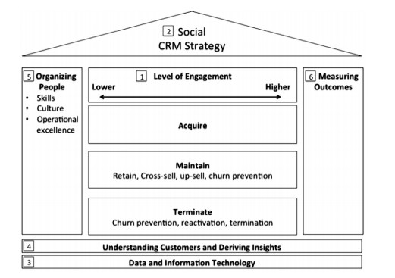
Source: (Malthouse, et al., 2013)

Malthouse, et al (2013) indicates in their extensive research that social media is creating new challenges to consumer engagement and customer relationships, as depicted in figure 4, Malthouse, et al (2013) developed a model in which to describe the current social consumer environment. This research suggests that customers are passive, responding to a company's actions primarily through their purchasing behaviour, however, the development of social media has enabled customers active participation in the relationship, by providing them with opportunities to engage with the firm. It is argued that there is a lack of a clear definition of consumer engagement by academics, however, most agree that there are varying degrees in engagement, whilst some agree this is due to the psychological state of the consumers and other focusing on the non-purchasing activities (Brodie, et al., 2013).

Malthouse, et al (2013) also simulates that it is vital that companies adopt a modern and innovated customer engagement strategy in order to maintain a strong relationship with their customers, without the use of social media it would become very difficult for companies to maintain and acquire consumer engagement, however, it is also clear that termination of these relationships may result in a negative effect against the firm. Therefore, it is argued that there is a lack of literature surrounding the effects of absence from social media and its effect on consumer engagement.

2.7 Conclusion

The current research surrounding social media marketing gives clear evidence to suggest that the use of social media as a marketing tool is one of the most popular marketing techniques in order to achieve a competitive advantage. However, it is also clear that traditional marketing is also still very popular with organisations that are already very established. The theory that social media marketing is vital to maintaining a competitive advantage over other organisations is yet to be established and will be the main theory surrounding the rationale of this research. Additionally, it is clear that the use of social media has some disadvantages such as the ability to spread bad publicity rapidly, which may have led to Weatherspoon’s decision to withdraw.

As such, the investigation into the effects of social media withdrawn on consumer behaviour and the concept of losing competitive advantage from the withdrawal from social media will be further explored in the data analysis chapter to seek to confirm or deny or develop upon these existing theories.

Methodology

This chapter will indicate the proposed research strategy as well as the intended data collection methods and techniques that will be implemented in this study to conclusively satisfy the research objective as follows:

- To conduct primary research in the form of interviews and questionnaires to identify the importance of social media marketing and its effects on consumer behaviour.
- Investigate the impact of Wetherspoons decision to withdraw from their social media marketing campaigns and its effect on organisational performance.

3.1 Defining Research and the Research Onion

Research can be defined as careful consideration of study regarding a particular concern or a problem using scientific methods (Bhat, 2017). Babbie (2007) suggests that research is a systematic inquiry to describe, explain, predict and control the observed phenomenon. It is argued that one of the most effective models for formulating an effective research strategy was developed by Saunders, et al., (2007) which was depicted as ‘The Research Onion’, as shown below.

Figure 6 – The Research Onion

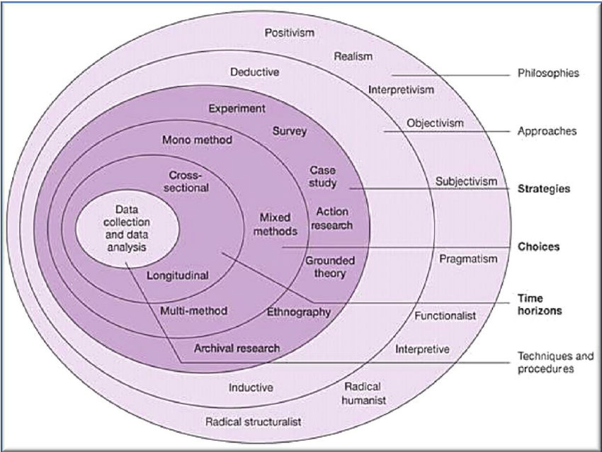

Source: Saunders, et al., (2007)

As depicted in Figure 5 it is clear that The Research Onion consists of many layers all relating to a particular stage of research. Using this model by following these layers from the core of the ‘onion’ to its outer layers, it is argued that the model creates a clear pathway to developing a successful and effective research strategy (Saunders, et al., 2007). It is also argued that the model greatly benefits the researcher by enabling a best practice research design in order to allow the researcher greater understanding and clarity with will contributed to a better data collection and analysis which positively effects the overall research question.

For the purpose of this study, a systematic approach will be implemented in order to best suit the objectives set out in order to successfully investigate this research overall underlying question of the impact of withdrawal from social media marketing activity, the study of Wetherspoons Swansea. This approach will allow the researcher greater development in the research design and methodology with best suits the main overriding research question.

3.2 Philosophy

Dudovskiy (2008) argues that research philosophy deals with the source, nature and development of knowledge. There are many philosophies in which research can be undertaken by, some include, pragmatism as well as realism. However, Saunders, et al., argues that there are two main philosophies that construct an ontological framework which as positivism and interpretivism. For the purpose of this research, an interpretivism research philosophy will be applied in order to best meet the objectives set out in the research question. However, many argue that a positivistic approach will aid the researcher in the use of hard quantitative data collection and analysis as well as aiding to investigate the main research question. However, an interpretivism philosophy incorporated in the soft qualitative data collection and analysis to complement the overall research question. The use of both philosophies will be present in the research, the philosophy will look to explore the effectiveness of social media marketing and its impact on consumers. Furthermore, the subjective interpretivism philosophy will be implemented in order to analysis the soft data collected from an interview to further understand the impact of Wetherspoons withdrawal from social media. However, as elements of positivism will be present in the research, it may be more accurate to pronounce the overall main philosophy as pragmatism.

3.2.1 Interpretivism

Edirisingha (2012) identifies the position of interpretivism in relation to ontology and epistemology is that interpretivism believes the reality is multiple and relative. Guba (1990) argues that these multiple realities also depend on other systems for meanings, which make it even more difficult to interpret in terms of fixed realities. Contrasting positivism, interpretivism avoids a highly structured style and adopts a more personal and flexible research structure which in turn helps the research gain valuable data which can be interpreted. Therefore, interpretivism is closely linked with a deductive approach to research as it aids the researcher to develop upon existing theories in order to best satisfy the research objectives.

3.2.2 Positivism

According to Pham (2017), positivism paradigm which under objectivism epistemology is a methodological philosophy in quantitative research where the researcher applies methods of natural sciences to discover the study of social science. It is argued that positivistic research consists of large samples as well as being highly structured, the means in which the research can be measured is predominately quantitative, however, many also argue that a positivistic approach can also be qualitative. Positivism ideology does not take into account for social and moral considerations in its data collection, contrasting that of interpretivism ideology that values these factors and considers the overall reason why an individual may come to a conclusion.

3.3 Research Approach

According to Chetty (2016), a research approach is a plan and procedure that consists of the steps of broad assumptions to detailed method of data collection, analysis and interpretation. It is clear that there are two main approaches a researcher can adopt, an inductive approach is closely linked with qualitative data analysis whereby the researcher primarily uses detailed reading of secondary data to derive concepts, themes, and models. By contrast, a deductive approach is closely linked with quantities data which is based on logic, whereby the researcher generates hypothesis based on logical processes.

Figure 7 - Components of Research Approach

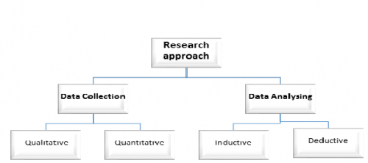

Source: Chetty (2016)

For the purpose of satisfying the research objectives, the researcher will adopt a mixed methods approach utilizing both inductive and deductive data analysing approaches in order to best suit the needs of the research. This mixed methods approach will enable the researcher to critically analyse both sets of qualitative and quantitative data in the form of interviews and questionnaires in order to best investigate the main research question. However, as the research has inherent limitations such as time and cost, the researcher will mainly adopt a deductive approach in order to develop a theory by implementing existing theories in the research.

Figure 8- The Process of deductive Research

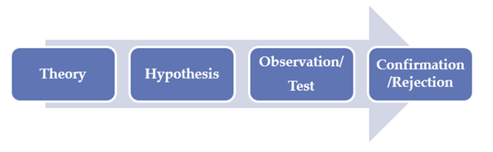

Source: Gioia et al., (2013)

The use of interviews as an observation tool in order to develop a theory on the potential effects of the withdrawn of social media activity by Wetherspoons Swansea will enable the researcher to gain valuable data in order to successfully answer the research question. Furthermore, as the researcher intends to also use a deductive approach, chapter two has provided a detailed overview of the current literature surrounding social media marketing and its effects on consumer behaviour. Therefore, the researcher is able to use a deductive approach when carrying out the research to link findings with current academic literature and models of social media. However, it is also clear in chapter two that there is a lack of literature surrounding the withdrawal from social media marketing, therefore an inductive approach is also vital to the successfulness of the research. Additionally, by utilising a deductive approach throughout the research, the researcher is able to either confirm or negate themes and theories that occur in the data analysis to further aid the researcher's findings.

3.4 Research Strategy

Saunders et al., (2007) argue that research strategy refers to how the researcher implements the data collection, this refers to the methods of data collection, in terms of the tools and techniques used. As depicted in the research onion model, there are five potential ways in which a researcher can collect primary data. For the purpose of this dissertation research, the researcher will look to utilise a survey in the form of a questionnaire to evaluate Wetherspoons social media presence as well as to identify any key trends that may have occurred as a result of Wetherspoons decision to withdrawn from social media. According to Nardi (2018), surveys are a primary form of quantitative data collection, surveys are typically used as a means to collect very large quantities of soft data used in statistical analysis. Due to the limitations of time and cost, the researcher is unable to use other research strategies such as an experiment, therefore, a survey and interview are the most effective strategies due to the current limitations.

Additionally, a qualitative approach will also be implemented in the form of an interview which will provide the researcher with hard and rich data in contrast to the quantitative data, therefore, a subjective and objective data analysis will also be implemented. The purpose of the interview data collection technique is to enable the researcher to subjectively analysis in order to make appropriate recommendations as well as aiding in the overall research objective of the effects of withdrawal from social media marketing specifically in the case of Wetherspoons Swansea. The rich data obtained from the interview will account for most of the evident data in this research, however, the large sample size of the survey will also account for a lot of the data in order to fully scope the effectiveness or ineffectiveness of withdrawal from social media in the case of Wetherspoons Swansea.

The research conducted will commence with a research questionnaire in which participants will be required to answer sixteen questions relating to their use of social media, how effectively they fell social media is to Wetherspoons as well as themes such as are they more likely to engage with companies on social media. Additionally, the interview will be conducted with a former employee of Wetherspoons Swansea in order to explore their views and opinions of the effects and the overall decision of Wetherspoons Swansea to withdraw. Furthermore, the interview will look to identify any indicators of the current successfulness of Wetherspoons decision.

3.5 Data Collection

3.5.1 Interview Technique

According to Valenzuela & Shrivastava (2006), the main strengths associated with interviews are, interviews are a more personal form of data collection that allows the researcher greater clarity when collecting data. This translates well to many aspects of data collection, as the researcher may seek a clear answer from a participant in order to effectively interpret the data. Furthermore, the interviewer also has the ability to further probe for a more detailed answer from the participant. For the purpose of this study, a semi-structured interview will be conducted to enable the researcher access to rich informative data. Furthermore, the researcher will prepare the questions in advance to ensure that the main points are covered whilst also allowing the participants to be as free and as flexible as possible.

3.5.2 Questionnaires

Throughout the data collection, a questionnaire data collection method will be adopted to provide the researcher with an alternative to the qualitative data approach. This will allow the researcher to compare and contrast the data collected from the interviews in relation to the questionnaire. According to McLeod (2018), a questionnaire is a research instrument consisting of a series of questions for the purpose of gathering quantitative information from respondents. Furthermore, questionnaires provide a cost effect and efficient way of obtaining large amounts of information from a large sample size. The research will use the data gathered from the questionnaire to better analyse Wetherspoons use of social media and its engagement with its consumers to better conclude the research question.

3.5.3 Triangulation Research Design

According to Turner & Turner (2012), triangulation is the means by which an alternate perspective is used to validate, challenge or extend existing findings. By implementing both qualitative and quantitative data collection methods, the research will benefit from the use of a mixed methods approach. This design strategy will support the researcher by challenging, validating and extending any findings from the data. The researcher intends to use this approach to compare and contrast findings from both data collection methods to gain a better understanding of Wetherspoons actions as well as the impact it has had to help conclude the research question.

3.5.4 Sample

Orthod (2004) suggests that the purpose of estimating the appropriate sample size is to produce studies capable of detecting clinically relevant differences. However, due to limitations in researcher data collection such as time and monetary cost, researchers often seek a sample size that best suits the needs of the research design. For the purpose of this research, a convenient sample will be implemented as a convenient sample is a non-random population sample. This will aid the researcher in increasing the overall reliability and validity of the research as well as reducing time and cost restrictions. The researcher will seek to adopt this sample in both forms of data collection specifically aimed at Wetherspoons customers as well as Wetherspoons employees in order to best satisfy the overall research objectives.

3.6 Research Limitations and Ethical Considerations

3.6.1 Resource limitations

Due to the limited time and lack of financial resources, it will be evident that the research will be impacted. This will be evident in the implementation of a convenient sample type whereby the sample may not be a true representation of the wider population; however, this study is primarily focused on the impact of withdrawal from Wetherspoons Swansea. Despite this, it is possible for the data collected and the analyses of the data to be subjective to a lack of reliability and validity.

3.6.2 Research Ethics

Altman (1980) identifies that there is a great importance of ethical implications in research, ethics has come significantly more important to researchers in order to conduct safe, true and effective data collection. Dalton & Ortengren (2011) argue that in order to effectively conduct research, the researcher must consider the participants in terms of their health and wellbeing as well as their capacity to answer such questions. In turn, this will allow the researcher the best possible results, in return this increase the researches validity and reliability. All aspects of data collection and research that this study undertakes will follow a strict ethical regulation outlined in appendix 1. Additionally, all participant will be aware of the details of the study, its aims and objectives as well as its purpose. All participant will be over the age of 18 as this will not further limit the research as they are able to provide their own consent. Wiles et al (2008) indicate that “All ethical guidelines for social researchers are clear that confidentiality is an important element of social research and that research participants should be made aware of who will have access to their data as well as being provided with details about the processes of anonymisation”. Therefore, all data collected such as participant information as well as the information from the data collection will be secure and strictly confidential as part of the ethical document issued in appendix 1.

Confidentiality can be seen as a positive indicator for increased validity and reliability as it helps the participants express true freedom of speech allowing the researcher access to sensitive data for analysis. As part of the data collection, an interview with a former employee of Wetherspoons will be conducted in order to gain a better understanding of why Wetherspoons decided to withdraw from social media activities from an employee’s viewpoint. Therefore, sensitive and potentially critical data involving Wetherspoons may be present which may lead to conflict between the two parties. Therefore, it is vital that the participant understands the researcher’s confidentiality policy.

3.7 Reliability and Validity

According to Golafshani (2003), reliability and validity are one of the most important elements in the process and outcome of the research, it is clear that both reliability and validity indicate whether the research has been able to meet their objectives as well as its credibility. Therefore, it is clear that the researcher must attempt to limit any errors such as bias and human error in the data collection and analysis. However, as outlined implementing the correct research design and approach is key to limiting these factors and ultimately satisfying the research objections. Therefore, it is proposed that all findings from this study data collection will be present in this research to seek to aid any other researchers looking to carry out a similar study

4. Data Analysis

4.1 Introduction

The aim of this chapter is to satisfy the second research objective of the study which is outlined below:

- Investigate the impact of Wetherspoons decision to withdraw from their social media marketing campaigns and its effect on organisational performance.

As outlined in chapter 3, a deductive approach will be utilized throughout the data analysis, whereby the researcher develops upon existing theories in order to test the hypothesis. The hypothesis used to construct the research collection methods was the most relevant themes and theories surrounding the subject which were present in chapter two: a literature review. However, as it was clear that there is a lack of literature surrounding aspects of the effects of withdrawal from social media activities and its effects, elements of an inductive approach may be present in order to best satisfy the research aims and objectives.

The mains themes surrounding social media marketing that was indicated in chapter two are shown below:

- It is argued that traditional forms of marketing as still very successful in a modern day marketing mix due to the inherent advantages such as high credibility. Many businesses still adopt traditional forms of marketing over newer forms such as social media marketing. (Trusov, et al., 2009), (Wroblewski, 2018).
- One of the main elements and focuses on social media marketing is consumer engagement. Furthermore, it is argued that consumer engagement is the overall overriding factor to the success of social media marketing over traditional marketing as it allows for two way communication. (Tuten & Ashley, 2014), (Jolly, 2019).
- Social media marketing can be viewed as a new field and a new business practice involved with the marketing of goods, services, information and ideas via the online social media. It is argued that social media marketing can be viewed as an extension of traditional marketing rather than a completely new field of marketing.
- Social media marketing has drastically changed the way businesses approach their marketing campaigns, it is the most popular form of marketing and without it, organisations would lose a competitive advantage.

In order for the researcher to meet the aims and objectives of the research, the summary of themes and theories presented from previous research surrounding social media marketing and its effects on consumer behaviour in addition to the primary data collection of the survey and interview will be implemented in the data analysis. Using the data collected, the researcher aims to confirm or disprove any present themes and ultimately conclude the research question.

4.2Main Findings

4.2.1 Induvial Interview Analysis

The Induvial Interview was conducted over a Skype conference call, the interview consisted of ten open-ended questions which enabled the researcher with free-flowing interactions with the participant. Additionally, the interview was conducted in a semi-structured approach between the interviewer and the former employee of Wetherspoons Swansea, the interview lasted for approximately 30 minutes. In accordance with the research ethics form, the personal data collected has been removed from the results of the interview enabling complete confidentiality.

4.2.1.1 Wetherspoons Social media Presence and Usage

The interview provided accurate and clear confirmations throughout, this includes Wetherspoons Swansea social media usage, their intended aims and objectives of the usage as well as their understanding of social media marketing. It is clear that each branch of Wetherspoons has its own social media page in which they are responsible for managing as indicated below.

‘Each Wetherspoons had their separate social media page, each branch of Wetherspoons would promote offers and events, although some were more activate than others. For example, they would promote events such as ale festivals, I believe that promoting events through social media was very successful for Wetherspoons as it brought more custom.’

From the data above it can be suggested that the use of social media as a marketing tool was successful for Wetherspoons as it brought more custom. However, it is also indicated that the use of social media between branches varied which may have had an effect on its effectiveness in other branches.

One theme that became apparent was that Wetherspoons decision to withdrawn from social media may have little to no impact on its customers buying behaviours, the participant was asked ‘Despite Wetherspoons decision to withdraw from social media, do you think this has had an impact on its customers and their buying behaviours’, the response as follows:

‘No, as far as I am aware of Wetherspoons has been as popular as ever, it’s not all about promotion, the food quality and prices are very good also Wetherspoons locations are very convenient. As most Wetherspoons are located in towns such as Swansea, people tend to come in no matter what. Wetherspoons has its local customers which buy on a regular occasion and I believe that most people already know Wetherspoons daily promotions so advertising on social media is a bit pointless.’

Additionally, the participant also adds:

‘I think people will go to Wetherspoon no matter whether they have bad rating online or complaints. I believe that this could be a reason why Wetherspoons decided to stop social media because they believe in word of mouth and also have a valued customer base.’

The interview evidence clearly indicates the advantages of using traditional methods of marketing outlined by Rai (2018) and Widjaya (2017) as the use of traditional marketing is a proven and successful form of marketing. The evidence also strongly collaborates well with Trusov et al (2009) as he concludes that effective word of mouth marketing is still a very popular and effective alternative approach. It is also clear within the data collected that Wetherspoons may have a ‘valued customer base’. This may be due to the strong consumer engagement which is reinforced by Brodie et al (2013), however, Ashley (2011) strongly argues that the use of social media as a consumer engagement tool is vital to maintaining a positive consumer base. However, it is clear through the data collected that Wetherspoons is still able to maintain a ‘valued customer base’ despite using social media as an engagement tool. Therefore, it can only be suggested that the use of social media may improve consumer engagement but ultimately, isn’t vital to maintaining good customer relationships.

4.2.1.2 Impact of Social Media

It is evident throughout the interview, themes such as the importance of social media and the impact of social media were present. The participant provided useful data indicating Wetherspoons approach to these themes, which are outlined in the previous response. This approach indicates that Wetherspoon understood the importance of social media marketing as outlined by Goh et al (2013) and Rishika et al (2013) as it provides many advantages over traditional forms of marketing. However, the participant also recognises that despite this, the impact of withdrawal from social media hasn’t had a major impact.

However, it is indicated that the decision from withdrawing from social media may have had an impacted Wetherspoons competitive advantage over its rivals as indicated below:

‘Potentially some people may see posts on social media from other restaurants and go there instead. I believe that many customers use social media to assess whether a restaurant is worth going to, I believe that social media has a great influence on younger customers, therefore, it would be wise to engage with them over the use of social media.’

This evidence suggests that other companies that are using social media as a marketing tool may be at an advantage, this is strongly argued by Dunn (2017) and as depicted by figure 3 that almost 2.6 million user access sites such as Facebook a month which gives companies the ability to access a vast customer base. However, it is clear from the data collected that Wetherspoons is still able to sustain a competitive market share to that of its rivals even without the use of social media.

Throughout the data collected, it is apparent that the negative impact from the withdrawal of social media is low, however, one main reason for Wetherspoons decision is revealed as avoiding the negative backlash that is very prominent in social media. It is confirmed from the response of the participant indicated below:

‘I can understand when people use social media platforms such as Facebook to complain about companies such as Wetherspoons which gives them a negative image. I believe that social media can be a tool to help companies, but it also can have major negative effects if the company are unaware of its customer's reactions and feelings towards them.’

‘I’m not actually 100% sure why they stopped it, but I assume that it would have a negative effect on Wetherspoons ability to reach certain customers. However, as Wetherspoons is a large company I don’t think that it will have a hugely negative effect and maybe it could have a positive effect on them by them not being subjective to criticism online.’

This evidence strongly supports Adams-Mott (2019) argument that social media can have a major negative impact on organisations that do not understand their customers, bad criticism is more apparent online. Therefore, it can be suggested that Wetherspoons decision may have had major benefits to the organisation. However, Malthouse et al (2013) argue the importance of social media as an engagement tool to help organisations evaluate and maintain a positive brand image online. It is clear that without an online presence, Wetherspoons is unable to defend themselves effectively from criticism.

4.2.2 Questionnaire Analysis

Additionally, to the data collected from the expert interview, data were also collected from a questionnaire from a sample of 106 participants. From the questionnaire results, the data collected was beneficial to the researcher as it enabled a quantitative element to the analysis which provided the researcher further development into the impact of the withdrawal of social media by Wetherspoons Swansea. The data collected was compared to the expert interview as well as the main themes and theories surround the topic as described in chapter 2 – The Literature Review. The questionnaire was created by ‘Google Forms’ and correlated into statistic graphs in order to best analyse the results, a template of the questionnaire as well as its accompanying documents can be found in the appendix.

4.2.2.1 Usage of Social Media

The data collected from the expert interview provided a clear analysis of the importance of social media and how it can be used effectively. The questionnaire sought to further develop the social media usage and its importance to organisations by querying questions such as ‘How often do you use social media’ as well as ‘what social media platforms do you use’ in order to better understand the current environment.

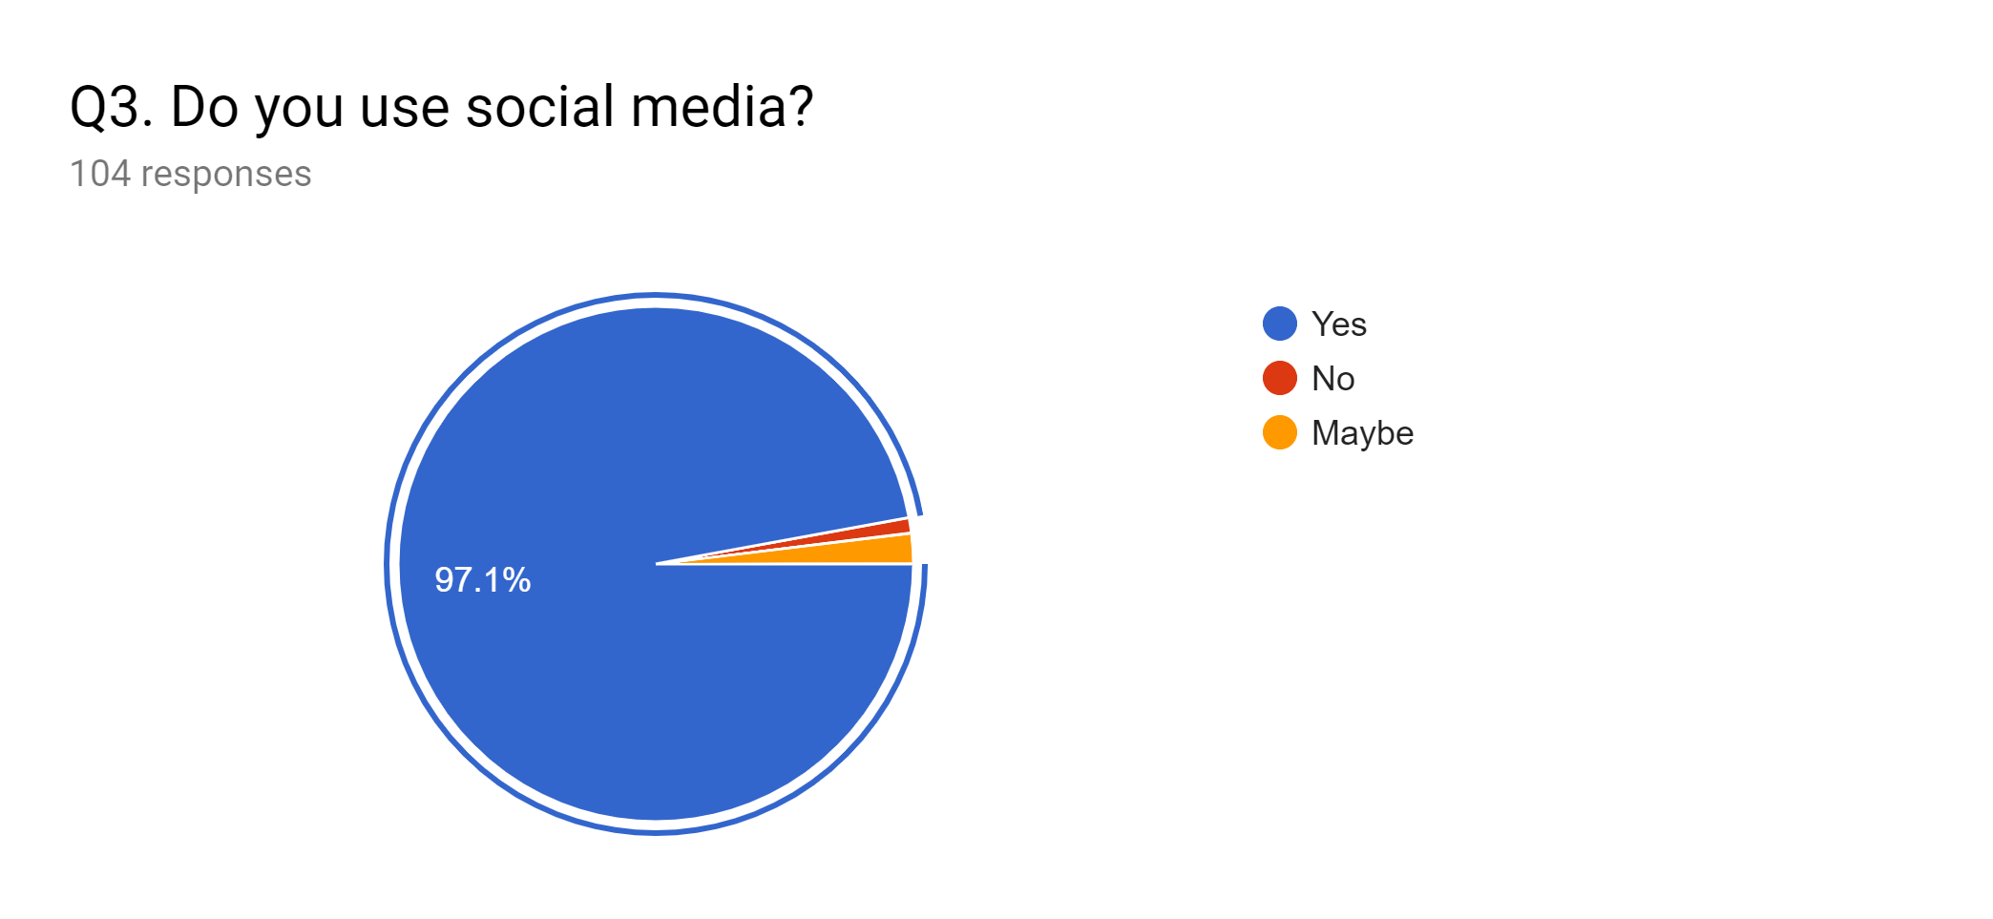
Figure 9 – Graph indicating the percentage of social media users

This statistical evidence shows that the majority of participants are active social media users this strongly supports Hootsuite (2018) statistical analysis of the current digital environment. This may also suggest that Wetherspoons, unlike its rivals, are missing out on accessing this vase customer base, however, it is unclear that all of these active social media users consider social media as a marketing tool and where they engage with it.

Figure 10 - Graph showing social media usage: male versus female

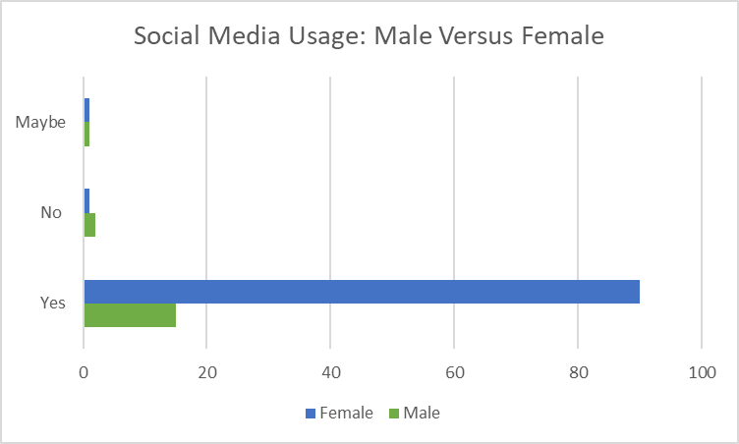

This figure further develops upon social media usage by comparing the data collected and compiling it into responses versus gender. From the evidence it is clear that it is predominately females that access social media more so than male, however as previously detailed, this may not be a true representation of the current social media usage as limitations to sample size is considered. However, it can be argued from the evidence that Wetherspoons customer base is predominately male, therefore, it can be suggested that this is why Wetherspoons has had little impact from their withdrawal.

Figure 11 – Graph indicating the reasons for social media usage

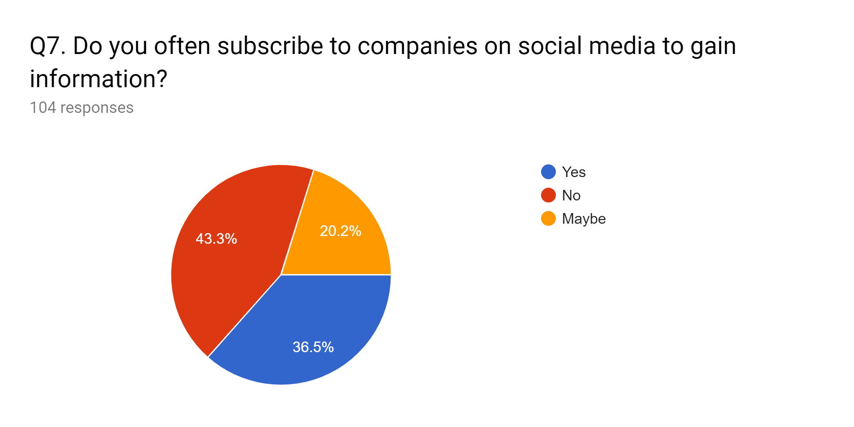

This data indicates that there is divided between using social media for the purpose of following organisations activities in order to gain information. However, it is clear that the majority of participants do not use social media to gain information on companies. This correlates well with Shakespeare (2018) who indicates through his research on social media that it appears that interacting with brands isn’t the priority. Over half (51 per cent) say that they mainly use social media for news content and entertainment.

Figure 12 – Graph showing the following of Wetherspoons Swansea through social media

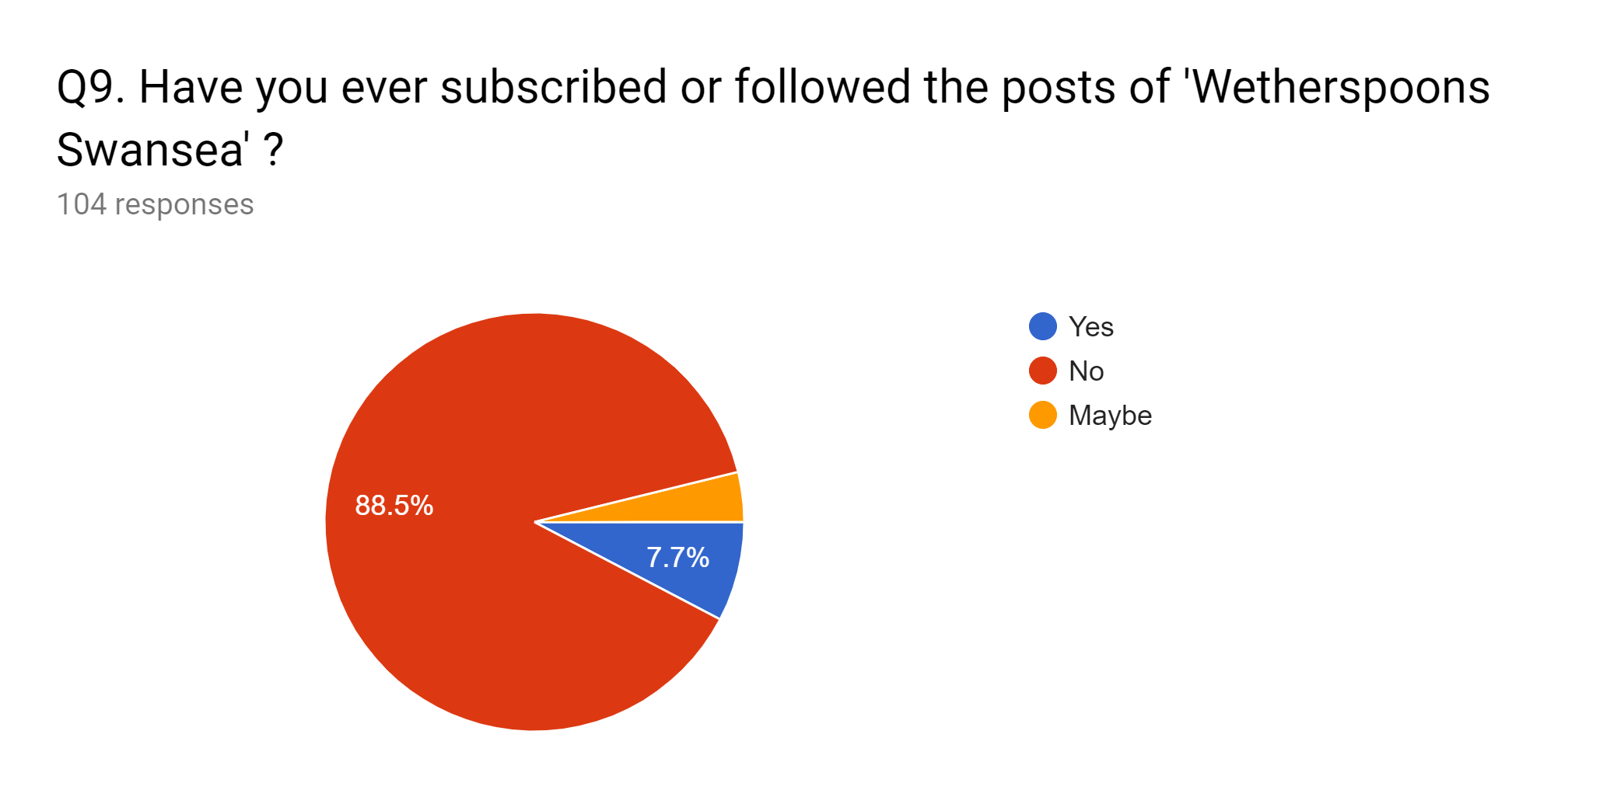
As depicted above this data also indicates that there is a lack of consumers actively engaging with companies in order to gain information but instead using social media for the purpose of entertainment and news content. Therefore, it is suggested that this may be one of the reasons Wetherspoons decided to withdraw from social media as it hasn’t been effective in there marketing strategies.

4.2.2.2 The Impact of Social Media

Figure 13 – Graph indicating the importance of social media reviews

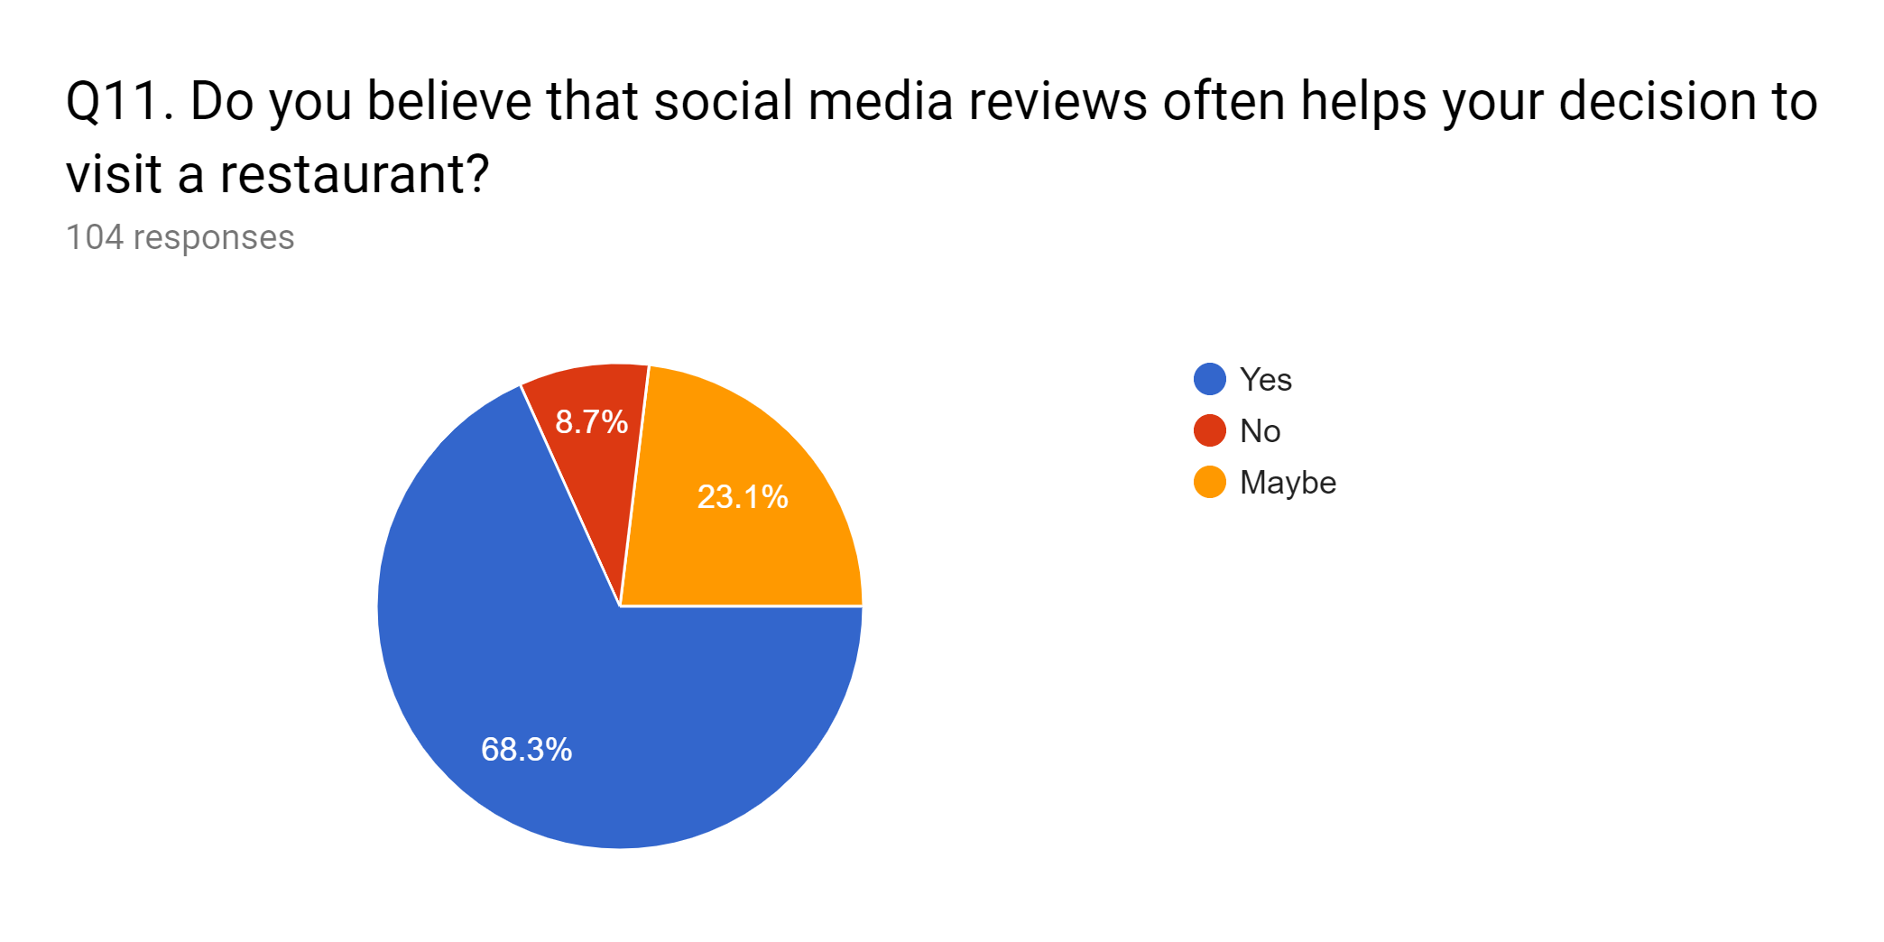
As the evidence above shows, the majority of participants believe that social media reviews often help their decision to visit a restaurant. This also supports Newberry (2018) argument that social media helps to create a positive brand image. Therefore, it can be suggested that Wetherspoons is currently lacking the ability to engage with its consumers which can cause a negative impact on how the company is seen online, especially with regards to reviews as they are not able to defend themselves as previously indicated. It can also be suggested from the data collected that Wetherspoons current marketing strategies do not align well with the use of social media as a marketing tool. This could be a potential reason why the company has decided to withdraw from social media as it had minimal effect on the organisation.

Figure 14 – Graph showing the response to how beneficial social media is for organisations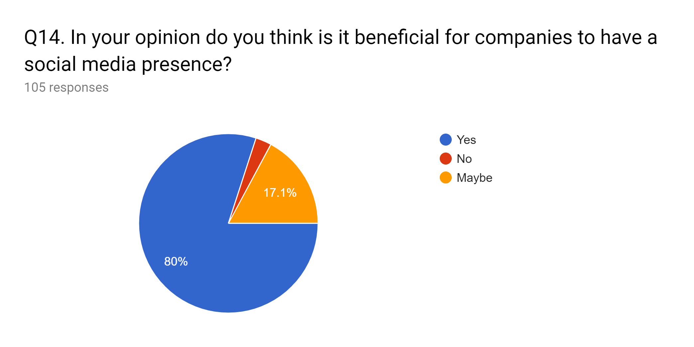
However, as depicted above, the data suggests that 80% of participants agree that social media is very beneficial for an organisation, the also positively correlates well with Vera (2018) that argues the importance of social media to organisations. Additionally, the survey data also reinforces that companies that use social media are more appealing.

Figure 15 – Graph indicating the type of content consumers engage with more

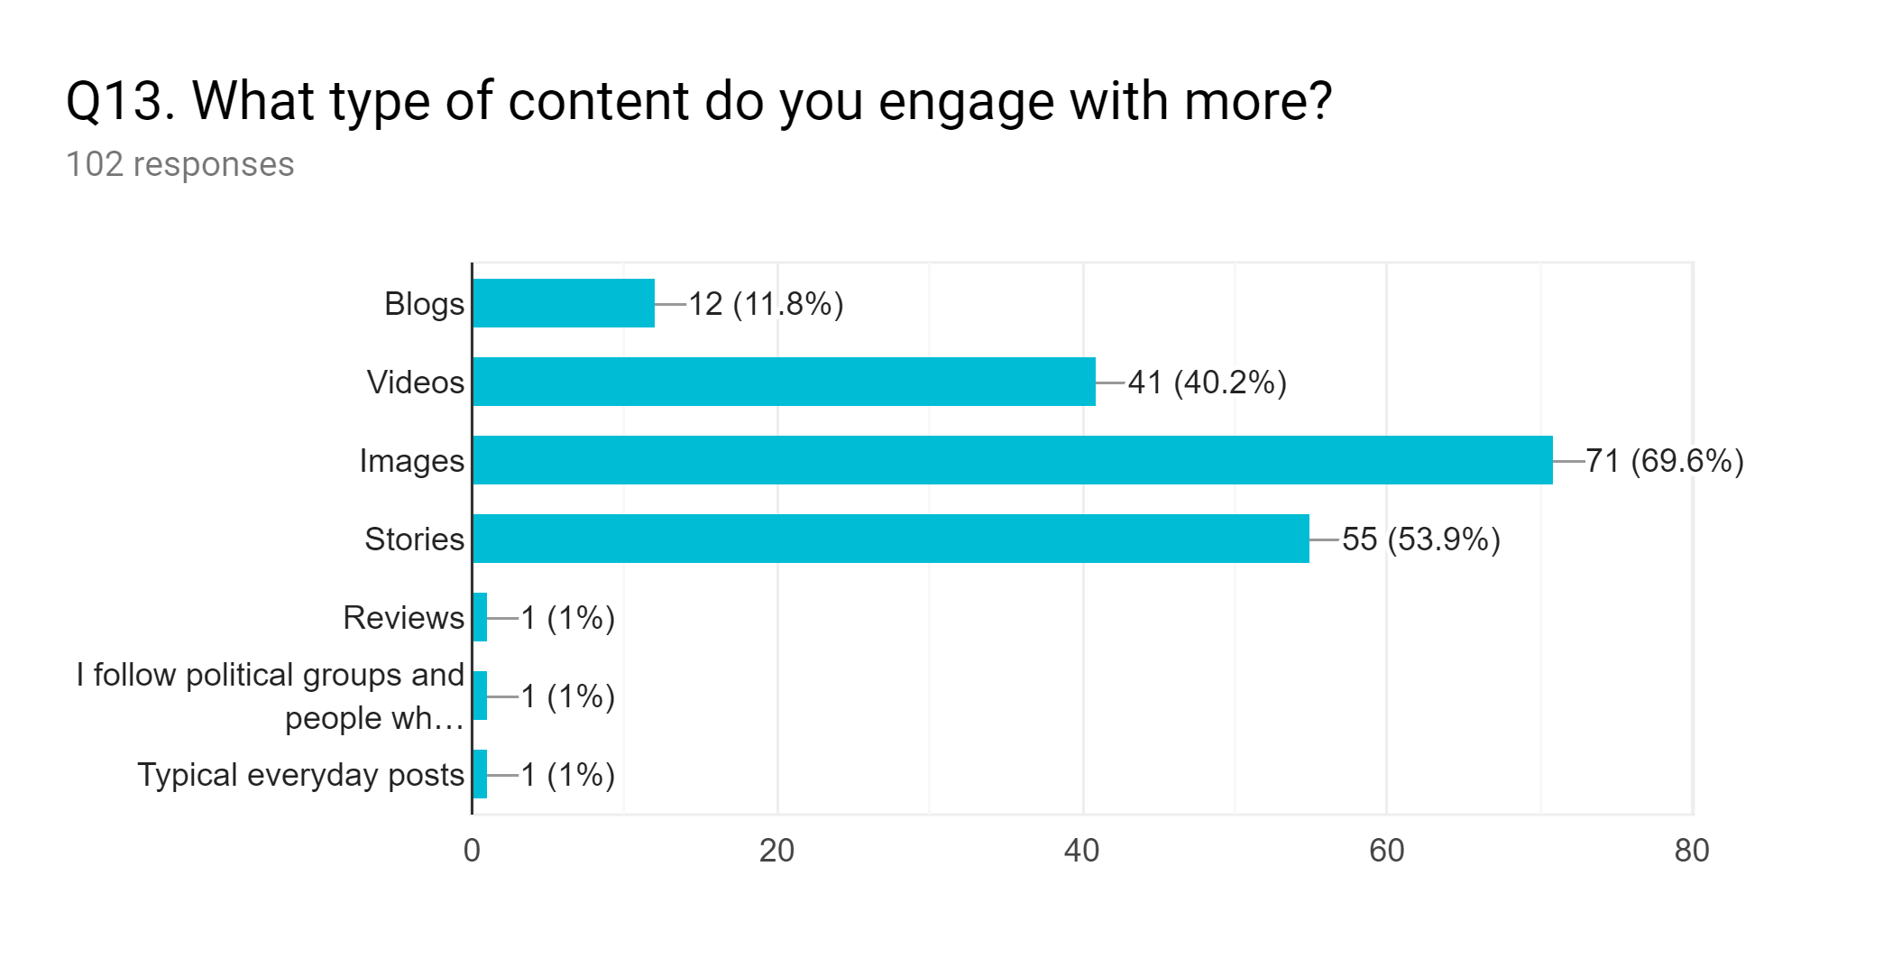
From the graph above, it is clear that images are the most engaging content for consumers. This could suggest that Wetherspoons is missing out on a very effective marketing campaign by simply posting images of their food on social media sites such as Instagram. However, as previously mentioned it is indicated that Wetherspoons focuses on a local consumer base which may not engage with social media.

Figure 16 – Word cloud indicating the most used words to describe companies that do not engage with social media

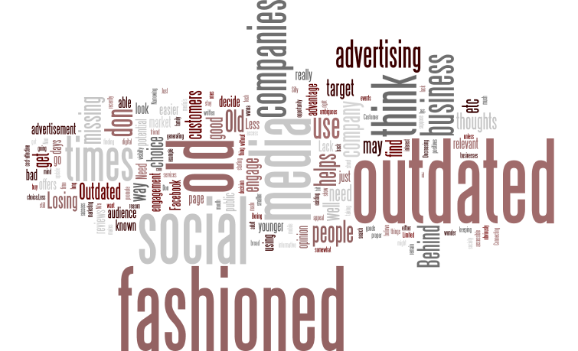

As indicated above, it is clear that ‘outdated’ and ‘old fashioned’ are the most popular word to describe companies that do not engage with social media. This may be due to the participant's opinions surrounding the topic, therefore, it is important to interpret the results accurately. Furthermore, data from the survey suggests that the majority of participants were aged between 21-34 which could have influenced the findings as social media has a greater influence on younger consumers to that of older consumers. Therefore, it could be suggested that this could be a reason why Wetherspoons withdrew from social media as it did not influence their target audience. However, it can be argued that there is still a major advantage having a strong social media presence as indicated in figure 16 that most consumers will see the company as ‘current’ and ‘innovative’.

Figure 17 – Graph indicating the engagement with companies online versus in person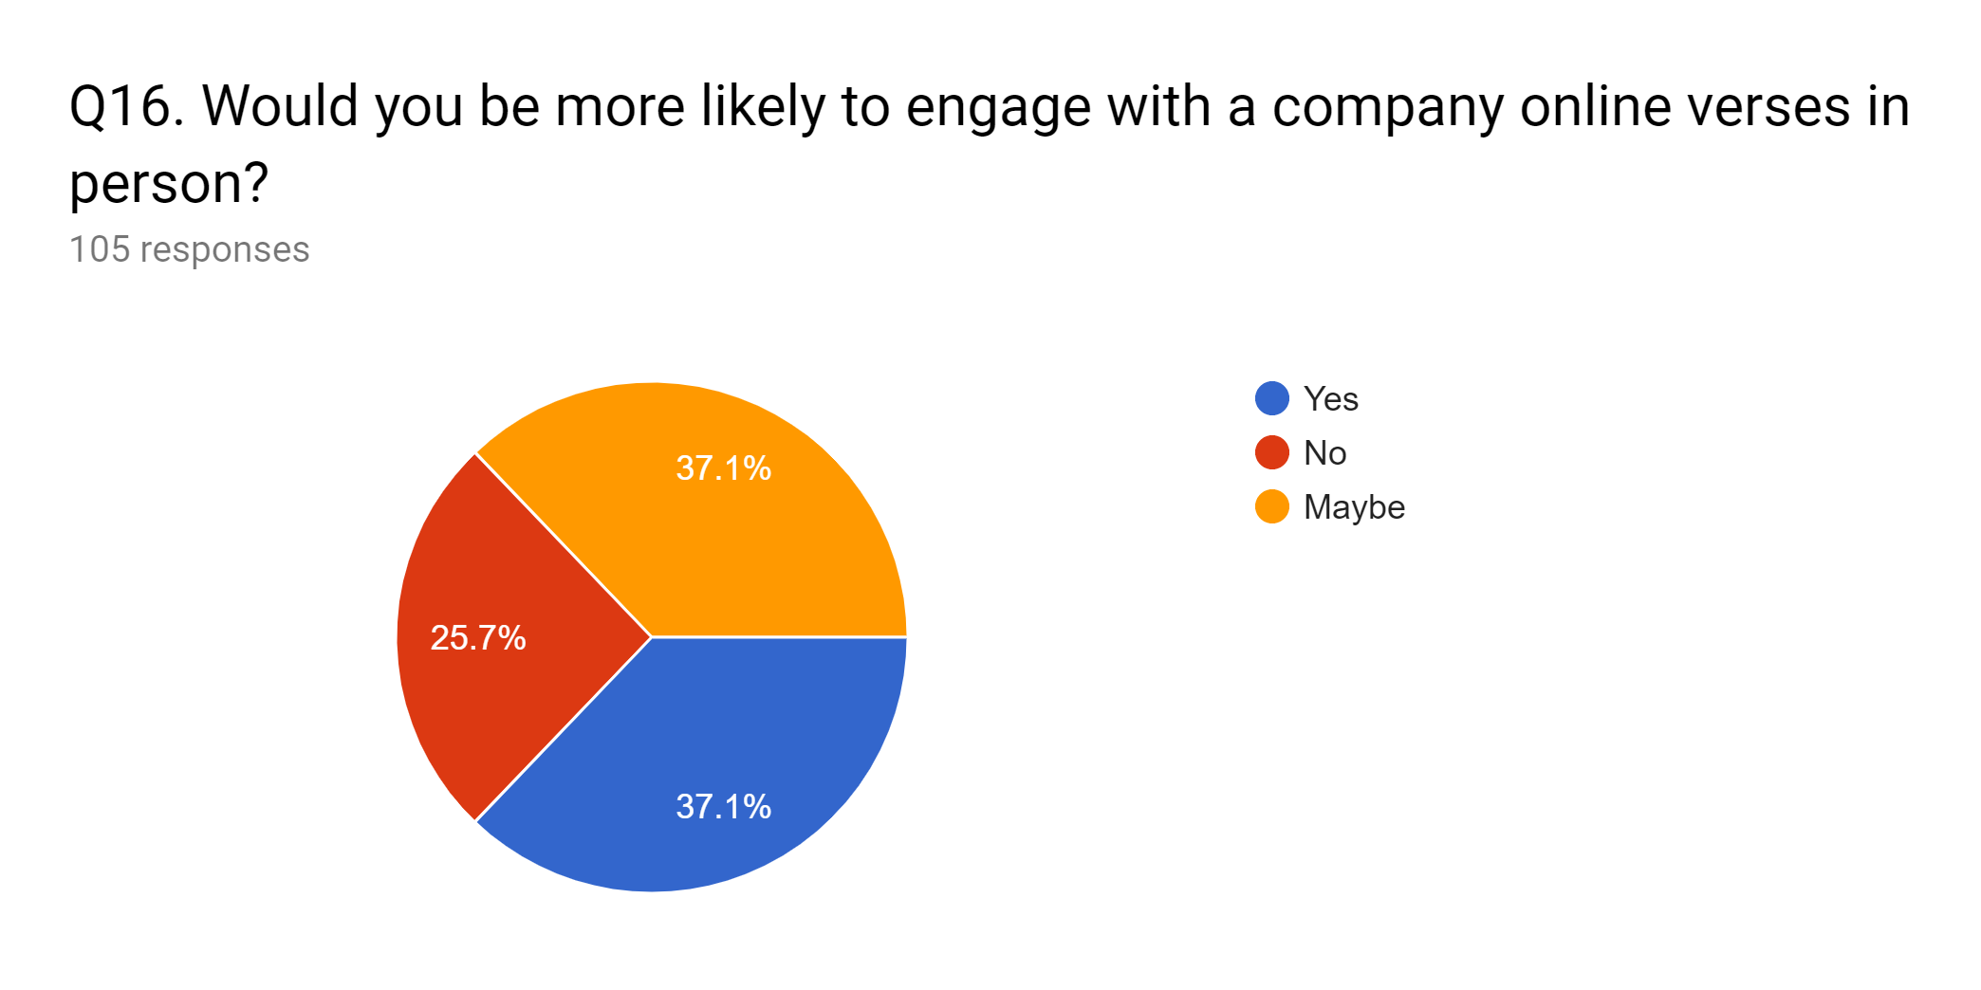

Figure 17 indicates that although social media is seen as a positive factor in branding and marketing, there is a mixed result over whether consumers find online engagement more compelling to that of traditional engagement in person. It could be suggested that online engagement is faster and more effective to the consumer, however, it is evident that consumers may prefer to engage with companies in person. Therefore, it is also suggested that this is an area of further research in order to further develop upon the relationship between social media and its effects on consumer engagement. It is clear that the decision to withdraw from social media hasn’t effected Wetherspoons ability to engage with its customers as they perform well in traditional methods of relationship marketing as identified by (Malthouse, et al., 2013).

4.2.2.3 Considered Variables

Throughout the data analysis process, the researcher has considered a number of variables that can be indicated such as the relationship between participants and their age, gender and demographic as well as personal opinions of the companies. It can be identified that these variables may impact the data collection and its findings, therefore, it is suggested that the relationship between these variables and the surrounding topic to be considered as areas of further research in order to further develop any future research on the topic (Salkind, 2010).

5. Conclusion

This final chapter will first evaluate whether the research as effectively achieved the aims and objectives and as well as identifying the resolution of the researcher’s findings in order to assess the overall successfulness of the research. The chapter will also include a discussion on the areas to which the researcher identifies for further analysis if the research was to be conducted again. Additionally, this chapter will look to resolve the final objective of this dissertation research study which is to provide recommendations on the importance of social media marketing, the usage of social media as a marketing tool and the impact of withdrawal from social media marketing.

The first objective set of this research was to conduct research on the importance and impact of social media marketing on consumers in the food and beverage industry in the case of Wetherspoons Swansea. This objective was met through conducting a critical and extensive literature review of the current surrounding academic literature including models, theories and themes surrounding the importance of social media as well as its impact on consumers. Researchers such as Felix et al (2017), Tuten & Ashley (2014) and Jolly (2019) provided extensive literature on the advantages of social media as a marketing tool as well as identifying the impact of social media on consumer engagement and behaviour. The literature review also provided some negative factors surrounding the use of social media, some of which were indicated as negative backlash and publicity which could have indicated the need for withdrawal from social media.

Researchers such as Dunn (2017) and Newberry (2018) indicated the current digital environment which includes extensive research into the effect of social media on organisations which included maintaining a competitive advantage and gaining better engagement from consumers. These arguments lead the literature into research based on traditional forms of marketing and how it affects organisations and their consumers. Researchers such as Kolter et al (2008) and Wroblewski (2018) contributed to the argument that traditional forms of marketing are still very popular and a proven method for successful marketing. However, the researchers both concluded that there are inherent limitations such as it can be timely and costly for organisations.

A critical evaluation of the literature surrounding social media marketing indicated that there is a lack of evidence from the withdrawal of social media and its effects on the organisations and their consumers. However, evidence of advantages and disadvantages where both present through the research of Trusov et al (2009) that argues the effectiveness of social media marketing, which concludes the need for a mixed methods approach of traditional and contemporary marketing tools when implementing a marketing campaign which is also reinforced by Newberry (2018).

In order to best satisfy objectives two and three, the researcher designed a research methodology and carried out primary research which was recorded in chapters three and four. The researcher applied relevant theoretical theories and themes critically indicated in chapter two to design a research strategy for the purpose of comparing and contrasting results in order to gain a better understanding of the research and ultimately satisfying the research title. It was clear that the use of an interpretivistic methodology was needed in order to effectively analyse the results of the qualitative and quantitative data collection methods under a deductive approach. The researcher applied a triangulation design, which included an extensive expert interview focusing on the impact of social media withdrawal from a former Wetherspoons employee to extract rich qualitative data for analysis. The data collection methods also included a survey questionnaire of 106 participants focusing on the impact of social media, its perceived benefits as well as social media usage in order to gain statistical data for analysis.
This provided the researcher with a better understanding of the current digital environment as well as enabling the research the ability to calculate graphs and figure to further develop upon the overall impact of Wetherspoons decision to withdraw from social media.

Subsequently, the analysis of the expert interview gave the researcher an insight into Wetherspoons perspective on social media and its usages. It was concluded that Wetherspoons understood the inherent advantages of social media and its uses as a marketing tool, however, their activity on social media was quite limited, to begin with. This was reinforced by the participant's responses to questions regarding Wetherspoons social media usage and their intended strategies. Additionally, it can be concluded that Wetherspoons main target audience was local, therefore, limiting the need for a social media presence as many of its consumers have already extensive knowledge of the companies promotions and branding. Furthermore, Wetherspoons decision to withdraw from social media can be concluded that negative factors surrounding social media such as backlash and bad publicity are too prominent. This was reinforced from the responses from both the expert interview and the public questionnaire.

The Questionnaire gave the researcher a great insight into the public opinion on social media usage by companies, its effects and impact on consumers. It can be concluded from the analysis of the data that although social media is very popular and effective in some area, for Wetherspoons application it may little to no effect to their business operations and subsequently have little to no effect on the business overall. It was concluded from the results that social media may not be the best tool for organisations to engage with its customers, which is one reason why Wetherspoons has decided to maintain a more traditional approach.

Finally, it can also be concluded that one main reason why withdrawal has little to no effect on Wetherspoons as they are already an established organisation alongside the great organisational locations, social media has a very limited influence on its consumers.

5.1 Areas of Further Research

As previously indicated, this research study may be subjected to inherent limitations associated with a dissertation study. It is purposed that one of the main limiting factors of this research is the lack of time as well as recourses such as finances. These factors, alongside the nature of the research question as it has been a recent event that only time will surely tell the overall impact of social media withdrawal, it is hard to predict the outcomes of recommendations from this study. Furthermore, due to the limited sample size, the research is also restricted in terms of representing a wider population.

It is purposed that eliminating these limitations would benefit the research greatly, this would increase both the reliability and validity of the research as well as representing a greater population. Furthermore, variables such as gender, age and demographics could be greater researched in relation to the results in order to further represent a more rounded research approach. Finally, one major area for further research would be whether or not other organisations will follow Wetherspoons and their decision to withdraw from social media altogether in the future and its wider impacts on consumers.

5.2 Recommendations

As the result of the data analysis of chapter four as well as the discussion of chapter five, three recommendations have complied in relation to social media usage as a marketing tool, its impacts and importance as well as the impact of withdrawal from social media in the case of Wetherspoons:

5.2.1 Recommendation 1

The impact of social media withdrawal on Wetherspoons has had little to no effect on its business operations, however, social media is still one of the most popular and rewarding brand marketing methods. Therefore, Wetherspoons should still consider the usage of social media in order to maintain a positive brand image.

5.2.2 Recommendation 2

Based on the data collected, social media platforms such as Instagram which provides visual information are more engaging for consumers. Therefore, Wetherspoons should adopt this approach in order to further engage with its customers in order to gain a more diverse customer base. Ultimately this can have a major positive impact on the company’s brand recognition.

5.2.3 Recommendation 3

More research is needed in order to fully analysis the future impact of withdrawing from social media, therefore, it is recommended that further research into this topic area should be implemented to fully analysis any future themes and theories surrounding social media withdrawal.

6. Bibliography

Adams-Mott, A., 2019. The Disadvantages of Using Social Networks as Marketing Tools. Chron, 4 March, pp. 1-2.
Altman, D., 1980. Medicine and Mathematics. BRITISH MEDICAL JOURNAL, 281(4), pp. 24-29.
Anon., 1999. Experiential Marketing: How to Get Customers to SENSE, FEEL, THINK, ACT and RELATE to Your Company, New York: Free Press.
Ashe-Edmunds, S., 2016. The Disadvantages of Traditional Advertising. Chron, 23 October, pp. 1-2.
Ashley , C., 2011. Why customers won't relate: obstacles to relationship marketing engagement. Journal of Business Research, 1(64), pp. 749-753.
Babbie, E. R., 2007. The Basics of Social Research. 4th ed. s.l.:Self Published.
BBC, 2018. Wetherspoon pub chain shuts its social media accounts. [Online]
Available at: https://www.bbc.co.uk/news/business-43781281
[Accessed 13 November 2018].
Bhat, A., 2017. WHAT IS RESEARCH- DEFINITION, METHODS, TYPES & EXAMPLES. Question Pro, 24 December, pp. 1-2.
Bilbruck, D., 2016. Why Is Social Media Marketing So Popular?. [Online]
Available at: https://marketeer.kapost.com/why-social-media-marketing/
[Accessed 19 January 2019].
Bowen, A., 2009. Customer engagement: a framework for assessing customer–brand. Journal of Hospitality Marketing, 18(6), pp. 574-596.
Brodie, R., Llic, A., Juric, B. & hollebeek, L., 2013. Consumer engagement in a virtual brand community: An exploratory analysis. Journal of business research, 1(66), pp. 105-114.
Buckland, T., 2018. What is traditional marketing?. Quora, 13 December, pp. 1-2.
Chaffey, D., 2012. Digital Marketing: Strategy, Implementation and Practice. 5 ed. UK: Pearson.
Chetty, P., 2016. Importance of research approach in a research. Project guru, 26 October, pp. 1-2.
Christie, S., 2018. JD Wetherspoon closes all of its social media accounts with immediate effect. The Telegraph, 16 April, pp. 1-2.
Clarke, L., 1992. Qualitative research: meaning and language. Jan, 17(2), pp. 242-252.
Constantinides, E., 2006. The marketing mix revisited: towards the 21st century marketing. Journal of marketing management, 22(3), pp. 407-434.
Curtis, J., 2016. New OER of tech marketing. [Online]
Available at: https://blog.lumenlearning.com/new-oer-to-teach-marketing
[Accessed 2 January 2019].
Dahil, M., Marzuki, K. & langgat, J., 2014. Factors Influencing SMEs Adoption of Social Media Marketing. Procedia - Social and Behavioral Sciences, 148(1), pp. 119-126.
Dalton, D. & Ortengren , M., 2011. Gender differences in ethics research: The importance of controlling for the social desirability response bias. Journal of Business Ethics, 103(1), pp. 73-93.
Dudovskiy, J., 2008. The Ultimate Guide to Writing a Dissertation in Business Studies: a step by step assistance. Electronic ed. s.l.:Self Published.
Dudovskiy, J., 2018. The Ultimate Guide to Writing a Dissertation in Business Studies: A Step-by-Step Assistance. 1st ed. s.l.:Stripe.
Dukart, B., 2018. 20 Important Benefits of Social Media Marketing Every Business Should Know. Coschedule , 23 July, pp. 1-2.
Dunn, J., 2017. The list of most popular social media apps. Business Insider, 27 july, pp. 1-2.
Edirisingha, P., 2012. Interpretivism and Positivism (Ontological and Epistemological Perspectives), s.l.: Word Press.
Etikan, I., 2016. Comparison of Convenience Sampling and Purposive Sampling. American Journal of Theoretical and Applied Statistics, 5(1), pp. 129-130.
Evans, D., 2010. Social media marketing: An hour a day. s.l.:John Wiley & Sons..
Felix, R., Rauschnabel, P. & Hinsch, C., 2017. Elements of strategic social media marketing: A holistic framework. Journal of Business Research, 70(1), pp. 118-126.
Gabriel, D., 2013. Inductive and deductive approaches to research. [Online]
Available at: http://deborahgabriel.com/2013/03/17/inductive-and-deductive-approaches-to-research/
[Accessed 14 November 2018].
Gioia, D., Corley, K. & Hamilton, A., 2013. Seeking qualitative rigor in inductive research: Notes on the Gioia methodology. Organizational research methods, 16(1), pp. 15-31.
Goh, Heng & Lin, 2013. Social media brand community and consumer behavior: Quantifying the relative impact of user-and marketer-generated content. Information Systems Research, 24(1), pp. 88-112.
Golafshani, N., 2003. Understanding reliability and validity in qualitative research.. The qualitative report, 8(4), pp. 597-606.
Golafshani, N., 2003. Understanding Reliability and Validity in Qualitative Research, Toronto: TQR.
Guba, E., 1990. The paradigm dialog, s.l.: Sage.
Hanlon, A., 2018. How to use the 7Ps Marketing Mix. Smart Insights, 31 May, pp. 1-2.
Harris, L. & Rae, A., 2009. Social networks: the future of marketing for small business. Journal of business strategy, 5(30), pp. 24-31.
Hausman, A., 2012. 16 Differences Between Traditional Media and Social Networking. Marketing Maven, 5 July, pp. 1-2.
Hoffman, D. & Fodor, M., 2010. "Can you measure the ROI of your social media marketing?.". MIT Sloan Management Review, 52(1), p. 41.
Hoffman, D. & Novak , T., 1996. Marketing in hypermedia computer-mediated environments. Journal of Marketing, 60(1), pp. 50-68.
Hollebeek , L., 2011. Exploring customer brand engagement: definition and themes. Journal of strategic Marketing, 1(19), pp. 555-573.
Hootsuite, 2018. 23 Benefits of Social Media for Business. [Online]
Available at: https://blog.hootsuite.com/social-media-for-business/
[Accessed 2 May 2019].
Johannesson, P., 2014. Research Strategies and Methods. 1st ed. s.l.:Springer.
Jolly, W., 2019. The 6 Most Effective Types of Social Media Advertising in 2019. Big Commerce, 19 January, pp. 1-2.
Kim, A. & Ko, E., 2012. Do social media marketing activities enhance customer equity?. Journal of Business research, 65(10), pp. 1480-1486.
Knatterud, 1998. uidelines for quality assurance in multicenter trials: a position paper., s.l.: s.n.
Kolter, P., Armstrong, G., Wong, V. & Saunders, J., 2008. Principles of Marketing. s.l.:Pearson Education.
kotler, P., 1967. Marketing Management: Analysis, Planning, Implementation, & Control. 8th ed. s.l.:Prentice Hall.
Lipsman, A., Mudd, G., Rich, M. & Bruich, S., 2012. The power of “like”: How brands reach (and influence) fans through social-media marketing. Journal of Advertising research, 52(1), pp. 40-52.
Malthouse, et al., 2013. Managing customer relationships in the social media era: Introducing the social CRM house. ournal of Interactive Marketing, 27(4), pp. 270-280.
Mangold, G., 2009. Social media: The new hybrid element of the promotion mix. Business Horizons, 52(4), pp. 357-363.
McCarthy, E., 1975. Basic Marketing: A Managerial Approach. 2nd ed. s.l.:Richard D. Irwin, Inc..
McLeod, S., 2018. Questionnaires. Simply Psychology, 14 November, pp. 1-3.
Methods, S. R., 2016. Deduction & Induction. [Online]
Available at: http://www.socialresearchmethods.net/kb/dedind.htm
[Accessed 13 November 2018].
Michaelidou, N., Siamagka, T. & Christodoulides, G., 2011. sage, barriers and measurement of social media marketing: An exploratory investigation of small and medium B2B brands. Industrial marketing management, 1(40), pp. 153-159.
Nardi, P., 2018. Doing survey research: A guide to quantitative methods, s.l.: Routledge.
Nelson, S., 2018. 7 reasons why social media marketing is important for your business. [Online]
Available at: https://www.digitaldoughnut.com/articles/2018/february/7-reasons-why-social-media-marketing-is-important
[Accessed 14 November 2018].
Newberry, C., 2018. 23 Benefits of Social Media for Business. Hootsuite, 2 May, pp. 1-2.
Orthod, P. J., 2004. How sample size influences research outcomes. Dental Press, 19(4), pp. 27-29.
Patterson, P., 2006. Understanding customer engagement in services.. Brisbane, ANZMAC.
Pham, L., 2017. A review of advantages and disadvantages of three paradigms: positivism, interpretivism and critical inquiry, Adelaide: The university of Adelaide.
Rai, S., 2018. What is traditional marketing?. Quora, 5 July, pp. 1-2.
Rai, S., 2018. What is traditional marketing?. Quora, 5 July, pp. 1-2.
Resnik, D. B., 2015. What is Ethics in Research & Why is it Important?, s.l.: National Insutite of Enviromental Social Services.
Rishika, R., Kumar & Janakiraman, R., 2013. he effect of customers' social media participation on customer visit frequency and profitability: an empirical investigation. nformation systems research, 24(1), pp. 108-127.
Rouse, M., 2018. Customer engagement. Tech Target, 24 December, pp. 1-2.
Rouse, M., 2018. social media marketing (SMM). What Is, 23 November, pp. 1-2.
Salkind, N., 2010. Demographics as variables in research, s.l.: Sage Research.
Saunders, M., Lewis, P. & Thornhill, A., 2007. research Methods for Business Students. 6th ed. London: Pearson.
Shakespeare, S., 2018. How will JD Wetherspoon fare after social media axe?. You Gov, 18 April, pp. 1-2.
Skills Your Need, 2018. The 7 Ps of Marketing Mix. [Online]
Available at: https://www.skillsyouneed.com/lead/7-marketing-ps.html
[Accessed 19 January 2019].
Soiferman, K., 2010. Compare and Contrast Inductive and Deductive. [Online]
Available at: https://files.eric.ed.gov/fulltext/ED542066.pdf
[Accessed 14 November 2018].
Solomon, M. & Tuten, T., 2017. Social Media Marketing. 2nd ed. s.l.:Sage.
Standberry, S., 2017. The Best Social Media Platforms for Social Media Marketing in 2018. LYE Marketing, 24 December, p. 1.
Trusov, M., Bucklin, R. E. & Pauwels, K., 2009. Effects of word-of-mouth versus traditional marketing: findings from an internet social networking site.. Journal of marketing, 73(5), pp. 90-102.
Turner, P. & Turner , S., 2012. Triangulation+In+Practice, Edinburgh: Edinburgh Napier University.
Tuten, T. & Ashley, C., 2014. Creative Strategies in Social Media Marketing: An Exploratory Study of Branded Social Content and Consumer Engagement. Psychology and Marketing, 32(1), pp. 146-157.
Valenzuela, D. & Shrivastava, P., 2006. Interview as a Method for Qualitative Research, s.l.: Self-published.
Vaus, D. D., 2013 . Surveys in Scoial Research. 5th ed. s.l.:Routledge.
Vera, L., 2018. Social media marketing and its impact on product promotion in small enterprises, s.l.: Turku Amk.
Vries, L. d., 2012. Popularity of Brand Posts on Brand Fan Pages: An Investigation of the Effects of Social Media Marketing. Journal of interactive marketing, 26(2), pp. 83-91.
Wetherspoons, 2018. About Us. [Online]
Available at: https://www.jdwetherspoon.com/ireland/pubs/introduction
[Accessed 3 May 2019].
Wetherspoons, 2019. Introduction. [Online]
Available at: https://www.jdwetherspoon.com/ireland/pubs/introduction
[Accessed 2 May 2019].
Widjaya, I., 2017. 5 ADVANTAGES OF TRADITIONAL MARKETING OVER DIGITAL MARKETING. SMB CEO, 2 April, pp. 1-2.
Wiles, R., Crow, G. & Heath, S., 2008. The management of confidentiality and anonymity in social research. International Journal of Social Research Methodology, 11(5), pp. 417-428.
Woody, C., 1927. The Values of Educational Research to the Classroom Teacher. The Journal of Educational Research , 16(3), pp. 172-178.
Wroblewski, M., 2018. Advantages & Disadvantages of Traditional Marketing. Chron, 12 October, pp. 1-2.
Zarrella, D., 2009. The social media marketing book. 1st ed. s.l.:O'Reilly Media, Inc."..

7. Appendices

Appendix 1 – Ethics Form

APPLICATION FOR ETHICAL APPROVAL

In order for research to result in benefit and minimise the risk of harm, it must be conducted ethically. A researcher may not be covered by the University’s insurance if ethical approval has not been obtained prior to commencement.

The University follows the OECD Frascati manual definition of research activity: “creative work undertaken on a systematic basis in order to increase the stock of knowledge, including knowledge of man, culture and society, and the use of this stock of knowledge to devise new applications”. As such this covers activities undertaken by members of staff, postgraduate research students, and both taught postgraduate and undergraduate students working on dissertations/projects.

The individual undertaking the research activity is known as the “principal researcher”.

Ethical approval is not required for routine audits, performance reviews, quality assurance studies, testing within normal educational requirements, and literary or artistic criticism.

Please read the notes for guidance before completing ALL sections of the form.

This form must be completed and approved prior to undertaking any research activity. Please see the Checklist for details of the process for different categories of application.

SECTION A: About You (Principal Researcher)

Full Name: |  |  | Tyler John Rowland
Tick all boxes which apply:
Member of staff: | ☐ | Student: |  | ☒ | Honorary research fellow: | ☐

Faculty/School/Centre: | Business
Campus: | Swansea Business School
E-mail address: | trowland.149838@student.uwtsd.ac.uk
Contact Telephone Number: | 07855826638
For students:
Student Number: | P149838 | Undergraduate | ☒
Programme of Study: | Business Management | Taught Postgraduate | ☐
Director of Studies/Supervisor: | Will Flemming | Research | ☐

SECTION B: Approval for Research Activity
Has the research activity received approval in principle?  (please check the Guidance Notes as to the appropriate approval process for different levels of research by different categories of the individual) |  | YES | ☒ | NO | ☐
 |  |  |  | Date
If Yes, please indicate the source of approval (and date where known): | Research Degrees Committee |  | ☐
 | Faculty Research Committee |  | ☐
 | Other (Will Flemming) |  | ☒ | 14/10/18

Approval in principle must be obtained from the relevant source prior to seeking ethical approval.

SECTION C: External Ethical Guidance Materials

Please list the core ethical guidance documents that have been referred to during the completion of this form (including any discipline-specific codes of research ethics, and also any specific ethical guidance relating to the proposed methodology). Please tick to confirm that your research proposal adheres to these codes and guidelines.
Dissertation handbook | ☒
Advise for supervisor | ☒
 | ☐

SECTION D: External Collaborative Research Activity

Does the research activity involve collaborators outside of the University? |  | YES | ☐ | NO | ☒
If Yes, please provide the name of the external organisation and name and contact details for the main contact person:
Institution
Contact person name
Contact person e-mail address

Where research activity is carried out in collaboration with an external organisation
Does this organisation have its own ethics approval system? | YES | ☐ | NO | ☐
If Yes, please attach a copy of any final approval (or interim approval) from the organisation

SECTION E: Details of Research Activity

Indicative title: | An investigation to the importance of social media marketing and its effects on consumer behaviour: A case of Wetherspoons
Proposed start date: | 18/10/18 | Proposed end date: | 12/05/19
Purpose of research activity (including aims and objectives)
Outline the purpose, aims and objectives of the research activity, including key research questions. Show briefly how existing research has informed the proposed activity and explain what the research activity will add and how it addresses an area of importance. (Maximum 300 words)
Aim: investigate the importance of social media marketing and its effects on consumer behaviour
- Objective 1: To conduct research into the importance and impact of social media marketing on consumers in the food and beverage industry in the case of Weatherspoons.
- Objective 2: Investigate the impact of Weatherspoons decision to withdraw from their social media marketing campaigns and its effect on organisational performance.
- Objective 3: Provide recommendations on the importance of social media marketing, the continued use of social media marketing and the impact of withdrawal from social media marketing.

(this box should expand as you type)
Proposed methods
Provide a brief summary of all the methods that may be used in the research activity, making it clear what specific techniques may be used. If methods other than those listed in this section are deemed appropriate later, additional ethical approval for those methods will be needed. (Maximum 600 words)
The proposed research methods are a physical interview with ex-employee from Wetherspoons as well as an online questionnaire via Google Forms.

(this box should expand as you type)
Location of research activity
Identify all locations where research activity will take place.
Questionnaires will be conducted online, and the interview will be conducted in the Swansea business school.

(this box should expand as you type)
Research activity outside of the UK
If research activity will take place overseas, you are responsible for ensuring that local ethical considerations are complied with and that the relevant permissions are sought. Specify any local guidelines (e.g. from local professional associations/learned societies/universities) that exist and whether these involve any ethical stipulations beyond those usual in the UK (provide details of any licenses or permissions required). Also specify whether there are any specific ethical issues raised by the local context in which the research activity is taking place, for example, particular cultural sensitivities or vulnerabilities of participants.
N/A

(this box should expand as you type)

SECTION F: Scope of Research Activity

Will the research activity include: | YES | NO
Use of a questionnaire or similar research instrument? | ☒ | ☐
Use of interviews? | ☒ | ☐
Use of diaries? | ☐ | ☒
Participant observation with their knowledge? | ☐ | ☒
Participant observation without their knowledge? | ☐ | ☒
Use of video or audio recording? | ☐ | ☒
Access to personal or confidential information without the participants’ specific consent? | ☐ | ☒
Administration of any questions, test stimuli, the presentation that may be experienced as physically, mentally or emotionally harmful / offensive? | ☐ | ☒
Performance of any acts which may cause embarrassment or affect self-esteem? | ☐ | ☒
Investigation of participants involved in illegal activities? | ☐ | ☒
Use of procedures that involve deception? | ☐ | ☒
Administration of any substance, agent or placebo? | ☐ | ☒
Working with live vertebrate animals? | ☐ | ☒
Other primary data collection methods, please explain in this box | ☐ | ☒

SECTION G: Intended Participants
Who are the intended participants: | YES | NO
Students or staff at the University? | ☐ | ☒
Adults (over the age of 18 and competent to give consent)? | ☒ | ☐
Vulnerable adults? | ☐ | ☒
Children under 18? | ☐ | ☒
Prisoners? | ☐ | ☒
Young offenders? | ☐ | ☒
Those who could be considered to have a particularly dependent relationship with the investigator or a gatekeeper? | ☐ | ☒
People engaged in illegal activities? | ☐ | ☒
Others (please identify):  Ex-employee of Wetherspoons | ☒ | ☐

Participant numbers and source
Provide an estimate of the expected number of participants. How will you identify participants and how will they be recruited?
1-100
this box should expand as you type)

Information for participants: | YES | NO | N/A
Will you describe the main research procedures to participants in advance, so that they are informed about what to expect? | ☒ | ☐ | ☐
Will you tell participants that their participation is voluntary? | ☒ | ☐ | ☐
Will you obtain written consent for participation? | ☒ | ☐ | ☐
Will you explain to participants that refusal to participate in the research will not affect their treatment or education (if relevant)? | ☐ | ☐ | ☒
If the research is observational, will you ask participants for their consent to being observed? | ☐ | ☐ | ☒
Will you tell participants that they may withdraw from the research at any time and for any reason? | ☒ | ☐ | ☐
With questionnaires, will you give participants the option of omitting questions they do not want to answer? | ☒ | ☐ | ☐
Will you tell participants that their data will be treated with full confidentiality and that, if published, it will not be identifiable as theirs? | ☒ | ☐ | ☐
Will you debrief participants at the end of their participation, in a way appropriate to the type of research undertaken? | ☒ | ☐ | ☐
If NO to any of above questions, please give an explanation
(this box should expand as you type)

Information for participants: | YES | NO | N/A
Will participants be paid? | ☐ | ☒ | ☐
Is specialist electrical or other equipment to be used with participants? | ☐ | ☒ | ☐
Are there any financial or other interests to the investigator or University arising from this study? | ☐ | ☒ | ☐
Will the research activity involve deliberately misleading participants in any way, or the partial or full concealment of the specific study aims? | ☐ | ☒ | ☐
If YES to any question, please provide full details
(this box should expand as you type)

SECTION H: Anticipated Risks

Outline any anticipated risks that may adversely affect any of the participants, the researchers and/or the University, and the steps that will be taken to address them.

If you have completed a full risk assessment (for example as required by a laboratory, or external research collaborator) you may append that to this form.
Full risk assessment completed and appended?

Yes ☐
No ☒

Risks to participants
For example: emotional distress, financial disclosure, physical harm, transfer of personal data, sensitive organisational information
No risk to participants

(this box should expand as you type)
If research activity may include sensitive, embarrassing or upsetting topics (e.g. sexual activity, drug use) or issues likely to disclose information requiring further action (e.g. criminal activity), give details of the procedures to deal with these issues, including any support/advice (e.g. helpline numbers) to be offered to participants. Note that where applicable, consent procedures should make it clear that if something potentially or actually illegal is discovered in the course of a project, it may need to be disclosed to the proper authorities
Support and helplines will be provided as well as a non-disclosure agreement
(this box should expand as you type)
Risks to investigator
For example: personal safety, physical harm, emotional distress, risk of accusation of harm/impropriety, conflict of interest
N/A
(this box should expand as you type)
University/institutional risks
For example: adverse publicity, financial loss, data protection
N/A

(this box should expand as you type)
Adverse outcomes
List measures put in place to limit any adverse effects or outcomes of research activity where appropriate. Include any emergency protocols.
All research will be conducted in a controlled environment will data being stored securely

(this box should expand as you type)

Disclosure and Barring Service
If the research activity involves children or vulnerable adults, a Disclosure and Barring Service (DBS) certificate must be obtained before any contact with such participants. | YES | NO | N/A
Has a DBS certificate been obtained? | ☐ | ☐ | ☒

SECTION I: Feedback, Consent and Confidentiality

Feedback
What feedback will be provided to participants, how will this be done and when?
The participants will be able to request the dissertation upon request via email as well as anything questions that they may have.

(this box should expand as you type)
Informed consent
Describe the arrangements to inform potential participants, before providing consent, of what is involved in participating. Describe the arrangements for participants to provide full consent before data collection begins. If gaining consent in this way is inappropriate, explain how consent will be obtained and recorded.
The questionnaire will have a section at the top that explains the reason for this research as well as describing what their involvement will be.

(this box should expand as you type)
Confidentiality / Anonymity
Set out how anonymity of participants and confidentiality will be ensured in any outputs. If anonymity is not being offered, explain why this is the case.
All data collected from the questionnaires and interviews will be confidential and store securely on a password protected document.

(this box should expand as you type)

SECTION J: Data Protection and Storage

In completing this section refer to the University’s Research Data Management Policy and the extensive resources on the University’s Research Data Management web pages (http://uwtsd.ac.uk/library/research-data-management/).
 | YES | NO
Does the research activity involve personal data (as defined by the Data Protection Act)?  “personal data” means data which relate to a living individual who can be identified—  (a) from those data, or  (b) from those data and other information which is in the possession of, or is likely to come into the possession of, the data controller, and includes any expression of opinion about the individual and any indication of the intentions of the data controller or any other person in respect of the individual. | ☒ | ☐
If YES, provide a description of the data and explain why this data needs to be collected:
Name and title of interviewee
(this box should expand as you type)
Does it involve sensitive personal data (as defined by the Data Protection Act)?  “Sensitive personal data” means personal data consisting of information as to –  (a) the racial or ethnic origin of the data subject,  (b) his political opinions,  (c ) his religious beliefs or other beliefs of a similar nature,  (d) whether he is a member of a trade union (within the meaning of the Trade Union and Labour Relations (Consolidation) Act 1992),  (e) his physical or mental health or condition,  (f) his sexual life,  (g) the commission or alleged commission by him of any offence, or  (h) any proceedings for any offence committed or alleged to have been committed by him, the disposal of such proceedings or the sentence of any court in such proceedings. | ☐ | ☒
If YES, provide a description of the data and explain why this data needs to be collected:
(this box should expand as you type)

SECTION J: Data Protection and Storage

In completing this section refer to the University’s Research Data Management Policy and the extensive resources on the University’s Research Data Management web pages (http://uwtsd.ac.uk/library/research-data-management/).
 | YES | NO
Does the research activity involve personal data (as defined by the Data Protection Act)?  “personal data” means data which relate to a living individual who can be identified—  (a) from those data, or  (b) from those data and other information which is in the possession of, or is likely to come into the possession of, the data controller, and includes any expression of opinion about the individual and any indication of the intentions of the data controller or any other person in respect of the individual. | ☒ | ☐
If YES, provide a description of the data and explain why this data needs to be collected:
Name and title of interviewee
(this box should expand as you type)
Does it involve sensitive personal data (as defined by the Data Protection Act)?  “Sensitive personal data” means personal data consisting of information as to –  (a) the racial or ethnic origin of the data subject,  (b) his political opinions,  (c ) his religious beliefs or other beliefs of a similar nature,  (d) whether he is a member of a trade union (within the meaning of the Trade Union and Labour Relations (Consolidation) Act 1992),  (e) his physical or mental health or condition,  (f) his sexual life,  (g) the commission or alleged commission by him of any offence, or  (h) any proceedings for any offence committed or alleged to have been committed by him, the disposal of such proceedings or the sentence of any court in such proceedings. | ☐ | ☒
If YES, provide a description of the data and explain why this data needs to be collected:
(this box should expand as you type)

Will the research activity involve storing personal data on one of the following: | YES | NO
Manual files (i.e. in paper form)? | ☒ | ☐
University computers? | ☒ | ☐
Private company computers? | ☐ | ☒
Home or other personal computers? | ☒ | ☐
Laptop computers/ CDs/ Portable disk-drives/ memory sticks? | ☒ | ☐
“Cloud” storage or websites? | ☐ | ☒
Other – specify: | ☐ | ☒
For all stored data, explain the measures in place to ensure data confidentiality, including details of password protection, encryption and anonymisation:
All storage of data will be password protected and only available to the researcher.

(this box should expand as you type)

Will the research activity involve any of the following activities: | YES | NO
Electronic transfer of data in any form? | ☐ | ☒
Sharing of data with others at the University? | ☐ | ☒
Sharing of data with other organisations? | ☐ | ☒
Export of data outside the European Union or importing of data from outside the UK? | ☐ | ☒
Use of personal addresses, postcodes, faxes, emails or telephone numbers? | ☐ | ☒
Publication of data that might allow identification of individuals? | ☐ | ☒
Use of data management system? | ☐ | ☒
Data archiving? | ☐ | ☒
If YES to any question, please provide full details, explaining how this will be conducted in accordance with the Data Protection Act (and/or any international equivalent):
(this box should expand as you type)

List all who will have access to the data generated by the research activity:
The researcher and supervisor upon request

(this box should expand as you type)
List who will have control of, and act as custodian(s) for, data generated by the research activity:
The researcher

(this box should expand as you type)
Give details of data storage arrangements, including where data will be stored, how long for, and in what form. Will data be archived – if so how and if not why not.
The data will be secured on a USB storage device for 3 months and then archived and compressed on a local computer.

(this box should expand as you type)

SECTION K: Declaration

The information which I have provided is correct and complete to the best of my knowledge. I have attempted to identify any risks and issues related to the research activity and acknowledge my obligations and the rights of the participants.

In submitting this application I hereby confirm that I undertake to ensure that the above named research activity will meet the University’s Research Ethics and Integrity Code of Practice
Signature of applicant:  T Rowland |  | Date: | 19/11/18

For students:
Director of Studies/Supervisor:
Signature:
Date:

For staff:
Head of School/Assistant Dean:
Signature:
Date:

Checklist: Please complete the checklist below to ensure that you have completed the form according to the guidelines and attached any required documentation:
☒ | I have read the guidance notes supplied before completing the form.
☒ | I have completed ALL RELEVANT sections of the form in full.
☒ | I confirm that the research activity has received approval in principle
☐ | I have attached a copy of final/interim approval from external organisation (where appropriate)
☐ | I have attached a full risk assessment (and have NOT completed Section H of this form) (where appropriate)
☒ | I understand that it is my responsibility to ensure that the above named research activity will meet the University’s Research Ethics and Integrity Code of Practice.
☒ | I understand that before commencing data collection all documents aimed at respondents (including information sheets, consent forms, questionnaires, interview schedules etc.) must be confirmed by the DoS/Supervisor, module tutor or Head of School.

Appendix 2 – Qualitative result to question 15 of survey

I don’t think it’s wrong to engage in social media but the ones that do have the advantage.
Boring
How can you make a proper success of your business if you don’t shout it from the rooftops
Lack customer engagement
It’s too ambiguous, companies should be present to remain relevant
Perhaps in the dark ages
N/a
Out dated
They're missing an opportunity
Behind the times and outdated, unless they have a product that is so well established and good that they do not need to engage in social media
Less informative
They are not taking advantage of social media's advertising power.
Old fashioned, out of touch.
It's their decision
By not using social media, the companies are not advertising their company to the wider public and are not allowing public written feedback/reviews to be made.
I question why not
They could be missing out on potential business. It’s also a good way of advertising offers or events. I like to read reviews as it helps me decide where to go or where to buy from. So, if a company has a page on social media it certainly helps.
They don't need to
I think smaller businesses wouldn't use much social media. some of the bigger companies that do use then a lot of then get slagged off for precious experiences in the stores
Customer reviews not accessible, equally companies don't promote positives or business.
Just a lil outdated
Old fashioned - it's a digital world. Connecting with customers and clients over social media is a cost-effective way of generating more revenue.
Outdated
It's their choice not to
each to their own i say
Behind in the times
the should
I wouldn't use them
It’s their choice
They might be missing out on engaging with potential and existing customers. Also finding what people want from them
None
Not up to tech, can show off if they are good etc.
Not very welcoming
You can’t look them up and decide if you want to go there
They may lack in reaching the right target market, when on social media id believe that the restaurant is modern and update with a lot of things.
No thoughts
old fashioned
No thoughts either way
Old fashioned
Outdated
I don’t mind if companies don’t have social media, I just prefer it if they did, makes it easier I find.
Only recently starting up or an old long running business.
No thoughts really.
They still are able to get their business out there in other ways I don’t think it’s all about social media
I think they should use social media as most people these days have access to a mobile phone and will search Facebook for example to find out about companies
It helps but it’s all about word of mouth. They could have 5* but you have a friend or family member who has experienced a bad time there and it puts you off going there.
Losing out on trade
Each to the own
Old fashioned
They do not engage with people
That company may not need it and be doing well without it
Off grid
Not for younger customers. Limited target audience.
Not really interested
Not keeping up with the times
Less known and a bit out of date
I always wonder why not because most companies do these days
They may be somewhat outdated.
Need to keep up with society
Missing a trick with marketing their goods, products, services etc
Silly people, the more you share the more you get back
Decreasing their visibility
I tend not to use them
It's easier to find out opening times, what offers are; etc when able to look on Facebook business page
Losing out on valuable advertisement
Outdated, behind with times
Need to move with the times.
Narrowing their audience - social media engagement helps them stay relevant in my opinion.
They will not appeal to a younger adult target market
I suppose that's their choice
Have not got an opinion
Behind the times
Their choice. Less advertisement.
I would think is there a reason why are they not using it
Behind the times
Don’t think any less.
Non consumer friendly
I don't think it is a bad thing i just think the company would obviously gain more interest
Losing out on advertising
Not so well known
It’s up to them
They are missing out on a broad advertising platform.
Lack of Marketing

Appendix 3- Questionnaire template

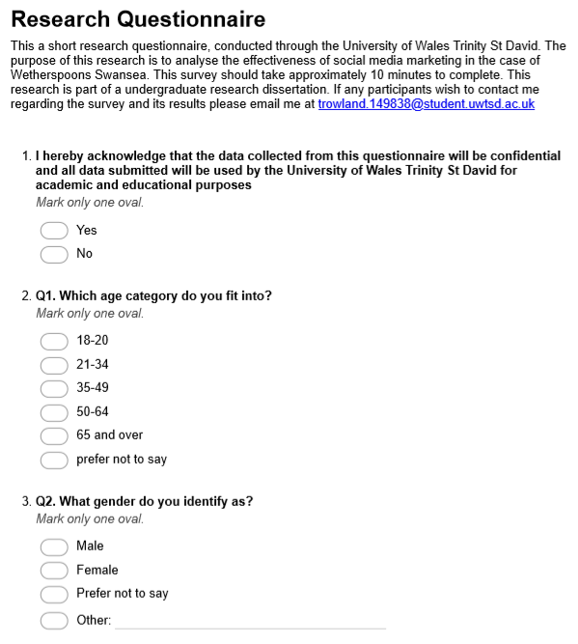

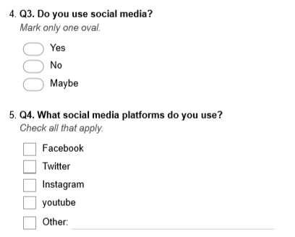

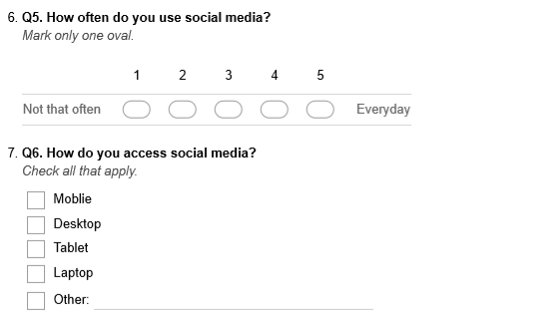
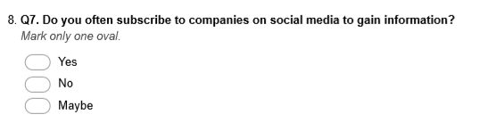

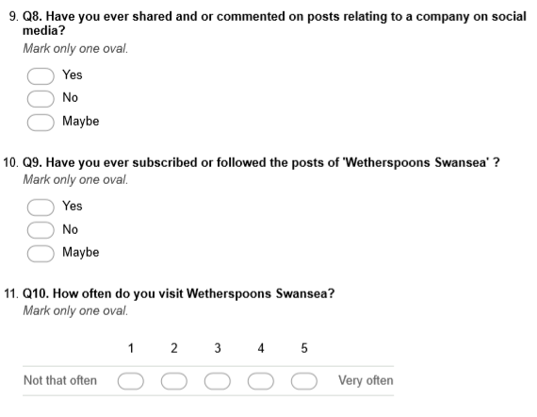
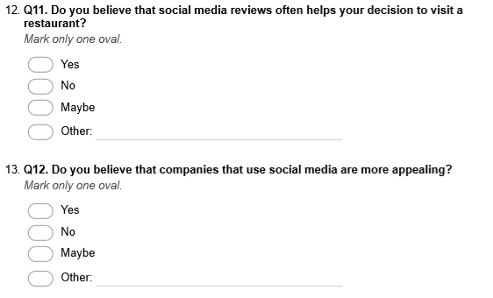

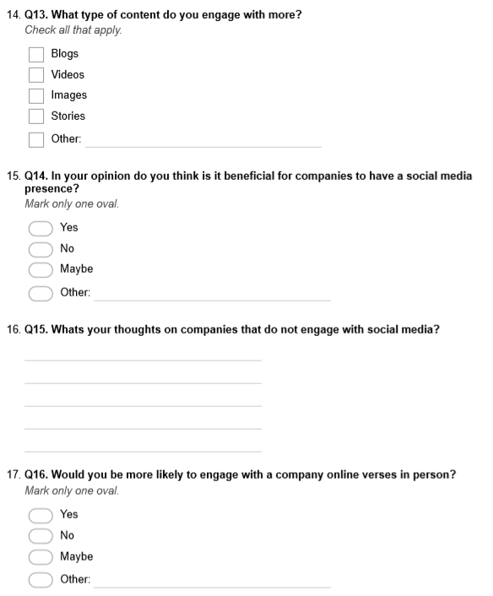
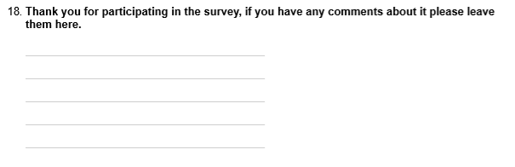

Appendix 4- Expert Interview Template

Expert Interview

My Name is Tyler Rowland, I am currently studying Business Management at UWTSD Swansea, as part of my dissertation study I am currently conducting research into the impact of withdrawal from social media a case study of Wetherspoons Swansea. In order to satisfy the research objectives this interview will seek to provide a better understanding of the topic area. This interview should take approximately 35 minutes to complete. This research is part of an undergraduate research dissertation. If any participants wish to contact me regarding the results, please email me at trowland.149838@student.uwtsd.ac.uk.
I hereby acknowledge that the data collected from this questionnaire will be confidential and all data submitted will be used by the University of Wales Trinity St David for academic and educational purposes

Sign: Date:

Have you worked for JD Wetherspoons Swansea?

How Long did you work at JD Wetherspoons Swansea?

What is your opinion companies such as Wetherspoons using social media as a marketing tool?

Were you ever asked to promote Wetherspoon’s social media pages or posts?

Do you think Wetherspoons understood the importance of social media marketing?

What are your thoughts on Wetherspoons decision to stop all social media activity?

What are your thoughts on why Wetherspoons decided to withdraw from social media activity?

In your opinion, do you think social media has a great influence on Wetherspoons customers?

Despite Wetherspoons decision to withdrawn from social media, do you think this has had an impact on its customers?

Do you believe that Wetherspoons is at a negative advantage to that of its rivals because of their decision?

Appendix 5- Completed Interview with Transcript

Expert Interview

My Name is Tyler Rowland, I am currently studying Business Management at UWTSD Swansea, as part of my dissertation study I am currently conducting research into the impact of withdrawal from social media a case study of Wetherspoons Swansea. In order to satisfy the research objectives this interview will seek to provide a better understanding of the topic area. This interview should take approximately 35 minutes to complete. This research is part of an undergraduate research dissertation. If any participants wish to contact me regarding the results, please email me at trowland.149838@student.uwtsd.ac.uk.
I hereby acknowledge that the data collected from this questionnaire will be confidential and all data submitted will be used by the University of Wales Trinity St David for academic and educational purposes

Sign: Date:

Have you worked for JD Wetherspoons Swansea?

Yes, I have.

How Long did you work at JD Wetherspoons Swansea?

I worked for two Wetherspoons one was for 6 months and the other was 2-3 months.

What is your opinion companies such as Wetherspoons using social media as a marketing tool?

It’s clever, because who doesn’t have social media these days? I’m for companies to use social media, I don’t use it a lot myself, but I know many people do that’s why I think is it clever from companies to implement social media as a marketing tool.

Were you ever asked to promote Wetherspoon’s social media pages or posts?

No, I only work as a bar and kitchen assistant, they were more the senior managements task, I assume the social media activity was delegated between the management team. However, If I was asked to promote for them I would of.

Do you think Wetherspoons understood the importance of social media marketing?

Yes, each Wetherspoons had their separate social media page, each branch of Wetherspoons would promote offers and events, although some were more activate than others. For example, they would promote events such as ale festivals, I believe that promoting events through social media was very successful for Wetherspoons as it brought more custom.

What are your thoughts on Wetherspoons decision to stop all social media activity?

I’m not actually sure why they stopped it, but I assume that it would have a negative effect on Wetherspoons ability to reach certain customers. However, as Wetherspoons is a large company I don’t think that it will have a hugely negative effect.

What are your thoughts on why Wetherspoons decided to withdraw from social media activity?

I can understand when people use social media platforms such as Facebook to complain about companies such as Wetherspoons which gives them a negative image. I believe that social media can be a tool to help companies, but it also can have major negative effects if the company are unaware of its customers reactions and feelings towards them.

In your opinion, do you think social media has a great influence on Wetherspoons customers?

I think people will go to Wetherspoon no matter whether they have bad rating online or complaints. I believe that this could be a reason why Wetherspoons decided to stop social media because they believe in word of mouth and also have a valued customer base.

Despite Wetherspoons decision to withdrawn from social media, do you think this has had an impact on its customers?

No, as far as I am aware of Wetherspoons has been as popular as ever, it’s not all about promotion, the food quality and prices are very good also Wetherspoons locations are very
convenient.

Do you believe that Wetherspoons is at a negative advantage to that of its rivals because of their decision?

Potentially, some people many see posts on social media from other restaurants and go there instead. I believe that many customers use social media to assess whether a restaurant is worth going to, I believe that social media has a great influence on younger customers, therefore, it would be wise to engage with them over the use of social media.

Appendix 6- Sample participant information sheet

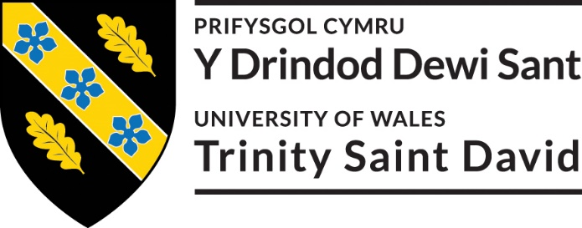
Cyfranogwr Rhif Adnabod:
Participant Identification Number:
FFURFLEN GANIATÂD CYFRANOGIAD | SAMPLE PARTICIPANT INFORMATION SHEET
TEITL Y PROSIECT: / PROJECT TITLE: The impact of social media withdrawal: a study of Wetherspoons Swansea

The research gathered from this questionnaire/interview will contribute to an undergraduate dissertation at the University of Wales Trinity Saint David.

The predominant aim of this dissertation is to critically analyse the importance of social media marketing and its effects on consumer behaviour as well as further investigate the impact of Wetherspoons decision to withdraw from social media marketing. To successfully reconcile this aim, this dissertation thought extensive research surrounding the subject will aim to achieve the following objectives:

- To conduct research on the importance and impact of social media marketing on consumers in the food and beverage industry in the case of Wetherspoons.
- Investigate the impact of Wetherspoons decision to withdraw from their social media marketing campaigns and its effect on organisational performance.
- To conduct primary research in the form of interviews and questionnaires to identify the importance of social media marketing and its effects on consumer behaviour as opposed to traditional forms of marketing.
- Provide recommendations on the importance of social media marketing, the continued use of social media marketing and the impact of withdrawal from social media marketing.

All data collected will be confidential, secure and private. No persons will be able to access the data without consent from the participant apart from the researcher in accordance of general data protection regulation.
If you have any questions or concerns, please contact Tyler Rowland at
trowland.149838@student.uwtsd.ac.uk
Thank you for your participation.

