Introduction
this part of course work I will talk about it deeply the subcontractors who’s take part from my construction commercial building blocks divided in different sub-blocks project overall these are the activity of my project Site clearance, Excavation for levelling, Guide wall construction Diaphragm Wall, Excavation top floor basemen, Anchoring, Excavation to basement Raft foundation, Steel structure, Pre-cast slab flooring, Zinc sheets roofing and Unitised Curtain walling.
The most of above activity I will handed by select subcontractors to carry out the work I need to do. To have clear understanding the subcontractors is a common term used in construction. Due to the uniqueness of each construction project, the work force is transient, multiple activity are involved, each project are planned and worked in short time frames, and variety of materials and equipment’s required, one single construction project is often sublet to many subcontractors. Subcontractors can contribute huge amount of value of total project value to in construction process

Subcontractors
Subcontractors are specialist in the execution of a specific job, they go about as a specialists of the generation arrangement of the temporary worker organization in providing materials, manpower, equipment, tools or designs, A subcontractor is a development firm that agreements with a general contractual worker to play out some part of the general contractual worker's work. In most development extends, a key part is played by subcontractors who are procured to perform particular errands on a venture. In the typical case, the general temporary worker will play out the essential operations and subcontract the rest of different forte contractual workers. Subcontracting is used much more extensively on housing and building construction projects they are resources to help the client to complete projects and provide specialized skills when needed. In other words, they are a flexible solution to labour.

Management of my Subcontractor
These are the effective tips to manage my subcontractors in my construction project.

Qualify your subcontractors
Take a look at out the subcontractors in advance of time so we realize what we are getting. Take a look at out their previous projects; confirm required licensing and insurance before they begin any work; and find out about any preceding worker’s completed and check in any change in safety facts.
- Screen thoroughly. Look at:
- Previous work experience
- Previous supervisory experience
- Safety records
- project management
- Legal history
- Their processes on and off the working site

Set expectations immediately
Once we've got absolutely everyone signed on we need to ensure all subcontractors understand how you need the paintings run and the usual of pleasant you require. Don’t just anticipate subcontractors understand exactly what to do. in the event that they purpose problems, they are able to expos to legally and operational troubles that would price you dearly
Use written contracts so the documents are binding and enforce accountability.

- Have a statement of work that specifies:
- Each party’s responsibilities and authority
- Detail of deliverables
- Quality standards and acceptance-of-work processes
- Constraints on the subcontractor
- Definitions of services
- Terms and conditions for all parties
We also need the customer to recognize who the subcontractors are and the jobs they play. Make it clean which you are the point of contact for the venture
Plan
Initially, a well-organized the operating website online will help get the most my subcontractors, Ensure we stroll the site earlier than paintings starts off evolved so everybody is everyone is familiar with the area
Include the subcontractors in:
- Safety talks
- Workflow planning
- Material deliveries
- Anything else impacting the subcontractor’s work.

Scheduling
All members of project needs to recognize how they suit into the whole mission. That is an area wherein a good programming resource can easily guide my task proper give up.
Create a venture plan that includes a precise scope that's then subsidized up by using the appropriate time table. The schedule ought to include restraints along with due dates for deliverables. It must also display contractual and different milestones so that you can account for development this construction commercial building blocks divided in different sub-blocks projects require supplemental schedules keeping all dependencies visible and to provide more documentation on how critical parts of the project will get done. A signed work authorization can help you keep track of when and where a subcontractor works on a given day. It also helps ensure previous work has been completed to the required standards.

Supplemental schedules include:
- The assigned cost account
- What budget it’s paid from
- All scheduling constraints
- All deliverables for that stage of the project
- The responsible manager’s name
- The names of reviewers
- The names of those who accept deliverables

Team building

Crew constructing is any other way to keep all people at the identical as one and feeling like a part of one family team. Begin with an icebreaker so everybody receives to realize one another. Then have them work on brief sporting activities to get them used to running collectively. Don’t let this disrupt any schedules. If wished, you can rent a person specialised in crew constructing to provide you a hand
Communicate early
We want to identify a single factor of contact for each subcontractor and offer all the data they want in order for them to fulfil their contract. Subcontractors want to talk with different member of the mission as properly; help them get together on speaking development and needs.
Set up and consist of verbal exchange channels as a part of any supplemental time table and put up a modern undertaking contact sheet for every subcontractor concerned. At the start give an explanation for the task in element, acquiring feedback we move. Open communication keeps the project prepared. Make it my venture to know your subcontractors other initiatives to keep matters coordinated and make sure availability. Have frequent conferences to review upcoming paintings and to preserve the focal point at the interdependency wished for the task
Establish progress reporting
We may use an informal ballot of every subcontractor to note into the each day logs. However, we ought to also establish a proper reporting structure along with weekly meetings with each subcontractors that drills all the way down to the fee account level.
Include:
- Progress made against authorized work
- Milestones achieved
- Accounting of costs billed
- Estimate of time remaining
- List of unplanned work and time spent
- Descriptions of any problems

As project manager (PM) we can then use the information to compile monthly reports that are itemized down to the work breakdown structure level at each meeting:
- Ask about potential issues
- Give feedback on work
- Include client evaluation

Deal with problems immediately, don’t let them grow or fester, Put explanations in writing and be specific about what the subcontractor must do to get back on schedule. We may need to spell out intermediate milestones for daily work and reporting. Emphasize the consequences if goals are not met. Once everything is communicated, solicit agreement and a signature from the subcontractor in question. Finally, meet at the end of each job to provide constructive feedback and adjust processes as necessary.
Show the money
Always make sure your subcontractors are paid on time, even if your client is late paying you. There is no better way to install the loyalty of good subcontractors. Include enough so they can both complete work and manage their job. A typical contract will specify partial payment at 30 and 60 days into the project, depending on its length. Review the hours the subcontractor reports and be available to answer questions and help with problems, we can use it as a record of payment and link it to procurement accounts and other databases to get a complete view of cash flow.

Project Management Life Cycle & How My Subcontractors Participate
These are five stage of project management
- project initiation (kick-off or start)
- project definition, planning and development
- project launch or implementation (sometimes known as project execution)
- project monitoring and controlling
- project clos

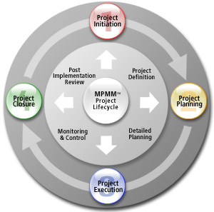

By info.co.uk
Project Initiation
Project Initiation is the first section within the venture lifestyles Cycle and basically includes setting out the assignment. You initiate a challenge through defining its reason and scope, the justification for initiating it and the solution to be applied. We will additionally want to recruit a suitably skilled mission crew, installation a challenge workplace and perform an cease of segment evaluate. The Project Initiation phase involves the following six key steps:

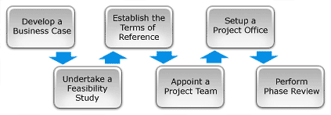
By Professional Edition 2015 Project Management

In this part of project life cycle my subcontractors responsibilities and role is to know what the project aims to achieve, what resources they need and what material they need as begin of work and to put forward the office and facility locations.

Project Planning
After defining the project and appointing the project crew, you're prepared to go into the special project planning segment. This involves growing a collection of making plans files to help guide the group throughout the challenge delivery. The Planning Phase involves completing the following 10 key steps:
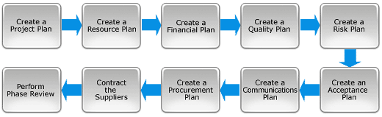
By Professional Edition 2015 Project Management

In this part of project life cycle my subcontractor’s responsibilities during this phase is to get all drawing, details of the site and create of a set of plans to help guide your project team through the project execution and closure. These plans should set out a clear specification for what needs to be done, who needs to do it, and when.
Project Execution
With a clear definition of the mission and a collection of detailed venture plans, you're now ready to enter the Execution section of the project. This is the phase in which the deliverables are physically built and presented to the purchaser for attractiveness.
while every deliverable is being built, a collection of management strategies are undertaken to display and manage the deliverables being output by means of the undertaking. Those tactics encompass dealing with time, fee, quality, alternate, dangers, troubles, suppliers, clients and communique. Once all of the deliverables have been produced and the client has every day the very last solution, the mission is ready for closure

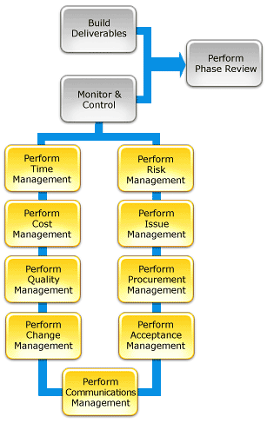
By Professional Edition 2015 Project Management

This part of project life cycle is most important part that my subcontractors responsibilities is to cover all given activities such as Guide wall construction Diaphragm Wall, Excavation top floor basemen, Anchoring, Excavation to basement Raft foundation, Steel structure, Pre-cast slab flooring, Zinc sheets roofing and Unitised Curtain walling. At this stage, it is important to carefully monitor and control the project to keep focus on its objectives. We can use a range of processes to help you manage things like time, cost, quality and risks, or to communicate progress and manage client acceptance

Project Monitoring and controlling
During the implementation stage, you should keep track of project progress and deal with any issues that arise from day-to-day work. Observe and measure project performance regularly against the predicted expectations of the project plan, and measure quality to maximize chances of project success in this stage my subcontractors need to work with the activity programs and finish every activity on time and delay or work not finish on time they have report the project manger
Project Closure
Project Closure involves releasing the very last deliverables to the consumer, turning in project documentation to the task terminating provider contracts, freeing project assets and communicating assignment closure to all stakeholders. The final step is to undertake a post Implementation review to discover the extent of task success and note any instructions discovered for future initiatives
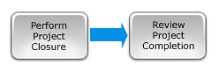

Project closure is the last phase in the project life cycle. During this phase my subcontractors need to finalization of all activities across the project, handover into project as usual, withdraw the plants and labour.

Conclusions

Selecting the proper subcontractor approach will help the task achievement of a project. Coordination and monitoring of subcontracted paintings in the course of the development stage is essential so as no longer carry any threat into the project proposed a rating machine for management of subcontractor with the aid of the use of neural community. In having access to the competitor subcontractors, and the season of my choice in specific subcontractor must consider five main parameters, namely price reduction, time reduction, technical/qualitative characteristic of the bid, contractual reliability of the competitor, and management skills of the competitor. Effective subcontractor selection and monitoring which can minimize the problem would determine the success of construction project.

Reference

Professional Edition 2015 Project Management Methodology by frank Stillo New York Chapter USA

Smith, N. (2000) Engineering Project Management, Oxford, Blackwell Science Ltd.
https://www.nibusinessinfo.co.uk/content/five-stages-project-management (Accessed 5 January 2018)
http://www.pn-projectmanagement.com/construction-management-blog/managing-your-subcontractors-ensuring-your-project-is-successful (Accessed 4 January2018)
http://blog.altiusva.com/5-things-you-are-responsible-for-if-youre-managing-subcontractors(Accessed 7 January 2018)

