managing change in tourism organisations
BMMB7011

Rhian Carys Ann Cook
MTour

VIRTUAL REALITY IN MUSEUMS: CASE STUDY OF THE BRITISH MUSEUM, LONDON

LECTURER: MIKE DAVIES

Table of Contents

Executive Summary 1
Introduction 3
Virtual Realities Relationship with Tourism 4
Why Virtual Reality has been introduced into the British Museum 6
Lewins Force Field Analysis 6
Kotter’s 8 Step Model 5
Beckhard & Harris Change Formula 7
Mendelows’ stakeholder matrix 8
Brexit implications surrounding The British Museum 12
Conclusion 14
References 17

Executive Summary
This report examines how The British Museum in London has introduced virtual reality into the museum. Virtual Reality was first introduced to the British Museum in 2015 in partnership with Samsung. After a successful virtual weekend, the Museum has adopted more ways of utilising virtual reality at the attraction. This includes virtual reality exhibitions inside the Museum as well as users having the ability to view through online platforms. In an increasingly digital World, the museum has introduced a digital change within the premises whilst maintaining exhibitions that are more traditional.
Within any organisation that has introduced change there is a need for critical analysis to consider how viable the changes will be long term. There are both negative and positive impacts of introducing virtual reality within the museum, both of which are analysed in this report. The report also analyses the impact of virtual reality on the marketing of The British Museum and its target markets. As one of the first museums to introduce an online virtual reality-viewing platform it is important to assess how and if visitor numbers have been impacted by the change, this is addressed in the report.
The need for change has been discussed throughout the report and theoretical models have been used to explain the drivers and resistors of change using Lewins Force Field Analysis, Kotters Eight Step Model and Beckhard and Harris’ Change Formula.
It has been established throughout this report that the main drivers for change have been engaging the centennial generation, maximising museum exhibits, staying relevant in a digital world and the preservation of cultural heritage. Alternatively, the report has found that the negative impacts of virtual reality in The British Museum is the suitability of the product for everyone because of negative side effects, the initial costs of setting up and maintaining digital collections, social impacts on users, and the fact that virtual reality lacks the complexity of real life objects. Though positive and negative impacts have strong arguments overall it is evident that the introduction of virtual reality into The British Museum has been a positive one.
Brexit is still not finalised and the influence on Museums is still unestablished as Britain finalises negotiations before March 2019. However, this report has assessed the possible outcomes of Brexit upon the Museum and has concluded that they will all have a detrimental effect on The British Museum. The possible loss of European Staff and Collaborators plus the possibility of losing inbound tourists if it is more difficult to enter the UK post Brexit will affect the Museums culture and finances.

Introduction

This report will be critically analysing a digital change in the tourism industry. The report will specifically focus on the introduction of Virtual Reality in The British Museum, London and why or if the change has been necessary. In addition, the report will consider how the change was implemented, the positive and negative impacts of introducing virtual reality to the museum, possible Brexit implications on the museums future and finally conclude if the change was an addition to The British Museum.
The British Museum was the UK’s leading attraction in 2017 receiving almost six million visits (Statistica , 2018) beating The National History Museum and The Victoria and Albert Museum with over four million and three million visits respectively.
Located in the Bloomsbury district of London, The Museum celebrated its 250th birthday in 2003 (The British Museum , 2017). It is a free Museum funded by Trustees, Patrons, The Department of Media, Sport and Culture, Membership, Fundraising and The British Museum Friends who raise funds in an American division as well as the UK (The British Museum , 2018 ).

Virtual Realities Relationship with Tourism

Tourism in general has largely benefitted from technological and digital advancements. Online bookings, user generated content and the accessibility of smart phones for research at home and whilst travelling have all played a major role in shaping the tourism industry into what it is today.
Virtual Reality is no exception to this, According to Guttentag (2010) in a touristic context, virtual reality is of upmost importance in tourism as almost all tourist experiences depend on visual stimulation. Similarly, William and Hobson (1995 ) encouraged virtual reality in tourism claiming it could revolutionize tourism relating to the promotion and selling of tourism. The fact that a destination, attraction or tour can be accessible at your fingertips around the World could encourage those immersing in virtual reality to go a step further and actually visit the destination they are experiencing through technology.
All over Europe and further afield museums and culture and heritage attractions have been introducing VR to their exhibitions. The British Museum was one of the first in the World to implement elements of virtual reality into their attraction. Other European Countries were quick to follow suit such as France, The Netherlands and Finland whilst The USA and Asian Countries such as Singapore are also incorporating VR into attractions (NY Times , 2018 ).
The British Museum initially started its journey into the World of Virtual Reality in 2009. In the basement of The Great Court, the Samsung Digital Discovery Centre (SDDC) was the Museums initial dive into the virtual World. Then in 2015 in the main museums building an augmented reality exhibition about the Bronze Age was opened up to the public with a mixture of real life objects and technology (The Guardian , 2015). The initial opening of the Bronze Age Exhibition welcomed over 1,200 visitors with 80% rating the exhibition as ‘very good’ (Rae, 2016). Since the SDDC opened its doors it has been visited by over 115,000 people (The British Museum , 2018 ). The most recent developments in virtual reality at the museum is the virtual reality Egyptian Gallery. Designed and developed in conjunction with Oculus, the gallery is accessible from anywhere in the World on smart devices or using Samsung Gear VR.

Why Virtual Reality has been introduced into the British Museum

Burke (2017 ) states organisations are constantly changing, often unplanned and gradually. Burke also claims that present day organisations are playing ‘catch up’ as the external environment is changing more rapidly now than in previous decades. This could be true for The British Museum, traditionally museums have been a place to admire historical relics, study anatomy, and ponder at artwork created long before our own time and to read and learn new things. At present, external factors have driven the change in the Museum to embrace digital change because of the demand for digitalisation in the World today.

Lewins Force Field Analysis

Lewin (1973) explained change though his force field analysis. In the middle, the ‘status quo’ represents the current situation that in the case of The British Museum would be that virtual reality has already been introduced. The drivers for change versus resisting change can be applied to The British Museum as shown on the next page.
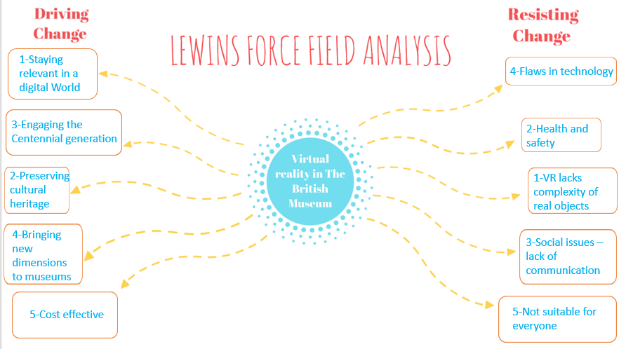
Based on: Lewins Force Field Analysis (Lewin, 1973).
The biggest driver for change within The British Museum has been staying relevant in a digital World that also relates to engaging the Centennial generation. The Centennial Generation, also referred to as Generation “Selfie”, Generation “Instant Gratification” and Generation “Reality TV” refers to those born after 1998 (Williams, 2017 ). The Centennials only know a World that has technology, they have had the internet at their fingertips all of their life and the Internet is a huge part of the Centennial’s lives. To ensure they stay relevant, The British Museum needs to appeal to this generation to engage younger people to keep fresh custom flowing through the Museum. Through the introduction of augmented and virtual reality, it ensures the centennial generation can understand the museum in a way they are familiar with. Visits to Museums are steadily declining with a decrease of 3.1% in 2015-16 for people under 18 and in formal education (Museum Association , 2017). A report released by the Department for Digital, Media, Culture and Sport (DMCS) who are the main source of funding for The British Museum showed in 2017/18 there was a 37.8% increase in visitors under the age of 18 across all of the DMCS sponsored Museums and Galleries. The British Museum being the third most popular attraction beneath The Science Group Museum and The Natural History Museum (Department of Media and Culture , 2018 ). Therefore, it is evident that although The British Museum is the most popular attraction in the UK it is under performing compared to its competitors concerning School visits. Educational visits are imperative to Museums as they provide a large percentage of visitor numbers and the aim is that the child will be inspired to return with their family increasing the visitor numbers further. The need to engage under 18’s is vital to The British Museum, and with the developments in digitalisation, it is likely to attract this demographic. It is possible that the Science Museum and The Natural History Museum have succeeded The British Museum is because of the large range of interactive exhibits. The British Museum understand this, thus both the Bronze Age and Egyptian VR exhibits have been targeted at the Key Stage 1 audience who have to study history as part of the curriculum, therefore one of the aims was to stimulate learning through technology (Rae, 2016).
Equally as important is the need to preserve Cultural Heritage. Every year Museums experience damage to displays and exhibition either through error whilst installing, consumers touching the exhibits or natural factors such as sunlight, temperatures and ageing. An example of using replicas to preserve cultural heritage is the Lascaux Caves, France. Due to irreversible damage caused by visitors, breathing out carbon dioxide, humidity and body heat the decision was made to close the caves to the public and create an exact replica that visitors could enjoy. Although met with some controversy, travel writer Chris Leadbeater (2015 ) says “The choice between seeing the real thing and being a part of its ruin simply by standing next to it – or enjoying a detailed state-of-the-art reproduction – is surely no choice at all”. Similarly, to the Lascaux Caves, The British Museum is offering the visitor a chance to enjoy cultural heritage whilst protecting it. Although the decision could be seen as controversial, when protecting artefacts and important elements of culture this should be prioritised over risking damage in exhibits.
Museums every year place thousands of artefacts in storage, some of which are never seen by the public eye as space is sparse and collections are extensive and expensive to display. Virtual reality has the ability to create new dimensions to museums that would not be physically possible and have the opportunity to open up collections to the World through online platforms (Durrant, 2017). Although it is positive to be able to display more collections through virtual reality, as shown in the resisting forces VR can lack complexity of real objects. Research has revealed that 70% of people visiting a museum website would subsequently be more likely to go and visit the ‘real’ museum as opposed to viewing the museum through a virtual platform (Sylaiou Styliani, 2009 ). This counteracts the need for virtual reality to be introduced on an online platform but has no impact on virtual reality as an exhibition in The British Museum as visitors who prefer to physically visit may still utilise VR at the Museum.
Other forces driving change is the cost effectiveness of digitalising collections. Digitalising collections and using virtual reality can be a costly process. An ENUMERATE report based on a survey of cultural heritage institutions shows they only intend to digitise 60% of their collections, due to cost (Axiell , 2016 ). However, although initial costings are high, the longevity of digitalising collections is more cost effective than maintaining collections physically and overheads lessen as staff numbers are likely to decrease. Technology often experiences flaws and virtual reality is no exception to this as shown in the resisting forces, this can effect visitor experience and can be costly to repair which causes a resistance to the change.
Social issues surround the development of virtual reality within museums. As the target market for VR at the British Museum is largely the key stage 1 visitor it could be possible that there are negative social affects on the key stage 1 user. Research surrounding the effects of digital technology has found that although children’s relationships generally are not negatively impacted by technology use, there are other areas that influence a child’s social skills that can be attributed to technology use. It has been established that the use of technology and computer games increases loneliness and depression in children as well as blurring the lines between reality and simulation (Kaveri Subrahmanyam, 2000). The potential negative effects of technology on adolescents learning has been studied by Professor Sherry Turkle, professor of Social Studies of Science and Technology at MIT. Turkle (2015 ) found that over the span of 20 years there is a 40% decline in college students on measurements of empathy and cited lack of face-to-face communication and too much time spent with technology instead of engaging is the reason why. Turkle also expressed that lack of face-to face interaction is one of the biggest contributors to bullying which is a problem in British Schools. Key stage 1 children are at a vital stage of development and building relationships and the ability to do so is detrimental to the child’s future. By promoting digital learning and in particular virtual reality, which does not require communication, The British Museum could be encouraging these trends. In spite of this virtual reality has been productive when utilised in learning with children who experience cognitive behavioural issues. There is increasing research to support the positive effects of VR in relation to individuals with Autism Spectrum Disorder (ASD). It has been documented that VR allows those with ASD to practice social skills in a safe environment with opportunity for repeated practice, which then can be used in the real world as well as the virtual world (S. Parsons, 2002). Overall, it appears negative behaviours associated with technology use for children and young people are a cause for concern in some areas, however largely the benefits of using technology and in particular virtual reality outweigh the negatives.
Virtual reality similarly to all technology will not be suitable for everyone. Oculus, the company that is working with The British Museum and developing their virtual portfolio list possible negative side effects as seizures, loss of awareness, eyestrain, twitching, visual abnormalities, disorientation, impaired hand-eye coordination, nausea and any symptoms similar to motion sickness amongst many other possible effects (Reed, 2014). It should also be noted that Samsung do not recommend use of VR if they are tired, have digestive problems, hungover, experiencing anxiety or emotional stress or have any flu like symptoms (Reed, 2014). Furthermore, Oculus and Samsung do not advise any person under the age of thirteen to use their virtual reality headsets (Hill, 2016). It would appear irresponsible for The British Museum in collaboration with Samsung and Oculus to be promoting the use of VR to children when the manufacturer state that the age range in question should not be using the technology. Manufacturer’s also state prolonged use is unadvisable and may increase the likelihood of adverse effects, the advised maximum being thirty minutes. However, the problem posed to the museum is how they can control the amount of time the public use on these headsets and in particular, how they control the use by children. It is also difficult to establish everyone who uses VR at the British Museum’s health and if they are fit enough to use the exhibitions that use VR. Reed (2014) states that the lack of evidence into the long term effects of VR should not stop us using it, although companies and users should proceed with caution. Professor Sarah Sharples who is the President of the Chartered Institute of Ergonomics and Human Factors supports this. Sharples tells The Guardian “Absolutely there are potentially negative effects of using VR. The most important thing that we should do is just to be cautious and sensible,” she says. “But we shouldn’t let that stop us from taking advantage of the massive potential this technology offers as well” (The Guardian , 2016).
Health and Safety is a major area for consideration for any attraction that is open to the public. Although museums at times can be overcrowded and thus a danger, virtual reality allows users to walk around using headsets that could alter their perception of their surroundings which could cause accidents. This negative impact of VR is also a resisting force to the change, with The British Museum experiencing high visitor numbers anyway, the notion that crowds of people could be walking around with restricted vision would provide a health and safety nightmare.
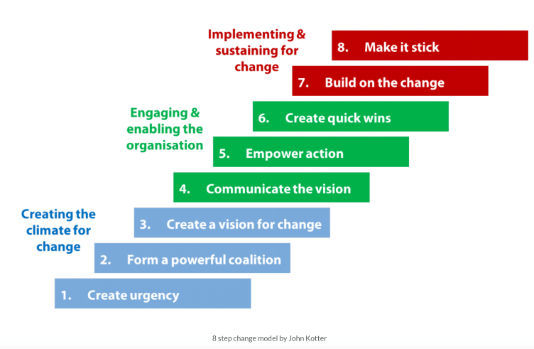
Kotter’s 8 Step Model According to Kotter (1995 ) “The eight common change errors slow new initiatives down, create unnecessary resistance, frustrate people endlessly, and sometimes completely kill needed change.” Kotter identified eight common reasons change fails in organisations before creating the eight-step model on how to successfully implement a planned change. As introducing VR into The British Museum was a planned change, to test its success it is useful to compare it to Kotter’s eight-step model.
The initial step in Kotter’s model is to create the climate for change starting with urgency. From the 2004/5 financial year, The British Museum experienced a period of growth reaching a peak of 6.8 million visitors in 2015/16 (GOV UK , 2018). However, in both 2016/17 and 2017/18 financial years the museum has seen a downturn in visitor numbers. The decline in visitor numbers is enough to create urgency for change and create new innovative ways to attract more visitors.
In 2009 The British Museum formed a coalition with Samsung to develop virtual reality in the Museum, this was implementing step two and three. By collaborating with Samsung, The British Museum created the vision for change and increased the power of this by introducing Oculus to the collaboration in 2017 to develop virtual reality further and make it accessible to online viewers as well as counted heads at the museum.
The Museum communicated the vision to the public who are a major stakeholder in the organisation through press releases in major UK newspapers. They also enabled themselves to create a ‘quick win’ by steadily implementing the change over one August weekend in 2015. By building hype around the event it got the public interested and over 1,200 people turned up to the initial virtual reality weekend.
Acting on the success of the VR weekend, The British Museum built on the change and created more user-friendly virtual reality aimed at the key stage 1 market. The change was further integrated when the Egyptian Collection adapted virtual reality for visitors to The British Museum, as well as making the VR collection fully accessible online enabling anyone with a smart device to access the collection anytime, anywhere.
Thus far, virtual reality in The British Museum has proved a welcome change. The venture with Samsung and later Oculus has won numerous awards including Best Augmented Reality Campaign, Best Education and Learning Sponsorship and Best Digital Museum Experience (The British Museum , 2017) as well as welcoming thousands of young people and families into the Samsung Digital Discovery Centre as well as online participants.

Beckhard & Harris Change Formula

Beckhard and Harris’ 1977 Change Formula is a relevant way to demonstrate the digital change within The British Museum.
The Formula is made up of Dissatisfaction X Vision X First Steps > Resistance to change
When applied to virtual reality at the British Museum the Formula would be:

D V F R
Drop in visitor numbers
Engaging Centennials
Keeping up with trends in a digital age
VR lacks complexity
Social Impacts
Health Impacts
Not suitable for everyone
Costly set up process
2009 – Samung collaboration – birth of SDDC
First Museum in the UK to start using virtual reality
Introducing VR in the museum and online to provide new collections and engage the younger generation


Based on: Beckhard & Harris (1977)
There are similarities between Beckhard and Harris’ Formula and the principles of Lewins Force Field Analysis shown explained previously. Both incorporate drivers for change against resistors for change, also known as Luddites.

Mendelows’ stakeholder matrix

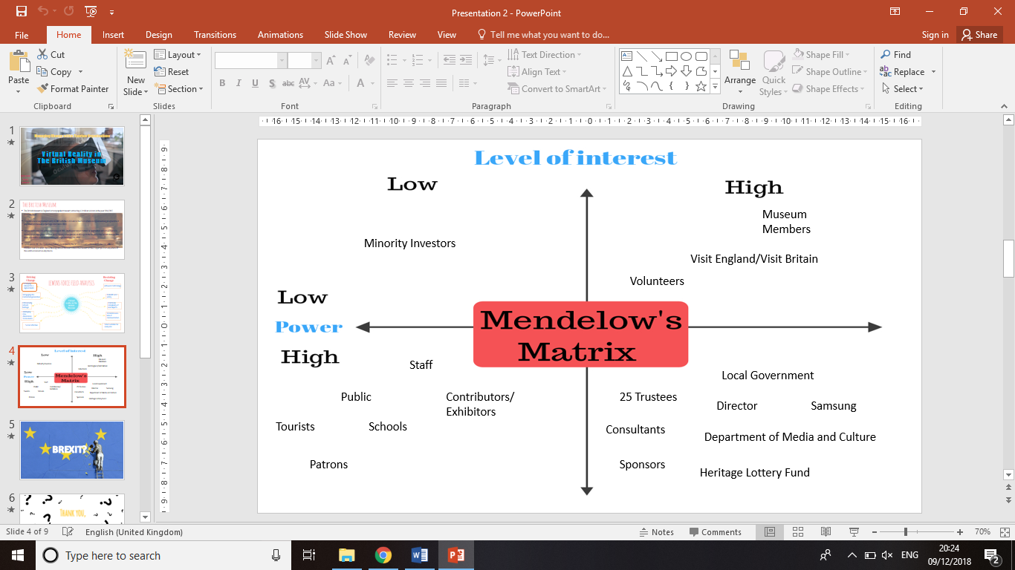
Adapted from: (Mendelow, 1981)
Mendelows’ stakeholder matrix demonstrates the different powers and levels of interest according to the main stakeholders in a business or organisation.
In the case of The British Museum, those who hold the most interest and power are the trustees, local government, director and the organisations who provide funding to the Museum and specifically to the development of virtual reality within the museum.
The local government hold a high level of power and interest because they not only part fund the museum but they are the main beneficiaries of any indirect economic impact that arises from visitors to the museum spending in the local area. As well as this, the economic impact effects the local government because increased numbers of people in the area requires attention to road planning and maintenance, increased amounts of litter and wear and tear on buildings and public walkways and increased health and safety provisions on busy days at the museum in the Bloomsbury area.
The director and trustees of the museum have a lot of power over the decision-making processes and have a high interest in the success of the museum, as it is a reflection on their performance. Likewise, consultants have a high level of power and interest if only for a short time within the consultancy period. Often consultants come in to manage change within an organisation and it is within their best interest to do a good job, as an outsider in the organisation they are often given high levels of decision making power during the consultancy period.
The main funding for The British Museum derives from The Department for Media, Culture and Sport. As the funding comes from the public purse it is crucial the museum spends wisely and the DMCS will have power over where funds are allocated, their interest level will also be high to ensure the museum is financially viable and is sustainable into the future. Similarly, the Heritage Lottery Fund have high influence over fund allocation if they are providing investment. The Museum will be unable to make any decisions without justifying what and why they are spending the money on to The Heritage Lottery, they hold a great deal of power as to continue a financial partnership their criteria must be adhered to.
As the provider of virtual reality, Samsung have an increased interest and power over the success of VR exhibitions in the Museum. As Samsung are not exclusive to the Museum and have virtual reality headsets on the market for the public, they have a high interest in ensuring customer satisfaction, as it is a useful marketing strategy and could in turn boost sales within their VR range. As the provider of technology, they have power over how they develop the VR exhibitions in collaboration with the museum. Without Samsung’s input the exhibitions and online VR presence may not exist and it would be costly should they withdraw for both parties.
Any visitor or contributor to the Museum including children, families, tourists and staff are likely to have a lower level of interest but high power. Any visitor or contributor can decide to use a different museum to exhibit at or visit. In a World were loyalty in consumers is in decline it is in the museums best interest to keep these people happy. As The British Museum is the highest ranked attraction in the UK, potential travellers will decide to visit when researching things to do regardless of what exhibits may be there at the time, thus enforcing the notion that the interest levels are low. Contrary, many visitors will choose to visit based on visiting something specific.
Staff can be identified as having low and high power dependant on the context, as well as having high and low interest. In terms of pay, job security and work place culture staff are likely to have a high interest. Therefore if the museum is underperforming the staff will have little power over big decisions taken by managers and major stakeholders but will be interested how it will personally effect their financial status and enjoyment in the workplace. Alternatively, staff hold a great deal of power as if they are unhappy in their workplace it is likely to effect performance and customer service. In turn, this will affect the visitor experience. Stanley (2005) conducted research into employee empowerment effects correlating to financial success and found corporations that empowered staff statistically had greater financial and investment results versus organisations lacking employee empowerment. Although The British Museum is a non-profit organisation, they do accept donations, which are more likely if staff have provided a good experience for guests. Furthermore, virtual reality is a relatively new investment for The British Museum the correlation between employee empowerment and positive investment results is important to maximise the potential of the virtual exhibits.
Those with a high level of interest but low power would include tourism boards such as Visit England or Visit Britain, because they have no financial ties to the museum they would not be part of any decision-making processes. However, they are highly interested in the running of the museum and its successes as it provides essential tourism figures and promotes Britain as a destination, which is their overall organisation aim. Volunteers would likely fit into this area also because they must have a high interest level to be interested in working free for the museum, but as an unpaid employee, it is doubtful they would have power over making decisions and would be expected to implement whatever The British Museum requires them to.

Brexit implications surrounding The British Museum

In 2016, The UK public voted via referendum to leave the European Union. At present, there is still a huge amount of uncertainty surrounding the implications of leaving the EU and how it will influence tourism.
Initially, the UK saw an increase in tourism immediately following Brexit with flight searches to the UK increasing by 61% from China, 49% from Canada and 31% from Europe while domestic tourism also increased (Reckless Agency , 2017 ). This surge in tourism could be attributed to the value of the pound increasing for inbound tourism and the decrease of the pound for domestic tourists. Unsurprisingly upon analysing visitor number data, it is evident that visitor numbers to The British Museum received much higher visitor numbers than pre-referendum with particular growth in the month of June through to November (GOV UK , 2018). However, the visitor increase was short lived with visitor numbers decreasing in 2017 and 2018. The uncertainty of Brexit negotiations could be a contributing factor to the recent decline. It is worth noting that terrorism may have also influenced this figure as London received an increase in terrorism activity that could be deterring tourists both domestic and inbound.
The inbound tourism market is monumental for the British Museum, between April 2015 and March 2016 the Museum attracted 4.4 million overseas visitors, in 2017/18 this number diminished to 3.65 million (Statistica , 2018). The loss of visitor numbers from overseas visitors can negatively affect the museums revenue, which has knock on effects. Although The British Museum is a free attraction, visitors spend on souvenirs, food and beverage and other retail offerings. VisitBritain estimates that Britain’s culture and heritage attracts £4.5 billion worth of spending by inbound visitors annually (Museums Association , 2010). Without sought after revenue from overseas visitors the museum will have less money to invest into new collections and further advancements, with the development of virtual reality being at risk being such a large upfront cost.
The European Funding provides a huge amount of funding to the arts and culture industry within the UK. The British Museum received £170, 486 from the EU for a programme aiming to generate new skills in addition to the £7million that received for research projects (Londonist , 2018). Currently there is unpredictability-surrounding replacement of EU funds by the UK Government. Becky Shaw (2016) a specialist in art law says, “EU funding for the arts runs into millions of pounds a year. Whilst the UK government will continue to support the arts, it is not unreasonable to expect a complete reassessment of how the arts in the UK are to be funded in the longer term.” Whilst there is no guarantee the UK Government will not subsidise funding, there is also inadequate information indicating they will. In times of austerity in Britain, it is questionable if the same amount of funding can be provided to arts and culture that the EU has because of the need to allocate funds to Public Services and because of budget cuts in Local and National Government.
The DMC states that 4.6% of workers in the UKs cultural sector are from the EU (European Union Committee, 2018) although the figure does not appear to be sizable, up to 23.7% percent of tourism hospitality employees in the UK are from the EU (Local Government Association , 2018) both of which can be attributed to the Museum sector. With uncertainty surrounding unimpeded access to EU workers to the UK, the loss of these workers will have a cultural impact on Museums in the UK including The British Museum because European Museums often collaborate. Not to mention the loss of skillset and diversity that could be possible if Brexit results in harsher working restrictions.

Conclusion

To conclude it is evident that there are both positive and negative effects of introducing virtual reality into The British Museum. The biggest benefits to the museum utilising virtual reality are the engagement of the centennial generation through using digitised education, something they have been accustom to their whole life. Children who are not focused academically may be more inclined to use something practical, which will stimulate their learning. The benefits it is proven to bring to those suffering with ASD are equally important as it shows the museum are supporting inclusivity. That said the museum should carefully consider the amount of time spent in virtual exhibitions due to lack of scientific research into the health connotations and possible effects on mental health in children and adults. By having a mixture of both virtual reality exhibitions and more traditional museum exhibits it is evident there is something for everyone and does not impact the traditional aspects that surround a museum visit.
Equally as important is the preservation of historic relics as once they are damaged they cannot be restored back to the original state, if at all. Adding in inevitable damage caused by environmental factors it is a much safer way of maximising the museum’s collections and the longevity of them. By adding more virtual reality exhibitions, the museum is able to display more to the visitor as opposed to many relics sitting in storage, which widens product the museum is offering.
The cost of digitising museums is also a negative impact upon the museum as well as technology flaws, which are often costly to repair. However, after initial set up costs, long term it may provide financial benefits due to a lesser demand for staff. As well as this, if a visitor is visiting through online platforms there are no costs to the Museum aside from the initial set up and maintenance of the programmes.
The visitor numbers for the British Museum have seen a steady decline over recent years so it is evident that in order to remain competitive new ways of enticing visitors have to be implemented. As the first Museum to use virtual reality in its exhibitions and online it is evident The British Museum are trying new innovative ways to increase visitor numbers and virtual reality has been a success according to visitor feedback.
Stakeholders are vital to the museum; The DMCS provide a huge amount of funding so it is important that they are happy with any changes that the museum makes, alongside other investors to secure future funding. Staff need to be empowered within the museum to ensure the digital change is a positive one, the fear surrounding job security and being replaced by digital exhibits will have the largest impact on customer service.
All of the negative and positive benefits of virtual reality are valid and should be continually assessed going forward to ensure the feasibility of VR within the museum. Extremely important is the impending problems that Brexit brings. Currently, the UK is in a situation where no affirmative deal has been established with the European Union. The impacts this could have on the museum are huge and need to be closely monitored to provide solutions to protect exhibitions, staff and potential tourists. If access to Britain becomes difficult for tourists, it is possible they will favour a different European destination.
The British Museum should continue to provide virtual reality to visitors to encourage visitors and by maintaining the long-established elements of the museum experience, it will expand its catalogue and accommodate all generations.

References
Adams, G. K., 2016. Economic fall out of Brexit will impact Museums- Warns MA. [Online]
Available at: https://www.museumsassociation.org/news/24062016-economic-fall-out-brexit-museums
[Accessed 27th November 2018].
Axiell , 2016 . Digital Transformation in the Museum Industry , Manchester : Axiell .
Burke, W. W., 2017 . Organization Change: Theory and Practice. s.l.:Sage Publications .
Department of Media and Culture , 2018 . Sponsored Museums and Galleries Annual Performance Indicators 2017/18 , London : Crown Copyright .
Durrant, A., 2017. How can virtual reality be applied to Museums?. [Online]
Available at: https://www.pebblestudios.co.uk/2017/07/29/how-can-virtual-reality-be-applied-to-museums/
[Accessed 26th November 2018].
European Union Committee, 2018. Brexit: Movement of People in the Cultural Sector , London : Authority of The House of Lords.
GOV UK , 2018. Assets Publishing Service. [Online]
Available at: https://assets.publishing.service.gov.uk/.../Museums_and_galleries_monthly_visits_September
[Accessed 26th November 2018].
Guttentag, D., 2010. Virtual Reality: Applications and Implications for Tourism. Tourism Management , Volume 31, pp. 637-651.
Hill, S., 2016. Is VR too dangerous for kids? We asked the experts. [Online]
Available at: https://www.digitaltrends.com/virtual-reality/is-vr-safe-for-kids-we-asked-the-experts/
[Accessed 9th December 2018].
Kaveri Subrahmanyam, R. E. K. P. M. G. E. F. G., 2000. The Future of Children. Children and Computer Technology , 10(2), p. 123.
Kotter, J., 1995 . Leading Change: Why transformation efforts fail. s.l.:Harvard Business Press.
Leadbeater, C., 2015 . Lascaux Cave and The Rise of The Fake Attraction. [Online]
Available at: https://www.telegraph.co.uk/travel/destinations/europe/france/aquitaine/articles/Lascaux-Cave-and-the-rise-of-the-fake-attraction/
[Accessed 26th November 2018].
Lewin, K., 1973. Force Field Analysis. The 1973 Annual Handbook for Group Facilitators , pp. 111-113.
Local Government Association , 2018. The Impact of Brexit on Tourism and Creative Industries. [Online]
Available at: https://www.local.gov.uk/parliament/briefings-and-responses/impact-brexit-tourism-and-creative-industries-17-april-2018
[Accessed 27th November 2018].
Londonist , 2018. What has the EU ever done for London?. [Online]
Available at: https://londonist.com/london/maps/interactive-map-of-eu-spending-in-uk
[Accessed 27th November 2018].
Mendelow, A., 1981. Enviornmental Scanning - The Impact of the Stakeholder Concept. ICIS, p. 20.
Museum Association , 2017. Educational visits to DCMS museums are decreasing. [Online]
Available at: https://www.museumsassociation.org/museums-journal/archive-search/31012017-numbers-of-educational-visits-to-museums-on-the-decrease
[Accessed 26th November 2018 ].
Museums Association , 2010. Tourists... Love Museums , London : Museums Associaton .
NY Times , 2018 . European Museums Get Adventurous With Virtual Reality. [Online]
Available at: https://www.nytimes.com/2018/03/12/arts/european-museums-get-adventurous-with-virtual-reality.html
[Accessed 23rd November 2018 ].
Oxford Learning , 2015 . How technology affetcs kids' social and emotional learning. [Online]
Available at: https://www.oxfordlearning.com/how-technology-affects-kids-social-and-emotional-learning/
[Accessed 3rd December 2018].
Paul Williams, J. P. H., 1995 . Virtual Reality and Tourism: fact or fantasy?. Tourism Management , 16(6), pp. 423-427 .
Rae, J., 2016. Virtual reality at the British Museum: What is the value of virtual reality environments for learning by children and young people, schools, and families?. [Online]
Available at: https://mw2016.museumsandtheweb.com/paper/virtual-reality-at-the-british-museum-what-is-the-value-of-virtual-reality-environments-for-learning-by-children-and-young-people-schools-and-families/
[Accessed 26th November 2018].
Reckless Agency , 2017 . What Impact Could Brexit Really have on Tourism?, London : Reckless Agency .
Reed, B., 2014. Samsung’s massive list of possible Gear VR side effects should terrify any sane gamer. [Online]
Available at: https://bgr.com/2014/12/09/samsung-gear-vr-side-effects/
[Accessed 3rd December 2018].
S. Parsons, P., 2002. The potential of virtual reality in social skills training for people with autistic spectrum disorders. Journal of Intellectual Disability Research , 46(5), pp. 430-443.
Stanley, D. J., 2005. The Impact of Empowered Employees on Corporate Value. Graziado Business Review, 8(1), pp. 1-10.
Statistica , 2018. Number of overseas visitors to the British Museum in London, England between 2008/9 and 2017/18. [Online]
Available at: https://www.statista.com/statistics/422375/british-museum-overseas-visitor-numbers-england-uk/
[Accessed 27th November 2018].
Statistica , 2018. Number of visits to leading visitor attractions in the United Kingdom (UK) in 2017*. [Online]
Available at: https://www.statista.com/statistics/559616/leading-visitor-attractions-in-the-united-kingdom-uk/
[Accessed 23rd November 2018].
Sylaiou Styliani, L. F. b. K. K. P. P., 2009 . Virtual museums, a survey and some issues for consideration. Journal of Cultural Heritage , Volume 10, pp. 520-528 .
T.Harris, R. B. a. R., 1977. Organizational Transitions: Managing Complex Change. 2nd ed. Reading : Addison-Wesley .
The British Museum , 2017. History of The British Museum. [Online]
Available at: https://www.britishmuseum.org/about_us/the_museums_story/general_history.aspx
[Accessed 23rd November 2018].
The British Museum , 2017. Your support: success stories. [Online]
Available at: https://www.britishmuseum.org/support_us/your_support/success_stories/samsung.aspx
[Accessed 27th November 2018].
The British Museum , 2018 . Report and Accounts for the year ended 31 March 2018 , London : APS Group.
The British Museum , 2018 . Review 2018, London : The British Museum .
The Guardian , 2015. British Museum uses virtual reality to transport visitors to the bronze age. [Online]
Available at: https://www.theguardian.com/culture/2015/aug/04/british-museum-virtual-reality-weekend-bronze-age
[Accessed 26th November 2018].
The Guardian , 2016. Long-term effects of virtual reality use need more research, say scientists. [Online]
Available at: https://www.theguardian.com/technology/2016/mar/19/long-term-effects-of-virtual-reality-use-need-more-research-say-scientists
[Accessed 9th December 2018].
Williams, D. D. A., 2017 . Who are the Cenntenials?. Centre for Strategic Diversity Leadership & Social Impact , 1(1), pp. 2-3.

