Academic Discipline of Hospitality and Tourism
Management
BA International Hotel Management
BMIH5005 Personnel Resourcing and Development
Student’s Name: Lidia Leva
Student ID: 2242891
Course Name:BMIH5005
Personnel Resourcing and Development
Module leader :Scott James

Proposal Topic - - Analyse the impacts of socio-economic force on employees’ performance management and monitoring in different work modes: Hospitality HR’s perspective

Table of Contents
Selected Company - IHG Hotel & Resorts 3
1. Introduction and Background 3
1.1 Introduction to the Organisation 3
1.2 Aim and Objective 3
1.3 Background of the topic 3
2. Discussion/Literature 4
2.1 Describe socio-economic factors, a part of PESTLE Analysis 4
2.2 Describe the industry trend associated with the hospitality sector 6
2.3 Discuss the emergence of different work modes in the hospitality industry over these years 6
2.4 Provide examples of how the selected international hotel brand monitors employee management in different work modes 8
2.5 What are potential solutions? 8
3. Evaluation and Conclusion 9
3.1 Conclusion 9
3.2 Recommendations 9
4. References 10

Selected Company - IHG Hotel & Resorts

1. Introduction and Background

1.1 Introduction to the organisation
IHG Hotels & Resorts is one of the largest growing hotel chain brands, which has been operating in the UK industry for more than 20 years now. The brand got established back in 2003 with its headquarters in Denham, United Kingdom. The company is present in different locations across 90 different countries all across the globe. The total number of employees for the hotel chain stands at 345,000 in all its different locations across various countries. The company has almost 6,028 hotels in different locations and from them, the brand accumulated a profit margin of worth 3.69 billion GBP as of 2022 (ihgplc.com, 2023).
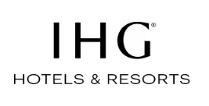
Figure 1: Official Logo of IHG Hotels & Resorts
(Source: ihg.com, 2024)

1.2 Aim and Objective
Aim: The primary aim of this research proposal is to figure out the impact of socio-economic factors on employees' performance management in different working modes
Objectives
- To identify the contribution of socio-economic factors on employee performance management for IHG Hotels & Resorts
- To analyse different issues that IHG Hotels & Resorts has faced over the years in monitoring employee performance in different working modes
- To recommend different strategies that IHG Hotels & Resorts can eventually tale to strategies employee performance monitoring in different working modes

1.3 Background of the topic
Issues related to socio-economic factors on employee performance monitoring
According to Friedman (2012), socio-economic factors can eventually prove to be lethal for the overall business development associated with a brand. IHG Hotels & Resorts has faced different problems over the years since the conclusion of the recent pandemic in managing their daily operation of serving people. Issues related to reluctance to travel due to the fear of cross-contamination, high prices of items due to inflation, labour market issues, and affordability are some of the major problems that the brand has faced over the years in managing its business operations. All of these factors combined have drastically dragged down the hotel occupancy rate for the brands in their different locations across the country.
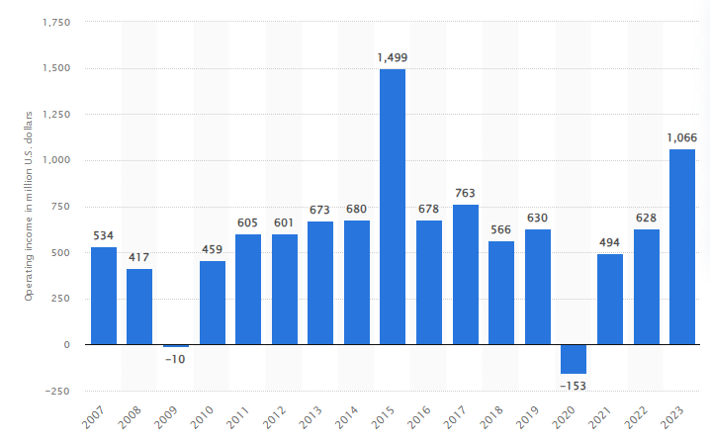
Figure 2: Performance of IHG Hotels & Resorts over the years
(Source: statista.com, 2024)
Impact of socio-economic factors on employee performance management in different working modes
As stated by Gallagher (2016), enforcing employees to work through different modes due to the effect of the pandemic has somewhat backfired for the hotel chain. Due to different work modes after the pandemic such as hybrid work mode, office work arrangement and flexi work mode, people have faced numerous problems in socialising with other people throughout. Similarly, lack of employee engagement and skill development activities adversely affected the overall motivating factor for the employees as well which is not an ideal scenario at any given point in time.

2. Literature

2.1 Description of socio-economic factors, a part of PESTLE Analysis
Socio-economic factors
Factors | Impact | Positive Analysis | Negative Analysis
Social | - Affordability  - Cultural differences | The affordability of people is something that is constantly growing with time since the conclusion of the pandemic. Due to this, people have started to invest more in travelling amenities than in the old days. | Due to the cultural differences between people, domestic as well as internal travelling is getting affected a lot. This is something, which is somehow affecting the overall performance of the brand on a large scale.
Economic | - Per Capita Income  - Inflation | Per capita income and the GDP growth rate are one such thing, which measures the overall growth of any country. Since the pandemic, the unemployment rate of the country has gone down a bit which has eventually enhanced the per capita income of people. This is the reason the hospitality industry has seen rapid growth in the last few years in terms of occupancy. | Inflation can be termed as one such major curse, which is somehow creating issues for different brands operating in the hospitality industry. Due to the rise in price for daily items, people are still thinking about daily necessities rather than travelling.
Technological | - Contactless payment application  - Investment on R&D | The development of their application has helped the brand in analysing the requirements of the consumers. As people now prefer contactless payment methods due to the fear of cross-contamination, application development has boosted the business a lot while managing operations in the hospitality sector. | Investing more in Research & Development is one such thing that different brands operating in the hospitality sector should be doing in adapting various cutting technologies into daily operations. Without adequate technical support, revenue generation can eventually get hampered for different brands operating in this industry.

2.2 Description of industry trend associated with the hospitality sector
Implementation of Virtual reality in travelling mode
As per the views of Horn (2009), the implementation of virtual reality has been one of such major elements that millennials and Gen-Z people prefer mow days as a part of their travelling plans. Due to the flexibility of travelling to different places in no time, augmented & virtual reality has become one of the most trending elements in recent years as far as the UK hospitality industry is concerned. However, apart from the millennials, many old people now prefer to use virtual reality more to experience digital travelling as per their convenience.
Usage of sustainable measures for promoting eco-friendly travelling
As opined by Johnston et al., (2012), sustainability is one such element, which is somehow growing in today's world as people have started to prefer adopting eco-friendly lifestyles a bit. Different eco-friendly stays various exotic places and sustainable travelling through electric vehicles are something that is trending a lot in the UK hospitality segment in recent years. Hence, brands are customising their operations to meet all these trends in the market so that many people can get attracted towards the brand on a large scale.

2.3 Discussion of the emergence of different work modes in the hospitality industry over these five years
As proposed by Kansakar et al., (2019, p. 65), adverse socio-economic context can possibly hamper the entire work development for an organisation as far as the hospitality industry is concerned. Due to the enforced lockdown during the pandemic time, people majorly forced to remain inside their homes and work from their places. Hybrid work modes, office work arrangements and flexible work modes are some of the major arrangements employee had to switch their working during the phase of a pandemic.

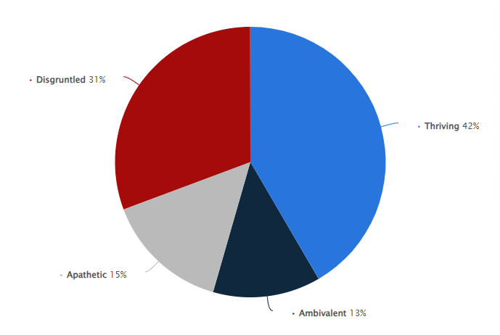
Figure 3: Mind-set of people associated with the UK hospitality sector during
Hybrid work situations
(Source: statista.com, 2023)
Hybrid work mode
According to Berg et al., (2018), hybrid work mode is mainly the combination of both offline working from the office and online working from remote locations. A hybrid mode of working is one of such major forms of doing operations that different brands eventually adopted to streamline all of their work during the pandemic phases. Brands operating in the hospitality sector rely on consumer satisfaction a bit more to manage their overall brand value. This eventually demands offline working of the employees to make customers happy about their stay at hotels.
Office work arrangement
Office work arrangement is the most conventional way of doing daily work from offline mode. The work arrangements are one such thing, which eventually gets hampered during the pandemic phases as lockdown eventually gets imposed on people. However, as soon as the fear of the pandemic got over, different brands operating in the hospitality industry started to normalise working from the office yet again as this entire industry is majorly dependent on quality B2C service to the consumers.
Flexi work modes
As per the views of Ali and Naeem (2022), flexible work mode is mainly a form of working where employees have the port choose their alternative schedule to work as per their convenience. Flexible working empowers people to work whenever they feel is the right to work at their convenience. This is mainly possible when someone is working from their home or some remote locations. This is yet another major mode of working which the workers had to go through during the time of the pandemic.

2.4 Examples of how the selected international hotel brand monitors employee management in different work modes
As stated by Salazar (2018, p. 675), employee management in terms of work analysis can prove to be the most important factor which eventually decides how much success a company is going to get in the long run. Managing sustainable performance from an entire hotel's perspective relies on different factors altogether. For example, Radisson Hotel, which is one of the famous hotel chains in the UK, does team meeting activities every week to manage the performance of different employees. The international brand is somewhat managing its operation by allowing employees to work as per their convenience through hybrid mode. This is somehow giving results to the brand as they are arguably considered one of the most successful brands operating in the UK market. Apart from that, IHG Hotels & Resorts uses an inbuilt performance tracker in their mobile application with which they eventually track the overall performance of their employees on a daily basis. However, the accuracy in telling the error percentage sometimes raised questions as well from the company's perspective. Hence, analysing the overall performance of the employees is one of such major important elements, which ultimately helps a brand to have a sustainable position in the market.

2.5 What are potential solutions?
Managing employee performance on a daily basis is important from a company's perspective in securing a better position in the competitive market. As the hospitality industry is all about perception and quality services, reviewing the performance of employees becomes more important in this particular sector. However, using different standard parameters, using regular meetings, review analysis and usage technology in tracking performance growth are some of the major solutions that different brands can look up to who function in this particular sector. Enhancement in employee performance can eventually help a brand in sustaining a competitive positioning in the market by generating more productivity in numbers. Using different analyses based on set parameters, subordinates and supervisors of a brand should always look to analyse the performance of employees daily.

3. Evaluation and Conclusion

3.1 Conclusion
Providing good quality service in terms of accommodation and comfort eventually decides the fate of a hospitality brand irrespective of different countries. IHG Hotels & Resorts is one of such premier hotel chains, which majorly known for its good services and quality accommodations among consumers. However, the brand had to suffer a lot during the time of the pandemic, as the movement of travellers was not there due to the enforced lockdown. This eventually forced the brand to switch to different working modes as per the convenience of the employee so that streamlining daily business operations can eventually get maintained. Having said that, observing daily operations is something that is eventually a complex job, which the subordinates had to suffer a lot during that phase. Most importantly, different working modes associated with employees of IHG Hotels & Resorts are something that got illustrated in this particular section of the proposal as well. The brand however is known for its quality service in the hospitality industry for which it comes under one of such very few premier brands, which has made for themselves in the last few years. Due to having different types of working modes among the employees, the hotel chain has faced problems in maintaining a decent level of productivity as well. Further, a few recommendations have also been made here in this section of the research proposal as well for a better understanding of the topic.

3.2 Recommendations
Implementing communication software into business operations
Monitoring and managing employee work development is one of such key elements that eventually decide the entire brand value from an organisational perspective. There are different elements regarding work development that the brand can eventually take to manage their entire employee performance on a large scale. Apart from that, IHG Hotels & Resorts should look after implementing different communication software into their business operations such as Asana and Trello so that it can eventually help the supervisors in communicating with the workers more prominently altogether.
Using data-driven technology to compare employee performance and error percentage
The brand should immediately look after integrating technology into its business activities to manage all the workings in a detailed manner. Apart from that, using data analytics and data-driven technology would be a major thing that the brand should look after to set up different KPI standards for its employees. This would eventually help the brand in comparing the employee working along with the error percentage with a set standard.

4. References
Ali, S. and Naeem, N., (2022). Hybrid Working Model: A Pathway to Success or Failure. Asian Journal of Economics, Business and Accounting, 22(20), pp.1-5. http://publish7promo.com/id/eprint/1493/
Berg, J., Furrer, M., Harmon, E., Rani, U. and Silberman, M.S., (2018). Digital labour platforms and the future of work: Towards decent work in the online world. https://apo.org.au/node/244461
Friedman, A. (2012) Continuing professional development: lifelong learning of millions. London: Routledge.
Gallagher, K. (2016) Essential study and employment skills for business and management students. Oxford: Oxford University Press.
Horn, R. (2009) The business skills handbook. London: Chartered Institute of Personnel and Development.
ihg.com, (2024). IHG Hotels & Resorts. [Online] Available at: https://www.ihg.com/hotels/us/en/reservation
ihgplc.com, (2023). Annual Report of 2022. [Online] Available at: https://www.ihgplc.com/en/investors/annual-report
Johnston, R. Clark, G. Shulver, M (2012). Service Operations Management,Pearson, London
Kansakar, P., Munir, A. and Shabani, N., (2019). Technology in the hospitality industry: Prospects and challenges. IEEE Consumer Electronics Magazine, 8(3), pp.60-65. https://ieeexplore.ieee.org/abstract/document/8684803/
Salazar, A., (2018). Hospitality trends: opportunities and challenges. Worldwide Hospitality and Tourism Themes, 10(6), pp.674-679. https://www.emerald.com/insight/content/doi/10.1108/WHATT-07-2018-0047/full/html
statista.com, (2023). Distribution of worker mindset regarding hybrid work worldwide in 2021, by category. [Online] Available at: https://www.statista.com/statistics/1248273/workers-hybrid-work-mindset-category/
statista.com, (2024). Operating income of the InterContinental Hotels Group (IHG) from 2007 to 2023. [Online] Available at: https://www.statista.com/statistics/223401/operating-income-of-the-intercontinental-hotels-group/

