Samina Sultana
Student No. 1912524
BSc Health and Social Care
Changemakers: Building your Personal Brand for Sustainable Employment
BMHP5015_BIRM
Lecturer: Chloe Harries
Assignment 1:
E-Portfolio Evidence of Learning

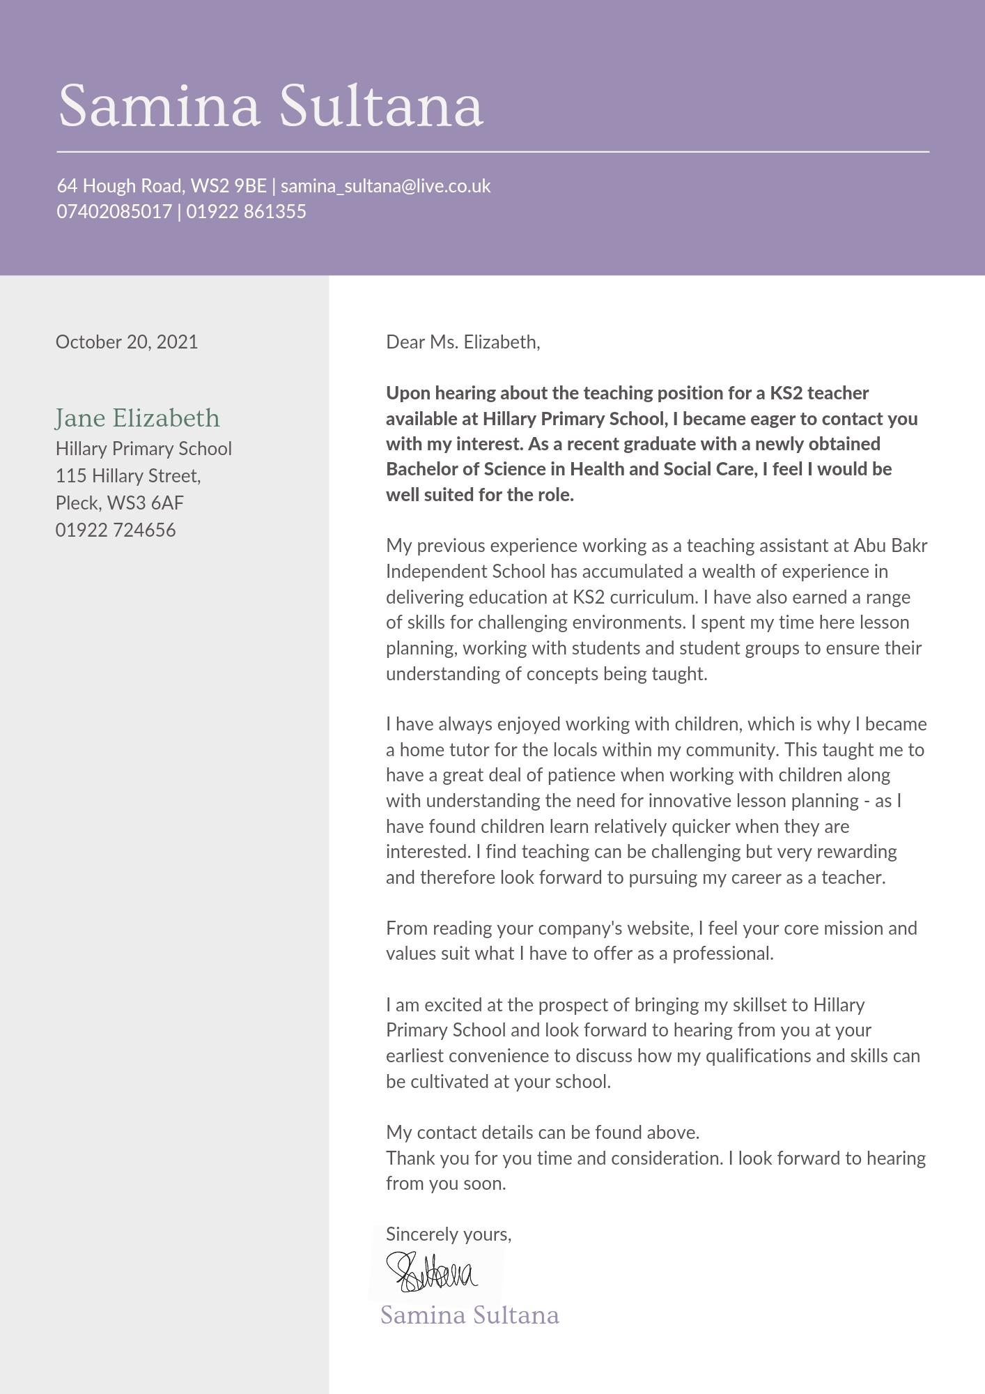
- Cover Letter

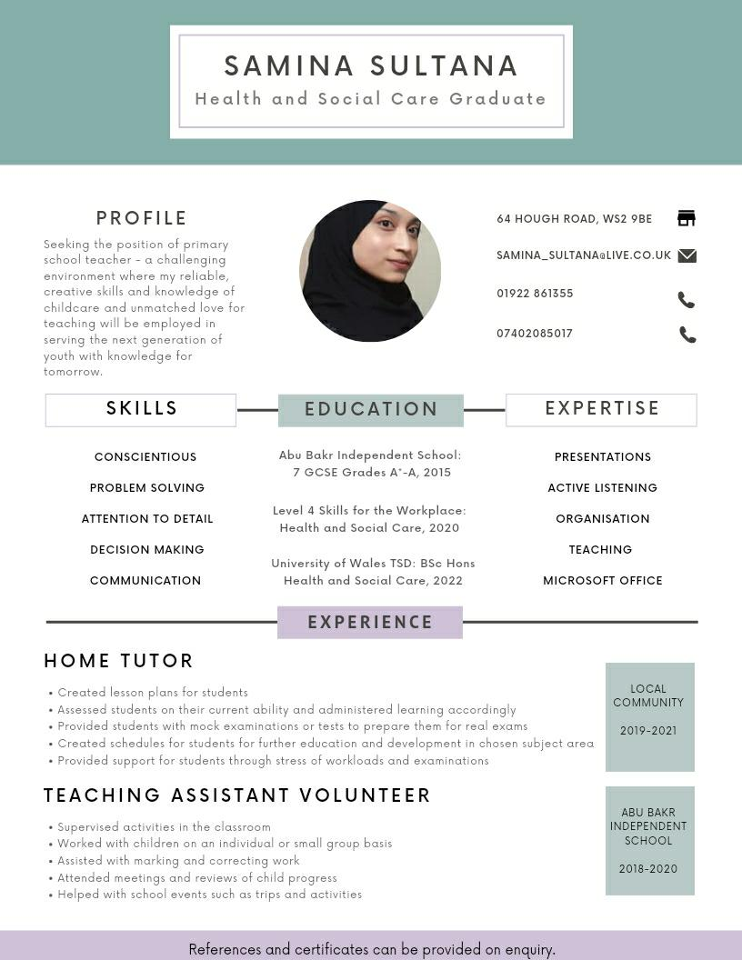
- Professional Health and Social Care CV

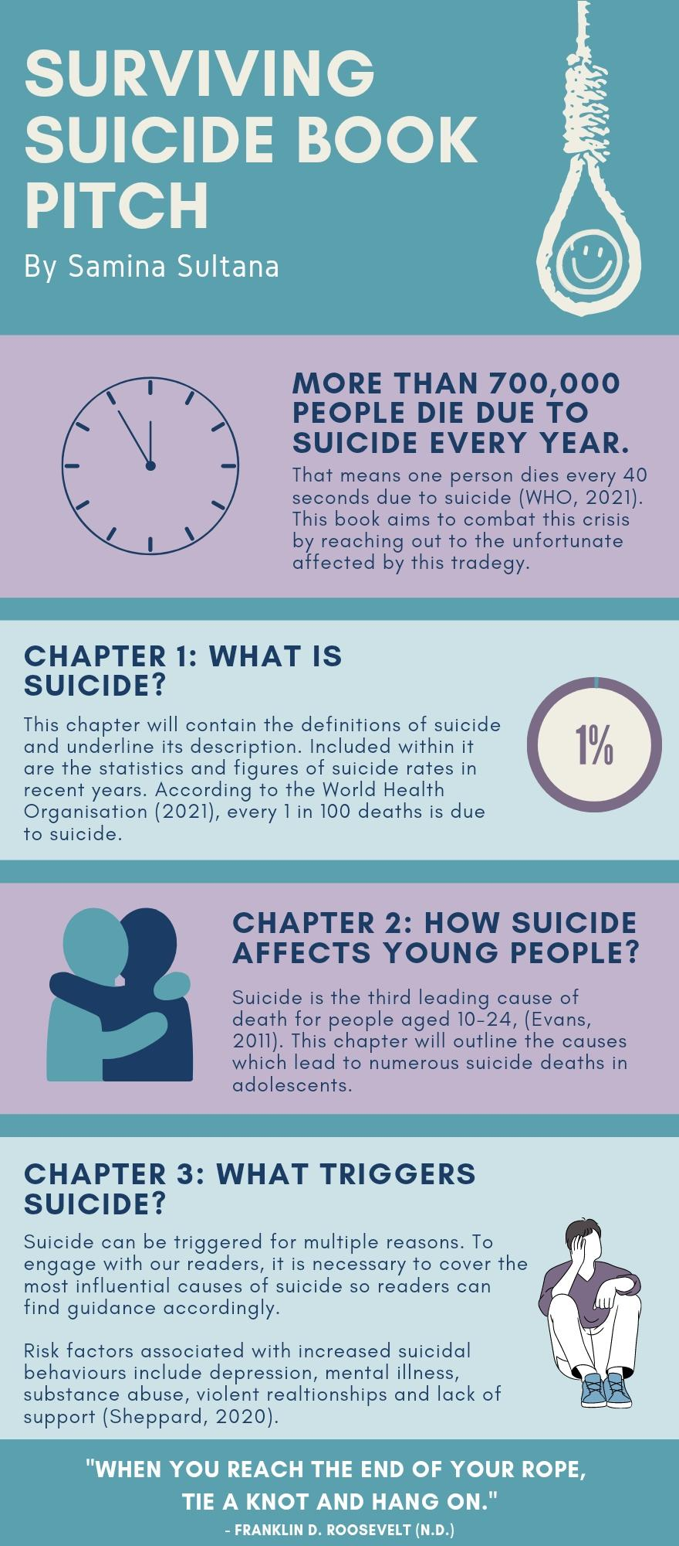
- Pitch


