Targedau / Targets | Sut rydych wedi gweithio ar hwn /  How you have worked on this | Ceir enghraifft ar /  An example can be found on
Targed/Target 1- Ensure that you acknowledge the source of your information throughout your work. | I have ensured to reference any information within my assignment and followed the Harvard referencing guide. | Throughout.
Targed/Target 2-Continue to refine your academic writing by reading articles in peer-reviewed journals. | I have ensured to read a variety of peer-reviewed journals. When using the UWTSD library website, I had filtered ‘peer-reviewed journals’ within my search. | Within reference list.
Targed/Target 3- Make explicit links between the points suggested in literature and your own research decisions. | I have made relevant links with Estyn reports and my own PTE practice with literature mentioned within my assignment. | Pages: 3,5,6,7,9.

Module: Core studies: The learner: who am I teaching?
Module code: ECAD6013
Student name: Saffron Robb
Student ID number: 2004033
Assignment title: Supporting your discussion with theory, practice and evidence from literature, critically reflect on how you would support an individual learner whose progress is being affected by specific barriers to his/ her learning during one particular transition period (horizontal or vertical).

An objective of this paper was to critically examine the view that Autism Spectrum Disorder (ASD) and Adverse Childhood Experiences (ACEs) can affect progression, particularly during a vertical transition. A vertical transition is described as a significant amendment to a pupil’s routine and a process that is ongoing (Jindal-Snape,2010, p.1; Dunlop and Fabian,2006, p.19).
Focusing specifically on a child transitioning from key stage two to key stage three and for the purpose of this assignment I will refer to the learner under the pseudonyms of Aled. To support Aled during the transition process, a support plan will be produced to configurate Aled’s current learning and future goals to staff, in addition to providing him with a voice by acknowledging what is important to him and his strengths within a one-page profile (Northamptonshire Government,2014). These will be found within part two of this assignment.

Hays-Grudo & Morris (2020, p.12) define ACEs as being exposed to various types of abuse, family dysfunction and neglect that could cause numerous health issues that could also affect cognitive and emotional development. After Aled’s parents had separated, the progression of his emotional development had declined and can therefore be identified as experiencing an ACE.
ASD can be known as a developmental and neurological disorder that disrupts occupational and social functioning including developing and obtaining relationships, this can also vary between individuals (Cashin,2020, p.10).
The Curriculum for Wales advises schools to be considerable to all learners’ needs throughout the curriculum and assessment design process, therefore pupils should be supported appropriately as progress will vary for each child. Furthermore, “progression for those with Additional Learning Needs (ALN) may not correlate with the broad two-to-three-year progression step as expressed in the descriptions of learning” (Welsh Government,2020). This corresponds to Article twenty-eight which is “Children have a right to an education. Discipline in schools should respect children’s human dignity” from the United Nations Convention on the Rights of the Child (2019a).

School transitions are of interest because it is seen as an event that is life-changing for children (Symonds, 2015).
The Welsh Government have produced a transition guidance for schools to support learners transitioning from year six to year seven. It suggests that plans are required to focus on the continuity of the Curriculum for Wales and progression of pupils and how their needs are supported throughout the transition process. It also mentions the importance of the learner’s progression and that practitioners from both schools work collaboratively during transition to develop a shared understanding of the progression, due to this, it is referred to as a process not an event (Welsh Government 2022).

An effective transition is considered as the inclusion of parents or guardians contributing to the learner’s transition process in addition to involvement from all staff communicating and sharing information effectively, furthermore, working with the partner schools and developing links within the community can enhance improvement for disadvantaged learners (Florian et al, 2017; Elliott-Johns and Jarvis, 2017). Referring to the support plan in part two, it involves Aled’s mother contributing to his learning, this therefore can be regarded as an effective strategy to aid Aled’s progress. It has also been demonstrated as good practice from an Estyn case study where a school had involved families through engagement programmes which resulted in parents gaining knowledge and understanding of what their child was learning, this would then allow families to aid them with work at home (Estyn,2020).
However, this could be difficult if Aled’s parent or guardian is unwilling to become involved or disagree with the schools’ provisions for him, on that account, it is seen as beneficial to generate strong relationships with parents and local partnerships (Richardson and Wolfe, 2001). During a transition phase, pupils who require additional support work effectively with organisations which results in a successful transition (Department for education, Lifelong Learning and Skills,2016). Therefore, that is the reason why I have involved Aled’s parent and stakeholders in the support plan (refer to part two).

Barnardo’s Cymru is one of the outside agencies involved in Aled’s support plan. Barnardo’s (2020) have developed a programme called PATHS which consists of a Social, Emotional Learning (SEL) scheme that can reduce the effects of ACEs but also support schools by providing training for staff, resources, working with parents and the development of the school holistically.
The Collaborative for Academic, Social and Emotional Learning (CASEL) is another agency that will be working collaborative with the school as mentioned on Aled’s support plan. Their framework is to create plans and share goals with families for their child but also provides the school with support on how to develop relationships with families. Their framework focuses on five areas of SEL which is known as the ‘CASEL wheel’ (refer to appendix 1) (CASEL,2022). The CASEL wheel demonstrates that strong family-community partnerships can advance SEL for pupils (CASEL, 2022) and this associates greatly to Bronfenbrenner’s Ecological systems theory which proposes that the social environments of a child can influence on their development (Haves et al,2017).
Nevertheless, Schlossberg suggests there are four elements to a successful transition and not only the factor of community and parent involvement as Bronfenbrenner indicates, Schlossberg identifies the four elements as the four S’s which are strategies, support, self and situation (The University of North Texas Health Science Center, N.D)
Both partnerships’ primary purpose is to develop pupils SEL and to work collaboratively with parents. This could support the parent becoming knowledgeable of ASD and ACEs and could then lead to becoming engaged, supportive, and getting involved at home. This is also extremely beneficial for Aled and his caregiver during his transition. For that reason, the support plan for Aled, not only involves outside agencies and his parent but also aims to consider his social-emotional skills to aid his development.

Aled’s support plan outlines the focuses to develop his emotional and social development as he has been diagnosed with ASD and has been exposed to ACEs. This can make the transitioning process difficult. It is believed that children with ASD can become overwhelmed during the transition process and that teachers should provide appropriate support (Nuske et al, 2019).
A child exposed to ACEs has a reduced ability to develop strong relationships with teachers then leading to poor academic attainment and long-term significance on school adjustment (McDoniel and Bierman,2022). For this reason, it is key to implement appropriate support plans for Aled to provide a predominant transition and hope that it does support his progression.

It is believed that if a supportive adult relationship is absent from someone who has been exposed to ACEs, could consequence in interrupted development, leading onto learning impairments and toxic stress (Bell et al,2021). It is known that active learning, resilience, motivation and problem-solving all develop from a secure attachment relationship and ACEs can force an undeveloped understanding of interaction and interpretation which could diminish the possibility of possessing a secure attachment (Whiitters,2020). As Aled’s parents have separated he may be at risk of attachment issues (Lin et al,2020).
Bowlby describes a secure attachment as a dependable adult being present within a child’s life and that they seem confident, attaining elevated achievement and willingness for risk taking, as well as being exposed to a ‘safe base’ (Watson and Ecken,2018). Erikson agrees with Bowlby’s theory and believes that having a significant relationship with a trustworthy adult as a child is linked to healthy development (Pittman et al,2011).
However, it is advised that pupils with ASD should be encouraged to utilise various rooms during year six to prepare them for the transition to year seven and keep that expected structure during their time secondary school (Autism Education Trust,2021).
For this reason, in the support plan it states that Aled will have access to a safe quiet space only when required, which is one of his preferences on his one-page profile which also mentions his love of trains. This space will be known as ‘railway junction’ and will be decorated with pictures of trains and will include a variety of train information books.
This has been demonstrated as a good method of practice observed in a placement school during my professional teaching practice. A pupil diagnosed with ASD had developed a strong relationship with one of the teaching assistants and that child would turn to them when they were upset or unsettled in a known safe area for that child which was the ‘reading cwtch’, this resulted in that child becoming comfortable to then eventually gaining confidence and improving academically which is reflected as a secure attachment according to Bowlby and Erikson (Pittman et al,2011).

Holistic learning refers to the focus on the ‘whole child’ by concentrating on all aspects of human personality that include emotional, intellectual, spiritual, and physical development (Nor and Embong, 2019). This associates closely to Maslow’s hierarchy of needs which concentrates on the growth of personal development that is influenced by the fulfilment of ‘basic needs’ for physical and emotional well-being, therefore these needs need to be considered and fulfilled to achieve and enhance overall development (Pichère. Et al,2015). However, every individual has different interpretation of basic needs (Koltko-Rivera, 2006).
A proactive school is one that takes a whole school approach to mental health and well-being, this then creates a timely response to any well-being or health issues that may emerge (Howard. Et al,2019).
Children with ACEs can find it difficult to maintain friendships and can become isolated which results in effecting their well-being, as friends are seen as a source of support. (McAuley and Rose, 2010). Pupils with ASD are also seen as having fewer and poorer quality friendships compared to those who are not diagnosed with ASD (Winchell. Et al, 2018). As this is not the outcome wanted for Aled, the support plan (refer to part two) includes a relationship building activity during week six that encourages peers to write down when a classmate has made a kind gesture to them, they are then all linked together to create a ‘kindness chain’.
I have observed this ‘kindness chain’ activity during professional teaching practice, as a result the children would seem proud once their act of kindness was read out to the class. This was a benefit to their well-being. However, there is a need to be cautious as some pupils may not have their name and act of kindness called out, this could then lead to the child feeling excluded and have a negative impact on their well-being (Kellock,2020).
Overall, I feel that well-being can be a crucial part of learning and applying the holistic approach to teaching can be beneficial, although there is a priority to develop Aled’s social-emotional development due to his needs rather than focusing on various aspects at the same time as this can suspend the progress of areas of development that are of most importance (De-Abreu. Et al,2022).

A one-page profile for Aled is to provide information to staff about the pupil that highlights their strengths and interests to create meaningful and personalised learning which can be beneficial during a transitioning period (Sanderson et al, 2014). This corresponds to the Welsh Governments assessment arrangements, where it is encouraged to involve pupils in their learning especially during the transition process, to also elaborate on what and how they would prefer to be taught, and to also suggests goals and next steps (Hwb 2020).
For pupils with additional learning needs, an effective practice of pupil voice is involving them in decision making (Supporting Service Children in Education Wales,2014). This relates to Article twelve within The United Nations Convention on the Rights of the Child (UNCRC) “Children have the right to say what they think should happen, when adults are making decisions that affect them, and to have their opinions taken into account” (Welsh government, 2021a). Pupils who are given the opportunity to voice opinions and have an active role in what they want to learn can become responsible and confident (Alderson,2008).
An example of effective practice has been identified within this Estyn report. Pupil participation was embedded throughout the school which allowed learners to voice their opinions and make decisions about their lessons in class which had improved pupil’s communications skills and confidence (Estyn,2019a).
This would also be the overall aim for Aled’s development, and the support plan, a successful transition, and his participation for his one-page profile should enable that.
Some barriers to consider when involving pupils in their own learning is that they may not want to get involved and can be uninterested or they may not be aware of the benefits or reasoning why they are engaging with it (Northwest Leicestershire government, 2008).
A strategy that could be applied to overcome this barrier is to incorporate their interest, for example, Aled’s one page profile mentioned that he has a liking for trains, therefore his one-page profile has been embellished with pictures of trains and he had assisted in creating it.
Involving pupils’ interest can make the learning experience enjoyable and can feed motivation to endeavour for more (Doherty and Hughes,2014).

Within the additional learning needs code for Wales, it states that teaching practitioners should allocate appropriate provision for pupils with Additional Learning Needs (ALN) and have a duty to take part in regular training and learning in relation to ALN (Welsh Government,2021b).
This is to ensure equal opportunities are given to children with ALN, also providing a strong focus on inclusion and achievement (Arshad. Et al, 2020). Yet there is a need to ensure that all information about Aled’s ASD diagnosis and exposure to ACEs is communicated effectively to the secondary school so that they can accommodate to his needs appropriately (National foundation for Education Research,2006). In this instance, the support plan and one page profile should carry that out.

The support plan includes the class teacher regularly visiting Aled at primary school six weeks before transitioning to secondary school, this will support him and build his confidence and skills and promote development of becoming a resilient learner (Rae,2014). However, it is seen as if “a pupil’s transition between primary and secondary are towards the end of Year 6, then it is already too late” (Learning with Autism, 2015, p.39).
Early transitions have proven effective within a school that has established a swimming club for year three:
There are very strong relationships with partner primary schools and highly effective transition arrangements that help pupils to settle quickly at Pentrehafod. Staff provide valuable opportunities for pupils from the school to work beneficially alongside those from primary schools to prepare them for the move from primary to secondary education. As a result, this helps those transferring from primary to settle quickly into their new school.
(Estyn,2019b, p.9).
Although early transition can be effective, it is important to also consider and retain consistency and structure to early transition plans as adaptions could form long-term effects of adjustment disorders (Fabian and Dunlop, 2002). It mentions in Aled’s one page profile (refer to part two) routine is important to him and any adjustments should be explained to him in advance, it also mentions he takes time to get to know people. This is especially essential for Aled as he has been diagnosed with ASD, it can be a tendency to seek identical daily routines and any changes could cause distress (Towle,2013). This is the reason why a member of staff has been appointed to him to provide one to one support and present a visual timetable to Aled each day as pupils with ASD may depend on someone for one-to-one assistance (Learning with Autism, 2015).
Vygotsky and Bruner both agree and believe that receiving one to one support from a More knowledgeable other through scaffolding is valuable to assist learning and allow pupils to move through the zone of proximal development, from being incompetent of something to then become independent in learning (Newman and Latifi, 2021; Takava,2008). Whereas Piaget viewed children as independent learners and referred to them as ‘lone scientists’ suggesting that adult support is not essential (Carey et al, 2015).
Nonetheless, it is essential to take into consideration that Aled has been diagnose with ASD and has been exposed to ACEs and it can be seen as a requirement to provide additional support (Rigles,2021).

It is believed that children with ASD can be exposed to further numbers of ACEs which could minimise progression in their learning as well as physical and mental health issues (Kerns .et al, 2017).
Therefore, regression can occur from ASD and may imply that Aled could have lost numerous months of skills and aspects of development (Prescott and Ellis, 2022). It could be suggested that Aled could repeat year six to regain the loss of many months of skills and development.
Gesell agrees and presumes that each pupil has a unique learning journey and develop at various paces which is influenced by external and internal factors and stages of equilibrium and disequilibrium (Curtis, 2011).
However, the Education Endowment Foundation (EEW) (2021) advises that repeating a year is unnecessary and has a negative impact and the loss of around three months of academic progress.

The overall objective is that in the future, Aled would progress competently and will gain and develop various life skills. A substandard transition could result in early dropouts from education leading to being unable to gain any qualifications and difficulty in obtaining a career (Welsh Government, 2019b). It has been considered that a successful transition can improve retention and eventually precede to employment (Welsh Government,2018). With statistics presenting findings of only twenty two percent of autistic adults are within employment (National Autistic Society, 2021), This highlights the importance of ensuring an efficient transition is implemented from primary to secondary school.
It is believed that children with ACEs can develop mental health issues and poor social and economic outcome during adolescence which could potentially lead to unemployment (Sparling. Et al,2022). Therefore, it is of upmost importance to support and prioritise Aled’s development as a child, especially during this transition as it is a major milestone and the importance to become successful and healthy in the future.

To conclude, this paper has considered the complications of ACEs and ASD throughout a transition process. The effectiveness of a devised support plan was evaluated, and I feel that overall, it would support the progress of Aled’s social-emotional development. It has been outlined that the transitioning process needs to be successful to provide good quality learning and to make the child feel safe and comfortable. A variety of elements needs to be considered during transitions, especially those with ASD and been exposed to ACEs. Therefore, planning effectively and involving parents and stakeholders can support the vertical transition.
Assessment for learning strategies will allow staff, stakeholders, and parent to observe Aled’s progress and will validate if the support plan has been effective.
Professional standards that are linked to the intervention are ‘Listening to learners’ and ‘Learners leading learning’ (Welsh Government,2017). This is because Aled had been made involved in his learning by creating his one-page profile and providing him with a voice as he states what is suitable for him to learn.
Professional learning has also been acknowledged as I have developed a deeper understanding of ACEs and ASD and the research has provided insights of effective methods for progression.
To enhance this intervention, additional support should be provided for Aled’s mother as a single parent, and involvement in added external agencies to develop her well-being and ability to support Aled at home. This would cover the ‘involving partners in learning’ element of the professional standards (Welsh Government,2017).

Part two:

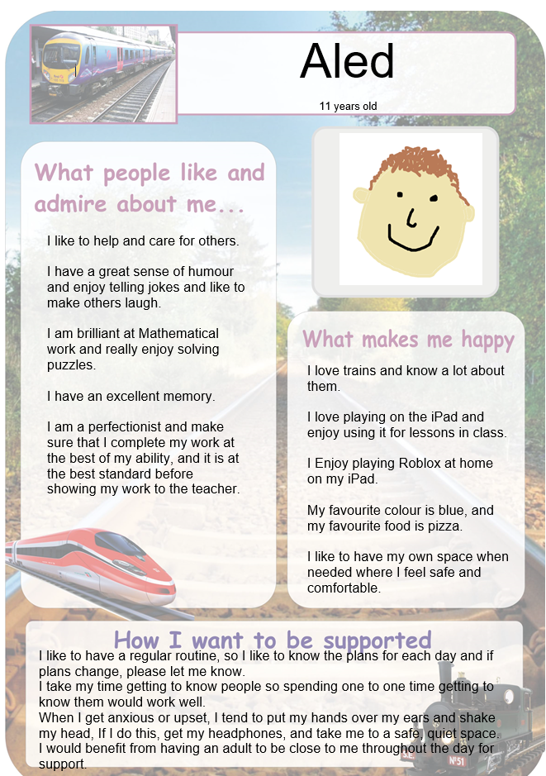

Support plan

This support plan is specifically aimed at advancing Aled’s social and emotional development over a six-week period. All activities are mainly linked to the Health and Well-being Area of Learning and Experience from the Curriculum for Wales (2022).

Aled will be appointed a quiet area known as ‘railway junction’ for when he needs to retreat there when distressed.

Throughout this six-week support plan, Aled will receive one to one support to complete interventions, inform parent/guardian of behaviour throughout the day and to utilise mood journal in school and at home.

The class teacher has met Aled over the period over six weeks, making regular visits to build a trusting relationship.
Aled’s one to one support will be a teaching assistant who will be fully trained and experienced to cater to Aled’s needs appropriately. The teaching assistant will complete daily check ins and provide Aled with a visual timetable each day.

After three weeks of the support plan, a halfway review will be conducted to review Aled’s progress. However regular meetings can be arranged with parent/guardian if needed/ wanted that can also involve outside agencies. Another meeting will the take place at the end of the six-week support plan to evaluate Aled’s progress and determine what are the next steps for him.

The school has Additional Learning Needs Co-ordinator, who will be involved in Aled’s support plan, attending the meetings, and observing his progress, in addition to Barnardo’s Cymru and The CASEL (Th Collaborative for Academic, Social and Emotional Learning) Program guide.
Assessment for learning strategies will be carried out and reviewed throughout to ensure progress is being made.
Week | Objective | Activity | Curriculum link | Tracking progress
1 | Acknowledge emotions during transition. | Change tunnel  (Class activity)  Discussing emotions of moving up to secondary school, working in groups. Statements will be read out, For example, “My first mathematics lesson”.  Signs will be displayed around the classroom (nervous, excited, not sure) and pupils will go to the sign that best describes how they feel and then explain.  Complete at the end of each day to understand Aled’s feelings during first week of transitioning. Statements will change throughout week (my first lesson to my second/third and so on). | Health and well-being  Progression step three  How we process and respond to our experiences affects our mental health and emotional well-being.  I can reflect on the way that past events and experiences have affected my thoughts, feelings, and actions.  I can anticipate how future events may make me and others feel. | Observe Aled’s movements.  Compare Aled’s worries at the start of the week to the end of the week.  If Aled is still going to the ‘nervous’ throughout on each statement made, work collaboratively with another pupil that had moved from ‘nervous’ to ‘excited’ during the week to compare and discuss their process of feelings and why they had changed.  At home  A mood journal could be completed after school and discuss the day with parent/carer.
2 | Building social skills and relationships | What I want my teacher to know about me  (Class activity)  Pupils will write facts or anything they would like their teacher to know about them.  These will then be on display in the classroom. | Health and well-being  Progression step three  Healthy relationships are fundamental to our well-being  I can make and maintain relationships that matter to me, identifying conflict and taking steps to resolve it.  I can reflect on the characteristics of safe relationships, and I can seek support when needed. | At the end of each day of the second week, the class teacher will read facts from each child’s worksheet and have an informal discussion amongst the rest of the class.  The pupils will be asked questions such as:  - How do you feel in your new class?  - Do you feel comfortable and safe in class?  - Are there people in school that you can talk to confidently?  - Who?  -Then evaluate answers
3 | Managing/recognising emotions | Smiling mind  (Mindfulness app)  (One to one)  With the Additional Learning Needs Co-ordinator, Aled will complete a series of mindfulness meditation activities.  The app will guide Aled through his journey of ‘internal weather’ through meditations.  On the app it will asks Aled of how he is feeling before and after the activities. | Health and well-being  Progression step three  How we process and respond to our experiences affects our mental health and emotional well-being.  I can recognise the benefits of being able to focus attention on my perceptions and thoughts and know that I am developing my self-awareness.  I can self-regulate my emotions in a healthy way using strategies that I have developed | Check feelings on app throughout week and discuss with Aled.  At home  Parent/carer can complete or repeat any mindfulness activities at home. Observe and discuss mindfulness journey. Fill in/continue mood journal.
4 | Managing emotions | What can I do when I am…...?  (One to one)  Worksheet activities that have the sentence ‘what can I do when I am…..?’ and each day there will be a different emotion. Therefore, if it was sad, Aled would then write or draw thing that would help him when he is sad.  It will include:  - Someone who can help  - Someone I can talk to  - Something I can do  - A song I can listen to  - Somewhere I can go | Health and well-being  Progression step three  How we process and respond to our experiences affects our mental health and emotional well-being.  I can see the benefits of communicating about feelings as one of a range of strategies which can help promote positive mental health and emotional well-being.  I can ask for help when I need it from people I trust. | Observing if Aled is approaching the people he mentioned on the worksheet activity when he is feeling a certain way. For example, Aled writes that the teaching assistant is someone he can approach when he is angry and going to the quiet corner, If Aled does get angry the teaching assistant can be made available immediately and keep record of when these occur and what was the trigger in mood journal.  At home  Have an alternative worksheet for home for different people to turn to when experiencing various emotions and record in mood journal.
5 | Building social skills and relationships | Social skills scenarios  (One to one)  Aled will be presented with a variety of school scenarios on cards which shows an illustration and a short summery of what is happening in the picture. For example, a picture of a child not sharing. Aled will then have to either write or verbally answer what he would do and say in that situation.  Using prior knowledge from last week’s activities, he can refer to who he can turn to or what to do when feeling a certain emotion. | Health and well-being  Progression step three  Healthy relationships are fundamental to our well-being.  I can make and maintain relationships that matter to me, identifying conflict and taking steps to resolve it.  I can reflect on the characteristics of safe relationships, and I can seek support when needed | Observing Aled’s behaviour and social responses to real life context compared to his completed work and reflecting upon it.
6 | Building social skills and relationships | Paperchain friendship  Class activity  Strips of paper will be given to each child to write something kind that has been done or said by their classmates and then writing their name on the back of it.  The strips of paper will then be chained together to create a ‘kindness chain’. Pupils are free to read and reflect. | Health and well-being  Progression step three  Healthy relationships are fundamental to our well-being.  I can make and maintain relationships that matter to me, identifying conflict and taking steps to resolve it.  I can reflect on the characteristics of safe relationships, and I can seek support when needed | At the end of each day, the acts or words of kindness will be read out to the class to compliment and encourage the pupils.  Ensure Aled is also recognising the purpose of the activity and is actively participating.

References:

Alderson, P. (2008) Young children’s rights : exploring beliefs, principles and practice. 2nd ed. London ;: Jessica Kingsley Publishers. Available at: https://web-p-ebscohost-com.ezproxy.uwtsd.ac.uk/ehost/ebookviewer/ebook/bmxlYmtfXzIzNjMwMF9fQU41?sid=2d78f442-5b07-461d-b4c3-741e954da88d@redis&vid=0&format=EB&lpid=lp_190&rid=0 (Accessed: 04 November 2022).
Arshad, R., Wrigley, T. and Pratt, L. (2020) Social justice re-examined : dilemmas and solutions for the classroom teacher. Updated and expanded edition. Edited by R. Arshad, T. Wrigley, and L. Pratt. London: UCL Institute of Education Press. Available at: https://ebookcentral.proquest.com/lib/trinity/reader.action?docID=6403353 (Accessed: 04 November 2022).
Autism Education Trust. (2021). Supporting learners with autism during transition. Available at: https://www.autismeducationtrust.org.uk/sites/default/files/2021-11/Supporting-learners-with-autism-during-transition.pdf/ (Accessed: 03 November 2022).
Barnardo’s. (2020) Using the PATHS Programme and Social Emotional Learning to mitigate the effects of Adverse Childhood Experiences. Available at: https://www.barnardos.org.uk/sites/default/files/uploads/Barnardos%20PATHS%20and%20SEL%20ACE%20Brochure%20-%20March%202020.pdf (Accessed: 01 November 2022).
Bell, M.F. et al. (2021) ‘Early school suspensions for children with adverse childhood experiences (ACEs)’, Journal of applied developmental psychology, 76, p. 101300–. Available at: https://doi.org/10.1016/j.appdev.2021.101300. (Accessed: 03 November 2022).
Carey, S., Zaitchik, D. and Bascandziev, I. (2015) ‘Theories of development: In dialog with Jean Piaget’, Developmental review, 38, pp. 36–54. Available at: https://doi.org/10.1016/j.dr.2015.07.003. (Accessed: 04 November 2022).
CASEL. (2022). What is the CASEL Framework? Available at: https://casel.org/fundamentals-of-sel/what-is-the-casel-framework/ (Accessed: 02 November 2022).
Cashin, A. (2020) Young people, adults and autism spectrum disorder. New York: Nova Medicine & Health. (Accessed 25 October 2022).
Curtis, S. (2011) ‘“Tangible as Tissue”: Arnold Gesell, Infant Behavior, and Film Analysis’, Science in context, 24(3), pp. 417–442. Available at: https://doi.org/10.1017/S0269889711000172. (Accessed: 04 November 2022).
De-Abreu, S. et al. (2022) ‘Teaching holistic environmental thought: A classroom approach’, Thinking skills and creativity, 46. Available at: https://doi.org/10.1016/j.tsc.2022.101141. (Accessed: 04 November 2022).
Department for Education, Lifelong Learning and Skills. (2016) Inclusion and Pupil Support, Cardiff: Welsh Assembly Government. Available at: http://gov.wales/docs/dcells/publications/160318- inclusion-and-pupil-support-en.pdf (Accessed:04 November 2022).
Doherty, J. and Hughes, M. (2014) Child development : theory and practice 0-11. Second edition. Harlow, England: Pearson. Available at: https://ebookcentral.proquest.com/lib/trinity/detail.action?pq-origsite=primo&docID=5173768 (Accessed: 04 November 2022).
Dunlop, A.-W. and Fabian, H. (2006) Informing Transitions In The Early Years. New York: McGraw-Hill Education. Available at: https://web-p-ebscohost-com.ezproxy.uwtsd.ac.uk/ehost/ebookviewer/ebook/bmxlYmtfXzIzNDE5OF9fQU41?sid=55f0b917-38f3-43ea-973e-99c772b013ec@redis&vid=0&format=EB&lpid=lp_19&rid=0 (Accessed:25 October 2022).
Education endowment foundation. (2021). Repeating a year. Available at: https://educationendowmentfoundation.org.uk/education-evidence/teaching-learning-toolkit/repeating-a-year (Accessed: 04 November 2022).
Elliott-Johns, S.E. and Jarvis, D.H. (2017) Perspectives on Transitions in Schooling and Instructional Practice. Toronto: University of Toronto Press,. Available at: https://doi.org/10.3138/9781442667105. (Accessed: 01 November 2022).
Estyn. (2019a). Strengthening the pupil voice. Available at: https://www.estyn.gov.wales/effective-practice/strengthening-pupil-voice (Accessed: 04 November 2022).
Estyn. (2019b). A report on Pentrehafod School. Available: https://www.estyn.gov.wales/system/files/2022-01/Pentrehafod%2520School_0.pdf (Accessed: 02 November).
Estyn. (2020). Effective school support for disadvantaged and vulnerable pupils-case studies of good practice. Available at: https://www.estyn.gov.wales/system/files/2022-01/Effective%2520school%2520support%2520for%2520disadvantaged%2520and%2520vulnerable%2520pupils%2520en_0.pdf (Accessed:02 November 2022).
Fabian, H and Dunlop, A.W (2002) Transitions in the Early Years. 1st edn. Taylor and Francis. Available at: https://www.perlego.com/book/1616813/transitions-in-the-early-years-debating-continuity-and-progression-for-children-in-early-education-pdf (Accessed: 3 November 2022).
Florian, L., Black-Hawkins, K. and Rouse, M. (2017) Achievement and inclusion in schools. Second edition. London: Routledge. Available at: https://web-p-ebscohost-com.ezproxy.uwtsd.ac.uk/ehost/detail/detail?vid=0&sid=79a0f420-9a47-4b06-b965-5469431ebb54%40redis&bdata=JnNpdGU9ZWhvc3QtbGl2ZQ%3d%3d (Accessed: 1 November 2022).
Hayes, N., Halpenny, A.M. and O’Toole, L. (2017) Introducing Bronfenbrenner : a guide for practitioners and students in early years education. London ;: Routledge. Available at: https://doi.org/10.4324/9781315646206. (Accessed: 02 November 2022).
Hays-Grudo, J. and Morris, A.S. (2020) Adverse and protective childhood experiences : a developmental perspective. Washington, District of Columbia: American Psychological Association. Available at: https://psycnet-apa-org.ezproxy.uwtsd.ac.uk/fulltext/2020-14999-001.pdf (Accessed: 25 October 2022).
Howard, C., Burton, M. and Levermore, D. (2019) Children’s Mental Health and Emotional Well-being in Primary Schools. 2nd edn. SAGE Publications. Available at: https://www.perlego.com/book/1432015/childrens-mental-health-and-emotional-wellbeing-in-primary-schools-pdf (Accessed: 4 November 2022).
Hwb, (2020) Supporting learner progression: assessment guidance. Available at: https://hwb.gov.wales/curriculum-for-wales/assessment-arrangements/supporting-learner-progression-assessment-guidance/#transition-along-the-3-to-16-continuum (Accessed: 04 November 2022).
Jindal-Snape, D. (2010) Educational transitions : moving stories from around the world. New York: Routledge. Available at: https://doi.org/10.4324/9780203859124. (Accessed: 24 October 2022).
Kellock, A. (2020) ‘Children’s well-being in the primary school: A capability approach and community psychology perspective’, Childhood (Copenhagen, Denmark), 27(2), pp. 220–237. Available at: https://doi.org/10.1177/0907568220902516. (Accessed: 04 November 2022).
Kerns, C.M. et al. (2017) ‘Brief Report: Examining the Association of Autism and Adverse Childhood Experiences in the National Survey of Children’s Health: The Important Role of Income and Co-occurring Mental Health Conditions’, Journal of autism and developmental disorders, 47(7), pp. 2275–2281. Available at: https://doi.org/10.1007/s10803-017-3111-7. (Accessed: 04 November 2022).
Koltko-Rivera, M.E. (2006) ‘Rediscovering the Later Version of Maslow’s Hierarchy of Needs: Self-Transcendence and Opportunities for Theory, Research, and Unification’, Review of general psychology, 10(4), pp. 302–317. Available at: https://doi.org/10.1037/1089-2680.10.4.302. (Accessed: 04 November 2022).
Learning with Autism. (2015) Autism: A Guide for Mainstream Primary Schools. Available at: https://autismwales.org/wp-content/uploads/2020/08/2015_Autism-A-Guide-for-Mainstream-Primary-Schools-ENG.pdf (Accessed: 02 November 2022).
Lin, H.-C. et al. (2020) ‘The Associations between Parental Conflict, Attachment Anxiety, and Somatic Symptoms in Adult Children Affected by Parental Separation’, Journal of divorce & remarriage, 61(3), pp. 168–185. Available at: https://doi.org/10.1080/10502556.2019.1679594. (Accessed: 03 November 2022).
McAuley, C. and Rose, W. (2010) Child well-being : understanding children’s lives. London: Jessica Kingsley. Available at: https://web-p-ebscohost-com.ezproxy.uwtsd.ac.uk/ehost/ebookviewer/ebook/bmxlYmtfXzM1Mjg0M19fQU41?sid=b92698b7-46cd-40d9-93ff-86bb7d5a40e1@redis&vid=0&format=EB&lpid=lp_19&rid=0 (Accessed: 04 November 2022).
McDoniel, M.E. and Bierman, K.L. (2022) ‘Exploring pathways linking early childhood adverse experiences to reduced preadolescent school engagement’, Child abuse & neglect, pp. 105572–105572. Available at: https://doi.org/10.1016/j.chiabu.2022.105572. (Accessed: 03 November 2022).
National Autistic Society. (2021) New shocking data highlights the autism employment gap. Available at: https://www.autism.org.uk/what-we-do/news/new-data-on-the-autism-employment-gap (Accesed:01 November 2022).
National Foundation for Educational Research. (2006). Transition from Primary to Secondary School: Current Arrangements and Good Practice in Wales. Available at: https://www.nfer.ac.uk/media/2243/wtn01.pdf (Accessed: 04 November 2022).
Newman, S. and Latifi, A. (2021) ‘Vygotsky, education, and teacher education’, Journal of education for teaching : JET, 47(1), pp. 4–17. Available at: https://doi.org/10.1080/02607476.2020.1831375. (Accessed: 04 November).
Nor, N. M. and Embong, R. (2019) Teachers Competency On Performance Using Holistic-Center Learning Tool. 1st edn. LAP LAMBERT Academic Publishing. Available at: https://www.perlego.com/book/3418093/teachers-competency-on-performance-using-holisticcenter-learning-tool-pdf (Accessed: 4 November 2022).
North West Leicestershire government. (2008) A Guide to The Effective Involvement of Children and Young People. Available at: https://www.nwleics.gov.uk/files/documents/guide_to_involving_children_and_young_people/Guide%20to%20Involving%20Children%20and%20Young%20People.pdf (Accessed: 04 November 2022).
Northamptonshire Government. (2014) One Page Profiles and Education, Health and Care Assessment & Plan. Available at:https://www.northamptonshire.gov.uk/councilservices/children-families-education/SEND/ehc/Documents/one%20page%20profile%20info.pdf (Accessed: 26 October 2022).
Nuske, H.J. et al. (2019) ‘Broken bridges—new school transitions for students with autism spectrum disorder: A systematic review on difficulties and strategies for success’, Autism, 23(2), pp. 306–325. Available at: https://doi.org/10.1177/1362361318754529. (Accessed: 03 November 2022).
Pichère, P., Cadiat, A.-C. and Probert, C. (2015) Maslow’s hierarchy of needs. Translated by C. Probert. Namur: Lemaitre Publishing. Available at: https://r1.vlereader.com/EpubReader?ean=1782806265876 (Accessed: 04 November 2022).
Pittman, J.F. et al. (2011) ‘Attachment, Identity, and Intimacy: Parallels Between Bowlby’s and Erikson’s Paradigms’, Journal of family theory & review, 3(1), pp. 32–46. Available at: https://doi.org/10.1111/j.1756-2589.2010.00079.x. (Accessed: 03 November 2022).
Prescott, K.E. and Ellis Weismer, S. (2022) ‘Children with ASD and Communication Regression: Examining Pre-Loss Skills and Later Language Outcomes Through the Preschool Years’, Journal of autism and developmental disorders, 52(5), pp. 1956–1970. Available at: https://doi.org/10.1007/s10803-021-05098-2. (Accessed: 04 November 2022).
Rae, T. (2014) Supporting Successful Transition from Primary to Secondary School. 1st edn. Taylor and Francis. Available at: https://www.perlego.com/book/1559218/supporting-successful-transition-from-primary-to-secondary-school-a-programme-for-teachers-pdf (Accessed: 2 November 2022).
Richardson, L.D.- and Wolfe, M.- (2001) Principles and practice of informal education : learning through life. London: Routledge. Available at: https://read.kortext.com/reader/pdf/670487/73 (Accessed: 01 November 2022).
Rigles, B. (2021) ‘Trajectories of adverse childhood experiences among children with autism’, Research in autism spectrum disorders, 89, p. 101876–. Available at: https://doi.org/10.1016/j.rasd.2021.101876. (Accessed: 04 November 2022).
Sanderson. H, Smith, T and Wilson, L. (2014). One page profiles in schools, a guide. Available at: https://localoffer.haltonchildrenstrust.co.uk/wp-content/uploads/2014/08/One-Page-Profile-school-guide.pdf (Accessed: 04 November 2022).
Sparling, E., Woods, K. and Ford, A. (2022) ‘Evaluation of an ACE-informed whole-school project development’, Educational psychology in practice, 38(1), pp. 37–56. Available at: https://doi.org/10.1080/02667363.2021.2016373. (Accessed: 04 November).
Supporting Service Children in Education Wales. (2014). Guidance: Service children pupil voice. Available at: https://www.sscecymru.co.uk/files/11.%20GUIDANCE%20Service%20children%20pupil%20voice.docx (Accessed: 04 November 2022).
Symonds, J. (2015) Understanding school transition : what happens to children and how to help them. London ;: Routledge. Available: https://ebookcentral.proquest.com/lib/trinity/reader.action?docID=3569095 (Accessed: 03 November 2022).
Takaya, K. (2008) ‘Jerome Bruner’s Theory of Education: From Early Bruner to Later Bruner’, Interchange (Toronto. 1984), 39(1), pp. 1–19. Available at: https://doi.org/10.1007/s10780-008-9039-2. (Accessed: 04 November).
The University of North Texas Health Science Center, (N.D) Schlossberg’s transition theory. Available at: https://www.unthsc.edu/students/wp-content/uploads/sites/26/Schlossberg.pdf (Accessed: 02 November 2022).
Towle, P.O. (2013) The early identification of autism spectrum disorders a visual guide. London ;: Jessica Kingsley Publishers. Available: https://web-s-ebscohost-com.ezproxy.uwtsd.ac.uk/ehost/ebookviewer/ebook/bmxlYmtfXzUzMDgyMV9fQU41?sid=cf124751-c79b-453a-a6ee-3a2732833479@redis&vid=0&format=EB&lpid=lp_95&rid=0 (Accessed: 03 November 2022).
Watson, M. and Ecken, L. (2018) Learning to trust: attachment theory and classroom management. Second edition. New York, NY: Oxford University Press. Available at: https://librarysearch.uwtsd.ac.uk/view/action/uresolver.do?operation=resolveService&package_service_id=8634641960002421&institutionId=2421&customerId=2415&VE=true (Accessed:03 November 2022).
Welsh Government (2021b) The ALN Code for Wales 2021. [Online].Available from: https://gov.wales/sites/default/files/publications/2021-03/the-additional-learning-needs-code-for-wales-2021.pdf (Accessed: 04 November 2022).
Welsh Government. (2017). Professional standards. Available at: https://hwb.gov.wales/professional-development/professional-standards (Accessed: 04 November 2022).
Welsh Government. (2018). Effective post-16 transitions and data sharing: a short guide for schools and post-16 learning providers. Available at: https://gov.wales/sites/default/files/publications/2019-03/effective-post-16-transitions-and-data-sharing-a-short-guide-for-schools-and-post-16-learning-providers.pdf (Accessed: 01 November 2022).
Welsh Government. (2019a) A Summary of the United Nations Convention on the Rights of the Child. Available at: https://gov.wales/sites/default/files/publications/2021-11/uncrc-summary-poster.pdf (Accessed: 26 October 2022).
Welsh Government. (2019b). Evaluation of the Integrated Autism Service and the Autism Spectrum Disorder Strategic Action Plan. Available at: https://autismwales.org/wp-content/uploads/2020/09/Evaluation-of-the-Integrated-Autism-Service-and-the-Autism-Spectrum-Disorder-Strategic-Action-Plan_010419_Eng.pdf (Accessed: 01 November ).
Welsh Government. (2020) Developing a vision for curriculum design. Available at: https://hwb.gov.wales/curriculum-for-wales/designing-your-curriculum/developing-a-vision-for-curriculum-design/#curriculum-design-and-the-four-purposes (Accessed: 26 October 2022).
Welsh Government. (2021a). A Summary of The United Nations Convention on the Rights of the Child. Available at: https://gov.wales/sites/default/files/publications/2021-11/uncrc-summary-poster.pdf (Accessed: 04 November 2022).
Welsh Government. (2022) Transition from primary to secondary school guidance. Available at: https://hwb.gov.wales/curriculum-for-wales/assessment-arrangements/transition-from-primary-to-secondary-school-guidance#what%E2%80%99s-changing-%E2%80%93-transition-from-primary-to-secondary-school-regulations-2022 (Accessed: 01 November 2022).
Whitters, H.G. (2020) Adverse childhood experiences, attachment, and the early years learning environment: research and inclusive practice. Abingdon, Oxon: Routledge. Available at: https://read.kortext.com/reader/pdf/563727/76 (Accessed: 03 November 2022).
Winchell, B.N., Schultz, T.R. and Sreckovic, M.A. (2018) ‘Preventing Bullying and Promoting Friendship for Students with ASD: Looking Back to Move Forward’, Education and training in autism and developmental disabilities, 53(3), pp. 243–252. Available at: https://www.proquest.com/docview/2175248973?accountid=130472&parentSessionId=EnehaPVx%2BEKW0iyAkVdr%2Bvb%2B02nzyxNsGgS1WrG5Yss%3D&pq-origsite=primo (Accessed: 04 November 2022).

Appendices:

Appendix one:
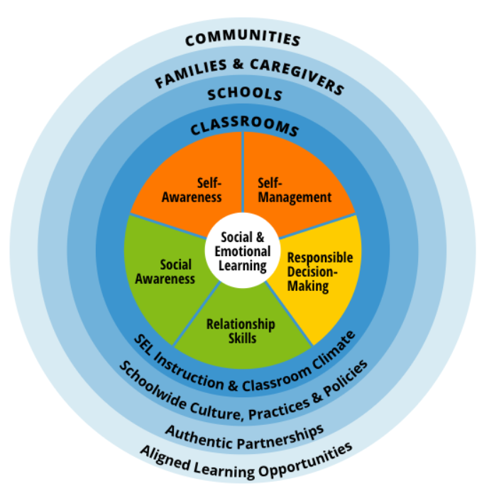
CASEL. (2022). What is the CASEL Framework? Available at: https://casel.org/fundamentals-of-sel/what-is-the-casel-framework/ (Accessed: 02 November 2022).

Appendix two:
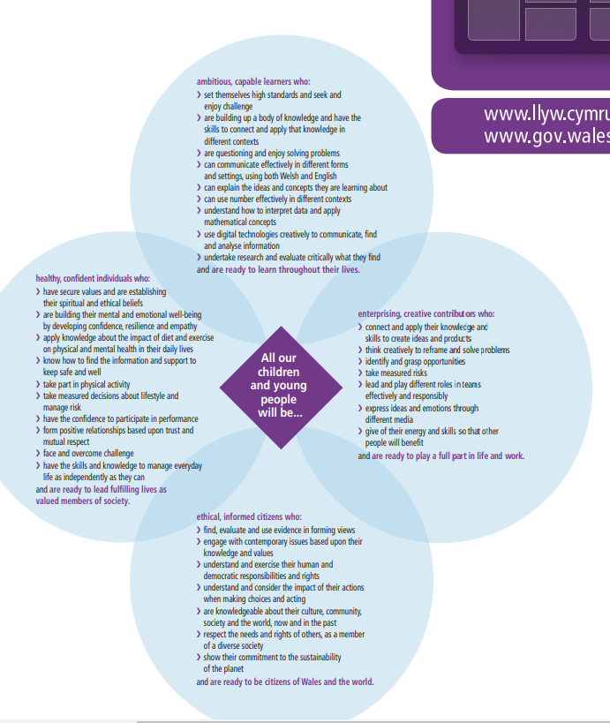

Welsh Government. (2020) Developing a vision for curriculum design. Available at: https://hwb.gov.wales/curriculum-for-wales/designing-your-curriculum/developing-a-vision-for-curriculum-design/#curriculum-design-and-the-four-purposes (Accessed: 26 October 2022).

