Research Cycle Diagrams.
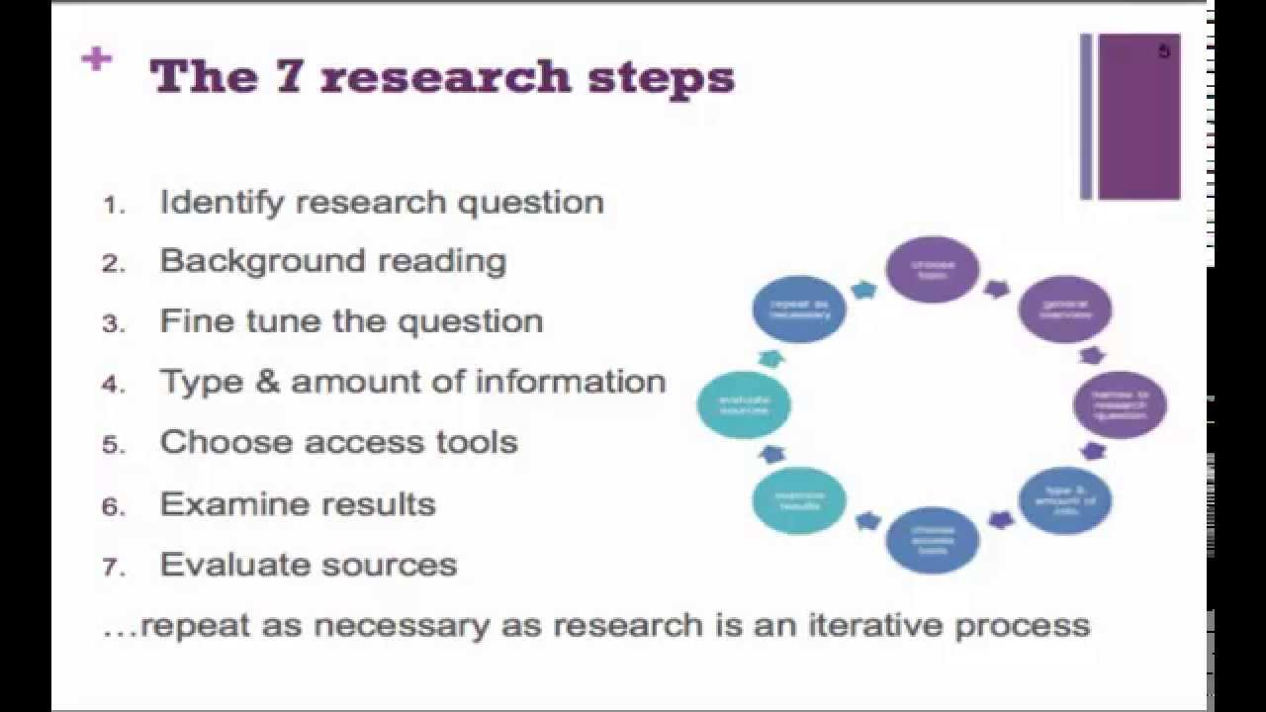

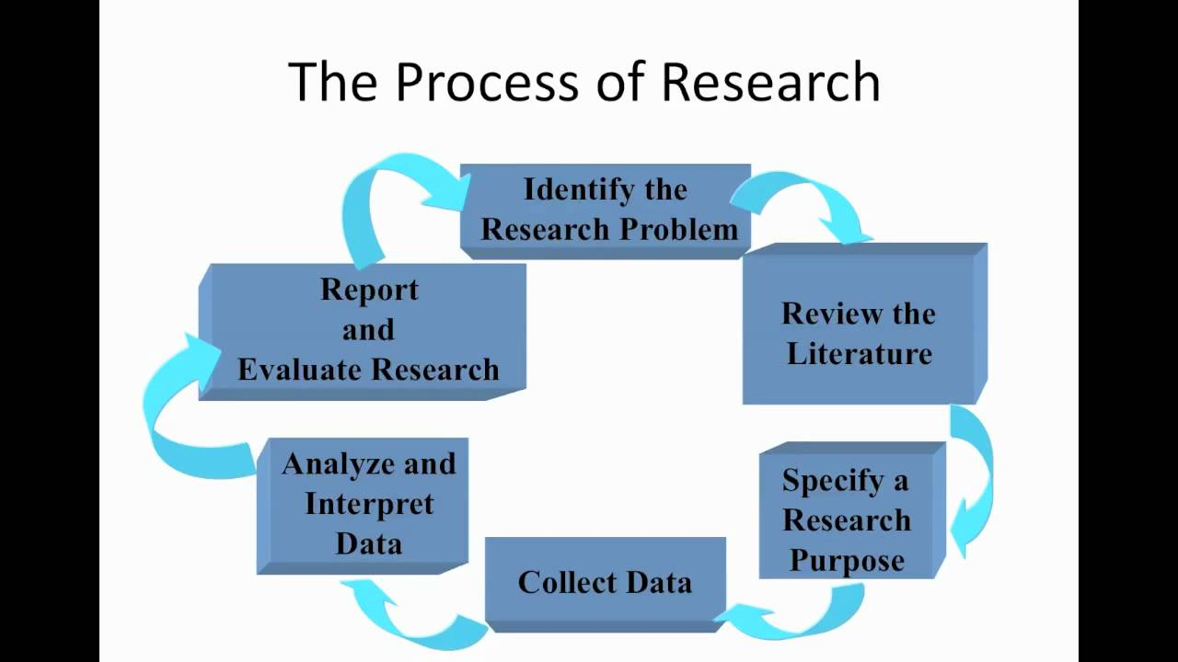
https://www.youtube.com/watch?v=miMnSowiq4s
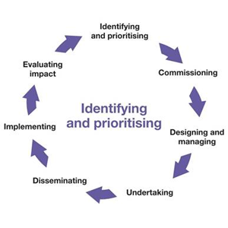
https://www.phc.ox.ac.uk/images/ppi/research-cycle/view

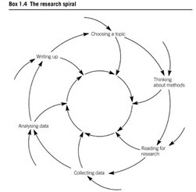

Blaxter, L., Hughes, C. and Tight, M. (2010) How to research, London, McGraw Hill.

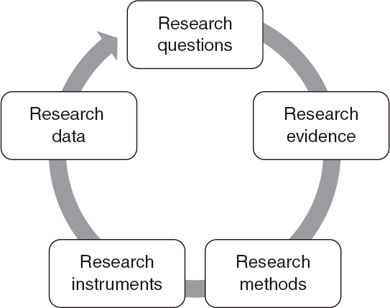

Menter, I., Elliot, D., Hulme, M., Lewin, J. and Lowden, K. (2016) A Guide to Practitioner Research in Education, London, SAGE.

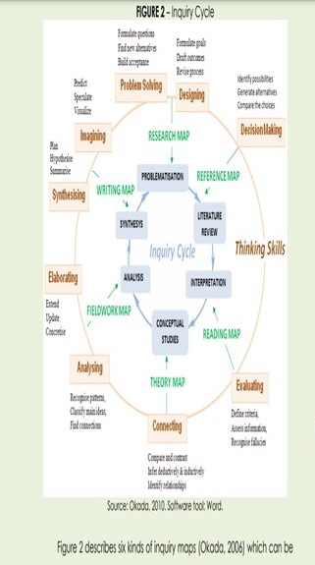

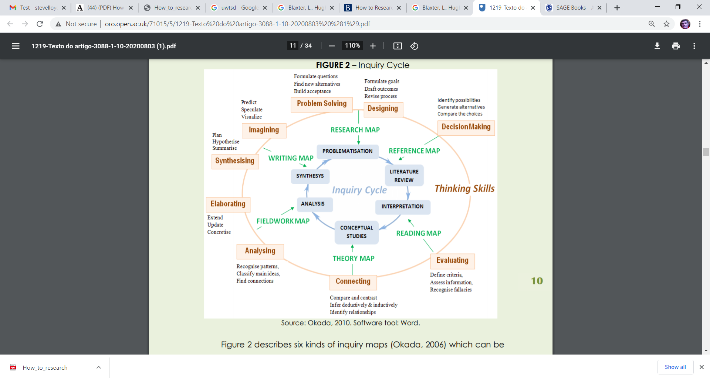

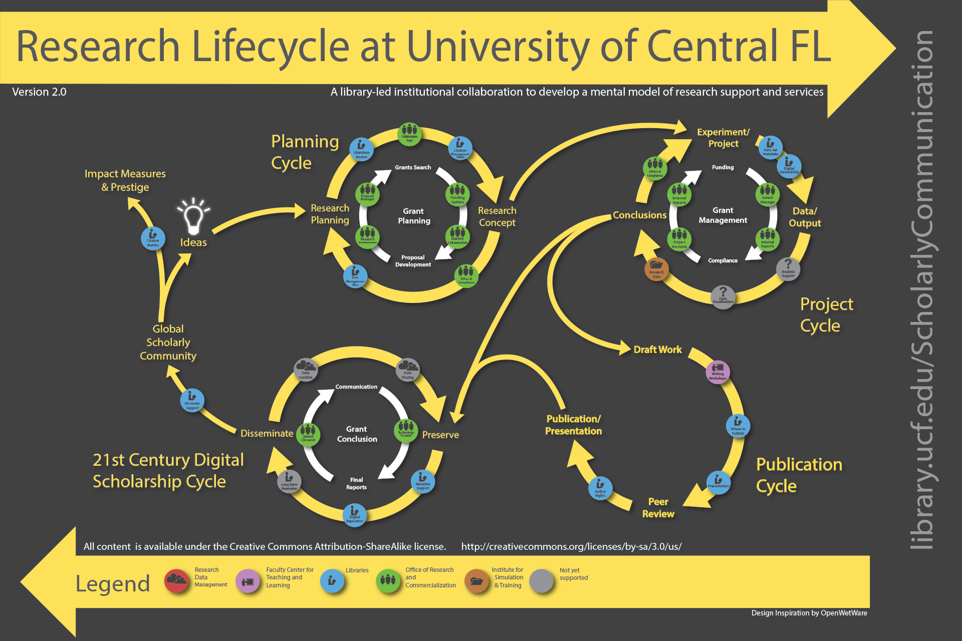

https://library.ucf.edu/about/departments/scholarly-communication/overview-research-lifecycle/

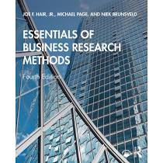

Joe F. Hair Jr., J.F., Michael Page, M. & , N. Brunsveld (2020) Essentials of Business Research Methods, London, Routledge.

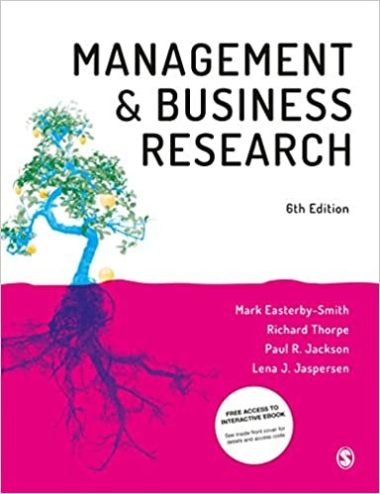

Easterby-Smith, M., Thorpe, R. (Author), Paul R Jackson, P.R. & Lena J. Jaspersen, L.J. (2018) Management and Business Research, London, Sage.

