
Financial Management
Strategic CFO Challenge: Saving a Failing Global Firm – General Electronics

Student Banner ID:
Student Name:
Module Code: LCMB7002
Word Count:

Table of Contents
Introduction 3
Section 1 – Financial Health Check 4
1.1 Revenue and Profitability Analysis 4
Net sales trend 4
Profitability ratios 5
1.2 Liquidity Analysis 6
1.3 Efficiency and Working‑Capital Ratios 7
1.4 Gearing and Solvency Ratios 8
1.5 Cash‑Flow Performance 9
1.6 Altman Z‑Score Analysis 9
1.7 Summary of Financial Problems 10
Section 2 – Working‑Capital Management Analysis 11
2.1 Working‑Capital Overview 11
2.2 Cash Operating Cycle (Cash Conversion Cycle) 11
2.3 Short‑Term Financing Options 12
2.4 Recommendations to Improve Working‑Capital Management 13
Section 3 – Strategic Financial Restructuring Plan 14
3.1 Rationale for Restructuring 14
3.2 Asset Restructuring Options 14
3.3 Capital Structure Restructuring 15
3.4 Operational Restructuring 15
3.5 Strategic Alliances, Mergers and Divestitures 16
3.6 Ethical Considerations and CSR 17
3.7 Recommended Restructuring Strategy 17
Section 4 – Investment Appraisal and Capital Budgeting 18
4.1 Project Descriptions 18
4.2 Methodology and Definitions 18
4.3 Investment Appraisal Results 19
4.4 Capital Rationing and Project Selection 20
4.5 Risk Considerations and Qualitative Factors 20
4.6 Investment Recommendation 21
Conclusion 21
References 23
Appendix A – Summary of Financial Statements 26
Appendix B – Excel Workbook and Charts 26

Introduction
General Electronics, a global consumer‑electronics firm, has encountered a sharp decline in sales and profitability over the last five years. You, as the newly appointed Chief Financial Officer (CFO), have been tasked with diagnosing the underlying causes of the company’s decline, evaluating its working‑capital practices, formulating a restructuring plan and analysing proposed investment opportunities. This report follows a structured approach:
- Financial health check – examining the consolidated income statement, balance sheet and cash‑flow statement, performing ratio analysis and applying the Altman Z‑score failure‑prediction model.
- Working capital management – analysing the cash operating cycle and recommending improvements.
- Strategic financial restructuring plan – recommending asset, capital and operational restructuring options, and considering ethical and international issues.
- Investment appraisal – assessing three prospective projects under a £60 million capital‑rationing constraint using payback period (PBP), accounting rate of return (ARR), net present value (NPV), profitability index (PI) and internal rate of return (IRR) techniques.
The analysis is based on five years of finance data (2020-24) and provides arguments with the help of tables, charts and models. The important concepts, including cash conversion cycle, Altman Z -score, and liquidity ratios, are defined and have a background in academic references (CFI, 2023). The report has a complete Excel workbook containing formulas and graphs.

Section 1 – Financial Health Check

1.1 Revenue and Profitability Analysis

Net sales trend
In 2020, net sales were at £614.68 billion and in 2024, the figure had reduced to 394.88 billion (Table 1). This 36 percentage decrease signifies a declining market share, stiff competition and potential obsolescence of products. The negative revenue curve is depicted in Figure 1, and the worsening Net income is depicted in Figure 2.
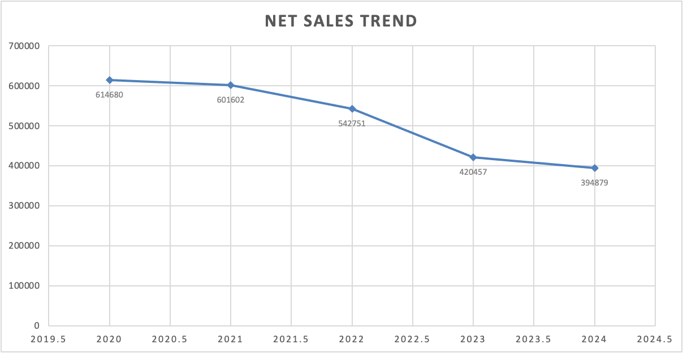
Figure 1. Net sales decline from 2020 to 2024
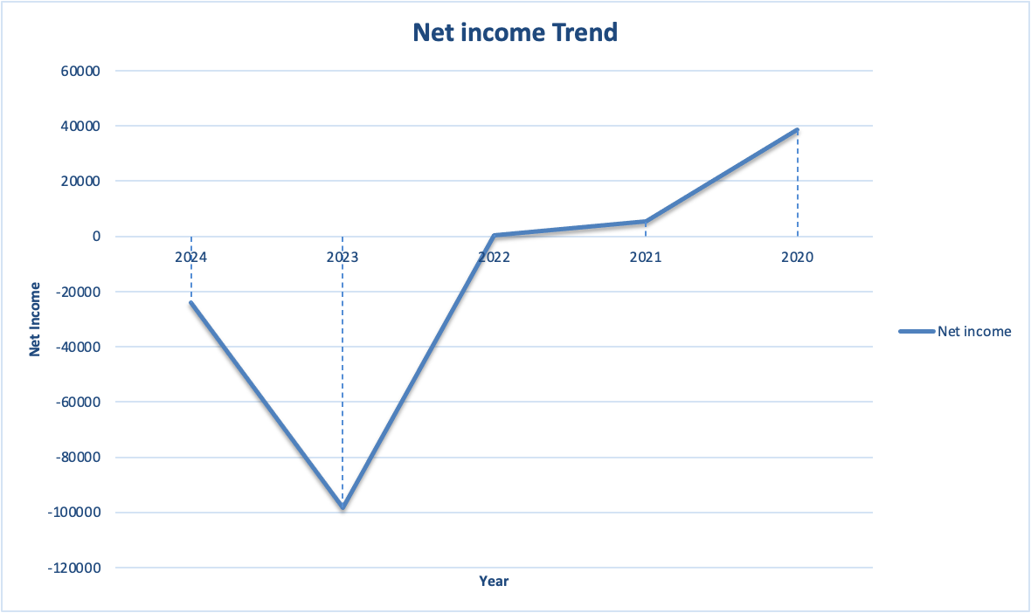
Figure 2. Net income collapse (net losses in 2023–2024)
Gross profit went down both in absolute terms, but it was positive over the years averaging 25% of sales. Nevertheless, operation costs raced high outperforming gross profit in 2023 and 2024. As a result, operating income was plunging to the negative side with a loss of £15.30 billion in 2024. Interest charges and other losses also worsened earnings (Rajgopal et al., 2024) giving successive net losses of £98.24 billion (2023) and 24.03 billion (2024). Such losses liquidated previous retained earnings and shook the shareholder confidence.

Profitability ratios
The gross profit margin was 27.0 in the five years as an average and decreased in 2024 compared to 28.9 in 2020 (Table 2). Operating profit margin became negative in 2023 ( -20.3 ) and 2024 ( -3.9 ). In 2024, net profit margin is at its worst, 6.3 in 2020 and -6.1 in 2024. Return on assets (ROA) and return on equity (ROE) became negative indicating the declining efficiency and increasing leverage. The destruction of shareholder value is evidenced by the negative ROE in 2023-2024.
Year | Gross profit margin | Operating margin | Net margin | ROA | ROE
2020 | 28.7 % | 6.1 % | 6.3 % | 7.6 % | 12.3 %
2021 | 28.8 % | 3.9 % | 0.9 % | 1.0 % | 1.9 %
2022 | 28.1 % | 2.7 % | 0.1 % | 0.1 % | 0.2 %
2023 | 23.2 % | –20.3 % | –23.4 % | –27.6 % | –54.9 %
2024 | 28.9 % | –3.9 % | –6.1 % | –7.4 % | –15.7 %
Table 1. Profitability ratios calculated from consolidated financial statements
These ratios reflect an acute profitability crisis. Increased operating costs compared to sales have weakened margins and decreased revenue compounds the issue. Negative operating margin indicates poor cost control; the management needs to immediately decrease fixed and variable costs, negotiate supplier contracts and stream overheads (Egbumokei et al., 2024).

1.2 Liquidity Analysis
Liquidity ratios assess how the firm is capable of covering its short-term liabilities (Hasidi, Baheri and Hajar, 2024). The current ratio measures the relationship between current assets and current liabilities; a value exceeding 1.0 means that a business organisation has sufficient short-term assets to meet its debts (Sumarni, 2025). The quick ratio (acid-test) does not include inventories and other less liquid assets; a more conservative measure since inventories might not be readily transformable to cash.
Year | Current ratio | Quick ratio
2020 | 1.82 | 1.15
2021 | 1.56 | 1.01
2022 | 1.56 | 0.91
2023 | 1.61 | 1.05
2024 | 1.53 | 1.03
Table 2. Liquidity ratios (current and quick)
Figure 3 illustrates the trend in the current ratio. This ratio was higher than 1.5 until 2022, when it fell to 1.53. The quick ratio is close to 1.0 which means that without inventory the firm just covers its current liabilities. The corporate finance guide by Bill indicates that a healthy current ratio is around 1.5-2.0, and a ratio of less than 1.0 indicates liquidity risk. General Electronics is therefore standing on the brink of sufficient liquidity; their decreasing cash reserves (since 2020: £74.30 billion to 2024: £26.78 billion) are worrying.
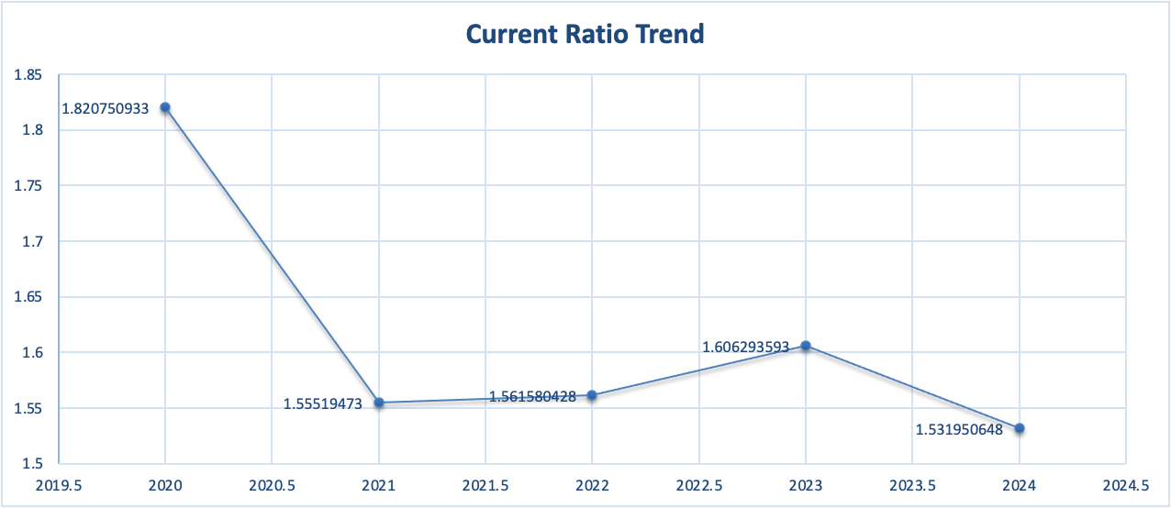
Figure 3. Current ratio trend showing slight deterioration (2020–2024)

1.3 Efficiency and Working‑Capital Ratios
The cash operating cycle (or cash conversion cycle) operational efficiency is represented as days inventory outstanding + days sales outstanding - days payables outstanding (Miswanto and Oematan, 2020). A lower cash conversion cycle represents that a business turns its inventory and receivables into cash in a short time; a high or increasing cycle is an indication of inefficient working-capital management. According to Asman et al. (2022), shorter (lower) cash conversion cycle is preferable, whereas negative cycle is desirable since the suppliers efficiently fund the operations.
Year | Inventory days | Receivable days | Payable days | Cash conversion cycle
2020 | 100.2 | 77.0 | 69.4 | 107.8
2021 | 114.5 | 78.8 | 78.6 | 114.7
2022 | 130.8 | 75.6 | 94.2 | 112.2
2023 | 99.8 | 97.5 | 64.5 | 132.8
2024 | 103.2 | 105.7 | 93.6 | 115.3
Table 3. Efficiency and working‑capital ratios
Inventory days (days inventory outstanding) have been high throughout the period, with a peak of 130.8 days in 2022 because of overstocking and mistakes in demand forecasting. In 2024, receivable days were 105.7 days and indicating a relaxed credit policy and slower collections. The number of payable days decreased to 93.6 days in 2024, which means that suppliers are becoming stricter in their payment conditions, probably because of the fear of the creditworthiness of the firm. Cash conversion cycle increased to 107.8 days in 2020 to 132.8 days in 2023, then moderated to 115.3 days in 2024. The high cycle makes cash trapped in working capital, which further increases liquidity stress.

1.4 Gearing and Solvency Ratios
Financial risk is magnified by high leverage. Debt-to-equity ratio has increased by 11 to 0.63 in 2024 (Table 4), implying that liabilities are now more than shareholders' equity by 11 %. Interest coverage is a measure of the capacity to cover debt interest due using earnings; it is calculated as earnings before interest and tax (EBIT) divided by the interest expense. Interest cover was negative in 2023 (-19.7) and 2024 (-4.5), indicating the inability to pay interest using profits. The company used extra borrowings to pay off. Although debt financing may exaggerate returns in times of growth, the present leverage ratio is not sustainable and raises the risk of default (Zheng, 2023).
Year | Debt‑to‑equity | Interest coverage
2020 | 0.63 | 28.3
2021 | 0.85 | 41.1
2022 | 0.88 | –4.3
2023 | 0.99 | –19.7
2024 | 1.11 | –4.5
Table 4. Gearing ratios (debt‑to‑equity and interest coverage)

1.5 Cash‑Flow Performance
The cash-flow statement demonstrates declining cash generation. The operating cash flow in 2024 was lower at 14.82 billion compared to that of 2020 (73.39 billion) despite significant non-cash-adjustments, including goodwill impairments (49.08 billion in 2024). Cash was always expended on investing activities, and capital expenditure amounted to over £14 billion each year. Funding operations reflect the use of short-term lines of credit: borrowings reached their highest point in 2022, with repayments being made in 2024. The cash balance was negative in 2024 and in 2023, the net cash declined by a total of 15.97 billion and 23.99 billion, respectively. The fall in operating cash flow and continuing negative free cash flow increases insolvency risk.

1.6 Altman Z‑Score Analysis
To gauge bankruptcy risk, the Altman Z‑score model (manufacturing version) combines five ratios: working capital/total assets, retained earnings/total assets, EBIT/total assets, equity/total liabilities and sales/total assets (Rashid, Khan and Qureshi, 2024). A Z‑score below 1.8 signals financial distress, 1.8 – 3.0 represents a grey zone and above 3.0 suggests safety (Ch and Zulfiati, 2019). Table 5 summarises the calculated Z‑scores and their interpretation.
Year | Z‑score | Interpretation
2020 | 2.55 | Grey zone – moderate risk
2021 | 2.35 | Grey zone, trend declining
2022 | 1.96 | Grey zone approaching distress
2023 | 1.44 | Distress – high bankruptcy risk
2024 | 1.78 | Distress – marginal improvement
Table 5. Altman Z‑scores for General Electronics
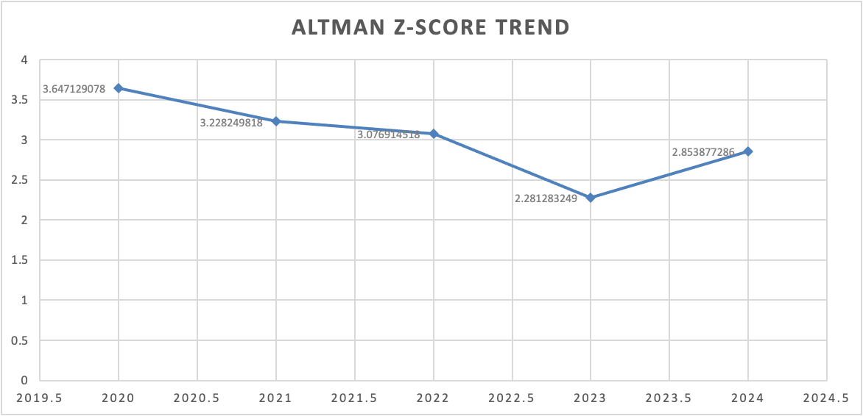
Figure 4. Z‑score trend showing movement into the distress zone
The Z‑score fell steadily from 2.55 in 2020 to 1.44 in 2023 before marginally improving to 1.78 in 2024. According to the Corporate Finance Institute, Z‑scores below 1.8 indicate a high probability of bankruptcy. This trend validates that General Electronics is on the verge of financial distress. The change of 2024 is the positive retained earnings ratio and a smaller total liabilities amount, but the company continues to be in the danger zone.

1.7 Summary of Financial Problems
The financial health audit shows a struggling company. There is a collapse in sales and profits, and shareholder equity has been eroded by losses. The liquidity ratios are at the threshold level of the recommended liquidity ratios, and the quick ratio shows the presence of a few liquid assets. Efficiency measures show that the cash conversion cycle is long, with slow inventory turnover and slow receivable collection. Gearing ratios indicate increasing leverage and negative interest coverage, which reveals failure to meet debt obligations through earnings. There is a falling operating cash flow despite extensive asset write-downs, and a Z-score indicates financial distress. Restructuring the capital base and working-capital management is needed to stabilise the business immediately; strategic action is needed.

Section 2 – Working‑Capital Management Analysis

2.1 Working‑Capital Overview
Working capital represents the resources needed to finance day‑to‑day operations – primarily inventories, receivables and payables (Kiymaz, Haque and Choudhury, 2024). Adequate working capital ensures liquidity, while excessive working capital ties up cash and depresses returns. General Electronics’ balance sheets reveal high levels of inventories and receivables relative to payables. In 2024, total current assets were £242.49 billion against current liabilities of £158.29 billion, producing working capital of £84.20 billion. However, nearly half of current assets are tied up in receivables (£114.18 billion) and inventories (£79.36 billion). Cash and cash equivalents have fallen to £26.78 billion, so day‑to‑day liquidity is constrained.

2.2 Cash Operating Cycle (Cash Conversion Cycle)
The cash conversion cycle (CCC) gauges how long cash is tied up in operating activities. It is computed as days inventory outstanding (DIO) plus days sales outstanding (DSO) minus days payables outstanding (DPO) (Asman et al., 2022). General Electronics’ CCC lengthened to 132.8 days in 2023 before moderating slightly to 115.3 days in 2024 (Table 3). The high CCC indicates that the company takes almost four months to convert cash spent on inventory into cash received from customers after paying suppliers. A CCC of this length is problematic in a high‑tech industry where product lifecycles are short and obsolescence risk is high.
Inventory management. In 2022, DIO was the highest at 130.8 days, as a result of the accumulation of finished goods and raw materials. The company underestimated the demand in some of its product lines, causing a surplus of inventory. Margins were further undermined by high carrying costs (storage, insurance and obsolescence). As of 2024, DIO dropped to 103.2 days, which is nevertheless high considering an electronics company. Inventory levels might be lowered by implementing just-in-time (JIT) procurement, improved demand forecasting, and combined supply-chain planning. Collaborating with suppliers to exchange sales information and switching to vendor-controlled inventory may assist in matching production to demand (Angulo, Nachtmann and Waller, 2004).
Receivable management. DSO increased by leaping from 77.0 days in 2020 to 105.7 days in 2024, which implies generous credit conditions and weak collection policies. High DSO immobilises cash and increases the chances of bad debts. The company ought to implement stricter lending conditions, offer tighter terms of payment and early payment discounts. Only a strong accounts receivable management system, enabling automated reminders and monitoring credit risks, can help speed up the receipt of cash. Receivables might also be converted into cash sooner than during invoice discounting, but at a price (Rus, 2025).
Payable management. DPO dropped to 93.6 days in 2024, as compared to 94.2 days in 2022, which means that suppliers are getting paid faster or the company is paying prematurely. Prolonging payment terms may decrease the CCC, yet it must be accompanied by ensuring the fidelity among the suppliers. With the firm financially distressed, suppliers might restrict credit; negotiation of longer payment terms, or seek supply-chain financing (pay early to avoid payables, provided by a bank, at a discount) or dynamic discounting (pay early at a discount in exchange provided by a bank) may be lifelines.

2.3 Short‑Term Financing Options
Due to the long cash conversion cycle and dwindling cash reserves, General Electronics needs additional short‑term financing. Options include:
- Rotating credit lines – The company has already been utilising lines of credit (with 36.96 billion outstanding in 2024). It may renegotiate conditions to make it more flexible and reduce interest expenses. Debt is a matter that has to be carefully handled, not to result in over-dependence.
- Factoring or invoice financing - Sales receivables can be sold to a factor or invoices taken out to increase cash flows. This alternative has the cost of financing, but it may be reasonable in the event that it avoids stockouts or lost sales.
- Inventory financing- Obtaining loans with inventory collateral could help sustain liquidity as the company clears inventory (Cai, 2024). This should be coupled with better forecasting so as not to build up accumulated inventory.
- Short-term notes or commercial paper - The issuance of short-term debts can be practicable when the investors are assured. Nevertheless, the credit ratings will most probably be degraded, and the cost of borrowing will increase.

2.4 Recommendations to Improve Working‑Capital Management
- Adopt JIT and demand supply chains. Minimise inventory through teamwork with suppliers, improving demand forecasting, and switching to smaller and more frequent production batches. This will minimise DIO and cut down on storage expenses.
- Strengthen credit controls. Check customer creditworthiness, assign credit limits and collect on time (Scott, Amajuoyi and Adeusi, 2024). Implement early-payment rewards and late-payment sanctions. Adopt an accounts receivable management system to track outstanding invoices.
- Bargain longer payment period. Enter into discussions with key suppliers to agree on extended payment terms without compromising relations. Look at supply-chain finance products offered by banks or fintech providers to lengthen DPO and still have suppliers paid on time.
- Concentrate treasury leadership. Visibility of cash flows will be centralised to contribute to better forecasting and the ability of the firm to manage liquidity. Cash pooling in subsidiaries can lessen idle funds in subsidiaries and assist in prioritising payments.
- Think of asset-backed financing. Secure cheaper financing by using receivables or inventory as security. Nonetheless, this financing has to be transitional, as underlying inefficiencies are resolved.
All these measures should actually reduce the cash conversion period, free up cash and enhance liquidity. When coupled with an extensive restructuring strategy (Section 3), they can stabilise the operations and lay a basis for future growth.

Section 3 – Strategic Financial Restructuring Plan

3.1 Rationale for Restructuring
The financial analysis indicates the decrease in sales, margins, high leverage, worsening cash flows and increasing bankruptcy risk. A turnaround plan should consider the operational and capital structure weaknesses (Obo, 2007). The Board needs a strategy that enhances profitability, decreases leverage, and regains investor confidence and gets the company on the path to long-lasting, ethical expansion.

3.2 Asset Restructuring Options
Selling non-core operations. General Electronics needs to revise its line of products and drop low-margin or unprofitable lines. The sale of nonperforming units may free up cash and lessen complexity, and enable management to concentrate on core competencies. Potential alternatives are legacy consumer-electronics divisions that are highly competitive and generate low margins. The disposition of non-core subsidiaries may result in cash flows to settle debt.
Sale-and-leaseback of real estate. The company has a large amount of property, plant and equipment (34.21 billion in 2024). A sale- and- leaseback may turn those assets into cash and allow them to be used operationally. Lease commitments will be more expensive to operate; however, the management needs to weigh the cost of leasing against the cost of decreased leverage.
Intangible asset monetisation. Patents, trademarks and technology are intangible assets (£24.04 billion in 2024). Without loss of ownership, these assets can be licensed to other companies or joint ventures. Alternatively, non-strategic intellectual property can be sold to generate liquidity (Rieck, 2025).
Asset write-downs and inventories. Surplus inventory will have to be acquired at a write-down to realisable value, recognising obsolescence in the product and relieving storage space. Additional impairment of long-lived assets might be required to recognise economic reality, although this will decrease book equity.

3.3 Capital Structure Restructuring
Equity injection. With high leverage and a losing operation, a large injection of equity is necessary. Alternatives are a rights issue to current shareholders, strategic investors, or a fresh issue of shares to the market. Equity injection enhances the balance sheet, better the debt-to-equity ratio and demonstrates intentions on turnaround. Nonetheless, the risk of dilution has to be addressed; current shareholders will not be eager to subscribe without a plausible recovery strategy.
Debt restructuring. The firm ought to negotiate with creditors to increase maturity, reduce interest or convert debt to equity. Debt-to-equity swaps lower the cost of interest and enhance cash flow. Creditors, however, can insist on concessions in the form of board positions or covenants. It can also think of converting short-term credit lines into convertible bonds, balancing between debt and equity characteristics.
Reissue treasury stock. The company has a high negative treasury stock (–£371.93 billion). Repurchasing a part of the shares would increase cash without additional dilution. Strategic partners can be offered treasury shares, or they can be used to pay debts.
Consider bond buybacks. Repurchases of bonds on the open market would create gains in case the company's debt is trading at a discount because of distress. This plan has to be well-timed and funded by either the liquidation of assets or new capital.

3.4 Operational Restructuring
Cost reduction. Operating costs are higher than gross profit, which indicates bloated cost structures. Management needs to perform zero-base budgeting and determine non-essential functions. Fixed costs can be minimised by consolidating manufacturing plants, automating manufacturing and outsourcing non-core operations. To restructure the staffing levels, labour negotiations may be required; these measures should be taken ethically and in accordance with the employment law (Oya and Schaefer, 2021).
Supply‑chain optimisation. Repackaging the supply chain to cut lead times and logistic expenses will enhance margins. To improve efficiency, lean manufacturing and process automation (e.g., Internet of Things sensors for predictive maintenance) can be implemented. Relationships with suppliers and contract manufacturers can decrease capital spending.
Revenue enhancement. In addition to cost minimisation, the company should stabilise and increase revenue. Solutions feature the introduction of new products, entering growing markets (e.g., smart home, electric mobility) and using a familiar brand name in new markets. The pricing strategy must be based on value-added differentiation, as opposed to commoditised price rivalry.

3.5 Strategic Alliances, Mergers and Divestitures
Mergers or acquisitions. Collaborating with or buying a lucrative rival may give synergies, extend product lines and offer economies of scale (Shijaku, Lou and Bauer, 2025). Indicatively, the merger with a local electronics company could increase distribution channels and cut down on overhead costs. But this is difficult to finance, considering the leverage of the company; any acquisition has to be made so that equity is involved in the target or the asset swaps.
JVs and strategic partnerships. Partnerships with tech companies may speed up the process of innovations and reduce research costs. Joint ventures lessen exposure to risks and offer entry to new markets without significant preliminary investment (Schulte, 2025). Connection with component suppliers may guarantee special prices and a supply guarantee.
International considerations. General Electronics, being a global company, is exposed to fluctuations in currencies, varying taxation regimes and political risks. The restructuring plan must consider repatriation of profits, transfer-pricing arrangements and hedging strategies. Exposure can be minimised by selling operations in high-risk jurisdictions or re-domiciling some subsidiaries (Ueta and Yasuda, 2025). Simultaneously, the company will have to adhere to local regulations and corporate social responsibility.

3.6 Ethical Considerations and CSR
Ethics should form the basis of financial decisions. Lay-offs and plant closures should be accompanied by fair severance, retraining programmes and community involvement. Divestitures are to take into account the effects on workers and the local economies. Sustainability of the environment should be considered a priority; circular-economy programmes can decrease waste and improve the brand image (Toponar et al., 2024). The company should also uphold anti-bribery, privacy and consumer-protection legislation.

3.7 Recommended Restructuring Strategy
The recommended approach combines asset sales, equity injection and operational restructuring:
- sell non-core business and sell-and-leaseback deals on properties to raise cash now to pay off debt.
- Issue a rights issue to raise new capital as equity capital; organise the offering with warrants to enlist participation. Parallel structure a debt-equity swap with creditors to enhance leverage.
- Adopt economisation solutions, shut down unused facilities, automate production and centralise procurement. Target operating expenses of 20 per cent of sales in three years.
- Use working-capital reforms in Section 2 and reduce the cash conversion cycle and liquidity.
- Create strategic partnerships in new markets and with technological partners to revitalise product pipelines. Do not make big purchases until the balance sheet is good.
- Integrate restructuring with ethical practices and CSR, which should be transparent and stakeholder-involving.
This low-risk approach will meet short-term liquidity requirements, cut down on leverage and enhance profitability and ensure sustainable growth.

Section 4 – Investment Appraisal and Capital Budgeting

4.1 Project Descriptions
The Board is considering three mutually exclusive projects (A, B and C). Each requires an initial investment and generates cash inflows over five years. Capital rationing limits the total investment to £60 million. All projects use straight‑line depreciation to zero residual value and a discount rate of 10 %.
Project | Initial investment (£ m) | Year 1 | Year 2 | Year 3 | Year 4 | Year 5
A | 40 | 10 | 12 | 14 | 10 | 8
B | 30 | 6 | 6 | 6 | 6 | 6
C | 50 | 5 | 10 | 20 | 25 | 15
Table 6. Proposed investment projects and cash inflows

4.2 Methodology and Definitions
Investment appraisal compares the present value and profitability of competing projects using several metrics. Definitions are summarised below.
- Payback period (PBP). The number of years needed to recover the initial investment from cash inflows. According to Investopedia, the payback period measures how long it takes for cash inflows to recoup the original outlay. A shorter payback is preferred because it indicates quicker recovery of the invested capital (Ridwan et al., 2025).
- Accounting rate of return (ARR). Average annual accounting profit (after depreciation) divided by the initial investment. This ratio provides a simple measure of profitability but ignores the time value of money.
- Net present value (NPV). The difference between the present value of future cash flows and the initial investment. The NPV rule states that projects with positive NPV should be accepted because they add value to the firm. When funds are limited, management should select the combination of positive‑NPV projects that maximises the sum of NPVs.
- Profitability index (PI). The ratio of the present value of future cash inflows to the initial investment. A PI above 1.0 indicates value creation.
- Internal rate of return (IRR). The discount rate used in calculating NPV so that NPV equals zero. According to Chen et al. (2022), IRR offers a point of reference: an IRR that is higher than the cost of capital must be accepted.

4.3 Investment Appraisal Results
The Excel model (Appendix B) computes the appraisal metrics. Table 7 summarises the results.
Project | Payback (years) | ARR | NPV (£ m) | PI | IRR
A | ≈ 3.4 | 7.0 % | 1.32 | 1.03 | 11.3 %
B | 5.0 | 0.0 % | –7.26 | 0.76 | 0.0 %
C | ≈ 3.6 | 10.0 % | 4.23 | 1.08 | 12.7 %
Table 7. Investment appraisal metrics (discount rate = 10 %)
Project A is less profitable with a cash inflow which produces an NPV of 1.32 million and an IRR of 11.3 per cent, slightly higher than the 10 per cent discount rate. The liquidity is moderate as the payback period is 3.4 years. Profitability index, however, stands at just 1.03, indicating that value creation is minimal.
Project B provides steady cash flows of 6 million per year but cannot compensate for its cost of capital. It gives a negative NPV (–£7.26 million) and an IRR of zero. Breakeven occurs at the very end of year 5, and the life of the project is equal to its payback period. Project B should not be accepted due to the firm's and its capital limitations and risk profile.
Project C has the highest investment (£50 million) but the highest NPV (£4.23 million), PI of 1.08 and IRR of 12.7 which is much higher than the 10 per cent discount rate. The payback period of 3.6 years compares to Project A, whereas the larger returns make it more appealing.

4.4 Capital Rationing and Project Selection
With a capital budget of £60 million, management cannot undertake all projects. Possible combinations and their total cost and combined NPVs are listed below:
- A + B: cost = £70 million (exceeds limit, not viable). NPV = £1.32 m – £7.26 m = –£5.94 m.
- A + C: cost = £90 million (not viable).
- B + C: cost = £80 million (not viable).
- C alone: cost = £50 million; NPV = £4.23 million.
- A alone: cost = £40 million; NPV = £1.32 million.
- B alone: cost = £30 million; NPV = –£7.26 million.
Only Projects A and C can be pursued separately within the limit of £60 million. Project C is higher in NPV and IRR than the other, and therefore maximises shareholder value. Project C, then, is to be chosen. Project A can be held back as a contingency should more funds become available or the risk profile of Project C be unacceptable, but Project B has to be simply rejected based on its negative NPV.

4.5 Risk Considerations and Qualitative Factors
While quantitative metrics favour Project C, qualitative factors must also be assessed:
- Cash‑flow volatility. The cash inflows of project C are back-loaded (e.g. £25 million in year 4), which creates forecasting risk. General Electronics would, however, handle this by carrying out a strong market research and scenario analysis. Timing risk should be mitigated by contingency plans, including deferring some expenditures or obtaining working-capital lines.
- Strategic alignment. Project C can be associated with new product lines, which are in line with the company restructuring strategy, which assists in repositioning the firm in the high-growth areas. Project A is smaller but could concern minor modifications to existing products, as its NPV is modest, and it does not contribute much to the strategy.
- Capital rationing. With the dire liquidity situation illustrated in Sections 1 and 2, (observed) investing in Project C of £50 million is already a stretch. The management should make sure that the project is funded via the rights issue or asset sale as set in Section 3.
- Risk and return trade‑off. The capital budgeting theory states that projects whose IRR exceeds the cost of capital must be accepted. The IRR of project C is 12.7 %. This comfortably exceeds the 10 per cent hurdle rate. Conversely, Project A just passes the hurdle rate and comes with a small risk premium.
- Ethical and environmental considerations. The corporation ought to evaluate the alignment of every project to the sustainability goals and corporate social responsibility promises. As an illustration, when Project C concerns renewable-energy products or circular-economy projects, this might help to increase brand reputation and long-term value.

4.6 Investment Recommendation
Project C is an investment that has been selected based on quantitative appraisal and qualitative assessment. It has the largest positive NPV, a high IRR over the hurdle rate and a profitability index of more than one. Payback period is satisfactory considering that the firm has a long cash conversion cycle. The project needs to be undertaken simultaneously with a restructuring plan: asset sales, equity financing and working-capital improvements should provide adequate liquidity to finance the project, without compromising the operations..

Conclusion
General Electronics is at a crossroads. The financial health cheque revealed declining revenues, worsening margins, excessive leverage, ineffective working-capital management and extreme liquidity strains. The liquidity ratios are only slightly exceeding safe levels, and the Altman Z-score has dropped into the distress range. The conversion cycle of cash is too long, and cash is tied up in inventory and receivables. The company may become bankrupt unless action is taken.
To liberate cash and reduce the cash conversion cycle, working-capital reforms are required, such as stricter credit controls, inventory management, and renegotiated payment terms. Strategic restructuring must include the disposal of non-core assets, an equity injection, and debt restructuring and aggressive cost reduction. These actions should be guided by ethical considerations and corporate social responsibility.
Lastly, investment appraisal shows that it is only Project C that gives an acceptable return within the capital rationing constraint. Projects A and B offer little or no value. Project C, which will be funded by the restructuring measures, may assist General Electronics in repositioning itself towards growth. By controlling finances and restructuring strategies and wise investments, the company can stabilise its activities, restore trust among stakeholders and set a path to a sustainable future.

References
Angulo, A., Nachtmann, H. and Waller, M.A. (2004). SUPPLY CHAIN INFORMATION SHARING IN A VENDOR MANAGED INVENTORY PARTNERSHIP. Journal of Business Logistics, 25(1), pp.101–120. doi:https://doi.org/10.1002/j.2158-1592.2004.tb00171.x.
Asman, F.N., Fernandez, D., Jamaludin, N.A., Omar Zaki, H. and Ghazali, A.W. (2022). Cash Conversion Cycle and Firm’s Performance. International Journal of Academic Research in Business and Social Sciences, 12(11). doi:https://doi.org/10.6007/ijarbss/v12-i11/15276.
Cai, G. (2024). Seller-Led Supply Chain Finance. pp.139–182. doi:https://doi.org/10.1007/978-3-031-56125-2_6.
CFI (2023). Altman’s Z-Score Model. [online] Corporate Finance Institute. Available at: https://corporatefinanceinstitute.com/resources/commercial-lending/altmans-z-score-model/.
Ch, F.N. and Zulfiati, L. (2019). Financial Distress Analysis with Altman Z Score Method and Value of SOEs Listed on BEI. Proceedings of the 5th Annual International Conference on Accounting Research (AICAR 2018). doi:https://doi.org/10.2991/aicar-18.2019.11.
Chen, Y., Dong, Z., Wu, Y. and Zhang, W. (2022). Various Methods Aim to Solve the Limitation of IRR. [online] www.atlantis-press.com. doi:https://doi.org/10.2991/aebmr.k.220307.198.
Egbumokei, P.I., Dienagha, I.N., Digitemie, W.N., Onukwulu, E.C. and Oladipo, O.T. (2024). Strategic contract management for drilling efficiency and cost reduction: Insights and perspectives. International Journal of Multidisciplinary Research and Growth Evaluation, 5(5), pp.1042–1050. doi:https://doi.org/10.54660/.ijmrge.2024.5.5.1042-1050.
Hasidi, M.H., Baheri, J. and Hajar, K.I. (2024). Financial Performance Evaluation Using Profitability and Liquidity Ratio Analysis. Jurnal Ilmiah Manajemen Kesatuan, 12(4), pp.1347–1358. doi:https://doi.org/10.37641/jimkes.v12i4.2742.
Kiymaz, H., Haque, S. and Choudhury, A.A. (2024). Working capital management and firm performance: A comparative analysis of developed and emerging economies. Borsa Istanbul Review, 24(3). doi:https://doi.org/10.1016/j.bir.2024.03.004.
Miswanto, M. and Oematan, D.S. (2020). EFFICIENCY OF USING ASSET AND FINANCIAL PERFORMANCE: THE CASE OF INDONESIA MANUFAKCTURING COMPANIES. MIX JURNAL ILMIAH MANAJEMEN, 10(2), p.180. doi:https://doi.org/10.22441/mix.2020.v10i2.003.
Obo, E.B. (2007). Businesses In Crisis: A Turn Around Strategy. ResearchGate, [online] 10(1), pp.151–155. Available at: https://www.researchgate.net/publication/370715284_Businesses_In_Crisis_A_Turn_Around_Strategy [Accessed 20 Nov. 2025].
Oya, C. and Schaefer, F. (2021). The politics of labour relations in global production networks: Collective action, industrial parks, and local conflict in the Ethiopian apparel sector. World Development, 146, p.105564. doi:https://doi.org/10.1016/j.worlddev.2021.105564.
Rajgopal, S., Basirian, E., Iqbal, A. and Srivastava, A. (2024). Reassessed Earnings with Capitalized Intangibles. SSRN Electronic Journal. doi:https://doi.org/10.2139/ssrn.4800818.
Rashid, F., Khan, R.A. and Qureshi, I.H. (2024). A Comprehensive Review of the Altman Z-Score Model Across Industries. SSRN Electronic Journal. doi:https://doi.org/10.2139/ssrn.5044057.
Ridwan, S., Syah, T.Y.R., Kustiawan, U. and Nofierni, N. (2025). Financial Planning and Investment Feasibility Analysis Based on Five-Year Projections Using ROI, NPV, IRR, and Financial Ratios. Journal La Bisecoman, [online] 6(2), pp.489–506. doi:https://doi.org/10.37899/journallabisecoman.v6i2.1970.
Rieck, A.K. (2025). Efficiently divesting special assets: Strategies for documenting a clean sale. Corporate real estate journal, 14(3), pp.234–234. doi:https://doi.org/10.69554/hulm2259.
Rus, M.-I. (2025). Optimizing Cash Flow. Ovidius University Annals. Economic Sciences Series, [online] 24(2), pp.635–640. doi:https://doi.org/10.61801/ouaess.2024.2.83.
Schulte, R. (2025). New venture risk management: Theoretical framework and research perspectives. Journal of the International Council for Small Business, pp.1–20. doi:https://doi.org/10.1080/26437015.2024.2448982.
Scott, Amajuoyi, N.P. and Adeusi, N.K.B. (2024). Effective credit risk mitigation strategies: Solutions for reducing exposure in financial institutions. Magna Scientia Advanced Research and Reviews, 12(1), pp.198–211. doi:https://doi.org/10.30574/msarr.2024.11.1.0084.
Shijaku, E., Lou, B. and Bauer, F. (2025). Exploring synergies in business restructuring: A dynamic framework. Business Horizons. [online] doi:https://doi.org/10.1016/j.bushor.2025.10.008.
Sumarni, E. (2025). PT Harta Solvency Performance Review Jaya Tbk : Comparison Debt to asset ratio, Debt to Equity ratio, Long Term debt to Equity Ratio, Times Interest Earned and Fixed Charge Coverage. SSRN Electronic Journal. doi:https://doi.org/10.2139/ssrn.5125170.
Toponar, O., Shpatakova, O., Kopchak, Y., Klievtsievych, N. and Miniailenko, I. (2024). Integrating the Circular Economy into Business Processes to Reduce Waste and Increase Environmental Sustainability. Grassroots Journal of Natural Resources, 7(2), pp.140–159. doi:https://doi.org/10.33002/nr2581.6853.070207.
Ueta, T. and Yasuda, N. (2025). Divestment of Foreign Subsidiaries for Deletion and Redeployment. Management International Review. doi:https://doi.org/10.1007/s11575-025-00569-5.
Zheng, H. (2023). Sovereign debt responses to the COVID-19 pandemic. Journal of International Economics, [online] 143, p.103766. doi:https://doi.org/10.1016/j.jinteco.2023.103766.

Appendix A – Summary of Financial Statements
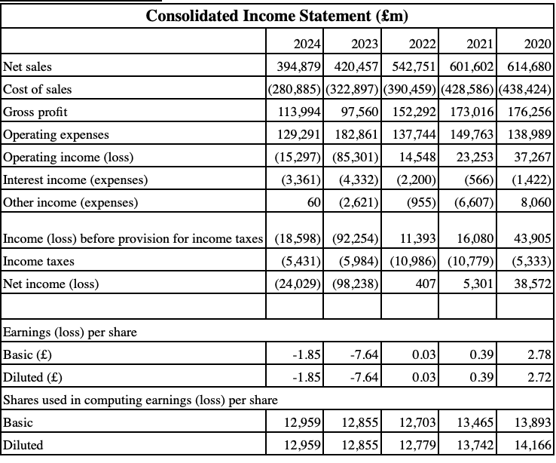
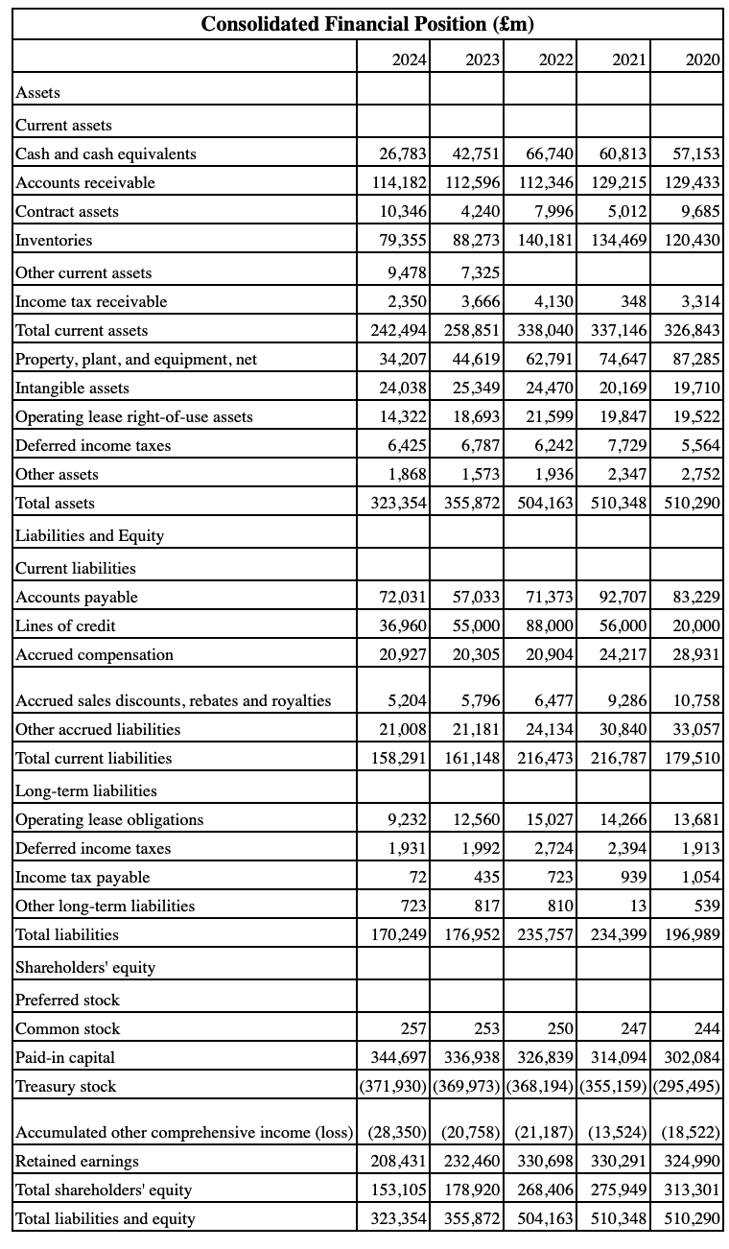
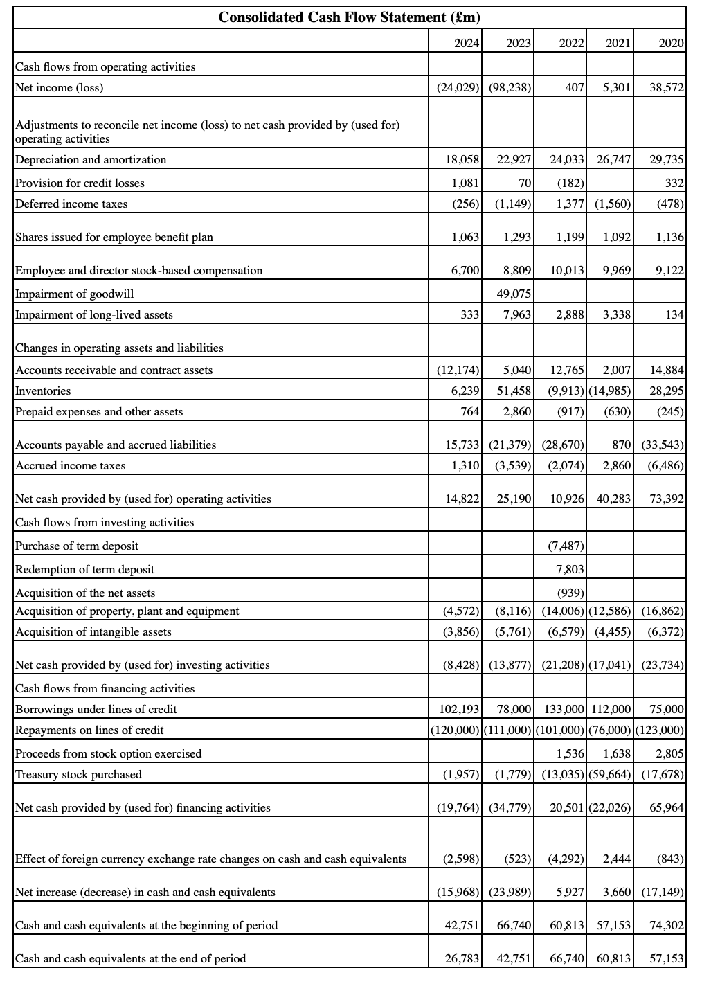

Appendix B – Excel Workbook


