This assignment looks into the limitations of each proposal for TSD secondary school. Finance and location are, not, however, because of infinite funding received by the school, and sufficient existing layout of school grounds. To match educational requirements a new school layout has been created for TSD in years 7-11, teaching pupils between 11 and 16 years at Key Stages 3 and 4 (Gov.UK, 2014).
The COVID-19 pandemic seriously impacted education, with solid foundations set out in Wales’ schools, outdoor learning, was a clear path to safe schooling. However, over time, more schools became aware of added benefits of outdoor learning both during and post-lockdown; as teachers and students saw benefits from outdoor learning (Quay et al (2020).

The proposed design for TSD external areas, revolves around development of three new outside learning zones with a stronger new emphasis, on quality outdoor education; which offers further development to lay foundations of lifelong physical activity and health. (Wainwright, 2016). Whereas outdoor play is also identified as a fundamental principle of Foundation Phase learning in Wales, to establish strong pedagogical foundations for learning outside the classroom (DofE, 2017; Welsh Government (WG), 2015).
"Physical literacy is the motivation, confidence, physical competence, knowledge, and understanding to value and take responsibility for engagement in physical activities for life" The International Physical Literacy Association, (2014).
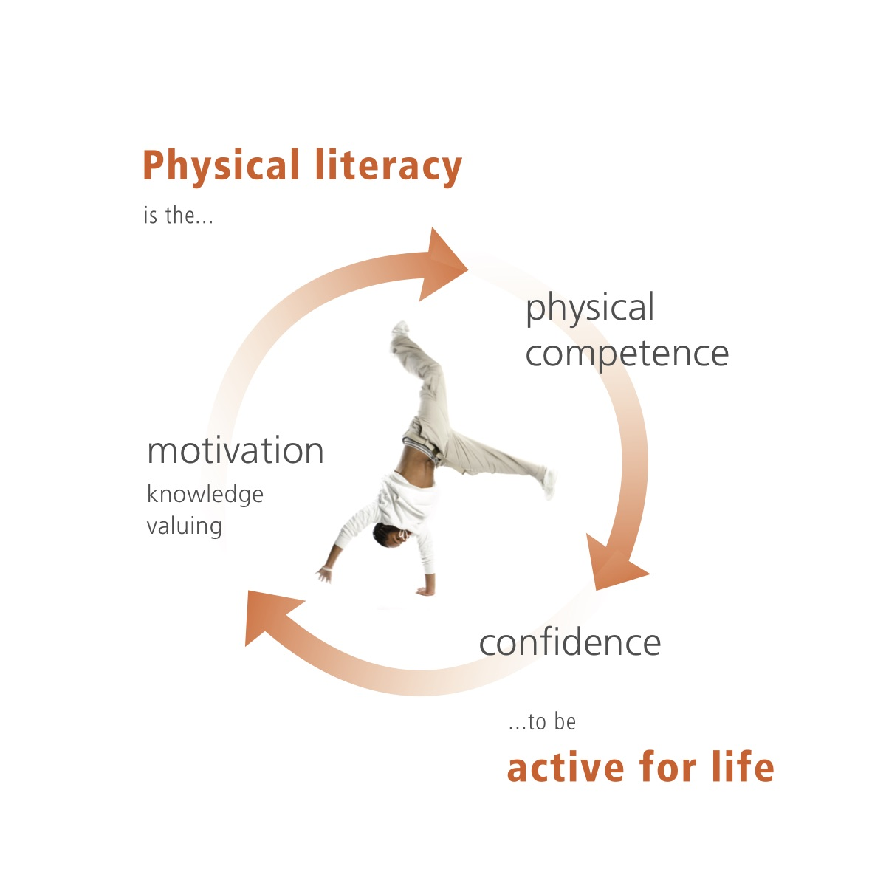
The focus of TSD’s school design proposal is, based on theory and my practical outdoor experiential learning with the appropriate outdoor play equipment, and re-imagining the whole proposed development of existing TSD school grounds; Outdoor Adventure (OA) learning environments can be created in compliance to Areas of Learning and Experience (Welsh Gov, 2020). APPENDIX
Successful Kinaesthetic Instruction for Pre-schoolers (SKIP) - Cymru addresses issues of poor motor development in early childhood. SKIP professional development is for training and mentoring early years practitioners that fit into play-based approach of the Foundation Phase. Dr. Wainwright as lead of the Wales Institute of Physical literacy in 2019 analyzed children in their classes to know developmentally what stage they are at (Wainwright, 2019).
The design proposals of TSD grounds start from a plan (Figure 2), showing potential design proposals for adventurous activities, and in support of existing physical educational (PE) programs offered by TSD and more in Appendix (Williams and Wainwright, 2020) in a framework for adventurous activities from a model-based approach to PE.
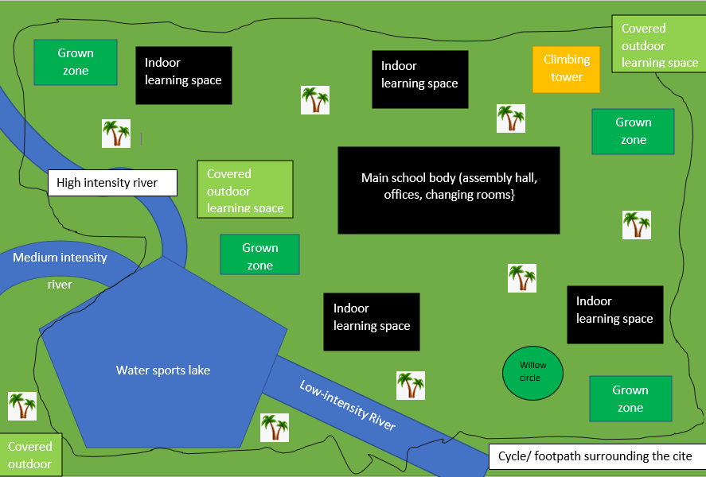
Figure2. Proposed layout for new Adventure Zone at TSD Secondary School.
The proposed TSD school grounds design (Figure 2) includes a new water-based teaching area re-named as “The Moist Zone.” This entirely new adventure area includes for a small lake of around 600 acres, which is an ideal size of lake, for example suitable to support learning to sail (Wade, 2022). This is because a small lake supports students to feel safer, by being able to see across the whole lake. The lake is also designed to be large enough to provide sufficient room to host a second session such as wild swimming, kayaking or stand-up paddle boarding (BCU 2022).
As well as the lake, proposals feature three new rivers which all feed recycled treated water back into the lake. The rivers have different mechanical flow rates, one being very calm - perfect for new beginners to develop river knowledge, understanding of safety, and confidence (Dingle and Kiewa, 2006).
The second river has faster-moving water, with few white-water elements to allow students, to take what they learned from river one to develop skills for more demanding water-based activities such as kayaking and canoeing. The third river is fast-flowing, fully white-water river to accommodate students who can demonstrate competent capability (BCU 2022) and wish by choice to challenge, develop skillsets on faster-flowing water.
This concept of developing different rivers with different levels of flow is demonstrated by Macintyre et al, (2019) were engaging in extreme sports focuses on kayaking. Students developed higher level of connection to nature and other kayakers; as well as increase in participants’ perceived well-being (MacIntyre et al, 2019).
However, Macintyre et al (2019) found entry barriers for getting into kayaking; due to perceived high-skill entry and equipment costs. TSD could consider offering inclusive paddling courses at reasonable cost, to further progress students’ skillset and to upskill wider community members by using similar goals as Scouts Plan, (2025).
Having identified kayaking, as helping to develop better healthy relationships, and supports make “informed behaviors that, encourage both to care for and respect themselves and others” (WG, 2022). This approach links into WG’s Curriculum’s ALOE for their ‘What Matters’ statements of ALOE health and well-being (WG, 2022).
As cold water swimming also brings links between physical activity and health and positive well-being (Owens et al, 2022, Parker et al, 2022). Wild swimming also helps to develop risk awareness and a safe attitude, and calm water swims show beneficial relaxation (McDougall et al, 2022); hence the innovative application of wild swimming as part of TSD proposals as an integral part of WG’s health and well-being ALOE (2022)
Regarding the limitations and risks of the “moist zone”, with any open body of water, risk of drowning will be a major consideration for the school. National water safety forum, (2022) (NWSF) is drafting a core lesson plan on water safety with Department of Education, alongside their national ‘Respect the Water’ campaign providing vital lifesaving advice throughout the UK (Walesonline, 2022).

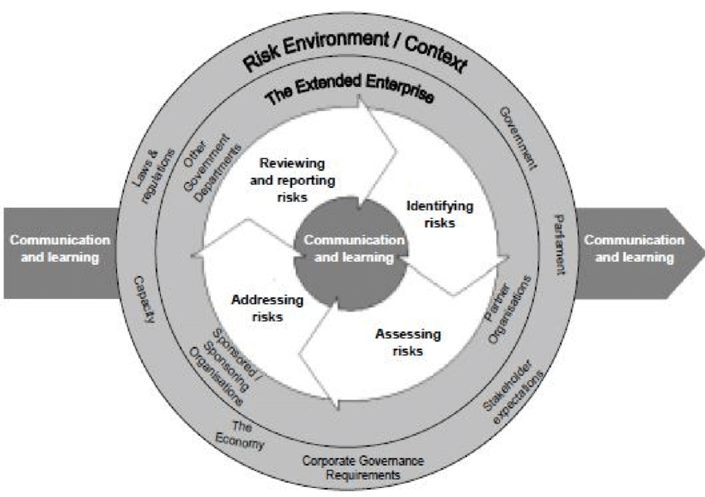

Figure 3. Risk management. Model of risk process and who and what must be considered.
Stanley and Moran (2021) studied risks regarding water-based activities of older adults but not young people. However, this study did identify how risks such as drowning, head injury, and entrapment (becoming stuck under the water) which are commonly associated with water sports such as wild swimming. Whereas kayaking, and sailing are perceived to have greater risks than in reality. Stanley and Moran (2021); Zwart and Ewert (2022) show how perceived risks of water sports can be identified and mitigated by having effective training, recognized qualifications, quality standards and comprehensive knowledge of all staff running adventure activities. Risk is therefore identified here as supported by Williams and Wainwright, (2016) as a non-negotiable or major limitation within OAE design proposals. However OAE risk can be effectively managed (Figure 3) and be informed from Foundation stage Outdoor Learning Handbook (WG, 2009) whilst it is acknowledged that adverse weather con-
additions as can be experienced in the UK are not conducive to positive learning for most
young people, neither should more benign weather conditions (rain, cloud, wind and
cold) be used as an excuse not to be active and physically engaged outdoors. On the con-
trary, developing pupils’ knowledge and skills in relation to the challenge presented by the
weather is one of the unique concerns for the model, and it would be far better that schools
provide undercover outdoor spaces and wet weather clothing to support
Whilst it is acknowledged that adverse weather con-
additions as can be experienced in the UK are not conducive to positive learning for most
young people, neither should more benign weather conditions (rain, cloud, wind and
cold) be used as an excuse not to be active and physically engaged outdoors. On the con-
trary, developing pupils’ knowledge and skills in relation to the challenge presented by the
weather is one of the unique concerns for the model, and it would be far better that schools
provide undercover outdoor spaces and wet weather clothing to support
Extra time, effort and adequate funding are further requisites to gain NGB qualifications, but needed to run all OAE activities. Relevant qualifications to run kayaking/wild swimming sessions are British Canoeing Union (BCU) qualifications. For example The Foundation Safety Rescue Training (FSRT) (British Canoeing, 2022). For PE teachers to run a kayaking session on rivers, a BCU Paddle Sports Instructor qualification (British Canoeing, 2021) is required. To qualify PE teachers to run a session on calm waters, near to land, is questionable if this is appropriate level for running sessions on TSD flowing rivers. However, not until latest BCU Paddlesports Leader qualification (British Canoeing Union, 2017) is gained – as this allows holders to run sessions further away from land but still, not white-water ready. As the appropriate qualification for this session, is a White-water Kayak Leader Award (British Canoeing, 2021), for PE teachers, to run kayaking sessions on all three flow-graded rivers. This elongated process to get teachers qualified to be able and insured to teach a major potential limitation of viability of proposed ”Moist zone”.
The ‘Green Zone’ is another proposed development for TSD, here there’s open spaces for learning, plots for growing and cultivating vegetables. While other green spaces are for various uses around the school such as indoor-outdoor learning, say during poor weather. The focus of adding a green zone to TSD is to enhance health and well-being in area of learning experiences (Holt et al, 2019) and meeting Welsh educational requirements (2022). The ‘What Matters’ statement, is for students to develop their own understanding of the effects of decisions; and how decisions affect their own lives, as well as the lives of others.
Therefore by helping students to understand decision-making, it also develops their own awareness of the impacts of decisions, risks within decision-making, and impacts from effective decision-making (Amiri, et al, 2021).The development of students’ decision-making is a necessity under AOLE’s principles of progression (Welsh Gov., 2021) looks towards developing confident students with their own understanding (Szymkowiak et al 2021).
Students are directed to lead their own learning, within the Green Zone with teacher taking on the role of “a more knowledgeable other”, as based on Vygotsky’s Zone of Proximal Development (ZPD) which, Cade et al, (2022) allows for a child-centred approach to learning to improve learner’s sense of better decision making. This is an important factor of proposed green zone, because ZPD is a key concept within the Welsh Curriculum (Welsh Gov, 2021).
The Green Zone design has a willow circle on site, with each year cohort taking cuttings of the willow, then as a class, they choose a spot to help grow the next year’s willow tree Akoumianaki-Ioannidou et al (2010) case study was based on a year’s worth of plant-based learning allowing the students to take ownership and care of a tree. This child-centred approach helps to develop a higher level of care, towards local environment, and for others.
Limitations of the “Green Zone” time is needed to establish growth, no matter what time of the year. This would mean an on-site groundskeeper is needed to specifically look after the plants; more especially over longer breaks such as Christmas or summer holidays as well half-term. Krugman and Iza, (2021) studied how plants were used to strengthen the community, findings showed how summers and winter breaks created conflict among communities. A potential solution would be for teachers to work periodically with an eco-consultant to create a sustainable schedule for growing appropriate plan
in limiting the “Green Zone” to what flowers, plants and trees are deemed as most appropriate in cost and durability terms and lifecycle with the unpredictable seasons, can no doubt create issues for teaching. Cost of replacing unsuitable, fragile or damaged plants are another trial of basic limitation, requiring constant reviews and recording with additional revenue funding resources to be budgeted for.
The “UP Zone”, based around a newly installed 15-meter tall climbing tower with 4 sides. Each side would present new challenges and opportunities to students. One side allows for three different levels of abseil. This is because, abseiling allows students to push each individual on different levels through experiential learning (Williams and Wainwright, 2016). APPENDIX. Providing students with a sense of care for their own development (Sveen and Denholm, 1997). The hard visible levels of progress for students lead into ALOE (WG, 2020).
Another side has three sections of climbs each five meters long and will also be layered, as a more challenging activity. This links to developing progression and confidence. In justifying developing students’ climbing, Gassner (2022) study showed how climbing was used as a therapy, with findings of improved well-being; so meeting the components of health and well-being AOLE.
The implication of a climbing wall that promotes the development and goal setting would provide enhanced benefits to TSD students. The other sides of the tower would be 15-meter climbing walls. One side has an overhang and the other a flat wall.
However, an added feature would be how students can be involved in creating all new routes for all sides of the tower the challenge by choice is a non-negotiable (Williams and Wainwright, 2016) to all design proposals aim to meet key goals of the new Health and Wellbeing AOLE (WG, 2022) and new personal growth model. (Williams and Wainwright, 2016) Appendix.
A major Limitation of the “UP Zone” young people are commonly afraid of heights, often before ever even trying it. Reed and Smith, (2021), studied fears related to OA, where heights were found as a major fear among young people, and a common phobia in young people- which could dissuade students from even wanting to try the “UP Zone”, even with adequate safety measures.
This is because, as children get older their own competence will also influence whether they are active or not (Wainwright, 2019) and generally avoid what they think they are bad at. As middle childhood stage (6-12 years) begin comparing themselves to others and if they don't feel they are competent, and are placed into structured sports too soon, confidence is lost and begin to opt out of physical activity. It is according to Wainwright (2019) therefore the accountability for quality of Physical Education provision as well as the quantity, which is crucial for pupils’ confidence to be maintained as they transition from play based to more structured physical activities, including say OAE (Wainwright, 2019). Quality provision however does have many cost limitations.
The “Up Zone” creates similar limitations to the “Moist Zone” where to get the most out of the new installations, appropriate qualifications are required to run the wall both safely and effectively, as a part of the new OAE curriculum.
Mountain Training, MT, (2018) states that, to run a climbing wall you need minimum of a Climbing Wall Instructor (CWI), (Mountain Training, 2018) qualification to help run a climbing wall session. The CWI would allow a PE teacher to help run a safe session for all people. However, along with the CWI, the PE teacher would need the Abseil Model that MT offers (Mountain Training, 2018). This add-on endorsement to the CWI would appropriately cover PE teachers to utilise the abseiling section of the “UP Zone”.
OA and ALOE’s both have similar outcomes. show how. Therefore by applying them directly into a secondary school curriculum will provide new outdoor learning experiences for young people and in community-focused schools out into the wider community (Figure 4.)
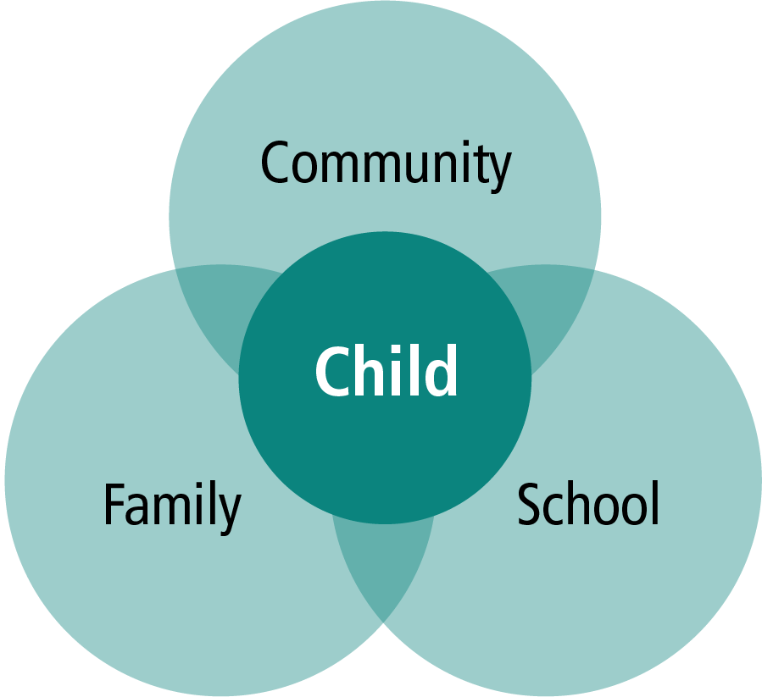
Figure 4. Three overlapping spheres of influence in children learn and grow: family, school and the community (Epstein, J. 2009. School, Family and Community Partnerships: caring for the children we share).
Each sphere supports developing learning experiences and hopes to grow/develop student’s sense of wellbeing, alongside keeping young people physically active. By identifying limitations of each zone shows in theory, how design proposals create great opportunities for young people.
A Community Focused School places the child at heart to connect family, school and community together in order to provide a holistic and integrated approach to learning and development (Estyn, Her Majesty’s Inspectorate for Education and Training in Wales. 2020.) Effective community schools make thoughtful use of school assets to improve lives of children and families in local communities. Working in partnership with local groups and organisations in enterprising and creative ways, seeking out gaps in local sport, cultural or care provision, including school holidays (Estyn, 2020).
Generally, I have presented three new design ideas for OA education based on the health and well-being AOLE’s for the Welsh Curriculum (2020), by proposing to design new Outdoor Education based zones, designed around TSD secondary school grounds, using new OA activities.
In conclusion, my proposed developments for TSD are ambitious but they set out to provide a fresh delivery approach to OAE, in comprehensive support to existing PE provision, and include for delivery of Welsh Curriculums ALOE provision for Health and Wellbeing (WG, 2022). Wales has a rich wealth of outdoor learning opportunities which help children and young people make connections within and across curriculum areas.
Given all the non-negotiable and limitations cited, a one year post is considered to be inadequate amount of time, and only a temporary post with a single school cohort to consult with and design OAE into a PE as a best fit for TSD. A three to five year contract term would make proposals more viable, so learning experiences should be deliverable within the normal school timetable for physical education and taught by the physical education teacher, with the assistance of other skilled professionals as required. With the intention being to allow every pupil the chance to gain experience of adventurous activities, that is authentic and meaningful to their lives in school, and to encourage lifelong participation and enjoyment in later life (Williams and Wainwright, 2020) Sport education is about becoming sport literate in the many different and varied ways that people experience and enjoy sport in their local communities. Where TSD are to manage risks, be more community focused, challenge by choice and provide experiential learning; so young people’s experience of OA is an exciting part of school physical education (Wainwight and Williams, 2012).
Finally, I am supportive of Williams and Wainwright (2020) argument that, this is the way forward for including adventurous activities within secondary school physical education but throughout all key stages, but that not all settings will be suitable. I am however biased due to my UWTSD OAE student status and my Professional Instructor roles in Paddlesports and Sailing.
Appendix Curriculum for Wales Blog- supporting information on AOLE.

Areas of Learning and Experience’ as a central element of the new curriculum
Posted on March 2, 2020 Read this full post in Welsh
‘Areas of Learning and Experience’ as a central element of the new curriculum | Curriculum for Wales Blog (gov.wales)
This is an updating {extract] of the popular June 2018 post: How ‘Areas of Learning and Experience’ are being developed as a central element of the new curriculum.
The new curriculum framework features overarching topics in the form of: an Introduction; Summary of Legislation; Designing your Curriculum, and Supporting learner progression: Assessment. And of course it features the Six Areas of Learning and Experience (Areas): Expressive Arts; Health and Well-being; Humanities; Languages, Literacy and Communication; Mathematics and Numeracy; Science and Technology. But how do they connect to the four purposes, the shared vision and aspiration for every child and young person in Wales and what do they comprise? In this post we answer those questions. Each AOLE comprises:

An abridged explanation of how it supports the four purposes
1. ‘What Matters’ statements and rationales – which provide foundation for learning in the Area, and set out ‘big ideas’ that underpin it.
2. Principles of Progression which set out how learners should make progress, and contribute to Four Purposes.
3. Descriptions of Learning- which articulate the essence of learning in the Area across five progression steps.
4. Designing your curriculum – AOLE-specific considerations.
Under Cross-curricular skills and integral skills; Specific considerations for this Area; Key links with other Areas; and ‘Cross-curricular skills and Integral skills’ have Literacy, Numeracy and Digital Competence, plus Integral Skills of Creativity and Innovation, Critical Thinking and Problem Solving, Personal Effectiveness and Planning and Organising. An example under Creativity and Innovation is: Encouraging presentation of information and findings in creative and innovative ways, and imagining possible futures based on evidence. Critical Thinking and Problem Solving is: Collecting, reflecting and critically evaluating use of sources and evidence. Personal Effectiveness is: Encouraging teamwork and being a reliable contributor by organising and carrying out enquiries. Planning and Organising is: Encouraging planning and organising of investigations, setting aims, objectives and success criteria, gathering and utilising a range of evidence, and reflecting on methods. Within ‘Specific considerations for this Area’ includes major themes, stressing need for developing sophisticated understanding of key concepts which enables learners to see knowledge as more than a list of unconnected facts. The ‘Approach to design’, ‘Local, national and wider world perspectives’, ‘Coverage/range’, ‘Coherence’, ‘Rigour’, ‘Focus’, ‘Sensitivity’, ‘Disciplinary concepts and contexts’ (for each discipline), ‘Considerations for provision of learning experiences’, and ‘Illustrating breadth’. ‘Key links with other Areas’ highlight how genuine and authentic links can naturally be made with the other Areas of Learning and Experience. ‘Cross-cutting Themes’ includes content on ‘Local, national and international contexts’, ‘Careers and work-related experiences’, and ‘Human rights education and diversity’.

Personal Growth through Adventure. A Model of Adventurous Activities of PE at Key Stages 2, 3, & 4.

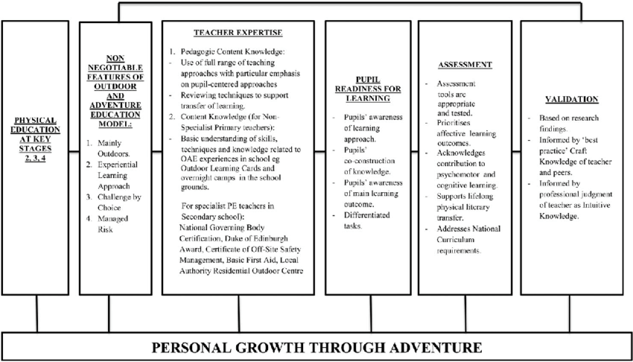
Personal Growth model through Adventure. Adapted from Williams and Wainwright, (2016).

HSE supportive Guidance on Managing Outdoor Learning Activities in Scotland- provided as a generic example for what has to be considered.
Curriculum for Excellence through outdoor learning (education.gov.scot)
Health and safety Executive considerations for Managing the health and safety of learners and staff in outdoor learning is vitally important but with careful planning and conduct, outdoor experiences can be both safe and stimulating. Many outdoor learning activities carry no higher risk than activities and situations faced by learners on a day-to-day basis. The law expects leaders and others to manage significant risks as far as is reasonably practicable – this does not mean eliminating all risks. It follows that, for every experience, an appropriate person should decide if the balance between risk and opportunity is appropriate for the learners concerned.
A powerful approach is to use risk/benefit analysis which consciously balances the benefits of an experience against the intrinsic risks along with risk assessment. Teachers and others taking children and young people outdoors are uniquely placed to manage this process. They should adopt an enabling attitude towards outdoor learning that identifies exciting, creative opportunities for learning.
Where appropriate they should use published guidance and the advice of senior staff and specialists to reduce risk to an acceptable level. Sometimes in planning, eliminating or controlling a hazard may seem so daunting that offering the experience seems impossible. That is the point for serious consideration but not necessarily the moment to cancel plans. Children and young people should not be denied experience simply because some significant but unlikely hazard could not be completely eliminated. A venture where all conceivable risk has been eliminated removes the opportunities for learners to develop their own strategies and attitudes towards risk. Learners should be at the centre of the risk management process from the outset. This guidance recognises that risk has both positive and negative aspects. With careful thought and planning it is possible to remove unreasonable risks from a venture without extinguishing the brilliant spark of personal adventure at the heart of outdoor learning. In planning and considering risks and benefits it is important to consider:
• Is the level of challenge appropriate to the learner group?
• How will risks be assessed and balanced against the benefits that can be expected?
• Can the rationale for this experience be justified even if events do not go according to plan?
• Are the management arrangements appropriate for the location selected?
• Are the leadership and supervisory staff appropriately skilled, qualified and experienced?
• How do we communicate with parents and carers?
• Could we benefit from enrolling partners?
• Are there any relevant examples of good practice that we can draw on?
Amazingly though – HSE state that at present, schools or other educational establishment (college, university etc.) do not require a AALA licence for provision to its own pupils or students. A licence is however required for provision to pupils of another educational establishment or to other members of the public, when provided in return for payment. Activity centres, field study centres etc. run by education authorities or departments are excluded from the definition of an educational establishment so are required to have a licence. Source: Are you a - AALA - HSE

References
Akoumianaki-Ioannidou, A., Paraskevopoulou, A.T. and Tachou, V. (2010) “The significance of plants in school grounds and environmental education of secondary schools in Trikala, Hellas,” Acta Horticulture, (881), pp. 843–846. Available at: https://doi.org/10.17660/actahortic.2010.881.139. (Accessed: November 22, 2022)
Amiri, A., Geravandi, S. and Rostami, F. (2021) “Potential effects of school garden on students' knowledge, attitude and experience: A pilot project on sixth grade students in Iran,” Urban Forestry & Urban Greening, 62, p. 127174. Available at: https://doi.org/10.1016/j.ufug.2021.127174 (Accessed: November 26, 2022)
British Canoeing, B.C. (2022) Foundation Safety and Rescue: British canoeing awarding body awards, British Canoeing Awarding Body. Available at: https://www.britishcanoeingawarding.org.uk/foundation-safety-rescue/ (Accessed: December 4, 2022).
British Canoeing, B.C. (2021) Paddlesport Instructor Level 1: Entry level paddlesports qualification, British Canoeing Awarding Body. Available at: https://www.britishcanoeingawarding.org.uk/level-1-paddlesport-instructor/ (Accessed: December 4, 2022).
British Canoeing, B.C. (2017) Supporting Your Current Qualifications, Paddlesport Leader Award. Available at: https://www.britishcanoeing.org.uk/news/2017/paddlesport-leader-award#:~:text=Supporting%20Your%20Current%20Qualifications&text=The%20Paddlesport%20Leader%20Award%20requires,out%20coaching%20on%20the%20water (Accessed: December 4, 2022).
British Canoeing, B.C. (2021) White Water Kayak Leader: British canoeing awarding body awards, British Canoeing Awarding Body. Available at: https://www.britishcanoeingawarding.org.uk/white-water-kayak-leader-moderate-water/ (Accessed: December 3, 2022).
Cade, J., Wardle, F. and Otter, J. (2022) “Quality early care and learning: Exploring child-centered pedagogy a qualitative multi-case study,” Cogent Education, 9(1). Available at: https://doi.org/10.1080/2331186x.2022.2144589 (Accessed: November 24, 2022).
Cirdan Sailing Trust, (2019) Available at: https;//cirdantrust.org (Accessed: November 26, 2022).
DofE (2017) Statutory framework for the early year’s foundation stage. Setting the standards for learning, development and care of children from birth to five. London: Department for Education.
Dingle, P. and Kiewa, J., (2006) Links between kayaking, fear, confidence and competence: Factors affecting women’s participation in paddling in a tertiary outdoor education course. Journal of Outdoor and Environmental Education, 10(1), pp.46-53.
Epstein, J. (2009) School, Family and Community Partnerships: caring for the children we share.
Estyn, Her Majesty’s Inspectorate for Education and Training in Wales, (2020) Community schools: Families and communities at the heart of school life. Available at; Community schools: families and communities at the heart of school life (gov.wales) (Accessed: December 3, 2022).
Gassner, L. et al. (2022) “The therapeutic effects of climbing: A systematic review and meta‐analysis,” PM&R [Preprint]. Available at: https://doi.org/10.1002/pmrj.12891 (Accessed: November 19, 2022).
Gov.UK, G.D. (2014) The national curriculum, GOV.UK. GOV.UK. Available at: https://www.gov.uk/national-curriculum (Accessed: November 12, 2022).
Holt, E.W. et al. (2019) Active and passive use of green space, health, and well-being amongst university students, International journal of environmental research and public health. U.S. National Library of Medicine. Available at: https://www.ncbi.nlm.nih.gov/pmc/articles/PMC6388138/ (Accessed: November 24, 2022).
Krugman, V.K. and Iza, L., 2021. Building collaborative partnerships in schools and communities. In Talent Development for English Language Learners (pp. 125-165). Routledge.
Macintyre, T.E. et al. (2019) An exploratory study of Extreme Sport Athletes' nature interactions: From well-being to pro-environmental behaviour, Frontiers. Frontiers. Available at: https://www.frontiersin.org/articles/10.3389/fpsyg.2019.01233/full (Accessed: November 17, 2022).
McDougall, C.W. et al. (2022) “Freshwater wild swimming, health and well-being: Understanding the importance of place and risk,” Sustainability, 14(10), p. 6364. Available at: https://doi.org/10.3390/su14106364 (Accessed: November 23, 2022).
Mountain Training, M.T. (2018) Abseil module, Mountain Training. Available at: https://www.mountain-training.org/qualifications/climbing/qualifications/climbing-wall-instructor/abseil-module (Accessed: December 4, 2022).
Mountain Training , M.T. (2018) Climbing wall instructor, Mountain Training. Available at: https://www.mountain-training.org/qualifications/climbing/qualifications/climbing-wall-instructor#:~:text=You%20must%20be%20at%20least%2018%20years%20old.,least%20three%20different%20climbing%20walls. (Accessed: December 4, 2022).
NWSF (2022) National Safety Water Forum Coordinating Group. Available At: http://www.nationalwatersafety.org.uk (Accessed 14th November 2022).
Ocean Youth Trust South (2019) Available at http://www.oytsouth.org (Accessed: November 17, 2022).
Owens, M., Townsend, E., Hall, E., Bhatia, T., Fitzgibbon, R. and Miller-Lakin, F., 2022. Mental health and wellbeing in young people in the UK during lockdown (COVID-19). International Journal of Environmental Research and Public Health, 19(3), p.1132.
Parker, A.G., Trott, E., Bourke, M., Klepac Pogrmilovic, B., Dadswell, K., Craike, M., McLean, S.A., Dash, S. and Pascoe, M., 2022. Young people's attitudes towards integrating physical activity as part of mental health treatment: A cross‐sectional study in youth mental health services. Early Intervention in Psychiatry, 16(5), pp.518-526.
Parker, Luke. (2022). Outdoor Learning, A Pathway to Transformational Learning? Or Another Educational Gimmick? International Journal for Cross-Disciplinary Subjects in Education. 13. 4600-4611. 10.20533/ijcdse.2042.6364.2022.0565.
Quay, J., Gray, T., Thomas, G. et al. What future/s for outdoor and environmental education in a world that has contended with COVID-19? Journal of Outdoor and Environmental Education 23, 93–117 (2020). Available at: https://doi.org/10.1007/s42322-020-00059-2 (Accessed 12th December 2022).
Reed, J. and Smith, H. (2021) “‘everything we do will have an element of fear in it’: Challenging assumptions of fear for all in outdoor adventurous education,” Journal of Adventure Education and Outdoor Learning, pp. 1–13. Available at: https://doi.org/10.1080/14729679.2021.1961092 (Accessed: November 30 , 2022).
Rockley Watersports College and Leaf Academy (2022) Available at: Poole Sixth Form College | Equivalent to BTEC | Rockley (Accessed 14th November 2022).
Royal Yachting Association, (2022) Available at: https://rya.org.uk (Accessed: November 12, 2022).
Scouts Vision, (2025). Our Vision for 2025 to prepare more young people with skills for life. Available at: https://www.scouts.org.uk (Accessed November 30th 2022).
Simuth, J., & Sarmany-Schuller, I. (2012). Principles for e-pedagogy. Procedia Social and Behavioural Sciences, 46, 4454–4456 Available at: https://doi.org/10.1016/j.sbspro.2012.06.274 . (Accessed December 12th2022).
Stanley, T. and Moran, K. (2021). “Perceptions of water competencies, drowning risk and aquatic participation among older adults,” International Journal of Aquatic Research and Education, 13(2). Available at: https://doi.org/10.25035/ijare.13.02.06 (Accessed: November 30th, 2022).
Sveen, R.L. and Denholm, C.J. (1997) “Testing the Theoretical Fit of an Abseiling Harness: A Study of an Australian Primary and Secondary Prevention Program. ,” The Journal of Primary Prevention, 18(2), pp. 213–225. Available at: https://doi.org/10.1023/a:1024642508725. (Accessed: November 25, 2022).
Szymkowiak, A. et al. (2021) “Information Technology and gen Z: The role of teachers, the internet, and technology in the education of young people,” Technology in Society, 65, p. 101565. Available at: https://doi.org/10.1016/j.techsoc.2021.101565 . (Accessed: November 27, 2022).
Wade, D. (2022) Best sailboats for lakes: Life of sailing, RSS. Available at: https://www.lifeofsailing.com/post/best-sailboats-for-lakes (Accessed: November 17, 2022).
Wainwright, N. (2019). UWTSD’s DR Nalda Wainwright presents at the launch of the National Assembly report into the physical activity of children and young people. Available at: http://www.asembly.wales/laid%20documents/cr-Id12369/cr-Id12369_e.pdf (Accessed: November 12, 2022).
Wainwright, N., and A. Williams. 2012. “Miss That’s the Best PE Lesson We’ve Ever Had and We
Couldn’t See for Most of the Adventurous Activities and Physical Education in Wales.”
Physical Education Matters 7 (2): 51– 54.
Wainwright, N., and A. Williams. 2012. “Miss That’s the Best PE Lesson We’ve Ever Had and We
Couldn’t See for Most of the Adventurous Activities and Physical Education in Wales.”
Physical Education Matters 7 (2): 51– 54.
Wainwright, N., and A. Williams. 2012. “Miss That’s the Best PE Lesson We’ve Ever Had and We
Couldn’t See for Most of the Adventurous Activities and Physical Education in Wales.”
Physical Education Matters 7 (2): 51– 54.
Wainwight, N. and Williams, A. (2012) “Miss, That’s the best PE lesson we’ve ever had and we couldn’t see for most of the adventurous activities and physical education in Wales”. Physical Education Matters. 7 (2):51-54.
Walesonline, (2022) Fourth child dies Solihull Lake. Available at: Boy, 6, becomes fourth child to die in frozen lake tragedy - Wales Online (Accessed 14 December 2022).
WG, (2009) Foundation Phase. Outdoor Learning Handbook Yr Adran Plant, Addysg, Dysgu Gydol Oes a Sgiliau Department for Children, Education, Lifelong Learning and Skills Available at: https://hwb.gov.wales/foundation-phase-outdoor-learning-handbook.pdf (gov.wales)(Accessed 12th December 2022)
WG, (2020) The New Curriculum for Wales Curriculum for life, Hwb. Available at: https://hwb.gov.wales/curriculum-for-wales (Accessed: November 12, 2022).
WG, (2022) Health and well-being: Statements of what matters, Hwb. https://hwb.gov.wales/curriculum-for-wales/health-and-well-being/statements-of-what-matters/ (Accessed: November 17, 2022).
Williams, A. & Wainwright, N. (2015). A new pedagogical model for adventure in the curriculum: part two – outlining the model. Physical Education and Sport Pedagogy. 21. 1-14. 10.1080/17408989.2015.1048212.
Williams, Andrew James and Nalda Wainwright. “Re-thinking adventurous activities in physical education: models-based approaches.” Journal of Adventure Education and Outdoor Learning 20 (2020): 217 - 229.UWTSD. Available at [PDF] Re-thinking adventurous activities in physical education: models-based approaches | Semantic Scholar (Accessed: November 12, 2022).
Zwart, R. and Ewert, A., (2022) Human Health and OA Recreation: Perceived Health Outcomes. Forests, 13(6), p.869.

