
Student Name | Smitkumar Bharatbhai Kachhadiya
Student ID Number | 2520164
Programme | MSc Public Health and Social Care in Practice
Module Code | LCHS7003
Module Title: | Community Care and Management of Longer-term Conditions
Assignment Title | Component 1- Information Booklet of Long-term Condition Management  ( HYPERTHYRODISM)
Lecturer’s name | Muhammed Khan

Table of Contents
Introduction 1
Epidemiology, Aetiology and Burden of Hyperthyroidism 2
Definition of Long Term Condition in the context of Hyperthyroidism 3
Prevalence rate of the disease in the UK and globally 3
Risk Factors 4
Economic and Social Burden 4
Physical, Psychological and Social Implications for patients 5
Physical Implications 5
Psychological Implications 6
Social Implications 6
Wider Impact to Families 7
Management and Evidence-based Treatments 7
Theoritical Perspectives and Models 8
House of Care (HoC) 8
Innovative Care for Chronic Conditions (ICCC) 9
Local and National Political Health and Social Care Agendas 11
Recommendations for Improvement 12
Conclusion 12
References 2

Introduction
Across the worldwide healthcare systems, long-term conditions (LTCs) have always been a major concern for healthcare professionals since they have to consistently manage them within patients through medication and psychological support (Entwistle et al., 2018). Hyperthyroidism has emerged as one of the serious LTCs, which require ongoing treatment for the long run (5-10 years) (Wiersinga et al., 2023). According to Bereda (2022), hyperthyroidism is characterised by the excessive production of two types of thyroid hormones from the thyroid gland: Thyroxine T4 and Triiodothyronine T3. These two hormones actively regulate metabolism, cardiovascular activity and energy balance, and as a consequence, they can negatively impact any bodily functions like irregular heartbeat, weight loss and muscle weakness if not under control (Biswas, 2025).
Key Characteristics of Hyperthyroidism:
- Increased Metabolic Rate
- Rapid Heart Rate (tachycardia)
- Weight Loss
- Anxiety and irritability
- Goitre (enlarged thyroid gland)
- Muscle Weakness
As per Lee and Pearce (2023), worldwide, 2.5% of individuals, mostly females, are suffering from hyperthyroidism, which is causing heart disease, osteoporosis and higher mortality. Similarly, when it comes to the UK, about 2% of British people have hyperthyroidism and 5% for those who are aged 60 or more (Gifford, 2025). In this regard, Lee and Pearce (2023) emphasised that Graves' disease is the most frequent cause of hyperthyroidism, affecting the thyroid gland of 2% of women worldwide and 0.5% of males.

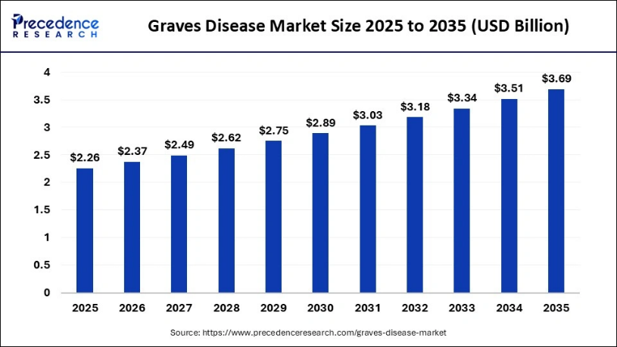
Figure 1: Graves’ Disease Market Size
(Source: Presence Research, 2026)
The size of the worldwide market for Graves' Disease (Overactive thyroid) is expected to grow from USD 2.37 billion in 2026 to 3.69 billion by 2035, indicating rising global and UK-based prevalence and treatment demand (Presence Research, 2026).

Region | Estimated Prevalence | Key Notes
Worldwide | 0.2-2.5% Population | Often diagnosed between 20-40 years of age.
United Kingdom | 2% | More common in women than in men.
Global and UK Prevalence Overview
Considering the increasing prevalence all over the world and the UK, this booklet is being developed with the purpose of assisting patients and medical professionals in properly managing thyroid hormone levels via long-term coordinated care.

Epidemiology, Aetiology and Burden of Hyperthyroidism
Defination:
Hyperthyroidism is a disease where the thyroid gland in the neck becomes overactive and produces a high amount of thyroxine hormone. Women globally are more affected by this disease than men. Epidemiologically, it is found that the people aged between 20 and 40 years are highly affected by Hyperthyroidism globally (NIH, 2026). Around 650,000 people in the UK are suffering from this disease (BTF, 2023). The main aetiology of this disease is the overactivity of thyroid gland and high production of T4 and T3 hormones (Wiersinga et al., 2023). In addition, the consumption of high iodine is one more aetiology of hyperthyroidism. In terms of the burden of this disease, it significantly increases the mental health complications, bone and cardiovascular diseases and brings significant economic burden (Lee and Pearce, 2023).

Definition of Long Term Condition in the context of Hyperthyroidism
The long-term condition of a disease denotes the health issue that occurs in the long run for the disease rather than providing a quick cure (Hsieh et al., 2022). In other words, the long-term condition also refers to the lifestyle change and consistent healthcare support for managing the disease over time. In the context of hyperthyroidism, it can lead to stroke and heart failure in the long run (Cleveland Clinic, 2024). In addition, it could cause some more disease, including:
- Graves ophthalmopathy.
- Eye disease.
In the long run, the patient who is suffering from hyperthyroidism should bring a change in lifestyle following a low-iodine diet and must sleep for at least 7 to 9 hours daily with moderate exercise and medicines like liothyronine (T3) (Inspira Health, 2024). In terms of healthcare support, Hyperthyroidism can be managed by consistent monitoring of TSH, T4 and T3 hormone levels, managing eye care using lubricating eye drops (Mayo Clinic, 2026).

Prevalence rate of the disease in the UK and globally
Hyperthyroidism is becoming a serious public health concern over time, and this disease is increasing day by day in the UK and globally. The evidence shows that globally, the prevalence rate of hyperthyroidism is around 0.2 to 2.5% (Lee and Pearce, 2023). Also, in the UK, the prevalence rate of Hyperthyroidism is around 2.1%, which is considerably lower than the global context (NICE, 2026).
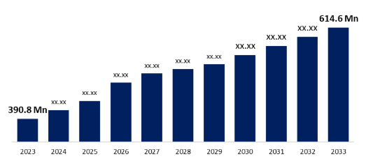
Figure 2: Global Graves disease increase between 2023 and 2033
(Source: Spherical Insight, 2024)
Also, in the global context, people aged between 20 years and 40 years are highly affected by Hyperthyroidism. Additionally, the evidence shows that globally, women are 10 times more affected than men (NHS, 2026). Therefore, it can be said that social and demographic factors significantly enhance Hyperthyroidism among the population.

Risk Factors
Some of the major risk factors concerning hyperthyroidism is being highlighted below:
- Gender and Age
- Family History
- Pregnancy
- Autoimmune disease
- High Iodine Intake
- Smoking
Hyperthyroidism is usually caused by a combination of biological and lifestyle factors, which makes the disease last longer among individuals and often leads to mortality. According to Mekki et al (2022), gender and age are the most significant determinants of hyperthyroidism, as women are usually the most exposed to this disease, particularly those who are between 20 and 40 years of age. This pattern gets aligned with the presence of autoimmune disorders among women with high hCG, such as those who are pregnant, which increases the chance of developing Graves’ disease (De Leo and Pearce, 2018).
However, it's not just gender and age; there are other factors that ensure this disease’s development. For instance, Nadeali et al (2025) underscore how family history plays a key role in the development of hyperthyroidism, as the majority of thyroid patients inherit it from their parents. In support of this statement, a clinical study showed that about 75% of worldwide thyroid patients have one or multiple family histories of thyroid-related diseases (Cleveland Clinic, 2020).
Besides the biological factors, there are lifestyle factors such as iodine intake and smoking, which also contribute to the development of hyperthyroidism. Moreno-Reyes et al (2025) argued that excess or insufficient iodine causes overstimulation or dysfunction of the thyroid gland, thereby increasing the risk of hyperthyroidism, which is further intensified by smoking that damages autoimmunity. Thus, self-management becomes increasingly important for individuals to keep this condition under control.

Economic and Social Burden
Due to the increase in Hyperthyroidism cases globally and in the UK, it significantly causes a social and economic burden. Some of the economic burden for this disease is:
- Cost of therapies like meditation.
- High usage of healthcare resources.
- Cost of tests, including TSH, T4, and T3.
Evidence shows that the patients who are suffering from Hyperthyroidism, are facing a high economic burden due to the high expenses for managing the disease. On an average, every patient globally spends around $460 to $2555 every year for the treatment and TSH tests for managing Hyperthyroidism (Feng et al., 2025). However, in the UK, the NHS offers free treatment to Hyperthyroidism patients, which indicates a lower economic burden on the UK people for the health treatment for this disease.
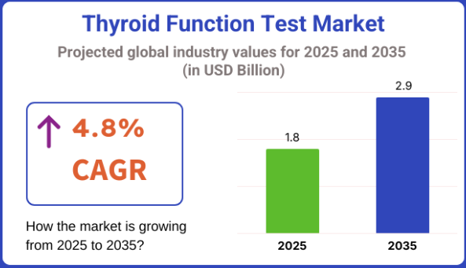
Figure 3: TFT test increases globally
(Source: FMI, 2025)
In terms of social burden, hyperthyroidism causes different factors, including:
- Psychological distress and mental stress.
- Impact on worklife.
A report shows that around 60% of the global hyperthyroidism patients are suffering from stress and anxiety, a serious psychiatric problem (Healthline, 2024). Therefore, this disease creates high social pressure by damaging the mental wellness of patients globally. Additionally, it is found that around 28% of the UK workforce face lower attendance-related problems in their worklife due to long-term illness like Hyperthyroidism (University of Aberdeen, 2024). Therefore, considering these facts and circumstances, it can be said that Hyperthyroidism has a significant social and economic burden.

Physical, Psychological and Social Implications for patients
People worldwide have been experiencing severe physical, psychological, and societal repercussions as a result of hyperthyroidism, which are outlayed below:

Physical Implications
- Cardiovascular Strain
- Metabolism and Weight
- Sensory Issues (Muscle Weakness, Hair Thinning)
Hyperthyroidism has multiple physical implications for those who are bearing it for a long enough time. For instance, the elevated thyroid hormones directly affect the control of heart functions by stimulating the sinoatrial nodes, forcing the heart to pump faster (Beck et al., 2021). Overactive thyroid further accelerates metabolism among patients by overproducing hormones like T3 and T4, which lead to unnatural bodily complications like weight loss and sensory issues such as hair thinning and impaired muscles (Rodolfi et al., 2025). These symptoms are also linked to increased heart rate, which causes unintentional sweating and frequent tremors, lowering overall energy levels.

Psychological Implications
- Anxiety & Nervousness
- Sleep disturbance (insomnia)
- Memory lapses
Besides physical complications, hyperthyroidism also psychologically strains human beings, as patients who are dealing with this condition for a longer period usually experience accelerated metabolism (NHS Inform, 2025). This creates hyperactivity, particularly a "fight-or-flight" response, which results in palpitation and heightened anxiety levels among patients. Unintentional weight loss from hyperthyroidism further intensifies anxiety, which often leads to sleep disorders, memory lapses, and ultimately causing severe insomnia (Mukherjee et al., 2024). This accelerates emotional and mental instability, negatively affecting cognitive performance, requiring consistent treatment.

Social Implications
- Impaired Work Ability
- Social Isolation
- Interpersonal Relationships
The overall physical and psychological consequences of hyperthyroidism also disrupt the social lives of patients by damaging their daily physical and mental functioning. For example, weak muscle and emotionally drained states prevent the persistent work ability of individuals in workplaces (Hasanvand, 2024). This intensifies chronic stress and often damages interpersonal relationships. Over time, these mental and emotional challenges slowly convince patients to socially isolate themselves from others, thereby limiting participation in social activities, which diminishes quality of life.

Wider Impact to Families
- Emotional Distress
- Economic Strain
Apart from the physical, psychological and social impact over patients, this long-term illness further negatively impact family members of patients. According to Aslam et al (2025) hyperthyroidism causes sugnificant emotional distress to family members of patients since they have to manage the patients who often gets nervouse because of this chronic illness. Similarly, being a long-term condition, hyperthyroidism treatment economically strain the families due to high medical costs (Al-Worafi, 2026).

Management and Evidence-based Treatments
Here, the current evidence-based management and treatment of hyperthyroidism is being highlighted.
- Antithyroid Drugs (ATDs)
- Radioactive Iodine (RAI) therapy
- Surgery (Thyroidectomy)
Medications such as Methimazole and Propylthiouracil are commonly prescribed to patients with hyperthyroidism as first-line treatments, which help in lowering the T3 and T4 hormone levels (Lee et al., 2023).
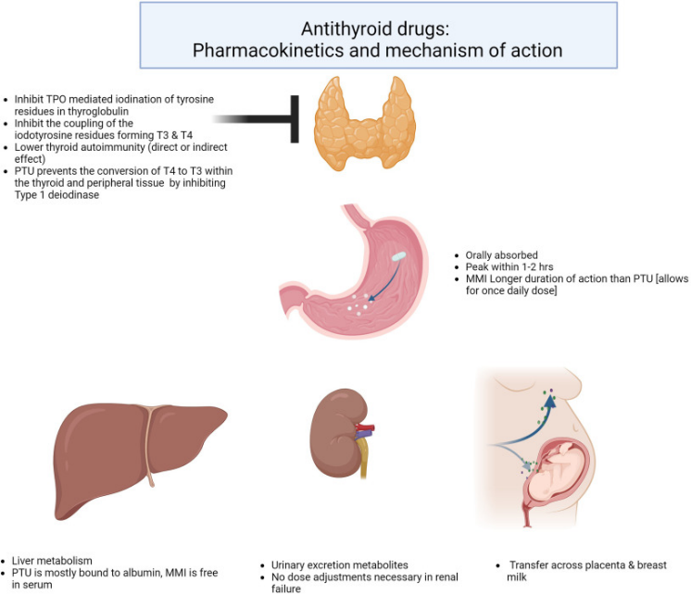
Figure 6: ATDs in action
(Source: Shah et al., 2025)
By inhibiting the synthesis of thyroid hormones, these medicines help in maintaining normal metabolic rates within the human body, which proves to be highly beneficial for pregnant women under strict monitoring (Shah et al., 2025).
Besides the first-line medications, there is a therapy-driven approach called RAI, which doctors often utilise as a long-term solution by destroying overactive tissue of the thyroid within patients (Daniels and Ross, 2023). NHS UK utilises this process as a single treatment method in which they offer iodine and radiation-driven drink or capsule to patients that helps in removing the overactive thyroid cells (NHS UK, 2026). However, this therapy is not suitable for pregnant or breastfeeding women due to the presence of radiation.
Lastly, in severe cases like the suspicion of cancer or large goitres, global healthcare clinics incorporate Thyroidectomy surgery, which allows surgeons to partially or totally remove thyroid glands (Kaplan et al., 2015). This helps healthcare professionals in restoring the natural flow of hormone levels in the human body.

Theoritical Perspectives and Models
Here, the two most relevant models are being utilised to showcase how both international and UK-based healthcare organisations are managing the treatment of hyperthyroidism.

House of Care (HoC)
The House of Care Model is a framework developed by the NHS England for helping the individuals in the UK who are suffering from long-term illnesses like Hyperthyroidism. By following this model, the UK healthcare organisations, including NHS, can assist the patients by providing the better quality of care for their long term wellness.
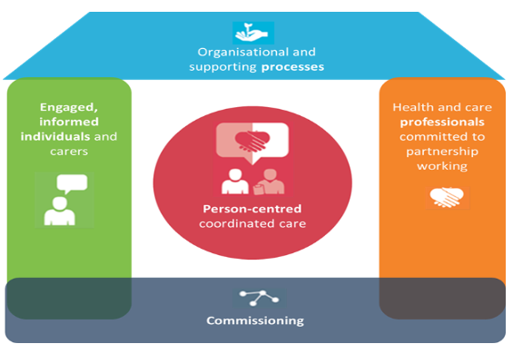
Figure 4: House of care model
(Adopted from Study Materials)
Person-centred coordinated care:
The central component of this model is Person-centred Collaborative care planning. For fighting and managing diseases like Hyperthyroidism, the NHS England has built a proper person-centred care by focusing the needs and preferences of patients. For better treatment, the NHS shares different symptoms of the disease. In addition, the NHS listens carefully to the problems of every patient and guides them properly about the medicines and other lifestyle guidelines. The NHS also provides specialist support to patients for the Thyroid Eye Disease (NHS, 2026). For wellness, the NHS provides anti-thyroid drugs to patients for the improvement of their health (NHS, 2026a). Following these ways, the NHS offers person-centered care to patients that aligns with the house of care model and ensures patients' wellness in the long run.
Engaged and informed patients and Health and care professionals committed to partnership working:
The NHS is quite serious in resolving and managing various critical long-term illnesses, including Hyperthyroidism. The multidisciplinary collaboration in the healthcare organisation is required to manage long-term diseases like Hyperthyroidism. The GPs of the NHS do the initial diagnosis of patients and give referrals to specialists (Bi and Liu, 2023). Thereafter the Endocrinology specialist of the NHS provides the best treatment to patients for balancing their hormonal imbalance, which is helpful to maintain lower Hyperthyroidism in the long run (NHS England, 2026). The effective partnership between the general practitioners and Endocrinology specialists ensures a better care delivery to patients, helping them fight hyperthyroidism. Following these ways, healthcare organisations are engaging patients. However, the lack of proper awareness and inefficient staff could limit the application of this model.

Innovative Care for Chronic Conditions (ICCC)
The ICCC framework is developed by WHO in order to expand the traditional Chronic Care Model (CCM), with an aim to acknowledge a more comprehensive policy environment across micro, meso and macro levels (WHO, 2026).
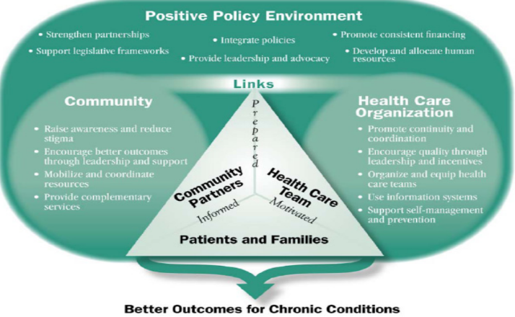
Figure 5: ICCC Model
(Adopted from Study Materials)
Micro Level (Individuals, families and healthcare teams)
This level encourages global healthcare enterprises to prioritise facilitating direct patient care and empower patients’ family members to support in self-management practices of patients (Oni et al., 2014). This helps both professionals and patients to manage chronic conditions. Following this principle, worldwide healthcare organisations are focusing on coordinated patient care through medications like Methimazole and Propylthiouracil (Tan et al., 2021). Additionally, organisations like the American Thyroid Association and the British Thyroid Foundation are offering education resources to educate patients and their families about recognising hyperthyroidism symptoms earlier and managing stress (ATA, 2026; BTF, 2026).
Meso Level (Community and Healthcare organisations)
The ICCC framework at this level encourages worldwide healthcare organisations to deliver care in a coordinated way by using local community support, such as collaborating with social services (Oliver-Baxter et al., 2013). Considering this idea, global healthcare associations like Thyroid Federation International (TFI) coordinate with national endocrine societies in order to increase disease awareness through medical campaigns and screening programmes (TFI, 2025). This helps in encouraging behavioural changes in patients and promoting overall better treatment of hyperthyroidism.
Macro Level (Policy and Health System)
Across this level, the ICCC framework prioritises the application of national and global policies to support global healthcare associations in managing chronic diseases (WHO, 2026). Based on this idea, international health bodies have developed treatment and funding policies such as the WHO Non-communicable Disease (NCD) Strategy (2013–2030), the ATA Guidelines & Statements and NICE: Thyroid Disease Assessment and Management Guidelines. These policies support both funding and treatment of hyperthyroidism and its related burden and implications across the world.
Overall, the ICCC model is essential for coordinated treatment of hyperthyroidism, but still, the prevalent workforce shortages, skill gap and resource constraints across the worldwide healthcare sector can limit the application of this model (Skills for Health, 2025).

Local and National Political Health and Social Care Agendas
The government of the UK has implemented different policies and frameworks that ensure the prevention of Hyperthyroidism, including the high quality treatment for the disease. Two key policies and their effectiveness in managing hyperthyroidism have been discussed hereunder. The key policies and frameworks are:
- NICE Guideline (NG145).
- British Thyroid Association guidelines.
NICE Guideline (NG145):
This guideline provides evidence-based suggestions about the prevention and management of thyroid disease among the young, adults and children. This guideline also aims to establish the standardised care process for thyroid patients across the NHS (NICE, 2023). To follow this guideline, the different healthcare organisations under the NHS trusts offer similar care delivery to hyperthyroidism patients. Additionally, the different departments of the NHS responsibly manage all the operations to ensure delivery of high quality, similar services to every patient (NHS, 2026). The NHS consists of Endocrinology specialists who are responsible to deliver immersive guidance about medicines and lifestyle changes to hyperthyroidism patients (NHS, 2026). Therefore, following these ways, the NHS organisations align their operations with the NICE Guideline (NG145) that enables high-class healthcare service delivery for hyperthyroidism patients.
British Thyroid Association (BTA) guidelines:
It offers clear guidelines for the healthcare professionals about the management and diagnosis of thyroid disease. These guidelines strongly recommend that healthcare professionals maintain the TSH level within a certain limit with regular checkups. This association also states that the healthcare professionals should use liothyronine (T3) in the case of hypothyroidism (BTF, 2026). By following the regulations of the British Thyroid Association, NHS England provides TSH level checkup opportunities to every hypothyroidism patient every 6 to 8 weeks (NICE, 2023). Additionally, the healthcare professionals of the NHS England routinely recommend liothyronine (T3) to patients suffering from hypothyroidism to balance of T3 hormone (NHS, 2025). Therefore, following these ways, the NHS UK follows the guidelines of BTA.

Recommendations for Improvement
For reducing hyperthyroidism and improve end-of-life care among worldwide population , some suggestions are offered below:
Strengthening the awareness of people:
The management of the global healthcare organisations should increase awareness about the prevention of hyperthyroidism. As an action, the healthcare organisations can promote the use of antithyroid medications that minimise the chance of thyroid occurring in the human body. As stated by Amrita et al. (2025), antithyroid meditation helps to reduce the chance of having hyperthyroidism disease. Also, the healthcare organisations should provide Radioactive Iodine Therapy for the prevention of thyroid cancer. Also, the awareness among patients is necessary as it helps to recognise the disease easily and improve end-of-life care. The high awareness additionally ensures a better self-management that prevents the occurrence of the disease.
Mitigating workforce skill gap:
Present workforce skill gap could raise a major issue in the treatment of patients that could lead to health risks for patients. To resolve the skill gap of healthcare professionals, the healthcare organisations should arrange monthly or weekly training sessions for employees that will improve their ability to provide proper treatment and self-management guide to hyperthyroidism patients (Flegl et al., 2022). Following these ways, healthcare organisations can improve the quality of care for thyroid patients.

Conclusion
To conclude, it can be asserted that hyperthyroidism is a highly prevalent long-term condition, affecting over 2.5% of the population worldwide, particularly females. Key risk factors like genetics, gender, pregnancy, smoking and iodine intake can make a thyroid patient’s health condition more vulnerable. Although organisations are implementing frameworks like the House of Care and Innovative Care for Chronic Conditions, a gap persists in terms of workforce and skill shortage, negatively affecting the quality of care. Key evidence-based treatments like frontline medications, RAI therapy and Thyroidectomy surgery are helping worldwide healthcare organisations to offer adequate care and help maintain the T3 and T4 hormone levels in patients.

References
Al-Worafi, Y. M. (2026). Handbook of Evidence-Based Pharmacist Care: Clinical, Economic, and Humanistic Impacts: Volume 2: Endocrine, Respiratory, and Renal Diseases and Disorders. CRC Press. Available at: https://books.google.com/books?hl=en&lr=&id=dcDGEQAAQBAJ&oi=fnd&pg=PP11&dq=hyperthyroidism+treatment+economically+strain+the+families+due+to+high+medical+costs&ots=vNFKQpP5OQ&sig=vtX7py2GqLuznFyk7ddXCYEBmcA
Amrita, C., Mitali, M., Kumari, C.S. and Rupesh, K., (2025). Can Yoga Help to Manage the Symptoms of Thyroid Diseases?. International Journal of Yoga, 18(1), pp.3-12. Available at: https://journals.lww.com/ijoy/_layouts/15/oaks.journals/downloadpdf.aspx?an=01370257-202501000-00002
Aslam, Z., Mehboob, H., and Waseem, M. (2025). HYPERTHYROIDISM & QUALITY OF LIFE. International Journal of Social Sciences Bulletin, 3(10), 159-174. Available at: https://socialsciencesbulletin.com/index.php/IJSSB/article/download/1314/1333
ATA (2026). ATA Alliance for Thyroid Patient Education. Available at: https://www.thyroid.org/patient-thyroid-information/alliance-physicians-thyroid/#:~:text=The%20American%20Thyroid%20Association%20(ATA)%20is%20a,Worldwide%20collaboration%20and%20collegiality%20*%20Ethical%20conduct (Accessed: 1 March 2026).
Beck, A. C., Sugg, S. L., Weigel, R. J., Belding-Schmitt, M., Howe, J. R., and Lal, G. (2021). ‘Racial disparities in comorbid conditions among patients undergoing thyroidectomy for Graves’ disease: an ACS-NSQIP analysis’. The American Journal of Surgery, 221(1), 106-110. Available at: https://www.sciencedirect.com/science/article/pii/S0002961020302907
Bereda, G. (2022). ‘Hyperthyroidism: Definition, causes, pathophysiology and management. J. Biomed’. Biol. Sci, 1(2), 1-11. Available at: https://www.researchgate.net/profile/Gudisa-Bereda/publication/360457855_Hyperthyroidism_Definition_Causes_Pathophysiology_and_Management/links/627804062f9ccf58eb38a6d4/Hyperthyroidism-Definition-Causes-Pathophysiology-and-Management.pdf
Bi, Y.N. and Liu, Y.A., (2023). GPs in UK: from health gatekeepers in primary care to health agents in primary health care. Risk management and healthcare policy, pp.1929-1939. Available at: https://www.tandfonline.com/doi/pdf/10.2147/rmhp.s416934
Biswas, B. (2025). The Art of Defeating Death: A Physician’s Journey Beyond the Threshold. Deep Science Publishing. Available at: https://books.google.com/books
BTF (2026). Resources for patients. Available at: https://www.btf-thyroid.org/resources-for-patients (Accessed: 1 March 2026).
BTF, (2023). Leisa's story - Graves' disease. Available at: https://www.btf-thyroid.org/leisas-story-graves-disease (Accessed: 1 March 2026).
BTF, (2026). Guidelines and statements. Available at: https://www.btf-thyroid.org/guidelines-and-statements (Accessed: 1 March 2026).
Cleveland Clinic, (2020). Thyroid Disease May Run in Your Family — and You Might Not Know It. Available at: https://health.clevelandclinic.org/thyroid-disease-may-run-in-your-family-and-you-might-not-know-it (Accessed: 1 March 2026).
Cleveland Clinic, (2024). ‘Hyperthyroidism’. Available at: https://my.clevelandclinic.org/health/diseases/14129-hyperthyroidism (Accessed: 1 March 2026).
Daniels, G. H., and Ross, D. S. (2023). ‘Radioactive iodine: a living history’. Thyroid, 33(6), 666-673. Available at: https://journals.sagepub.com/doi/abs/10.1089/thy.2022.0344
De Leo, S., and Pearce, E. N. (2018). ‘Autoimmune thyroid disease during pregnancy’. The lancet Diabetes & endocrinology, 6(7), 575-586. Available at: https://www.thelancet.com/journals/landia/article/PIIS2213-8587(17)30402-3/abstract
Entwistle, V. A., Cribb, A., and Owens, J. (2018). ‘Why health and social care support for people with long-term conditions should be oriented towards enabling them to live well’. Health care analysis, 26(1), 48-65. Available at: https://link.springer.com/article/10.1007/s10728-016-0335-1
Feng, A.Y., Soffer, J.M., Mitchell, M.B., Williams, L.C., Abdelhamid Ahmed, A.H., Randolph, G.W. and Bhattacharyya, N., (2025). Estimating the Annual Healthcare Expenditure Costs and Utilization of Thyroid Disorders in the United States. Head & Neck, 47(12), pp.3294-3300.
Flegl, M., Depoo, L. and Alcázar, M., (2022). The impact of employees’ training on their performance improvements. Quality Innovation Prosperity, 26(1), pp.70-89. Available at: https://qip-journal.eu/index.php/QIP/article/download/1665/1336
FMI, (2025). Thyroid Function Test Market. Available at: https://www.futuremarketinsights.com/reports/thyroid-function-tests-market (Accessed: 1 March 2026).
Gifford, B. (2025). Hypothyroidism (underactive thyroid). Available at: https://www.nutritionist-resource.org.uk/topics/hypothyroidism.html (Accessed: 1 March 2026).
Hasanvand, M. B. (2024). ‘Job Stress and Its Management’. Protection and Prevention Approaches in Occupational Health and Safety, 35. Available at: https://books.google.com/books
Healthline, (2024). ‘Hyperthyroidism and Mental Health Impact.’ Available at: https://www.healthline.com/health/hypothyroidism/hyperthyroidism-psychiatric-symptoms (Accessed: 1 March 2026).
Hsieh, P.H., Geue, C., Wu, O., McIntosh, E. and Siebert, S., (2022). How do multiple long-term conditions impact on the cost-of-illness in early rheumatoid arthritis?. RMD open, 8(2). Available at: https://rmdopen.bmj.com/content/rmdopen/8/2/e002454.full.pdf
Inspira Health, 2024)
Kaplan, E., Angelos, P., Applewhite, M., Mercier, F., and Grogan, R. H. (2015). Surgery of the thyroid. Available at: https://europepmc.org/books/nbk285564
Lee, S. Y., and Pearce, E. N. (2023). Hyperthyroidism: a review. Jama, 330(15), 1472-1483. Available at: https://pmc.ncbi.nlm.nih.gov/articles/PMC10873132/#:~:text=Conclusions%20and%20Relevance:,predominant%20component%20of%20the%20tumor.
Lee, S. Y., Modzelewski, K. L., Law, A. C., Walkey, A. J., Pearce, E. N., and Bosch, N. A. (2023). ‘Comparison of propylthiouracil vs methimazole for thyroid storm in critically ill patients’. JAMA Network Open, 6(4), e238655. Available at: https://jamanetwork.com/journals/jamanetworkopen/article-abstract/2803923
Lee, S.Y. and Pearce, E.N., (2023). ‘Hyperthyroidism: a review’. Jama, 330(15), pp.1472-1483. Available at: https://pmc.ncbi.nlm.nih.gov/articles/PMC10873132/pdf/nihms-1958909.pdf
Mayo Clinic, (2026). ‘Hyperthyroidism (overactive thyroid)’. Available at: https://www.mayoclinic.org/diseases-conditions/hyperthyroidism/diagnosis-treatment/drc-20373665#:~:text=Thyroid%20eye%20disease,and%20mycophenolate%20mofetil%20(Cellcept). (Accessed: 1 March 2026).
Mekki, O. J., Yosif, M. K., Alrikabi, S. K. J., Alrikabi, M. S. K., and Saadoon, A. A. (2022). ‘Hyperthyroidism: Demography and Clinical Criteria in Al–Nasiriyah City (2022)’. Available at: https://www.researchgate.net/profile/Olfet-Jabbar-Alhassani/publication/372780278
Moreno-Reyes, R., Fuentes Peña, C., Nuñez, J. F., Sánchez, M. B., Carvajal, J. J., Roble, K., ... and Jara, E. L. (2025). ‘Critical role of iodine and thyroid hormones during pregnancy’. International Journal of Molecular Sciences, 26(21), 10247. Available at: https://www.mdpi.com/1422-0067/26/21/10247
Mukherjee, U., Sehar, U., Brownell, M., and Reddy, P. H. (2024). ‘Sleep deprivation in dementia comorbidities: Focus on cardiovascular disease, diabetes, anxiety/depression and thyroid disorders’. Aging (Albany NY), 16(21), 13409. Available at: https://pmc.ncbi.nlm.nih.gov/articles/PMC11719105/
Nadeali, Z., Mohammadi-Zaniani, Z., Biglari, S., Molavi, N., Zardoui, K., Mirfendereski, S., ... and Polychronakos, C. (2025). ‘Investigating TSHR gene variants in consanguineous families: novel insights into variable expression in familial congenital hypothyroidism’. Frontiers in Endocrinology, 16, 1559281. Available at: https://www.frontiersin.org/journals/endocrinology/articles/10.3389/fendo.2025.1559281/full
NHS England, (2026). Specialised endocrinology. Available at: https://www.england.nhs.uk/commissioning/spec-services/npc-crg/group-a/specialised-endocrinology/ (Accessed: 1 March 2026).
NHS Inform, (2025). Overactive thyroid. Available at: https://www.nhsinform.scot/illnesses-and-conditions/glands/overactive-thyroid/#:~:text=Excess%20levels%20of%20thyroid%20hormones,unexplained%20or%20unplanned%20weight%20loss (Accessed: 1 March 2026).
NHS UK, (2026). Treatment. Available at: https://www.nhs.uk/conditions/overactive-thyroid-hyperthyroidism/treatment/ (Accessed: 1 March 2026).
NHS, (2025). Liothyronine in hypothyroidism (Guidelines). Available at: https://www.rightdecisions.scot.nhs.uk/tam-treatments-and-medicines-nhs-highland/adult-therapeutic-guidelines/endocrine/liothyronine-in-hypothyroidism-guidelines/ (Accessed: 1 March 2026).
NHS, (2026). ‘Overactive thyroid (hyperthyroidism)’. Available at: https://www.nhs.uk/conditions/overactive-thyroid-hyperthyroidism/ (Accessed: 1 March 2026).
NHS, (2026). Symptoms: Overactive thyroid (hyperthyroidism). Available at: https://www.nhs.uk/conditions/overactive-thyroid-hyperthyroidism/symptoms/ (Accessed: 1 March 2026).
NHS, (2026a). Anti-thyroid drugs. Available at: https://www.swbh.nhs.uk/wp-content/uploads/2012/07/Anti-thyroid-drugs-ML5742.pdf
NICE, (2023). Thyroid disease: assessment and management. Available at: https://www.nice.org.uk/guidance/ng145 (Accessed: 1 March 2026).
NICE, (2023). Thyroid disease: assessment and management. Available at: https://www.nice.org.uk/guidance/ng145/chapter/recommendations (Accessed: 1 March 2026).
NICE, (2026). ‘CKS via NICE is only available to eligible users within the UK’. Available at: https://cks.nice.org.uk/topics/hyperthyroidism/background-information/prevalence/ (Accessed: 1 March 2026).
NIH. (2026). ‘Hyperthyroidism’. Available at: https://www.ncbi.nlm.nih.gov/books/NBK537053/#article-29850.s4 (Accessed: 1 March 2026).
Oliver-Baxter, J., Brown, L., and Bywood, P. (2013). ‘Integrated care: what strategies and other arrangements support and influence integration at the meso/organisational level’. Adelaide: Primary Health Care Research and Information Service. Available at: https://www.academia.edu/download/41822948/Integrated_care_What_strategies_and_othe20160131-2947-sf7fwz.pdf
Oni, T., McGrath, N., BeLue, R., Roderick, P., Colagiuri, S., May, C. R., and Levitt, N. S. (2014). ‘Chronic diseases and multi-morbidity-a conceptual modification to the WHO ICCC model for countries in health transition’. BMC public health, 14(1), 575. Available at: https://link.springer.com/article/10.1186/1471-2458-14-575
Presence Research (2026). Graves Disease (Overactive Thyroid) Market Size, Share and Trends 2026 to 2035. Available at: https://www.precedenceresearch.com/graves-disease-market (Accessed: 1 March 2026).
Rodolfi, S., Rurale, G., Marelli, F., Persani, L., and Campi, I. (2025). Lifestyle interventions to tackle cardiovascular risk in thyroid hormone signaling disorders. Nutrients, 17(13), 2053. Available at: https://www.mdpi.com/2072-6643/17/13/2053
Shah, R., Adamson, S. E., and Jasim, S. (2025). ‘Management aspects of medical therapy in Graves disease’. Endocrine Practice, 31(4), 536-546. Available at: https://www.sciencedirect.com/science/article/pii/S1530891X2400870X
Skills for Health, (2025). The growing gap in UK healthcare. Available at: https://www.skillsforhealth.org.uk/article/the-growing-gap-in-uk-healthcare/ (Accessed: 1 March 2026).
Spherical Insight, (2024). ‘Global Graves’ Disease (Overactive Thyroid) Market Size, Share, and COVID-19 Impact Analysis’. Available at: https://www.sphericalinsights.com/reports/graves-disease-overactive-thyroid-market (Accessed: 1 March 2026).
Tan, S., Chen, L., Jin, L., and Fu, X. (2021). ‘The efficiency and safety of methimazole and propylthiouracil in hyperthyroidism: a meta-analysis of randomized controlled trials’. Medicine, 100(30), e26707. Available at: https://journals.lww.com/md-journal/fulltext/2021/07300/The_efficiency_and_safety_of_methimazole_and.21.aspx/1000
TFI, (2025). Working for the benefit of thyroid patients worldwide. Available at: https://www.thyroid-federation.org/#:~:text=What%20we%20do,research%20related%20to%20thyroid%20disorders. (Accessed: 1 March 2026).
University of Aberdeen, (2024). Thyroid disease isn't the end for your career prospects, new study finds. Available at: https://www.abdn.ac.uk/news/23192/ (Accessed: 1 March 2026).
WHO. (2026). Innovative care for chronic conditions : building blocks for actions. Available at: https://www.who.int/publications/i/item/innovative-care-for-chronic-conditions-building-blocks-for-actions (Accessed: 1 March 2026).
Wiersinga, W. M., Poppe, K. G., and Effraimidis, G. (2023). ‘Hyperthyroidism: aetiology, pathogenesis, diagnosis, management, complications, and prognosis’. The lancet Diabetes & endocrinology, 11(4), 282-298. Available at: https://www.thelancet.com/article/S2213-8587(23)00005-0/abstract
Wiersinga, W.M., Poppe, K.G. and Effraimidis, G. (2023). 'Hyperthyroidism: aetiology, pathogenesis, diagnosis, management, complications, and prognosis'. The Lancet Diabetes & endocrinology, 11(4), pp.282-298. Available at: https://sostelemedicina.ucv.ve/documentos/manuales/hyperthyroidism-aetiology-pathogenesis-diagnosis.pdf

