Student Name: Patiecia Malongo
Student ID:2333381
Programme: BSc Health and Social Care
Module code:BMHP5014
Lecturer:Parese Ahmed
Assignment Title: Component 2

Changemakers: Creativity and Value Creation

Bridging the Gap: A Digital-Community Integrated Support System for Homeless Healthcare Access in the UK

Table of Contents
Component 1- Poster 3
Component 2- Written Assignment Written Pitch 4
1. INTRODUCTION 4
2. PROBLEM ANALYSIS 4
3. YOUR INNOVATION: CARELINK HUB 4
4. HOW IT WORKS 5
5. TARGET DEMOGRAPHIC & IMPACT 5
6. TECHNOLOGY INTEGRATION 5
7. IMPLEMENTATION PLAN 6
8. VALUE, FEASIBILITY & CHALLENGES 6
9. FUTURE SCALABILITY 6
10. CONCLUSION 6
References 8

Component 1- Poster
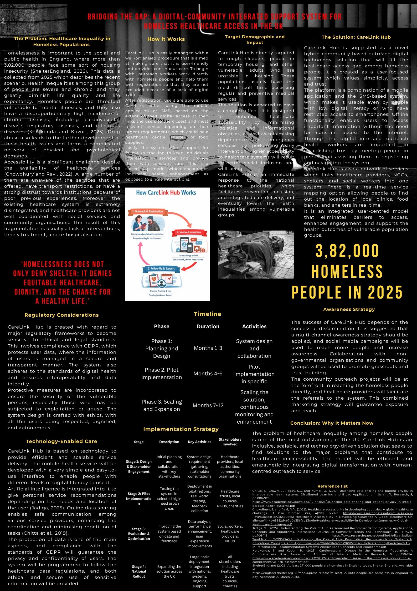

Component 2- Written Assignment Written Pitch

1. INTRODUCTION
CareLink Hub is a proposed digital and outreach model that should be integrated to reduce healthcare disparities in homeless people in the UK. The problem of homelessness has become one of the most acute in the field of public health, as the number of homeless people in England is more than 382,000 and many of them have serious mental and physical health problems (Shelter, 2025). Access to care is still low, despite the services that are available. The innovation will enhance accessibility, coordination, and inclusion with an integrated health and social care approach, which is user-centred.

2. PROBLEM ANALYSIS
The issue of homelessness in the UK is an interplay between health and social care disparities. The homeless are more exposed to mental health issues, misuse of substances, and chronic conditions and have been found to die much more than the rest of the population (Office for National Statistics, 2023). However, healthcare is very unequal in access. The barriers include structural issues, including the absence of a permanent address, insufficient awareness of services, and the difficulty of transport to primary care services (Aldridge et al., 2018). More importantly, the current networks of NHS and social care lack efficiency, which leads to ineffective coordination of the activities of healthcare providers, local authorities, and third-sector organisations (Khan, 2023). This fragmentation is a source of care discontinuity and strengthening of exclusion. Moreover, a lack of trust in the formal institutions enhances underutilisation of services (Warda et al., 2023). Thus, an evident gap exists in integrated, user-based healthcare access models that can significantly aid the gap between health and social care delivery to homeless individuals. This is in line with the necessity to create more coordinated and inclusive models of service delivery in the UK.

3. YOUR INNOVATION: CARELINK HUB
CareLink Hub is an integrated health and social care model, which is a hybrid between digital technology and outreach, community-based interventions (to enhance access to healthcare among homeless people). The innovation is a mobile application and SMS-based system, which will be more accessible to digitally excluded people, as well as outreach workers who will help facilitate the engagement and the establishment of trust. Among the important features are real-time service mapping. This allows a user to find nearby health care services, shelters, and other support services, and an integrated data system that links NHS services with the local authorities and third-sector organisations. This solves some of the main obstacles present in existing systems: limited access is minimised by mobile connectivity, mistrust by human contact, and service fragmentation by coordinated care pathways. As a result, the model aids in a more liberal, people-centred method of delivering healthcare (NHS England, 2023).

4. HOW IT WORKS
The CareLink Hub uses a user-centred, well-organised journey that is aimed at providing accessibility and continuity of care. First, the outreach workers enrol people into the system and record their basic needs and preferences. The platform can then be accessed through the use of a mobile application or SMS, where users can determine and locate healthcare and social services that are near them in real time. The system enables cross-provider referral, which has ensured the coordination of service delivery between the NHS and community organisations. It allows continuous follow-up, which is facilitated by automated notifications and outreach communication and helps maintain lasting contact with services. This will promote continuity of care and minimise chances of disengagement of services among vulnerable populations (Faculty for Homeless and Inclusion Health, 2022).

5. TARGET DEMOGRAPHIC & IMPACT
The target population of CareLink Hub includes mainly homeless persons and other socially marginalised groups that have high barriers to healthcare access. Through the innovation, health disparities are minimised, and health outcomes of vulnerable populations are improved by increasing the accessibility and coordination of services. This strategy is in line with the NHS Long Term Plan that encourages health equity and early intervention. More importantly, the model promotes preventative healthcare, and less pressure on the system is achieved through the minimal use of emergency services (NHS England, 2025).

6. TECHNOLOGY INTEGRATION
CareLink Hub also utilises a mobile platform with the assistance of SMS to make sure that anyone can use it, and the system offers AI-powered recommendations to help users find the relevant services. Data-sharing functionality is integrated to facilitate the coordination of healthcare and social care providers, whereas strict compliance with GDPR will guarantee the safety of data and ethical utilisation. This technological infrastructure will make it more responsive and interconnected as it will make the care system more efficient and scalable (Department of Health and Social Care, 2022).

7. IMPLEMENTATION PLAN
Introduction of CareLink Hub is implemented in phases that include design, pilot, and national rollout, which will guarantee feasibility and incremental improvement. The important stakeholders involved are NHS organisations, local councils, and third-sector partners, which are supported by the proper funding, training of the workforce, and the digital infrastructure. The adherence to the GDPR and NHS policy frameworks will guarantee the ethical, secure and realistic deployment (NHS England, 2023).

8. VALUE, FEASIBILITY & CHALLENGES
CareLink Hub will provide social value in two aspects: enhanced health outcomes, in addition to decreased NHS burden due to prevention care. Nevertheless, there are risks of challenges disrupting effectiveness, like the problem of digital exclusion, lack of funding, and lack of trust. These are controlled with the use of SMS-based access, cross-sector partnerships, and outreach engagement. Although its implementation involves an investment, the model is still possible because it is compatible with integrated care priorities and long-term cost-efficiency (National Audit Office, 2023).

9. FUTURE SCALABILITY
CareLink Hub has a high scalability potential due to its expansion across the regions of the UK and other vulnerable groups, like refugees and the low-income population. Integration in national digital health systems and Integrated Care Systems models facilitates wider systemic reach that helps to transform the inclusive provision of healthcare over the long term (Department of Health and Social Care, 2022).

10. CONCLUSION
CareLink Hub is a timely and integrated solution to health and social care inequalities that have been persistent among homeless people. It is sustainable as it combines digital innovation and human-centred outreach. The call-to-action is based on the policymakers, NHS stakeholders and the community organisations to invest in and implement this model in order to transform equitable access to care in the UK.

References
Aldridge, R.W., Story, A., Hwang, S.W., Nordentoft, M., Luchenski, S.A., Hartwell, G., Tweed, E.J., Lewer, D., Katikireddi, S.V. and Hayward, A.C., 2018. Morbidity and mortality in homeless individuals, prisoners, sex workers, and individuals with substance use disorders in high-income countries: a systematic review and meta-analysis. The Lancet, 391(10117), pp.241-250.
Chitta, S., Crawly, J., Reddy, S.G. and Kumar, D., (2019). Balancing data sharing and patient privacy in interoperable health systems. Distributed Learning and Broad Applications in Scientific Research, 5, pp.886-925. https://www.academia.edu/download/121443823/Balancing_data_sharing_and_patient_privacy_in_interoperable_health_systems.pdf
Chowdhury, J. and Ravi, R.P., (2022). Healthcare accessibility in developing countries: A global healthcare challenge. J Clin Biomed Res, 4(152), pp.2-5. https://www.researchgate.net/profile/Rejoice-Ravi/publication/365806651_Healthcare_Accessibility_in_Developing_Countries_A_Global_Healthcare_Challenge/links/63852d467b0e356feb93061e/Healthcare-Accessibility-in-Developing-Countries-A-Global-Healthcare-Challenge.pdf
Department of Health and Social Care (2022) Data saves lives: Reshaping health and social care with data (no date) GOV.UK. Available at: https://www.gov.uk/government/publications/data-saves-lives-reshaping-health-and-social-care-with-data/data-saves-lives-reshaping-health-and-social-care-with-data (Accessed: 21 March 2026).
Faculty for Homeless and Inclusion Health (2022). Inclusion health: Applying all our health. GOV.UK. Available at: https://www.gov.uk/government/publications/inclusion-health-applying-all-our-health/inclusion-health-applying-all-our-health (Accessed: 21 March 2026).
Jadiga, S., (2025). Understanding the Role of AI in Personalized Recommendation Systems, Applications, Concepts, and Algorithms. International Journal of Computer Trends and Technology (IJCTT), 73(1), pp.106-118. https://www.researchgate.net/profile/Shrikaa-Jadiga-2/publication/389957743_Understanding_the_Role_of_AI_in_Personalized_Recommendation_Systems_Applications_Concepts_and_Algorithms/links/67ddd5fafe0f5a760f5cfdad/Understanding-the-Role-of-AI-in-Personalized-Recommendation-Systems-Applications-Concepts-and-Algorithms.pdf
Khan, Z., (2023). The emerging challenges and strengths of the National Health Services: a physician perspective. Cureus, 15(5).
Korukonda, S. and Kovuri, P., (2025). Cardiovascular Disease in the Homeless Population: A Comprehensive Risk Assessment. Archives of Internal Medicine Research, 8, pp.150-154. https://www.academia.edu/download/123282122/cardiovascular_disease_in_the_homeless_population_a_comprehensive_risk_assessment.pdf
National Audit Office (2023). A picture of the National Audit Office Logo Session 2022-23 17 July 2023. Available at: https://www.nao.org.uk/wp-content/uploads/2023/07/New-hospital-programme-report.pdf (Accessed: 20 March 2026).
NHS England (2023) Integrated care systems: design framework. Integrated Care Systems: Design framework. Available at: https://www.england.nhs.uk/wp-content/uploads/2021/06/B0642-ics-design-framework-june-2021.pdf (Accessed: 20 March 2026).
NHS England (2025). Fit for the Future: 10 Year Health Plan for England. Available at: https://webarchive.nationalarchives.gov.uk/ukgwa/20250707103655/https://www.longtermplan.nhs.uk/ (Accessed: 20 March 2026).
Office for National Statistics (2023). Deaths of homeless people in England and Wales: 2021 registrations, Deaths of homeless people in England and Wales - Office for National Statistics. Available at: https://www.ons.gov.uk/peoplepopulationandcommunity/birthsdeathsandmarriages/deaths/bulletins/deathsofhomelesspeopleinenglandandwales/2021registrations (Accessed: 21 March 2026).
Shelter (2025). At least 382,000 people are homeless in England today. Shelter England. Available at: https://england.shelter.org.uk/media/press_release/at_least_382000_people_are_homeless_in_england_today_ (Accessed: 21 March 2026).
ShelterEngland (2026) At least 382,000 people are homeless in England today, Shelter England. Available at: https://england.shelter.org.uk/media/press_release/at_least_382000_people_are_homeless_in_england_today_ (Accessed: 21 March 2026).
Warda, E.R., Taye, A., Perskin, M. and Taylor, L., (2023). Does missing trust lead to overuse or underuse of health care services?. American Journal of Managed Care, 29(8).

