Engineering DesignM4X01160
Drill Press Redesign and Reflective Report
BEng (Hons) Mechanical & Manufacturing Engineering

Ben Woodhead [P151944]
1/2/2018

Contents
Abstract; 2
Manufacturing Method; 2
Initial Assessment; 3
Redesign & Changes; 4
Finite Element Analysis 6
Assessment of Redesign/Potential Future Adjustments; 8
References; 9

Abstract;
The purpose of this assignment is to assess the design and manufacturing method used to produce the main grip and slider section (Slider Unit) of a drill press assembly, and redesign the unit and manufacturing method to better suit the high volume production (~500 units per week) requested by the customer. The redesign will focus on reducing the cost, weight and production time of the part, whilst at least maintaining if not improving the functionality of the part. This will mean selecting a suitable production method for the part before beginning the redesign, in order to maximise the efficiencies of the chosen method in the designing process.

Manufacturing Method;
The manufacturing method required for the production of this part will be chosen by applying the following factors;
- Lead time – the customer has requested a quantity of 500 units produced per week, so this rules out long run-time methods such as CNC machining or 3D printing.
- Operational parameters – the final material must be strong and stiff enough to correctly support a hand drill during operation, withstand the force of the return spring, be light enough to be easily operated by one person precisely and carry out the required amount of movement cycles for the projected lifetime of the part; this is supposed to be ~500,000 cycles. This removes materials such as flexible polymers and heavy metals such as steels.
- Price – the final product is not a particularly unique or expensive product, so in order to meet the required profit margins the customer needs the product to be as inexpensive as possible. This rules out high-end materials such as carbon fibre or expensive lightweight alloys such as a magnesium/aluminium blend.
Because of these factors the most suitable process for such low-cost, high-volume parts would be polymer injection moulding, with an ABS material providing suitable mechanical properties for the operation of the Drill Press Assembly. The main advantages of an ABS plastic are its high dimensional stability, impact resistance and resistance to corrosive materials (Protolabs, 2018); these features make it an ideal material for the required operation, as well as the likely workshop environment that the product will be exposed to within its lifetime. Sizeable impacts and exposure to chemicals such as greases, solvents and other potentially corrosive compounds are more than likely within these conditions, so the ability to deal with them easily is paramount.
The downside to polymer injection moulding however is the high initial cost, due to the expensive mould tool that must be produced in order to create the mouldings. While this is always going to represent a large percentage of the initial capital outlay, it can be kept to a minimum by not having very tightly controlled tolerances or complex multi-plane geometry within the design that require an excessive amount of machine set-ups or specific tooling for production. Additionally, this large capital outlay is offset by the amount of parts this tool can produce over its lifespan; a single injection mould tool can produce hundreds of thousands of individual mouldings (Bayer, 2000), reducing the cost-per-part of the tooling to a factor of pennies.

Initial Assessment;
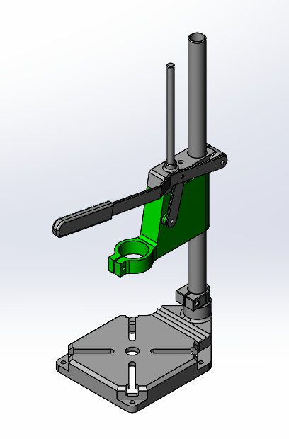
Figure 1 - Initial Concept Design
From the inspection of the original design, a number of factors were found that could potentially harm the production efficiency or the mechanical operation of the assembly. These will be the key features to address in the redesign in order to successfully mass-produce a correctly working part;
- Excess material – this is the primary concern of the design, as the Sliding Unit part in question is a large solid block of material, which has a negative effect on multiple aspects of the production process;
  - Increased material cost – more material costs more money.
  - Increased production cost – the large, thick sections of material will take much longer to cool, increasing the run time of each individual part and so increasing the cost.
  - Increased lead time – linking to the increased production cost, the longer individual run time of the parts compared to a more lightweight design will increase the overall lead time, potentially limiting the number of units able to be produced per week from the target 500.
  - Potential structural issues – large solid bodies are more prone to moulding problems such as hot tearing, sinkage and misruns due to the unstable cooling of the inner and outer regions of the thick areas. More uniform wall thicknesses across the part will aid the control of cooling, reducing the likelihood of moulding defects.
- Size-on-size fits – the mechanical operation of the assembly could be compromised by the matching sizes of the shaft and bore sections. Unless very accurate post-machining operations are performed on the polymer parts after moulding, matched by very tight tolerancing on the Main Shaft, the standard tolerancing of injection moulding would not be suitable for a tight sliding fit of the Sliding Unit around the mating part. Oversizing of the bore would result in an overly loose fit that would allow the drill to ‘wobble’ during use affecting usability, and undersizing would cause the Sliding Unit to seize on the shaft, or even not fit at all during assembly. This problem could be solved by directly moulding sleeve bearings in to the part as cores, allowing proper bearing fits to be achieved without the need for expensive post-machining operations.
- No ‘stop’ function – a useful function on most pillar-style drill presses is the ability to fix the Sliding Unit at a certain position on the Main Shaft. This can be achieved by simply adding a thumbscrew that pierces through to the shaft bore, allowing it to pinch on to the Main Shaft. However, with a polymer part a machine thread is not recommended to be tapped directly in to the material, so some sort of insert should be moulded in to the part as a core to hold the thumbscrew, much like the sleeve bearings.

Redesign & Changes;
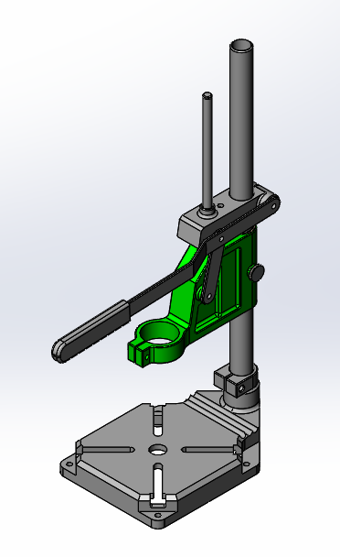
Figure 2 - Redesigned Assembly
The above image shows the redesigned assembly of the Drill Press Assembly – many of the original design features such as the clamping mechanism, Clamp/Main Shaft hole centre distance and handle mechanism have been kept as these worked effectively on the initial design; what has been changed however is detailed below, with the annotated exploded view image to provide a closer view. These – with the exception of the stop function – are not operational changes, but refinements to better suit the product to the requested large-scale manufacturing.
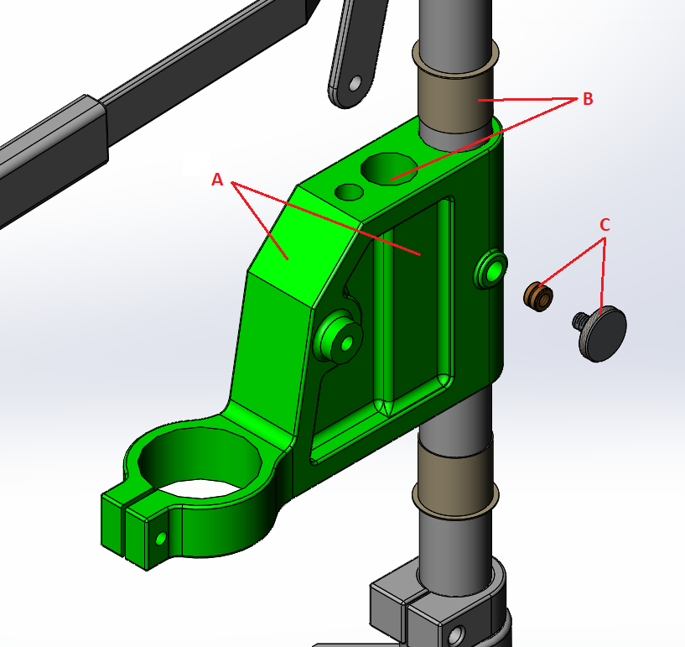
Figure 3 - Exploded View of Redesigned Assembly
- A – weight saving; cuts have been made in to the model in order to remove the material that served either little or no function in the operation, but caused significant issues during production. The wall thicknesses have been kept greater than the recommended minimum thickness of 1.143mm (Protolabs, 2018), but by removing the thick solid body sections there is much less variation in wall thickness as recommended in the Bayer Design Guide (Bayer, 2000) to improve uniform cooling rates and reduce risk of deformation problems such as sinkage or tearing. These thinner walls will also help reduce the material and production costs, as obviously less material takes less time to cool in the mould. Additionally, the sharp corners of these pockets – and the sharp edges in general – have been removed as these often pose a problem for moulding; often misruns or flash burrs can occur at these points due to their small geometry, so by adding small radii these issues can be removed.
- B – bore tolerancing; the standard tolerance of injection moulded parts across a dimensioned hole of less than 25.4mm is +/-0.13mm (DesignInfoSystem, 2018), which is not suitable for a smooth but tight shaft movement. In order to achieve the preferred operational fit on the Main Shaft bore, the best solution would be to have a sleeve bearing directly moulded in to the part; this removes the need for expensive and time-consuming post-machining of each part, but will provide a proper bearing tolerance unachievable by standard injection moulding. By utilising standard IGUS sleeve bearings (Part no. GFM-2526-25) an F9 bearing tolerance of +0.020/+0.072mm can be achieved for minimal cost. Additionally, these sleeve bearings have a coefficient of friction between 0.08 and 0.15µ (IGUS, 2018) and are designed for a high wear resistance. This means the Sliding Unit will perform much better than with an ABS bore for a longer lifecycle with minimal cost added. On the second shaft bore for the Guide Shaft, while the mating part does not actually move in relation to the Sliding Unit, the size-on-size Ø10mm bore and shaft diameters could affect the assembly of the Drill Press. Using the +/-0.005mm/mm resin tolerance listed on Protolabs’ ABS (Protolabs, 2018), the maximum wall thickness of 11.5mm around the bore could result in an undersizing of the bore diameter by 0.0575mm, potentially causing assembly issues. By opening the bore to Ø10.2mm the Guide Shaft should have an easy fit at any acquired dimension within the tolerance. As a final benefit, the use of these sleeve bearings and loosened fits means there does not have to be any tight specific tolerances on the part mould tool, as the standard machining tolerances will be adequate. This will further reduce the cost of the initial mould tool.
- C – ‘stop’ feature; this feature has been added to increase the functionality of the product, allowing the Sliding Unit to be fixed in a specific position on the Main Shaft. By adding the threaded brass insert in to the moulding as a core, the need for the plastic to hold the machine thread is removed. This is important as while the thumbscrew is not removed from the thread under normal operation, over-tightening of the screw could result in the thread being stripped if it was cut directly in to the plastic. By adding the brass insert, the thread strength is greatly improved, so any over-tightening of the screw is much less likely to cause failure of the feature.

Finite Element Analysis
In order to gain an insight in to how the new design compared under analysis to the original, a small FEA study was performed on each part. The bore housing the Main Shaft was allocated as the fixed geometry, with a 50N downward force applied to the handle pin bore and a 15N upward force to the drill grip to create a basic simulation of the forces the part would experience during operation. The displacement was the key factor measured for each part, as this would be the best indicator of how well the part withstood the opposing forces. The results for this study are shown below;
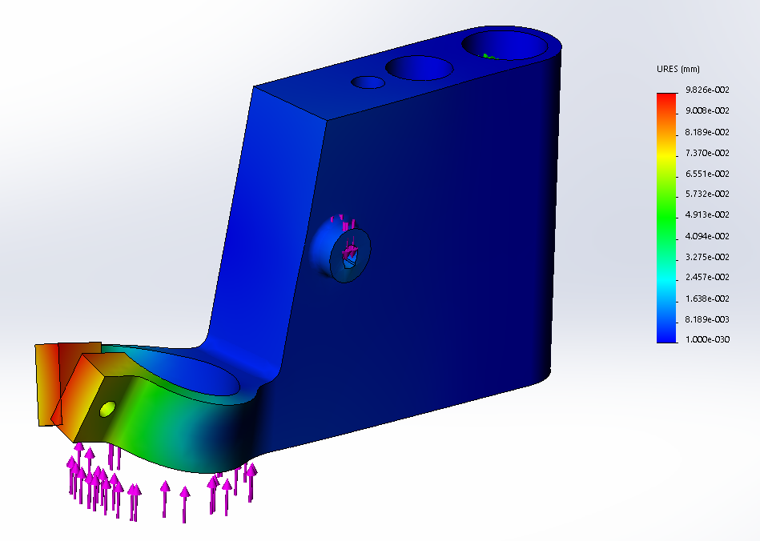
Figure 4 - Displacement Analysis of Original Part
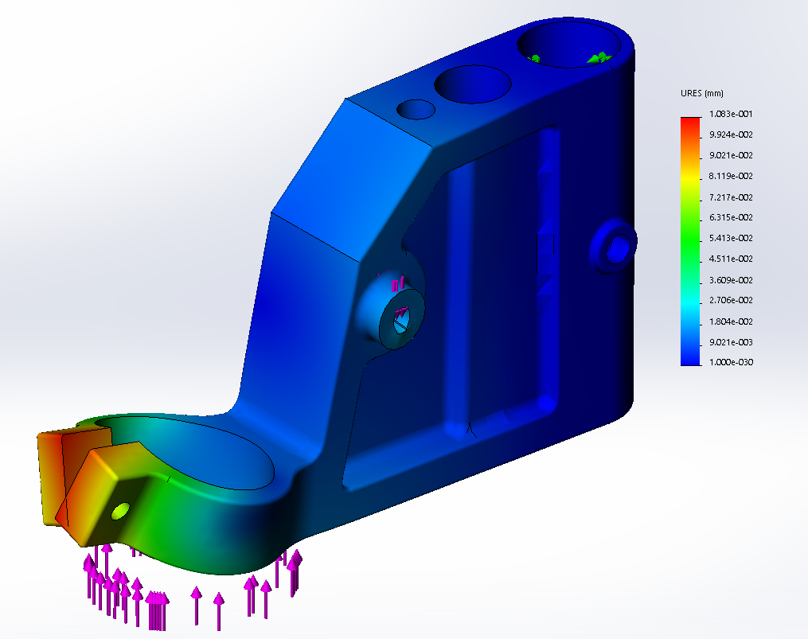
Figure 5 - Displacement Analysis of Redesigned Part
As the results show, the maximum displacement experienced by both parts is around 0.10mm, which is perfectly acceptable for the given conditions. Because of this, the redesigned part would be deemed suitable to take through to the trial phase.

Assessment of Redesign/Potential Future Adjustments;
Due to the way the current redesign completes the relatively simple task perfectly adequately, the main way to improve the design in any future reviews would be to further reduce the weight and cost whilst still maintaining the operational ability. I believe the best chance for this would be future reductions in the pricing, and increases in the availability, of 3D printed parts for production volumes. Currently 3D printing is still largely reserved for the prototyping market due to the high costs of machines and associated materials – 1 cubic metre of reinforced ABS+ FDM filament material currently being purchased for £186 from Stratasys Systems by Eddyfi UK – but the rate at which these prices have fallen in recent years indicates that soon prices will bring the technique to a wider production audience. Should the Sliding Unit be produced using additive manufacturing techniques then much more complex design would be possible, allowing the design to be ‘skeletonised’ with a series of undercut features that are not suitable for polymer injection moulding. This would considerably reduce the material cost of the part if the stock material costs became comparable to those of injection moulding, and reduce the weight of the part without compromising any of the strength or stiffness.
The other potential future change that could benefit the Sliding Unit product would be the reduction in price of Carbon Fibre Reinforced Polymers for injection moulding, which could be utilised to achieve the same strength and stiffness characteristics with considerably smaller part design features. While it is unlikely that CFRP’s will ever match ABS for stock price, by being able to have a design that incorporated much thinner features with the same strength and stiffness characteristics, the production costs could be significantly improved due to the considerably quicker cooling times compared to larger sections of ABS.

References;
Protolabs, 2018, ‘Injection moulding design guidelines: thermoplastics’, [Online], Available: https://www.protolabs.co.uk/services/injection-moulding/plastic-injection-moulding/design-guidelines/, [01-01-18]
Protolabs, 2018, ‘Manufacturing Materials’, [Online], Available: https://www.protolabs.co.uk/materials/comparison-guide/?filter=injection-molding-materials, [01-01-18]
Bayer, 2000, ‘Engineering Polymers – Part Mold and Design, Thermoplastics’, Pittsburgh PA, Bayer Corporation
DesignInfoSystem, 2018, ‘Plastic Injection Molding Part Tolerance’, [Online], Available: http://www.designinfosystem.com/index.php?option=com_content&view=article&id=55&Itemid=57, [01-01-18]
IGUS, 2018, ‘iglidur® G, sleeve bearing with flange, mm’, [Online], Available: https://www.igus.co.uk/product/?artnr=GFM-1011-026, [01-01-18]

