HPHI4005
Age of Revolution:

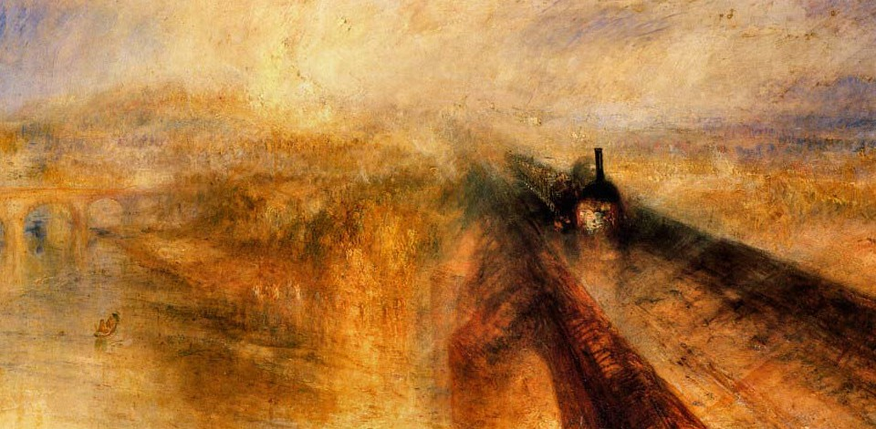

Transformation & Change in Europe & Beyond, c. 1789–1848
Study Guide
Semester 1 Block 2, 2019–2020

Module convenor:
Alexander Scott (alexander.scott@uwtsd.ac.uk)
Office hours:
Monday 1pm–2pm; Wednesday 9am–10.45am; Friday 9am–9.45am
Lectures:
2pm–5pm in Arts 4 on Monday, Tuesday, Thursday and Friday

Cover image: JMW Turner,
Rain, Steam and Speed (1844)
OVERVIEW
HPHI4005 offers an introduction to studying modern history at university level. It is the first of three Level 4 ‘survey’ modules which cover the end of the 18th century through to the end of the 20th century, with HPHI4005 focusing specifically on the period 1789–1848. The module does not (and cannot) aspire to offer a comprehensive chronological overview of this era; rather, it examines key case studies – the French, Industrial and Haitian Revolutions – which are integral to understanding 18th/19th-century history, and which also offer legacies that continue to shape today’s world. We shall consider the key social, political and cultural impacts of each of these revolutions, while also introducing students to some of the vital contents of ‘an historian’s toolkit’ – principally analysis of primary sources, essay-writing techniques, and an understanding of historiography. One of the means by which the module attempts to do the latter is by adopting – yet simultaneously critiquing – the periodization of modern history proposed by Eric Hobsbawm in The Age of Revolution.

AIMS
- To familiarise students with key themes, events and ideas that characterise the study of what Eric Hobsbawm termed ‘the Age of Revolution’.
- To familiarise students with historiographical debates surrounding ‘the Age of Revolution,’ and to highlight problematic issues related to historical interpretations and perspective.

LEARNING OUTCOMES
Upon the successful completion of this module, the student should be able to:
- Demonstrate a workable general knowledge of key themes and events that characterised the period 1789–1848, and be able to articulate what made 1789–1848 a distinctive period in European and global history.
- Absorb and apply information from a range of primary and secondary materials.
- Analyse and assess primary and secondary materials in a confident, critical and reflexive manner.
- Appreciate the dimensions of key historiographical debates surrounding the so-called ‘Age of Revolution,’ and be able to formulate evidence-based arguments that intervene in historiographical debates.

ASSESSMENT
Assessment comprises THREE 700-WORD GOBBETS and ONE 2000-WORD ESSAY
- Gobbet 1: due Sunday 27 October 23.59
- Essay: due Wednesday 13 November, 23:59
- Gobbet 2: due Sunday 17 November, 23:59
- Gobbet 3: due Sunday 17 November, 23:59

Assessment 1: Gobbets
Students are tasked with producing three gobbet analyses (i.e. critical appraisals of assigned sources). These analyses will be based on extracts from assigned primary texts and/or images relating to the French, Industrial and Haitian Revolutions. Each of the gobbets will be graded using the standard FHPA marking criteria; however, the final grade comprise only the two gobbets with the highest grades. This is to allow for formative assessment. Each gobbet should be no more than 700 words in length.
When writing their gobbets, students should address the following areas:
- Context
- Who is the author/producer of the source, and does this affect interpretation of it?
- When and where was the source produced, and what impact do these factors have on interpretation of it?
- What type of audience might the source have had originally, and does this affect interpretation of it?

- Content
- What are the source’s key features? What details or aspects stand out the most?
- Are there any particularly quotable lines from the source?
- Are there any key points that the author wanted to express?
- Is there anything notable about the language, style, rhetorical or artistic techniques used in the source?

- Significance
- What is the historical significance of this particular source? What gives it historical renown? What role did it play in particular historical events?
- What does the source tell us about out the specific events depicted and the broader themes explore on the module? Why might this source have been chosen as an exemplar of the module’s themes?
- What have other commentators said about the source? How have historians evaluated its significance?

Assessment 2: Essay
Question:
- What important political and/or social transformations were brought about by the French Revolution, and what was the cultural impact of these transformations? In answering, students may wish to consider the revolution’s impact on:
- Art, music, literature
- Philosophical ideas and ideologies
- Everyday life
- Conceptions of time and space
- Conceptions of nationhood and citizenship
- Gender roles

ASSESSMENT CRITERIA
Coursework will be graded in accordance with the general criteria adopted by the Faculty of Humanities and Performing Arts (see below); but with specific emphasis in the following subject-specific areas:

ENGAGEMENT WITH LITERATURE
For history students, this implies that a mixture of appropriate primary and secondary sources (plus any other relevant forms of evidence) are used effectively and in a critical manner. Emphasis is also placed on the ability to demonstrate understanding of relevant historiographical issues, and the proper use of quotations and MHRA referencing conventions.

KNOWLEDGE AND UNDERSTANDING
For history students, this implies a sound grasp of the chosen topic and time-period, and that forms of evidence and relevant theories/methods/approaches are used in a critical, reflective manner.

COGNITIVE AND INTELLECTUAL SKILLS
For history students, this implies the ability to formulate, sustain and articulate a coherent evidence-based argument. Particular emphasis is placed on the ability to demonstrate critical analysis as opposed to description/narrative, as well as the ability to situate a topic within broader chronological and scholarly contexts.

PRACTICAL SKILLS
For history students, this implies the ability to locate and apply relevant forms of evidence via primary and secondary research. Particular emphasis is placed on the ability to devise original insights and arguments, as opposed to those that are derivative of existing literature. The ability to demonstrate an understanding of relevant historiographical issues is also key.

TRANSFERABLE SKILLS FOR LIFE AND PROFESSIONAL PRACTICE
For history students, this implies the ability to communicate their ideas in a logical, legible and coherent manner. Correct spelling and grammar is key, with emphasis also placed on clear presentation and correct formatting. Completing the assigned task – and answering any questions contained within in it – is also essential, as is adherence to particular instructions for coursework tasks. At the same time, creative responses to assigned tasks/questions are valued.

FHPA GENERAL ASSESSMENT CRITERIA
Level 4 | FAIL | MARGINAL FAIL | SATISFACTORY  (third-class) | GOOD  (2.2) | VERY GOOD  (2.1) | EXCELLENT  (first-class) | EXCEPTIONAL  (first-class)
Category | 0-29% | 30-39% | 40-49% | 50-59% | 60-69% | 70-84% | 85-100%
Engagement with literature (including reading, referencing,  academic conventions and  academic honesty) | Little or no evidence of reading and/or reliance on inappropriate sources.  Views and findings mostly unsupported and non-authoritative.  Referencing conventions used incoherently or largely absent. | Poor engagement with essential reading. No evidence of wider reading. Reliance on inappropriate sources, and/or indiscriminate use of sources. Heavily reliant on information gained through class contact. Inconsistent and weak use of referencing. | Engagement with a limited range of mostly relevant and credible sources but with some reliance on information gained through class contact. Some omissions and minor errors.  Referencing conventions evident though not always applied accurately or consistently. | Engagement with an appropriate range of literature, including sources retrieved independently. Some over-reliance on texts rather than other sources. Referencing may show minor inaccuracies or inconsistencies. | Engagement with a wide range of literature, including sources retrieved independently.  Selection of relevant and credible sources. Generally sound referencing, with no/very few inaccuracies or inconsistencies. | Engagement with an extensive range of relevant and credible literature. Consistently accurate application of referencing. | Exceptional engagement with an extensive range of relevant and credible literature. High-level referencing skills consistently applied.
Knowledge &understanding (Knowledge of the basic underlying concepts and principles of a subject.) | Major gaps in knowledge and understanding of the basic underlying concepts and principles of the subject matter. Inclusion of irrelevant material. Substantial inaccuracies. | Gaps in knowledge of the basic underlying concepts and principles, with flawed or superficial understanding. Some significant inaccuracies and/or irrelevant material. | Limited knowledge and understanding of the basic underlying concepts and principles within the subject area. Some elements may be missing. | Knowledge of the basic underlying concepts and principles is accurate with a good understanding of the field of study but lacks depth and/or breadth. | Competent knowledge of the basic underlying concepts and principles. Exhibits very good understanding. | Excellent knowledge and understanding of the basic underlying concepts and principles of the subject. | Exceptional, detailed knowledge and understanding of the basic underlying concepts and principles
Cognitive & intellectual skills  (Evaluate underlying concepts and principles of a subject and interpret qualitative and quantitative data in order to develop lines of argument and make sound judgements.) | Wholly or almost wholly descriptive work. Little or no evaluation of the underlying concepts and principles.  Failure to develop arguments, leading to illogical or invalid judgements. Minimal or no use of  evidence to back up views. | Largely descriptive work, with superficial evaluation of the underlying concepts and principles. Weak interpretation of data, flawed development of arguments and judgements. Information accepted uncritically, uses generalised statements made with scant evidence and unsubstantiated opinions. Ideas sometimes illogical and contradictory. | Limited attempt at evaluation of the underlying concepts and principles, tending towards description.  Can interpret qualitative and quantitative data but with some errors. Some evidence to support emerging arguments and judgements but these may be underdeveloped or with a little inconsistency / mis-interpretation. | Good evaluation of the underlying concepts and principles. Can interpret qualitative and quantitative data, with minor errors.  An emerging ability to use evidence to support the argument.  Mostly valid arguments and logical judgements. | Sound evaluation of the underlying concepts and principles. Can interpret qualitative and quantitative data accurately. Ability to devise arguments using evidence to make mostly appropriate and valid judgements. | Excellent evaluation of the underlying concepts and principles. Can interpret qualitative and quantitative data accurately and with some insight. Excellent ability to devise arguments using evidence and make appropriate and valid judgements. | Exceptional evaluation of the underlying concepts and principles based evidence. Outstanding interpretation of qualitative and quantitative data.  Exceptional ability to devise arguments using evidence and make wholly appropriate and valid judgements.
Practical skills  (Different approaches to solving problems in particular contexts.) | Limited or no use of taught, basic methods, materials, tools and/or techniques.  Little or no appreciation of the context of the application.  Very weak evidence of different approaches to problem-solving in particular contexts. | Rudimentary application of taught, basic methods, materials, tools and/or techniques but without consideration and competence. Flawed appreciation of the context of the application.  Weak evidence of different approaches to problem-solving in particular contexts. | An adequate awareness and mostly appropriate application of basic methods, materials, tools and/or techniques.  Basic appreciation of the context of the application.  Can identify problems in particular contexts and propose basic alternative approaches or solutions though there may be errors. | A good and appropriate application of basic methods, materials, tools and/or techniques.  Clear appreciation of the context of the application.  Good evidence of different approaches to problem-solving in particular contexts and proposes mostly appropriate solutions. | A very good application of a range of basic methods, materials, tools and/or techniques.  Very good consideration of the context of the application. Very good evidence of different approaches to problem-solving in particular contexts and proposes appropriate solutions. | An advanced application of a range of taught, basic methods, materials, tools and/or techniques.  The context of the application is well considered, and insightful.  Excellent evidence of different approaches to problem-solving in particular contexts and proposes appropriate solutions. | Exceptional levels of application and deployment skills in particular practical contexts. Outstanding identification of problems in particular contexts and formulation of wholly appropriate, thoughtful solutions / different approaches.
Transferable skills for life & professional practice  (Communicate the results of their study/work accurately and reliably, and with structured and coherent arguments; the qualities needed for employment requiring the exercise of some personal responsibility within a structured and managed environment.) | Work is poorly structured, disorganised, inaccurate and/or confusingly expressed. Very weak use of language and/or very inappropriate style. Failure to work effectively individual or as part of a group. Little or no evidence of the skills for employment requiring the exercise of some personal responsibility. | Work is poorly presented in a disjointed manner. It is loosely, and at times incoherently, structured, with information and ideas often poorly expressed. Weak use of language and/or inappropriate style. Flawed approach to individual or group work, meeting only partial obligations to others. Limited evidence of the skills for employment requiring the exercise of some personal responsibility. | Mostly ordered presentation and structure in which relevant ideas / concepts are reasonably expressed. Work may lack coherence and/or accuracy in places. Can work as part of a group, meeting most obligations to others but perhaps with limited involvement in group activities.  Demonstrates the basic skills for employment requiring the exercise of some personal responsibility, with some areas of minor weakness. | Mostly coherent, organised and accurate work, in a suitable structure and is for the most part clearly expressed. Can work effectively independently and/or as part of a team, with clear contribution to group activities.  Demonstrates the skills for employment requiring the exercise of some personal responsibility, with some areas of strength and some of minor weakness. | Work is accurate, coherent, fluent, well-structured and organised.  Can work effectively independently and/or as part of a team, with very good contribution to group activities. Demonstrates very good skills for employment requiring the exercise of some personal responsibility, with just occasional minor weakness. | Work is coherent, very fluent and is presented professionally. Can work effectively independently and/or as part of a team, with an excellent contribution to group activities. Demonstrates excellent skills for employment requiring the exercise of some personal responsibility with an appetite for further development. | Work is accurate, exceptionally coherent, very fluent and presented well. Can work effectively independently and/or as part of a team, with an exceptional contribution to group activities. Demonstrates exceptional skills for employment requiring the exercise of some personal responsibility with an appetite for further development.

MODULE TIMETABLE
WEEKS 1–2 French Revolution
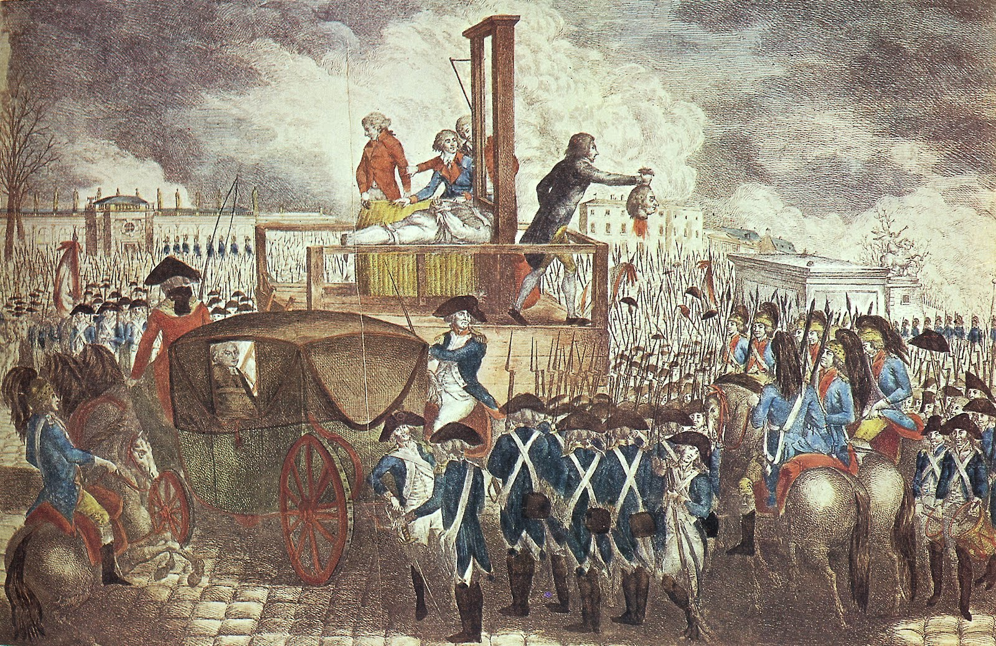
Georg Heinrich Sieveking, Execution of Louis XVI (1793)
WEEK 1
Lecture 1, Monday 21 October
Introduction to ‘the Age of Revolution’
Topics to include:
- Module overview
- Historiography: Hobsbawm and The Age of Revolution
- French Revolution: The Basics
Readings:
- Eric Hobsbawm, The Age of Revolution, 1789–1848 (New York: Vintage Books, 1996 [1962]), pp. ix–26.

Lecture 2, Tuesday 22 October
The Ancien Régime
Topics to include:
- France circa 1789
- Versailles and the Bourbons
- Rural and urban France
- The Three Estates
Readings:
- Duc de Saint-Simon, The Court of Louis XIV (c. 1740–1755)
- Portraits of King Louis XIV, XV and XVI
- Jacob-Nicolas Moreau, ‘Principles of Monarchy’ (1773)
- Arthur Young on Rural France (1792)
- Statement concerning dues and burdens of inhabitants of the seigneury of Montjoye-Vaufrey (1789)
- Louis-Sébastien Mercier on workers in Paris (1783)
- Emmanuel Sieyès, ‘What Is the Third Estate?’ (1789)

Lecture 3, Thursday 24 October
An Age of Reason
Topics to include:
- The Enlightenment
- The American Revolution
Readings:
- Montesquieu on the Nobility (1721)
- US Declaration of Independence (1776)
- Voltaire on Inequality (1765)
- ‘Political Authority’ (1751), ‘Encyclopaedia’ (1755), ‘Philosopher’ (1765) in The Encyclopaedia
- Immanuel Kant, ‘Answering the Question: What is Enlightenment?’ (1784)

Lecture 4, Friday 25 October
1789 and All That
Topics to include:
- The Estates General
- Tennis Court Oath
- Storming of the Bastille
- Declaration of the Rights of Man
Readings:
- Jacques-Louis David, Tennis Court Oath (1791)
- Keversau, ‘A Conqueror of the Bastille Speaks’ (n.d)
- National Assembly, Decree Abolishing the Feudal System (11 August 1789)
- National Assembly, Decree on the Abolition of the Nobility (19 June 1790)
- National Assembly, Declaration of the Rights of Man and Citizen (26 August 1789)
- Description of the Royal Menagerie (1789)

WEEK 2
Lecture 5, Monday 28 October
From ‘Moderate’ Revolution to ‘Radical’ Revolution
Topics to include:
- Jacobins and Girondins
- The Terror
Readings:
- Thouret, ‘Report on the Basis of Political Eligibility’ (29 September 1789)
- Robespierre, ‘Speech Denouncing the New Conditions of Eligibility’ (22 October 1789)
- National Assembly, Constitution of 1791
- National Convention committee statement on revolutionary calendar (October 1793)
- National Convention, Constitution of 1793
- Louis-Léopold Boilly, Portrait of a Sans-Culotte (1792); Description of Sans-Culottes, Père Duchesne, 1794
- Robespierre, ‘On Political Morality,’ 5 February 1794
- National Convention, ‘The Cult of the Supreme Being,’ June 8 1794

Lecture 6, Tuesday 29 October
From Regicide to Empire to Restoration
Topics to include:
- Thermidorian Settlement and Revolution of Coup of 18 Brumaire
- The Napoleon Myth
- Art and the French Revolution
- Study Skills: Footnotes
Readings:
- Philip G Dwyer, ‘Napoleon Bonaparte as Hero and Saviour: Image, Rhetoric and Behaviour in the Construction of a Legend,’ French History, Vol. 18, No. 1 (2004), pp. 379–403.

Word-processed gobbet: deadline Thursday 1 November, 12noon

Lecture 7, Thursday 31 October
Women and the French Revolution
Topics to include:
- Women’s roles in Ancien Régime and Revolutionary France
- Declaration of the Rights of Woman
- Study skills: Essay plans
Readings:
- Article from the Encyclopaedia on ‘Woman’ (1756)
- Madame B*** B***, ‘A Woman’s Cahier’ (1789)
- Petition of Women of the Third Estate to the King (1 January 1789)
- Olympe de Gouges, The Declaration of the Rights of Woman (September 1791)
- Philippe Fabre d’Eglantine and Jean-Baptiste Amar, Discussion of Women’s Political Clubs and their Suppression (29–30 October 1793)

Lecture 8, Friday 1 November
British Reactions to the French Revolution
Topics to include:
- Historiography of French Revolution
- Burke vs. Paine
- Romanticism
Readings:
- British Library, ‘The Impact of the Napoleonic Wars in Britain’ and ‘The Impact of the French Revolution in Britain’ <http://www.bl.uk/romantics-and-victorians/articles/the-impact-of-the-napoleonic-wars-in-britain>
- British Library, The Impact of the French Revolution in Britain’ <http://www.bl.uk/romantics-and-victorians/articles/the-impact-of-the-french-revolution-in-britain>

WEEK 3 INDUSTRIAL REVOLUTION
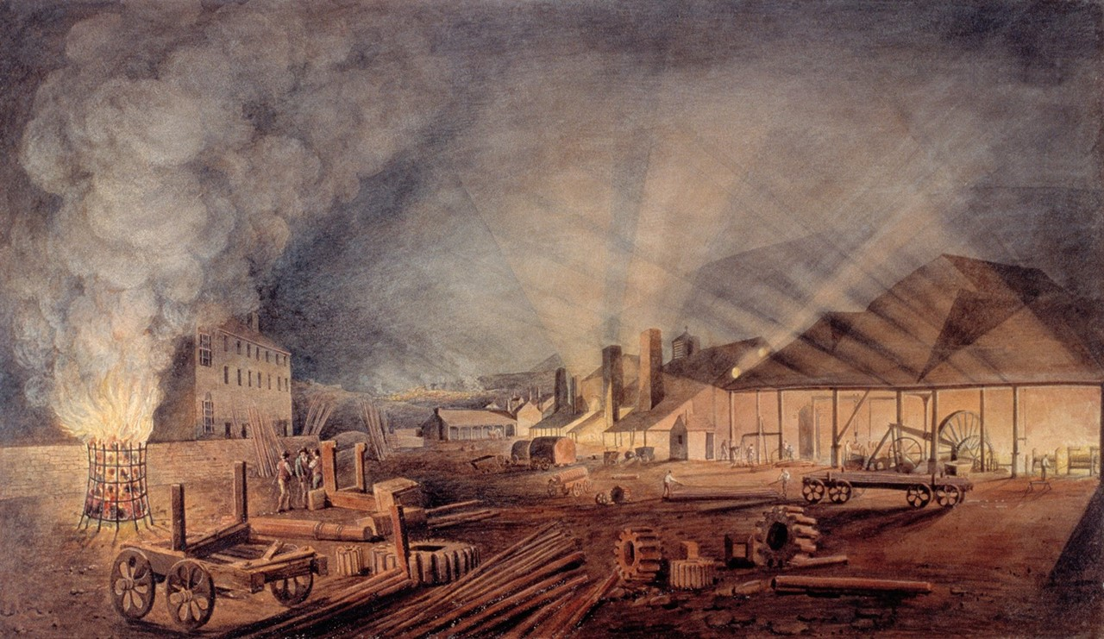
Thomas Horner, Rolling Mills, Merthyr Tydfil (1817)
Lecture 9, Monday 4 November
An Age of Steam
Topics to include:
- Defining the Industrial Revolution
- The Coming of the Railway
Readings:
- Eric Hobsbawm, The Age of Revolution, 1789–1848 (New York: Vintage Books, 1996 [1962]), pp. 27–52.
- ‘Opening of the Liverpool and Manchester Railway,’ Liverpool Mercury, September 17 1830
- TT Bury, Coloured Views on the Liverpool and Manchester Railway, with Plates of the Coaches, Machines, &c. from Drawings Made on the Spot by Mr TT Bury (London: R Ackermann, 1831).

Lecture 10, Tuesday 5 November
Romanticism, Riots and Reform
Topics to include:
- Responses to Industrialisation in Art and Literature
- Peterloo, Luddites, Chartists
- Parliamentary Reform
Readings:
- Thomas Pether, View from Kersal Moor (c. 1820)
- JMW Turner, Rain, Steam and Speed (1844)
- William Wordsworth, ‘On the Projected Kendal and Windermere Railway’ (1844)
- William Wyld, Manchester from Kersal Moor (1852), St George’s Hall, Liverpool (1852)
- RG Pattricoux, Manchester Town Hall, Albert Square, Manchester (1892)

Lecture 11, Thursday 7 November
Life in Industrial Britain
Topics to include:
- Urbanisation
- The Factory System
- Engels on Industrial England
Readings:
- Friedrich Engels, The Condition of the Working Class in England (1845) extracts

Lecture 12, Friday 8 November
1848 and All That
Topics to include:
- Marx and Engels
- Europe between Revolutions
- Revolutions and their Response, 1848–1849
Readings:
- Karl Marx and Friedrich Engels, The Communist Manifesto (1848)

WEEK 4 HAITIAN REVOLUTION
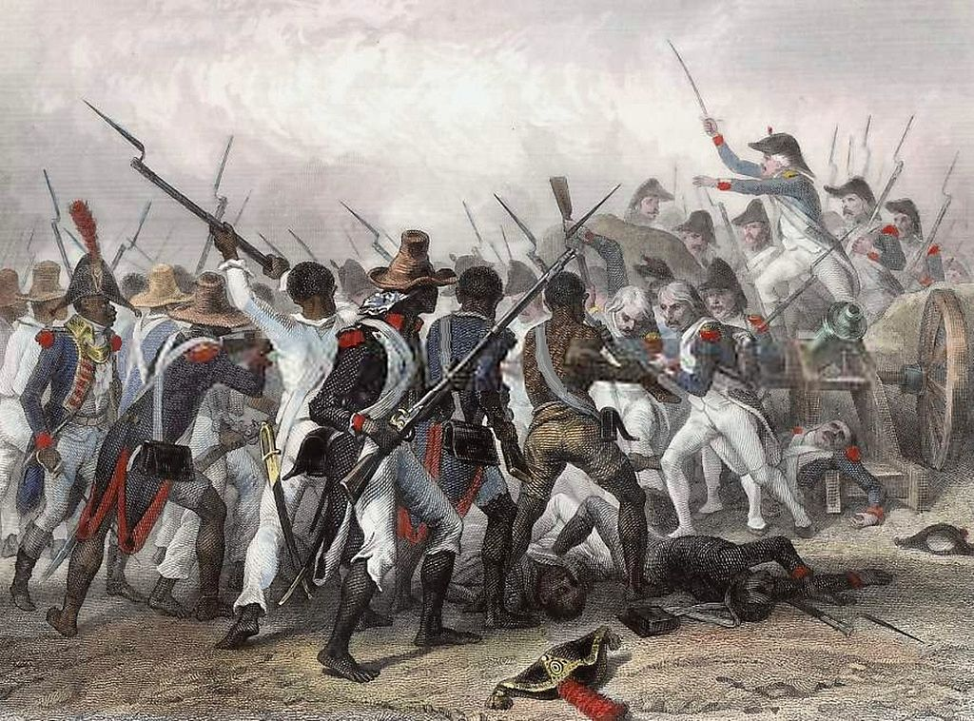
Auguste Raffet, The Battle of Crête-à-Pierrot, March 1802 (1839).
Lecture 13, Monday 11 November
Slavery and Colonialism in the Americas
Topics to include:
- European colonisation in the Caribbean
- Transatlantic slavery
- Mulatto and colonists’ demands
Readings:
- Code Noir (March 1685)
- Grievances of Free Citizens and Landowners (1789)
- Motion by Vincent Ogé the Younger to the Assembly of Colonists (1789)

Lecture 14, Tuesday 12 November
Toussaint L’Ouverture and the Black Jacobins
Topics to include:
- The Toussaint Myth
- Revolution in Saint-Domingue
- Independence
- Slavery and the Louisiana Purchase
Readings:
- Saint-Domingue Constitution of 1801
- Toussaint L’Ouverture, Memoir… Written by Himself extracts (1802)
- Declaration of the Independence of the Blacks of St. Domingo (1803)
- William Wordsworth, ‘To Toussaint L'Ouverture’ (1803)
- Marcus Rainsford on Toussaint L'Ouverture (1805)

Essay deadline Wednesday 14 November, 3pm

Lecture 15, Thursday 14 November
Historiography of the Revolution and ‘Thinking the Unthinkable’
Topics to include:
- Rethinking Hobsbawm’s Age of Revolution
- CLR James and the Haitian Revolution
- Postcolonialism
- Trouillot’s ‘Unthinkable History’
Readings:
- Michel-Rolph Trouillot, Silencing the Past: Power and the Production of History (Boston: Beacon Press, 1995), pp. 70–107.
- CLR James, The Black Jacobins (1938) extracts

Lecture 16: Friday 15 November
MOPPPING-UP SESSIONS

