Effective
Team
Working
And
Communications
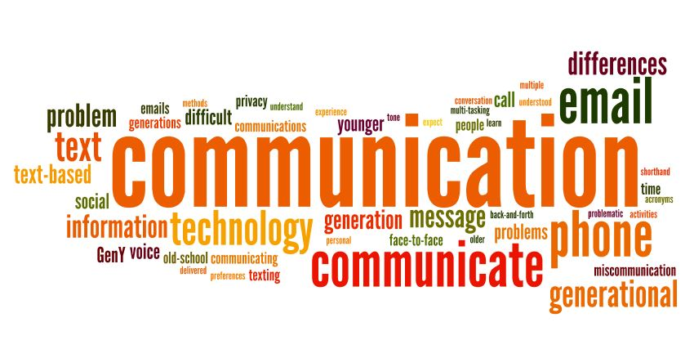
Idowu Lowo

Reference ID – 1919461
Group 4
Lecturer – Dr Saqib Shamim

INTRODUCTION:
Communication is about more than just exchanging information. It is about understanding the emotions and intentions behind the information. Having being able to relate clearly a message, one needs to also listen very attentively to understand the meaning of what is being said, and make the sender has the feeling of being heard and understood. I will explain what is communication, the two major types of communications-(verbal and non-verbal), encoding and decoding, and is impact in communication processes. The tree models and their respective theories, including what effective communication is and relate to its importance to business set up or managerial activities.

COMMUNICATION:
This is an act of imparting or exchanging of information either by speaking, or writing from one person, or group of person to another. It is the creation of thoughts, ideas, emotions, and understanding between sender(s) and receiver(s). Though, individuals, group of individuals, organizations, and even nations spend most of their time communicating, (sending or receiving information), one cannot assume that meaningful communication occurs in all exchanges. Once a memorandum letter, fax, or email has been sent, many are inclined to believe that communication has taken place. However, it does not, until facts and understanding have passed between the sender and the intended receiver. And in such a situation, we can conclude that communication is completed.

VERBAL COMMUNICATION:
This is the sharing of information through speech, words, and sound, this may include radio or television announcements, telephone conversation, speeches, and interviews. A good example of a verbal communication is saying “NO” when someone, ask you to do something you don’t want to do. Effective verbal communication involves the use of interpersonal skill. The basic factor is the clarity of voice, perception, and the listening skills of the recipient. This type of communication can be influenced by either, by eye contact, gesture, and facial expression. Also, hearing, and understanding skills of the recipient to fully understand the meaning, and thus, motivate responses accordingly. Furthermore, the choice of language and the presentation of information by the sender build the impact of communication on the recipient.

NON-VERBAL COMMUNICATION:
Spoken or written words are not the only means for message sharing. When there is no words used, and the recipient understand what the sender means, or asking, then it is known as non-verbal communication. This could be through body language, eyes contact, postures gestures, facial expression, “chromatics and Haptic”, these are another aspect of non-verbal communication-touching and use of colures. Another excellent way to represent any information through non-verbal are;- pictures, symbols, and graphs, textures, hairstyles, mood, and architectures. All these shows could represent people interest and priority or preferences. (workplacestrategies)

IMPOTANT ELEMENTS OF COMMUNICATION:
There are three basic elements necessary to conduct a communication;- the sender, a medium(platform over which information is conducted), and the recipient.
In this case, the sender is considered most involved in the whole process because, the full understanding of the information to be delivered rest on this person. On the other hand, the receiver does not at times or necessary know about the sender and the subject of information the sender intend to deliver. (

COMMUNICATION PROCESS:
Two common elements in every communication exchange are the sender and the receiver. Below diagram shows the involvement of the two elements in communication processes.

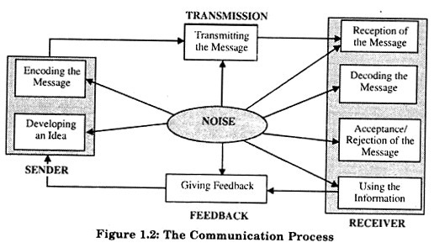

The above diagram, illustrate communication processes. The sender introduces the communication by using words and symbol to put forward information into a message for the receiver, the individual(s) receiving the message. (indeed, 2020)

ENCODING AND DECODING:
This is a process of sending message between a person and another. As shown above, the sender encodes the idea by selecting words, symbol, or gestures in composing a message. The effect of the encoding is the message which could be verbal, non-verbal, or written language. The receiver is the individual(s) to whom the message is sent, the message is now decoded into meaningful information. However, accurate decoding of the message by the receiver is critical to effective communication.
Therefore, decoding refers to the interpretation of information from the perspective of the receiver. It is when the receiver now clearly, understand the meaning of the information sent, we can then conclude that the information is successful, or concluded. (Wikipedia)

COMMUNICATION MDELS AND THEORIES:
We have three main communication models namely; Shannon Weaver, (1948), David Berlos, (1960), and Schramm, (1945) models respectively.



This model has four components; Sources-Message-Channel-Receiver. This four has determinant factors affecting each. From the illustration above, it shown that both the sender, and receiver, shares determinant factors affecting it. It is important that both the sender and the receiver demonstrate good communication skills. Such skills, like, “Attitude”. The attitude of the sender towards himself and the receiver will determine to a large extend the meaning and effectiveness of the communication. Another is communication skills; this may include reading, listening, speaking, and other related skills. Knowledge is another factor determining factor, familiarity of the sender and the receiver of the subject matters, having good knowledge helps free flow communication. Social System; values, beliefs, religion, rules, locations, and circumstances can affect communication. Cultural diversity can also influence message and its interpretations. Messages; this is the bulk of information sent by the sender to the receiver. This could be in form of speech, text, audio and video. Key factors in the message are, content of the message; (items in the message), elements, which are the gesture, signs, and the language used in the message. Treatment, this is how the message is conveyed. Structure; how the message is structured. Codes; this applies to the form in which the message is conveyed. Channel; there are different channels like; seeing, touching, hearing, smelling, and tasting.
However, disadvantages of David Berol’s SMCR model communication are as follows; there is no concept of feedback, it does not give room for noise, or any kind of barriers in communication process, It is a linear model of communication, It could be complex and difficult. There is no two way communications, and the sender and the receiver must be at the same measure to be effective. However, that rarely happens in everyday life. The main setback of the model is the absent of sixth sense, such as, thinking, understanding, analyzing etc, which is an asset to human beings as a channel of communication. (Businesstopia in communication 2018)

SHANNON WEAVER MODEL OF COMMUNICATIN (1948)


The above diagram shows the Shannon Weaver’s model of sending information from one person to another. This model is called the “mother of all models”. Social scientist use the term to refer to as an integrated model of the concept of information source, message, and feedback.
This model has six concepts; sender (information source) – the person who makes the message, chooses the channel and sends the message. Encoder (Transmitter)- Encoder is the sender who uses machine, which converts message into data. Channel- the medium used to send the message. Decoder (Receiver)- this is the machine used to translate signals into message. Receiver (Destination)- Receiver is the person who gets the message, and provides feedback according to the context. Noise- this are physical disturbances like people, environment, and other related disturbances which makes default the original message sent.
An example of Shannon Weaver model in related to a company; A director managing a company sends a message to one of his manager about a meeting happening about their brand promotion. But the manager does not receive the full message because of noise. It goes this way;
Managing Director: we have a meeting at the board room ( “10 am” goes missing due to the disruption in the conversation as a result of noise)
Manager (feedback): At what time?
Here,
Sender: Managing Director
Encoder: Telephone Network Company
Channel: Mobile network
Noise: Missing text due to disruption
Decoder: Mobile phone
Receiver: Manager
The above illustration shows transmission error, which is noise. The feedback lets the Director to know that the message reached uncompleted. The receiver has the opportunity to get the full text only after the feedback. Shannon Weaver admit the three level of communication problem as; Technical problem, Semantic, and Effectiveness problems. Advantages of this model includes- concept of noise which makes communication effective by removing problem caused by noise. This model takes communication as a two way process, and thus makes it applicable in general communication. It makes communication quantifiable. It is believe to be more effective in person-person communication than group or audience. It does not give room for noise. Feedback is not accorded more importance like message sent, and critics see this model as a misinterpretation of nature of human communication because is not estimate. (Communicationtheory, 2018)

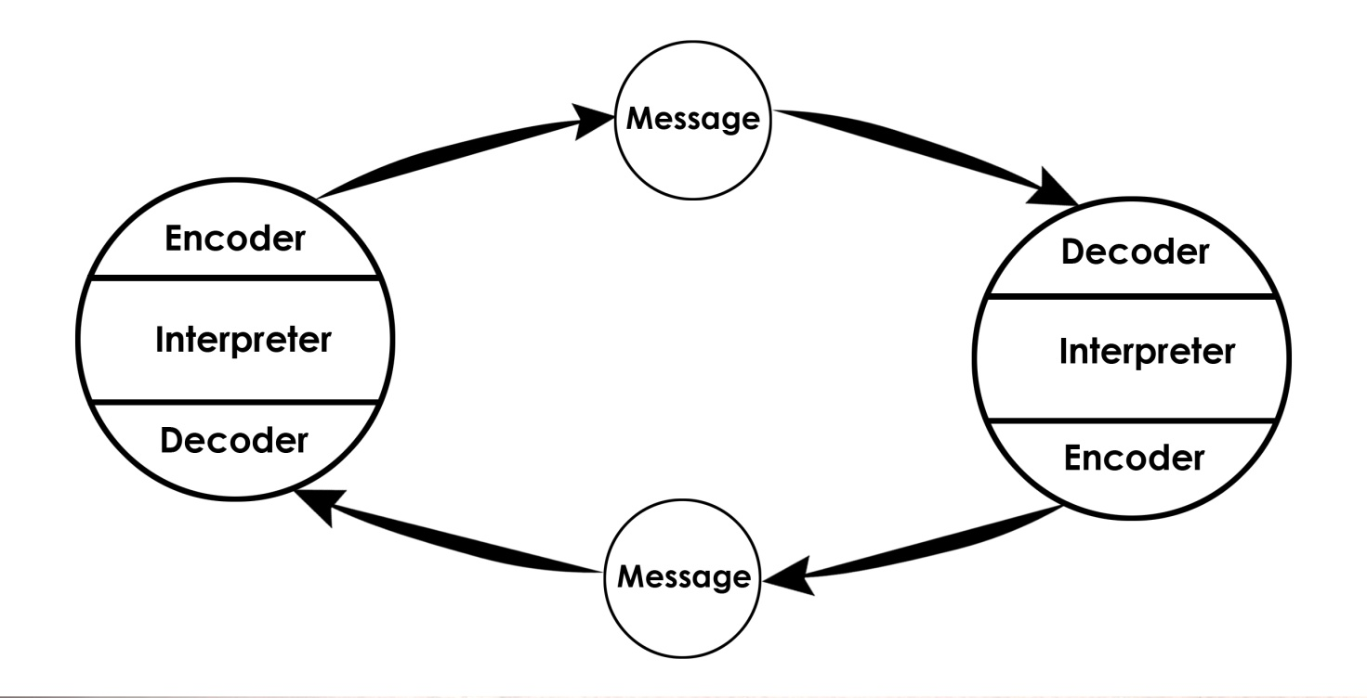
SCHRAMM MODEL OF COMMUNICATION (1945)

SCHRAMM:
The Schramm communication model is a cyclical communication model containing all the basic principles of communication, but can only be useful when the message is understood by the receiver, interpret correctly and send it back to the sender. However, the message remains uncompleted if the receiver is unable to decode the message sent. If this process is not accomplished, hence, there is a breakdown in communication. This model emphasizes on individual, and knowledge. For example, a message send to my colleague and interpreted wrongly, the respond will not has any bearing to the message, in such case, the message become in material or irrelevant. This model emphasizes the importance of a feedback in a complete communication processes.
There is a similarity between Shannon Weaver and Schramm models, which differs from Berlos model which looks more complex because it downplays the human aspect such thinking, analyzing and understanding between the sender and the receiver. It also ignores the barriers to communication like; language, culture, knowledge, and social barrier. (Ben J, 2018)

IMPORTANCE OF EFFECTIVE COMMUNICATION:
Effective communication is about more than just exchanging information. It is the about understanding the emotions and the intentions behind the information, and the ability to listen and interpret the message correctly. Through this, the sender or source of information has the feeling of being heard and understood.
Effective communication in a working environment is very important for efficiency, enhanced performances, and productivities. The employees can experience increased, morale, and commitment if they can communicate up and down the organization communication chain. It also builds trust among employees, and makes them look continuously valuable asset to the business. (Incorp.asia, 2018)

METHODS OF COMMUNICATION:
The standard method of communication are speaking or writing by sender and listening or reading the receiver. However, am going to duel on other methods aside verbal and non verbal communication, reason being that, I have dealt with the later at the initial stage of my writing. Writing,: is an important method of communication, this may include ; email, text, reports, memo. Researchers agreed that of all the four communications styles, this is the one that can lead to the most misunderstanding. Good writing skills, is needed for this type of communication. The message must be transparent and undemanding for easy understanding. I may need to send a report to my boss at work, or could officially compulsory to send an e-mail to a customer, I should be able to write it constructively, and well articulated. I may be looking for a job, and my CV is needed, in presenting it, that will give an impression of my employability. (Cliffnotes)

COMMUNICATION BETWEEN MANAGEMENT AND EMPLOYEE:
Good communication is an important factor in attaining, productivity, and continues solid working bearing at all degree in an organization. (Michael, P., 2020). Employee can encounter more morale, productivity and dedication if they can have a free flow communication within the company communication channels. (Incorp.assia 2018). Employer who cares about the effectiveness of the company communication, leaves all parties involved contented and feeling accomplished. When a message is comprehensive, there will be no room for misinterpretation or alteration of the message, which reduces the potential for conflict. (Stevenson, 2017). Better internal communication is vital between management and employee. This could be seen as formal and informal structures depending on the organization focal point. The cultural setting of the organization also set on the flow of communication in such environment. In any organization, there is always the host, and home country culture. Is the management using a formal, arranged in order of rank, with information flowing top down, or unofficial style, with information flowing bottom top. All these, depends on organization structure and location of establishment. For example, countries in Europe, Asia, America, culture in these counties allow an open minded participation with informal approach in management, where employees has the opportunity to use their ingenious and acumen . This may not be achievable in a country like China, because they tend to use the formal structure, hierarchical attitude.

“COMMUNICATION PRACTICES AT STEINER NIGERIIA LIMITED”:
MR Johnson Benet is the Managing Director of Steiner Nigeria Limited, a company dully registered in Nigeria carrying out business in daily consumables. Mr. Babatunde Joshua, a graduate of Business Administration is newly employed as the sales Manager which duties include among others, attending to clients and customers needs. Mr. Johnson, as the Managing Director holds the duty of co-coordinating all the various departments including the sales, which is one the key department in the company. Following continuous negative attitude of Mr. Joshua – (the sales manager), as claimed by one of the company clients, a complaint was formally lodged with Directors office. The Director calls the attention of the sales manager to his office to hear his side of the issue. The sales manager, proved that, to the best of his knowledge, his done nothing wrong, and tried to prove his innocence. The client was eventually called to directors office for a discussion –(verbal communication). The client who happens to comes Asia (China) contested that when ever, the sales manager is having informal meeting with all the clients, after almost every statement the sales manager will nod is head, this he claimed is a gross gesture of disrespect to his personality according to their culture. The issue was resolved, but this was attributed to a noise in the communication between the sales manager the china client. This is as a result in differences in culture which Berlos Model of communication talk about, the social system on both the source and receiver. However, after that episode, at the end of the board meeting, the Director announced a tremendous increased, sales margin and total net profit for the company chiefly due to the effective communication and team work between the Director, and the formidable sales team head by Mr. Joshua.
Therefore, for a company to have a healthy and well orchestrated business team, employers must demonstrate sound, frequent, and effective communication system that will enhance a better overall productivity of the company. This was the focus of Steiner Nigeria Limited that makes them outstanding, progressive, and sustainable company.

CONCLUSION:
I have been able to define communication, types of communication, and the elements. I also mentioned the basic communication processes, encoding, decoding, and their applications in communication system. Furthermore, I addressed the three major communication models, their benefits and impediments of each model. I have also written about the importance of effective communication in relation to work place conditions, and the effect of a free flow communication between the employer and the employee.

REFERENCES:
Ben Jeans (2019) https;wwwtoolshero.com.schramm
Ben Jeans, (2019) Schramm model of communication
Berlos SMCR model of communication
Business communication & Etiquette / importance of Business Communication
Businesstopia (2018)
Businesstopia, (2018)
https:/www.businesstopia.net/communication
Https:/www.businesstopia.net/communication/language-barrier
Htts:/www.businesstopia.net/communication/berlo-model-communication
www.cliffnotes.com
Communication in Businesstopia, 2018
https:/www.communicationtheory.org (2018)
www.indeed.com
https:/ www.incorpasia2018 importance of good communication at workplace
https;/www.incorpasia 2018. (Importance of Good communication at workplace)
Michael P., 2020 http:/www.micahelpage.co.uk
Obiyor B.C, ( 2020) the importance of communication online
Pedro nerves, Robert Eisenberger2012 management communication and employee performance: the contribution of perceived organizational support ( page 452-464) published online
Stevenson,2017. The importance of effective communications
Https:/www.toolshero.communicatiion
https;/www.toolshero.com>schram
tylertalkstruth.wordpress.comm
Wroblewski M.T, (2019)
www.wikipedia.org
www.workplacestrategiesformental.com

