Title: Component 1: Coursework - Project Plan

Module: Project Management (LCBB5005)

Programme:
BA (Hons) Business Management
Lecturer: Dr. Essa Bah

Student Name: FLORINA MADALINA GUGOI
Student ID: 2111163

Table of Contents
Introduction 3
Project Aim, Objectives, and Scope 3
Aim of the Project 3
Specific and Measurable Objectives 3
Scope of the Project 3
Detailed Project Breakdown 4
Project Outputs (Deliverables and Results) 4
Work Breakdown Structure (WBS) 4
Timeline and Milestones 5
Resource Allocation 6
Risk Management and Mitigation 6
Identification of Potential Project Risks 6
Risk Mitigation Strategies 6
Stakeholder Analysis 7
Analysis of Key Stakeholders 7
Roles and Responsibilities of Each Stakeholder 8
Project Schedule (Gantt Chart) 9
Conclusion 10
References 11

List of figures:
Figure 1: Work Breakdown Structure of the Project 5
Figure 2: Project Schedule (Gantt Chart) 9

Introduction
The selected project will aim to create and adopt a novel digital marketing plan for a partially developed mid-sized retail business. The company's key objective is to raise general awareness about its existence online and attract more people to interact with it. With the increasing weight placed on digital media in business, especially in the retail industry, firms need to implement adequate digital marketing approaches that capture the current consumer.
In the past, the company depended on actual store sales; nonetheless, because of some dynamic changes in customer buying behaviour, especially the new trend to go for e-commerce, the company now requires a more comprehensive e-commerce strategy. For this project, the importance resides in its ability to contribute to the company's competitive advantage in a highly saturated market. The importance and outcome of adopting a strategic approach is to gain new customers, increase its revenue potential and gain greater customer loyalty in the online marketing environment. This project is also the company's first significant investment in digital transformation as a critical direction of further business development.

Project Aim, Objectives, and Scope

Aim of the Project
Collectively, the main goal of this project is to create and implement a sound digital marketing plan that popularises the company online, drives traffic to the company's site and, ultimately, its business, and increases overall sales from online marketing campaigns.

Specific and Measurable Objectives
- Increase website traffic by 30% within six months of implementation.
- Grow the company’s social media following by 20% in the same period.
- Achieve a 15% increase in online sales within the first three months of execution.
- Improve customer engagement rates through personalised email marketing campaigns.

Scope of the Project
The scope of this project includes:
- The development and execution of the digital marketing strategy, focusing on SEO, social media, email marketing, and PPC campaigns.
- Performance monitoring and optimisation of digital campaigns.
- Excluded from the scope is any redesign of the company’s website or alteration of its existing product line.

Detailed Project Breakdown

Project Outputs (Deliverables and Results)
The project will yield several vital outputs that go a long way in achieving the company's overall digital marketing goals. The primary deliverables are:
- An exhaustive solution for reaching clients via the Web, tailored to the company’s audience.
- Adjustable textual, visual, and aural content of a Website that has a positive effect on its Search Engine positioning
- Constant live and public debates would enhance the brand's recognition factor and expand the customer base.
- Email marketing templates and scheduled campaigns to reach customers directly.
- Pay-per-click (PPC) campaigns targeting potential customers based on demographics and behaviour.
Anticipated Results:
- A significant increase in online traffic, engagement, and conversion rates.
- Enhanced customer retention and loyalty through personalised email campaigns.
- A measurable improvement in brand visibility across digital platforms.
Activities Required to Deliver the Outputs
Several activities are deemed crucial to realise the above-stated deliverables. These include:
- Digital Market Research: Used as a start to discover current market trends and customer behaviours.
- SEO and Content Development: Writing SEO-optimised texts for the website and social media.
- Email Marketing Setup: Creating individual email newsletters and controlling customer lists and databases.
- PPC Campaigns: Designing, launching, and managing ad campaigns.

Work Breakdown Structure (WBS)
The Work Breakdown Structure (WBS) provides a detailed breakdown of the project’s tasks into manageable units (Sequeira and Lopes, 2018). Below is a simplified structure:
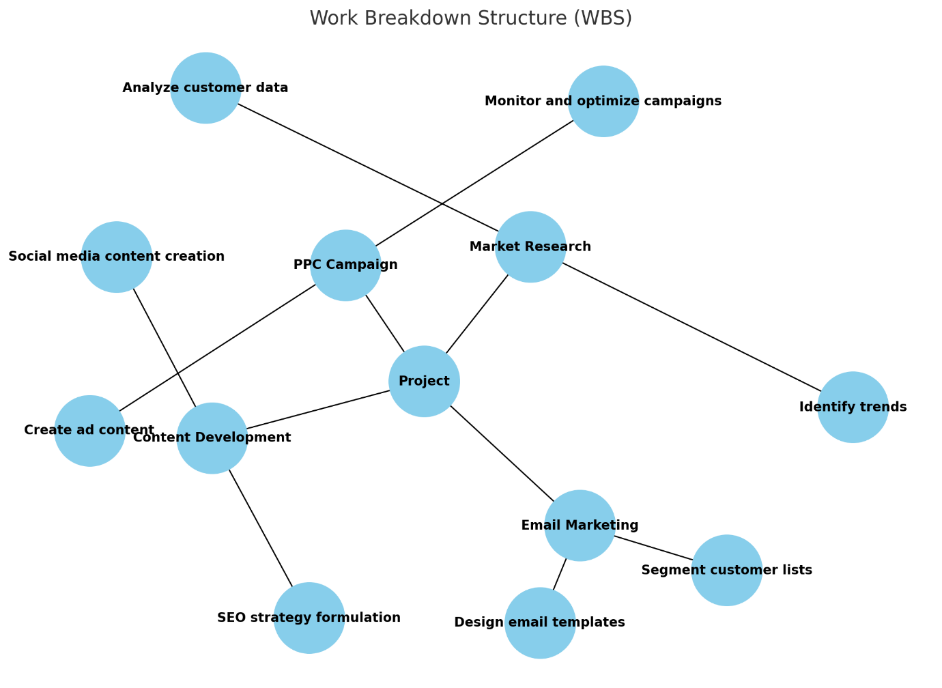
Figure 1: Work Breakdown Structure of the Project
Source: (Self-Made)
The Work Breakdown Structure (WBS) defines any project's main activities and related sub-activities. Starting right from Market Research, the overall process involves data analysis of customer data and trend predictions. Content Development includes Search Engine Optimisation and Social Media Feed posting. Email Marketing comprises the creation of templates and the categorisation of customer lists. Finally, the PPC Campaign deals with creating the ad content and overseeing the project, meaning it has a proper structure for the campaign.

Timeline and Milestones
Each task has associated milestones, ensuring timely completion:
- Week 1-2: Market research completed.
- Week 3-5: SEO content developed and implemented.
- Week 4-6: Email marketing templates created and segmented customer lists finalised.
- Week 6-7: PPC campaigns launched.

Resource Allocation
The human resources are project managers, content developers, marketers, and technical support teams. Each team member is assigned according to his specialisation. Marketing tools are considered material resources, such as Google Analytics, an SEO tool, or an email marketing list (Jadhav and Yallatti, 2018).

Risk Management and Mitigation

Identification of Potential Project Risks
In any project, there are possible threats that can result from inside and outside forces affecting the project's range, time or assets. This project faces several risks:
- Budget Overrun: PPC campaigns are one of the biggest concerns since they can lead to overspending in the allocated budget (King et al.,2015). Some costs, such as higher advertising bids or any other costs arising from any alteration to the overall campaign, may prove worth the financial plan of this project.
- Low Customer Engagement: However, even with an optimisation of the strategies used in digital marketing, the engagement of the customers may not even rise to the expected levels (Santini et al., 2020). Such failures can include poor content quality, wrong targeted audience, or even platform-related issues.
- Technical Issues: As seen above, the project relies on digital infrastructure. Logistic issues or other technical issues, such as website downtime, poor SEO, or issues with email delivery, can also slow progress and possibly hinder the project's results.
- Data Security and Privacy Concerns: Collecting and using customer data for marketing purposes involves several risks, including data losses or leakages, which would have undesirable consequences for the firm's image and even the law (Zeng et al.,2017).
- Team Coordination Challenges: Lack of compliance or communication between separate individuals or outside consultants may result in longer planning times or even problems with project execution (Reeves et al., 2017).

Risk Mitigation Strategies
To address these risks, the following mitigation strategies are proposed:
- Budget Control Measures: A precise financial control system that regulates spending is necessary, and the PPC campaign should be controlled in terms of the budget. It is preferable to control the amount spent on each campaign daily, and this can be achieved by checking campaigns' performance daily to cut down any unnecessary spending early enough (Barr and Mcclellan, 2018).
- Enhanced Customer Engagement Strategies: To counter the problem of low engagement, it is important to measure engagement and make adjustments correspondingly (Steinhoff et al.,2018). Using A/B for campaigns, one can identify which strategies are more effective for the targeted clients. The A/B test is one of the best ways to enhance the marketing investment return (Kohavi and Longbotham, 2017).
- Technical Support and Backup Plans: This way, the absence of a technical problem’s solution due to a lack of adequate IT expertise will be avoided because a dedicated IT team should be available throughout the project. Also, reliable system cheques and systematic data backups can help avoid or solve all kinds of technological hitches.
- Data Protection Protocols: Low risks of data breaches can be achieved by ensuring compliance with data privacy regulations, such as the General Data Protection Regulation (GDPR) or the use of secure data handling systems (Lee and Ahmed, 2021). Training employees on best practices can also improve the level of protection.
- Effective Communication: Also, constant team meetings, transparent communication, and a system (such as Asana Trello) that keeps the main stakeholders aware of the current development and deadlines in the project can contribute to the success of the project at each phase (Kamila and Marzuq, 2024).

Stakeholder Analysis

Analysis of Key Stakeholders
The stakeholders in a project should include many people within different organisations and institutions to ensure that a project is successful. In this project, key stakeholders include:
- Company Leadership: The primary stakeholders involved with the project’s task are the senior managers, who are responsible for top management and resource approval. They are mainly supposed to give directions on how the project should be implemented and ensure that it implements the company's long-term vision (Davis, 2017).
- Marketing Team: The marketing communications team is part of the organisation’s internal resources that are 'on the frontline' in implementing the digital marketing strategy (Stegman, 2020). They are involved in the production of content, social media accounts, and overall campaign administration.
- IT Department: The IT department constantly runs cheques on virtually all a business's technical features, including but not limited to the business website, email marketing platforms, and any other digital tools employed (Mithas and Rust, 2016). They are also solely responsible for handling the data security aspect of the business as well as any technical problems that occur.
- External Consultants: The expansive structure requires the hiring of specialised consultants, particularly for PPC and SEO, since they bring in outside knowledge and expertise. The candidates' experience makes it possible to follow industry standards and achieve the intended project outcomes.
- Customers: Customers are the last category of stakeholders who will also be represented as indirect clients, given that their actions will define the effectiveness of the chosen digital marketing tactics. The goals surrounding the project's operation are all focused on acquiring and interacting with this population base.
- Data Protection Officers (DPO): Due to its marketing's strong focus on customer data, the company needs to guarantee that all data processing and collection operations adhere to specific legal requirements or GDPR (Recio, 2017). This is their responsibility as they are responsible for reducing risks to data privacy.

Roles and Responsibilities of Each Stakeholder
- Company Leadership: Leadership also lies with the organisation's higher authorities in terms of decision-making, for instance, the budgeting process. They make sure that the goals of a specific project are harmonised with the firm's strategic goals (Freeman and Dmytriyev, 2017). That is also why they monitor progress and take action when important decisions require their attention.
- Marketing Team: The marketing team is supposed to implement all the activities embedded in the project plan while undertaking the project. This comprises writing SEO-friendly articles, running social media pages, and sending emails. They are also involved in evaluating the campaigns and finding out how to enhance the rates and degree of resulting engagement.
- IT Department: Safeguarding the infrastructure that the IT department provides is the responsibility of ensuring that the digital marketing strategy works effectively. This involves making sure that the company's website is performing properly, that email is working properly, and that data is safeguarded.
- External Consultants: Consultants specialise in PPC, SEO, analysis, and many other areas. They are expected to direct the marketing personnel well on how to fine-tune their marketing initiatives to get the most out of them. Their responsibilities entail guiding the campaigns by providing best practices, analysing the campaign data, and modifying them depending on performance information (Bianchi et al., 2015).
- Customers: However, customers will not be directly involved in the project's implementation, although their engagement with the company's various digitised marketing operational strategies will greatly contribute to its effectiveness. This shows how the marketing team will use analytics to determine the engagement pattern and increase or decrease the marketing approach accordingly.
- Data Protection Officers (DPO): In the specified context, the DPO is mainly responsible for complying with data protection laws, especially in connection with the processing of customer data for marketing purposes. They must review data collection processes, offer recommendations on GDPR compliance where necessary, and contain any risks associated with data.

Project Schedule (Gantt Chart)
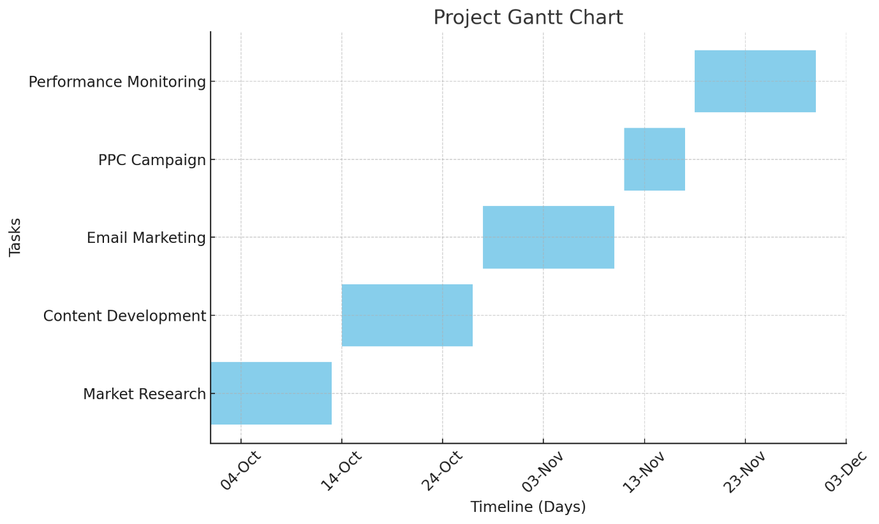
Figure 2: Project Schedule (Gantt Chart)
Source: (Self-Made)
The above chart represents the Gantt chart of the project, where the different titles show the various tasks and the duration of each task. The project starts with Market Research, scheduled from October 1 to October 13, 2024. Content Development follows, taking place from October 14 to October 27. After that, the Email Marketing task will run from October 28 to November 10. The PPC Campaign is scheduled between November 11 and November 17. Finally, the Performance Monitoring phase, which runs from November 18 to November 30, involves ongoing evaluation and adjustments.
Every task has a Timeline, which allows the project to move from one phase of development to another without interruption. The Gantt chart helps the project manager understand the project's time management plan and monitor project time.
This specific format ensures that the overall project does not derail since the stakeholders can review schedules and resources at a determined time.

Conclusion
Therefore, this project plan defines how the overhauling digital marketing strategy will be adopted to increase the company's online visibility, customer relations, and broad sales. The project's organisational structure relies on clear objectives and goals during each stage, starting with market research, content creation, email marketing, and PPC ads. These tasks are properly planned, and the phases are well coordinated for good sequencing and timing. This scholarship holds that applying project management techniques, namely WBS and a Gantt chart, is instrumental in determining the project's success. The WBS is used to segment work tasks that seem large and complicated so that they can be easily managed. At the same time, the Gantt chart is preferred due to its ability to present the project timeline so that anyone managing the project can quickly assess when specific work has been done and needs to be done. In addition, contingency measures have also been provided in the plan in case of risks, such as a higher budget or technical complications affecting the project's standing. Having the key stakeholders, from the managerial level of the company to the shareholders and external consultants, involved in the process guarantees the alignment of the project with the company's goals. In conclusion, through the practical use of these two structured project management approaches, the company can conduct an efficient digital marketing campaign to help it compete well into the future in an ever-growing online marketplace.
.

References
Barr, M. J. and Mcclellan, G. S. (2018) Budgets and financial management in higher education. San Francisco, Ca: Jossey-Bass, A Wiley Brand.
Bianchi, M. et al. (2015) 'Organising for Inbound Open Innovation: How External Consultants and a Dedicated R&D Unit Influence Product Innovation Performance', Journal of Product Innovation Management, 33(4), pp. 492–510. doi: https://doi.org/10.1111/jpim.12302.
Davis, K. (2017) ‘An empirical investigation into different stakeholder groups perception of project success’, International Journal of Project Management, 35(4), pp. 604–617.
Freeman, R. E. and Dmytriyev, S. (2017) ‘Corporate Social Responsibility and Stakeholder Theory: Learning from Each Other’, Corporate Social Responsibility and Stakeholder Theory: Learning from Each Other, 1(1).
Jadhav, Mrs. V. S. and Yallatti, Dr. R. M. (2018) 'A Critical Study on Digital Marketing concerning Different Components of Digital Marketing', International Journal of Trend in Scientific Research and Development, Special Issue(Special Issue-ICDEBI2018), pp. 231–233. doi: https://doi.org/10.31142/ijtsrd18711.
Kamila, J. S. and Marzuq, M. F. (2024) ‘Asana and Trello: A Comparative Assessment of Project Management Capabilities’, JOIV: International Journal on Informatics Visualization, 8(1), pp. 207–212. doi: https://doi.org/10.62527/joiv.8.1.2595.
King, M. A., Abrahams, A. S. and Ragsdale, C. T. (2015) ‘Ensemble learning methods for pay-per-click campaign management’, Expert Systems with Applications, 42(10), pp. 4818–4829. doi: https://doi.org/10.1016/j.eswa.2015.01.047.
Kohavi, R. and Longbotham, R. (2017) ‘Online Controlled Experiments and A/B Testing’, Encyclopedia of Machine Learning and Data Mining, pp. 922–929. doi https://doi.org/10.1007/978-1-4899-7687-1_891.
Lee, C. and Ahmed, G. (2021) ‘Improving IoT Privacy, Data Protection and Security Concerns’, International Journal of Technology, Innovation and Management (IJTIM), 1(1), pp. 18–33. doi: https://doi.org/10.54489/ijtim.v1i1.12.
Mithas, S. and Rust, R. T. (2016) ‘How Information Technology Strategy and Investments Influence Firm Performance: Conjecture and Empirical Evidence’, MIS Quarterly, 40(1), pp. 223–245. doi: https://doi.org/10.25300/misq/2016/40.1.10.
Recio, M. (2017) ‘Practitioner’s Corner ∙ Data Protection Officer: The Key Figure to Ensure Data Protection and Accountability’, European Data Protection Law Review, 3(1), pp. 114–118. doi: https://doi.org/10.21552/edpl/2017/1/18.
Reeves, S., Xyrichis, A. and Zwarenstein, M. (2017) ‘Teamwork, collaboration, coordination, and networking: Why we need to distinguish between different types of interprofessional practice’, Journal of Interprofessional Care, 32(1), pp. 1–3. doi https://doi.org/10.1080/13561820.2017.1400150.
Santini, F. de O. et al. (2020) ‘Customer Engagement in Social media: a Framework and meta-analysis’, Journal of the Academy of Marketing Science, 48(6), pp. 1211–1228. doi: https://doi.org/10.1007/s11747-020-00731-5.
Sequeira, S. and Lopes, E. (2018) ‘Simple method proposal for cost estimation from work breakdown structure’, Procedia Computer Science, 64(1), pp. 537–544. doi: https://doi.org/10.1016/j.procs.2015.08.559.
Stegman, J. D. (2020) ‘The Importance of Managerial Communication’, The Bulletin of the Association for Business Communication, 51(3), pp. 25–26. doi: https://doi.org/10.1177/108056998805100310.
Steinhoff, L., Witte, C. and Eggert, A. (2018) ‘Mixed Effects of Company-Initiated Customer Engagement on Customer Loyalty: The Contingency Role of Service Category Involvement’, Journal of Service Management Research, 2(2), pp. 22–35. doi: https://doi.org/10.15358/2511-8676-2018-2-22.
Zeng, E., Mare, S. and Roesner, F. (2017) ‘End User Security and Privacy Concerns with Smart Homes’, Symposium On Usable Privacy and Security, pp. 65–80.

