Introduction
This essay will assess whether the UK Soft Drinks Industry Levy (SDIL) is an effective economical solution to reduce sugar consumption and decrease negative externality costs. Additionally, it will be assessed whether negative advertising campaigns have been effective in promoting healthier substitutes.
Sugar-sweetened beverages have been associated with significant health issues, including obesity, Type 2 diabetes and tooth decay and this incidence has been increasing at an alarming rate. For example, the global prevalence of obesity has tripled since 1975 (World Health Organisation , 2017) and the global incidence of diabetes has almost quadrupled since 1980, with 90% being Type 2 diabetes (Gov.UK, Health matters: preventing Type 2 Diabetes, 2018).
An analysis of the UK soft drinks industry will be conducted by examining the reason for market failure and negative externalities. This will be achieved through the use of hypothetical diagrams as well as evidencing the actual costs of these diseases.

The Failure of the UK Soft Drinks Industry before the Sugar Tax
Prior to 2018 there were no regulations in the UK regarding the quantity of sugar contained in beverages and this provided the soft drinks industry with the freedom to formulate beverages based on their own recipes and standards. However, sugar-sweetened beverages have been recognised as a negative internality on an individual’s health as well as a significant negative externality on society, particularly the National Health Service and tax payer (The World Bank Group , 2020).
Research frequently associates the excessive consumption of sugar-sweetened beverages with obesity and Type 2 diabetes (Diabetes UK, 2015). For example, in 2017 27% of adults and 20% of children aged between 10 and 11 were obese in England and the annual cost to the NHS was estimated to have reached £5.1 billion. The cost of obesity to the wider society was estimated to be £27 billion (Beech, et al 2020). Additionally, in 2017 there were 3.1 million people in England diagnosed with diabetes and 90% of these were Type 2 diabetes (Diabetes UK, 2017). Gov.UK (2018) reported that 9% of the NHS budget was used for treatments to people with Type 2 diabetes in 2017, which amounted to £8.8 billion and of which 80% of these direct costs were related to complications of Type 2 diabetes. There are also major indirect costs, such as the loss of productivity due to increased death and illness and the need for informal care. It has been suggested that if current lifestyle behaviours persist then one in three people will be obese and one in ten people will have Type 2 diabetes by 2034 in the UK (reference).
Sugary soft drinks were also identified as contributing to tooth decay, especially in young children. According to Public Health England a child has a decayed tooth extracted in hospital every ten minutes and the cost to the NHS amounts to £3.4 billion each year.
https://www.theguardian.com/society/2018/apr/06/childrens-teeth-rotting-in-their-mouths-because-of-sugary-foods-say-experts
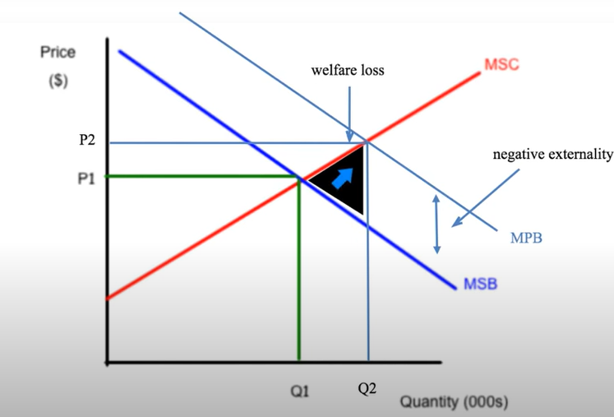
The negative externality costs that have occurred from the over consumption of sugary-sweetened beverages which have adversely affected third parties is summarised in figure 1. The marginal social benefits are less than the marginal private benefits. However, before the implementation of the sugar tax there was a free market which allowed consumers to maximise their private benefit and consume sugar-sweetened beverages where the marginal social costs met the marginal private benefits which are represented at the market equilibrium of P2, Q2 (see fig 1). Consumers were over consuming sugar-sweetened beverages, instead of consuming at a social optimal point of P1, Q1. Due to over consumption and negative externality costs the government was required to legislate in an attempt to reduce the welfare loss created

(Fig 1) (Cartwright,2015)

In summary the UK soft drinks industry was failing prior to the Governments introduction of taxation.

Methods to Improve Market Failure
As previously identified, the excessive consumption of sugar-sweetened beverages led to negative externality costs with the costs not being reflected in the prices charged. Methods to improve market failure and externalities vary depending on the industry, product and country. Negative externalities can be resolved through the use of regulations, taxes or property rights (reference). A negative externality of consumption exists when the private benefits to a consumer of a product are greater than the social benefits of its consumption. Therefore, there are spill-over costs resulting from over consumption which effect a third party outside of the market (Welker,2011).
Indirect taxes are considered as an effective instrument available to Governments to rectify market failure and in this case reduce significant consumption of sugar-sweetened beverages and enhance social welfare (Allcott, et al 2019). Advertising campaigns are another important solution to encourage consumers to change consumption habits. Both of these solutions will be discussed in further detail and how they were utilised by the UK Government to improve market failure.

Solution One: Indirect Tax
The UK Government introduced the SDIL, also known as the sugar tax, in 2018 to rectify the negative externalities being imposed through consumption. The Sugar Tax was originally created in association with the Governments childhood obesity plan, however, it also aims to decrease overall obesity rates, Type 2 diabetes and tooth decay (Thornton,2018).
The UK sugar tax is categorised as a specific excise tax which is based on the sugar content of beverages (Obesity Evidence Hub, 2020). The sugar tax requires manufactures and importers to pay a charge of 24p per litre for beverages over 8 grams of sugar per 100 ML, 18p per litre for beverages with 5-8 grams of sugar and no charge for products with less than 5 grams of sugar (Scarborough, et al., 2020). This is an example of a market-based instrument, specifically a price-based method, which is viewed as an incentive approach to encourage reduction. An alternative approach is the command-and-control instrument which enforces regulations, however, this can be viewed as inflexible for manufacturers (reference).
The Sugar Levy was designed as an incentive to encourage companies to reformulate their sugar-sweetened beverages to reduce sugar content, however, if this was not achieved then the manufacturers could decide whether to pass on the cost to consumers (Thornton,2018).
Figure 2 hypothetically demonstrates the effect of the sugar tax on a producer. It can be identified that the demand is relatively price elastic, therefore, a minor change in the price of a product could potentially lead to a significant fall in consumption and the majority of the tax would be paid by the supplier. However, in most instances the manufacturers pass on the tax to consumers in the form of higher prices which has been demonstrated in the UK.
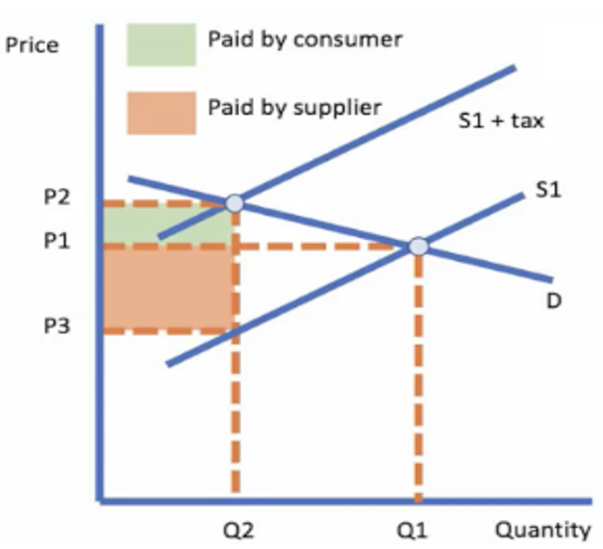
(Fig 2) (Riley,2018)
The UK Sugar Levy was created as a pricing mechanism to influence consumer behaviour at the point of purchase. For example, the tax aims to reduce the consumption of sugar-sweetened beverages from Q2 to Q1 (see fig 3). Consequently, the sugar tax increases costs to producers and as a result there is an upward shift in the marginal cost curve which potentially moves the quantity consumed in the marketplace back to Q1. This is associated with the Law of Demand which states that a rise in price is combined with a fall in quantity demanded as it is expected that consumers view price as a barrier that reduces consumption (Callan, et al 2013). If this is achieved, then the deadweight welfare loss triangle would be reduced and the socially efficient level of output at Q1 will be achieved. The welfare loss triangle represents the total social costs exceeding social benefits.
https://www.youtube.com/watch?v=1M31QATY-7M

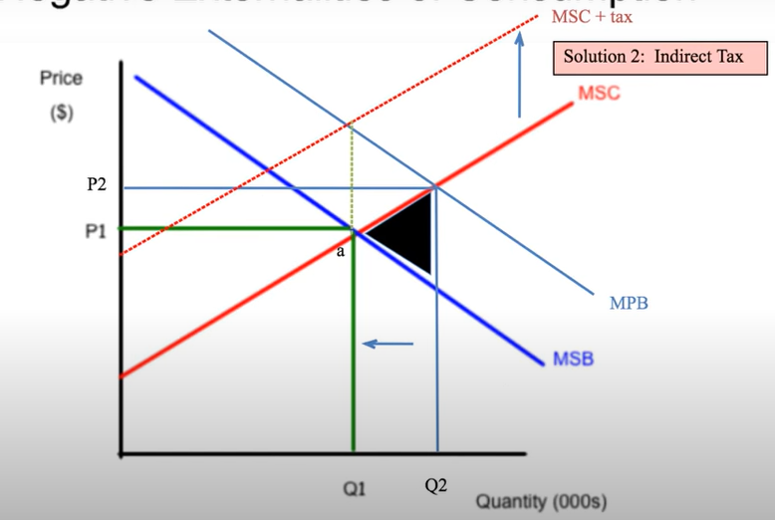
(Fig 3) (Cartwright,2015)

The sugar tax impacts consumers as they are required to pay an increased price, however, the additional cost provides revenue for the Government which is then used to fund advertising campaigns and primary school health and wellbeing programmes (Stewart,2016).

Solution Two: Negative Advertising Campaigns
The UK Sugar Levy is also used to discourage excessive consumption of sugar-sweetened beverages by highlighting the detrimental health impacts using negative advertising campaigns. This solution is also referred to as ‘the signalling effect’ of a tax and is considered one of the most effective contributions (Sassi,2016). ‘Change4Life Smart Swaps’ is an example of a negative advertising intervention that was used to encourage families to switch to healthier, low calorie beverages (Halliday,2014). Digital marketing campaign activities included issuing an e-newsletter to over one million families as well as promoting healthier beverage substitutes through social media pages and across the NHS Choices website (Public Health England, 2015).
Figure 4 identifies that educating consumers about the risks of sugar-sweetened beverages could potentially shift the marginal private benefit curve downwards which would allow the socially optimal point of A to be achieved. Achieving the price equilibrium point of A would allow the quantity of sugar-sweetened beverages consumed which in turn would allow some welfare cost to be eliminated.
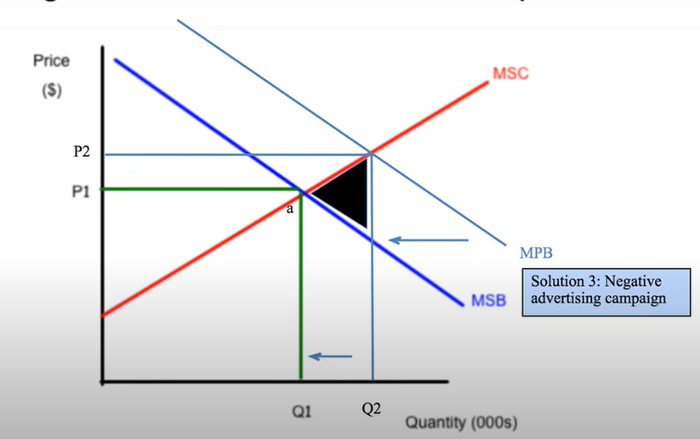
(Fig 4) (Cartwright,2015)

Negative advertising campaigns are associated with the ‘fear appeal’ strategy which aims to alert and influence consumer behaviour and to encourage consumers to purchase a particular product (Williams,2012). There was a decline in the sales of sugar-sweetened beverages by more than 8% during this campaign period compared to the previous year (Public Health England, 2015). Negative advertising campaigns are considered to be effective, however, there is currently limited evaluation available to suggest whether health related benefits have been realised (The World Bank Group, 2020).

The Sugar Levy raised £153.8 million in revenue in the first six months after implementation (Jenrick,2018). The revenue has been used to fund a variety of programmes which included Primary Sports Premium and Healthy Pupils Capital. These initiatives allow primary school pupils to be educated about the importance of health and wellbeing as well as providing sports equipment, facilities and healthy school breakfast clubs. These initiatives include Primary Sports Premium and Healthy Pupils Capital (Gov.UK,2018). The amount raised in taxation was far below the predicted £500 million largely due to the reformulation of products (Henderson,2018).

Market Performance in the UK Soft Drinks Industry after the Implementation of the Sugar Tax
This section will assess whether the soft drinks industry responded positively to the implementation of the sugar tax and whether overall health-related issues associated with sugar-sweetened beverages decreased. Additional solutions will be recommended to decrease consumption and negative externality costs.

Evidence reveals that the UK soft drinks industry responded positively to the sugar tax with overall sugar content being reduced, products being reformulated and substitute products being created (National Institute for Health, 2020). For example, eight out of the ten largest beverage manufactures, including Coca-Cola and Britvic, had reduced the sugar content of their drinks by at least 15% (Bawden, 2020). Additionally, only 8.4% of soft drinks in the UK are currently exposed to the Sugar Levy (Graham, 2018).
Sugary drinks have taxes on them so less people want them so supply would go downon diagram A.
The sugar tax increased the cost to the producers, therefore the supply of sugar-sweetened beverages decreased and caused the supply to shift left as shown in A. However, on the other hand, the demand for substitute beverages increased because the price of sugar-sweetened beverages was more expensive which resulted in the supply curve shifting to the right as shown in B (see fig 5). watch video.
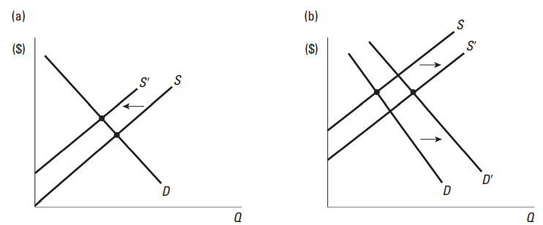
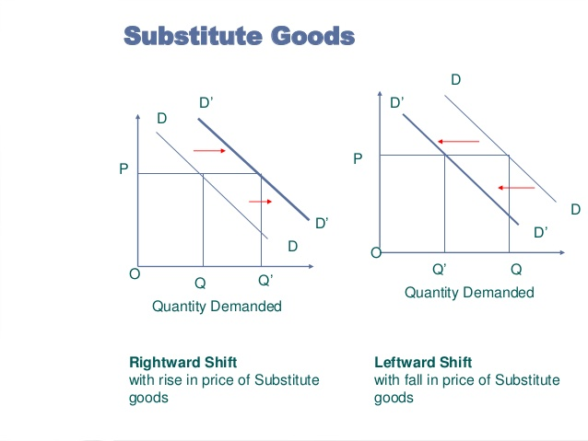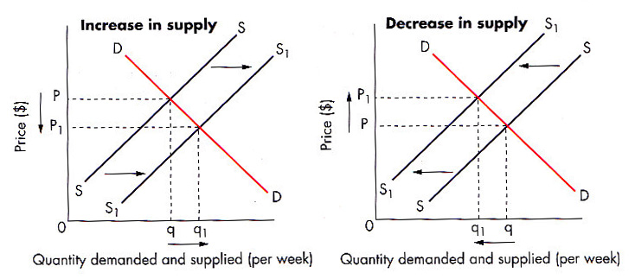

(Fig 5) (Callan, et al 2013).

Evidence revealed that a ‘historic change’ in sales of soft beverages took place after the sugar tax was enforced (Winkler, 2019). For example, substitute beverages rose by 40% and the total volume of sugar-sweetened beverages was cut in half (Ralph, 2021). However, the significant decrease in consumption did not have a lasting effect. For example, figure 6 reveals the performance of sugar-sweetened beverages in comparison to healthier substitute beverages in licensed premises in the UK. During 2018 beverages effected by the sugar tax more than doubled the sales of alternative drinks at £1.85 billion (Conway,2020).
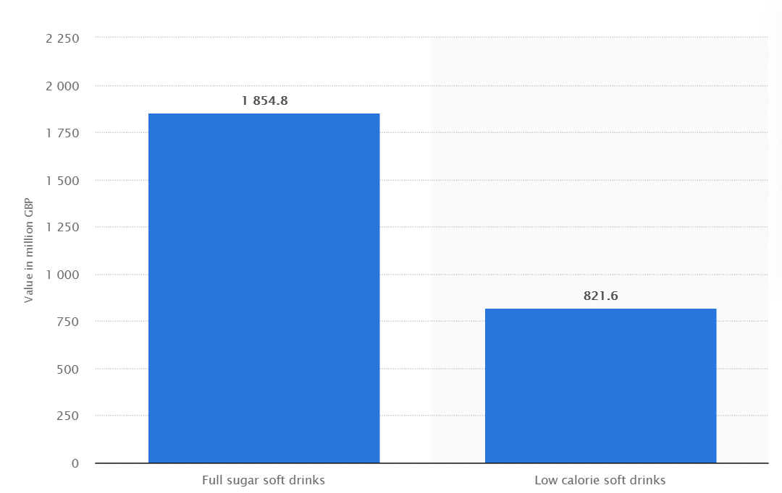
(Fig 6) (Conway,2020).

In 2019, it was found that 28% of adults and 21% of children aged between 10 and 11 were categorised as obese in England. Both of these statistics were a 1% increase compared to 2017 (Baker, 2021). According to Boseley (2018) the sugar tax will not resolve childhood obesity or tooth decay issues and it is considered that parents have a responsibility to change sugar consumption habits.
The financial costs of obesity are inherently uncertain, however, it is estimated that costs to the NHS will reach £8.5 billion by 2025 (Baker,2021) and £9.7 billion by 2050 if existing consumption trends continue (House of Commons Library, 2017). These statistics only reflect costs to the NHS and do not account for wider economic consequences for society.
According to Diabetes UK (2019) 3.3 million people in England were diagnosed with diabetes and 90% of these were Type 2 diabetes. This is a 200,000 increase compared to 2017. In 2019 it was highlighted that treatments for diabetes accounted for 10% of the overall NHS budget which is a 1% increase compared to 2017. Half of the costs spent on Type 2 diabetes can be rectified as they are considered as excess expenditure which is based on ineffective self-management and consumption habits (Pym,2019).

Need to mention tooth decay

These statistics identify that there is a need for further government intervention to reduce the increasing statistics related to obesity, Type 2 diabetes and tooth decay. It is argued that a single policy will not significantly reduce the consumption of sugar-sweetened beverages and other interventions need to be considered (Riley,2018). However, it could be argued that the UK sugar tax was only implemented in 2018, therefore there is not enough evidence to determine whether the tax has been effective (MacGuill,2017). The World Bank Group (2020) states that well-designed sugar taxes have the ability to contribute to considerable advancements in reducing health related issues including obesity, Type 2 diabetes and tooth decay, but only if the tax rates are set sufficiently high.
Figure 7 identifies that there are approximately 50 sugar-sweetened beverage taxes globally (Cawley, et al 2019). Norway has had a sugar-sweetened beverage tax since 1981, however, in 2017 the country decided to increase the tax by 40% from 3.34 NOK (0.35 EUR) per litre to 4.75 NOK (0.49 EUR) per litre (Ovrebo, et al 2020). The highest charge for the UK sugar tax is 24p.
At the end of 2017, only 14% of adults were classified as obese compared to 20% in 2008 (World Obesity Federation, 2017). Additionally, only one in six children were classified as overweight compared to one in three children in the UK (Harris, 2018).
Evidently an increased tax rate is having an effect on rectifying negative health-related issues, however, someone argues that the tax has led to the industry becoming less competitive and that the higher price is significantly contributing to a decline in sales and revenue.
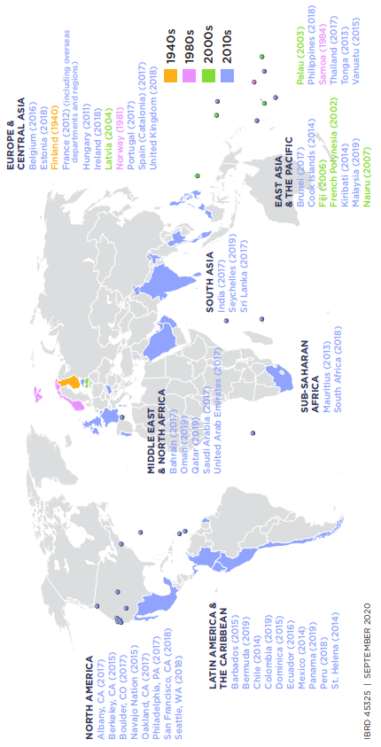
(Fig 7) (Cawley, et al 2019).

Recommendations
Currently the sugar tax charges manufacturers based on the sugar content contained in beverages and this charge is passed on to the consumer. However, Tamir et al (2018) recommends that organisations use subsidies as a solution to discourage the consumption of sugar-sweetened beverages and to increase the consumption of healthier substitutes through increasing accessibility, variety and affordability. Therefore, subsidies can provide incentives for manufactures as well as consumers as the price differential between beverages will potentially cause an increase in quantity demand for healthier alternatives and decrease health care costs. For example, figure 8 highlights that subsidies can reduce costs of production which causes the supply to increase from S1 to S1+Sub. As a result of this, price decreases from P1 to P2 and quantity increases from Q1 to Q2.
Although the intention of a subsidy is to reduce the price for consumers, the producers also keep some of the subsidy. Therefore, subsides can be viewed as a negative development as manufacturers can potentially take advantage of the incentive (reference).

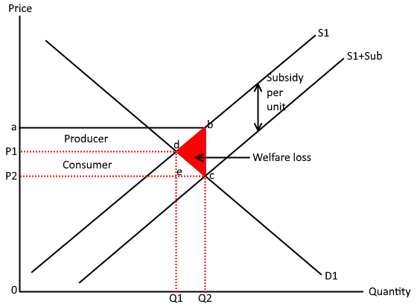
(Fig 8)
https://edexceleconomicsrevision.com/home/theme-1-introduction-to-markets-and-market-faliure/indirect-taxes-and-subsidies/

Conclusion
Evidence revealed that the UK soft drinks industry was failing prior to the implementation of the Sugar Levy as highlighted through the negative externality costs including obesity, Type 2 diabetes and tooth decay.
However,
Subsidies have been recognised as a potential solution to further encourage manufacturers to provide additional low sugar beverages and to decrease prices.

Bibliography
Allcott, H., Lockwood, B., & Taubinsky, D. (2019). SHOULD WE TAX SUGAR-SWEETENED BEVERAGES? AN OVERVIEW OF THEORY AND EVIDENCE. Cambridge: National Bureau of Economic Research.
Baker, C. (2021, January 11). Obesity Statistics. Retrieved from House of Commons Library: https://commonslibrary.parliament.uk/research-briefings/sn03336/
Bawden, T. (2020, January 13). Sugar tax drives sharp decrease in sweetness of soft drinks as charities call for milkshakes to be included. Retrieved from INews: https://inews.co.uk/news/health/sugar-tax-working-milkshakes-soft-drinks-food-industry-384829
Beech, J., Cooper, E., Holmes, J., & McKenna, H. (2020, March). What role do taxes and regulation play in promoting better health? Retrieved from The Kings Fund: https://www.kingsfund.org.uk/sites/default/files/2020-03/tax-regulation-briefing-2020.pdf
Boseley, S. (2018, April 06). Children's teeth rotting in their mouths because of sugary foods, say experts. Retrieved from The Guardian: https://www.theguardian.com/society/2018/apr/06/childrens-teeth-rotting-in-their-mouths-because-of-sugary-foods-say-experts
Callan, S., & Thomas, J. (2013). Environmental Economics and Management: Theory, Policy, and Applications. America : South-Western, Cengage Learning. .
Cartwright, B. (2015, December 31). Negative Externality of Consumption Diagram & Solutions | Market Failure Diagram | IB Microeconomics. Retrieved from YouTube: https://www.youtube.com/watch?v=DSmFdkEWb2s
Cawley, J., Thow, A.-M., Wen, K., & Frisvold, D. (2019). The Economics of Taxes on Sugar-Sweetened Beverages: A Review of the Effects on Prices, Sales, Cross-Border Shopping, and Consumption. Annual Review of Nutrition , 317-338.
Conway, J. (2020, November 26). Full sugar versus low calorie drinks sales in food service in the United Kingdom 2018. Retrieved from Statista: https://www.statista.com/statistics/712218/full-sugar-versus-low-calorie-soft-drink-sales-in-food-service-in-the-united-kingdom-uk/
Diabetes UK. (2015, July 22). new research linking sugary drinks with type 2 diabetes. Retrieved from Diabetes UK: https://www.diabetes.org.uk/about_us/news/diabetes-uk-responds-to-new-research-linking-sugary-drinks-with-type-2-diabetes-
Diabetes UK. (2017). Diabetes prevalence 2017 (november 2017). Retrieved from Diabetes UK: https://www.diabetes.org.uk/professionals/position-statements-reports/statistics/diabetes-prevalence-2017
Diabetes UK. (2019). Diabetes Prevalence 2019. Retrieved from Diabetes UK: https://www.diabetes.org.uk/professionals/position-statements-reports/statistics/diabetes-prevalence-2019
Gov.UK. (2018, May 24). Health matters: preventing Type 2 Diabetes. Retrieved from Gov.UK: https://www.gov.uk/government/publications/health-matters-preventing-type-2-diabetes/health-matters-preventing-type-2-diabetes
Gov.UK. (2018, April 05). Soft Drinks Industry Levy comes into effect. Retrieved from Gov.UK: https://www.gov.uk/government/news/soft-drinks-industry-levy-comes-into-effect
Graham, P. (2018). Convenience and Impulse. Retrieved from Britvic : https://www.britvic.com/~/media/Files/B/Britvic-V3/documents/pdf/sdr-convenience-and-impulse-cover-2018-v1.pdf
Halliday, J. (2014, January 02). Soft drinks targeted by new government health campaign. Retrieved from The Guardian: https://www.theguardian.com/lifeandstyle/2014/jan/02/soft-drinks-targeted-health-campaign
Harris, B. (2018, March 14). Will a sugar tax help reduce obesity? Retrieved from World Economic Forum: https://www.weforum.org/agenda/2018/03/will-a-sugar-tax-help-reduce-obesity/
Henderson, T. (2018, May 04). The Soft Drinks Industry Levy – What Will It Change? Retrieved from Family Money: https://www.familymoney.co.uk/uk-tax/soft-drinks-industry-levy/
House of Commons Library. (2017, June 26). Obesity: a public health crisis? Retrieved from House of Commons Library: https://commonslibrary.parliament.uk/obesity-a-public-health-crisis/
Jenrick, R. (2018, November 20). Sugar tax revenue helps tackle childhood obesity. Retrieved from Gov.UK: https://www.gov.uk/government/news/sugar-tax-revenue-helps-tackle-childhood-obesity
MacGuill, D. (2017, October 10). FactCheck: Do taxes on sugary drinks actually work? Retrieved from TheJournal.ie: https://www.thejournal.ie/sugar-soft-drinks-tax-does-it-work-health-benefits-facts-2918363-Oct2017/
National Institute for Health. (2020, February 25). Sugar tax had no lasting negative impacts on the UK soft drinks industry. Retrieved from National Institute for Health: https://www.nihr.ac.uk/news/sugar-tax-had-no-lasting-negative-impacts-on-the-uk-soft-drinks-industry/24156
Obesity Evidence Hub. (2020, February 11). Countries that have implemented taxes on sugar-sweetened beverages (SSBs). Retrieved from Obesity Evidence Hub: https://www.obesityevidencehub.org.au/collections/prevention/countries-that-have-implemented-taxes-on-sugar-sweetened-beverages-ssbs
Ovrebo, B., Halkjelsvik, T., Meisfjord, J., & Bere, E. (2020). The effects of an abrupt increase in taxes on candy and soda in Norway: an observational study of retail sales. International Journal of Behavioral Nutrition and Physical Activity, 1-9.
Public Health England. (2015, October). Sugar Reduction: the evidence for action. Retrieved from Public Health England: https://assets.publishing.service.gov.uk/government/uploads/system/uploads/attachment_data/file/470177/Annexe_6._Knowledge__education__training_and_tools.pdf
Pym, H. (2019, September 19). How much does diabetes cost the NHS? Retrieved from BBC News: https://www.bbc.co.uk/news/health-49758070
Ralph, E. (2021, February 08). The State of Sugar and Health Taxes in 2021. Retrieved from Kerry: https://www.kerry.com/insights/kerrydigest/2018/the-state-of-sugar-and-health-taxes-around-the-world
Riley , G. (2018, January 15). Sugar Taxes . Retrieved from Tutor2U: https://www.tutor2u.net/economics/reference/economics-of-a-sugar-tax
Riley, G. (2018, January 15). Sugar Taxes. Retrieved from Youtube : https://www.tutor2u.net/economics/reference/economics-of-a-sugar-tax
Sassi, F. (2016). Taxing sugar. Retrieved from British Medical Journal: https://www.bmj.com/content/352/bmj.h6904
Scarborough, P., Adhikari, V., Harrington, R., Elhussein, A., Briggs, A., Rayner, M., . . . White, M. (2020). Impact of the announcement and implementation of the UK Soft Drinks Industry Levy on sugar content, price, product size and number of available soft drinks in the UK, 2015-19: A controlled interrupted time series analysis. Plos Medicine, 1.
Stewart, N. (2016). The economic impact of the Soft Drinks Levy. Oxford: Oxford Economics.
Tamir, O., Cohen-Yogev, T., Furman-Assaf, S., & Endevelt, R. (2018). Taxation of sugar sweetened beverages and unhealthy foods: a qualitative study of key opinion leaders’ views. Israel Journal of Health Policy Research, 1-11.
The World Bank Group . (2020, September). TAXES ON SUGAR SWEETENED BEVERAGES: International Evidence and Experiences. Retrieved from The World Bank Group : https://openknowledge.worldbank.org/bitstream/handle/10986/33969/Support-for-Sugary-Drinks-Taxes-Taxes-on-Sugar-Sweetened-Beverages-Summary-of-International-Evidence-and-Experiences.pdf?sequence=6
Thornton, J. (2018, June). The UK has introduced a sugar tax, but will it work? Retrieved from London School of Hygiene & Tropical Medicine: https://www.lshtm.ac.uk/research/research-action/features/uk-sugar-tax-will-it-work#:~:text=It%20was%20introduced%20in%20April%202018%20as%20part,high%20sugar%20brands%20and%20avoid%20paying%20the%20levy.
Welker, J. (2011, November 24). Negative Externalities of Consumption as a Market Failure. Retrieved from YouTube: https://www.bing.com/videos/search?q=negative+externalities+and+market+failure+consumption+&&view=detail&mid=899B595CE169461623DB899B595CE169461623DB&&FORM=VRDGAR&ru=%2Fvideos%2Fsearch%3Fq%3Dnegative%2Bexternalities%2Band%2Bmarket%2Bfailure%2Bconsumption%
Williams, K. (2012). Fear Appeal Theory. International Journal of Economics and Business Research, 63-82.
Winkler, J. (2019, May 21). UK Sugar Tax: Historic sales shift to sugar-free. Retrieved from Beverage Daily: https://www.beveragedaily.com/Article/2019/05/21/UK-sugar-tax-sees-historic-sales-shift-to-sugar-free
World Health Organisation . (2017). Taxes on Sugary Drinks: Why do it? Retrieved from World Health Organisation: https://apps.who.int/iris/bitstream/handle/10665/260253/WHO-NMH-PND-16.5Rev.1-eng.pdf;sequence=1
World Obesity Federation. (2017). Obesity prevalence. Retrieved from Global Obesity Observatory: https://data.worldobesity.org/country/norway-163/#data_prevalence

