

Student name:Florence Mirembe
Student ID: 2313074
Module name: Module: Independent Project
Module code: (BMHP6020_LON)
Title: Exploring Fall Prevention and Improving Care Practices for Senior Citizens in UK Care Homes.
Supervisor’s name: Dr. Jolly Nwankwo
Component 2: Element 2 - Project Poster
Submission: 03/7/2026

Recognition of AI Tool Application
I certify that neither the research for this assignment nor its completion involved the use of any artificial intelligence tools or techniques. I further affirm that no artificial intelligence was used in the creation of any of the submitted content. I have kept all the notes, drafts, and supporting materials I used to prepare this work, and I am aware that I might be asked to produce them as proof.

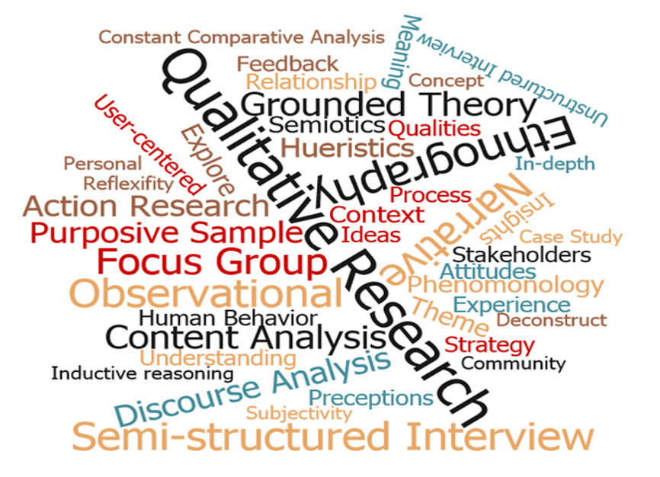  This Photo by Unknown Author is licensed under CC BY |  | Exploring Fall Prevention and Improving Care Practices for Senior Citizens in UK Care Homes:  Aim:  To investigate fall prevention approaches and care procedures among elderly residents. Approximately one-third of UK adults aged over 65 experience falls annually, with nearly half over 80 (Public Health England, 2017).  - Falls limit older adults’ health and independence (Billot et al., 2020).  - Falls reduce mobility, confidence, and social engagement (Lee et al., 2020).  - Strong evidence supports fall prevention strategies (GOV.UK, 2022).  Methods for data collection and analysis:  - Five-stage framework based on the Arksey and O’Malley scoping review ensures a systematic and organised analysis of the literature (Taylor and Pagliari, 2018).  Identify research topics, locate appropriate research, choose studies, arrange data, and present findings  - summaries.  Data Collection Methods:  A selection of 10 peer-reviewed journal articles published between 2016 and 2026 were collected.  Search Strategy:  - Keywords: Fall prevention, care practices, care homes, senior citizens, UK, United Kingdom.  - Databases: PubMed, Google Scholar, ProQuest, UWTSD digital library, for systematic literature retrieval.  Sources: Peer-reviewed studies and grey literature, ensuring a comprehensive evidence base.  Inclusion Criteria:  - Studies focused on senior citizens in the UK, Published in English, 2016–2026 and Primary or secondary research.  Exclusion Criteria:  - Studies conducted outside the UK, Research on children or adolescents, Publications before 2016, Books, websites, and non-peer-reviewed reports. |  | 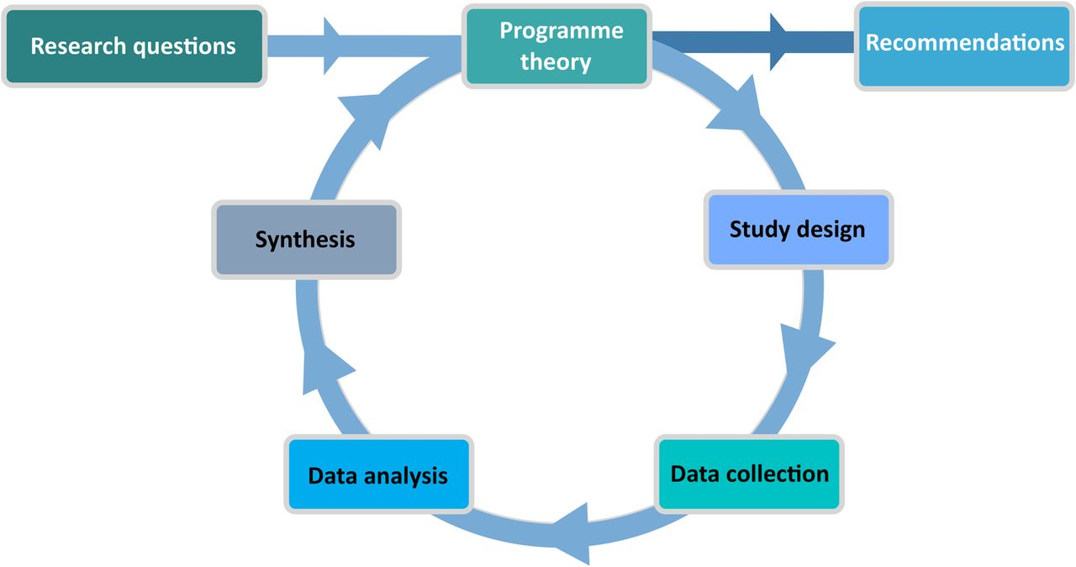  This Photo by Unknown Author is licensed under CC BY-NC
Methodology:  - This study uses secondary qualitative research design steered by the Arksey and O’Malley’s Scoping Review Framework (Westphaln et al., 2021).  - A scoping review maps the existing evidence on fall prevention, identifies gaps in knowledge, and clarifies current care practices for older adults across healthcare, nursing, and social care settings in UK care homes.  - The method provides a systematic and transparent approach for examining a wide range of evidence from different sources.  - Fall prevention research benefits from multiple evidence sources, including policy papers, clinical trials, and care home audits.  - Combining these sources provides a thorough understanding of effective fall prevention strategies. |  |  |  | Data Analysis Method:  - Thematic analysis was used to identify patterns across qualitative data (Braun and Clarke, 2021).  Six steps process  - Familiarisation, Initial coding, Pattern identification, Theme refinement, Theme definition and naming, and Finding representation.  Ethical Considerations:  - Only secondary data were used, eliminating the need for direct participant involvement.  - No vulnerable adults were included; therefore, formal ethical approval was not required.  - Maintained research integrity using credible sources, accurate Harvard referencing, and objective presentation of findings.  - Ethical approval granted by UWTSD.  Conclusion:  - Falls in care homes are largely preventable with proper interventions.  - Structured assessments, staff training, and environmental changes reduce fall risk.  - The methodology ensures rigorous and transparent analysis.  - Findings support practical recommendations to improve care practices in UK care homes.  - Ongoing medication review and risk monitoring are crucial to ensure therapies remain safe.

References
Braun, V. and Clarke, V. (2021) ‘One Size Fits all? What Counts as Quality Practice in (reflexive) Thematic analysis’, Qualitative Research in Psychology, 18(3), pp.328–352. Available at: https://doi.org/10.1080/14780887.2020.1769238.
Billot, M. et al. (2020) ‘Preserving Mobility in Older Adults with Physical Frailty and Sarcopenia: Opportunities, Challenges, and Recommendations for Physical Activity Interventions; Clinical interventions in aging, 15, pp. 1675–1690. Available at: https://doi.org/10.2147/CIA.S253535.
GOV.UK (2022) Falls: Applying All Our Health. Gov.uk. Available at: https://www.gov.uk/government/publications/falls-applying-all-our-health/falls-applying-all-our-health (Accessed 8 March 2026).
Lee, S.-P., Hsu, Y.-W., Andrew, L., Davis, T. and Johnson, C. (2020) ‘Fear of Falling Avoidance Behaviour Affects the inter-relationship between Vision Impairment and Diminished Mobility in community-dwelling Older Adults; Physiotherapy Theory and Practice, pp.1–9. Available at https://doi.org/10.1080/09593985.2020.1780656.
Taylor, J. and Pagliari, C. (2018) ‘Comprehensive Scoping Review of Health Research Using Social Media Data; BMJ Open, 8(12), p.e022931. Available at https://doi.org/10.1136/bmjopen-2018-022931.
Public Health England (2017) Falls and Fracture Consensus Statement Supporting Commissioning for Prevention. Available at: https://assets.publishing.service.gov.uk/media/5a7f4316ed915d74e6229625/falls_and_fractures_consensus_statement.pdf (Accessed 8 March 2026).
Westphaln, K.K., Regoeczi, W., Masotya, M., Vazquez-Westphaln, B., Lounsbury, K., McDavid, L., L., Lee, H., Johnson, J. and Ronis, S.D. (2021) ‘From Arksey and O’Malley and Beyond: Customizations to Enhance a team-based, Mixed Approach to Scoping Review Methodology; MethodsX, 8(101375), p.101375. Available at https://doi.org/10.1016/j.mex.2021.101375.

