University of Wales Trinity Saint David
Wales Institute of Science and Art

Electronics Circuit Testing and Applications
Electronics Control Systems (ACHA4010)

Jake Hicks
2306026
March 2024
Contents
1 Task 2 1
1.1 Scope Time Division Calculations (4) 1
1.2 Function Generator output sine wave (3) 2
1.3 Unsmoothed Rectifier Wave (3) 3
1.4 Smoothed Rectifier Wave with capacitor (3) 4
1.5 Drop in Voltage Question (4) 5
1.6 Different Voltage Readings Question (5) 6
1.7 Rectifiers use in Automotive applications Question. (4) 7
1.8 Probing Question (4) 8
2 Task 3 9
2.1 Scope Time Division Calculations (4) 9
2.2 Function Generator output square wave (3) 10
2.3 Capacitor charge and discharge wave marked at correct points. (3) 11
2.4 Basic Capacitor Calculations (3) 12
2.5 Capacitor discharge table (4) 13
2.6 Gradient Plot and calculations (4) 14
2.7 Capacitor Uses (5) 15
2.8 Inaccuracies Question (4) 16
3 References 17

Table 1 - Voltage Results Table 6
Table 2 - Capacitor Discharge Result Table 13

Figure 1 - Function Generator Output Sinewave 2
Figure 2 - Unsmoothed Rectifier Wave 3
Figure 3 - Function Generator Output Square Wave 10
Figure 4 - Capacitor Charge and Discharge Wave 11
Figure 5 - Capacitor Charge and Discharge Wave with Markers at 63.2% Voltage 12
Figure 6 - Log (V) Against Time Results Graph 14

Task 2

Scope Time Division Calculations (4)

When it comes to time division, to find the period of one full waveform, the formula below is used.
$$T= \frac{1}{f}$$
Or
$$Time Period= \frac{1}{Frequency}$$
Substituting in the 10Hz that should be the AC signal, we would get the equation:
$$\frac{1}{10Hz}=0.1 second$$
This can then be simplified to 100 milliseconds (100ms), for the length of the waveform.

Function Generator output sine wave (3)
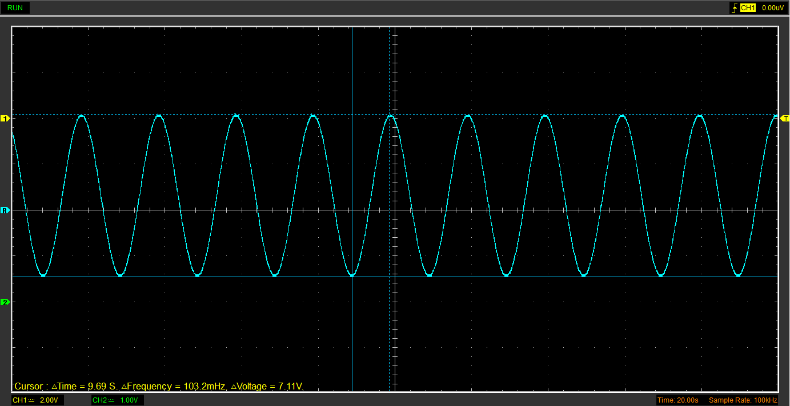
Figure 1 - Function Generator Output Sinewave

Unsmoothed Rectifier Wave (3)
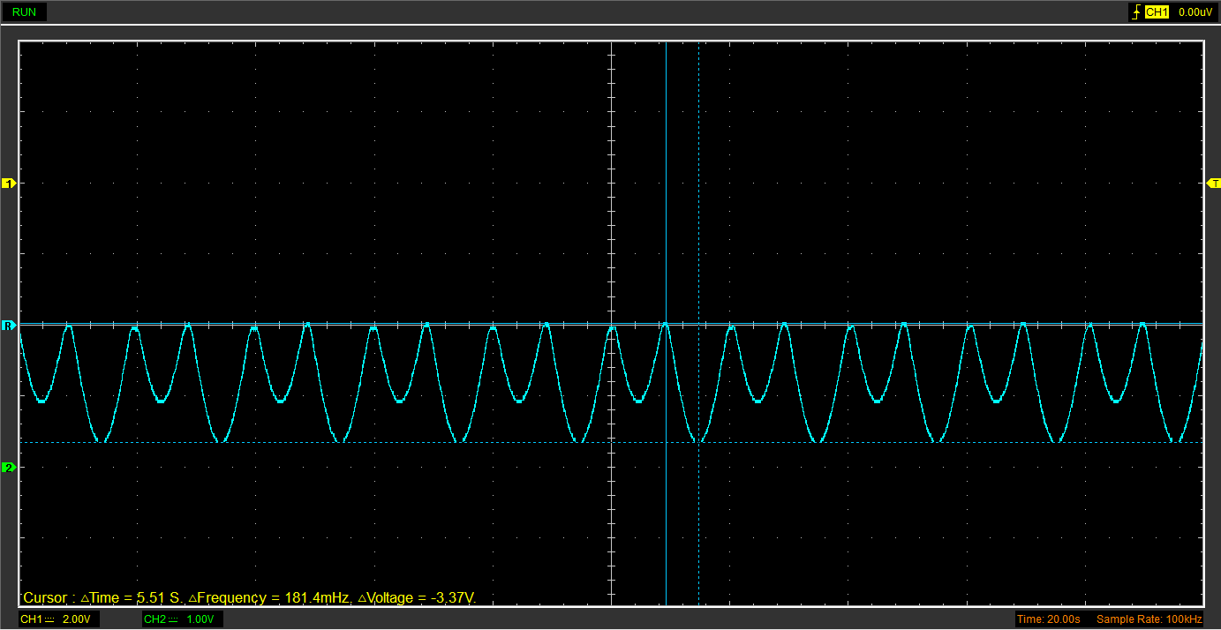
Figure 2 - Unsmoothed Rectifier Wave

Smoothed Rectifier Wave with capacitor (3)
.rfc file was corrupted

Drop in Voltage Question (4)
The voltage across a rectifier circuit will almost never reach the peak voltage of the input, whether it be a sinewave or square wave input. This is caused by the drop in voltage across each component in the circuit, primarily the diodes used to create the rectifier. Diodes tend to have a voltage drop of around 0.6V – 0.7V, which is going to then take from the input voltage, leaving the peak voltage of the circuit potentially a few volts lower than its input.

Different Voltage Readings Question (5)
Table 1 - Voltage Results Table
 | Peak Positive Voltage | Peak to Peak Voltage | RMS Voltage
Figure 1 | 4.19V | 7.11V | 2.51V
Figure 2 | 74.9mV | 3.37V | 1.19V

RMS voltage, standing for Root Mean Square, is a continuously changing voltage that is the square of the instantaneous values of the wave signal during its cycle. The RMS voltage is more important regarding AC signals rather than DC signals as AC signals vary continuously in respect to time. On the other hand, DC signals remain relatively constant with time (Electrical4u, 2021).
The RMS is the square root of the mean value of the squared function of the instantaneous values, meaning rather than being an easily measurable value that can be observed from the waveform itself, like peak positive and peak to peak voltage (Electronic Tutorials, 2014).

Rectifiers use in Automotive applications Question. (4)
In the automotive industry, rectifiers have their uses within several parts on the vehicle with more components becoming more electronically powered. The alternator will employ the use of a rectifier system to driver the load of the vehicle, though variations of the rectifier are available based on a manufacturer’s needs, such as costs and power output (Perreault and Caliskan, 2004).
As Electronics Media, (2021), points out, rectifiers can be made to be miniature in size and highly resistant to high ambient temperatures, which makes them ideal fits for aiding in the operation of LED lighting, the engine control units and fuel injection systems. There is constant innovation on this front, with many manufactures creating new rectifiers with better efficiency, meaning reduced reverse current and lower forward voltage losses, and improving the safety and durability of these devices by increasing the temperature window for safe operation; they are also constructed to remain stable at maximum reverse voltage, which all plays into safety during use within in a vehicle as automobiles are products and need to be made to accompany as many scenarios as possible in a safe manor for the user and others.

Probing Question (4)
When it comes to probing a rectifier circuit, we were unable to probe both the input from the function generator and the rectifier output. Reason being in that each set of probes has a positive and negative that need to be inserted into the circuit to get a reading, and by placing two negative probes into said circuit, a short circuit is created and causes undesired results whilst the circuit no longer functions as desired.
A way to avoid this is to use a battery powered probe as it will then have a different ground to the function generator input, which would then allow both to be applied to the circuit at once. Another fix is to use differential probes, which measure the input voltage relative to ground. These allow the measure of the voltage difference between two inputs in contrast to a single-ended probe by using a differential amplifier to subtract one signal from the other, resulting in a single reading, all without causing a short circuit (EEVBlog, 2012).

Task 3

Scope Time Division Calculations (4)
To calculate the RC time constant using the capacitor and resistor chosen, their capacitance and resistance values must be used, respectively in the formula:
$τ=RC$
Or
$Time Constant=Resistance x Capacitance$
Therefore, inputting the values of the 330Ω resistor and 1µF (marked “105”) capacitor that were chosen, we get the equation:
$$330 x \left(1 × {10}^{-6}\right)=330 × {10}^{-6}$$
This can be then simplified to 330µs (nanoseconds).
The frequency of the function generator can also be calculated, thought this time the waveform is square. The frequency of 20 time periods of the resistor/capacitor combination is equal to or greater than the frequency of the function generator, and thus is calculated differently with the formula:
$$f_{(function generator)}≤ \frac{1}{12τ}$$
Substituting in the value of the last equation, 300µs, we get the formula:
$$f ≤ \frac{1}{12 x (330 × {10}^{-6})}$$
Simplified to:
$$f ≤252.\dot{52}$$
Now with the frequency value, the time division value of the waveform can be calculated, using the same equation.
$$T= \frac{1}{f}$$
$$T= \frac{1}{252.\dot{52}}$$
$$T=3.96 × {10}^{-3}$$
This can be simplified to 3.96ms, for the length of the waveform.

Function Generator output square wave (3)
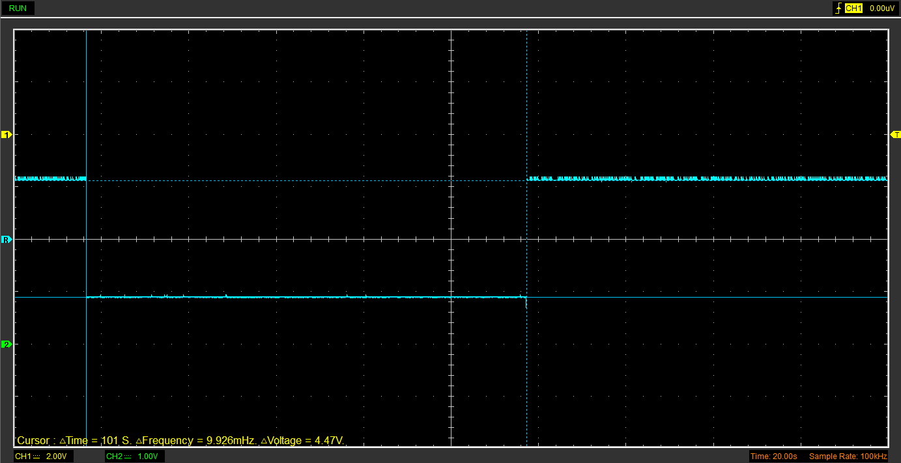
Figure 3 - Function Generator Output Square Wave

Capacitor charge and discharge wave marked at correct points. (3)
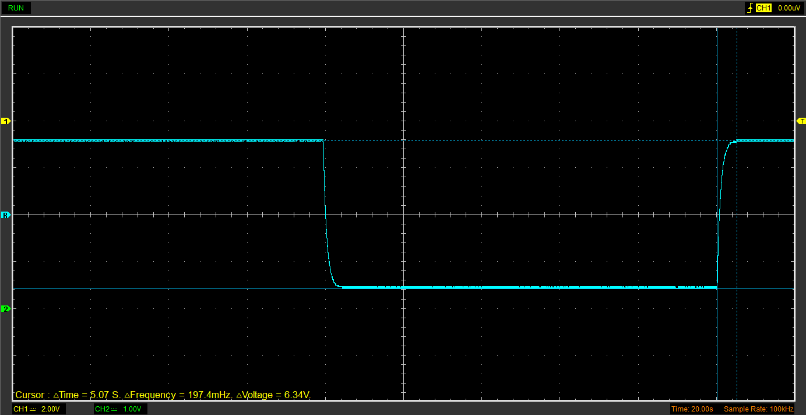
Figure 4 - Capacitor Charge and Discharge Wave

Basic Capacitor Calculations (3)
To find the capacitance of the capacitor, the formula τ = RC is required, but to use it, the value of τ needs to be found before we can rearrange the formula. We already know R to be 330Ω.
Taking the waveform of the capacitor altered square wave input, we can use the equation:
$$\left(Peak Voltage- Start Voltage\right) × 63.2\%+Start Voltage=V Top Cursor$$
Looking at figure 4, the voltage difference between the two peaks can be observed to be 6.34V, which can be used as the peak voltage. Using that, the start voltage can be referred to as just 0V.
$$\left(6-0\right)×0.632+0=3.792 Volts$$
Taking 3.792 Volts and finding it on the raising side of the waveform, as seen in figure 5, the Hantek program can present the time constant of 894ms.
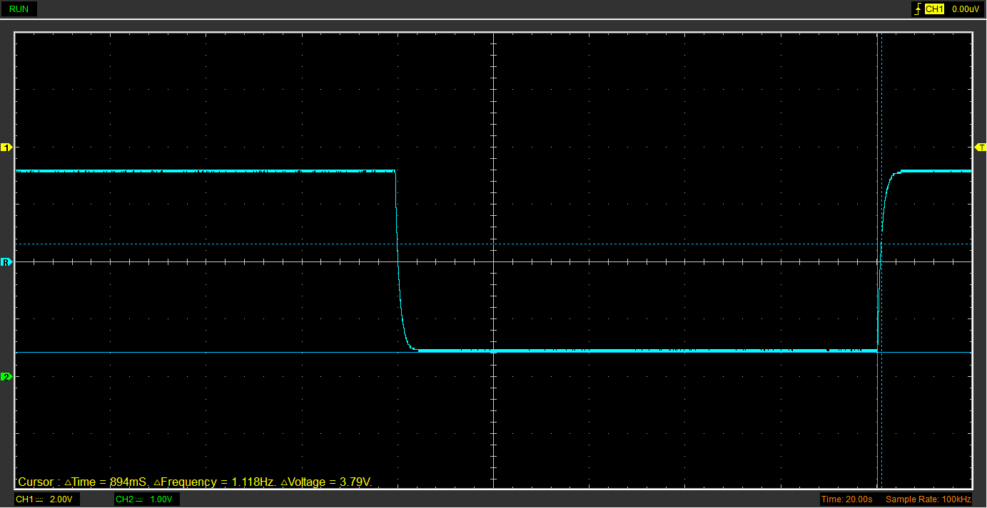
Figure 5 - Capacitor Charge and Discharge Wave with Markers at 63.2% Voltage
Now the originally referred to equation can be used to find capacitance, after transposition.
$$τ=RC →C= \frac{τ}{R}$$
$$\frac{894 × {10}^{-3}}{330}=0.0027F \left(2sf\right)$$
Simplifying the result, the capacitance comes out with a result of 2.709mF.

Capacitor discharge table (4)
Table 2 - Capacitor Discharge Result Table
Time (s) | Voltage (V) | ln (V) | dy = y2 – y1  dy = ln(V)2-ln(V)1 | dx = x2- x1  dx = Time2 – Time1 | dy/dx
0.008697 | 3.2 | 1.974081026 | x | x | x
0.008724 | 0.6275 | 1.532016765 | -0.442064261 | 2.7E-05 | -16372.75039
0.008751 | -0.8157 | 1.158232485 | -0.373784281 | 2.7E-05 | -13843.86225
0.008778 | -1.6941 | 0.835471056 | -0.322761429 | 2.7E-05 | -11954.127
0.008805 | -2.2588 | 0.554574531 | -0.280896525 | 2.7E-05 | -10403.575
0.008832 | -2.6353 | 0.310934624 | -0.243639906 | 2.7E-05 | -9023.700238
0.008859 | -2.8235 | 0.162543929 | -0.148390695 | 2.7E-05 | -5495.95167
0.008886 | -2.949 | 0.049742092 | -0.112801837 | 2.7E-05 | -4177.845826
0.008913 | -3.0118 | -0.011870173 | -0.061612264 | 2.7E-05 | -2281.935721
0.00894 | -3.0745 | -0.077421147 | -0.065550974 | 2.7E-05 | -2427.813867

Gradient Plot and calculations (4)

Figure 6 - Log (V) Against Time Results Graph
Figure 6 shows the relationship between log (V) and time, which can be given a line of best fit with a gradient of y = -8322.2x + 75.039. Since gradient equations are constructed in the form y = mx + c, we can use this to find the capacitance of the resistor by using the fact that m = -1/RC.
$$m = \frac{-1}{RC} → C= \frac{-1}{Rm}$$
After transposing the formula, the known values can be inserted.
$$\frac{-1}{-8322.2 ×330}=364.12 ×{10}^{-9}$$
The answer can be simplified to 364.12nF of capacitance.
This is a different value to what was calculated in section 2.4, with it being 743,985.49% larger at 2.709mF.

Capacitor Uses (5)
Capacitors can be used in various scenarios for a multitude of purposes, including:
- A flashlight can make use of a dc energy storage system, that requires capacitors to power the LEDs, as a secondary battery. (Miller, 2016)
- The Rockster R1100DE Rock Crusher makes use of a hybrid power system, partly powered by a diesel generator, and partly by an electrochemical capacitor energy storage system, though most of the power is provided through the diesel motor. (Miller, 2016)
- A diesel-electric hybrid city bus uses a bidirectional energy storage system which delivers and absorbs power, depending on whether the capacitors need to charge or discharge. (Miller, 2016)
- The Starting-Lighting-Ignition (SLI) battery used in internal combustion engines vehicles has a pulse energy storage system, one which intermittently sends out a discharge in a single pulse. The SLI takes a single pulse and uses it to start the engine of the vehicle. (Miller, 2016)
Aluminium electrolytic capacitors have numerous applications within automobiles, such as:
- Quality of life features; wind wipers, air conditioning, automatic window motors. (Powers, 2015)
- Safety and control systems; power steering, airbag controls and braking systems. (Powers, 2015)
- Engine Control Units; petrol and diesel engine controls. (Powers, 2015)
- Electric motor drives; fuel pumps and fans. (Powers, 2015)

Inaccuracies Question (4)
The reason that some of the measured values could deviate so far from their specified value, marked by the manufacturer, may be because of the tolerances of the individual components. With a circuit featuring many components, each with their own tolerances that their true value lies somewhere within, the overall results of the circuit may be far different from the theorised results, where everything is calculated with ideal values. (Spence and Soin, 1997, p. 1).
An obvious component to point out would be the resistor (Spence and Soin, 1997, p. 4). A resistor is manufactured with four bands on it, three to signify the ideal value of the resistor, and one to display the tolerance. The tolerance band is usually either gold or silver to show a 5% or 10% tolerance respectively. A resistor at the extents of the tolerance margin could massively alter the output of a circuit, especially with larger resistors.
Another reason for such a deviation from the supposed value of the components, this could also come down to testing errors, such as incorrect circuits, faulty components and mistakes in the calculations, all of which could result in a largely skewed resulting value.

References
Electrical4U (2021) RMS Voltage: What it is? (Formula And How To Calculate It). Available at: https://www.electrical4u.com/rms-or-root-mean-square-value-of-ac-signal/#What-is-RMS-Voltage
Electronic Tutorials (2014) RMS Voltage Tutorial. Available at: https://www.electronics-tutorials.ws/accircuits/rms-voltage.html
Perreault, D.J. and Caliskan, V. (2004) ‘Automotive Power Generation and Control’, IEEE Transactions on Power Electronics, 19(3), pp. 618-630. Available at: https://ieeexplore.ieee.org/abstract/document/1296737
Electronics Media (2021) Nexperia’s Silicon Germanium (SiGe) Rectifiers are now available from element14. Available at: https://www.electronicsmedia.info/2021/10/11/rectifiers-for-automotive-communications-infrastructure-server-market/ (Accessed: 19 March 2024).
EEVBlog (2012) EEVblog #279 - How NOT To Blow Up Your Oscilloscope! Available at: https://www.youtube.com/watch?v=xaELqAo4kkQ
Miller, J.R. (2016) ‘Engineering electrochemical capacitor applications’, Journal of Power Sources, 326, pp. 726-735. Available at: https://doi.org/10.1016/j.jpowsour.2016.04.020
Powers, N. (2015) Capacitor-Powered Cars: Capacitors in Automotive Applications. Available at: https://www.arrow.com/en/research-and-events/articles/capacitors-in-automotive-applications
Spence, R and Soin, R.S. (1997) Tolerance Design of Electronic Circuits. London: Imperial College Press.

