Name: Julian Tyrell
ID Number: 1702374
BA Course Title: Advertising & Brand Design
Word Count: 2348
Tutor:

A Contextual Essay

Introduction:

This essay will focus on 3 key words, the key words will be Money, Power and

Reputation, each word will have its own section within in this Essay with an

example of a well-known businesses and how they would use these 3 key

words to further themselves along and how successful they are in doing so

when, within each section my comments and information shall be backed up

with references and key images to enforce the information within the essay.

After each section we will reach our conclusion which will hold any final

thoughts along with a final question that will be linked to the keywords that

will be mentioned within which will prepare me for my final dissertation within

my final year.

Word one: Money

Money and/or wealth can be viewed in many different ways, it can be seen as

holding valuable possessions in high amounts such as Currency, precious

stones or gems or even metals such as gold or silver. This is one of the more

well-known ways to view wealth/money however people can be wealthy in

other ways such as spiritually by looking after themselves physically and

mentally and surrounding themselves with comforts such as friends or families

some believe that this can be a sign of spiritual wealth, these 2 major views on

money and wealth have been debated by spiritual leaders and philosophers for

years now and is still continuing as I write this Essay now. “Many people take

no care of their money till they come nearly to the end of it, and others do just

the same with their time.” (Johann Wolfgang von Goethe, Caring for money

and time) This quote I feel is a much more neutral and plays off of both sides

pointing out the flaws in either side of the debate and how people are wasting

time and resources in such a debate and should spend their time and

resources elsewhere either by bettering their lives or someone else’s or just by

doing something that makes them feel better about themselves or happy with

what they have. ‘’It is health that is real wealth and not pieces of gold and

silver.’’ (A quote by Gandhi found in "Spiritual Wealth Management: The

Abundance Bible and Prosperity Manifesto". Book by George S. Mentz (p. 114),

September 1, 2012.) Many spiritual leaders find this quote to hole the core

beliefs of their teaching or knowing’s. Personally, I find that finding a good

balance between the 2 beliefs is true happiness and should be sought after

rather than focussing efforts on one side.

Example: Apple

Apple are seen to be one of the biggest world earners with an estimated $215

billion earned in 2017, placing them within the top 10 in the Finance Online

list, a creditable online financial website which lists annually the top earners of

each year. Apple is a tech company that was established in 1976 that

specialised in innovative and ground breaking technologies such as the

Macintosh Computer in later years finally evolving and branching out into

several other products such as smartphones (iPhone) Laptops (MacBook air/

MacBook pro) and Desktop Computers. Over time the Apple product line has

been seen as a product used by a type of more artistic audience such as

illustrators, graphic designers and advertisers, they hold quite a high price tag

the technology and craftsmanship is shown and with their large profits they

can further invest into researching and furthering their achievements.

However, in recent years they have gotten into several controversy’s after

their former CEO Steve Jobs passed away, under new leadership the business

has taken to doing some rather strange things with their products such as

removing key features such as wire ports, and application support e.g.

removing headphone jacks from their smart phones and encouraging

consumers to purchase a far more expensive form of wireless earphone that is

only compatible with their own products, it was also discovered by some

unknown tech savvy individuals that certain apple products had been created

to start failing after a certain amount of time had passed so the consumers

would have to purchase a newer rendition of the product along with batteries

always being a major issue for them. Apple has been known in recent years to

cut corners in an effort to increase profits, a serious sign of greed on their

behalf which isn’t a good sign although it makes sense for one of the largest

grossing business to do such things in order to earn such a large annual income

for their. ‘’Get closer than ever to your customers. So close that you tell them

what they need well before they realize it themselves’’. Steve Jobs

(The Seed of Apple's Innovation, Peter Burrows, BusinessWeek, 12 Oct 2004)
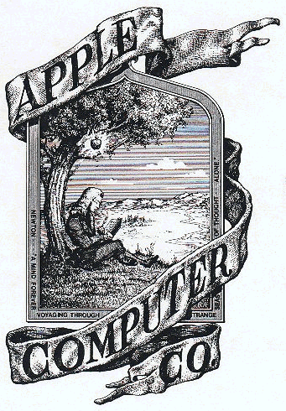

(The Newton Apple Crest Logo created in 1976 by Ronald Wayne, sourced from ‘’The History of Apple’’, edibleapple.com blog post)

Word Two: Power

Power can be seen on several different ways, it can be seen as physical power,

someone or something performing physical feats that are impressive or

intimidating to others, something like this could assert the someone or

somethings dominance and maybe impress their peers in the process as the

raw physical strength or ‘power’ needed to perform such a feet would be a

dramatic proportion, another way power can be seen is when a person or

persons can be seen to have a large amount of influence over others, over

politics or over nations even, usually these types of people are seen to be in

positions of government such as political party leaders or country leaders,

people can see this power in a good light however some may use it in a

negative aspect such as a dictatorship taking place of a government and

oppressing others however certain people who have power or influence may

not be as visible to the public and may use the power within in the shadows

and would rather avoid the lime light and be unknown to most and work in

secrecy such as certain government branches “If you're going to kick authority

in the teeth, you might as well use two feet.”

(Keith Richards, Keith Richards: In His Own Words). A more practical use for the

term of power is energy, such as electricity or other fuel sources that provided

our machinery and technology with power and helped us further our

civilisations and economies, it can also been seen as a way of measuring

something, you can measure power in many different ways such a Hertz,

Joules, wattage or Voltage or through temperature such as Fahrenheit, Celsius

and so one. Power can be seen and used in a large variety of ways weather its

physical or practical, a show of strength or a measurement of energy. “Nearly

all men can stand adversity, but if you want to test a man's character, give him

power.” (Abraham Lincoln, The Gettysburg Address)

Example: Jeff Bezos (CEO of Amazon)

Jeff had started the website Amazon in 1995 as a online bookstore however he

had always wanted to develop and improve the website to become an

‘everything store’ to rival sites like E-Bay and other online shopping stores, he

wanted to corner the market and make amazon a one stop powerhouse for

consumers looking for anything and everything worldwide, he worked

extremely quick and expected other to do so as well, it’s be noted that Jeff

Bezos didn’t really understand the work – life balance and expected a lot of his

staff to work a minimum of 60 hour work weeks and has been noted to be

rather heartless when it came to hiring and firing and workplace quality of life

however his ruthless business tactics have netted him in position in Forbes

magazine as one of the most powerful business men and in combination with

his investing and expanding he’s managed to create a lot of contacts within the

business worlds with a high standing which in return improves him and his

businesses credibility which increases the power or influence he’d have over

his company and the consumers which forwards his business and keeps its

standing as one of the most high earning businesses with an estimated total

brand value of $160 billion worldwide and a total profit estimation of $250

billion. ‘’The common question asked in business is ‘why?’ that’s a good

question, but an equally valid question is ‘why not?’ ‘’ – Jeff Bezos.


(Amazon.com original logo in 1994 sourced from a blog post on RealBusiness.com)

Word Three: Reputation

Reputation is very straight forward with not few other meanings however

there is a spectrum to it, someone’s the reputation of someone or something

can be set on a scale and can be seen in different lights from different parties

depending on a series of factors which can make things for the someone or

someone’s in question very confusing and complex and could make it feel like

they’re walking on egg shells in an attempt to make and keep everyone happy

if they were trying to get several parties of people to all like them at once,
reputation is usually achieved through feats or acts carried out that have some

level of note to them a great way this is portrayed is through fantasy or

mythical stories, books, films etc. Where the hero or heroes are slowly

becoming more and more famous and renowned for their acts, the majority of

it good. The scales of reputation are usually Fame, acts which give the

individual a positive light resulting in people apricating or ‘liking’ them

more than they once were or can accepting them into their ranks. However,

the opposite of Fame is Infamy, infamy is usually gained by someone or

someone’s going out an committing negative acts, most cases of this is through

criminal activity such as theft or more violent crimes such as murder, a classic

example of this was shown in the hunt for Bonnie and Clyde, the notoriety and

infamy had the a majority of the southern states of the United States of

America attempting to apprehend the 2 outlaws by any means necessary in

order for themselves to gain some fame and a serious reputation as the ones

who apprehended the infamous duo. However, infamy and famous reputation

can be switched around depending on who you speak to or who you are trying

to impress, if you are looking for people to fear you maybe you actively seek

out an infamous reputation to enforce your image that you what others to see

of you or you do this to gain acceptance from peers who have chosen to go

down the same path however some people choose to not even advance their

standing or reputation or don’t have the ability to do such things, they either

prefer to stay off the grid or off the social standing radar and just get on with

their lives.

“As a general rule, a reputation is built on manner as much as on achievement.” ― (Joseph Conrad, The Secret Agent)

Example: Facebook

Facebook has had an extremely rocky ride with their reputation in recent years

after having a lot of controversy with sharing/selling private information to

third party sites and businesses for use in advertising and selecting

demographics as well as gaining information on citizens for more shady

political advancements however in its early years Facebook was seen as an

innovated and welcome site for billions of people across the globe to interact

with friends and/or family member in both a private and a public light for

select people or everyone to see without the worry of what was going on

behind the scenes, with games and other forms of entertainment on the site

for users to use most thought the sight to be harmless and fun for everyone

until recent years exposed the company and forever tainted its reputation and

its unlikely that they will ever bounce back from the damage that has been

done by the recent infamous exploits that have been revealed to the public by

news outlets.

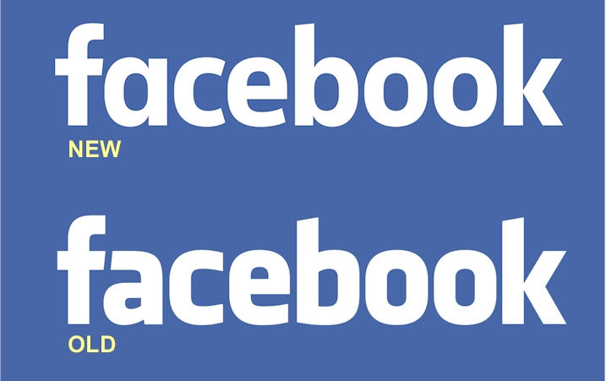

(A comparison image of the original Facebook logo and the more recent updated version from a blog post on logomyway.com)

Conclusion:

In conclusion I feel that the 3 key words mentioned when put together make

an exceptional power house and usually follow one another in a form a

metaphorical circle with one usually resulting in another e.g. Money can

sometimes result in power or influence on others or Reputation can usually

lead to wealth maybe via people donating out of your kindness or out of fear

of your infamy. Power is usually the result of a combination of both Money and
Reputation because most people within power roles either accumulated the 2

beforehand or inherited them both. Businesses have usually a very good

balance between all 3 in order maintain their business models, without these

models they have created they could be losing, influence, image, profits and

business from many customers or other smaller/larger businesses from across

the globe and without these, the examples that I have mentioned above would

not be where they are today if they hadn’t found a balance between these 3

key words which I believe are key points that each company or business should

keep close to their business models or branding measures when starting up

and continue to think about them throughout their businesses career in order

to achieve their goals and selected outcomes which will now lead onto my

question which will be discussed further in my dissertation ‘’How do

businesses use money in order to acquire influence worldwide to accumulate

power and influence over chosen sectors and customer bases across the

globe?’’

Bibliography

- Realbusiness.com

- Edibleapple.com

- Logomyway.com

- The Gettysburg Address, Abraham Lincoln

- Keith Richards: In his own words, Keith Richards

- The Seed of Apple's Innovation, Peter Burrows, BusinessWeek, 12 Oct 2004, Steve Jobs

- "Spiritual Wealth Management: The Abundance Bible and Prosperity Manifesto". Book by George S. Mentz (p. 114), September 1, 2012.), Gandhi

- Caring for Money, Johann Wolfgang von Goethe

