17-111-2023

Aman r gyani (2243885)
MOdule Profssor – Vasilios
Modile – International Marketing
IKEA CHINA
INTRODUCTION


(Source – IKEA CHINA WEBSITE)

Ingvar Kamprad established the Swedish global retailer IKEA in 1943. With more than 460 outlets throughout 61 countries, it is one of the biggest furniture sellers in the world. IKEA is renowned for its reasonably priced furniture and housewares in the Scandinavian design. IKEA first entered the Chinese market in 1998, and since then it has grown to include 37 locations in the nation's major cities. IKEA is one of the most well-liked furniture companies in China, and its goods are renowned for being useful, affordable, and having a Scandinavian aesthetic.

An introduction to a PESTLE analysis of IKEA in China is provided below:

IKEA is among the biggest furniture merchants in the world and has a substantial presence in China. A complex legal structure, stringent labour restrictions, and growing inflation are just a few of the difficulties the company encounters in the Chinese market. IKEA does, however, also have a lot of prospects, including a growing middle class, growing consumer interest in Western brands, and growing investment in renewable energy. The political, economic, social, technological, legal, and environmental issues affecting IKEA's operations in China will be examined in this PESTLE analysis. IKEA will receive advice from the analysis on how to deal with these difficulties and seize the chances.

Table of Contents
1. Environmental Audit 4
2. Evaluate IKEA International Market Entry Strategies 8
3. Cultural and Social Factors Influence Consumer Buying Behaviour and Current Marketing Strategies Employed By IKEA China 12
4. Uppsala Model 15
6. The Marketing Challenges Encountered by IKEA China 17
7. Marketing strategy used by Ikea to gain a sustainable competitive advantage in the Chinese market 19
8. Implementation Plan for The Proposed Strategy 22
9. REFERENCE – 25

Environmental Audit
PESTEL ANALYSIS

- Political
- Foreign investment in the retail industry is generally welcomed by the Chinese government. IKEA's ability to operate and grow in China for more than 20 years is proof of this. (Source - website of IKEA China)
- Additionally, the Chinese government is dedicated to lessening its environmental impact. The fact that this is in line with IKEA's sustainability objectives may provide them with a competitive edge in the Chinese market. But the Chinese government is also autocratic and unpredictable. Because it may be difficult for the company to make plans, IKEA may be at risk as a result. The source is the 2022 China Report by Freedom House.
- Economic
- The middle class in China is substantial and growing. Because its target market is middle-class consumers, IKEA has a great opportunity here. the 2022 China Statistical Yearbook. (Rocca, 2016). The Chinese economy is growing swiftly. This will be advantageous for IKEA as well because it shows that there is a growing need for its products and services. (Involves World Bank DataBank) But despite these challenges, China's economy is nevertheless facing serious problems, such as growing inflation and sluggish GDP growth. This could harm IKEA's operations because it might lead to lower consumer spending. Using Bloomberg Economics as a reference
- Social
- Western brands and goods are becoming more appealing to Chinese customers. As a Western brand, this is wonderful news for IKEA. (Dong and Tian, 2009).
- Environmental awareness is growing among Chinese customers. IKEA's commitment to sustainability is a further advantage. (Source: Global Consumer Sustainability Report for 2022 from Nielsen) However, Chinese shoppers are also cost-conscious. IKEA may find this difficult because it wants to make sure that its pricing is reasonable compared to those of neighbourhood shops. (Source: 2022 China Retail Report by Euromonitor International)
- Technological
- China is a pioneer in online shopping. IKEA has the chance to increase its market share in China by making an e-commerce investment. (Source: Global E-commerce Update 2022 from eMarketer) China is also investing heavily in renewable energy. This aligns with IKEA's sustainability goals, which could give IKEA a competitive advantage in the Chinese market. (Source: China National Energy Administration 2022 Renewable Energy Development Report) However, China's intellectual property laws are not as strong as those in other countries. This could pose a risk to IKEA, as its products could be copied by Chinese competitors. (Prasad Bingi and Khamalah, 2000).
- Legal
- The legal system in China is complicated. IKEA can find it challenging to follow all relevant laws and regulations as a result. (Source: 2022 China Legal and Regulatory Environment Report by the US-China Business Council) Additionally, China has severe labour rules. As a result, IKEA might have to pay its employees more wages and benefits, which would raise its costs. (Source: 2022 Labour Law Guide published by China's Ministry of Human Resources and Social Security) The Chinese government is, nevertheless, attempting to enhance and make its legal system more business friendly. IKEA might gain from this in the future. China is dealing with several environmental issues, including water and air pollution. This can hurt IKEA's company since it might result in increased expenses and a decline in the demand for its goods. (Source – Wang et al., 2022) The Chinese government, however, is dedicated to lessening its environmental impact. The fact that this is in line with IKEA's sustainability objectives may provide them with a competitive edge in the Chinese market.
- Conclusion
The PESTLE study reveals that there are both possibilities and challenges for IKEA in the Chinese market. IKEA may be successful in the Chinese market by concentrating on its advantages, such as its well-known brand, dedication to sustainability, and extensive product line. IKEA should thoroughly evaluate the difficulties it faces and create plans to deal with them.
Recommendations for IKEA
- Sustainability: IKEA should draw attention to its dedication to sustainability and showcase its programmes and products for Chinese consumers. Given that Chinese consumers are more concerned about the environment, this could provide IKEA a competitive edge in the Chinese market. (Gong, Jiang and Jia, 2023).
- Invest in e-commerce: To reach more Chinese consumers, IKEA should invest in e-commerce. Leading the way in e-commerce is China. By 2020, all single-use plastic products from the IKEA product line worldwide as well as from the dining spaces used by customers and employees. Realise zero-emission home delivery by 2025*. By 2030, IKEA hopes to cut its entire carbon footprint by 70% on average per product. Eliminating all single-use plastic items from the IKEA product line globally as well as from the patron and employee dining areas in stores* by 2020. By 2025*, achieve zero-emission home deliveries. reducing IKEA's overall carbon impact by 70% on average per product by 2030. (Yu et al., 2016.)

SWOT ANALYSIS
Strengths
IKEA, a globally recognized brand, offers stylish furniture at affordable prices. Its leadership in cost leadership and product diversity caters to various consumer preferences in China. The brand's cost-effective products and flat packaging reduce transportation and storage costs, providing a competitive advantage in price-sensitive markets. IKEA's commitment to sustainability aligns with the growing demand for eco-friendly products in China, demonstrating its commitment to a sustainable future. (Gurl, 2017).
Weakness
IKEA faces challenges in adapting to cultural differences in the Chinese market, as the furniture chain faces intense competition from domestic brands. The Chinese market is diverse, with furniture styles, sizes, and colors requiring customization. IKEA's global supply chain, complex, and large, may cause disruptions, such as transportation delays or supply shortages, affecting its operations in China.

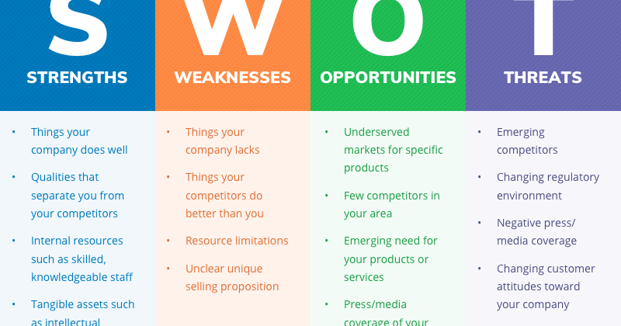(Source -bp.blogspot.com)
This Photo by Unknown Author is licensed under CC BY-SA

Opportunity
IKEA is leveraging the growth of China's urbanization to cater to the growing middle class, thereby increasing demand for quality home goods and furniture. The company's online presence is expanding, enhancing customer convenience. The rising middle class's evolving tastes and preferences are also driving the growth of e-commerce in China, presenting an opportunity for IKEA to expand its online presence and cater to the growing urbanization trends.
Threats
IKEA is leveraging the growth of China's urbanization to cater to the growing middle class, thereby increasing demand for quality home goods and furniture. The company's online presence is expanding, enhancing customer convenience. The rising middle class's evolving tastes and preferences are also driving the growth of e-commerce in China, presenting an opportunity for IKEA to expand its online presence and cater to the growing urbanization trends. (Leigh, 2009).

Evaluate IKEA International Market Entry Strategies

There are two different entry modes of IKEA in China: “wholly owned subsidiary” and “joint venture”.2 Apr 2017

- Wholly owned subsidiary (WOS): A wholly owned subsidiary (WOS) is a foreign company that owns 100% of a local company. This means that the foreign company has full control over the local company's operations, management, and profits.

- Joint venture (JV):
A joint venture (JV) is a business partnership between two or more companies from different countries. Each company contributes to the JV and shares in its profits and losses. IKEA entered the Chinese market in 1994 through a joint venture with a local company. This was a common entry mode for foreign companies at the time, as China had strict regulations on foreign investment. However, IKEA eventually transitioned to a wholly-owned subsidiary model in 2015.


(Source – Non Profitllaw Vlog)

Here are some of the key differences between wholly-owned subsidiaries and joint ventures:
- Control: A WOS gives the foreign company full control over the local company. This can be beneficial for companies that want to maintain their brand identity and operating standards. However, it can also be risky, as the foreign company is fully responsible for the local company's performance. A JV, on the other hand, requires the foreign company to share control with the local partner. This can be helpful for companies that need local expertise or access to distribution networks. However, it can also lead to conflict or disagreements between the partners.
- Risk: A WOS is generally considered to be a riskier entry mode than a JV. This is because the foreign company is fully responsible for the local company's performance. If the local company fails, the foreign company could lose all its investment. A JV, on the other hand, shares the risk between the foreign company and the local partner. This can be beneficial for companies that are new to the Chinese market or that are concerned about the risks of investing in China.
- Profit: A WOS allows the foreign company to keep all the local company's profits. This can be beneficial for companies that are looking to maximize their profits. A JV, on the other hand, requires the foreign company to share the profits with the local partner. This can reduce the foreign company's profits, but it can also help to ensure that the local company is profitable. IKEA's decision to transition to a wholly owned subsidiary model in China was likely motivated by several factors. First, IKEA wanted to have full control over its brand image and operations in China. Second, IKEA had gained a better understanding of the Chinese market and was more confident in its ability to succeed on its own. Third, China had relaxed its regulations on foreign investment, making it easier for foreign companies to operate wholly owned subsidiaries. The transition to a wholly owned subsidiary model has been successful for IKEA. The company has expanded rapidly in China and now has over 30 stores in the country. IKEA is also one of the most popular brands among Chinese consumers. However, it is important to note that a wholly owned subsidiary model is not always the best entry mode for foreign companies in China. There are still some challenges that foreign companies face in China, such as cultural differences, regulatory hurdles, and competition from local companies. Therefore, foreign companies should carefully consider their needs and goals before choosing an entry mode for the Chinese market.

- Other strategies:
- Localizing its products and services. IKEA has adapted its products and services to meet the needs of Chinese consumers. For example, IKEA offers smaller furniture items to accommodate smaller Chinese homes. IKEA also offers a wider range of Chinese food and snacks in its restaurants.
- Partnering with local businesses. IKEA has partnered with several local businesses in China. For example, IKEA has partnered with Chinese suppliers to produce furniture. IKEA has also partnered with Chinese retailers to sell its products online. Investing in marketing and advertising. IKEA has invested heavily in marketing and advertising in China. IKEA's marketing campaigns focus on its core values of affordability, quality, and design. IKEA also uses a variety of marketing channels, including television, print, and social media.
- Building a strong brand image. IKEA has built a strong brand image in China by focusing on its core values and by providing a unique shopping experience. IKEA's stores are known for their large size, their wide range of products, and their family-friendly atmosphere.
These strategies have helped IKEA to become one of the most successful foreign retailers in China. IKEA is now the second-largest furniture retailer in China, after only Hong Kong-based retailer Red Star Macalline.

In addition to the above strategies, IKEA has also used the following creative approaches in China:
- Partnering with Chinese celebrities - IKEA has partnered with several Chinese celebrities to promote its products and services. For example, IKEA has partnered with Chinese actress Yang Mi and Chinese singer Jackson Yee. (Song, 2018.)
- Using social media - IKEA has been very active on social media in China. IKEA uses social media to promote its products and services, to interact with Chinese consumers, and to build its brand image. (Leftheriotis, and Giannakos, 2014.)
- Offering unique shopping experiences - IKEA has offered some unique shopping experiences to Chinese consumers. For example, IKEA has offered a "sleep-in" event where consumers could spend the night in an IKEA store. IKEA has also offered a "wedding in a box" service where consumers could purchase all of the items they needed for their wedding from IKEA.
These creative approaches have helped IKEA to stand out from its competitors and to attract Chinese consumers.

Cultural and Social Factors Influence Consumer Buying Behaviour and Current Marketing Strategies Employed By IKEA China

Cultural and social factors play a significant role in influencing consumer buying behavior in China. IKEA China has successfully adapted its marketing strategies to take into account these unique factors.

Cultural Factors
Chinese culture is collectivistic, meaning that individuals are more likely to place the needs of the group over their own needs. This is in contrast to Western cultures, which are more individualistic. Chinese consumers are also more likely to value harmony and consensus. IKEA has taken these cultural factors into account in its marketing strategies. For example, IKEA stores in China are typically larger than those in the West, and they feature more communal spaces, such as restaurants and playgrounds. This is because Chinese consumers value spending time with their families and friends. IKEA also offers a variety of services that cater to Chinese consumers' collectivist culture, such as group shopping discounts and family-friendly amenities. Another important cultural factor in China is the emphasis on saving face. Chinese consumers are often reluctant to spend money on expensive or ostentatious goods, as they do not want to be seen as boastful or arrogant. IKEA's affordable prices and simple designs appeal to Chinese consumers' desire to save face. (Tarnovskaya and de Chernatony 2011.)
Social Factors
Social class is also an important factor that influences consumer buying behavior in China. The Chinese middle class is rapidly growing, and this is driving demand for high-quality, affordable products. IKEA's products are well-positioned to meet the needs of this growing segment of the Chinese population. Family and reference groups also play a significant role in influencing consumer buying behavior in China. Chinese consumers are often more likely to purchase products that are recommended by their family and friends. IKEA has built a strong brand reputation in China, and its products are often seen as being of high quality and value. This positive brand reputation has helped IKEA to gain the trust of Chinese consumers and their reference groups. (Wei and Zou, 2007.)

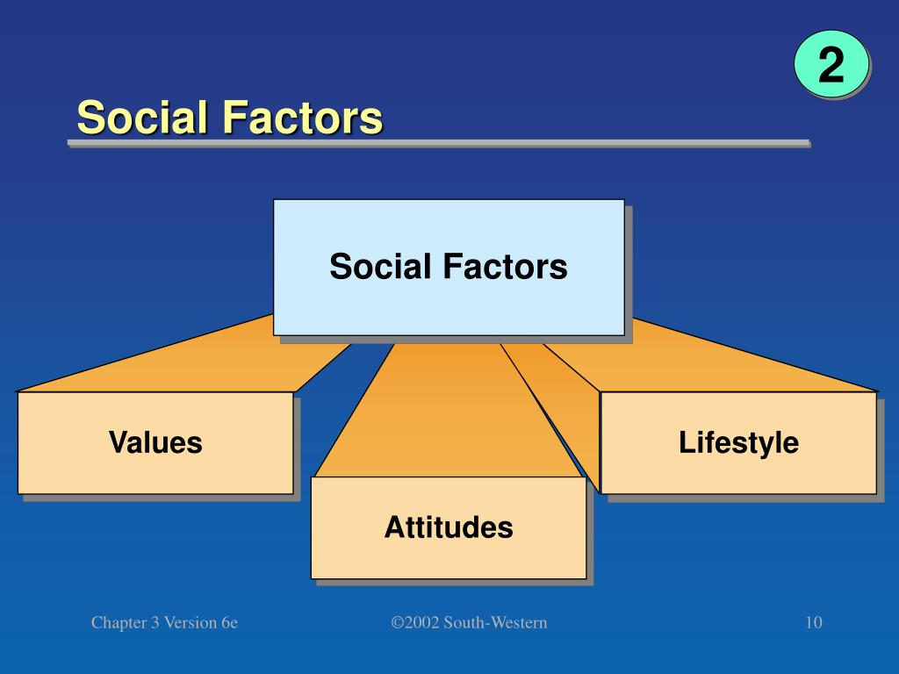
(Source – Slide Server)
Current Marketing Strategies Employed by IKEA China
IKEA China has employed a number of marketing strategies to target the unique cultural and social factors of the Chinese market. Some of these strategies include:
- Localization: IKEA has localized its products and services to meet the needs of Chinese consumers. For example, IKEA offers a variety of Chinese-style furniture, and its restaurants serve Chinese food. IKEA also has a team of Chinese designers who develop products specifically for the Chinese market. (Roy, 2020.)
- Omnichannel retailing: IKEA China offers a seamless omnichannel shopping experience. Consumers can shop for IKEA products online or in-store, and they can also pick up their orders in-store or have them delivered to their homes. This convenience is important to Chinese consumers, who are increasingly shopping online. (Dang, 2022)
- Social media marketing: IKEA China uses social media platforms such as WeChat and Weibo to connect with Chinese consumers. IKEA's social media posts are typically informative and engaging, and they often feature Chinese celebrities and influencers. IKEA also uses social media to run promotions and contests. (Giunta, 2016.)
Examples of IKEA's Current Marketing Strategies in China
- In 2022, IKEA China launched a campaign called "IKEA Home Stories" on WeChat. The campaign featured a series of short videos that told the stories of Chinese families and how they use IKEA products in their homes. The campaign was a success, and it helped IKEA to connect with Chinese consumers on a more emotional level.
- In 2023, IKEA China partnered with Chinese e-commerce giant Alibaba to launch a new online shopping platform. The platform offers a wide range of IKEA products, as well as convenience features such as same-day delivery. The partnership is expected to help IKEA to reach a wider range of Chinese consumers and to increase its sales in the Chinese market.

Uppsala Model
Incremental Internationalization:
The Uppsala model suggests that firms internationalize gradually, starting with the exploration of markets that are geographically and culturally close before moving to more distant and unfamiliar markets. Internationalization is seen as a learning process where firms acquire knowledge and reduce uncertainty over time.
Learning Process:
According to the Uppsala model, firms learn about foreign markets through their own experiences. Learning is a crucial aspect of the internationalization process and occurs through various activities, such as exporting, forming alliances, or establishing subsidiaries.
Market Commitment:
The model emphasizes the concept of market commitment, suggesting that firms become more committed to foreign markets as they gain experience and reduce uncertainty. The commitment may involve increasing investments, establishing local operations, or forming strategic alliances with local partners.
Psychic Distance:
The concept of "psychic distance" is central to the Uppsala model. It refers to the perceived cultural and business differences between the home country and the target foreign market.
Firms are more likely to enter markets with lower psychic distance initially and then gradually move to markets with higher psychic distance as they accumulate knowledge and experience.
Networking:
The model recognizes the importance of networks and relationships in the internationalization process. Firms often rely on relationships with other companies, business networks, and local partners to access information and resources in foreign markets.
International Entry Modes:
The Uppsala model suggests that firms typically start with relatively low-commitment entry modes, such as exporting, and then progress to higher-commitment modes like joint ventures or wholly owned subsidiaries as they become more familiar with the foreign market.
- Hofstede's Cultural Dimensions for IKEA in CHINA
Power Distance (PDI):
China has a high Power Distance Index, indicating a hierarchical society where people accept the unequal distribution of power. IKEA may need to consider this cultural aspect in its management structure and communication style. Clear hierarchical structures and communication channels may be more accepted.
Individualism vs. Collectivism (IDV):
China tends to be more collectivist, emphasizing close relationships and group harmony. IKEA may need to consider this in its marketing and product offerings, emphasizing products for families or groups rather than individualistic themes.
Masculinity vs. Femininity (MAS):
China is often considered a more masculine society, valuing competitiveness, assertiveness, and success. IKEA may emphasize products that align with these values, such as functional and innovative furniture designs.
Uncertainty Avoidance (UAI):
China has a moderate Uncertainty Avoidance Index, indicating a tolerance for ambiguity. However, IKEA may still need to consider this aspect in its marketing and customer communication, ensuring clarity and providing information that reduces uncertainty.
Long-Term Orientation vs. Short-Term Normative Orientation (LTO):
China tends to have a long-term orientation, valuing perseverance and thrift. IKEA can align its strategies by emphasizing durable and long-lasting products. Additionally, considering the long-term relationship with customers and the community can be beneficial.
Indulgence vs. Restraint (IND):
China tends to be more restraint-oriented, emphasizing the importance of adhering to social norms and avoiding actions that may be perceived as indulgent. IKEA may need to consider this in its marketing and promotional activities, ensuring they align with cultural norms.
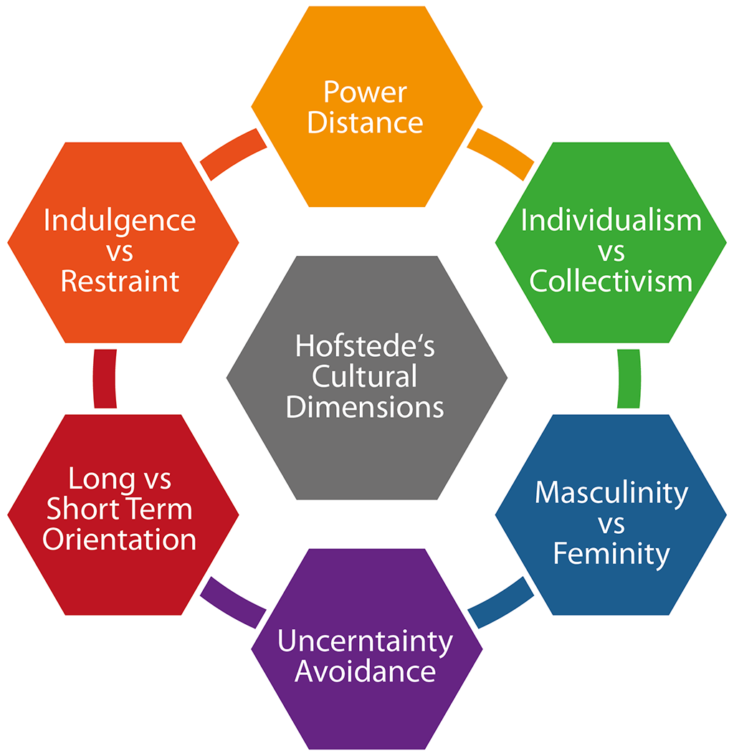
(Source - casework eu)

The Marketing Challenges Encountered by IKEA China

IKEA has encountered several marketing challenges in China since entering the market in 1994. These challenges can be broadly categorized into four areas:

Marketing Challenges Encountered by IKEA China

1. Competition
IKEA faces stiff competition from both local and international furniture retailers in China. Local retailers often have a better understanding of Chinese consumer preferences and can adapt their products and services accordingly. International retailers such as Walmart and Carrefour also offer a wide range of furniture products at competitive prices. (He, 2022.)
2. Consumer preferences
Chinese consumer preferences are rapidly changing, and IKEA has had to adapt its marketing strategy accordingly. For example, in the early days of its operation in China, IKEA focused on selling its iconic flat-pack furniture. However, Chinese consumers have become increasingly sophisticated and demanding in recent years, and they are now looking for a wider range of furniture styles and options.
3. Reaching and engaging consumers
IKEA has found it difficult to reach and engage Chinese consumers. Traditional marketing channels such as television and print advertising are not as effective in China as they are in other markets. IKEA has also struggled to adapt its online marketing strategy to the Chinese market. (Bolos et al., 2016)
4. E-commerce
The e-commerce market in China is growing rapidly, and IKEA has had to adapt its business model accordingly. IKEA now sells a range of its products online through its website and third-party e-commerce platforms. However, IKEA faces competition from several established online furniture retailers in China.
In addition to these four general challenges, IKEA has also faced a number of specific challenges in China, such as:
- Pricing: IKEA's prices are generally higher than those of local furniture retailers in China. This is due to many factors, including import duties and the cost of operating large stores in urban areas.
- Product design: IKEA's products are designed for Western homes, which are typically larger and have different layouts than Chinese homes. IKEA has had to adapt some of its products for the Chinese market, but this has been a challenge.
- Brand perception: IKEA is seen as a foreign brand in China, and some Chinese consumers are reluctant to buy foreign products. IKEA has worked to build its brand awareness and reputation in China, but this is a long-term process. (Rodrigues and Brandão, 2021.)
Despite these challenges, IKEA has been able to achieve some success in China. The company has opened over 30 stores in China and has a growing customer base. IKEA has also adapted its marketing strategy to the Chinese market, and it is now one of the leading furniture retailers in the country.
E-commerce: IKEA has invested heavily in its e-commerce business in China. The company has its website and sells its products through third-party e-commerce platforms. IKEA has also launched a mobile app to make it easier for consumers to shop online.

Marketing strategy used by Ikea to gain a sustainable competitive advantage in the Chinese market

Marketing Strategy for IKEA to Gain Sustainable Competitive Advantage in the Chinese Market

IKEA is a Swedish multinational furniture retailer that is known for its affordable prices, stylish designs, and DIY assembly. The company has been successful in many countries around the world, but the Chinese market has been particularly challenging. To gain a sustainable competitive advantage in China, IKEA needs to adapt its marketing strategy to meet the unique needs and preferences of Chinese consumers.

Here is a proposed marketing strategy for IKEA in China:

1. Focus on the omnichannel shopping experience
Chinese consumers are increasingly shopping online and using their smartphones to research and purchase products. IKEA needs to provide a seamless omnichannel shopping experience that allows customers to shop online, in-store, or through their mobile devices.
IKEA can do this by investing in its e-commerce platform, making sure that its website and mobile app are easy to use and navigate. The company should also offer omnichannel features such as click-and-collect and ship-from-store. (Mosquera, Pascual and Ayensa, 2017.)

2. Leverage social media and word-of-mouth marketing
Social media is a powerful tool for reaching and engaging Chinese consumers. IKEA should use social media platforms such as Weibo and WeChat to share new product announcements, promotions, and inspirational content. The company should also encourage customers to share their IKEA experiences on social media by offering incentives such as discounts or prizes. Word-of-mouth marketing is also very important in China. IKEA can promote word-of-mouth marketing by offering excellent customer service and creating a positive brand experience. The company should also encourage customers to refer their friends and family to IKEA by offering referral bonuses. (Martensen and Mouritsen, 2016.)

3. Customize products and services to meet the needs of Chinese consumers
Chinese consumers have different needs and preferences than consumers in other markets. IKEA needs to customize its products and services to meet the specific needs of Chinese consumers. For example, IKEA can offer smaller furniture items to fit into smaller Chinese apartments. The company can also offer more traditional Chinese furniture designs. IKEA can also adjust its marketing messages to appeal to Chinese consumers. For example, the company can emphasize the importance of family and community in its marketing.

4. Partner with local businesses
IKEA can gain a competitive advantage in China by partnering with local businesses. This includes partnering with local suppliers, distributors, and retailers. IKEA can also partner with local businesses to offer complementary products and services. For example, IKEA can partner with local restaurants to offer food and beverage options in its stores. IKEA can also partner with local interior design firms to offer design services to its customers. (Hammel and Denhar 2007.)

5. Invest in sustainable practices
Chinese consumers are becoming increasingly aware of the importance of sustainability. IKEA can gain a competitive advantage by investing in sustainable practices. This includes using sustainable materials in its products, reducing its environmental impact, and supporting social causes. For example, IKEA can use recycled materials in its products and offer energy-efficient appliances. IKEA can also reduce its environmental impact by using renewable energy sources and reducing its waste production. IKEA can also support social causes such as environmental protection and education. (Laurin and Fantazy, 2017.)

Justification
The proposed marketing strategy is designed to help IKEA gain a sustainable competitive advantage in the Chinese market by focusing on the following key areas:
Omnichannel shopping experience: Chinese consumers are increasingly shopping online and using their smartphones to research and purchase products. IKEA needs to provide a seamless omnichannel shopping experience that allows customers to shop online, in-store, or through their mobile devices. (Bierling and Hagman, 2018.)
Social media and word-of-mouth marketing: Social media is a powerful tool for reaching and engaging Chinese consumers. IKEA should use social media platforms such as Weibo and WeChat to share new product announcements, promotions, and inspirational content. The company should also encourage customers to share their IKEA experiences on social media by offering incentives such as discounts or prizes. (Pang, 2022.)
Customization: Chinese consumers have different needs and preferences than consumers in other markets. IKEA needs to customize its products and services to meet the specific needs of Chinese consumers.
Local partnerships: IKEA can gain a competitive advantage in China by partnering with local businesses. This includes partnering with local suppliers, distributors, and retailers. IKEA can also partner with local businesses to offer complementary products and services.
Sustainability: Chinese consumers are becoming increasingly aware of the importance of sustainability. IKEA can gain a competitive advantage by investing in sustainable practices. (Rangan et al., 2014) By focusing on these key areas, IKEA can differentiate itself from its competitors and gain a sustainable competitive advantage in the Chinese market.
The Chinese market is one of the largest and most important furniture markets in the world. IKEA has the potential to be very successful in this market, but it needs to adapt its marketing strategy to meet the unique needs and preferences of Chinese consumers. By focusing on omnichannel shopping experience, social media and word-of-mouth marketing, customization, local partnerships, and sustainability, IKEA can gain a sustainable competitive advantage in the Chinese market.

Implementation Plan for The Proposed Strategy

I. Market Research and Analysis:
Consumer Insights:
Conduct in-depth research to understand Chinese consumer behavior, preferences, and cultural influences.
Utilize data analytics and market surveys to identify specific product preferences and lifestyle trends.
Competitor Analysis:
Analyze local and international competitors to identify gaps in the market and areas where IKEA can differentiate itself.
Evaluate successful strategies and potential pitfalls of competitors in the Chinese market.
II. Product Development and Localization:
Customized Product Designs:
Collaborate with local designers and artisans to create furniture and home goods that reflect Chinese aesthetics.
Regularly update product offerings to stay in tune with changing trends and customer preferences.
Innovation and Technology Integration:
Invest in research and development to introduce innovative products that cater to the evolving needs of Chinese consumers.
Leverage technology, such as smart home solutions, to enhance product features.
III. Supply Chain and Logistics:
Local Sourcing:
Strengthen relationships with local suppliers to ensure a stable and diverse supply of raw materials.
Establish a robust supply chain network to minimize lead times and optimize inventory management.
Efficient Logistics:
Implement advanced logistics and distribution systems to streamline the transportation of products from suppliers to stores.
Optimize inventory levels to reduce holding costs while maintaining product availability.
IV. Marketing and Branding:
Cultural Relevance:
Develop marketing campaigns that resonate with Chinese cultural values and traditions.
Utilize local influencers and celebrities in marketing initiatives to enhance brand awareness.
In-Store Experience:
Redesign stores to create a culturally immersive experience.
Train staff to provide personalized assistance and product knowledge, enhancing the overall shopping experience.
V. E-commerce Integration:
Enhanced Online Platform:
Upgrade the online shopping platform to mirror the in-store experience.
Implement targeted digital marketing strategies to reach a wider online audience.
Digital Engagement:
Utilize social media and other digital channels for interactive and engaging customer interactions.
Implement online-exclusive promotions and offerings.
VI. Sustainability Initiatives:
Green Practices:
Communicate IKEA's commitment to sustainability through local initiatives.
Source materials responsibly and highlight eco-friendly practices.
Community Engagement:
Engage in community projects and partnerships that align with sustainability goals.
VII. Regulatory Compliance and Risk Management:
Legal Compliance:
Stay updated on and comply with local regulations and standards.
Establish a risk management plan to address potential challenges unique to the Chinese market.
Contingency Planning:
Identify potential risks such as political instability or economic fluctuations and develop contingency plans.
VIII. Performance Measurement and Feedback:
Key Performance Indicators (KPIs):
Establish KPIs to measure the success of the differentiation strategy.
Regularly review and adjust strategies based on performance metrics.
Customer Feedback:
Implement mechanisms to collect and analyze customer feedback.
Use feedback to continuously improve products and services.
IX. Employee Training and Development:
Cultural Sensitivity Training:
Provide ongoing training for employees to enhance cultural sensitivity and understanding.
Foster a culture of innovation and adaptability.
Skill Development:
Equip employees with the necessary skills to provide excellent customer service and support the implementation of new technologies.
X. Conclusion and Adaptation:
Regularly review the implementation plan, considering changes in the market environment, consumer behavior, and competitor actions.
Adapt strategies based on feedback, emerging trends, and the evolving needs of the Chinese market.

REFERENCE –
- Bierling, K. and Hagman, A., 2018. The Age Of Experience: A Qualitative Study of the Revitalisation of the Customer’s Physical Retail Experience based on the Example of IKEA.
- Bolos, C., Idemudia, E.C., Mai, P., Rasinghani, M. and Smith, S., 2016. Conceptual models on the effectiveness of e-marketing strategies in engaging consumers. Journal of International Technology and Information Management, 25(4), p.3.
- Dang, Y., 2022. Key factors in designing successful retail omnichannel.
- Dong, L. and Tian, K., 2009. The use of Western brands in asserting Chinese national identity. Journal of Consumer Research, 36(3), pp.504-523.
- Giunta, V., 2016. IKEA in China: A “Glocal” Marketing Strategy. Market Entry in China: Case Studies on Strategy, Marketing, and Branding, pp.73-93.
- Gong, Y., Jiang, Y. and Jia, F., 2023. Multiple multi-tier sustainable supply chain management: a social system theory perspective. International Journal of Production Research, 61(14), pp.4684-4701.
- Hammel, L. and Denhart, G., 2007. Growing local value: How to build business partnerships that strengthen your community. Berrett-Koehler Publishers.
- He, M., 2012. The Possibilities for Differentiation in the Chinese Furniture Industry: Case Company: IKEA China.
- https://nonprofitlawblog.com/assets/Joint-Venture-3-2048x1229.jpeg
- https://www.ikea.cn/cn/en/
- https://www.slideserve.com/zaide/the-marketing-environment-and-marketing-ethics
- Laurin, F. and Fantazy, K., 2017. Sustainable supply chain management: a case study at IKEA. Transnational Corporations Review, 9(4), pp.309-318.
- Leftheriotis, I. and Giannakos, M.N., 2014. Using social media for work: Losing your time or improving your work?. Computers in Human Behavior, 31, pp.134-142.
- Martensen, A. and Mouritsen, J., 2016. Using the power of Word-Of-Mouth to leverage the effect of marketing activities on consumer responses. Total Quality Management & Business Excellence, 27(7-8), pp.927-943.
- Mosquera, A., Pascual, C.O. and Ayensa, E.J., 2017. Understanding the customer experience in the age of omni-channel shopping. Icono14, 15(2), p.4.
- Pang, Z., Pu, Y. and Ahmad, R.N.Z.B.R., 2022. Brand Attitude, Brand Experience, Brand Love and Word of Mouth: Evidence from China and Malaysia's IKEA. International Journal of Tourism and Hospitality in Asia Pasific (IJTHAP), 5(3), pp.76-91.
- Parry, R. and Bu, Q., 2022. The Future of China's US-Listed Firms: Legal and Political Perspectives on Possible Decoupling. Wm. & Mary Bus. L. Rev., 14, p.641.
- Prasad Bingi, A.M. and Khamalah, J., 2000. The challenges facing global e-commerce. Information Systems Management, 17(4), pp.22-30.
- RANGAN, V.K., TOFFEL, M.W., DESSAIN, V. and LENHARDT, J., 2014. Sustainability at IKEA Group.
- Rocca, J.L., 2016. The making of the Chinese middle class: Small comfort and great expectations. Springer.
- Rodrigues, C. and Brandão, A., 2021. Measuring the effects of retail brand experiences and brand love on word of mouth: a cross-country study of IKEA brand. The International Review of Retail, Distribution and Consumer Research, 31(1), pp.78-105.
- Roy, D., 2020. Impact of Consumer Market Preferences on Expansion Strategies: Strategies Used by IKEA in the International Market.
- Song, X., 2018. Hollywood movies and China: Analysis of Hollywood globalization and relationship management in China’s cinema market. Global media and China, 3(3), pp.177-194.
- Tarnovskaya, V.V. and de Chernatony, L., 2011. Internalising a brand across cultures: the case of IKEA. International Journal of Retail & Distribution Management, 39(8), pp.598-618.
- Wang, H., Guo, X., Liu, T. and Xu, H., 2022. Framework and function of “three lines and one permit”: a preemptive and integrated policy for the environmental impact assessment system in China. Environmental Impact Assessment Review, 94, p.106763.
- Wei, L.Q. and Zou, X., 2007. IKEA in China: facing dilemmas in an emerging economy. Asian Case Research Journal, 11(01), pp.1-21.
- Yu, Y., Wang, X., Zhong, R.Y. and Huang, G.Q., 2016. E-commerce logistics in supply chain management: Practice perspective. Procedia Cirp, 52, pp.179-185.
- https://casework.eu/lesson/dimensions-of-culture/

