
Student Name: Md. Shajal Mia
Student Id: 2437642
Title: “From Legal Dispute to Cultural Relevance: An Analysis of Aldi UK’s Reactive Social Media Marketing During the Colin and Cuthbert Caterpillar Cake Dispute”

Supervisor: Xavier Matieni
Words Count:


MASTER'S DEGREES BY EXAMINATION AND DISSERTATION
Declaration Form
I, Md. Shajal Mia, declare that this dissertation has been composed by myself, that the work contained herein is entirely my own except where explicitly stated otherwise in the text, and that this work has not been submitted for any other degree or qualification, in whole or in part, except as specified.

Signature: Md. Shajal Mia
Date: [Date of submission]

Contents
Acknowledgements vi
Abstract vii
Chapter 1: Introduction 1
1.1 Background and Context 1
1.2 Rationale and Professional Significance 2
1.3 The Research Problem and the Gap it Addresses 3
1.4 Aim, Objectives and Research Questions 4
1.5 Scope and Boundaries 5
1.6 Structure of the Dissertation 6
Chapter 2: Literature Review 7
2.1 Introduction 7
2.2 Foundations: Brand Storytelling and Social Media 7
2.3 Tension One: Improvisation and Timeliness 8
2.3.1 The Case for Speed and Topicality 8
2.3.2 The Case for Caution: When Improvisation Underperforms 9
2.3.3 The #FreeCuthbert Case in the Context of This Tension 10
2.4 Interpretive Lenses: Humour, Narrative and Brand Personality 10
2.4.1 Humour: A Context-Dependent Device 10
2.4.2 Brand Personality: Sincerity, Excitement and the Challenger 11
2.4.3 Humour in Brand-to-Brand Exchanges: The Role of Market Position 12
2.4.4 Narrative: Character, Conflict and Resolution 12
2.5 Tension Two: Open Rivalry-Opportunity or Escalation? 13
2.5.1 The Challenger-Brand Concept 13
2.5.2 The Traditional Warning: Avoid Public Rivalry 13
2.5.3 The Rivalry-Humour Connection: Top Dog vs. Underdog 14
2.5.4 The Unresolved Question: Rivalry in a Legally Sensitive Context 14
2.6 Cultural Relevance and International Adaptation 14
2.6.1 Brands as Cultural Participants 14
2.6.2 The Standardisation-Adaptation Debate 15
2.6.3 Cultural Relevance as Strategic Construction 15
2.7 Tension Three: Reputational and Legal Risk—Crisis or Paracrisis? 16
2.7.1 Situational Crisis Communication Theory 16
2.7.2 The Paracrisis Concept 16
2.7.3 The Tension: Proportionate Response or Crisis Overreaction? 17
2.8 Comparative Synthesis: Three Unresolved Tensions 18
2.9 Towards an Integrated Conceptual Framework 18
2.10 Summary 20
Chapter 3: Methodology 21
3.1 Research Philosophy 21
3.2 Research Design: A Single, Bounded Case Study 21
3.3 Case Boundaries 22
3.4 Data Sources and Corpus Construction 22
3.5 Unit of Analysis and Sampling 23
3.6 Coding and Thematic Analysis Procedure 24
3.7 Descriptive Mapping 26
3.8 Research Quality and Trustworthiness 26
3.9 Ethical Considerations 27
3.10 Limitations of the Design 27
Chapter 4: Findings 29
4.1 Introduction 29
4.2 Descriptive Mapping: What Was Published and When 29
4.2.1 Corpus Overview 29
4.2.2 Temporal Distribution and Dispute Timeline 30
4.2.3 Visible Engagement Indicators 31
4.2.4 Coded Theme Frequency 32
4.2.5 Secondary Corpus Composition 32
4.3 Interpretive Analysis: How the Message Was Constructed 33
4.3.1 Humour: Forms, Functions and Limitations 33
4.3.2 Narrative: Character, Conflict and Resolution 34
4.3.3 Brand Personality: Sincerity, Excitement and Challenger Positioning 35
4.3.4 Cultural References and Local Relevance 36
4.3.5 Comparison with Contemporary External Coverage 36
4.4 Evaluative Assessment: Proportionality to Reputational and Legal Risks 38
4.4.1 Reputational Risk Management 38
4.4.2 Legal Risk Assessment 39
4.4.3 The Proportionality Question: Opportunity or Overreach? 40
4.5 Summary of Findings in Relation to Research Questions 41
Chapter 5: Discussion 43
5.1 Introduction 43
5.2 Tension One: Timing, Improvisation and the Execution-Quality Question 43
5.2.1 From Fast Relevance to Execution Quality 43
5.2.2 Three-Phase Structure and Strategic Control 44
5.2.3 Implications of the Tension Between Improvisation and Timeliness 44
5.3 Tension Two: Open Rivalry as Opportunity or Escalation 45
5.3.1 Humour as a Strategic Response Device 45
5.3.2 Challenger-Brand Positioning: The Underdog Narrative 46
5.3.3 Cultural Context and Localisation 46
5.3.4 Tension Two Revisited: Open Rivalry Implications 47
5.4 Tension Three: Evaluative Assessment—Proportionality and Risk Management 47
5.4.1 The Paracrisis Lens and the #FreeCuthbert Campaign 47
5.4.2 Legal Risk and Communication Choices 48
5.4.3 Implications for the Crisis-Versus-Paracrisis Tension 49
5.5 The Three Tensions Revisited: Confirmed, Qualified or Challenged? 49
5.6 Implications for International Business 50
Chapter 6: Conclusion and Recommendations 51
6.1 Summary of the Study 51
6.2 Contribution to Knowledge 52
6.3 Limitations 53
6.4 Recommendations for Practice 54
6.5 Recommendations for Future Research 55
6.6 Concluding Remarks 56
References 57
Appendices 64
Appendix A: Primary Corpus Log (16 Posts) 64
Appendix A2: Full Post Text and Screenshots 65
Appendix B: Secondary Source Log 70
Appendix C: Codebook 72
Appendix D: Coding Matrix and Coding Justifications 73
Appendix E: Evidence Trail from Data to Conclusions 75
Appendix F: Secondary Source Codebook and Coding Matrix 76

Acknowledgements
I would like to thank my supervisor, Xavier Matieni, for their guidance and constructive feedback throughout this project, and in particular for encouraging me to make the evidence trail behind my findings fully transparent.
I am also grateful to the academic staff at the University of Wales Trinity Saint David for their teaching and support during my studies.
Finally, I thank my family and friends for their patience and encouragement while I completed this dissertation.

Abstract
This dissertation investigates the case of Aldi UK's reactive social media marketing responses within the trademark dispute with Marks and Spencer over the Colin and Cuthbert Caterpillar Cake product and the insights this marketing communication provides into the concepts of cultural relevance, challenger-brand positioning and responsible reactive marketing within the UK grocery market. In a qualitative-dominant, single bounded case study design, the study examines a corpus of 16 verified primary social media posts published by Aldi UK on X (formerly Twitter) between 15 and 20 April 2021, as well as eleven verified contemporaneous external sources from the marketing trade press, mainstream news and legal-professional commentary. Thematic analysis, structured by a three-stage descriptive, interpretive and evaluative framework, shows that Aldi UK's #FreeCuthbert campaign included humorous, personified and storytelling elements, and made frequent humorous reference to the court case itself (Legal Sensitivity was coded in 9 of 16 posts, 56.3%), while avoiding any argument about the legal merits of the dispute. The trade press described the campaign as a creative success and a masterclass in reactive marketing, mainstream news presented it as a humorous, viral response to the legal action, and legal-professional commentary focused mainly on the legal merits, although some commentators linked the social media response to the reputational and legal stakes of the case. The results suggest that, in this case, reactive marketing in a legally sensitive context was both timely and strategically managed, in a form this study calls ‘prepared improvisation’, and that its cultural success depended on localised humour and cultural scripts that do not necessarily travel easily from one market to another. The dissertation offers an integrated interpretation of the reactive-marketing, challenger-brand and paracrisis literatures and provides cautious, transferable recommendations for international challenger brands dealing with similar events.

Chapter 1: Introduction

1.1 Background and Context
Social media has fundamentally changed the relationship between brands and their publics. Kaplan and Haenlein (2010) define social media as internet-based applications, built on the foundations of Web 2.0, that allow users to create and exchange content, so that an organisation can no longer fully control its message. Brand meaning is therefore co-created by what a firm says and what others say about it in public (Gensler et al., 2013; Goh, Heng and Lin, 2013). Brands can now respond in the moment and gain cultural relevance almost instantly, yet a misjudged response can just as quickly provoke controversy, litigation or public backlash.
The Colin vs Cuthbert Caterpillar Cake saga is one of the most high-profile examples of this dynamic in the UK grocery sector. In April 2021, Marks and Spencer took Aldi UK to court, claiming that Aldi’s Cuthbert the Caterpillar cake infringed the trademark of its own Colin the Caterpillar cake (Wilson Gunn, 2021; Geldards LLP, 2021). Rather than responding through legal or corporate affairs channels, Aldi UK built a social media campaign around the hashtag #FreeCuthbert, presenting Cuthbert as an imprisoned personality and inviting the public to follow the story. More recently the campaign had a charitable purpose and was labelled a “perfect” case of reactive communication as part of the marketing community (The Drum, 2021; Marketing Week, 2021).
This dissertation does not stand to judge the trademark claim in itself or make an attempt to quantify the effect (if any) this campaign has had on consumers' behaviour or sales. It's more about what it tells us, however, about high-profile reactive marketing in the UK and how Aldi UK communicated around the issue. This study is thus an analysis of marketing communication, not a legal or commercial analysis.

1.2 Rationale and Professional Significance
Three related reasons bring this study into contact with marketing scholarship and the International Business (IB) and in consequence highlight a practical problem in international communication: How can brands operating internationally communicate when local legal conflicts arise while at the same time safeguarding their reputations and controlling exposure to legal claims?
One of the reasons relates to challenger-brand positioning. The challenger's strategy was to compete on attitude and cultural visibility as per challenger-brand theory (Morgan, 1999; Berendt, Uhrich and Thompson, 2018) which suggests that challengers do not compete on resources, but rather attitude and culture. This theory has so far been mostly examined in non-legally sensitive contexts, and the question of this study is then whether positioning can be preserved during a real legal dispute and at what cost. This is important for IB because foreign retailers can be a threat to local retailers.
The second is an international adaption reason. The multinational retailers have to maintain a uniform brand image worldwide while, at the same time, adapt to local market (Levitt, 1983; Theodosiou and Leonidou, 2003; Douglas and Craig, 2011). Britishness was used as a powerful element and a familiar supermarket item ripe for parody in the #FreeCuthbert campaign; British comic understatement and a David and Goliath story. The case is thus an illustration of the local resonance a global brand enjoyed in one market and the possibility of replicating the approach elsewhere based on culturally specific humour.
Reputational & legal risk is the third reason. A court case can generate visibility not only to the judicial process but to the public opinion one as well. Situational crisis communication theory (SCCT) (Coombs, 2007) and the related concept of the paracrisis (Coombs and Holladay, 2012) have been developed primarily in cases of moral failure or operational crisis – not where a brand chooses to engage in public debate in the context of legal proceedings. This study investigates whether any of these frameworks can provide a basis for conducting a campaign in such a manner.
Professionally, the results could be useful for international marketers who are involved in legal issues that go public and where a brand has influence over the public opinion, but not over what it can say. There are transferable lessons to be learned in the case for other challenger brands for which a reactive approach is a viable marketing strategy.

1.3 The Research Problem and the Gap it Addresses
The three elements this case combines are well documented, but largely separately. Newsjacking content tied to a recognisable current event produces more positive brand attitudes (Angell et al., 2019), and timely, humorous real-time content generates virality (Borah et al., 2020), although improvised messages can underperform when badly targeted or open to misinterpretation (Chae, Rodríguez-Vilá and Bharadwaj, 2025). A second stream shows that inter-firm rivalry can reinforce differences between competing brands (Berendt, Uhrich and Thompson, 2018) and that humorous content is received differently from a market leader than from a challenger (Béal, Lécuyer and Guitart, 2025). A third strand considers when a public response stops being reputationally safe: SCCT links appropriate responses to the responsibility attributed to the organisation (Coombs, 2007), while the paracrisis concept describes visible reputational threats that still require careful management (Coombs and Holladay, 2012).
The gap is therefore not simply that the Aldi/Cuthbert case has received little academic attention. Existing research does not explain what happens when reactive timing, humour, challenger positioning and reputational or legal risk converge in a single event. The positive effects of informal, entertaining, contest-centred content (Borah et al., 2020; Berendt, Uhrich and Thompson, 2018; Béal, Lécuyer and Guitart, 2025) have not been examined in a legal clash, where stakes are higher and limits on communication tighter. Likewise, the caution of crisis and paracrisis theory (Coombs, 2007; Coombs and Holladay, 2012) does not explain why a bold, humorous response might suit a legally charged situation.
The #FreeCuthbert case suits this purpose because it is well documented and brings all of these dynamics together within a short time frame. The conceptual framework in Chapter Two is used to examine how the descriptive (what was published and when), interpretive (how the message was constructed) and evaluative (whether the response was proportionate to the risks) dimensions interact within a single legally contested case.

1.4 Aim, Objectives and Research Questions
Aim
To analyse how Aldi UK used reactive social media marketing during the Colin and Cuthbert Caterpillar Cake dispute, and to evaluate what this communication reveals about cultural relevance, challenger-brand positioning and responsible reactive marketing in the UK grocery context.
Objectives
1. To map Aldi UK’s publicly accessible dispute-related social media communication using descriptive indicators of post type, timing, coded theme frequency and visible engagement where historically available.
2. To identify how humour, narrative, brand personality and cultural references were used within Aldi UK’s reactive communication.
3. To compare Aldi UK’s communication with the framing of the campaign in credible contemporaneous marketing, media and legal-professional coverage.
4. To evaluate the strategic opportunities and reputational or legal constraints that the case suggests for international challenger brands using reactive marketing in the UK.
Research Questions
RQ1: What types of posts in terms of timing, frequency, engagement indicators (likes and retweets), and cemented themes were prominent in publicly accessible reactive social media communication from Aldi UK during the dispute?
RQ2: How were humour, narrative, brand personality and cultural references employed to construct Aldi UKs reactive marketing message?
RQ3: How did time-ordered marketing, media and legal-oriented communication provide narratives about the campaign's cultural relevance and challenger-brand profile?
RQ4: What strategic confers and reputational or legal threats does the case demonstrate for UK international challenger brands engaged with reactive marketing?

1.5 Scope and Boundaries
The study is purposefully delimited to allow for findings that will be proportionate to the evidence available, and to ensure that the findings do not exceed those claims that the design can support.
Temporal boundary: The initial corpus is the posts published on Aldi UK between 15 and 20 April 2021, from the public announcement of the dispute to the charitable spin-off of the campaign. Later trade-press and awards journalism will be included with the reporting of the campaign (Marketing Week, 2021; The Drum, 2021; eurobest, 2021), which is drawn from April to December 2021. The complete story arc may be examined within this period of time, from initial response, to escalation of the campaign, to extension for charity.
Actor boundary: The analysis is restricted to the public production of Aldi UK. Marks and Spencer communications are referred to only as background information from secondary sources, as they are not a second unit of primary analysis; however, they are included because they are specific to Aldi UK, and all decisions were made by Aldi UK.
Content boundary: Aldi UK's posts and external coverage. Audience comments, usernames, private messages, social-listening software, scraping tools and bulk data extraction are not used. Where it is possible to recover engagement indicators such as likes and shares, these are recorded descriptively and only used as indicators of engagement, rather than as measures of underlying psychological engagement or consumer attitudes.
Analytical boundary: The objective of this research is not to establish the legal liability in a specific situation of trademark conflict, nor to quantify sales, consumer confidence, brand loyalty or any commercial value. Its findings are not statistical claims but analytical conclusions, presented as transferable insights rather than generalisations.
The boundaries are elaborated in more detail in the discussion of limitations in Chapter Three and again in Chapter Six.

1.6 Structure of the Dissertation
Chapter Two reviews the literature and synthesises it into a conceptual framework built around three unresolved tensions. Chapter Three sets out the methodology, including the research philosophy, case-study design, data sources and thematic analysis. Chapter Four presents the findings using the framework’s descriptive, interpretive and evaluative structure. Chapter Five discusses the findings in relation to the literature and each tension, and Chapter Six sets out the contributions, limitations and recommendations.

Chapter 2: Literature Review

2.1 Introduction
This chapter reviews the literature that guides the analysis of Aldi UK’s #FreeCuthbert campaign. Rather than summarising themes one by one, it is organised around three unresolved tensions: between improvisation and timeliness, between the opportunities and risks of open rivalry, and between crisis-response and paracrisis logic. These tensions structure the conceptual framework in Section 2.9, which is carried forward into the methodology in Chapter Three.
Section 2.2 outlines brand storytelling on social media. Sections 2.3–2.7 then address improvisation and timeliness; humour, narrative and brand personality as interpretive lenses; challenger positioning and rivalry; cultural relevance and adaptation; and reputational and legal risk. Section 2.8 synthesises the three tensions, and Section 2.9 presents the framework.

2.2 Foundations: Brand Storytelling and Social Media
Social media can be defined as internet-based applications, built on the technological foundations of Web 2.0, that allow users to create and exchange content, so that organisations must cede some control over their messages to users (Kaplan and Haenlein, 2010). Brands therefore no longer control the story, and audiences routinely reinterpret and retell brand messages in their own way.
Gensler et al. (2013) describe brand meaning on social media as co-created through the interaction between what a company says about itself and what the public says about it. Kietzmann et al. (2011) identify the building blocks through which this happens—identity, conversations, sharing, presence, relationships, reputation and groups—and Berthon et al. (2012) note that these give ordinary users the tools to become active co-producers of brand meaning.
This framing is useful because it focuses the researcher on what can be analysed: the brand’s visible public messages and credible external framing, rather than treating each audience response as data or making claims about consumer psychology. The focus can therefore be on what the brand published, how it framed its message, and how that message was framed externally.
Ashley and Tuten (2015) identify emotional, functional and interactive creative strategies in branded social content and argue that the strategy chosen shapes reception. de Vries, Gensler and Leeflang (2012) show that the popularity of brand posts can be analysed through content characteristics such as vividness and interactivity, without claims about deeper consumer attitudes. Colliander and Dahlén (2011) find that the persuasive power of social content depends on the perceived authenticity of the voice behind it, which supports treating tone, rather than volume of activity, as an analytical priority.
Hollebeek, Glynn and Brodie (2014) conceptualise consumer brand engagement as cognitive, emotional and behavioural, and warn that behavioural indicators such as shares, likes and retweets do not measure the psychological construct itself: a share may signal agreement, amusement or simply a wish to join the conversation. This study therefore logs observable engagement descriptively but does not treat it as evidence of loyalty, trust or purchase intention.
Implication for this research: post type, timing and historical engagement can be logged and described, but they should not be treated as evidence of consumer loyalty, trust or purchase intention. Such a distinction is important for the descriptive strand, which is concerned with what was published and when (RQ1), but not with audience response as the dependent variable.

2.3 Tension One: Improvisation and Timeliness

2.3.1 The Case for Speed and Topicality
According to Borah et al. (2020), activities that are written and performed “on-the-spot, in response to a third party stimulus” on social media are called “improvised marketing interventions”. According to them, there are two elements of successful interventions – humour and time. In their analysis of a massive cross-section of brand reactions to external events, the researchers found that companies that respond promptly and in a witty way increase this attention—and in some cases increase their company value.
This was a very close match with the #FreeCuthbert campaign, which was a reactive campaign based on an unscheduled campaign brief as part of an ongoing court case, and which incorporated topical humour rather than a pre-planned creative brief. Indeed, the campaign's creators described it as ‘agile’ and ‘super-responsive' (eurobest, 2021); speed is not only a by-product, but actually a key feature of this award-winning campaign.
Time is another strategic dimension that can be seen in newsjacking studies. Angell et al. (2019) conducted an experiment to examine the relationship between newsjacking content and its ability to generate positive attitudes toward the news content and the brand, and they found that newsjacking content led to more positive attitudes than non-topical content, with the recognisability of the underlying story as a moderator. This implies that the legal battle was part of the #FreeCuthbert strategy from the outset; in order to be effective, there needed to be a well-known case for the public to become aware of between two retailers in the UK.

2.3.2 The Case for Caution: When Improvisation Underperforms
The literature also sounds a note of caution. Chae, Rodríguez-Vilá and Bharadwaj (2025) compare RTM messages that are planned to those that are improvised, and they find that improvised RTM messages result in lower engagement, primarily because viewers believe them to be less informative and less creative than planned messages. It can have an impact depending on factors like a “tuned” brand voice, but overall, I would rank improvisation as being a risk with more than planning.
This leaves a tension that is not resolved in the literature. The benefits of speed and topicality are demonstrated by Borah et al. (2020) and Angell et al. (2019); in the case of improvised action, the disadvantages are demonstrated by Chae et al. (2025). The issue now is whether these two are two sides of the same coin or if they can live together. Is it possible for a brand to be quick without compromising on the quality of its content production that is usually related to planning?

2.3.3 The #FreeCuthbert Case in the Context of This Tension
The #FreeCuthbert was one of the most popular of its type. Was its success due to speed, execution quality or a mixture of the two? There are indications in the literature that merely speeding up isn't sufficient; it is important how it's executed. The originators of the campaign, however, outlined a simple process, one that was strategically designed, of both debating the situation in a reputational manner, not a legal one and using the hashtag #FreeCuthbert and Cuthbert's character to frame the campaign, which took only 24 hours to be decided (Marketing Week, 2021).
This indicates a skill of “prepared improvisation”, which is a quick response made in a very clear strategic framework, but one which may not have been foreseen in the actual trigger.
This study's improvisation-timeliness tension seems to have been resolved by improvisation's speed and strategic clarity that is evident in the #FreeCuthbert campaign. This study investigates whether the three phases of the campaign (Initial Response, Campaign Escalation, Charitable Extension) can be considered as a strategic control that reduced the risks of improvisation highlighted by Chae, Rodríguez-Vilá and Bharadwaj (2025), while maintaining the benefits of timeliness highlighted by Borah et al. (2020) and Angell et al. (2019).

2.4 Interpretive Lenses: Humour, Narrative and Brand Personality

2.4.1 Humour: A Context-Dependent Device
Pope Francis's style shows the manner in which he uses humour as a device that is dependent on the context.
Eisend (2011) and Yu et al. (2022) both consider humour as a tool of communication that is context-specific. Meta-analysis by Eisend indicates that humour can aid persuasion in some contexts, and detract from message content in others, depending on, for example, the complexity of the message and the familiarity of the brand. However, Weinberger and Gulas (1992) also find that humour can be an effective attention grabber, but not a conversion aid or a persuader, and Speck's taxonomy (1991) aids in differentiating among the various types of humour in a single campaign.
It is reported by Yu et al. (2022) that humour can mitigate the effects of negative feedback on social media, albeit in a more limited context. It is not possible to extrapolate this result to claim that humour is always effective, or that it led to a specific effect for Aldi, but it is certainly a good reason to see humour as a strategic device that is worth researching in greater depth.

2.4.2 Brand Personality: Sincerity, Excitement and the Challenger
Aaker (1997) takes another approach to brand communication and provides a set of dimensions that can be used to understand how a brand is being perceived: sincerity, excitement, competence, sophistication and ruggedness. The broader brand-equity framework in which such personality cues are supposed to play an important role is provided by Keller (1993) and Aaker (1996): good and consistent brand associations are viewed as a key contributor to long-term brand value, and that's why a marketing campaign of this kind has stakes that are more than just news cycle.
Personality cues are an important but challenging component of the analysis: a joke can carry some consideration about personality without being a stable brand attribute; or a brand can be funniest in a campaign, but a not-funny brand in the long run. The #FreeCuthbert corpus enables us to investigate whether the personality indicators it contained are campaign-specific or are an indicator of longer-term positioning.

2.4.3 Humour in Brand-to-Brand Exchanges: The Role of Market Position
A more specific sub-field investigates humor in public interactions between competing brands, which is more akin to #FreeCuthbert than the work on brand-internal humour. In the name of benign violation theory, Béal, Lécuyer and Guitart (2025) suggest that audiences perceive a mildly transgressive message as funny only when they believe it is a comic creation rather than a ploy for other reasons, but also when they see such a message from a “top dog” brand as humour rather than a cover for hidden motives, and when they perceive the source as an “underdog”. Lastly, Béal, Lécuyer and Guitart (2025) claim that reception is more positive when the sender and receiver exchange humour.
So the relative position of Aldi UK and Marks and Spencer is important. Marks and Spencer is established heritage brand with a high positioning whilst Aldi is a discount challenger to the established supermarket brands. This positioning makes understanding the humour of the #FreeCuthbert corpus more understandable: Aldi UK's role as underdog in the dispute may have helped to make their response more palatable than a similar one from the claimant.

2.4.4 Narrative: Character, Conflict and Resolution
The story line provides another perspective. Escalas (2004) contended that narrative transportation immerses the consumer in the brand narrative, influences brand attitudes and creates more intense emotional reactions. The #FreeCuthbert campaign has a clear story line of three parts: Character introduction (Cuthbert the cake with personality), conflict (Cuthbert imprisoned/wrongfully charged), and resolution (Cuthbert saved by doing good deeds). The narrative structure doesn't operate as an ornamental device, but is meant to make the legal battle seem like a moral drama to the audience instead of just a legal battle.
For this study, the #FreeCuthbert corpus cannot be analysed only through the lens of the presence or absence of humour, personality or narrative; attention needs to be paid to its specific forms and timing during the campaign, as well as to its incorporation of the challenger position of the brand in a legally challenging context.

2.5 Tension Two: Open Rivalry-Opportunity or Escalation?

2.5.1 The Challenger-Brand Concept
The challenger-brand proposition (Morgan, 1999) suggests that the smaller brand will be able to out compete larger brand incumbents in attitude and culture rather than resources. This idea has been noted by Fournier (1998) who noted that consumers behave towards brands as they behave towards people, and thus loyalty and competitive narratives are available to brands. A challenger brand is a brand that plays the role of an underdog or of a champion of the people, more simply: a brand that opposes the establishment in favour of its users.
The concept is directly relevant to the Aldi UK positioning – Aldi has always been a discount no frills challenger brand versus the existing supermarket brands. The #FreeCuthbert campaign has this line of thinking and simplifies it to a legal challenge, where Aldi UK plays the role of an underdog versus a far larger force.

2.5.2 The Traditional Warning: Avoid Public Rivalry
This challenger orientation is at odds with one of the basic tenets of traditional marketing thinking: that companies should avoid openly attacking rivals, because competitive warfare can take on a life of its own, spiralling out of control and generating neither constant nor predictable gain (Beard, 2010). Beard analysed historical comparative advertising wars and found that public rivalries can escalate unexpectedly, harming both parties' reputations.
Recent studies have shown that this traditional wisdom is not only being challenged but fundamentally complicated. According to Berendt, Uhrich and Thompson (2018), inter-firm brand rivalry can help make competing brands more salient—to each other’s customers and to the public as a whole—rather than harming both parties. Experimental work demonstrates that this classical axiom—never “talk down the competition”—has exceptions, and that public rivalry can strengthen brand differentiation for both brands.

2.5.3 The Rivalry-Humour Connection: Top Dog vs. Underdog
Béal, Lécuyer and Guitart (2025), discussed earlier in relation to humour, also note that the reception of a public and humorous exchange with a competitor depends, among other things, on the brand’s positioning as dominant or subordinate. A humorous response from an underdog brand is likely to be perceived differently—more positively—than the same response from a top dog brand. This suggests that Aldi UK’s challenger positioning may have been a necessary condition for the campaign’s positive reception, and that a similar campaign by Marks and Spencer might have been perceived very differently.

2.5.4 The Unresolved Question: Rivalry in a Legally Sensitive Context
The result of this is the second tension: public rivalry can create distinctiveness (Berendt, Uhrich and Thompson, 2018) and favour underdog brands (Béal, Lécuyer and Guitart, 2025) or can result in unpredictable escalation (Beard, 2010). The literature does not tell us how these dynamics can materialise in a context within legal frameworks, where stakes are raised and what a brand can say is limited.
Relevance of research: This research is relevant because it was a public 'action' in response to a suit filed by a bigger competitor in a lighthearted yet bold campaign called #FreeCuthbert. The purpose of this study is to measure the success of the campaign in achieving a balance between opportunity and escalation, or to run the risk of legal and reputational problems. Reputational risk is also a critical issue in the discussion of balance between open competition and the risk of escalation in Section 2.7.

2.6 Cultural Relevance and International Adaptation

2.6.1 Brands as Cultural Participants
Brands become culturally powerful when they appeal to an audience to which they bring myths and tensions that are already evocative, as Holt (2004) claims. This isn't about replicating culture, it's about engaging in dialogue with how audiences are seeing themselves already in their own cultural context.
Cayla and Arnould (2008) apply this argument to international and cross-cultural branding, where they claim that effective global brands are more likely to thrive locally, and hence do not advance a one-size-fits-all global narrative, but allow local teams to place the cultural significance within certain markets. This is directly relevant to a UK campaign based on British comic understatement and in a product with a deep place in the national psyche – the “national institution” that is the caterpillar cake (eurobest, 2021).

2.6.2 The Standardisation-Adaptation Debate
Theodosiou and Leonidou (2003) build upon the Levitt (1983) standardisation arguments and combine the results of many decades of empirical studies on standardisation versus adaptation in international marketing. They discover the ideal compromise between a universal solution and adaptation to the local environment, depending on the market. This is supported by Douglas and Craig (2011) who believe that the optimal balance is market and competitive context dependent, hence may not be a blanket rule for all markets with the same impact.

2.6.3 Cultural Relevance as Strategic Construction
Holt's explanation of how a local cultural signifier – in this instance a popular British supermarket item and a very British comic understatement – can be made culturally intelligible and shareable. Theodosiou and Leonidou join Douglas and Craig in helping to identify if this approach to local communication is conscious and effective, or an adaptation of the international brand.
These are not frames that are interchangeable because they are not one and the same nor were they created to respond quickly to a legally sensitive event on social media. The standardisation-adaptation literature has a stronger focus on strategic fit and consistency across markets, whereas Holt emphasises meaning and narrative.
This research focuses on the fact that the #FreeCuthbert campaign melded quite distinctly British elements of cultural signposts: the caterpillar cake as a familiar item of national culture, British comic understatement and the David and Goliath narrative. This study does not aim to claim that the cultural relevance is a universal rule of international marketing, but only that cultural relevance was constructed and if it served as an adaptation tactic for a multinational brand.

2.7 Tension Three: Reputational and Legal Risk—Crisis or Paracrisis?

2.7.1 Situational Crisis Communication Theory
The most widely cited advice on how to gauge if an organisation's response to a threat is appropriate is in Coombs (2007), in which the amount of responsibility attributed to an organisation for the triggering event determines the appropriate response. The problem with operational, product-safety or ethical crises, does not correspond easily to the current case, as SCCT was originally designed for. There is no presumption of an injured party, failure of a safety, and constant wrongdoing as there is in SCCT. Bad news is not always devastating; a trademark dispute is just one of two business entities.
Why use a crisis/reputational lens: A legal dispute may not be a crisis in operational terms as SCCT is intended to address, but a legal battle that happens publicly – in the press and social media – does present a risk to reputation. The question is therefore, can frameworks of reputationally sensitive situations be used to account for the communication decisions made? For non-operational risk, this study implements a concept that is called Paracrisis (Coombs and Holladay, 2012) instead of SCCT, because it is a more balanced concept for non-operational risk.

2.7.2 The Paracrisis Concept
Coombs and Holladay (2012) take the concept of the reputational threat one step further by describing the paracrisis, a threat that can be seen publicly via social media but does not reach the operational crisis. When dealing with an issue which may lead to legal action, but is not life-threatening, Paracrisis offers a more balanced approach in regard to its how and when. This is furthered in Coombs (2015) who notes the trend towards organisations perceiving visible-but-non-catastrophic risks as a communicative rather than operational process.
It is relevant to the current case, as the legal claim was itself a public event – it was news reported and Aldi UK's social media response was seen almost instantly. So, the question is, did Aldi UK reacted proportionately to the para-crisis they have faced or have they over reacted and put themselves at risk of an escalation of the dispute?

2.7.3 The Tension: Proportionate Response or Crisis Overreaction?
This puts in place a third tension. SCCT would recommend a measured and defensive response, given that some of the blame for the triggering event may be placed on Aldi UK who manufactured the product which it was believed infringed on Trader's trademark. The paracrisis literature, on the other hand, gives a freer license for the humourous tone of a non-operational crisis of which the risk is not equal to that of an operational crisis.
The Paracrisis lens refers to the nature of the risk but does not suggest that a bold approach is "right" and there is no rulebook for the literature which indicates which of these approaches should be taken in legally sensitive situations.
The importance of this tension: the #FreeCuthbert campaign was bold, it was fun. Was this in line with the reputational and legal risk or was it a threat to go over the edge of the paracrisis? In Chapters Four and Five the risk-management dimensions of the campaign (displacement of conflict onto a character, humour as de-escalation, charitable extension as reputational cover, and abstention from direct engagement in the legal arena) are discussed to gauge whether the response was proportionate.

2.8 Comparative Synthesis: Three Unresolved Tensions
The literature above does not provide a definitive answer on what happens when a firm responds rapidly and publicly to a competitor in a legally contentious environment. Instead, it reveals three unresolved tensions that this study addresses:
Tension 1 — Improvisation vs. Timeliness: Fast, topical content drives favourable attitudes (Borah et al., 2020; Angell et al., 2019) vs. improvised content often underperforms planned content (Chae, Rodríguez-Vilá and Bharadwaj, 2025). The literature does not explain when one effect dominates the other, or whether they can be reconciled.
Tension 2 — Open Rivalry — Opportunity vs. Escalation: Public rivalry can build distinctiveness (Berendt, Uhrich and Thompson, 2018) vs. conventional advice to avoid competitor conflict (Beard, 2010), with the effect further depending on top-dog/underdog status (Béal, Lécuyer and Guitart, 2025). The literature does not explain how these dynamics operate in a legally sensitive context.
Tension 3 — Seriousness of Reputation — Crisis vs. Paracrisis: Full crisis-responsibility logic (Coombs, 2007) would suggest caution when the organisation bears responsibility vs. the paracrisis lens (Coombs and Holladay, 2012) suggests proportionate rather than maximal response. The literature does not explain how to decide between these approaches in a legally sensitive context.
The gap this study addresses: Existing research examines each tension separately, but does not explain how they interact when they converge in a single, legally sensitive event. The #FreeCuthbert case allows these tensions to be examined together rather than in isolation.

2.9 Towards an Integrated Conceptual Framework
This dissertation is not based on any particular theory in Sections 2.2-2.7. Rather, it synthesises these in a conceptual matrix to answer three questions:
What was actually published by Aldi UK and when in the dispute? (Descriptive) This question will focus on Tension 1 (improvisation versus timeliness) and is mainly drawn from literature from the field of brand storytelling and real time marketing (Sections 2.2 – 2.3).
Question 2 (Interpretive): How did the humour, the story, the brand personality and challenger/rivalry positioning work together to deliver the message? Covers Tension 2 (whether public contestation makes opportunities or escalates) and is largely based on humour, personality and challenger-brand literature (Sections 2.4–2.5), and then on culture (Section 2.6).
Question 3 (Evaluative): Was the response commensurate with the reputational and legal risks? This question is aimed at a distinction between Tension 3 (crisis vs. paracrisis) and is mainly derived from the literature on the paracrisis and on the reputational risk (Section 2.7).
These questions can't be answered on their own. Without a descriptive mapping, the tone and positioning of the film cannot be understood, and without the interpretative analysis of how the movie was constructed, there is no way to make a fair assessment of the movie.
Table 2.1: Conceptual Framework Mapping
Framework Question | Literature Strands | Key Tension
1. Descriptive: What was published, and when? | Brand storytelling (2.2); real-time/improvised marketing (2.3) | Fast, topical content drives favourable attitudes (Borah et al., 2020; Angell et al., 2019) vs. improvised content often underperforms planned content (Chae, Rodríguez-Vilá and Bharadwaj, 2025)
2. Interpretive: How was the message constructed? | Humour and personality (2.4); challenger and rivalry positioning (2.5); cultural relevance (2.6) | Public rivalry can build distinctiveness (Berendt, Uhrich and Thompson, 2018) vs. conventional advice to avoid competitor conflict (Beard, 2010); effect further depends on top-dog/underdog status (Béal, Lécuyer and Guitart, 2025)
3. Evaluative: Was the response proportionate to its risk? | Reactive marketing in a reputationally sensitive setting (2.7) | Full crisis-responsibility logic (Coombs, 2007) risks overstating the stakes vs. the narrower paracrisis lens (Coombs and Holladay, 2012), which still cannot alone explain why a bold, non-cautious response was well-received
How the lenses relate: The five lenses—brand storytelling, real-time marketing, humour/narrative/personality, challenger positioning and cultural relevance—are interdependent. Whether humour is appreciated depends on cultural relevance, and challenger positioning affects whether rivalry reads as a plucky underdog or as reckless provocation. The paracrisis lens is then used to judge whether the response was proportionate.
What this framework does not claim: The framework does not predict which side of each tension the case will fall on; that is an empirical question answered in Chapters Four and Five.

2.10 Summary
This chapter has identified three unresolved tensions—improvisation versus timeliness, open rivalry as opportunity or escalation, and crisis versus paracrisis logic—and organised them into a framework of descriptive, interpretive and evaluative questions that guides the coding in Chapter Three and the structure of Chapters Four and Five.

Chapter 3: Methodology

3.1 Research Philosophy
This study adopts an interpretivist approach. It is concerned with the meaning of the #FreeCuthbert communication—its humour, cultural references and relationship to the legal dispute—as a product of the communication process and its context, not as an inherent property of the communication itself. This position is consistent with the research questions posed in Section 1.4, which are concerned with how a message is constructed and socially developed, not with testing a hypothesis about population behaviour.
Case study research does not mandate any single philosophical perspective and may be undertaken from a broadly interpretivist or constructivist viewpoint (Yin, 2018). This dissertation adopts that position and treats the corpus as a finite set of texts that can be read and interpreted, rather than as a random sample on which statistical inference can be made.
This philosophical stance carries a methodological implication already signalled in Section 1.5: the study does not attempt to measure audience psychology, attitude change or purchase intent, which would require a different, quantitative or experimental design of the kind used by Béal, Lécuyer and Guitart (2025) or Chae, Rodríguez-Vilá and Bharadwaj (2025). Instead, it offers an evidence-based reading of the published text and how it was represented externally—a level at which an interpretivist case study can make a meaningful and proportionate contribution.

3.2 Research Design: A Single, Bounded Case Study
This is a single-case design, following Yin’s (2018) rationale for studying one case in depth. Two of Yin’s grounds apply. First, the case is revelatory: #FreeCuthbert has not previously been analysed through the combined lens of the reactive-timing, rivalry and paracrisis literatures, so a single in-depth case is well suited to revealing how they interact. Second, it is naturally bounded in time (Aldi UK’s posts between 15 and 20 April 2021, with secondary coverage from April to December 2021; Section 1.5), in space (the UK) and by actor (Aldi UK alone).
The design mirrors the descriptive, interpretive and evaluative structure of the conceptual framework in Section 2.9: what was published and when (descriptive); how the message was constructed (interpretive); and whether the response was proportionate, viewed through the paracrisis lens, to the reputational and legal risk involved (evaluative). This structure is carried forward into the coding process described in Section 3.6.
This is a qualitative, interpretivist single-case design in which simple descriptive counts (post frequency, timing, coded-theme frequency) support—but do not replace—the qualitative analysis. This terminology is used consistently for the design throughout the dissertation.

3.3 Case Boundaries
The case boundaries follow Section 1.5. The dispute became public in April 2021; the primary corpus ends on 20 April 2021 with the charitable extension, while secondary coverage is followed to the end of 2021, when the campaign was reviewed in trade-press and awards commentary (The Drum, 2021; Marketing Week, 2021; eurobest, 2021). The analysis centres on Aldi UK; Marks and Spencer’s communication is used only as background drawn from secondary sources. Only publicly available material is collected: no private messages, comment threads, user-generated content or data requiring a login or platform-specific tools.

3.4 Data Sources and Corpus Construction
The corpus is derived from two complementary strands linked to Objectives 1–3 in Section 1.4. The main strand is Aldi UK’s own public social media communication about the dispute or about Cuthbert during the relevant period, obtained manually from brand-owned public profiles, from publicly available archived snapshots (such as the Wayback Machine) where original records could no longer be accessed, or from screenshots published in credible contemporary news coverage of the case. This mixed retrieval method reflects the limitations of investigating a social media event several years after it took place, and its impact on completeness is discussed in Section 3.10.
The secondary strand consists of contemporary trade marketing press (such as Marketing Week and The Drum), mainstream news coverage of the dispute and, where available, legal-professional commentary on the trademark claim. Sources are included only when they are identifiable and were published in 2021; in this dissertation, “contemporaneous” refers to sources published within that year. Most appeared in April or May 2021 as the dispute unfolded, but three (Marketing Week, 2021; The Drum, 2021; eurobest, 2021) were published later in an awards context and are treated as retrospective industry assessments, which is taken into account in Section 4.3.5. This strand is used for triangulation and informs Objective 3 and RQ3. Unverifiable sources were excluded; an article in The Independent, for example, was excluded because its wording and publication date could not be confirmed.
Both strands are assembled without social-listening software, scraping tools, third-party analytics tools or bulk data extraction, in line with the scope set out in Section 1.5. Historical engagement indicators (like or share counts visible on a post, or covered in some secondary report of it) are recorded descriptively where they can be reliably recovered and are not treated as measures of the underlying psychological engagement construct described by Hollebeek, Glynn and Brodie (2014).

3.5 Unit of Analysis and Sampling
The unit of analysis for the primary strand is the public communication artefact—which may include image or video content, a caption, and any associated thread—published on Aldi UK’s social media accounts; for the secondary strand, the unit is the published article. Logging each unit individually allows the descriptive mapping required by Objective 1 and RQ1 to be produced directly from the corpus record, rather than reconstructed after the fact.
Sampling is criterion-based rather than random (Yin, 2018). The primary corpus includes all Aldi UK posts that explicitly reference the Cuthbert dispute, the Colin and Cuthbert cakes or the #FreeCuthbert hashtag. Because historical social media material cannot be fully recovered years later (Section 3.10), these are best described as the identifiable and recoverable posts meeting the criteria, not a guaranteed complete population. For the secondary strand, only contemporaneous, independently dated sources from identifiable, credible outlets are included, with trade press and mainstream UK news preferred to unattributed blogs. Seventeen posts were initially identified; one (P17) was excluded because it could not be verified, leaving 16 posts, each linked to its original X URL (Appendix A), with full text, media and a screenshot in Appendix A2. Each post was coded against the codebook in Appendix C, and the coding matrix and written justifications in Appendix D allow every frequency in Table 4.3 to be traced to individual posts. The secondary sources were coded against a separate codebook (Appendix F), and Appendix E sets out the evidence trail from coded data to themes, findings, interpretation and conclusions.

3.6 Coding and Thematic Analysis Procedure
The data analysis in Chapters Four and Five uses the six-phase approach to thematic analysis developed by Braun and Clarke (2006). No qualitative analysis software is used to code; coding is done manually and the items are recorded in a structured spreadsheet, with a brief explanation of each coded item and the reason for the code (reproduced in Appendices D and F). This is consistent with the simple-tools boundary outlined in Section 1.5 and supports the dependability criterion outlined in Section 3.8. This follows Miles and Huberman’s (1994) recommendation that qualitative coding decisions should be explicit and auditable, rather than visible only in the final report.
This dissertation does not code openly and then organise themes as they are discovered; instead, it takes the three-question conceptual framework presented in Section 2.9 as a coding frame, while remaining open to themes that emerge from the corpus but were not expected a priori. This is best described as a predominantly deductive, theory-informed thematic analysis with openness to inductive codes—the descriptive frequency counts (Section 3.7) are a supporting device within this qualitative design, not a separate quantitative strand, and simple frequencies alone do not make the design mixed-methods. In practice, one pattern emerged inductively: the three-phase temporal structure reported in Section 4.2.2 was not part of the a priori coding frame but was identified from the dates and times in the corpus log (Appendix A). No further inductive codes were added beyond the eight interpretive codes in Appendix C.
A distinction is kept through, between descriptive attributes, codes and themes. For each of these posts, the descriptive attributes of date and time, as well as the campaign dispute phase, are recorded in the corpus log (Appendix A); post format (text only, image, GIF or quote-post) is also recorded in Appendix A2, and post-level engagement during the campaign period (Section 4.2.3) is not recovered. With the categories of humour, narrative structure, personification, brand personality cues, challenger/rivalry positioning and cultural reference from the literature review (Sections 2.4-2.6), together with charity linkage and legal sensitivity, eight interpretive codes (Appendix C) are generated: each of these codes is reported as the descriptive frequency count, and each code is then analysed thematically, as an interpretive finding, with regard not only to its presence but to the way in which it functions, the time in which it occurs, and the relationship that it has to the other codes. The evaluative strand (Section 2.7, and the paracrisis lens) is not an independent set of codes, but is constructed at the theme level by reading combinations of interpretive codes (legal sensitivity, charity linkage, personification and challenger positioning), against the individual post's phase (as listed on the evidence trail in Appendix E). Seven framing codes (Appendix F) were separately coded in the secondary strand to reflect the success, humour, challenger positioning, cultural relevance of the campaign and its legal stakes of the campaign, which supports RQ3.
If a post does not fall easily into any one of the classifications above (e.g., the campaign as a whole is lighthearted but the post is specifically rejecting Marks and Spencer by name), this is not considered to be an analytical error, but as a meaningful finding, which is explored in Section 4.4.1 and Chapter Five.
Note on evidence vs interpretation: It is important to first identify what the corpus reveals, and then to attempt to explain what the researcher believes it means. Statements about the reasons for a decision or what a decision was intended to achieve are interpretive propositions, not facts, though they may seem so, given the lack of access to internal Aldi UK decision making, records or interviews. The distinction between these is maintained by the use of language throughout the analysis that suggests they were meant to be interpreted as being in some way ‘consistent with' or ‘suggesting' or ‘functioning within the communication as'… but not ‘as a risk-management message' or ‘strategically used' as such statements suggest knowledge of managerial intent.
This structure means that each code can be traced back to a piece of literature and, if applicable, back to one of the three unresolved tensions found in Section 2.8.

3.7 Descriptive Mapping
For the descriptive strand, basic counts are taken from the corpus log: the number of primary posts by type and date (relative to key dispute dates), how often each descriptive and interpretive code occurs in the corpus, and, where available, summaries of historical engagement indicators. Consistent with the qualitative-dominant design set out in Section 3.2, these counts are reported only as frequencies and proportions. They document and support the qualitative findings in Chapters Four and Five, but do not provide any quantitative causal or correlational claims.

3.8 Research Quality and Trustworthiness
As a qualitative, interpretive design, the quality of this research is assessed against the trustworthiness criteria proposed by Lincoln and Guba (1985) rather than positivist criteria of validity and reliability, and follows Tracy’s (2010) broader “big-tent” criteria for judging qualitative research quality, which include worthy topic, rich rigour and credibility.
Credibility is supported through triangulation between the primary corpus and the secondary strand of contemporaneous coverage, checking interpretive statements about tone and positioning, where possible, against independent contemporaneous observers of the same material.
Transferability is supported through the thick description of the case boundaries, corpus and coding procedure set out in this chapter, which allows another researcher to form their own judgement about whether the findings transfer to a different, though comparable, case (Silverman, 2013).
Dependability is supported by the documented, spreadsheet-based audit trail of coding decisions described in Section 3.6 and reproduced in Appendices D, E and F, which records not only how each unit was coded but the reasoning behind the decision, allowing it to be reviewed and, if necessary, challenged.
Confirmability is supported by a short reflexivity note in which the researcher discloses his position as a non-UK-based postgraduate researcher analysing British cultural humour and British retail competition—an interpretive position rather than a neutral one—and by demonstrating that the corpus was coded directly, using a code-and-justification approach, rather than relying on impressionistic reading.

3.9 Ethical Considerations
The study follows the Internet Research: Ethical Guidelines 3.0 (franzke et al., 2020). All primary data come from the brand’s own public communication, published for the widest possible audience; no private accounts, closed groups, comment sections or user-generated content are analysed, and no individual social media user is identified, quoted or profiled. No personal data as defined under UK data protection law is collected, and no paywalled or restricted content is accessed. The research followed the university’s ethics review process for dissertations using publicly available data, consistent with the approval obtained for the project design (Section 1.5).

3.10 Limitations of the Design
In addition to the evidential boundaries provided in Section 1.5, there are three other limitations that follow directly from the design decisions made in this chapter.
First, the results do not lend themselves to statistical generalisation across other brands, other disputes, or other markets; where the results are extended to other international challenger brands, they are offered as suggestions based on the analytical generalisation appropriate to case study research (Yin, 2018).
Second, the primary corpus is not necessarily a complete archive of what was published on the platforms in question, and engagement indicators, where available, could not be re-checked against real-time platform data. Because the case is studied several years after the event, the primary corpus is not guaranteed to match what was available on the platforms at the time.
Third, thematic coding is an interpretative process, even when it is tightly guided by a conceptual framework and documented with a chain of evidence; the measures of trustworthiness described in Section 3.8 are designed to make this interpretation as transparent and defensible as possible, but do not eliminate the interpretative process from the analysis.
These are not excuses for the qualitative design chosen, but a recognition that interpretation is inherent in the process.

Chapter 4: Findings

4.1 Introduction
This chapter presents the thematic analysis of Aldi UK’s social media communication during the Colin and Cuthbert dispute and of contemporaneous external coverage. It follows the framework in Section 2.9: descriptive mapping of what was published and when (RQ1; Section 4.2), interpretive analysis of how the message was constructed (RQ2; Section 4.3), comparison with external framing (RQ3; Section 4.3.5) and evaluative assessment of proportionality (RQ4; Section 4.4). Section 4.5 summarises the findings, and Appendix E links each theme to the coded data on which it rests.
All findings are drawn from openly accessible material, and interpretive statements are offered as readings of the corpus rather than as claims about Aldi UK’s internal decision-making, to which the study had no access.

4.2 Descriptive Mapping: What Was Published and When

4.2.1 Corpus Overview
The primary corpus comprises 16 verified posts on X (formerly Twitter) meeting the inclusion criteria in Section 3.5. This figure represents the posts that could be identified and verified, not necessarily everything Aldi UK published (Section 3.10). Table 4.1 summarises the corpus by date.
Table 4.1: Primary Corpus by Platform and Date
Platform | 15 April 2021 | 16 April 2021 | 19–20 April 2021 | Total
Twitter/X | 1 | 11 | 4 | 16
Total | 1 | 11 | 4 | 16
The secondary corpus contains eleven verified sources: three from the marketing trade press (Marketing Week, 2021; The Drum, 2021; eurobest, 2021), three mainstream news reports (ITV News, 2021; LBC, 2021; RTÉ News, 2021) and five legal-professional sources (Geldards LLP, 2021; Harper Macleod LLP, 2021; Hussain, 2021; Swinburne Maddison LLP, 2021; Wilson Gunn, 2021). RTÉ News is an Irish outlet; it is included because it reported the dispute as it unfolded on 16 April 2021.

4.2.2 Temporal Distribution and Dispute Timeline
Distributing the time component of the dispute and identifying the temporal distribution of the dispute. A coded temporal analysis reveals that the posts Aldi UK shared on Twitter can be divided into three broad categories, similar to the different public moments in the chronology of the dispute. This kind of structure is evident in the corpus, and it is possible that it is a conscious act of forward planning on Aldi UK's part; however, the public information available does not allow this to be confirmed and is an issue for Chapter Five.
Phase 1: Initial Response (15 April 2021)
The initial response stage of the disaster (Phase 1) began on 15 April 2021.Phase 1: Initial Response (15 April 2021). The first identifiable post relating to the dispute appeared on 15 April 2021. This stage is represented by a single post (P01) which mimics the ‘This is not just any court case, this is…’ slogan used by Marks and Spencers, and introduces the #FreeCuthbert story. The post is coded for 7 of the 8 codes, including Legal Sensitivity, and the campaign mentions the court case in all of its posts (Appendix D).
Phase 2: Campaign Escalation and #FreeCuthbert Development (16 April 2021)
This is the most active period, comprising 11 posts (P02–P12; 68.8% of the corpus), all published on a single day. Posts in this phase are characterised by courtroom humour (“Judge: Show us the evidence! Us: What evidence?”, P05; “Cuthbert has been found GUILTY… of being delicious”, P06), the personification of Cuthbert as a prisoner in a “Packaging update” (P03), direct mockery of Marks and Spencer (“Marks & Snitches more like”, P04) and replies to other brands and public figures, including Judge Rinder, Dulux and BrewDog (P09, P10, P12).
Phase 3: Charitable Extension and Resolution (19–20 April 2021)
The third phase comprises four posts (P13–P16; 25.0% of the corpus). The two posts from 19 April continue the story (“Had a pretty busy weekend ngl”, P13; “.@MonopolyUK Do these work?”, P14), while the two posts from 20 April move the campaign towards charity: one asks Marks and Spencer whether Colin and Cuthbert can be “besties” (P15), and the other calls on rival supermarkets to bring their caterpillars together for charity (P16). These are the only two posts coded for Charity Linkage, and both still refer to the legal dispute (Appendix D).

4.2.3 Visible Engagement Indicators
Post-level engagement figures from the campaign period (likes and retweets at the time) could not be recovered. When the posts were re-accessed in September 2026 (Appendix A2), X displayed cumulative counts—for example, about 117,000 likes for P04—but these reflect more than five years of accumulated activity rather than engagement during the campaign, and are therefore not analysed. Table 4.2 therefore reports only the engagement indicators given in verified contemporaneous sources.
Table 4.2: Engagement Indicators Reported in Contemporaneous Sources
Indicator | Reported figure | Source | Related post(s)
Trending position | Number one trending topic on Twitter within a few hours of the first post | Marketing Week (2021) | P01
Likes and retweets | Thousands of likes and retweets | Geldards LLP (2021) | #FreeCuthbert tweets overall
User-generated video views | More than 30 million views across social media | Marketing Week (2021) | Campaign as a whole
Sources: Marketing Week (2021); Geldards LLP (2021).
These figures are illustrative context only. In line with Sections 1.5 and 3.4, they are not treated as measures of consumer attitude, engagement or purchase intent, and they cannot show which content features produced the attention the campaign received.

4.2.4 Coded Theme Frequency
The frequencies of interpretive codes across the primary corpus were produced through the thematic coding process outlined in Section 3.6 (Appendix D).
Table 4.3: Interpretive Code Frequencies Across Primary Corpus
Interpretive Code | Frequency (Posts) | Percentage of Corpus
Humour | 16 | 100.0%
Personification | 12 | 75.0%
Narrative Progression | 16 | 100.0%
Challenger Positioning | 10 | 62.5%
Cultural Reference | 14 | 87.5%
Brand Personality Cue | 16 | 100.0%
Charity Linkage | 2 | 12.5%
Legal Sensitivity | 9 | 56.3%
Interpretive note on frequencies: These frequencies indicate presence, not significance or effectiveness. A low-frequency code such as Charity Linkage may be analytically important if it appears at a pivotal point, while a code present in every post is not necessarily the main feature of each. Three codes—Humour, Narrative Progression and Brand Personality Cue—were applied to all 16 posts; they therefore describe the campaign as a whole rather than distinguishing between posts, so Section 4.3 concentrates on how these features vary in form and function.

4.2.5 Secondary Corpus Composition
The secondary corpus of contemporaneous external coverage is summarised in Table 4.4; each source is coded in Appendix F.
Table 4.4: Secondary Corpus by Source Type
Source Type | Number of Sources | Key Publications
Marketing Trade | 3 | Marketing Week, The Drum, eurobest
Mainstream News | 3 | ITV News, LBC, RTÉ News
Legal-Professional | 5 | Geldards LLP, Wilson Gunn, Harper Macleod LLP, Swinburne Maddison LLP, Legal Cheek
Total | 11

4.3 Interpretive Analysis: How the Message Was Constructed

4.3.1 Humour: Forms, Functions and Limitations
Humour is present in all 16 posts in the corpus (100%) and takes three broadly distinguishable forms, each associated with a different communicative function.
Self-deprecating humour. Some posts use self-deprecation, typically when commenting on public reaction or on the dispute itself. One post asks Dulux “How do we delete tweets?” (P10), a self-aware joke about Aldi’s own posting that appears to soften potential criticism.
Character-based humour. Most of the humorous posts rely on character-based comedy centred on the personified Cuthbert, showing him behind bars in a “Packaging update” (P03), declaring him “found GUILTY… of being delicious” (P06) and placing him in a mock courtroom exchange (P05). This humour is consistent with the benign violation principle (Béal, Lécuyer and Guitart, 2025): the “violation” is the legal dispute and its implicit accusation of copying, while the presence of a cake character, a familiar supermarket product and a recognisably British comic tone appears to render that violation benign.
Observational humour. Four posts use humour without personifying Cuthbert (P04, P10, P11, P14), commenting on the situation from outside the story — for example, proposing a documentary with the “Working title: Making a Caterpillar” (P11). This style of humour presents Aldi UK as a bemused bystander rather than an engaged combatant.
Humour is present in every phase, including the two charity-linked posts of Phase 3 (P15, P16). This appears consistent with humour functioning as an executional tool of the campaign rather than as a fixed brand personality trait; the implications for brand personality theory (Aaker, 1997) are explored in Chapter Five.

4.3.2 Narrative: Character, Conflict and Resolution
Phase 1: Character introduction. Cuthbert is not given as a product but as a person, outside of the legal battle between the two companies. The one Phase 1 post (P01) sets up the disagreement as a “court case” using a mock-up of the slogan of Marks and Spencer's: “This is not just any court case, this is…”.
Phase 2: Escalation and conflict. The story of Injustice is for the record, as Cuthbert is put behind bars in a “Packaging update” (P03), “found GUILTY… of being delicious” (P06) and trial even faces him (“Judge: Show us the evidence!”, P05; “Live from inside the courtroom”, P07). The hashtag #FreeCuthbert invites the public to join in, as it is presented as a call to action for the “release” of Cuthbert. Legal language is not completely ignored: six of the eleven Phase 2 posts are coded for Legal Sensitivity, but the courtroom doesn't serve as a place for lawyering, but as a site for jokes (Appendix D). This is an interpretation that frames the controversy as a moral tale in legalese.
Phase 3: Resolution. The ending of this story is positive and hopeful – Aldi asks Marks and Spencer if they can be “besties” (P15) and invites rival supermarkets to get involved in a charitable campaign (P16). This provides a definite end point to the narrative, while at the same time accounting for the dispute by comparing the cost of lawyers and giving charity (P15, P16), which can be interpreted as consistent with a risk averse approach to campaign closure (Section 4.4).
The wrangle then becomes a tale of salvation coming from the release of a sympathetic character instead of a court ruling, and one in which Aldi UK are not depicted as a company being taken to court for trademark infringement.
In this module, students will learn the importance of brand positioning for brand success through the lens of brand personality, specifically sincerity, excitement and challenger positioning.

4.3.3 Brand Personality: Sincerity, Excitement and Challenger Positioning
With the framework of Aaker (1997) two major personality dimensions were found in the corpus.
Sincerity. There is some evidence of warmth and good will in some posts, such as the idea that Colin and Cuthbert should become “besties” (P15) and that rival supermarkets should unite for charity (P16); the brand is also defined by its low-cost and normal pricing. The dimension may be seen as a counterweight to cynicism or opportunism that a lighthearted reaction to a lawsuit might foster.
Excitement. Other posts involve excitement (as in “Marks & Snitches more like”, P04) and confidence in relation to a bigger player, and the adventure suggested by the #FreeCuthbert story. This size is related to the “underdog” positioning of challenger-brand theory (Section 2.5) in which boldness becomes an asset over resources.
The sincerity-excitement tension. Some of the posts have more than one dimension and offer some tension within the post. The idea of “besties” in P15, for instance, is a friendly proposition that is directed squarely at the brand Aldi is up in arms against: @marksandspencer. Both goodwill and comedic boldness. Not all posts strike this balance so well, some are sincere, others are just playing along with the joke.
Challenger positioning. In 10 of 16 posts (62.5%) the challenge was made explicit or implicit. The explicit positioning is direct comparison (“Marks & Snitches more like”, P04) and the implicit is from the broader story of a discount challenger of an established and heritage brand. It persists in Phase 3 (P13, P15, P16) in a gentler, less competitive manner, with P15 seeking to position itself as friends rather than rivals to Marks and Spencer, implying positioning as a challenger was more a tactic than a reflection of the overall brand positioning of Aldi UK (Chapter Five).

4.3.4 Cultural References and Local Relevance
87.5% of 16 posts is found to include recognisable cultural references. They are especially relevant to Objective 2 of this study which provides further insight into how Aldi UK were able to develop messages relevant to their local audiences whilst appealing to the multinational brand.
The corpus is based on the British culture in three ways. In the first place it is a comic voice that is clearly British, the same as those used by other creators within the series, relying on the recognisable tone and tone of voice that is common in British comics (as Holt [2004] suggests brands use meaning already in culture). Second, it is based on a common cultural trope—the “David and Goliath” concept of a challenger confronting a stronger adversary. Thirdly, it's about common British names and brands, such as Judge Rinder (P09), Dulux (P10), BrewDog (P12), Monopoly (P14), Tesco, Sainsbury's and Asda (P16). These decisions combine to give the brand a cultural presence in the UK market.

4.3.5 Comparison with Contemporary External Coverage
This section addresses RQ3 by comparing how marketing trade, mainstream news and legal-professional coverage framed the campaign (coding in Appendix F, Tables F1–F3). Framing differed consistently by source type, although the secondary corpus is too small (eleven sources) to generalise about whole professional communities.
Marketing trade coverage (3 sources). The marketing trade press frames the campaign very favourably. The Drum (2021) describes it as a “masterclass in reactive social media marketing”, and the chair of its awards jury called it a great example of crisis management. Marketing Week (2021) links the campaign to Aldi’s ‘lovable disrupter’ reputation and reports that it became Aldi’s biggest news story to date, while the eurobest (2021) awards entry, written by the campaign’s creators, presents it as agile and super-responsive. This coverage focuses on creative and strategic success and pays very little attention to reputational or legal risk. All three sources were published later in 2021 in an awards context (Section 3.4), which may partly explain their favourable, outcome-focused framing.
Mainstream news coverage (3 sources). Mainstream news reports present the campaign mainly as a humorous and viral reaction to the legal action, while reporting Marks and Spencer’s legal arguments in a factual way. ITV News (2021) notes that Aldi’s social media team had responded to the legal action “with a stream of mocking posts and memes” and reports the later move towards charity, and LBC (2021) similarly describes a stream of posts about the legal challenge, including a sketch of Cuthbert in court. RTÉ News (2021), an Irish outlet, presents the dispute as a viral social media story in which the public, Aldi and other supermarkets joined in with jokes. None of these reports assesses the legal or reputational risks of Aldi’s approach.
Legal-professional coverage (5 sources). These sources focus mainly on the legal merits but differ in how they treat the campaign. Wilson Gunn (2021) analyses the trade mark and passing-off arguments without discussing the campaign, while Geldards LLP (2021) separately describes Aldi’s Twitter response as an exceptionally successful PR campaign. Two commentaries link the campaign to the case: Harper Macleod LLP (2021) suggests that Marks and Spencer may have misjudged the moment given public support for Aldi, and Swinburne Maddison LLP (2021) asks whether the campaign, by drawing in other retailers, highlighted how many similar cakes exist and so weakened Marks and Spencer’s case. Legal Cheek (Hussain, 2021) reports the dispute light-heartedly without legal analysis.
Framing discrepancies. Marketing trade coverage stresses creative and strategic success; mainstream news presents the campaign as a humorous, viral story while reporting the legal claim factually; and legal-professional commentary focuses mainly on the legal merits, with some commentators linking the campaign to the reputational and legal stakes of the dispute. This pattern suggests that the campaign was interpreted through distinct professional lenses, and that even some legal observers did not see it as entirely separate from the case. These differences in framing are revisited in the evaluative assessment in Section 4.4.

4.4 Evaluative Assessment: Proportionality to Reputational and Legal Risks

4.4.1 Reputational Risk Management
The evaluative strand employs the framework of the paracrisis concept (Coombs and Holladay, 2012) to determine the appropriateness of Aldi UK's response in terms of its reputational commitment. While these are readings of the corpus, rather than evidence of Aldi UK's internal risk-management processes, they are four recurring features of the corpus that suggest risk-aware communication (Table 4.3, Appendix E).
Feature 1: Displacement of conflict from brand to character. In most posts (12/16, 75.0%), Cuthbert is described as a person. This moves the focus away from the legal argument and from Aldi UK being a defendant to Cuthbert being a character, and enables members of the public to interact with the story without interacting with any legal argument.
Feature 2: Humour as a de-escalation device. This humour is present in all 16 posts and is generally light throughout the campaign, with no post directly criticising the product or legal position of Marks and Spencer, but with one post mocking the brand by name, “Marks & Snitches more like” (P04). It's a pattern to be reported as the use of humour to manage, not to escalate the conflict, as is common in public rivalry (Beard, 2010).
Feature 3: Charitable extension as reputational cover. The Phase 3 charitable effort is part of an increasing trend in open-ended, pro-social messaging, providing the campaign with a means to avoid a narrowly commercial interpretation. It is not surprising to have it come four days after the first post, as that seems to mark a move from conflict management to 'resolving' the conflict while maintaining goodwill with the public.
Feature 4: No direct legal involvement. None of the posts contradict the law's responsibility or directly contest the claims of Marks and Spencer's, but the court case is discussed openly, only as a topic for jokes (see P01, P05 and P07). This is aligned with a non-escalatory response, which the literature in paracrisis connects with actual reputational threats (Coombs and Holladay, 2012), but cannot determine whether this was an intentional choice or an avoidance of the legal problem.

4.4.2 Legal Risk Assessment
This analysis is inherently limited as the dissertation does not examine legal liability nor the validity of the trademark's claim, and cannot assert that Aldi UK reduced their legal liability. It analyses just what the communication options and legal-professional coverage disclose about sensitivity to legal risk.
Communication-level legal sensitivity appears evident. The absence from the corpus of any direct legal engagement supports a communicative approach that avoids statements that might be credibly interpreted as admissions or otherwise exploited in the underlying proceedings. This keeps the communication well away from legal argument, as it is built around a character and an expectation of humour, and the charitable extension offers a positive frame that is separate from the eventual legal outcome or any settlement of the dispute.
Legal risk was not the dominant framing in external coverage. Most legal-professional sources analyse the claim on its merits, and none suggests that the campaign created new liability for Aldi; two link it to the case, suggesting that the public reaction made Marks and Spencer’s action look misjudged (Harper Macleod LLP, 2021) or even supported Aldi’s position (Swinburne Maddison LLP, 2021).
What cannot be established. The pattern is consistent with awareness of legal risk, but the corpus cannot show that it reflects a formal internal risk-management process or that it affected the trademark proceedings. The study supports a claim only about how legal risk was handled at the level of the message.

4.4.3 The Proportionality Question: Opportunity or Overreach?
Bringing together the descriptive, interpretive and evaluative strands, several lines of evidence are consistent with a proportionate response, although they cannot prove it.
The identified features are consistent with risk-aware communication. The four features from Section 4.4.1—displacement, humour, charitable extension and legal abstention—are jointly consistent with avoiding aggressive legal argument and personal attack, while keeping enough control of the narrative to shift from a conflict framing to one of resolution.
The campaign did not foreclose alternative outcomes. The charitable extension in Phase 3 supports the suggestion that the campaign narrative, rather than the legal outcome of the trademark dispute, provided closure; this is also consistent with the literature on proportionate response, since more than one pathway to a positive conclusion remained open regardless of how the legal case developed.
The pattern is more fitting of a thoughtful response than an off-the-cuff one. No one can prove it from the corpus, but this is the most likely explanation of the findings, that the campaign has been shaped by a careful rather than a hasty reaction, by continued cultural references, and by the absence of legally incriminatory speech.
The results are not 100% “safe” from the campaign. The dispute was unresolved during the analysis window, the campaign relied on public goodwill rather than any legal right, and longer-term reputational effects fall outside this study (Section 1.5). The most that can be said is that the response appears proportionate on the available evidence.

4.5 Summary of Findings in Relation to Research Questions
RQ1: The corpus contains 16 verified posts published on X between 15 and 20 April 2021, in three phases (Initial Response: n=1, 15 April; Campaign Escalation: n=11, 16 April; Charitable Extension: n=4, 19–20 April). Humour, Narrative Progression and Brand Personality Cue were each coded in all posts, followed by Cultural Reference (87.5%), Personification (75.0%), Challenger Positioning (62.5%) and Legal Sensitivity (56.3%). Campaign-period engagement figures could not be recovered, but Aldi was reported to be trending at number one on Twitter within hours of the first post (Marketing Week, 2021).
RQ2: Humour takes three forms—self-deprecating, character-based and observational—with character-based humour most common and consistent with benign violation theory. The campaign follows a three-part narrative arc of introduction, conflict and resolution that reframes the legal dispute as a moral drama. Brand personality cues reflect sincerity and excitement, in some tension, and cultural references (87.5%) draw on British humour, familiar scripts, brands and public figures.
RQ3: Marketing trade coverage frames the campaign as a creative and strategic success; mainstream news presents it as a humorous, viral response; and legal-professional commentary focuses on the legal merits, although two commentaries link the campaign to the stakes of the case. Given the small secondary corpus, this pattern should not be generalised.
RQ4: The case suggests that reactive marketing can manage a legally sensitive situation by displacing conflict onto a character, sustaining controlled humour, offering charity as a route to resolution and avoiding legal argument. This is consistent with challenger positioning being feasible in a legally sensitive context without obvious reputational damage, but it rests on culturally specific humour, sustained narrative control and a single case.
Chapter Five discusses the implications of these findings in relation to the literature and the conceptual framework, while Chapter Six presents the conclusions and recommendations for practice and future research.

Chapter 5: Discussion

5.1 Introduction
This chapter relates the findings of Chapter Four to the literature and conceptual framework in Chapter Two. It is organised around the three tensions (Sections 5.2–5.4), which are brought together in Section 5.5, before Section 5.6 considers the implications for international business. Throughout, a distinction is kept between what the case suggests and what the corpus directly demonstrates (Section 3.6).

5.2 Tension One: Timing, Improvisation and the Execution-Quality Question

5.2.1 From Fast Relevance to Execution Quality
Aldi UK’s first identifiable post appeared within 48 hours of the dispute becoming public (Section 4.2), consistent with Borah et al.’s (2020) description of improvised marketing interventions as executed close in time to a triggering event. The campaign’s creators describe it as something that “could only have happened on social” (eurobest, 2021), and public attention was, on the available evidence, concentrated in the period immediately after the first legal reporting.
The literature, however, identifies a trade-off between timeliness and execution quality: event-linked, humorous content is associated with favourable attitudes (Borah et al., 2020; Angell et al., 2019), yet improvised real-time messaging generally underperforms planned content (Chae, Rodríguez-Vilá and Bharadwaj, 2025). The #FreeCuthbert case is informative because it is consistent with a rapid response combined with a high degree of narrative and tonal control.
Given that the campaign's makers claim the ‘Cuthbert approach' – adopting a ‘public opinion' stance, as opposed to a legal one – was determined within the first 24 hours (Marketing Week, 2021), such interventions could also be based on existing strategic or creative skills rather than being a purely instinctive decision.

5.2.2 Three-Phase Structure and Strategic Control
The three-phase nature in the temporal analysis (Initial Response, Campaign Escalation, Charitable Extension (Section 4.2.2) indicates that there is some degree of strategic control over what is otherwise an unpredictable communication event. The corpus is not a single reactive burst, but is rather structured – or at least structured in appearance – as it has a beginning, middle and end.
This pattern needs to be read carefully. The three phase structure is identified solely from the corpus and does not, on its own, provide any evidence of the intention of Aldi UK to implement these three phases; there are no internal campaign plans, interviews, or other direct evidence of intention. We can only say that the pattern looks like structured improvisation and not an elaborately planned concertation. That qualification was in line with Angell et al.’s (2019) claim that recognisability is significant when it comes to successful newsjacking content, as Aldi UK's continued interaction was built around a dispute that was already recognisable, rather than an individual post. The campaign's own creators state an escalatory logic, ‘very shortly after the initial 48 hours we decided that rather than pulling back and going dark, we would turn up the volume in this debate’ (eurobest, 2021), which aligns with a sustained engagement strategy as opposed to just a reactive touch point, though that is the campaign team's account of the logic, and not necessarily independently verifiable proof of motive.
The move to the Charitable Extension phase moves from the Conflict framing to a resolution that is not tied to the outcome of the litigation. This setup indicates that there could be a role for reactive marketing in legally significant instances, as long as there is a specific way to resolution, even if the initial response is more spontaneous.

5.2.3 Implications of the Tension Between Improvisation and Timeliness
It's in line with the benefits of rapid topical content found in Borah et al. (2020) and Angell et al. (2019) and offers a solution to (but not a contradiction of) Chae, Rodríguez-Vilá and Bharadwaj's (2025) caution about unplanned improvisation. The results of this study can be summarised as “prepared improvisation”, that is, rapid reply in pre-planned strategic parameters. The evidence for prior preparation is indirect—Marketing Week (2021) shows only that the approach was settled within 24 hours, and the claim rests mainly on the campaign team’s own account (eurobest, 2021)—so this remains a working hypothesis to be tested through further cases.
In practice, it points to brands building reusable strategic frameworks that allow them to react at speed rather than relying on spontaneous creativity in the moment.

5.3 Tension Two: Open Rivalry as Opportunity or Escalation

5.3.1 Humour as a Strategic Response Device
Humour’s presence in all 16 posts is consistent with Eisend’s (2011) view of humour as a context-dependent device. The three forms identified in Chapter Four, with character-based humour predominant, are consistent with benign violation theory (Béal, Lécuyer and Guitart, 2025): the legal dispute supplies the “violation”, while the personification of Cuthbert and a British comic tone make it “benign”.
This offers a plausible explanation for why the humour appears to have been well received. By shifting the framing from an adversarial contest between two national retailers onto a cake character, Aldi UK’s communication is consistent with reducing the apparent severity of the “violation” while retaining its entertainment value. This broadly fits Yu et al.’s (2022) finding that humour can soften reactions to negative events on social media, although that study examined a different context and a single case cannot establish causation.
Because humour appeared across all three phases, it is consistent with a campaign device rather than an enduring brand trait. Applying Aaker’s (1997) framework is therefore difficult: both sincerity and excitement cues appeared, and the corpus cannot show whether they reflect lasting characteristics or campaign-specific choices.

5.3.2 Challenger-Brand Positioning: The Underdog Narrative
These are the results from the challenger-brand perspective that public competition can be a golden opportunity for a challenger. Marketing Week (2021) calls Aldi UK a lovable disrupter, while challenger positioning (62.5% of posts) portrays the fighting as one between a low-cost challenger and a long-established brand with heritage. The definition of challenger by Morgan (1999) is that challenger brands compete on attitude and culture instead of resources, which is a concept that we have been following.
The campaign's creators claim that the campaign sought to win through attitude, not resources, and that “the goal of the campaign was to win in ‘the court of public opinion, not (in) the High Court'” (eurobest, 2021). The “Aldi and the People vs M&S” (eurobest, 2021) framing also positions Aldi UK as the underdog, backed by a public opinion against a bigger entity.
The results also support the findings of Béal, Lécuyer and Guitart (2025) who concluded that market leaders and challengers receive humour differently. Aldi UK's challenger framing might have provided a more accommodating platform for humour than Marks and Spencer would have had, but this can only be tested via a single case design (Section 3.3).
Challenger positioning occurs in all 3 phases but is used in P3 in conjunction with charitable, cooperative framing (P15, P16). This implies that it was more about an issue and not necessarily a part of Aldi UK's identity, thus international challenger brands would have to think about if this is a sustainable approach beyond one dispute.

5.3.3 Cultural Context and Localisation
The results are consistent with cultural relevance that is created through British humour, familiar cultural references and scripts, and reference to well-known brands and public figures (Section 4.3.4). This aligns with Holt's (2004) description of brands tapping into culturally available meaning and Cayla and Arnould's (2008) finding that global brands can be successful locally when they mean different things in different cultures, and the makers' own characterization of the caterpillar cake as “a national institution” (eurobest, 2021).
The informal “Had a pretty busy weekend ngl” (P13) and the wordplay of “Marks & Snitches more like” (P04) and familiarity with British brands makes the brand culturally-rooted in the UK. This is an adaptation approach as opposed to a standardisation approach (Theodosiou and Leonidou, 2003; Douglas and Craig, 2011) and the local references would require extensive adaptation to be transferred to other markets.
For global challenger brands, this means that such marketing can—and, as an exploratory hypothesis, must—sometimes rely on culturally resonant symbols and scripts which are not equally available in all markets. Although the lessons learned from Aldi UK can be assumed to be applicable to other national settings, the cultural context and law differ.

5.3.4 Tension Two Revisited: Open Rivalry Implications
The case is consistent with Berendt, Uhrich and Thompson’s (2018) finding that public rivalry can improve a challenger’s distinctiveness, and with Béal, Lécuyer and Guitart’s (2025) evidence that humour is received differently from leaders and underdogs. It does not overturn Beard’s (2010) warning about escalation; rather, Aldi UK’s communication shows features consistent with avoiding it—character displacement, humorous de-escalation and a charitable resolution. Open rivalry may therefore be pursued without unpredictable escalation, but this appears to depend on sustained narrative control and a route to resolution rather than being a low-risk default.

5.4 Tension Three: Evaluative Assessment—Proportionality and Risk Management

5.4.1 The Paracrisis Lens and the #FreeCuthbert Campaign
The results suggest that the paracrisis concept (Coombs and Holladay, 2012) frames the reputational threat behind the #FreeCuthbert response better than an acute crisis-responsibility account. The dispute did not involve an operational failure, a safety concern or the kind of event that Coombs’s (2007) situational crisis communication theory was designed to address (Section 2.7). Instead, the paracrisis lens frames it as a reputational risk that is out in the open and needs managing publicly but does not reach the level of crisis response.
The four features identified in Section 4.4.1—displacement onto a character, humour as de-escalation, the charitable extension and abstention from legal engagement—are jointly consistent with managing this risk while keeping public attention on the story, and Marketing Week (2021) reports that the trade press saw the campaign as seizing control of the narrative. Extending the campaign across three phases, rather than stopping at the peak of virality, also fits Men and Tsai’s (2013) view that public relationships are built through sustained interaction, although this remains a conjecture.

5.4.2 Legal Risk and Communication Choices
The corpus is never brought to the crux of the legal claims; neither party admits nor denies responsibility for the situation in Aldi UK, and the court case is merely used as the basis for jokes, making the legal dispute a moral one. The legal-professional coverage reviewed (Section 4.3.5) does not indicate that the campaign increased the legal risk, and a single commentary implies that it may have benefited Aldi's legal position (Swinburne Maddison LLP, 2021), confirming the impression that the communication decisions will not have led to a new legal risk.
This correlates with the proportionate, non-escalatory response that is linked to visible reputational threat in the paracrisis literature (Coombs and Holladay, 2012). It implies that a legally sensitive event could potentially be a culturally significant event when presented in this way, but it doesn't imply that the campaign reduced Aldi UK's liability in the underlying proceedings which is outside the scope of this study.
The analysis cannot substantiate that the campaign was “safe”, since the conflict was left unresolved, the campaign was built on goodwill and the reputational impact of the campaign was not assessed.

5.4.3 Implications for the Crisis-Versus-Paracrisis Tension
In this case, the threat to reputation was visible, thus enabling proportionate, not full-scale, crisis responses (as in the paracrisis literature; Coombs and Holladay, 2012). The features identified did not lead to an overly cautious attitude or to an overly aggressive attitude, but rather to an optimum cultural attitude. In such a paraprisis setting, a self-assured and funny reply seems fitting as long as it is appropriate and there is a strategy for the turn to resolution. This is a qualification, rather than a replacement, of Coombs's (2007) SCCT and is still a single-case finding.

5.5 The Three Tensions Revisited: Confirmed, Qualified or Challenged?
Tension 1 — Improvisation vs. Timeliness. The case is broadly in line with Borah et al. (2020) and Angell et al. (2019) in highlighting the advantage of fast, topical and humorous content, but does not oppose, but rather qualifies, Chae, Rodríguez-Vilá and Bharadwaj's (2025) caution about the danger of unplanned improvisation. This campaign—the apparent success of which is the reason for this study’s title—has focused more on speed and strategic clarity (what this study calls “prepared improvisation”) than on speed alone. The implication is that the capacity for effective reactive marketing may depend less on raw speed than on the ability to execute quickly from prior strategic preparation, though this remains a proposition drawn from a single case rather than an established generalisation.
Tension 2 — Open Rivalry: Opportunity vs. Escalation. This is in line with the findings of Berendt, Uhrich and Thompson (2018) that public rivalry can increase distinctiveness for a small brand and Béal, Lécuyer and Guitart (2025) that humour is received differently depending on whether it comes from a top dog or an underdog. Aldi UK’s communication shows features consistent with avoiding the escalation Beard describes—character displacement, humorous de-escalation and a charitable resolution. This suggests that, in this case at least, open rivalry was pursued without visible escalation, and that doing so may depend on effective control of the narrative and a clear way out.
Tension 3 — Seriousness of Reputation: Crisis vs. Paracrisis. The case supports the view, drawn from the paracrisis literature (Coombs and Holladay, 2012), that publicly visible reputational risks are often better managed through a response proportionate to the risk than through a full crisis response. Aldi UK’s response is consistent with balancing the risk of appearing overly cautious—and losing the cultural moment—against the risk of appearing aggressive and inviting further reputational exposure. The case suggests that, within a paracrisis framing, a humorous response can be appropriate provided it is controlled and paired with a planned exit into resolution.

5.6 Implications for International Business
The following implications are offered as conditional propositions suggested by this single UK case, to be tested against further evidence, rather than as established rules for international marketing practice.
Implication 1: Cultural relevance appears to depend on local cultural insight. British comic understatement, shared vocabulary and the cultural significance of the caterpillar cake appear central to the campaign’s resonance. Brands seeking a similar approach elsewhere would need market-specific cultural knowledge, consistent with the standardisation-adaptation literature (Levitt, 1983; Theodosiou and Leonidou, 2003; Douglas and Craig, 2011).
Implication 2: Challenger positioning is not universally available. Because the reception of humour and rivalry depends on whether a brand is seen as a leader or an underdog (Béal, Lécuyer and Guitart, 2025), international brands would first need to assess whether a challenger position is credible in the local market and how it would be received.
Implication 3: Legal risk requires deliberate communication design. In the case of a live legal issue, this suggests that there is a way to reduce the legal risk at the communication level, which is to try to shift the conflict to the character level, instead of playing the legal game, and to find an end that is not dependent upon the outcome of the legal case. There is no evidence that these decisions mitigate Aldi UK's legal liability and local law in relation to marketing during live disputes is highly divergent.
Implication 4: Structured phasing may support sustained, controlled campaigns. The three phases observed are consistent with an approach that sustains public engagement while retaining narrative control, suggesting value in frameworks that can be triggered quickly and followed through to resolution.

Chapter 6: Conclusion and Recommendations

6.1 Summary of the Study
This dissertation examines Aldi UK’s reactive social media marketing in the Colin and Cuthbert Caterpillar Cake dispute with Marks and Spencer. It employed a qualitative, interpretivist single bounded case study design (Section 3.2), using the descriptive-interpretive-evaluative framework developed in Chapter Two to inform thematic analysis on a corpus of 16 verified primary social media posts published between 15 and 20 April 2021, together with eleven verified contemporaneous external sources.
Against RQ1, the descriptive mapping found 16 posts distributed across three phases, with the most frequently coded themes being Humour (100%), Personification (75.0%), Narrative Progression (100%) and Challenger Positioning (62.5%), alongside Brand Personality Cue (100%) and Cultural Reference (87.5%); contemporaneous sources report that the campaign was trending at number one on Twitter within hours of the first post. Against RQ2, the interpretive analysis found that humour operated through three distinguishable forms; that the narrative followed a three-phase arc of introduction, conflict and resolution; that brand personality cues centred on sincerity and excitement, in some tension with each other; and that cultural relevance was constructed through British humour, familiar cultural scripts and familiar brands and public figures. Against RQ3, marketing trade coverage framed the campaign favourably as a “masterclass” in reactive marketing, mainstream news presented it as a humorous, viral response, and legal-professional commentary focused mainly on the legal merits, although some commentators linked the campaign to the reputational and legal stakes of the case—a pattern suggesting that the campaign’s significance was read differently depending on professional perspective. Against RQ4, the case suggests that reactive marketing may be able to manage legally sensitive situations through displacement of conflict onto a character, humour as de-escalation, a charitable extension offering an alternative resolution, and abstention from direct legal engagement, while depending on culturally specific humour and sustained narrative control.

6.2 Contribution to Knowledge
Three contributions are presented in modest terms, framed as a case-based synthesis rather than as a new field or theory.
Contribution 1: An integrated interpretation of reactive marketing, challenger-brand positioning and paracrisis. The study brings together three largely separate literatures and shows how they intersect in a single legally sensitive event. The descriptive-interpretive-evaluative framework (Section 2.9) is offered as a template to be tested against further cases, not as a universal model.
Contribution 2: Case evidence for the paracrisis lens in a legally sensitive context. The case suggests that, for a reactive campaign during an active lawsuit, the paracrisis lens (Coombs and Holladay, 2012) fits better than the crisis-responsibility logic of Coombs (2007), provided narrative control is sustained and a route out of the dispute exists; whether this holds more widely remains to be tested.
Contribution 3: Timing and execution through “prepared improvisation”. The three-phase structure suggests that reactive marketing may depend less on speed for its own sake than on rapid execution within a clear strategic frame, although the study has no direct evidence that such a frame existed before the dispute (Section 5.2). The concept offers a basis for examining how execution quality and timing interact in real-time marketing.
The study also observed that framing differed between marketing trade and legal-professional coverage (Section 4.3.5); given the small secondary corpus, this is not put forward as a standalone contribution but as warranting further inquiry beyond this study.

6.3 Limitations
Limitation 1: Single-case design. These results are analytically informative but not statistically generalisable beyond this UK case. The implications in Section 5.6 are conditional propositions, and further research is needed to see whether similar patterns occur in other markets, industries or disputes.
Limitation 2: Evidence limitations. The study relies on public evidence collected several years after the events. Engagement figures from the campaign period could not be recovered, one post (P17) could not be verified, and available coverage tends to favour the more sensational aspects of the story. The primary corpus is therefore a criterion-based collection rather than an exhaustive archive, and the secondary corpus is small (eleven sources, including only three mainstream news reports, one of them Irish). The study cannot explain why audiences reacted as they did, identify Aldi UK’s intentions or measure legal culpability or market impact.
Limitation 3: Interpretive nature of the analysis. Even with an explicit framework and an auditable chain of evidence (Section 3.6), thematic coding remains interpretive, and the researcher’s position as a non-UK-based postgraduate analysing British humour and retail competition is an interpretive standpoint rather than a neutral one.
Limitation 4: Absence of audience perspective. Audience comments, user-generated content and consumer views were deliberately excluded (Section 1.5), so the study cannot show how consumers actually perceived the campaign, and recoverable engagement indicators cannot capture psychological engagement (Hollebeek, Glynn and Brodie, 2014).
Limitation 5: No assessment of commercial impact. The study does not show that the campaign changed consumer behaviour, sales or loyalty; industry awards (The Drum, 2021) are creative judgements rather than evidence of commercial results.

6.4 Recommendations for Practice
Recommendations are presented as conditional decision principles, that is, principles that apply in circumstances similar to those supported by the findings.
Recommendation 1: Build reusable strategic frameworks for reactive response. As this case is consistent with “prepared improvisation” (Section 5.2), brands in legally sensitive situations may wish to develop reusable tone, positioning and narrative structures in advance so that a timely response does not sacrifice execution quality, although a single case cannot show that this outperforms ad hoc reaction.
Recommendation 2: Invest in local cultural knowledge before adapting this approach elsewhere. Because cultural relevance here (Section 4.3.4) relied on culturally loaded humour and references, international brands should treat local cultural research as a precondition for using this approach in new markets (Theodosiou and Leonidou, 2003; Douglas and Craig, 2011).
Recommendation 3: Keep communication designs simple to avoid creating, not solve, legal issues. The corpus reveals that legal risk was managed at the level of communication (Section 4.4.2) by shifting the communication of the brand, away from legal argument, without the litigation result. Brands that are targeted in an active dispute should consider reactive marketing as managing communication risk, but not the litigation strategy.
Recommendation 4: Carry out campaigns with a route to resolution. Since the three-phase structure is a retained narrative control, brands need to outline a clear path to end from the initial phase and not just a series of reactions.
Recommendation 5: Do not use challenger positioning until you have an idea of how credible it is. However, the acceptance of humour and competition is dependent on market position (Béal, Lécuyer and Guitart, 2025), so a response such as that by Aldi UK may not be appropriate in other markets and should not be assumed to be.
Recommendation 6: Monitor framing in professional and not just public audiences. Due to the different framings between the marketing trade coverage and the legal-professional coverage (Section 4.3.5), brands should track legal, reputational stakeholders as well as marketing and media audiences.

6.5 Recommendations for Future Research
Recommendation 1: Cross-cultural and cross-legal comparison. Comparative research between cultural and legal contexts may help to validate these approaches outside the UK and beyond this issue.
Recommendation 2: Audience-perspective studies. This study deliberately avoided a look at how consumers interpreted the campaign, as this could be revealed through interviews, surveys or ethically managed analysis of their own and other consumers' content.
Recommendation 3: Conduct longitudinal studies for the effect of reputation. Long-term studies can monitor the reputation, sentiment and performance before, during and after comparable campaigns to prove long-term results.
Recommendation 4: Quantitative analysis of a larger sample. More generalisable findings might be found in a quantitative examination of content, timing and engagement of numerous reactive campaigns.
Recommendation 5: Cross-challenger-brand comparative studies. Comparative case studies of other challenger brands in various market situations and sectors could help to determine if these trends are unique to Aldi UK.
Recommendation 6: Legal-outcome research. This study would not answer the question of how these campaigns relate to litigation strategy, settlements or legal outcomes.
The Internal organisational perspective is recommended. This study's external perspective would be complemented by interviews with practitioners to gather insights into how marketing and legal/communications teams work together during the course of legally-sensitive reactive campaigns.

6.6 Concluding Remarks
The results indicate that public attention was not seen to escalate in this instance, even though the use of social media marketing was reactive and took place in a context where the legal landscape is sensitive. It seemed to be successful, and it was fast and clear, there were culturally relevant references, it was de-escalating, and it was a road to resolution that was largely outside of the legal sphere.
It is the first unified framework that articulates three tensions that have been explored in isolation by previous research: improvisation versus timeliness, open rivalry as opportunity or escalation, and the seriousness of reputational risk. In this instance, they seem to have been handled in a carefully orchestrated manner and further research is required to determine if this is the norm in the larger world (Section 6.5).
The case points out the importance of local cultural knowledge, communication level legal risk awareness, structured campaign phasing (transferable questions), which are not rules for brands in similar legal and reputational contexts.
Future studies should address these limitations, such as single case design and the lack of evidence of the audience. Comparative and longitudinal research will be useful in finding out what extent the patterns found here exist outside this particular case.
From the findings of this research, it can be concluded that marketing communication in a sensitive legal situation is not just a creative exercise but it is a strategic process that combines elements of story telling and positioning that must be done by integrating cultural context, creativity and risk management. It looks like a quick stunt or a funny joke, but #FreeCuthbert's apparent success is more likely a result of the mix of its components than of any single component, particularly when #FreeCuthbert finds itself in a similar situation to other international brands in the legal clash with public opinion.

References
Aaker, D.A. (1996) Building strong brands. New York: Free Press. Available at: https://archive.org/details/buildingstrongbr00aake (Accessed: 24 September 2026).
Aaker, J.L. (1997) ‘Dimensions of brand personality’, Journal of Marketing Research, 34(3), pp. 347–356. https://doi.org/10.1177/002224379703400304
Angell, R., Gorton, M., Bottomley, P., Marder, B., Bhaskar, S. and White, J. (2019) ‘News you can use! Evaluating the effectiveness of newsjacking based content on social media’, Information Technology & People, 33(2), pp. 755–773. https://doi.org/10.1108/ITP-04-2019-0177
Ashley, C. and Tuten, T. (2015) ‘Creative strategies in social media marketing: an exploratory study of branded social content and consumer engagement’, Psychology & Marketing, 32(1), pp. 15–27. https://doi.org/10.1002/mar.20761
Beard, F.K. (2010) ‘Comparative advertising wars: an historical analysis of their causes and consequences’, Journal of Macromarketing, 30(3), pp. 270–286. https://doi.org/10.1177/0276146710367786
Béal, M., Lécuyer, C. and Guitart, I. (2025) ‘Humor in online brand-to-brand dialogues: unveiling the difference between top dog and underdog brands’, Journal of Interactive Marketing, 60(2), pp. 196–215. https://doi.org/10.1177/10949968241266828
Berendt, J., Uhrich, S. and Thompson, S.A. (2018) ‘Marketing, get ready to rumble: how rivalry promotes distinctiveness for brands and consumers’, Journal of Business Research, 88, pp. 161–172. https://doi.org/10.1016/j.jbusres.2018.03.015
Berthon, P.R., Pitt, L.F., Plangger, K. and Shapiro, D. (2012) ‘Marketing meets Web 2.0, social media, and creative consumers: implications for international marketing strategy’, Business Horizons, 55(3), pp. 261–271. https://doi.org/10.1016/j.bushor.2012.01.007
Borah, A., Banerjee, S., Lin, Y.T., Jain, A. and Eisingerich, A.B. (2020) ‘Improvised marketing interventions in social media’, Journal of Marketing, 84(2), pp. 69–91. https://doi.org/10.1177/0022242919899383
Braun, V. and Clarke, V. (2006) ‘Using thematic analysis in psychology’, Qualitative Research in Psychology, 3(2), pp. 77–101. https://doi.org/10.1191/1478088706qp063oa
Cayla, J. and Arnould, E.J. (2008) ‘A cultural approach to branding in the global marketplace’, Journal of International Marketing, 16(4), pp. 86–112. https://doi.org/10.1509/jimk.16.4.86
Chae, M.-J., Rodríguez-Vilá, O. and Bharadwaj, S. (2025) ‘Real-time marketing messages and consumer engagement in social media’, Journal of Business Research, 191, article 115266. https://doi.org/10.1016/j.jbusres.2025.115266
Colliander, J. and Dahlén, M. (2011) ‘Following the fashionable friend: the power of social media’, Journal of Advertising Research, 51(1), pp. 313–320. https://doi.org/10.2501/JAR-51-1-313-320
Coombs, W.T. (2007) ‘Protecting organization reputations during a crisis: the development and application of situational crisis communication theory’, Corporate Reputation Review, 10(3), pp. 163–176. https://doi.org/10.1057/palgrave.crr.1550049
Coombs, W.T. (2015) Ongoing crisis communication: planning, managing, and responding. 4th edn. Thousand Oaks, CA: Sage. Available at: https://collegepublishing.sagepub.com/products/ongoing-crisis-communication-4-238868 (Accessed: 24 September 2026).
Coombs, W.T. and Holladay, S.J. (2012) ‘The paracrisis: the challenges created by publicly managing crisis prevention’, Public Relations Review, 38(3), pp. 408–415. https://doi.org/10.1016/j.pubrev.2012.04.004
de Vries, L., Gensler, S. and Leeflang, P.S.H. (2012) ‘Popularity of brand posts on brand fan pages: an investigation of the effects of social media marketing’, Journal of Interactive Marketing, 26(2), pp. 83–91. https://doi.org/10.1016/j.intmar.2012.01.003
Douglas, S.P. and Craig, C.S. (2011) ‘The role of context in assessing international marketing opportunities’, International Marketing Review, 28(2), pp. 150–162. https://doi.org/10.1108/02651331111121954
Eisend, M. (2011) ‘How humor in advertising works: a meta-analytic test of alternative models’, Marketing Letters, 22(2), pp. 115–132. https://doi.org/10.1007/s11002-010-9116-z
Escalas, J.E. (2004) ‘Narrative processing: building consumer connections to brands’, Journal of Consumer Psychology, 14(1–2), pp. 168–180. https://doi.org/10.1207/s15327663jcp1401&2_19
eurobest (2021) #FreeCuthbert. Available at: https://www2.eurobest.com/winners/2021/social_and_influencer/entry.cfm?entryid=3529 (Accessed: 20 August 2026).
Fournier, S. (1998) ‘Consumers and their brands: developing relationship theory in consumer research’, Journal of Consumer Research, 24(4), pp. 343–353. https://doi.org/10.1086/209515
franzke, a.s., Bechmann, A., Zimmer, M., Ess, C. and the Association of Internet Researchers (2020) Internet research: ethical guidelines 3.0. Available at: https://aoir.org/reports/ethics3.pdf (Accessed: 15 August 2026).
Geldards LLP (2021) Colin v Cuthbert: not just any caterpillar cake…, 23 April. Available at: https://www.geldards.com/insights/colin-v-cuthbert-not-just-any-caterpillar-cake/ (Accessed: 21 September 2026).
Gensler, S., Völckner, F., Liu-Thompkins, Y. and Wiertz, C. (2013) ‘Managing brands in the social media environment’, Journal of Interactive Marketing, 27(4), pp. 242–256. https://doi.org/10.1016/j.intmar.2013.09.004
Goh, K.Y., Heng, C.S. and Lin, Z. (2013) ‘Social media brand community and consumer behavior: quantifying the relative impact of user- and marketer-generated content’, Information Systems Research, 24(1), pp. 88–107. https://doi.org/10.1287/isre.1120.0469
Harper Macleod LLP (2021) Colin v Cuthbert: the great British cake-off. Available at: https://www.harpermacleod.co.uk/insights/colin-v-cuthbert-the-great-british-cakeoff/ (Accessed: 03 September 2026).
Hollebeek, L.D., Glynn, M.S. and Brodie, R.J. (2014) ‘Consumer brand engagement in social media: conceptualization, scale development and validation’, Journal of Interactive Marketing, 28(2), pp. 149–165. https://doi.org/10.1016/j.intmar.2013.12.002
Holt, D.B. (2004) How brands become icons: the principles of cultural branding. Boston, MA: Harvard Business School Press. Available at: https://archive.org/details/howbrandsbecomei0000holt (Accessed: 04 September 2026).
Hussain, A. (2021) ‘Lawyer bakes “Kavanagh Caterpillar QC” cake to “defend” Aldi’s Cuthbert in tasty IP battle’, Legal Cheek, 30 April. Available at: https://www.legalcheek.com/2021/04/lawyer-bakes-kavanagh-caterpillar-qc-cake-to-defend-aldis-cuthbert-in-tasty-ip-battle/ (Accessed: 05 September 2026).
ITV News (2021) Cuthbert the Caterpillar stages comeback to raise money for charity amid copyright row with M&S, 20 April. Available at: https://www.itv.com/news/2021-04-20/cuthbert-the-caterpillar-stages-comeback-to-raise-money-for-charity-amid-copyright-row-with-m-and-s (Accessed: 23 September 2026).
Kaplan, A.M. and Haenlein, M. (2010) ‘Users of the world, unite! The challenges and opportunities of social media’, Business Horizons, 53(1), pp. 59–68. https://doi.org/10.1016/j.bushor.2009.09.003
Keller, K.L. (1993) ‘Conceptualizing, measuring, and managing customer-based brand equity’, Journal of Marketing, 57(1), pp. 1–22. https://doi.org/10.1177/002224299305700101
Kietzmann, J.H., Hermkens, K., McCarthy, I.P. and Silvestre, B.S. (2011) ‘Social media? Get serious! Understanding the functional building blocks of social media’, Business Horizons, 54(3), pp. 241–251. https://doi.org/10.1016/j.bushor.2011.01.005
LBC (2021) Aldi announces return of Cuthbert the Caterpillar amid copyright row with M&S, April. Available at: https://www.lbc.co.uk/article/063c59b70fc3458aaaf7da5bcf2e13ab-DWyts5_2/ (Accessed: 03 September 2026).
Levitt, T. (1983) ‘The globalization of markets’, Harvard Business Review, 61(3), pp. 92–102. Available at: https://hbr.org/1983/05/the-globalization-of-markets (Accessed: 24 September 2026).
Lincoln, Y.S. and Guba, E.G. (1985) Naturalistic inquiry. Beverly Hills, CA: Sage. Available at: https://in.sagepub.com/en-in/sas/book/naturalistic-inquiry (Accessed: 01 September 2026).
Marketing Week (2021) How Aldi’s ‘Free Cuthbert’ campaign won the supermarket caterpillar wars, 22 November. Available at: https://www.marketingweek.com/masters-awards-aldi-free-cuthbert/ (Accessed: 10 July 2026).
Men, L.R. and Tsai, W.-H.S. (2013) ‘Toward an integrated model of public engagement on corporate social networking sites: antecedents, the process, and relational outcomes’, International Journal of Strategic Communication, 7(4), pp. 257–273. https://doi.org/10.1080/1553118X.2013.822373
Miles, M.B. and Huberman, A.M. (1994) Qualitative data analysis: an expanded sourcebook. 2nd edn. Thousand Oaks, CA: Sage. Available at: https://archive.org/details/qualitativedataa00mile (Accessed: 02 September 2026).
Morgan, A. (1999) Eating the big fish: how challenger brands can compete against brand leaders. New York: John Wiley. Available at: https://archive.org/details/eatingbigfishhow00morg (Accessed: 24 September 2026).
RTÉ News (2021) #CaterpillarWars cake dispute takes flight on Twitter, 16 April. Available at: https://www.rte.ie/news/newslens/2021/0416/1210355-cake-dispute/ (Accessed: 23 August 2026).
Silverman, D. (2013) Doing qualitative research: a practical handbook. 4th edn. London: Sage. Available at: https://archive.org/details/doingqualitative0000silv_r4r5 (Accessed: 29 August 2026).
Speck, P.S. (1991) ‘The humorous message taxonomy: a framework for the study of humorous ads’, Current Issues and Research in Advertising, 13(1–2), pp. 1–44. https://doi.org/10.1080/01633392.1991.10504957
Swinburne Maddison LLP (2021) Key legal considerations in the battle of Colin v Cuthbert, 10 May. Available at: https://www.swinburnemaddison.co.uk/insights/article/key-legal-considerations-in-the-battle-of-colin-v-cuthbert/ (Accessed: 13 July 2026).
The Drum (2021) Aldi’s #FreeCuthbert campaign takes Grand Prix at The Drum Awards for Social Media, 12 November. Available at: https://www.thedrum.com/news/aldis-freecuthbert-campaign-takes-grand-prix-the-drum-awards-social-media (Accessed: 10 July 2026).
Theodosiou, M. and Leonidou, L.C. (2003) ‘Standardization versus adaptation of international marketing strategy: an integrative assessment of the empirical research’, International Business Review, 12(2), pp. 141–171. https://doi.org/10.1016/S0969-5931(02)00094-X
Tracy, S.J. (2010) ‘Qualitative quality: eight “big-tent” criteria for excellent qualitative research’, Qualitative Inquiry, 16(10), pp. 837–851. https://doi.org/10.1177/1077800410383121
Weinberger, M.G. and Gulas, C.S. (1992) ‘The impact of humor in advertising: a review’, Journal of Advertising, 21(4), pp. 35–59. https://doi.org/10.1080/00913367.1992.10673384
Wilson Gunn (2021) Marks and Spencer v Aldi – Colin v Cuthbert, 28 May. Available at: https://www.wilsongunn.com/resource/news/trade-marks/marks-and-spencer-v-aldi-colin-v-cuthbert-2 (Accessed: 01 September 2026).
Yin, R.K. (2018) Case study research and applications: design and methods. 6th edn. Thousand Oaks, CA: Sage. Available at: https://us.sagepub.com/en-us/nam/case-study-research-and-applications/book250150 (Accessed: 24 September 2026).
Yu, Y., Huang, L., Qing, P. and Chen, T. (2022) ‘How humor reduces the impact of negative feedback on social media’, Journal of Interactive Marketing, 57(4), pp. 601–613. https://doi.org/10.1177/10949968221123771

Appendices

Appendix A: Primary Corpus Log (16 Posts)
This log lists every post in the primary corpus (Sections 3.4–3.5). All posts were published on Aldi UK’s official X (formerly Twitter) account, @AldiUK, in April 2021. Times are UTC and are derived from each post’s X status ID. Post IDs match those used in the coding matrix (Appendix D), so any claim in Chapter Four can be traced to a specific post. The full text, media and a screenshot of every post are given in Appendix A2. Post IDs follow the order in which posts were logged during data collection and are not strictly chronological within 16 April; the publication order on that day was P02, P11, P12, P09, P05, P07, P03, P04, P10, P08, P06. The phase allocation in Section 4.2.2 is based on publication dates and is unaffected.
ID | Date and time (2021, UTC) | Post text (opening words) | Source URL
P01 | 15 Apr, 16:59 | This is not just any court case, this is… | https://x.com/AldiUK/status/1382740269540466692
P02 | 16 Apr, 11:40 | Just Colin our lawyers. | https://x.com/AldiUK/status/1383022475206873089
P03 | 16 Apr, 16:06 | Packaging update. | https://x.com/AldiUK/status/1383089432350298115
P04 | 16 Apr, 16:46 | Marks & Snitches more like. | https://x.com/AldiUK/status/1383099496100466693
P05 | 16 Apr, 14:17 | Judge: Show us the evidence! Us: What evidence? | https://x.com/AldiUK/status/1383062039447408641
P06 | 16 Apr, 18:51 | Cuthbert has been found GUILTY… of being delicious. | https://x.com/AldiUK/status/1383130890683961354
P07 | 16 Apr, 15:14 | Live from inside the courtroom. | https://x.com/AldiUK/status/1383076426224705540
P08 | 16 Apr, 17:39 | Cecil, Wiggles, Curly, Clyde. We got you. | https://x.com/AldiUK/status/1383112800969588738
P09 | 16 Apr, 13:30 | .@JudgeRinderTV How's your diary looking? | https://x.com/AldiUK/status/1383050242904444932
P10 | 16 Apr, 17:13 | .@DuluxUK How do we delete tweets? | https://x.com/AldiUK/status/1383106355788181505
P11 | 16 Apr, 12:47 | Working title: Making a Caterpillar. | https://x.com/AldiUK/status/1383039465120268289
P12 | 16 Apr, 13:10 | .@Brewdog And they say Cats and Dogs don't get along! | https://x.com/AldiUK/status/1383045026519846912
P13 | 19 Apr, 14:42 | Had a pretty busy weekend ngl. | https://x.com/AldiUK/status/1384155345375793155
P14 | 19 Apr, 16:05 | .@MonopolyUK Do these work? | https://x.com/AldiUK/status/1384176280929636352
P15 | 20 Apr, 08:34 | Hey @marksandspencer can Colin and Cuthbert be besties? | https://x.com/AldiUK/status/1384425308930064387
P16 | 20 Apr, 10:00 | Morning @Tesco @sainsburys @asda… | https://x.com/AldiUK/status/1384446799029616641

Appendix A2: Full Post Text and Screenshots
The full text of each of the posts in the main corpus is reproduced in this appendix, the media attached to each post is described, and each post is shown on a screen shot. No log-in was performed during the 24 September 2026 when screenshots were taken from the public X pages linked in Appendix A. All the screenshots are cropped to display only Aldi UK's post and not others' responses, as in Section 3.9. The times in the screenshots refer to the local time of the capture device (UTC+6), and will be six hours ahead of the UTC times in Appendix A. The number of likes and comments (reposts and replies) shown in the screenshots are cumulative totals as of the capture date (Section 4.2.3) and are not analysed in this study.
Table A2.1: Full Post Text and Media
ID | Published (UTC) | Full post text | Media
P01 | 15 Apr, 16:59 | This is not just any court case, this is… #FreeCuthbert | Text only.
P02 | 16 Apr, 11:40 | Just Colin our lawyers. #FreeCuthbert | Text only.
P03 | 16 Apr, 16:06 | Packaging update. #FreeCuthbert | Photo of a Cuthbert the Caterpillar cake box with jail bars and a padlock over the window, showing Cuthbert behind bars.
P04 | 16 Apr, 16:46 | Marks & Snitches more like. #FreeCuthbert | Text only.
P05 | 16 Apr, 14:17 | Judge: Show us the evidence! Us: What evidence? #FreeCuthbert | GIF of a boy with a chocolate-smeared face, from the chocolate-cake scene in the film Matilda.
P06 | 16 Apr, 18:51 | Cuthbert has been found GUILTY… ..of being delicious. #FreeCuthbert | Text only.
P07 | 16 Apr, 15:14 | Live from inside the courtroom. #FreeCuthbert | Pencil courtroom sketch labelled “FIG. 1”, showing Cuthbert in the dock between two figures.
P08 | 16 Apr, 17:39 | Cecil, Wiggles, Curly, Clyde. We got you. @Waitrose @Sainsburys @Tesco @Asda #FreeCuthbert | Text only.
P09 | 16 Apr, 13:30 | .@JudgeRinderTV How’s your diary looking? Asking for a friend. #FreeCuthbert | Text only.
P10 | 16 Apr, 17:13 | .@DuluxUK How do we delete tweets? #FreeCuthbert | Text only.
P11 | 16 Apr, 12:47 | .@BuzzFeedUK @NetflixUK Working title: Making a Caterpillar. Any other suggestions? #FreeCuthbert | Quote-post of @BuzzFeedUK: “Waiting for the 10-part @NetflixUK documentary” [laughing emoji].
P12 | 16 Apr, 13:10 | .@BrewDog And they say Cats and Dogs don’t get along! [caterpillar, handshake and dog emojis] #FreeCuthbert | Quote-post of @BrewDog: “Cuthbert the Caterpale Ale? #FreeCuthbert”.
P13 | 19 Apr, 14:42 | Had a pretty busy weekend ngl. #FreeCuthbert | Photo of a Cuthbert the Caterpillar cake box with a copy of “Patents, Copyrights & Trademarks For Dummies” placed inside beside the cake.
P14 | 19 Apr, 16:05 | .@MonopolyUK Do these work? #FreeCuthbert | Image of a Monopoly “Chance – Get Out of Jail Free” card.
P15 | 20 Apr, 08:34 | Hey @marksandspencer can Colin and Cuthbert be besties? We’re bringing back a limited edition Cuthbert and want to donate profits to cancer charities including your partners @macmillancancer & ours @teenagecancer. Let’s raise money for charity, not lawyers #caterpillarsforcancer. | Text only.
P16 | 20 Apr, 10:00 | Morning @Tesco @sainsburys @asda @Morrisons @waitrose @coopuk. Cuthbert needs the help of Curly, Clyde, Cecil, Charlie, Morris and Wiggles. Caterpillars clubbing together to raise money for charity, not lawyers. #caterpillarsforcancer. Up for it? | Text only.
Figure A2.1: Screenshots of Posts P01–P16 (captured 24 September 2026)
P01  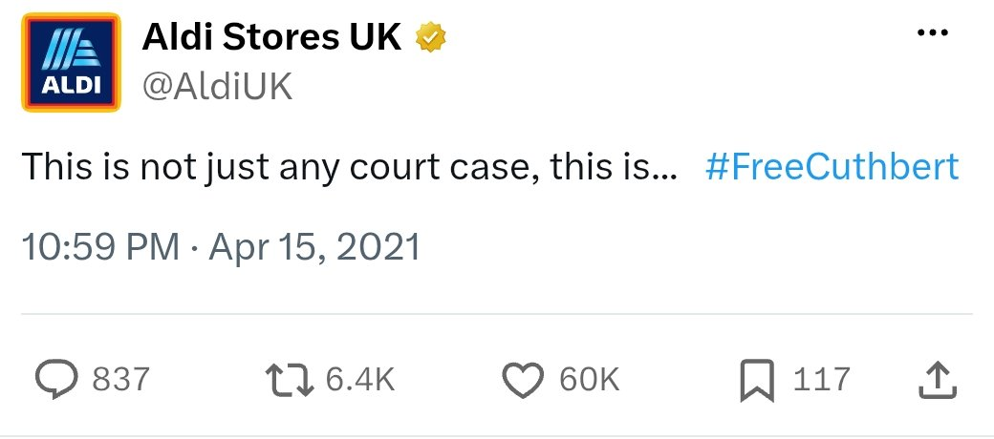 | P02  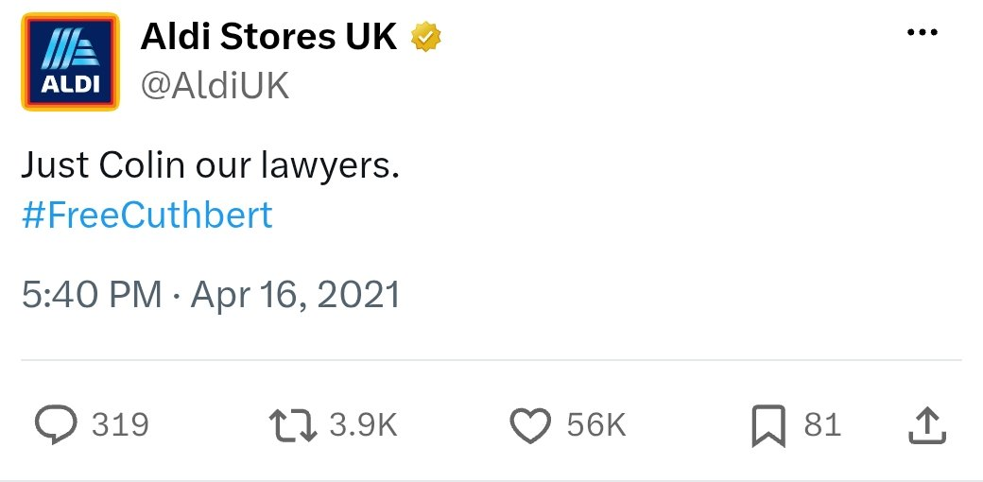
P03  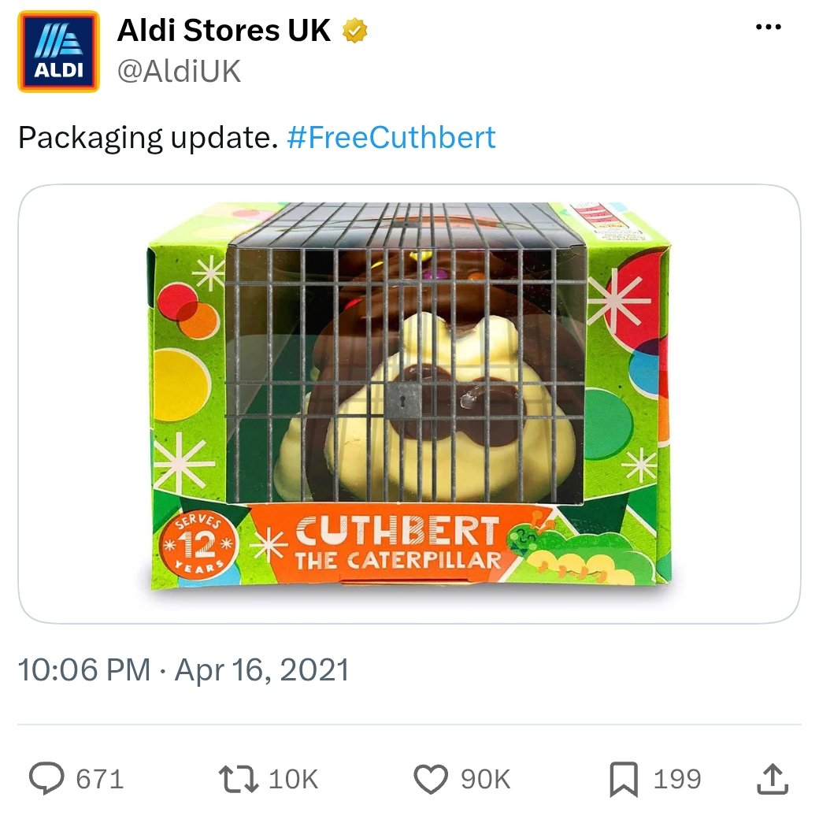 | P04  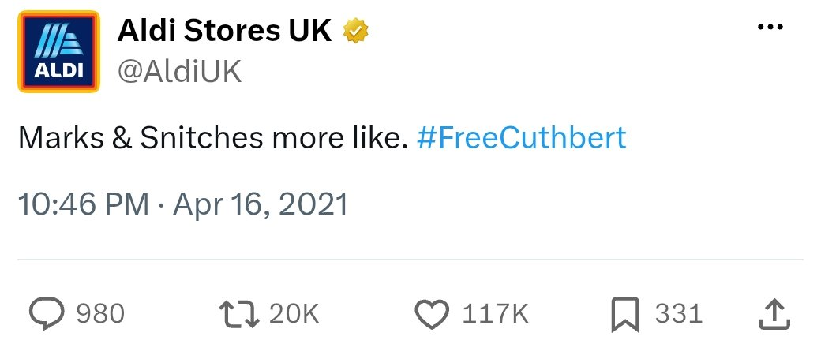
P05  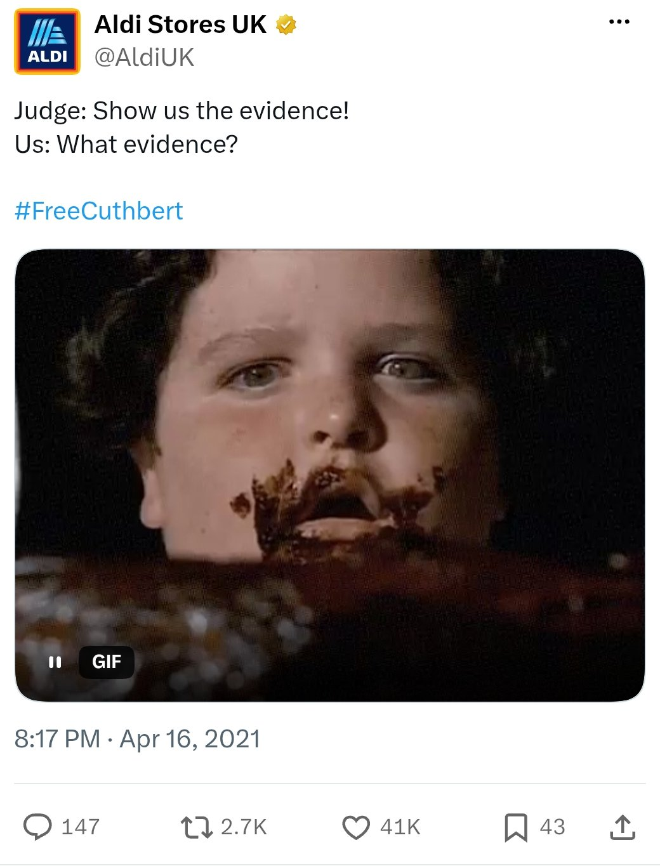 | P06  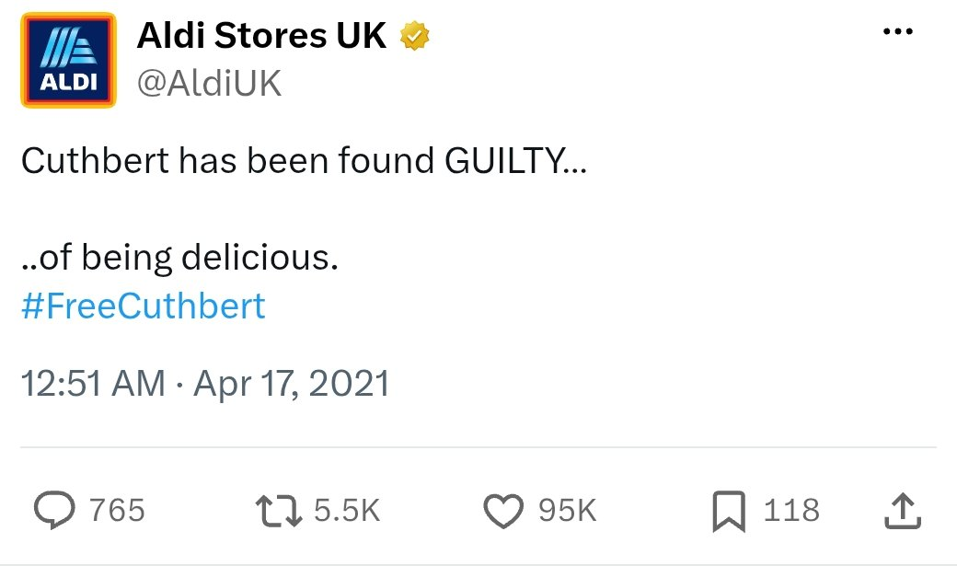
P07  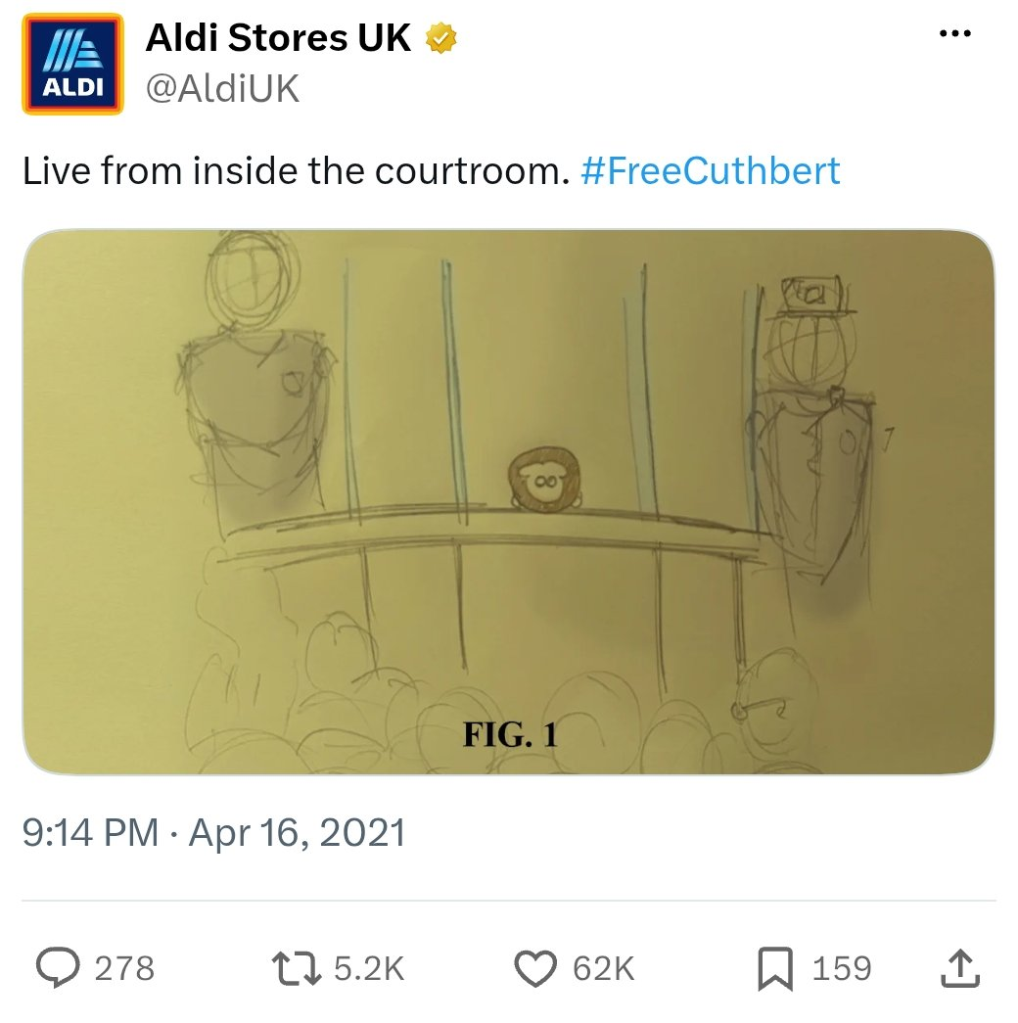 | P08  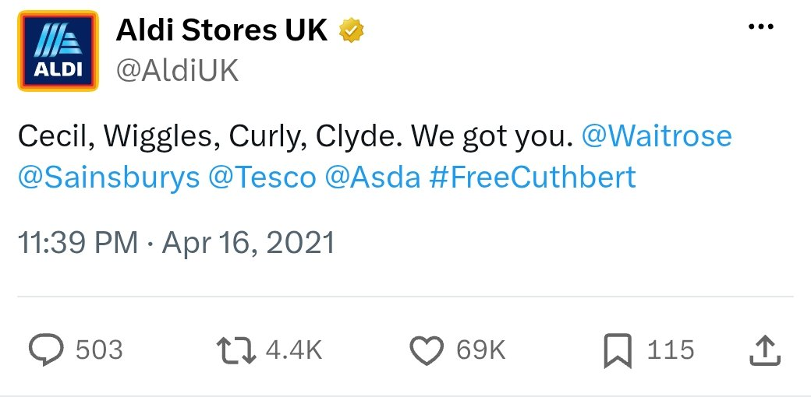
P09  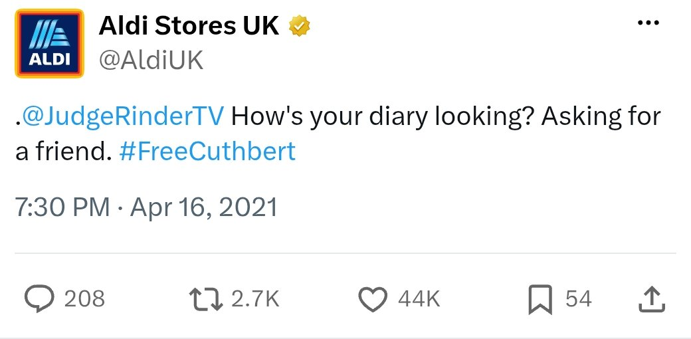 | P10  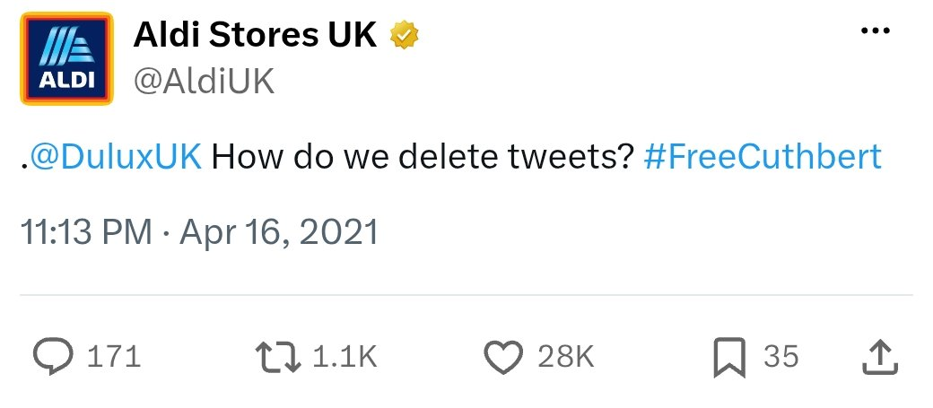
P11  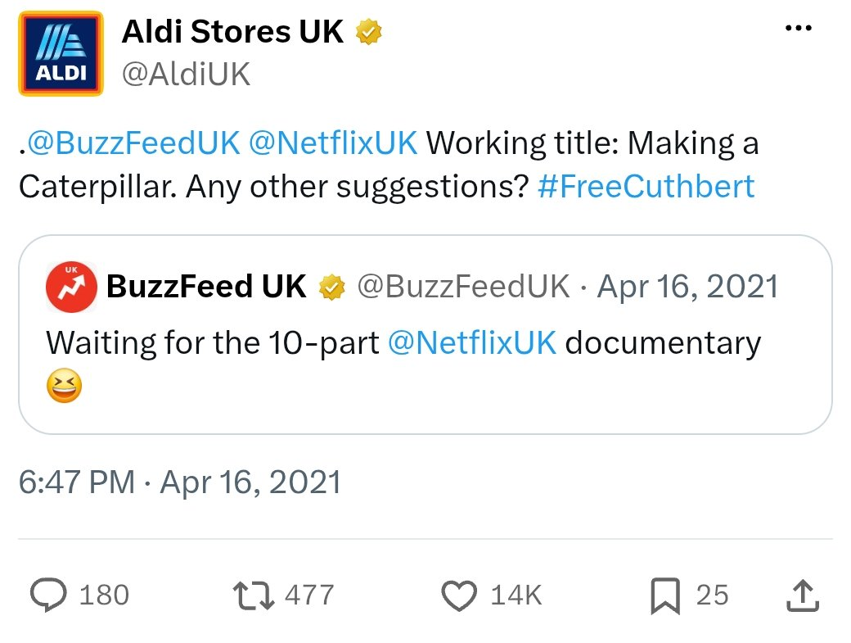 | P12  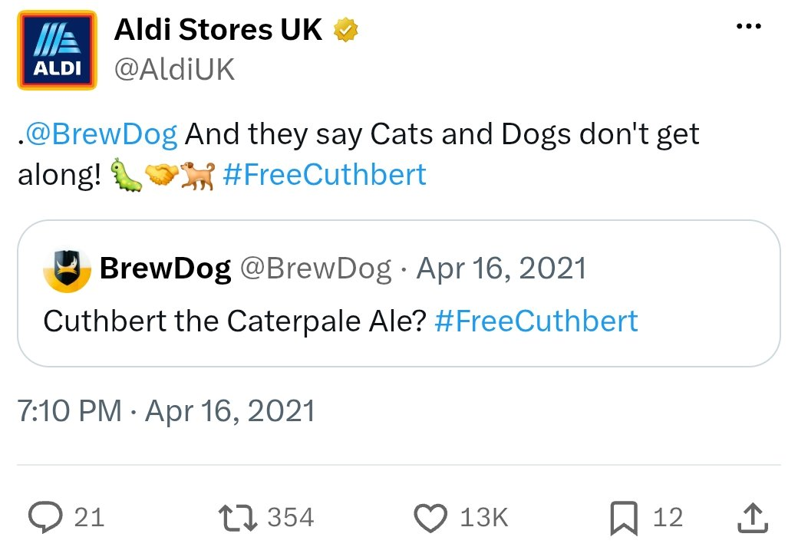
P13  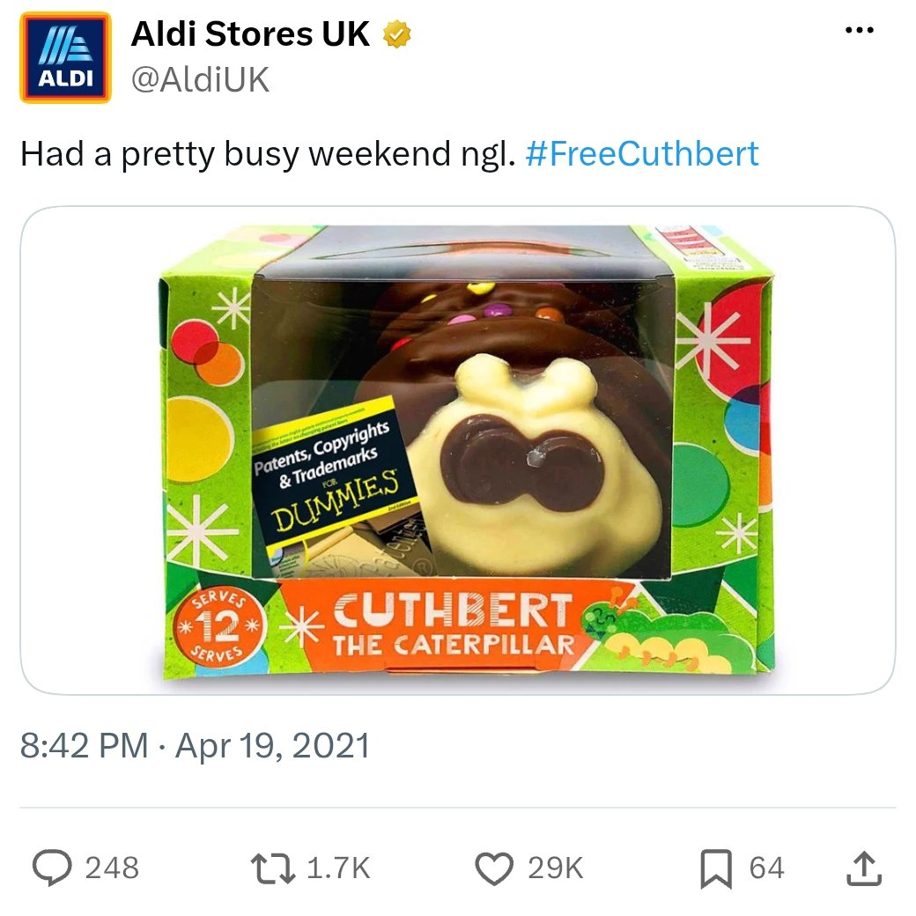 | P14  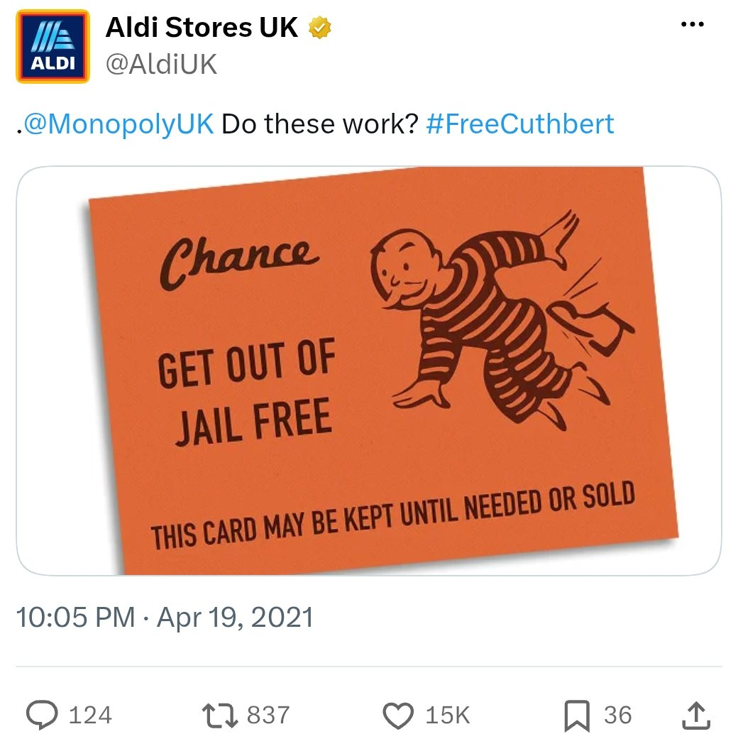
P15  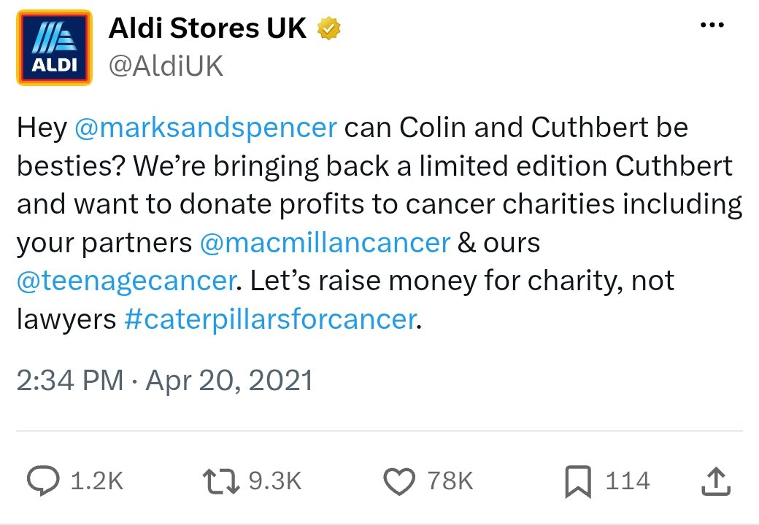 | P16  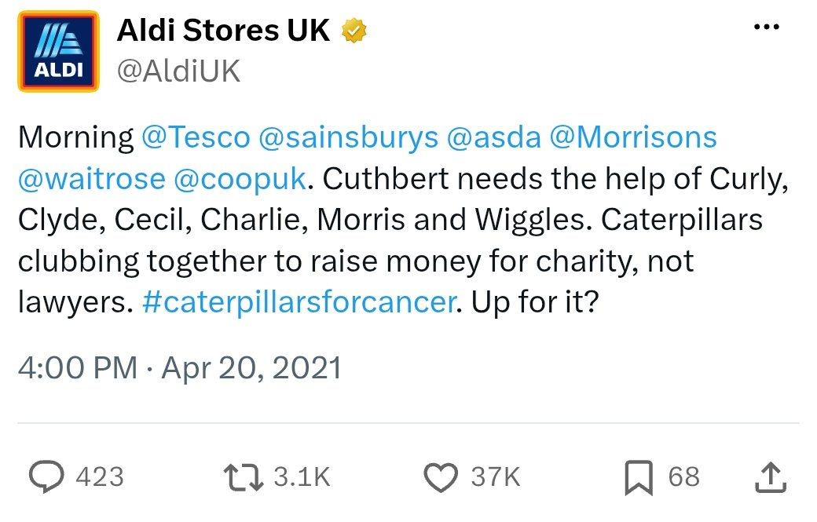

Appendix B: Secondary Source Log
This log lists the contemporaneous external sources used in Chapter Four for which a full reference is provided in the Reference List. One further article, from The Independent, was identified but excluded because its wording and publication date could not be verified. One primary post (P17) was also excluded; see Appendix A. S01–S03 were published later in 2021 in an awards context and are treated as retrospective industry assessments (Section 3.4). The coding of all eleven sources is reported in Appendix F.
ID | Source | Category | Full reference
S01 | Marketing Week | Marketing trade | Marketing Week (2021) ‘How Aldi’s ‘Free Cuthbert’ campaign won the supermarket caterpillar wars’, 22 November. Available at: https://www.marketingweek.com/masters-awards-aldi-free-cuthbert/ (Accessed: 10 July 2026).
S02 | The Drum | Marketing trade | The Drum (2021) ‘Aldi’s #FreeCuthbert campaign takes Grand Prix at The Drum Awards for Social Media’, 12 November. Available at: https://www.thedrum.com/news/aldis-freecuthbert-campaign-takes-grand-prix-the-drum-awards-social-media (Accessed: 10 July 2026).
S03 | eurobest | Marketing trade (awards) | eurobest (2021) ‘#FreeCuthbert’. Available at: https://www2.eurobest.com/winners/2021/social_and_influencer/entry.cfm?entryid=3529 (Accessed: 20 August 2026).
S04 | Geldards LLP | Legal-professional | Geldards LLP (2021) ‘Colin v Cuthbert: not just any caterpillar cake…’, 23 April. Available at: https://www.geldards.com/insights/colin-v-cuthbert-not-just-any-caterpillar-cake/ (Accessed: 21 September 2026).
S05 | Wilson Gunn | Legal-professional | Wilson Gunn (2021) ‘Marks and Spencer v Aldi – Colin v Cuthbert’, 28 May. Available at: https://www.wilsongunn.com/resource/news/trade-marks/marks-and-spencer-v-aldi-colin-v-cuthbert-2 (Accessed: 21 September 2026).
S06 | ITV News | Mainstream news | ITV News (2021) ‘Cuthbert the Caterpillar stages comeback to raise money for charity amid copyright row with M&S’, 20 April. Available at: https://www.itv.com/news/2021-04-20/cuthbert-the-caterpillar-stages-comeback-to-raise-money-for-charity-amid-copyright-row-with-m-and-s (Accessed: 23 September 2026). Quote used: “Aldi’s social media team have responded to legal action with a stream of mocking posts and memes.”
S07 | LBC | Mainstream news | LBC (2021) ‘Aldi announces return of Cuthbert the Caterpillar amid copyright row with M&S’, April. Available at: https://www.lbc.co.uk/article/063c59b70fc3458aaaf7da5bcf2e13ab-DWyts5_2/ (Accessed: 23 September 2026). Quote used: “Aldi’s social media team promptly responded with a stream of posts about the upcoming legal challenge and a sketch of Cuthbert in court.”
S08 | RTÉ News (Ireland) | Mainstream news | RTÉ News (2021) ‘#CaterpillarWars cake dispute takes flight on Twitter’, 16 April. Available at: https://www.rte.ie/news/newslens/2021/0416/1210355-cake-dispute/ (Accessed: 23 September 2026). Quote used: “The dispute has gone viral on social media, with users making jokes and sharing photos of their own caterpillar cakes.”
S09 | Harper Macleod LLP | Legal-professional | Harper Macleod LLP (2021) ‘Colin v Cuthbert: the great British cake-off’. Available at: https://www.harpermacleod.co.uk/insights/colin-v-cuthbert-the-great-british-cakeoff/ (Accessed: 23 September 2026).
S10 | Swinburne Maddison LLP | Legal-professional | Swinburne Maddison LLP (2021) ‘Key legal considerations in the battle of Colin v Cuthbert’, 10 May. Available at: https://www.swinburnemaddison.co.uk/insights/article/key-legal-considerations-in-the-battle-of-colin-v-cuthbert/ (Accessed: 23 September 2026). Quote used: “Aldi’s PR team have wholeheartedly embraced this opportunity and gone full tilt with their social media response.”
S11 | Legal Cheek | Legal-professional (legal news) | Hussain, A. (2021) ‘Lawyer bakes ‘Kavanagh Caterpillar QC’ cake to ‘defend’ Aldi’s Cuthbert in tasty IP battle’, Legal Cheek, 30 April. Available at: https://www.legalcheek.com/2021/04/lawyer-bakes-kavanagh-caterpillar-qc-cake-to-defend-aldis-cuthbert-in-tasty-ip-battle/ (Accessed: 23 September 2026). Quote used: “Aldi hit back with a series of jokey tweets.”

Appendix C: Codebook
The eight interpretive codes applied to every post in the primary corpus (Section 3.6). A post received a code (1) when it met the definition below, and no code (0) otherwise.
Code | Definition
Humour | The post uses a joke, pun, irony, or funny image.
Personification | The post presents Cuthbert or another caterpillar as having human feelings, actions, or roles.
Narrative Progression | The post adds a new part or development to the campaign story.
Challenger Positioning | The post presents Aldi as challenging or responding to M&S.
Cultural Reference | The post refers to popular culture, entertainment, games, or another recognisable brand.
Brand Personality Cue | The post shows Aldi’s informal, playful, cheeky, or conversational style.
Charity Linkage | The post directly mentions charity, fundraising, or a charitable cause.
Legal Sensitivity | The post directly refers to the court case, lawyers, evidence, or legal dispute.

Appendix D: Coding Matrix and Coding Justifications
Table D1 records the code applied (1) or not applied (0) to each post. The column totals produce the frequencies reported in Table 4.3. Table D2 gives the author’s justification for every code applied to each post, so that each “1” in Table D1 can be checked against the post itself.
Table D1: Coding Matrix (n = 16)
ID | Hum. | Pers. | Narr. | Chall. | Cult. | Brand | Char. | Legal
P01 | 1 | 1 | 1 | 1 | 1 | 1 | 0 | 1
P02 | 1 | 1 | 1 | 1 | 0 | 1 | 0 | 1
P03 | 1 | 1 | 1 | 0 | 1 | 1 | 0 | 1
P04 | 1 | 0 | 1 | 1 | 1 | 1 | 0 | 0
P05 | 1 | 1 | 1 | 1 | 1 | 1 | 0 | 1
P06 | 1 | 1 | 1 | 1 | 1 | 1 | 0 | 1
P07 | 1 | 1 | 1 | 1 | 1 | 1 | 0 | 1
P08 | 1 | 1 | 1 | 1 | 1 | 1 | 0 | 0
P09 | 1 | 1 | 1 | 0 | 1 | 1 | 0 | 1
P10 | 1 | 0 | 1 | 0 | 1 | 1 | 0 | 0
P11 | 1 | 0 | 1 | 0 | 1 | 1 | 0 | 0
P12 | 1 | 1 | 1 | 0 | 1 | 1 | 0 | 0
P13 | 1 | 1 | 1 | 1 | 0 | 1 | 0 | 0
P14 | 1 | 0 | 1 | 0 | 1 | 1 | 0 | 0
P15 | 1 | 1 | 1 | 1 | 1 | 1 | 1 | 1
P16 | 1 | 1 | 1 | 1 | 1 | 1 | 1 | 1
Total | 16 | 12 | 16 | 10 | 14 | 16 | 2 | 9
% | 100.0 | 75.0 | 100.0 | 62.5 | 87.5 | 100.0 | 12.5 | 56.3
Key: Hum. = Humour; Pers. = Personification; Narr. = Narrative Progression; Chall. = Challenger Positioning; Cult. = Cultural Reference; Brand = Brand Personality Cue; Char. = Charity Linkage; Legal = Legal Sensitivity.
Table D2: Coding Justifications
ID | Why these codes were applied
P01 | Humour and Cultural Reference: parodies M&S’s well-known “This is not just any…” advertising slogan. Personification: Cuthbert is framed as a party to a “court case”. Narrative Progression: introduces the #FreeCuthbert story. Challenger Positioning: responds directly to M&S’s action. Brand Personality Cue: informal, playful tone. Legal Sensitivity: refers directly to the court case.
P02 | Legal pun: Humour is a legal term. Personification: Cuthbert is addressed as if he were a person in need of legal assistance. Narrative Progression: continues the narrative of the courtroom. Challenger Positioning: a fun reaction to M&S' legal move. Affecting Cue: playfulness, humorous language. Legal Sensitivity: refers to lawyers.
P03 | Humour and Personification: the post depicts the Cuthbert cake box as having jail bars and padlocks over the window, likening Cuthbert to a prisoner (Appendix A2). Narrative Progression: Cuthbert is "imprisoned". Cultural Reference: uses familiar popular culture prison imagery. Brand Personality Cue: A mock-corporate “Packaging update” used playfully. Legal Sensitivity: imprisonment is depicted as a result of the legal disagreement.
P04 | Humour and Cultural Reference: “Marks & Snitches” is wordplay on a recognisable brand name and the slang term “snitches”. Narrative Progression: casts M&S as the informer in the story. Challenger Positioning: a direct jibe at M&S. Brand Personality Cue: informal and cheeky style.
P05 | Humour: turns a courtroom exchange into a joke (“Judge: Show us the evidence! Us: What evidence?”). Cultural Reference: the “Judge: … Us: …” meme format and a GIF from the chocolate-cake scene in the film Matilda, implying the “evidence” has been eaten. Personification: Cuthbert is treated as a defendant in the case. Narrative Progression: the story moves into the trial. Challenger Positioning: mocks the strength of M&S’s case. Brand Personality Cue: conversational meme style. Legal Sensitivity: uses “Judge” and “evidence”.
P06 | Humour: Cuthbert is “GUILTY… of being delicious”. Personification: Cuthbert receives a verdict like a person on trial. Narrative Progression: the trial reaches a “verdict”. Challenger Positioning: undercuts M&S’s accusation by recasting it as praise. Cultural Reference: borrows the courtroom-drama verdict convention. Brand Personality Cue: playful tone. Legal Sensitivity: uses legal language (“guilty”).
P07 | Humour and Cultural Reference: parodies courtroom-sketch reporting—the post includes a pencil sketch (FIG. 1), labelled with the courtroom, of Cuthbert in the dock. Personification: Cuthbert is on trial as a person. Narrative Progression: Picks up the trial story line. Challenger Positioning: makes the action of M&S a public performance. Target Product: a yellow plastic cup.Target Audience: 3- to 4-year-olds. Legal Sensitivity: refers to the courtroom.
P08 | Humour and Personification: talks about the caterpillars from the supermarkets that have Cuthbert in their back (Cecil, Wiggles, Curly, Clyde). Narrative Progression: broadens the characters in the story. Challenger Positioning: implicitly conflicts with M&S by building a coalition of other retailers' recognisable products. Cultural Reference: is the other retailers' recognisable product. Brand Personality Cue: casual and energising voice.
P09 | Humour: asks TV judge Judge Rinder whether he is free, “Asking for a friend”. Personification: the “friend” is Cuthbert, treated as a person needing a judge. Narrative Progression: the story seeks a judge. Cultural Reference: a well-known TV personality. Brand Personality Cue: direct, conversational reply. Legal Sensitivity: refers to judging the case.
P10 | Humour: self-deprecating question to Dulux, “How do we delete tweets?”. Narrative Progression: comments on Aldi’s own role in the unfolding story. Cultural Reference: brings in another recognisable brand. Brand Personality Cue: self-aware, informal style.
P11 | Humour and Cultural Reference: proposes a documentary, “Working title: Making a Caterpillar”, echoing well-known true-crime documentary titles. Narrative Progression: presents the saga as a story worthy of a film. Brand Personality Cue: playful, informal tone.
P12 | Humour and Cultural Reference: the “Cats and Dogs” line uses a familiar phrase in a reply to BrewDog, another recognisable brand. Personification: the campaign characters are treated as able to make friends. Narrative Progression: adds a new ally to the story. Brand Personality Cue: conversational tone.
P13 | Humour and Brand Personality Cue: understated, slang wording (“Had a pretty busy weekend ngl”). Personification: gives Cuthbert’s situation a human feel. Narrative Progression: resumes the story after the weekend. Challenger Positioning: keeps Aldi’s playful challenge to M&S alive into the new week.
P14 | Humour and Cultural Reference: asks Monopoly whether its cards “work”, referring to a familiar board game. Narrative Progression: continues the imprisonment storyline. Brand Personality Cue: playful tone.
P15 | Humour and Personification: suggests Colin and Cuthbert become “besties”. Narrative Progression: turns the story towards reconciliation. Challenger Positioning and Cultural Reference: addressed directly to @marksandspencer, a recognisable brand and Aldi’s opponent. Brand Personality Cue: friendly, informal tone. Charity Linkage: moves the campaign towards charity. Legal Sensitivity: contrasts charity with money spent on lawyers.
P16 | Humour and Personification: asks other supermarkets to bring their caterpillars together. Narrative Progression: extends the story into a charitable phase. Challenger Positioning and Cultural Reference: names several competing brands (@Tesco, @sainsburys, @asda). Brand Personality Cue: informal greeting. Charity Linkage: makes the charity purpose explicit. Legal Sensitivity: contrasts raising money for charity with spending money on lawyers.

Appendix E: Evidence Trail from Data to Conclusions
Table E1 shows, for each theme reported in Chapter Four, the coded data on which it rests (Appendices A, D and F), where it is reported as a finding, where it is interpreted in Chapter Five, and which conclusions or recommendations in Chapters Five and Six draw on it. Post and source IDs refer to Appendices A and B; code frequencies refer to Table D1 and Table F2.
Table E1: Evidence Trail (Data → Codes → Themes → Findings → Interpretation → Conclusions)
Theme (RQ) | Data and codes | Finding | Interpretation | Conclusion / recommendation
T1. Three-phase campaign structure (RQ1) | Publication dates and times (Appendix A): P01 on 15 April; P02–P12 on 16 April; P13–P16 on 19–20 April. Narrative Progression 16/16; Charity Linkage only in P15–P16. Phase structure identified inductively from the timing data (Section 3.6). | 4.2.2; 4.3.2 | 5.2.2 (structure consistent with structured improvisation, not evidence of planning) | 6.1 (RQ1); 6.2 Contribution 3; 5.6 Implication 4; 6.4 Recommendation 4
T2. Humour as a sustained but controlled device (RQ2, RQ4) | Humour 16/16. Character-based: P03, P05, P06. Self-deprecating: P10. Observational (no personification): P04, P10, P11, P14. Only P04 mocks M&S by name. | 4.3.1; 4.4.1 Feature 2 | 5.3.1; 5.3.4 | 6.1 (RQ2, RQ4); 6.6
T3. Displacement of conflict onto a character (RQ2, RQ4) | Personification 12/16 (all posts except P04, P10, P11, P14); Legal Sensitivity 9/16, always expressed through Cuthbert’s story (P01–P03, P05–P07, P09, P15, P16). | 4.3.2; 4.4.1 Feature 1 | 5.3.1; 5.4.1 | 5.6 Implication 3; 6.4 Recommendation 3
T4. Challenger positioning that softens into cooperation (RQ2) | Challenger Positioning 10/16; direct jibe in P04; continued in Phase 3 (P13, P15, P16) in a cooperative form (P15 addressed to @marksandspencer). Brand Personality Cue 16/16. | 4.3.3 | 5.3.2; 5.5 Tension 2 | 5.6 Implication 2; 6.4 Recommendation 5
T5. Constructed British cultural relevance (RQ2) | Cultural Reference 14/16 (all except P02, P13); familiar brands and public figures in P09, P10, P12, P14, P16; UK slang and understatement in P02, P13. | 4.3.4 | 5.3.3 | 5.6 Implication 1; 6.4 Recommendation 2
T6. Legal sensitivity handled through humour, not legal argument (RQ4) | Legal Sensitivity 9/16; no post argues the legal merits or denies liability (Table D2). Secondary codes SC5–SC7: none of the eleven sources suggests the campaign created new legal risk (Table F2). | 4.4.1 Feature 4; 4.4.2 | 5.4.2 | 5.6 Implication 3; 6.4 Recommendation 3
T7. Charitable extension as a route to resolution (RQ4) | Charity Linkage 2/16 (P15, P16), both also coded Legal Sensitivity; charity comeback reported by ITV News (S06). | 4.2.2; 4.4.1 Feature 3; 4.4.3 | 5.2.2; 5.4.1; 5.5 Tension 3 | 6.1 (RQ4); 6.4 Recommendation 4; 6.6
T8. Framing differs by professional lens (RQ3) | Secondary codes (Table F2): SC1 success framing mainly in trade press (S01–S03); SC2 humour/virality framing in mainstream news (S06–S08); SC5 legal-merits focus in legal-professional sources (S04, S05, S09, S10); SC6 campaign–legal link only in S09 and S10. | 4.3.5 | 5.4.1; 5.4.2 | 6.1 (RQ3); 6.2 (closing note); 6.4 Recommendation 6
Note: counts refer to the 16-post primary corpus (Table D1) and the eleven-source secondary corpus (Table F2). Section numbers refer to this dissertation.

Appendix F: Secondary Source Codebook and Coding Matrix
The eleven secondary sources (Appendix B) were coded manually against the seven framing codes in Table F1. A source received a code (1) when it met the definition and no code (0) otherwise. Table F2 records the coding, and Table F3 gives the evidence for each source’s coding. These codes support the comparison of external framing in Section 4.3.5 (RQ3).
Table F1: Secondary Source Codebook
Code | Definition
SC1 Success framing | The source presents the campaign as a creative, strategic or award-worthy success.
SC2 Humour/virality framing | The source presents the campaign mainly as a humorous or viral social media story.
SC3 Challenger framing | The source presents Aldi as a challenger, disruptor or underdog in relation to M&S.
SC4 Public participation / cultural resonance | The source describes the public joining in with, supporting or responding to the campaign.
SC5 Legal-merits focus | The source analyses the trade mark or passing-off merits of M&S’s claim.
SC6 Campaign–legal link | The source explicitly links the social media campaign to the legal or reputational stakes of the case.
SC7 Risk of Aldi’s approach assessed | The source assesses reputational or legal risks created by Aldi’s social media approach.
Table F2: Secondary Source Coding Matrix (n = 11)
ID | SC1 | SC2 | SC3 | SC4 | SC5 | SC6 | SC7
S01 | 1 | 1 | 1 | 1 | 0 | 0 | 0
S02 | 1 | 0 | 0 | 0 | 0 | 0 | 0
S03 | 1 | 0 | 0 | 0 | 0 | 0 | 0
S04 | 1 | 1 | 0 | 0 | 1 | 0 | 0
S05 | 0 | 0 | 0 | 0 | 1 | 0 | 0
S06 | 0 | 1 | 0 | 0 | 0 | 0 | 0
S07 | 0 | 1 | 0 | 0 | 0 | 0 | 0
S08 | 0 | 1 | 0 | 1 | 0 | 0 | 0
S09 | 0 | 0 | 0 | 1 | 1 | 1 | 0
S10 | 0 | 0 | 0 | 0 | 1 | 1 | 0
S11 | 0 | 1 | 0 | 1 | 0 | 0 | 0
Total | 4 | 6 | 1 | 4 | 4 | 2 | 0
Key: SC1 = Success framing; SC2 = Humour/virality framing; SC3 = Challenger framing; SC4 = Public participation / cultural resonance; SC5 = Legal-merits focus; SC6 = Campaign–legal link; SC7 = Risk of Aldi’s approach assessed. SC7 was applied to no source; this absence supports the finding in Section 4.3.5 that no source assessed the risks of Aldi’s approach.
Table F3: Secondary Source Coding Justifications
ID | Why these codes were applied
S01 | SC1: reports the campaign as Aldi’s biggest news story to date. SC2: reports number-one trending status. SC3: links it to Aldi’s ‘lovable disrupter’ reputation. SC4: reports more than 30 million views of user-generated video (Table 4.2).
S02 | SC1: describes the campaign as a “masterclass” in reactive social media marketing and reports the jury chair’s praise for it as crisis management; it does not assess the risks of Aldi’s approach (SC7 = 0).
S03 | SC1: the campaign creators’ awards entry presents the campaign as agile and super-responsive and describes the decision to “turn up the volume” (Section 5.2.2).
S04 | SC5: concentrates on the legal basis of M&S’s claim. SC1 and SC2: separately describes Aldi’s Twitter response as an exceptionally successful PR campaign attracting thousands of likes and retweets. SC6 = 0 because the campaign is not linked to the legal stakes.
S05 | SC5: analyses M&S’s trade mark and passing-off arguments without discussing Aldi’s social media campaign.
S06 | SC2: reports that Aldi’s social media team responded to the legal action with “a stream of mocking posts and memes” and reports the later move towards charity.
S07 | SC2: describes a stream of posts about the legal challenge, including a sketch of Cuthbert in court.
S08 | SC2 and SC4: presents the dispute as a viral story in which users joined in with jokes and photos of their own caterpillar cakes.
S09 | SC5: discusses the legal merits. SC4 and SC6: links the volume of social media comment and the public’s apparent support for Aldi to the suggestion that M&S may have misjudged the moment.
S10 | SC5: sets out key legal considerations. SC6: asks whether Aldi’s campaign, by drawing in other retailers, highlighted how many similar cakes exist and so weakened M&S’s case.
S11 | SC2 and SC4: reports the dispute light-heartedly, repeating Aldi’s jokey tweets and describing a lawyer baking a cake to “defend” Cuthbert; it does not analyse the legal issues (SC5 = 0).

