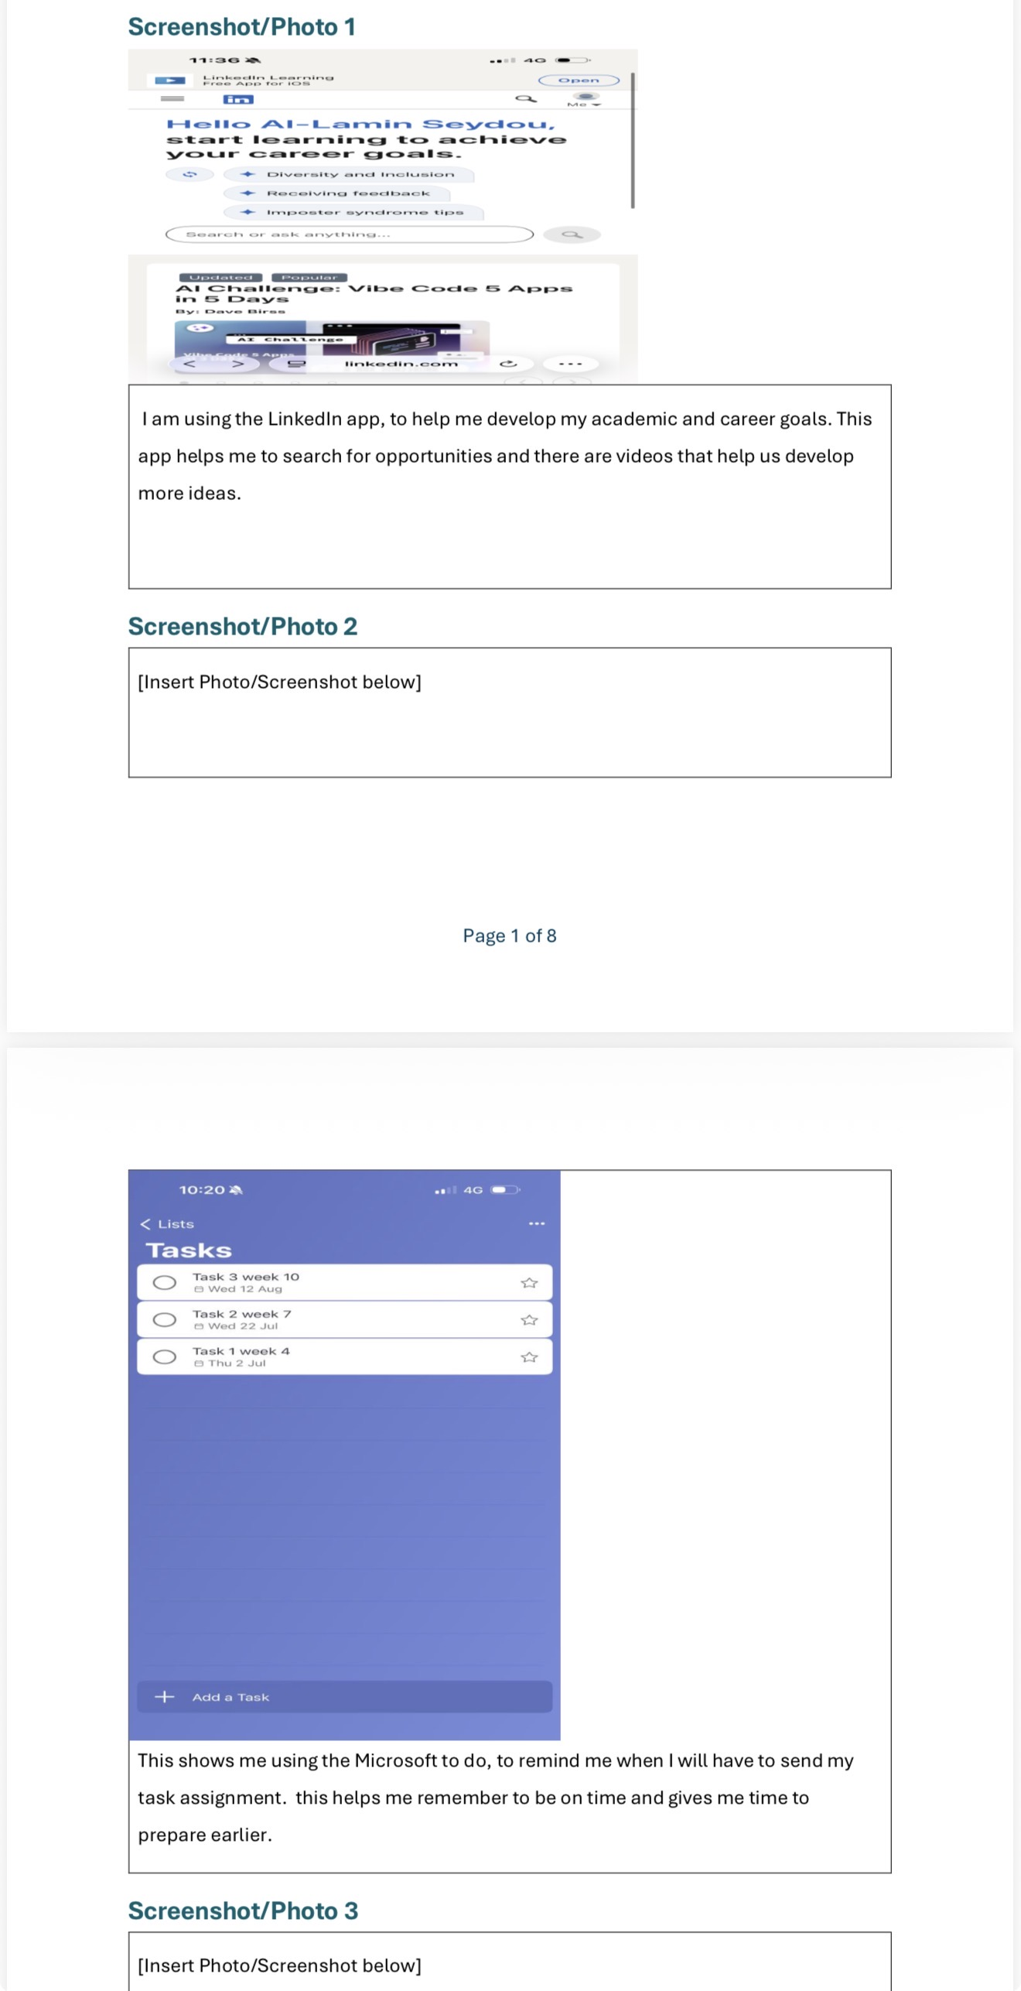
THE PORTFOLIO: MY DIGITAL LIFE-DS1

The image shows how I use digital tools to support my academic and career development. The first screenshot shows me using LinkedIn to explore career opportunities, develop latest ideas, and access useful learning resources and videos. This helps me improve my knowledge and become more aware of opportunities that can support my future career goals.
The second screenshot shows me using Microsoft to Do to organise my assignments and tasks. I use it to set reminders and keep track of deadlines, which helps me manage my time effectively and prepare for my work in advance.
Through these activities, I used several important skills, including digital literacy, time management, organisation, research, communication, and self-motivation. I also developed my ability to use online platforms for learning and career development. Overall, these digital tools help me stay organised, meet deadlines, discover opportunities, and work towards achieving my academic and career goals.
Tool, I used- Microsoft word.
Skills I used- explaining what each screenshot shows, showing my strengths and weaknesses. Using software to explain my work.

DS2 SCENARIO: NICK BEE

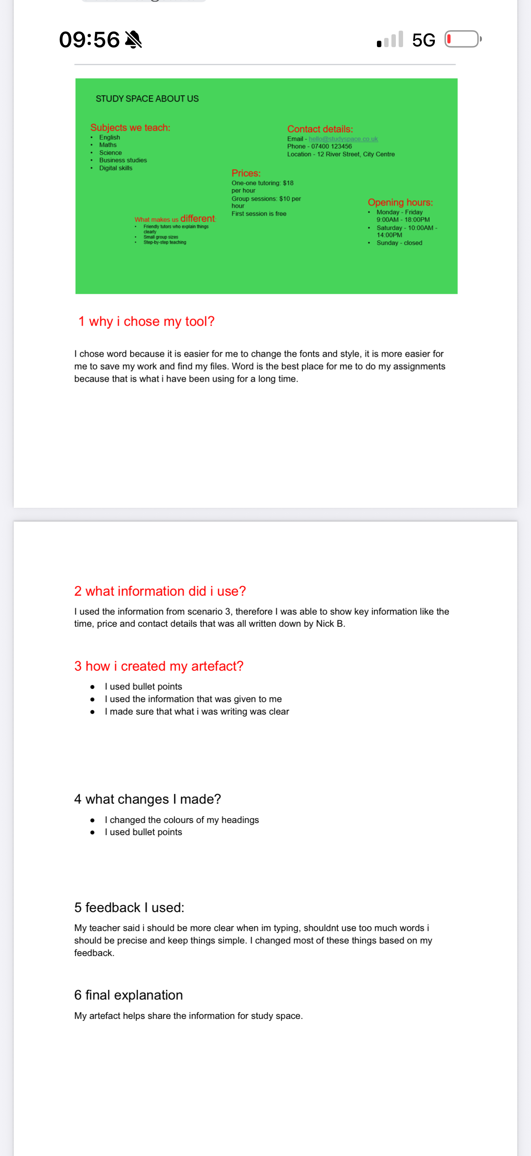
This image shows my coursework document reflecting on a promotional flyer I created for a tutoring service called Study Space. My document displays a green banner at the top containing details like subjects taught, pricing, contact information, and opening hours, followed by numbered evaluation questions reflecting on my process.

To complete this assignment, I used PowerPoint and Microsoft Word. as my primary tools. I chose Word because I am familiar with it, and it makes it easy for me to format text, change fonts and styling, and manage my files.

Tool used- PowerPoint and Microsoft word.
Skills I used- using PowerPoints to create and design my work
Adjusting text and reducing the size.
Using clear image and colour so that the presentation is easier to understand.

ACADEMIC SKILLS – READING AND TAKING NOTES.

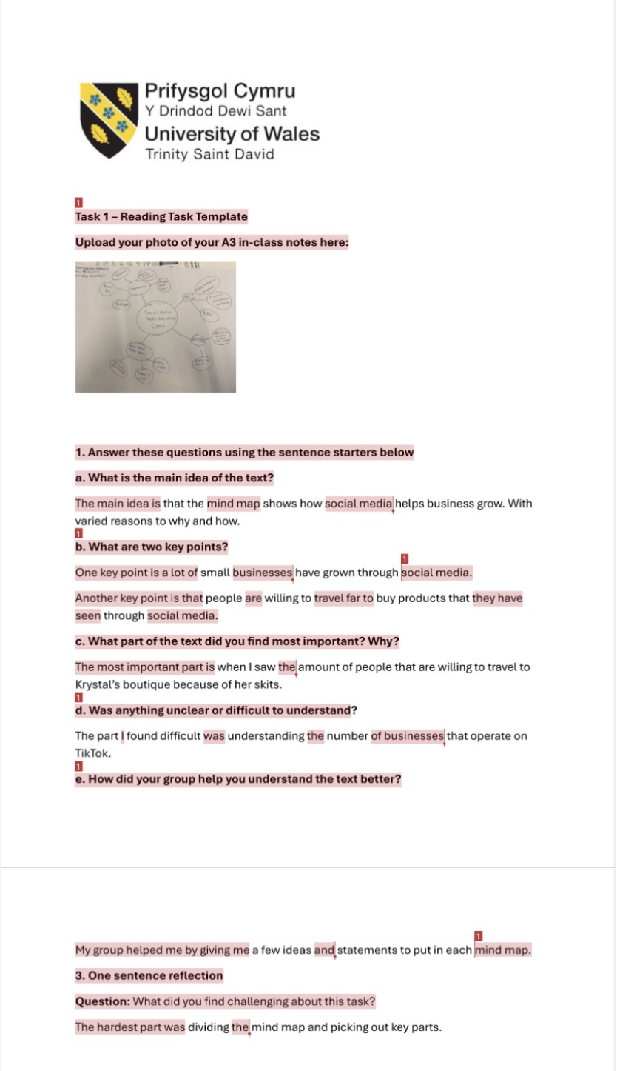
Tool used – Microsoft word.
Skills used –
Critical thinking, summarising skills, teamwork and collaboration, self reflection and finding key information

- What is showed? - An A3 mind map created during class, with social media and business growth as the main topic.

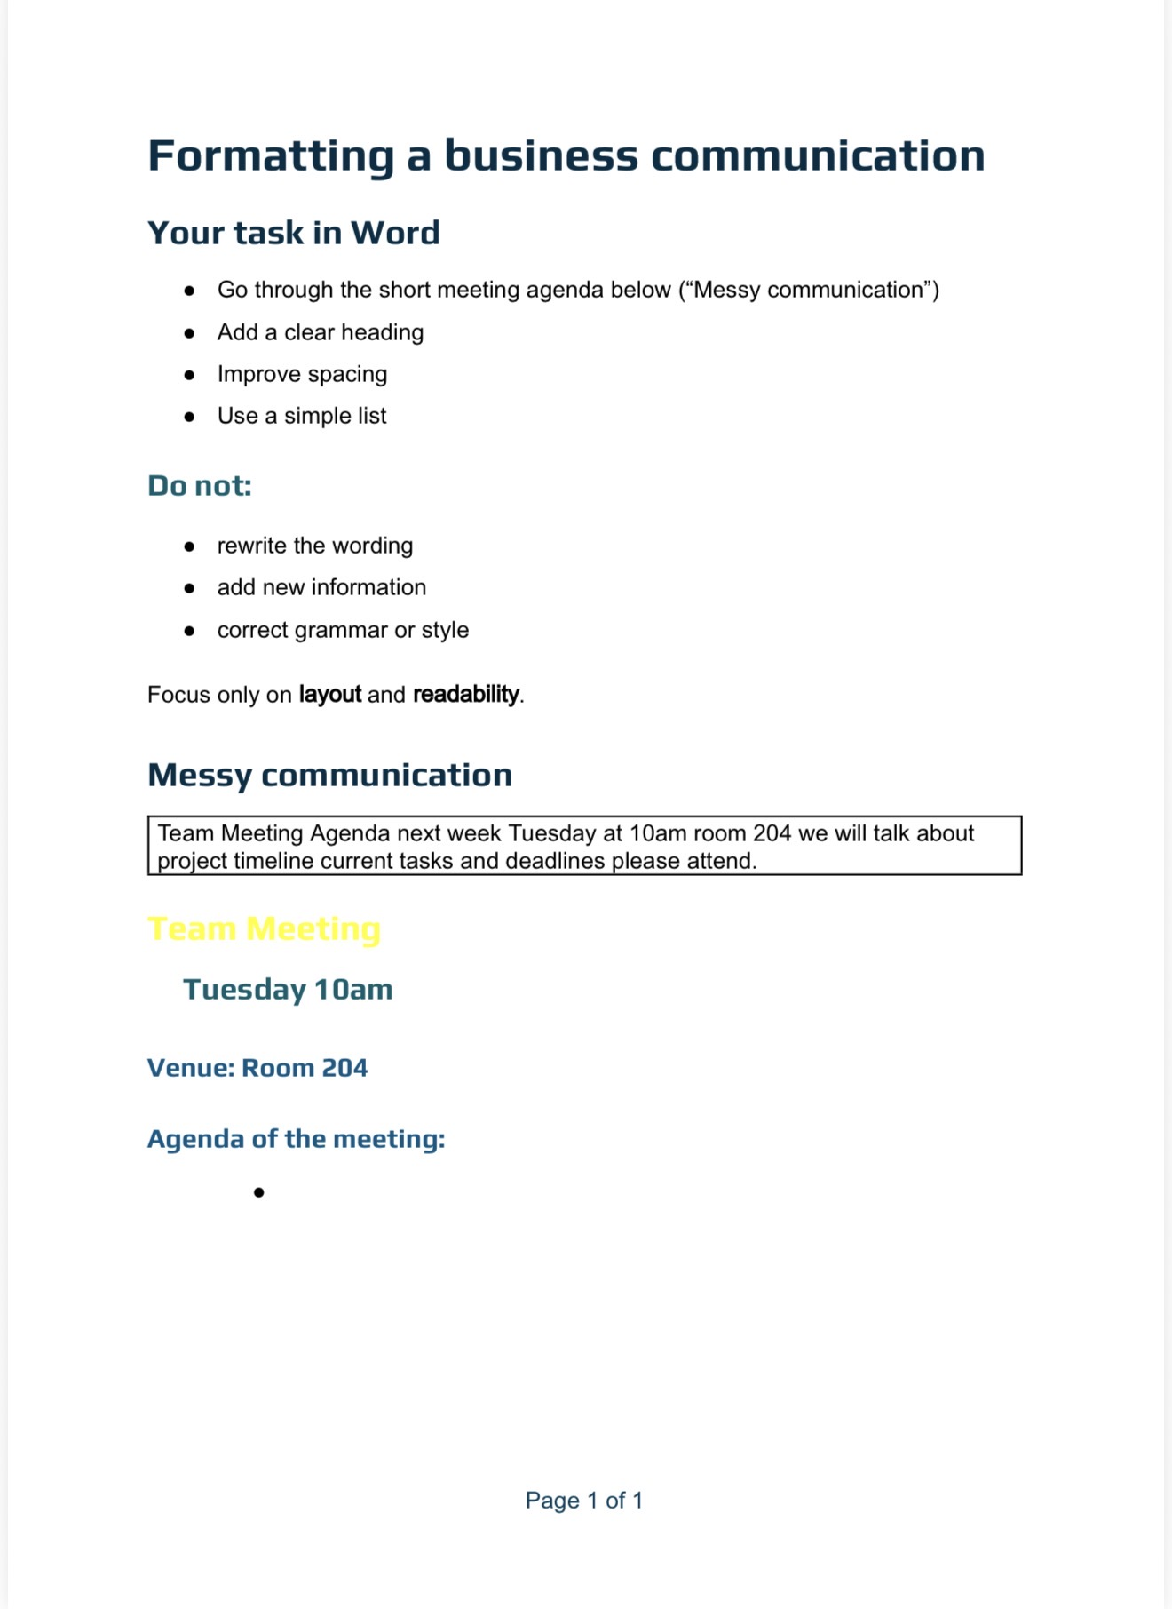
MESSY DOCUMENTS

What is showed?
The image shown above is a messy meeting agenda. And the task we had to do was improve the layout and readability without changing the words.

What tool I used?
Microsoft word.

What I found difficult?
What I found difficult was changing the messy document information that was giving without replacing or adding words. I had to pay attention to the spacing, heading and how to present the meeting information clearly.

CONCLUSION
This shows some of the topics that I done during the 10-week period. The first portfolio shows my digital life. The second portfolio shows DS2 scenario. The third portfolio shows the reading and taking notes that I done for AS2. And the final portfolio shows the messy document. The one that I found most difficult was the messy document because it was hard rewording sentences without adding words. The tool I found the most useful was Microsoft because it was quite easy to do most of my work and save it also, I had a little bit of experience with this tool.

