BMSW6102
Development of innovative product OR unique service proposition
Student Name: Andreea Scorpie
Student Number: 2030448
Lecturer’s Name: Charles Nwaogwugwu
Date : 30/08/2023

Eco-Beauty Online Service Company (EBOS)

Table of Contents
Task 1: Eco-Beauty Online Service Company (EBOS) 3
Executive Summary 3
Introduction 4
The Unique Service Proposition 4
eCommerce 6
Marketing 9
Privacy and Data Protection 11
Conclusion 12
References 13
Appendices 14
Task 2: Narrated Presentation 14

Task 1: Eco-Beauty Online Service Company (EBOS)

Executive Summary
This business plan aims to present a unique business idea using design-thinking, innovation models, and theories that explore the essential features of the innovation and creative processes. It will develop the Eco-Beauty Online Service Company (EBOS), offering high-quality beauty services through online platforms using video tutorials by professional cosmetologists. The company mission is to solve global beauty problems for ladies using innovation and sustainability concepts. The company is proposed to be based in Cardiff, Wales. The uniqueness of EBOS is that it will offer 100% of its services online and that all the services will be based on eco-friendly products and innovations. EBOS targets ladies who are 18 years and above around the globe. EBOS Company will open online shops with Shopify and Amazon, where it will outline its beauty services. Using its website, it will create several menus, including the service menu, the payment method menu, the customer service menu, the rating menu and the community development menu. The EBOS payment system will accept payment methods like card, mobile, and bank. The company will use promotional strategies such as social media, website & SEO marketing, direct mailing, special offers and referrals. All customer data shall be protected per the Data Protection Act 2018 and Privacy and Electronic Communications Regulations (PECR).

Introduction
Any company, regardless of the goods or services it provides, would benefit from developing a clear and actionable value proposition for its customers. The best value propositions help a company earn a competitive advantage and easily penetrate a new market. This business plan aims to present a unique business idea using design-thinking, innovation models, and theories that explore the essential features of the innovation and creative processes. The plan will identify a niche market in which to operate and provide recommendations about an e-commerce website via which the company may interact with its customers.

The Unique Service Proposition
Business Name
Eco-Beauty Online Service Company (EBOS) was derived from three ideas (digital innovation, environmental conservation and cosmetics). Eco means the natural environment since the company offers beauty services tailored from environmentally friendly products such as natural fruits. The Beauty aspect is used to represent the cosmetic services that the company will offer. The company will be purely an e-business, thus incorporating the online aspect in the name. Customers throughout the globe will be allowed to access the company's services through its website, where all the business operations shall be done. Furthermore, the customers will be interacted with through social media platforms such as Facebook, Twitter, Instagram, Tiktok and direct mailing.
Company Objective, Mission and Vision
The Eco-Beauty Online Service Company (EBOS) aims to offer high-quality beauty services through online platforms using video tutorials by professional cosmetologists. The company mission to solve global beauty problems for ladies using innovation and sustainability concepts. The company's vision is to be a world-leading beauty consultancy based on resource sustainability through digital innovation.
Services
The Eco-Beauty Online Service Company (EBOS) is a beauty service company offering eco-friendly beauty services through online video tutorials. The company will be based in Cardiff, Wales. There will be minimal physical contact with the customers since the company aims to target home-based customers accessing beauty advice and consultations online. The uniqueness of EBOS is that it will offer 100% of its services online and that all the services will be based on eco-friendly products and innovations. For instance, the company will advise its customers to acquire their beauty products from natural fruits such as grapes, palm fruits, avocadoes, lemons, and oranges, among others, as key primary ingredients in producing body lotions and oils. The goal is to improve the appearance and health of the customers' skin, especially the skin of the ladies. The main services to be offered by EBOS include;
- The company will provide consultancy services through video tutorials about making, using and maintaining lotions from natural fruits.
- The company will provide beauty consultancy advice through skills for mixing and using the oils for the customer's benefit.
- The company will provide beauty consultancy advice through video tutorials on how to apply sunscreen, facial oil, moisturisers, face wash and cleansers.
- It will also provide beauty consultancy advice through video tutorials on using exfoliators, toners, eye creams and serums.
Target Customers and Market
EBOS targets ladies who are 18 years and above. There are two sorts of customer segments that the company will prioritise meeting. First, it will create an extensive online presence to offer its services to customers worldwide. Second, it will establish a store in Cardiff, Wales, to physically offer beauty services to the residents in this area. The main market will be ladies who can access the internet across the globe. The company will develop an EBOS website that will contain a business system whereby customers will be able to interact with professional cosmetologists. The company's business system will also integrate aspects such as beauty service options, customer interaction options, payment options, and several cosmetologists, among other options. Customers from all continents will be able to access the EBOS website. The company will also use online platforms such as Facebook, Twitter, Instagram, Tiktok and direct mailing to interact with customers across the globe.
Business Sustainability
According to Dyllick and Muff (2016), business sustainability is doing business without negatively impacting the environment, community, or society. Besides offering beauty services to its customers, EBOS company will work closely with the community by fostering sustainability initiatives. The company will initiate the “EBOS use one and plant two’ initiative to discourage the community from depleting the fruits such as grapes, palm fruits, avocadoes, lemons, and oranges, among others, for beauty purposes. In addition, the company will be sponsoring the community with seedlings and gardening consultations.
Competitor Analysis
The number of business companies involved in the beauty industry has grown substantially in recent years due to the sector's inherent appeal. The increasing demand in the business may be attributed to its rising popularity. Some industry competitors that have dominated the global beauty market include Procter & Gamble, L’Oreal, Huda Beauty, NG Beauty World, and Unilever, among others (MarketWatch, 2023). Most firms in the global beauty industry face direct competition from these firms due to their market strengths. With absolute powerhouse brands like Charlotte Tilbury and Jo Malone London, as well as a significant number of little independent enterprises using fresh British ingredients, the United Kingdom is still a key player in the increasingly globalised beauty sector (Davies, 2021). Most of these competitors have established their strong competitiveness through the presence of physical stores and the selling of physical beauty products. However, few have invested in selling beauty products or services online. Their absence in the online beauty business and beauty consultancy services gives the EBOS company an added advantage in entering the beauty industry. The EBOS company will be unique, specifically offering beauty consultations and advice online. The services will be based on developing and using natural eco-friendly products for beauty.

eCommerce
The EBOS Company Online Shop
EBOS Company will open an online shop on Shopify to outline its beauty services. While in their homes, customers will be allowed to place orders for the respective services they need. Once the order is received, the EBOS beauty professionals will directly attend to them without involving suppliers or manufacturers, as shown in Figure 1 below.
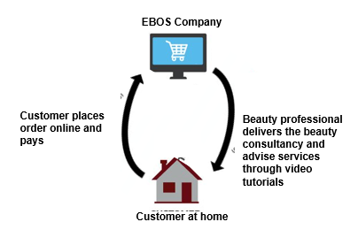
Figure 1: Customer ordering beauty services on EBOS's Shopify shop. (Source: author)
The EBOS Company will also open an online shop at Amazon. Like the Shopify shop, the EBOS at Amazon will not involve the suppliers or the manufacturers since it will directly deal with customers. The customers are only expected to order the beauty service they need and are linked to the respective professional beauty cosmetologist for a video tutorial. The customers will then pay after service delivery. Shopify and Amazon were chosen as the e-commerce platforms for this business plan because they allow customers to shop from the comfort of their own homes. Online shopping, as Taher (2021) argues, streamlines the process and puts the customer at ease.
Creating Content
The EBOS Company will offer beauty consultancy services through video tutorials via Shopify and Amazon as its main online platforms. However, the company expects to extend its services to online platforms like eBay and Alibaba. The service menu will highlight all the company's services in detail and have a preview tutorial video of about 10 seconds. The platform shall also have a payment method menu, customer service menu, rating menu and community development menu. The overview of the EBOS Company website shall be shown in Figure 2 below;
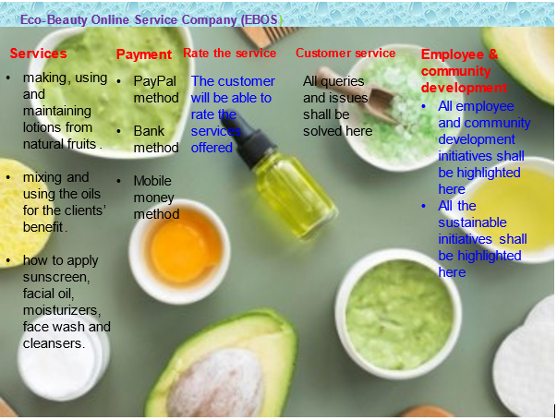
Figure 2: The EBOS Company website. (Source; author)
The service menu shall contain a detailed description of the beauty services EBOS Company offers with the respective beauty professionals. For instance, consultancy service tutorial videos about making, using and maintaining lotions from natural fruits and beauty consultancy tutorial videos inform of skills for mixing and using the oils for the customer's benefit. Other services will include; detailed beauty consultancy advice tutorial videos on using exfoliators, eye creams, toners, serums, sunscreen, facial oil, face wash, moisturisers and cleansers.
The payment menu will contain a system powered by the respective online platform (Amazon, eBay, Alibaba or Shopify). The payment options such as card, PayPal, mobile money or bank will be highlighted. This is because different countries across the globe allow varying money transfer methods. The customers shall also be allowed to rate various services received through the "rate the service menu." However, any customer has any query or issue shall be solved via the "customer service menu." Since EBOS Company will foster sustainability, it will also have an employee and community development menu where sustainability and development initiatives such as "use one plant two" shall be explained in detail.
Payment Services
The EBOS payment system will accept payment methods like cards, PayPal, mobile money and bank. However, before the company starts to operate, it will ensure that it complies with the PCI-DSS compliance requirements (Razack and CISA, 2022). For instance, the company will offer services like data encryption, complete system protection against malware, the installation of security solutions, and the development of secure software. EBOS Company will also ensure validation and certification as soon as possible before starting its operations. Based on the volume and type of data transactions performed, firms may choose from a number of PCI DSS compliance certification levels (Razack and CISA, 2022).

Marketing
Target Customers
EBOS targets ladies who are 18 years and above. There are two sorts of customer segments that the company will prioritise meeting. First, it will create an extensive online presence to offer its services to customers worldwide. Second, it will establish a store in Cardiff, Wales, to physically offer beauty services to the residents in this area. The main market will be ladies who can access the internet across the globe. The company will develop an EBOS website that will contain a business system whereby customers will be able to interact with professional cosmetologists. Customers from all continents can access beauty services through the EBOS website from Amazon and Shopify. The company will also use online platforms such as Facebook, Twitter, Instagram, Tiktok and direct mailing to interact with customers across the globe.
Service Promotion
The promotions strategy for the EBOS Company is as follows:
Social Media: EBOS Company will maintain official profiles on popular social media websites including Twitter, Facebook, and Instagram, where regular updates will be made regarding the latest offerings, featured customers who are making use of the services, and upcoming sales and events. The postings will be visually appealing with high-quality photographs and will encourage customers to interact by offering discounts for tagging friends in the comments.
Website & SEO Marketing: EBOS Company will first contact a web designer for website creation. Users will be able to place service orders online through a user-friendly website with convenient navigation. The website will contain a business system whereby customers can interact with professional cosmetologists. The company's business system will also integrate aspects such as beauty service options, customer interaction options, payment options, and several cosmetologists, among other options. Customers from all continents will be able to access the EBOS website. EBOS Company will appear at the top of the results page thanks to our SEO efforts when a prospective consumer does a search on Amazon or Shopify for beauty services.
Direct Mailing: The company plans to do analytics on its customers, yielding insights into their profiles, preferences, and habits. This data will then be used to inform the company’s campaign. After the analytics, the company will then make a direct mailing list. The list will be generated based on the names and addresses acquired from the existing customers and those who are recurrent. The emails will then be designed in a letter format detailing new offers, events, discounts and other relevant information about the company's services.
The EBOS Company Customer Journey
The EBOS Company will master the concept of customer intimacy to control the experience. The journey will be calculated when a customer clicks on the company’s website. The customers will be motivated by the preview video tutorials and free video samples on beauty advice. There will also be offers and discounts on every service offered.
The EBOS Company will not just sell beauty services. It will sell what people are best at remembering – the experience. The company will aim to retain loyal customers by packaging the product with an unforgettable experience. The company will sell experience and service quality over just services. It will clearly understand customer experience and infuse that into the core of its business strategy. The diagrammatic representation of the EBOS customer journey is shown in Table 1 below;
Table 1: The EBOS customer journey
 | Awareness | Decision | Service | Loyalty
Customer Action | Through beauty services advertisements | Decide to order the services | Enjoy the beauty consultation and advises | Come back or bring referrals
Emotions | Feel attracted to the services | Feel satisfied | Feel satisfied and valued | Feel valued
Pain Points | Might be uninterested | Might be uninterested | Might be unsatisfied | Miss some services
Solution | The company will use marketing and promotion strategies to create more service awareness. | The company will use offers and discounts to attract them back | The company will use offers and discounts to attract them back | The company expects to diversify its services to incorporate real products after sometime

Privacy and Data Protection
The management and storage of personal information for thousands of customers puts e-commerce businesses in a vulnerable position (Forbes, 2022). The Data Protection Act 2018 requires everyone responsible for using personal data to conform to strict data protection requirements (Government Digital Service, 2018). They must make sure the data is used honestly, equitably, and in compliance with the law. The EBOS Company will perform both active and passive scans and maintain an inventory of all parts of the service and the relationships between them.
As per the Privacy and Electronic Communications Regulations (PECR), the EBOS Company will give its customers specific privacy rights in relation to electronic communications (Information Communication Office, 2023). EBOS will comply with PECR, whereby customers will be asked permission before being sent random marketing emails. The customers will be given options to subscribe or unsubscribe from the emails. The company will also provide clear information about the cookies it will require customers to accept, for instance, permission to access their email location, active time and service synchronisation. EBOS will assure its customers that if they need to erase their captured personal data, it will do so and that their privacy will be invaded without consent.
The EBOS Company will ensure safe cloud storage of the customers' data and that the data will be only used for the intended purpose. Only the company can access the acquired data, which will be destroyed after usage. The company will generate a password lock system to ensure total authentication before data access. While logging into the company's website, the customer's profile will be protected from unauthorised intrusion. All the financial processes shall be based on safety and integrity.

Conclusion
This business plan aims to present a unique business idea using design-thinking, innovation models, and theories that explore the essential features of the innovation and creative processes. It developed the Eco-Beauty Online Service Company (EBOS), offering high-quality beauty services through online platforms using video tutorials by professional cosmetologists. The company mission to solve global beauty problems for ladies using innovation and sustainability concepts. The company is proposed to be based in Cardiff, Wales. The uniqueness of EBOS is that it will offer 100% of its services online and that all the services will be based on eco-friendly products and innovations. EBOS targeted ladies who are 18 years and above around the globe. EBOS Company will open online shops with Shopify and Amazon, where it will outline its beauty services. Using its website, it will create several menus, including the service menu, the payment method menu, the customer service menu, the rating menu and the community development menu. The EBOS payment system will accept payment methods like cards, PayPal, mobile money and bank. The company will use promotional strategies such as social media, website & SEO marketing, direct mailing, special offers and referrals. All customer data shall be protected per the Data Protection Act 2018 and Privacy and Electronic Communications Regulations (PECR).

References
Davies, G., 2021. 14 British beauty brands we love. [online] Good Housekeeping. Available at: https://www.goodhousekeeping.com/uk/beauty/g37491902/british-beauty-brands/ [Accessed 3 Jul. 2023].
Dyllick, T. and Muff, K., 2016. Clarifying the meaning of sustainable business: Introducing a typology from business-as-usual to true business sustainability. Organisation & Environment, 29(2), pp.156–174. https://doi.org/10.1177/1086026615575176
Forbes. 2022. Council Post: 16 Effective Ways E-Commerce Companies Can Protect Customer Data. [online]. Available at: https://www.forbes.com/sites/forbestechcouncil/2022/02/08/16-effective-ways-e-commerce-companies-can-protect-customer-data/?sh=1f770f85de99 [Accessed 4 Jul. 2023].
Government Digital Service. 2018. Data protection. [online] GOV.UK. Available at: https://www.gov.uk/data-protection#:~:text=The%20Data%20Protection%20Act%202018%20is%20the%20UK's%20implementation%20of,used%20fairly%2C%20lawfully%20and%20transparently [Accessed 4 Jul. 2023].
Information Communication Office. 2023. What are PECR? [online] Available at: https://ico.org.uk/for-organisations/direct-marketing-and-privacy-and-electronic-communications/guide-to-pecr/what-are-pecr/#:~:text=The%20Privacy%20and%20Electronic%20Communications,in%20relation%20to%20electronic%20communications. [Accessed 4 Jul. 2023].
MarketWatch. 2023. Beauty and Cosmetics Market Competitive Analysis till 2030. [online] Available at: https://www.marketwatch.com/press-release/beauty-and-cosmetics-market-competitive-analysis-till-2030-2023-04-10 [Accessed 3 Jul. 2023].
Razack, Y. and CISA, I., 2022. A Security Awareness Program for PCI DSS Compliance: Implementation and Legal and Ethical Issues to Be Considered. ISACA Journal, 1, pp.1-9.
Taher, G., 2021. E-commerce: advantages and limitations. International Journal of Academic Research in Accounting Finance and Management Sciences, 11(1), pp.153–165. http://dx.doi.org/10.6007/IJARAFMS/v11-i1/8987

Appendices

Task 2: Narrated Presentation
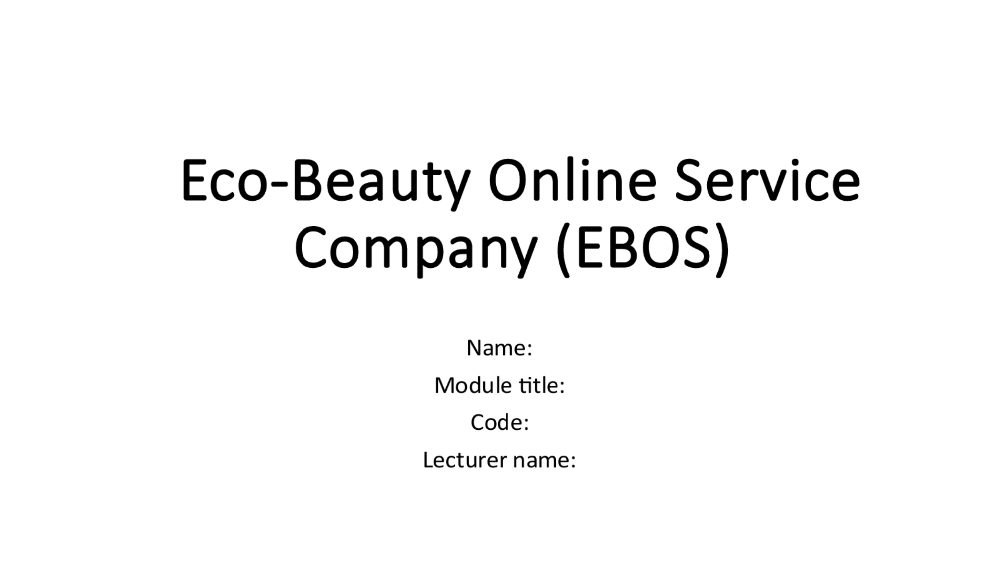
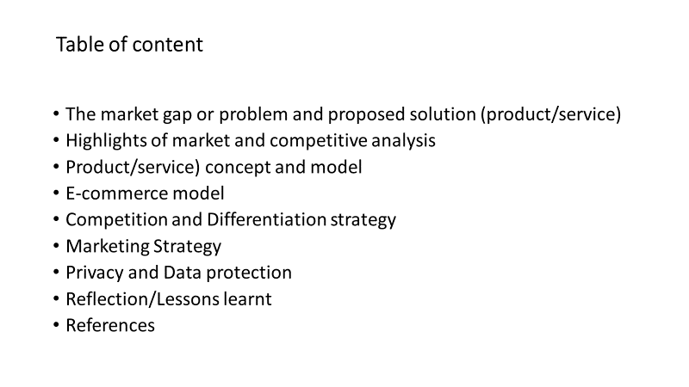
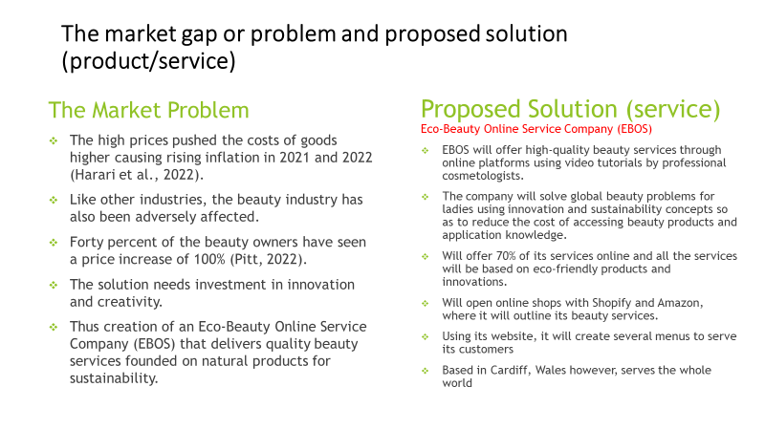
- Hello and welcome. In this presentation, I will innovate an online beauty service company called Eco-Beauty Online Service Company (EBOS), offering beauty consultations through video tutorials. The services will be based on natural and eco-friendly products. This presentation will identify the market problem and explain the composition of the service company. I will also analyse the beauty industry/market trends and the current competitive environment. I will then summarise the business concept and model and develop the company’s competitive and differentiation strategies. The presentation will also elaborate on the company’s marketing strategy and how it will protect its customers’ data. Finally, I will reflect on the knowledge I gained from this innovative business plan and how I will apply it.
- The market problem: The global rise in the cost of living due to increased energy prices leading to inflation is something not to ignore (Harari et al., 2022). The high prices pushed the costs of goods higher, causing rising inflation in 2021 and 2022 (Harari et al., 2022). Like other industries, the beauty industry has also been adversely affected. Most beauty business owners are struggling to make ends meet due to the huge increase in the cost of their electricity bills over the last year, according to a study by the British Association of Beauty Therapy and Cosmetology (Pitt, 2022). Forty percent of them have seen a price increase of 100%, and the other ten percent have seen a potentially catastrophic increase of 200% (Pitt, 2022). Replacing the situation requires much investment in innovation and creativity to develop new means of living that will bring down the cost of living. This will involve the creation of an Eco-Beauty Online Service Company (EBOS) that delivers quality beauty services founded on natural products for sustainability.
- The proposed solution: The Eco-Beauty Online Service Company (EBOS) will offer high-quality beauty services through online platforms using video tutorials by professional cosmetologists. The company mission is to solve global beauty problems for ladies using innovation and sustainability concepts so as to reduce the cost of accessing beauty products and application knowledge. The company is proposed to be based in Cardiff, Wales. The uniqueness of EBOS is that it will offer 70% of its services online and that all the services will be based on eco-friendly products and innovations. EBOS targets ladies who are 18 years and above around the globe. EBOS Company will open online shops with Shopify and Amazon, where it will outline its beauty services. Using its website, it will create several menus, including the service menu, the payment method menu, the customer service menu, the rating menu and the community development menu.
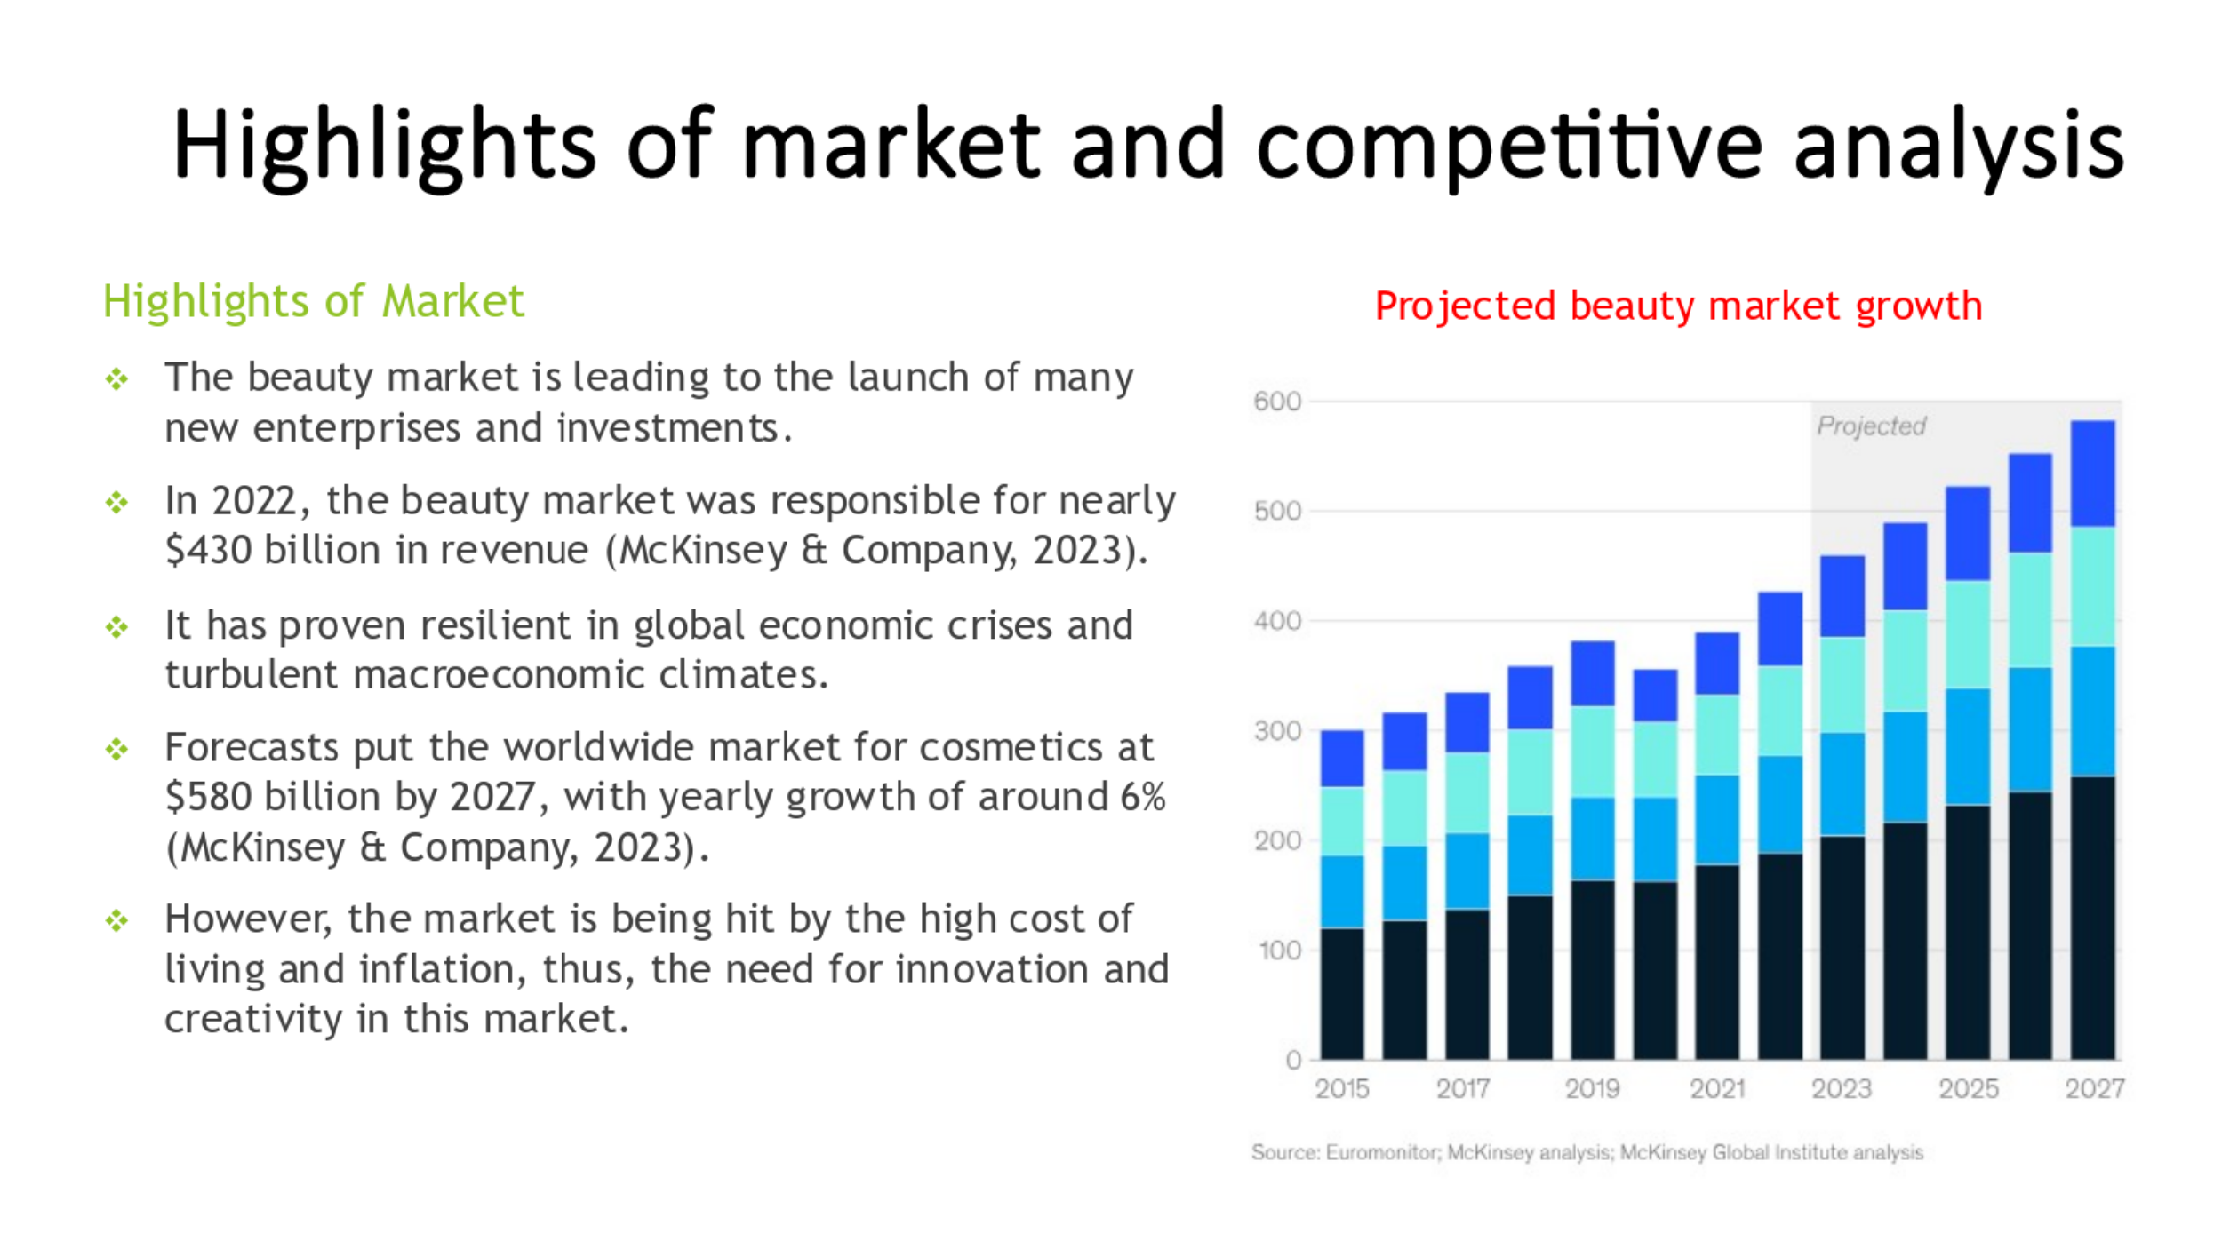
The attractiveness of the beauty market has been hard to ignore, leading to the launch of many new enterprises and investments. Brands must make choices that set them apart to thrive in today's dynamic and more competitive marketplace. In 2022, the beauty market was responsible for nearly $430 billion in revenue (McKinsey & Company, 2023). There is now a rising trend in beauty among all demographics. It has proven resilient in global economic crises and turbulent macroeconomic climates. Some persuasive arguments may explain today's job seekers' huge interest in the beauty industry. Forecasts put the worldwide market for cosmetics at $580 billion by 2027, with yearly growth of around 6%, due to the robust recovery that has taken place since the COVID-19 epidemic's height (McKinsey & Company, 2023). This is on the level with or somewhat above the norm compared to other consumer markets, including footwear, apparel, and eyewear. However, the market is being hit by the high cost of living and inflation, thus, the need for innovation and creativity in this market.
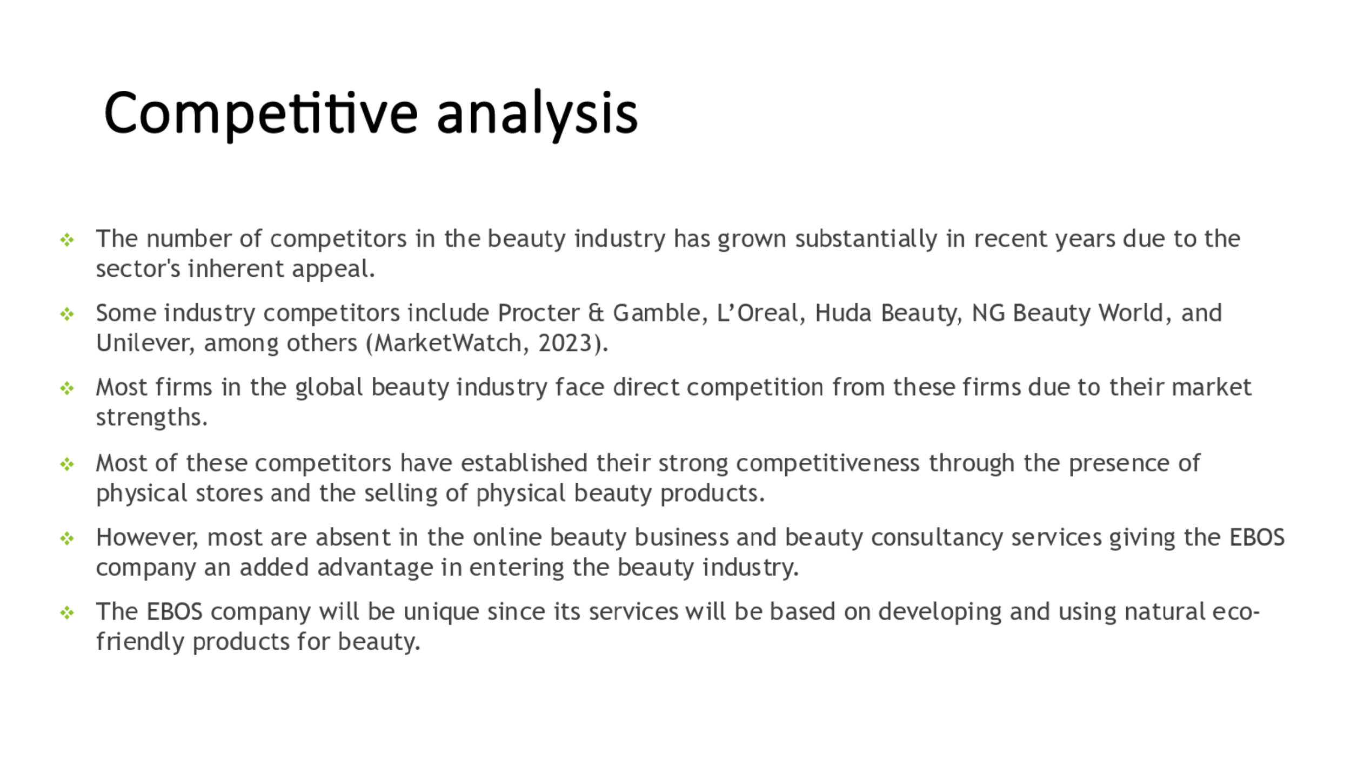
The number of business companies involved in the beauty industry has grown substantially in recent years due to the sector's inherent appeal. The increasing demand in the business may be attributed to its rising popularity. Some industry competitors that have dominated the global beauty market include Procter & Gamble, L’Oreal, Huda Beauty, NG Beauty World, and Unilever, among others (MarketWatch, 2023). Most firms in the global beauty industry face direct competition from these firms due to their market strengths. With absolute powerhouse brands like Charlotte Tilbury and Jo Malone London, as well as a significant number of little independent enterprises using fresh British ingredients, the United Kingdom is still a key player in the increasingly globalised beauty sector (Davies, 2021). Most of these competitors have established their strong competitiveness through the presence of physical stores and the selling of physical beauty products. However, few have invested in selling beauty products or services online. Their absence in the online beauty business and beauty consultancy services gives the EBOS company an added advantage in entering the beauty industry. The EBOS company will be different, specifically offering beauty consultations and advice online. The services will be based on developing and using natural eco-friendly products for beauty.
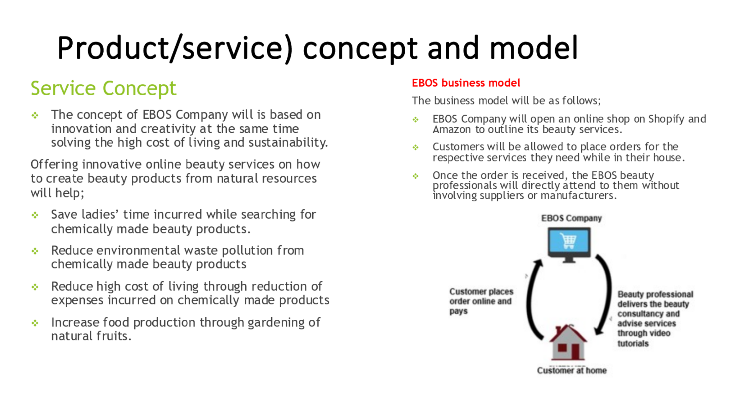
- Service Concept: The beauty industry is often believed to have a negative image when it comes to problems of environmental responsibility. This is because the annual loss of 18 million acres of forest is directly attributable to the beauty industry, which is responsible for producing up to 120 billion pieces of plastic packaging annually. Besides the obvious issue with packaging, businesses who care about their environmental impact have problems with carbon emissions, water use, and power consumption. How could a cosmetics or personal care product retailer get started on its path to sustainability? How can we make ecologically sound practises the standard in the cosmetics industry? The answers for these questions are based on innovation and creativity as presented in the slide above.
- Service Model: EBOS Company will open an online shop on Shopify and Amazon to outline its beauty services. While in their homes, customers will be allowed to place orders for the respective services they need. Once the order is received, the EBOS beauty professionals will directly attend to them without involving suppliers or manufacturers, as shown in figure below. Shopify and Amazon were chosen as the e-commerce platforms for this business plan because they allow customers to shop from the comfort of their own homes. Online shopping, as Taher (2021) argues, streamlines the process and puts the customer at ease.
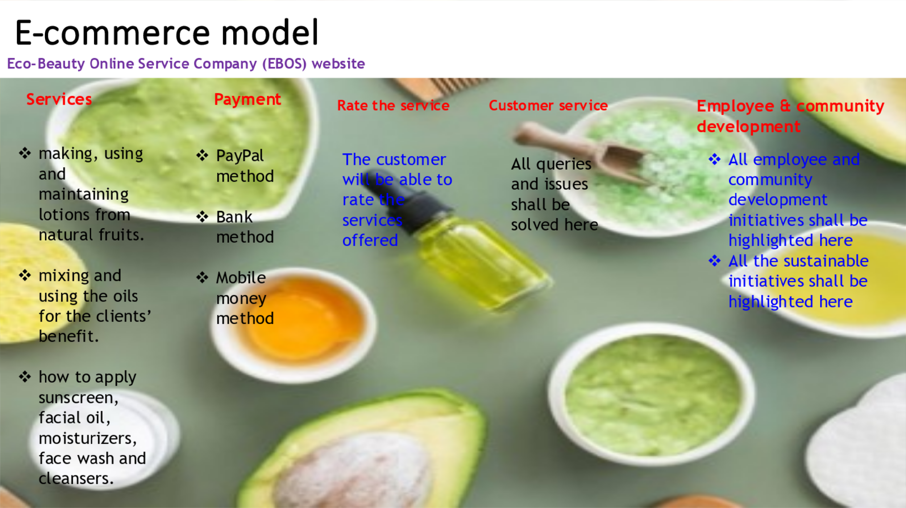
- The EBOS Company will offer beauty consultancy services through video tutorials via Shopify and Amazon as its main online platforms. However, the company expects to extend its services to online platforms like eBay and Alibaba. The service menu will highlight all the company's services in detail and have a preview tutorial video of about 10 seconds. The platform shall also have a payment method menu, customer service menu, rating menu and community development menu. The overview of the EBOS Company website shall be shown in the slide above.
- The service menu shall contain a detailed description of the beauty services EBOS Company offers with the respective beauty professionals. For instance, consultancy service tutorial videos about making, using and maintaining lotions from natural fruits and beauty consultancy tutorial videos inform of skills for mixing and using the oils for the customer's benefit. Other services will include; detailed beauty consultancy advice tutorial videos on using exfoliators, eye creams, toners, serums, sunscreen, facial oil, face wash, moisturisers and cleansers.
- The payment menu will contain a system powered by the respective online platform (Amazon, eBay, Alibaba or Shopify). The payment options such as card, PayPal, mobile money or bank will be highlighted. This is because different countries across the globe allow varying money transfer methods. The customers shall also be allowed to rate various services received through the "rate the service menu." However, any customer has any query or issue shall be solved via the "customer service menu." Since EBOS Company will foster sustainability, it will also have an employee and community development menu where sustainability and development initiatives.
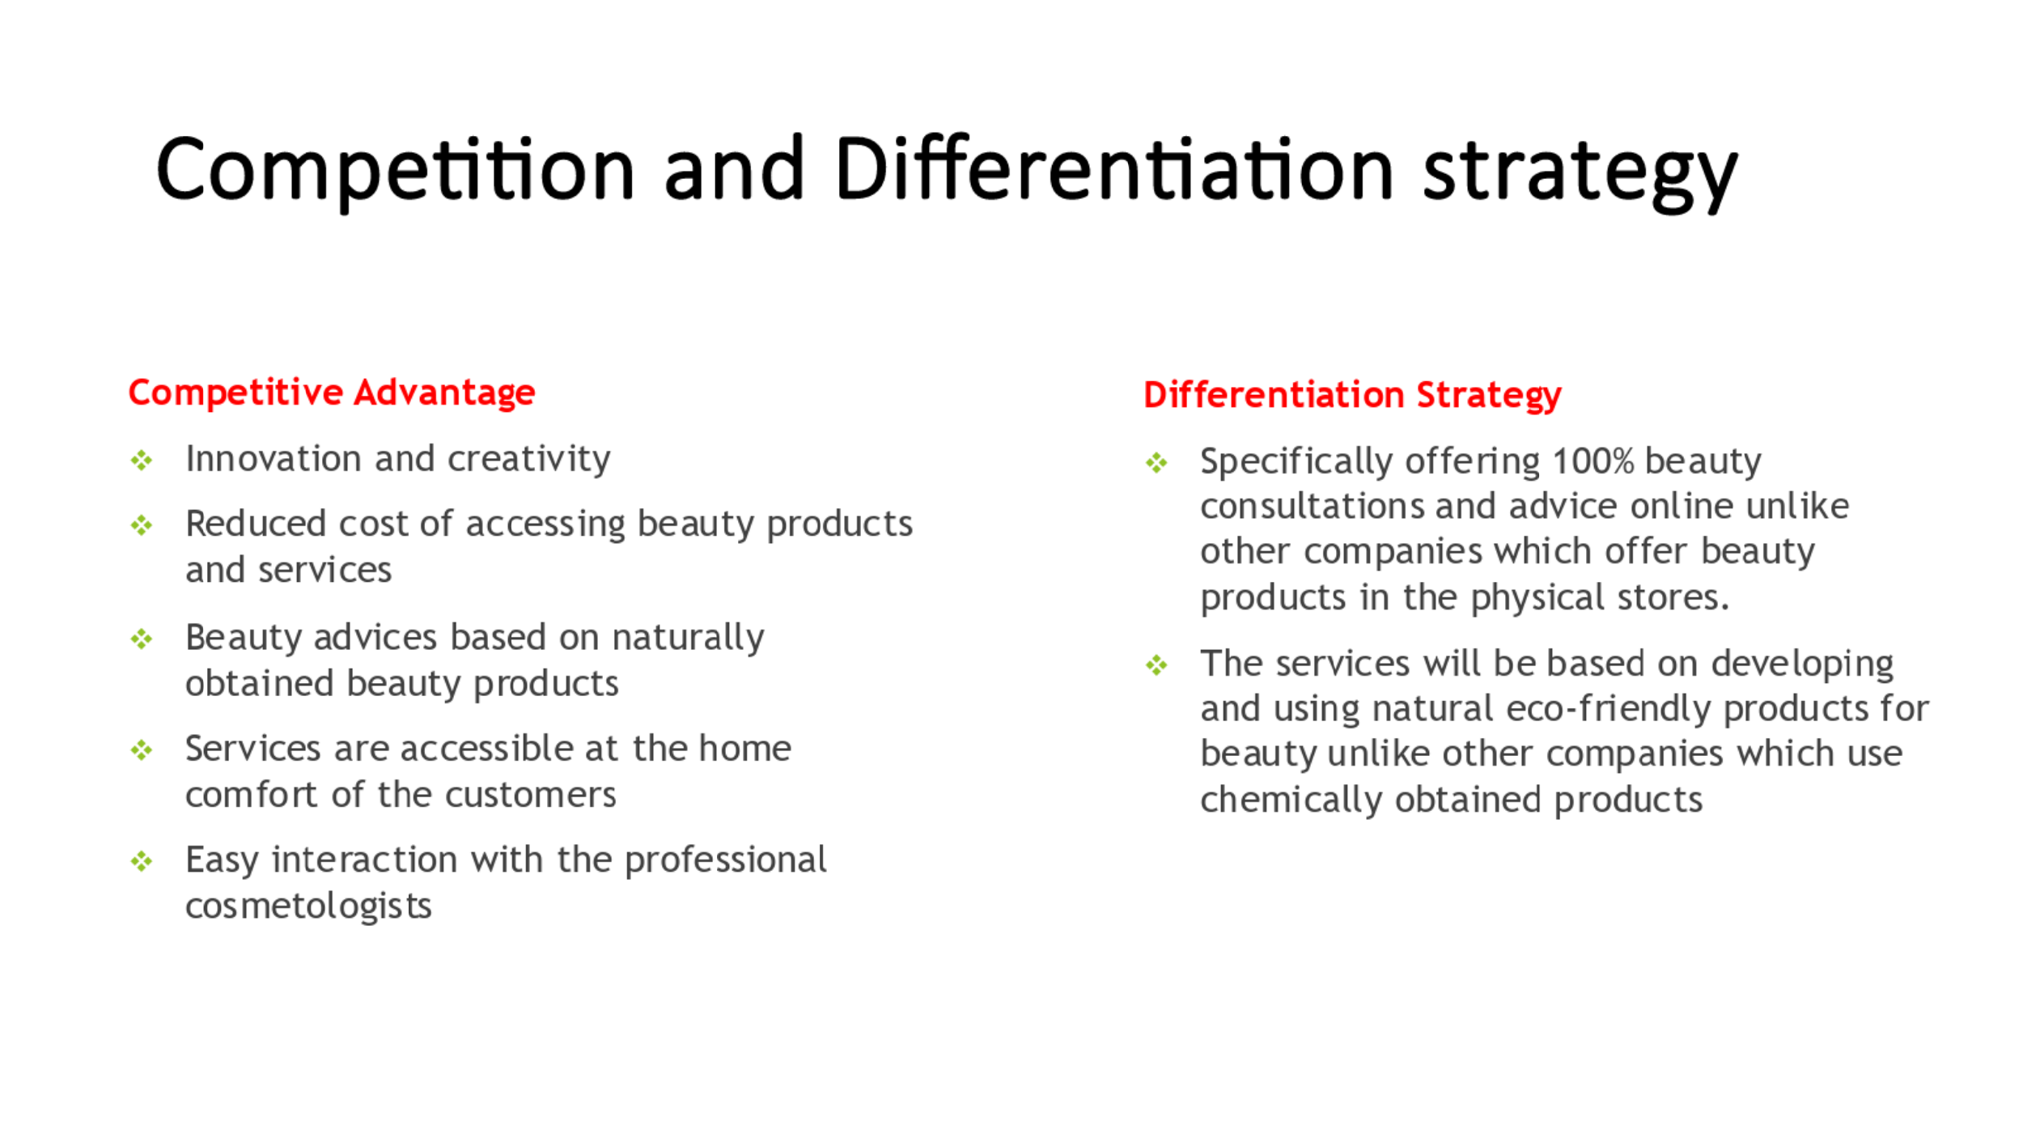
- Eco-Beauty Online Service Company (EBOS) will be based on the innovative and creativity concepts offering beauty consultancy services founded on eco-protection idea. Unlike other beauty companies which offer chemically made products, EBOS business model will be based on natural products like fruits. The company will serve customers around the globe using online platforms such as Amazon and Shopify thus reducing the time and cost of customers incurred while looking for chemically obtained beauty products. The eco-concept will give the company a competitive advantage since it will foster environmental conservation.
- The EBOS company will be unique, specifically offering beauty consultations and advice online. The services will be based on developing and using natural eco-friendly products for beauty.
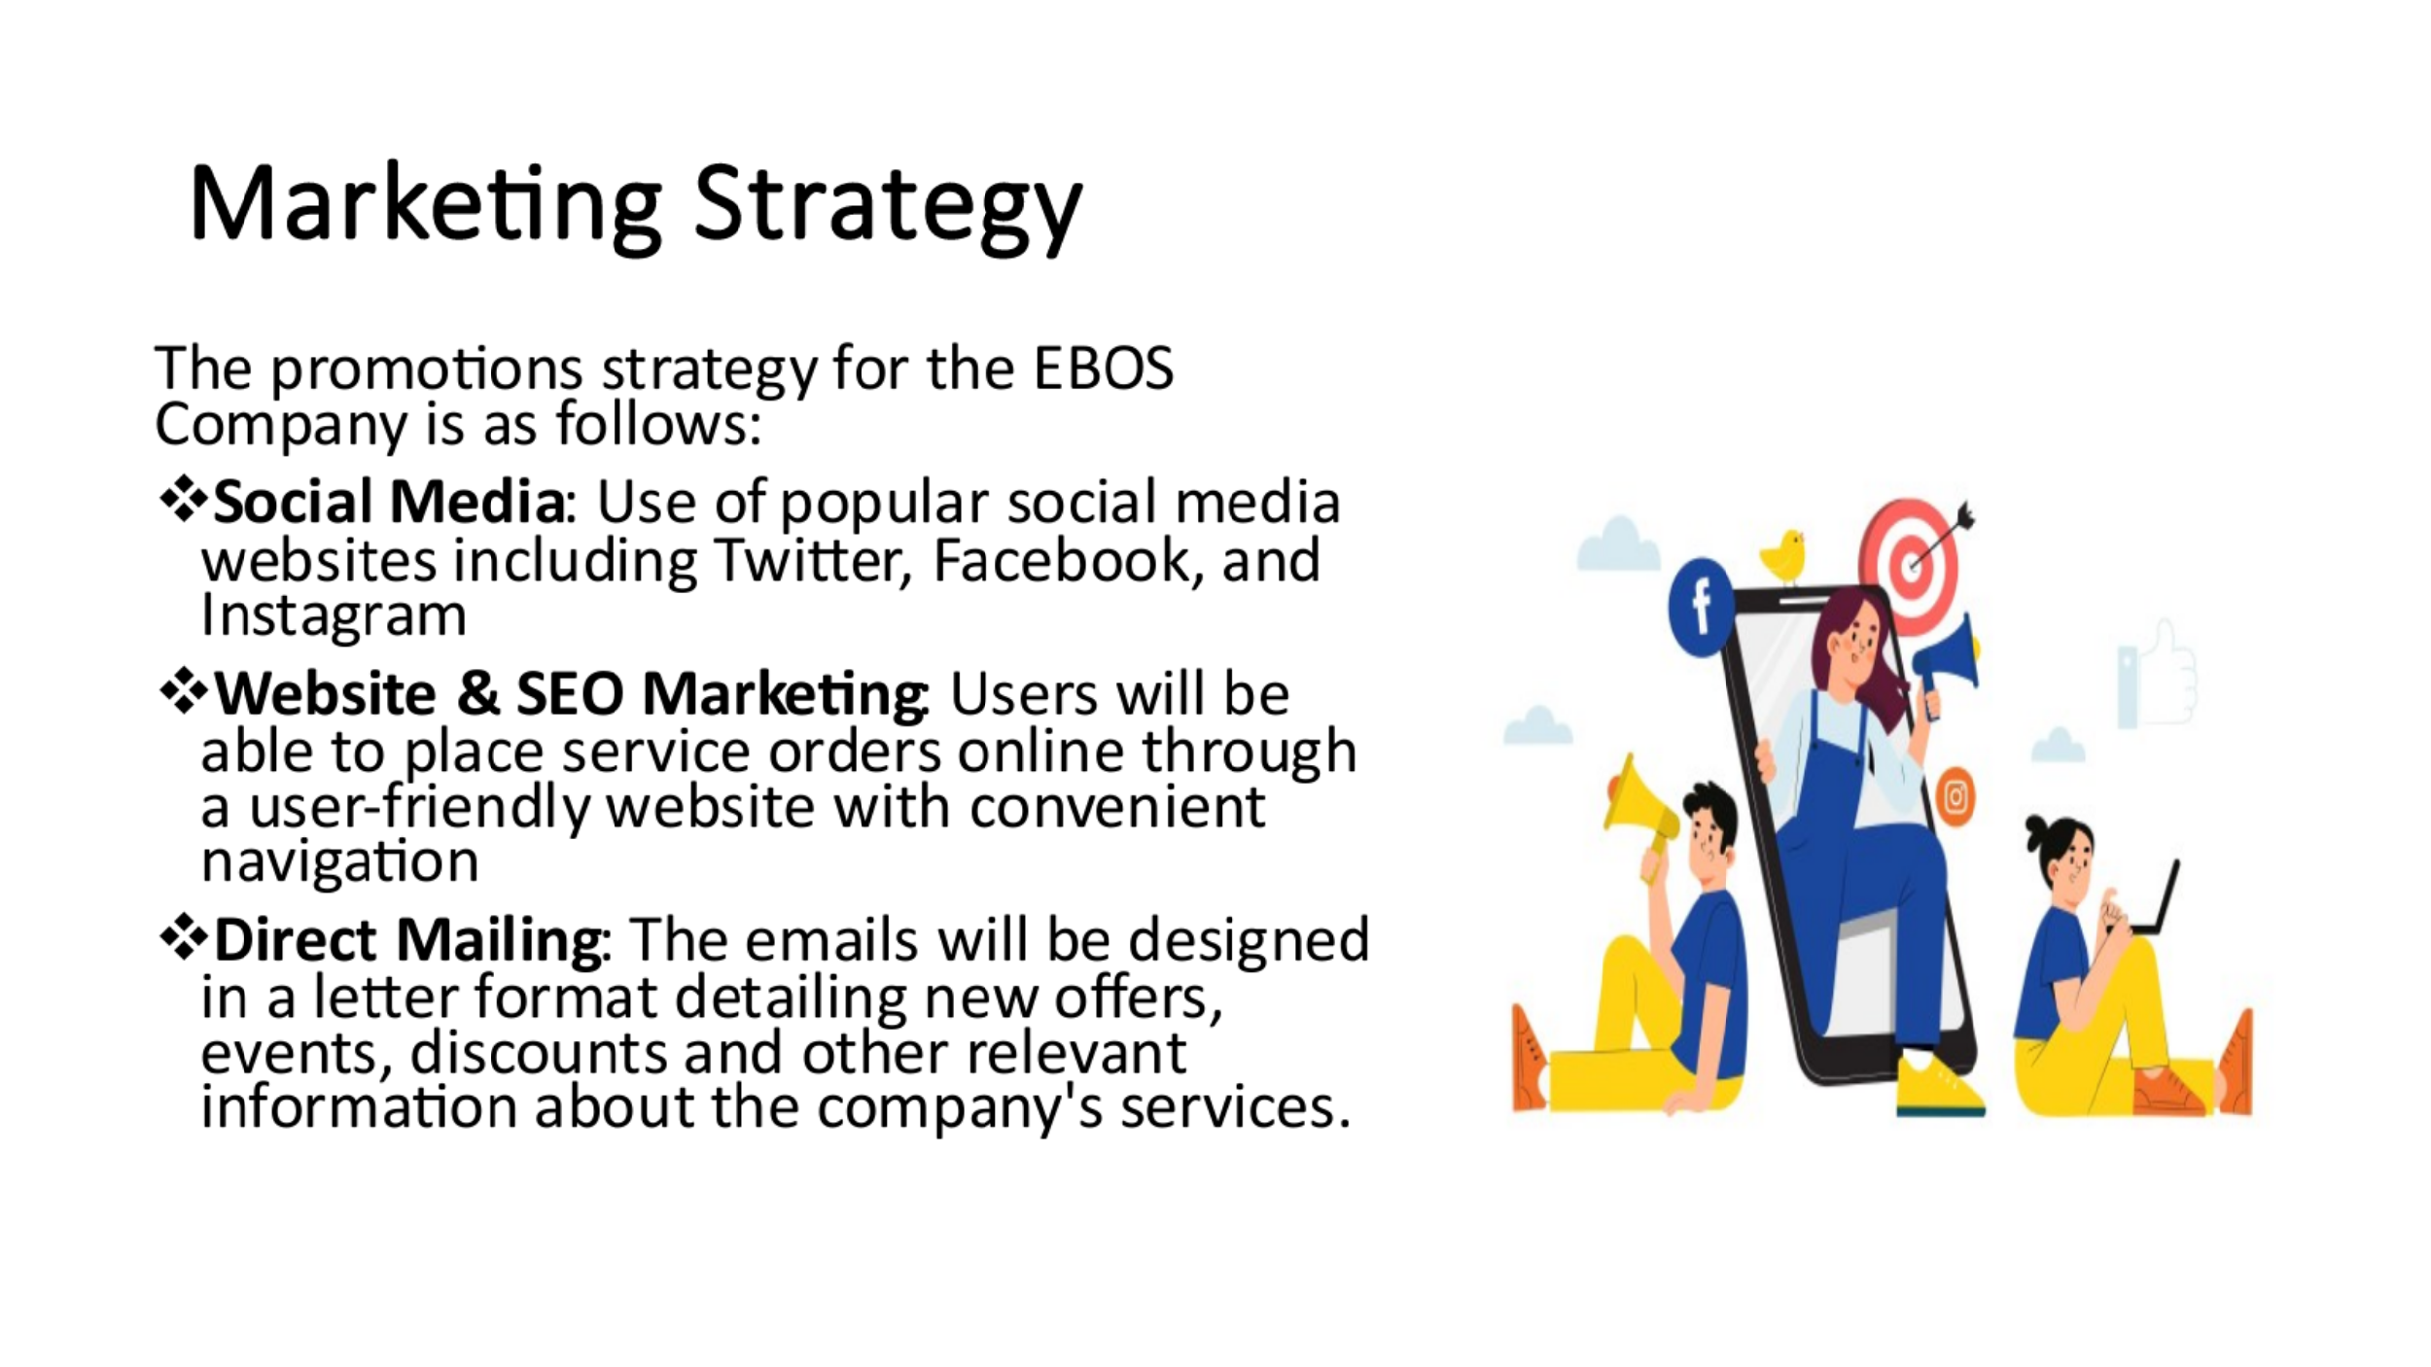
- Social Media: EBOS Company will maintain official profiles on popular social media websites including Twitter, Facebook, and Instagram, where regular updates will be made regarding the latest offerings, featured customers who are making use of the services, and upcoming sales and events. The postings will be visually appealing with high-quality photographs and will encourage customers to interact by offering discounts for tagging friends in the comments.
- Website & SEO Marketing: EBOS Company will first contact a web designer for website creation. Users will be able to place service orders online through a user-friendly website with convenient navigation. The website will contain a business system whereby customers can interact with professional cosmetologists. The company's business system will also integrate aspects such as beauty service options, customer interaction options, payment options, and several cosmetologists, among other options. Customers from all continents will be able to access the EBOS website. EBOS Company will appear at the top of the results page thanks to our SEO efforts when a prospective consumer does a search on Amazon or Shopify for beauty services.
- Direct Mailing: The company plans to do analytics on its customers, yielding insights into their profiles, preferences, and habits. This data will then be used to inform the company’s campaign. After the analytics, the company will then make a direct mailing list. The list will be generated based on the names and addresses acquired from the existing customers and those who are recurrent. The emails will then be designed in a letter format detailing new offers, events, discounts and other relevant information about the company's services.
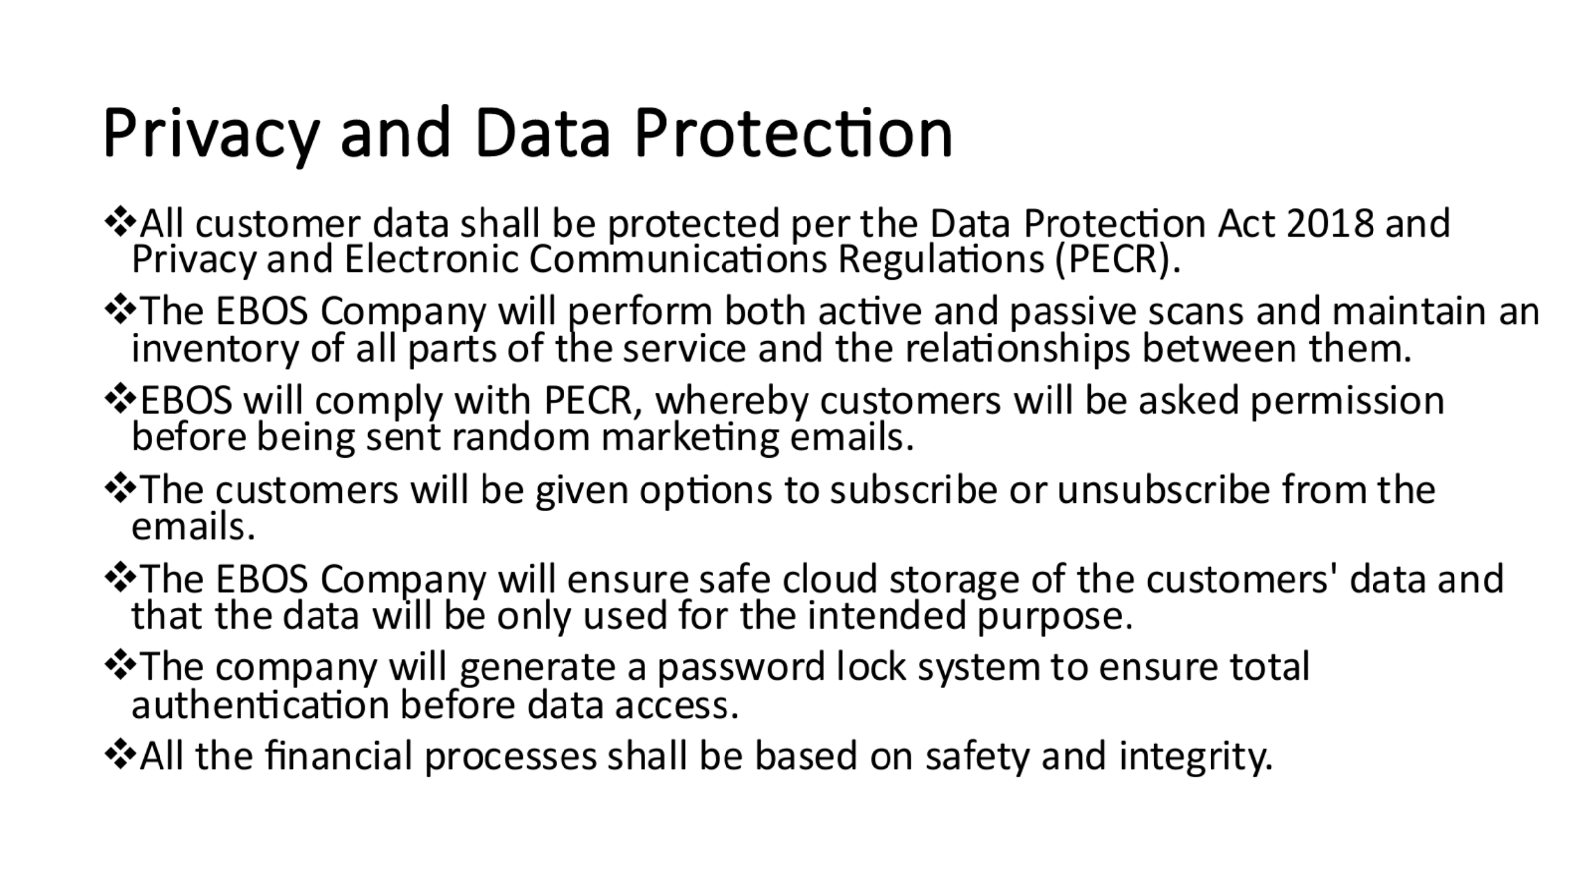
- The management and storage of personal information for thousands of customers puts e-commerce businesses in a vulnerable position (Forbes, 2022). The Data Protection Act 2018 requires everyone responsible for using personal data to conform to strict data protection requirements (Government Digital Service, 2018). They must make sure the data is used honestly, equitably, and in compliance with the law. The EBOS Company will perform both active and passive scans and maintain an inventory of all parts of the service and the relationships between them.
- As per the Privacy and Electronic Communications Regulations (PECR), the EBOS Company will give its customers specific privacy rights in relation to electronic communications (Information Communication Office, 2023). EBOS will comply with PECR, whereby customers will be asked permission before being sent random marketing emails. The customers will be given options to subscribe or unsubscribe from the emails. The company will also provide clear information about the cookies it will require customers to accept, for instance, permission to access their email location, active time and service synchronisation. EBOS will assure its customers that if they need to erase their captured personal data, it will do so and that their privacy will be invaded without consent.
- The EBOS Company will ensure safe cloud storage of the customers' data and that the data will be only used for the intended purpose. Only the company can access the acquired data, which will be destroyed after usage. The company will generate a password lock system to ensure total authentication before data access. While logging into the company's website, the customer's profile will be protected from unauthorised intrusion. All the financial processes shall be based on safety and integrity.
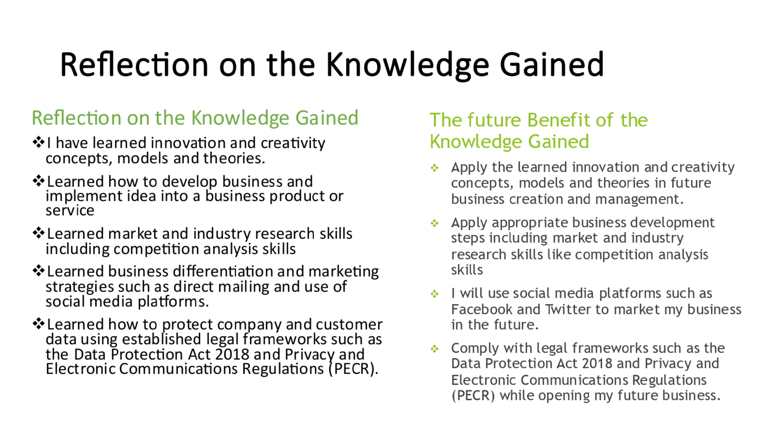
- This presentation has equipped me with a lot of knowledge. I have learned innovation and creativity concepts, models and theories. I have learned how to develop business and implement idea into a business product or service. I have learned market and industry research skills including competition analysis skills. I have also learned business differentiation and marketing strategies such as direct mailing and use of social media platforms. Finally, I learned how to protect company and customer data using established legal frameworks such as the Data Protection Act 2018 and Privacy and Electronic Communications Regulations (PECR).
- In the future, I will apply the learned innovation and creativity concepts, models and theories in business creation and management. I will apply appropriate business development steps including market and industry research skills like competition analysis skills. As a result of this presentation, I will use social media platforms such as Facebook and Twitter to market my business in the future. Finally, I will comply with legal frameworks such as the Data Protection Act 2018 and Privacy and Electronic Communications Regulations (PECR) while opening my future business.


