University of Wales Trinity Saint David
Wales Institute of Science and Art


Project Planning

Engineering Management ACHA5012
Word count: 2407

Alexander Joseph Jay
2416946
10/11/25

Contents
1. Introduction 3
2. Group 3
2.1 Roles and responsibilities 3
2.2 My role 4
3.0 Group tasks 6
4.0 My tasks 7
4.1 Preliminary Bill of Materials 8
4.2 Specialist Equipment Required 8
5.0 Group Milestones 9
5.1 My Gateway 10
6.0 My Risks 11
7.0 Gant Charts 12
7.1 Group Gantt Chart 12
7.2 Personal Gantt Chart 12
8.0 References 13

Introduction
This project’s purpose is to plan and convert a Formula 750 chassis from its traditional internal combustion engine to a modern electric drivetrain. At the beginning of the project, the group were provided with only the chassis, bodywork, batteries and an electric motor. This project will simulate a professional motorsport workflow and team environment to design an electric race car from the ground up and to demonstrate the feasibility of adapting a pre-existing race car chassis to electric power, while maintaining performance and reliability.
This report outlines my contribution to the project and presents planning, resource management and engineering considerations required to deliver my assigned responsibilities. These include evaluating and integrating the electric motor, collaboration with controller and battery engineers to ensure correct power delivery, deployment and regeneration and the modification of a traditional MX5 differential to a chain driven one. This report also goes over the timescales, tasks, and risks associated with my role, alongside an overview of how they contribute to the success of the overall project.

Group

2.1 Roles and responsibilities
Name of member | Role | Responsibilities
Alex | Motor and Drivetrain | Setting up and testing the motor, designing and implementing the drivetrain (Drive shafts, Differential, Chain/belt, flywheel and motor).
Daniel | Mass Distribution | Deciding where parts and components should be placed to deliver the most balanced mass distribution and optimising the suspension around it.
George | Group Leader | Keeping all group members on task by setting deadlines and deciding the order in which they need to be completed. They must also make sure the whole project is coming together to reach the overall goal and make necessary changes when needed to the plan.
Tasha | Battery Research | To gather data and information on the batteries being used for the project, so the configuration, the number of batteries required, where they must be positioned in the chassis and how they need to be safely stored/contained.
Tristain | Packaging and Wiring | Creating suitable and safe casing and panelling around any parts which require it, as well as deciding how to wire the components together.
Lily | Controller Unit | To research how to use the controller unit and code necessary electronic systems (i.e. motor and cooling).
Ellis | Driver Cell | Ensuring the driver's safety and comfort in the car while providing necessary information to the driver on the dashboard.
Jac | CAD | Must make sure all changes, parts and necessary models are made in CAD so that there is a reference to design around.
-Table 1, Team members primary roles and responsibilities

2.2 My role
Skills and personality traits required for my role
As the motor and drivetrain lead my responsibilities require a combination of analytical and collaborative skills including:
Technical Skills
- Ability to evaluate the cooling requirements and integration of solutions.
- Mechanical competence in drivetrain components especially in the differential due to the change from a tradition to a chain driven set up.
- Ability to interpret technical data as well as safety information.
- Problem solving skills to address compatibility of components, their mounting and performance issues.
- Understanding of electric motor characteristics such as torque and power curves, thermal constraints and efficiency.
Professional and Team Skills
- Open communication with the team members responsible for the controller and batteries to align plans and requirements.
- Time management to ensure the drivetrain is ready and tested before full car test deadline.
- Attention to detail due to working with high voltage components and rapidly rotating assemblies.

Belbin’s Team Roles
Based on my responsibilities I believe my job most closely aligns with the following Belbin’s team roles as described by the University of Cambridge (IFM, 2025):
Plant
Plants are creative, think outside the box and apply technical knowledge to solve complex issues. This aligns with my responsibility to redesign the MX5 differential to be chain driven as well as creating a design for the overall drivetrain.

Implementer
Implementers are practical and focus turning ideas into working designs. This fits well with my task being so hands on which includes component modification, component testing and ensuring both safety and reliability of all my designs.

Belbin’s category | Implementer | Coordinator | Shaper | Plant | Resource investigator | Monitor evaluator | Team worker | Complete finisher
Score | 12 | 9 | 13 | 8 | 8 | 11 | 7 | 6
Best fit | 10 | 8.8 | 11.6 | 7.3 | 7.8 | 8.2 | 10.9 | 5.5
Variation | +2 | +0.2 | +1.4 | +1.3 | -2.2 | +2.8 | -3.9 | -0.5
-Table 2, My ‘Belbin’s Self Perception Inventory’ multiple choice quiz results

3.0 Group tasks
Task | Description | Date of Completion | Hours required
Research Regulations | Research the regulations specific to their segment. | 19/10/25 | 4
Fitting the Floor | The floor for the car must be  made before other parts are inserted. The group will need to work together to make sure it’s assembled properly. | 28/11/25 | 3
Design Battery Housing | The batteries for this  project require aluminium casing with a kill switch and cooling included, which will need to be custom designed | 30/11/25 | 8
Manufactured Battery Box | This may have to be done  out of house so will take time, but it will need to be CNC machined. | 25/01/26 | -
Installing Radiators | Making mounts for radiators and installing them. | 30/01/26 | 5
Installing Coolant Pumps and Lines | Linking all the components to the pumps and the radiators and ensuring that the desired fluid flow rate is achieved. | 30/01/26 | 4
Purchasing Parts | It is the groups responsibility to make sure all parts needed are researched and purchased in time. | 31/01/26 | 2
Assemble Drivetrain | The rear axles will be custom made for the car to connect from an MX5 differential onto the wheels. We also will have to modify the differential. | 6/02/26 | 3
Adjustments and Modifications to Body | With all the changes to the car, the body kit will need modification to accommodate the parts. | 20/02/26 | 10
Testing Car | Taking data on car performance compared to the championship. | 13/03/26 | -
Presentation Work | Ahead of the viva the order and slides for the presentation must be made. | 22/03/26 | 5
-Table 3, List of group tasks to be completed along with deadlines and expected hours required

4.0 My tasks
Task Number | Task | Deadline | Time Given to Complete
1 | Research motor | 12/10/25 | 10 hours
2 | Project planning | 2/11/25 | 15 hours
3 | Make motor bracket | 7/11/25 | 3 hours
4 | Learn motor software | 28/11/25 | 5 hours
5 | Set up motor for testing | 28/11/25 | 4 hours
6 | Test motor and software | 5/12/25 | 4 hours
7 | Research similar motor tunes | 7/12/25 | 6 hours
8 | Make a first tune | 7/12/25 | 4 hours
9 | Test the first tune | 8/12/25 | 4 hours
10 | Refine tune | 3/01/26 | 5 hours
11 | Test second tune | 4/01/26 | 2 hours
12 | Research half-shafts | 5/01/26 | 6 hours
13 | Purchase half-shafts | 5/01/26 | 2 hours
14 | Send half-shafts off to be modified | 12/01/26 | 2 hours
15 | Create output shaft | 12/01/26 | 10 hours
16 | Design new differential housing | 14/01/26 | 5 hours
17 | Differential modification | 24/01/26 | 21 hours
18 | Research sprocket size | 25/01/26 | 2 hours
19 | Create/buy a sprocket for motor | 26/01/26 | 4 hours
20 | Create mount in car for motor | 30/01/26 | 10 hours
21 | Create mount in car for differential | 30/01/26 | 11 hours
22 | Research and buy chain | 3/02/26 | 3 hours
23 | Test drivetrain in car | 10/02/26 | 4 hours
Total Task hours |  |  | 146 hours
-Table 4, My tasks along with deadlines and expected time required
Task Descriptions
- Research the motor specifications, dimensions, safety hazards and cooling requirements
- Planning for overall project, deciding the best way to drive the car from the motor and the tasks I will need to do to complete the project.
- Create a bracket to test the motor on the bench.
- Familiarise myself with SEVCON configuration software from DVT.
- Wire up the motor, batteries, controller and computer ready to test.
- Test the motor on a bench.
- Look at similar electric motor tunes for electric race cars and set clear performance targets for our own.
- Work with the controller team member to configure a first draft tune.
- Set the motor up and test the first draft tune.
- Compare to traditional ICE formula 750 performance and take lessons from first tune to smooth out any issues and improve performance.
- Test refined motor tune to hopefully deliver performance similar or better than the tradition ICE formula 750 cars.
- Research the half shafts used in traditional formula 750 cars.
- Purchase a pair of half-shafts.
- Send half-shafts off to be modified so they fit in the chassis and have the correct joints to connect the hubs to the differential.
- Design and create an output shaft for the motor.
- Design new differential lay out so it will be chain driven rather than drive shaft driven.
- Take the MX5 differential and implement the chain design.
- Research how big the sprocket connected to the motor needs to be to create the desired final drive which the team settled on being around 2.8.
- Buy/make a sprocket for the motor
- CAD up and create a mount which will allow the motor to sit securely in the rear of the car while handling the rotational force of the motor.
- CAD up and create a mount which will allow the differential to sit securely in the rear of the car.
- Calculate how strong and how long the chain must be to handle the peak torque the motor will create.
- Test the drivetrain on a low power and torque tune to discover potential issues while mitigating risk of damage.

4.1 Preliminary Bill of Materials
Item | Source | Cost | Lead time
Half-Shafts | GSF Car Parts (Nov, 2025) | £246 | 1 week
Half-Shaft Modification | TBD | £500 | 2 weeks
Differential | Team member (Jac) | Free | 5 days
Sprocket | Gemini Karts (Nov, 2025) | £30 | 1 week
Chain | KartPartsUK (Nov, 2025) | £30 | 5 days
Total Estimated Cost |  |  | £806
-Table 5, Preliminary bill for required parts including source and lead times

4.2 Specialist Equipment Required
Because my role requires both hands on and technical planning I require a range of specialist equipment, this is including but not limited to:
- SolidWorks 2025 – to create designs for components I need to manufacture
- A high power computer – enough to run SolidWorks on smoothly
- Pillar drill – to create motor stands and mounts in the car
- Welding rig – to weld mounts to the car’s chassis
- CNC machine – to create precision mounts for the differential and motor
- Callipers – to measure alignment and size of components
- DVT motor software – software to program motor
- Grinder/belt sander – finish edges of mounts

5.0 Group Milestones
Milestone | Description | Deadline
CAD Chassis Completed | A detailed SolidWorks model of the chassis produced and shared within the group. | 31/10/25
Motor Test Complete | Using software from DVT Software, the motor has been tested, and a preliminary final drive and power curve have been determined. | 5/12/25
Controller Software Optimised | Controller software investigated and optimised for all requirements (I.e. motor). | 4/01/26
Viva 1 Complete | Presentation of current progress and overall plan for group project laid out and presented. | W/C 8th December 2025
Drivetrain Assembled | The drivetrain parts have all been necessarily modified and installed inside the chassis (Driveshafts, Differential, Motor, flywheel and chain/belt). | 6/02/26
Battery Cases Manufactured | The two different battery cases have been designed and manufactured, adhering to space, cooling and weight requirements. | 25/01/26
Floor Complete | Floor of the car designed, manufactured and installed in the car. | 28/11/25
All Critical Components Purchased | All components listed on the ‘Required parts list’ have been purchased. | 31/01/26
Brake Lines + Accelerator Working | Brake lines fitted and bled, as well as the throttle position sensor working. | 7/02/26
Final Chassis Adjustments complete | Chassis adjustments required for the fitting of all parts and cooling are complete. | 20/02/26
Cooling + Wiring Systems Fitted | Cooling for the car has been fitted + filled and all components have been wired up. | 30/01/26
Final Fittings to Car Complete | Any final components fitted to the car. | 6/02/26
Car Testing Complete | Testing of the fully assembled car has been successful and pre-established performance goals have been achieved. | 13/03/26
Viva 2 Complete |  | 24/03/26
-Table 6, Group milestones along with deadlines

5.1 My Gateway
Objective
My gateway objective is the modification of the Mazda MX5 differential from driveshaft input to chain driven configuration, capable of competing on par with ICE Formula 750 cars, while making sure the modified assembly meets strict technical and safety criteria prior to its use.
Measurable Criteria:
Dimensional
- Chain alignment: Misalignment between motor and differential sprockets must be <2mm
- Sprocket runout: Maximum radial runout must be <1mm when chain is connected and rotated by hand
Peformance
- Differential output must allow the motor at peak sustained rpm to power the car to speeds exceeding 95mph
- Mechanical drivetrain total efficiency must be >80% during testing
Structural (During a simulated 10 minute motor test)
- No derailments occur
- Moving parts observed not to rub on anything and no unusual noises
- Mounting brackets deflect < 2mm under peak sustained torque
Documentation
- Full CAD model of conversion complete and approved by project assessor
- Risk assessment must be completed and agreed on by group leader
Cost
- Total cost of differential assembly modification does not exceed £500

Pass/Fail Criteria
Pass
All measurable criteria above have been met, and the differential system is approved to be used on the car in its current form.
Fail
Any criteria above are not satisfied. Rework will then be required before progression can continue and all criteria have been met.

6.0 My Risks
Risk 1 - Chain Drive Failure
The drivetrain relies on a in house chain drive conversion of the differential. Oversights such as the chain being too weak, torque spikes or sprocket and differential misalignment may cause excess stress, derailing or snapping of the chain. This could damage the motor, differential, chassis or the bodywork. Any damage to these components may delay the whole project while repairs are made or replacement parts are bought in.
Mitigation
- Use of precision alignment tools i.e. lasers to align the sprocket on the motor and sprocket on the differential.
- Have a safety factor for the chain of 1.5x the peak torque the motor should produce.
- Add a chain tensioner so chain can be placed on loose and then tightened.
- First test of assembled powertrain will be on a low power and torque curve from the motor to observe if there are any issues.
Risk 2 – Differential Modification Error
The differential we will have is going to be a traditional driveshaft driven MX5 diff. I will then have to modify it to be chain driven, which presents many opportunities for issues to arise. If I make a mistake during the modification and damage or break part of the differential, it will delay the project while repairs or new parts are purchased, which may lead to missed milestones for the group. Or due to working with dangerous equipment, I may end up injuring myself, if I’m not careful, which could lead to delays in my area of the project.
Mitigation
- Draw up a detailed step by step plan for the modification showing it to a lab technician to get their more experienced input.
- Take time and do not rush the hands on building of the new casing to prevent injury
- Watch videos of people who have done this conversion before to understand their process.
- Inspection by lab technician at key points to ensure process stays safe and proper.

7.0 Gant Charts

7.1 Group Gantt Chart
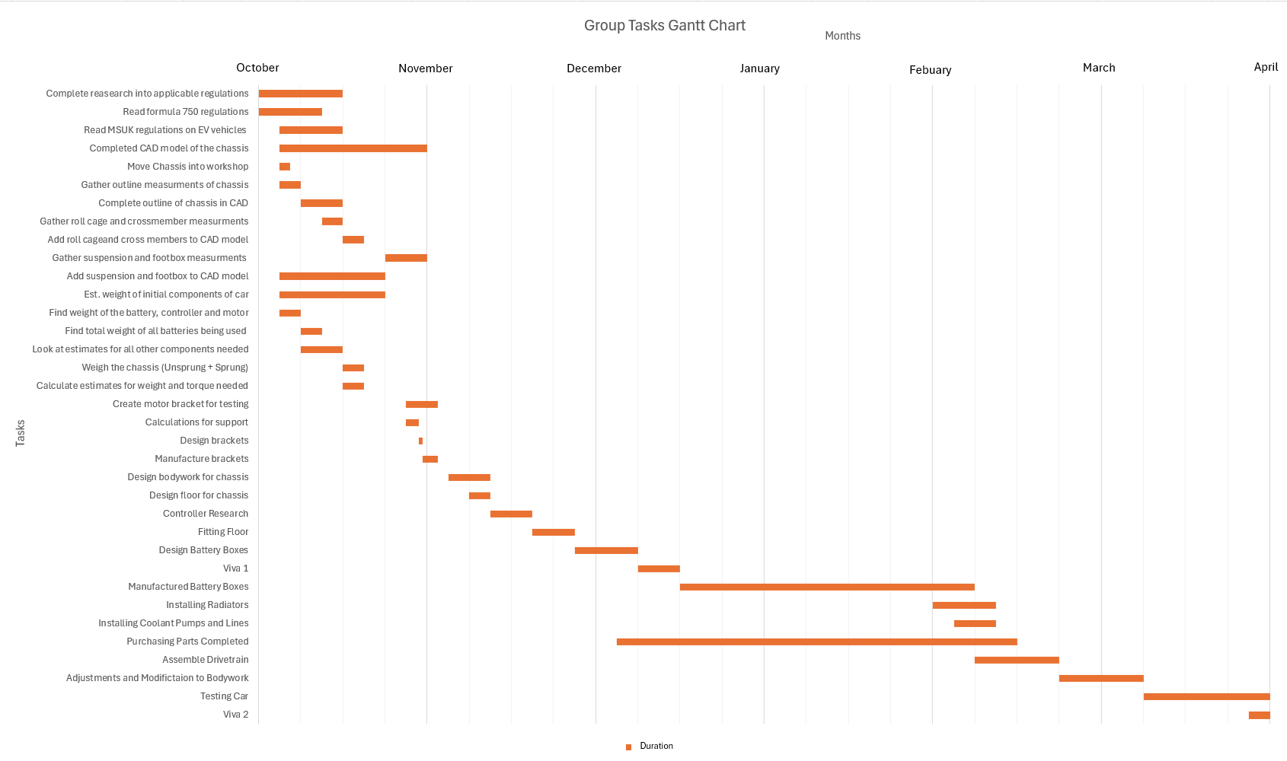
-Figure 1, Group task Gantt chart

7.2 Personal Gantt Chart
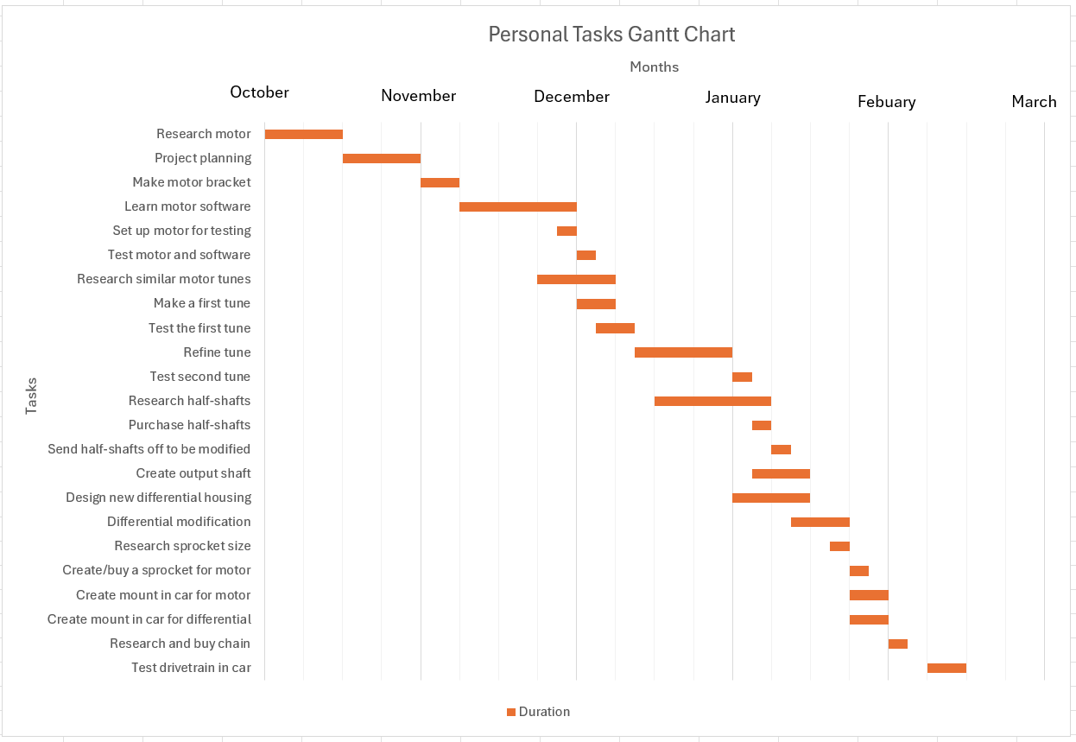
-Figure 2, My personal tasks Gantt Chart
Total Task Time = 146 hours
Total Team Meeting time = 42 Hours
Total Project Time = 188 hours

References
(IFM,2025) - Cambridge University Engineering Department, “Belbin’s Team Roles”, ifm.eng.cam.ac.uk, accessed 23 November 2025, https://www.ifm.eng.cam.ac.uk/research/dmg/tools-and-techniques/belbins-team-roles/.
GSF Car Parts. (2025) Driveshafts / Half-shafts. Available at: https://www.gsfcarparts.com/parts/transmission/final-drive/driveshaft (Accessed: 23 November 2025).
Gemini Karts. (2025) Drive sprockets. Available at: https://www.geminikarts.co.uk/product/drive-sprockets/ (Accessed: 23 November 2025).
KartPartsUK. (2025) Chains. Available at: https://www.kartpartsuk.com/products/chains-sprockets/chains (Accessed: 23 November 2025).

