Managing projects in a workplace

28/06/2020

Managing projects

Taslima begum

1713205

Contents
Introduction page 1
Phase 1 page 3
Phase 2 page 7
Phase 3 page 13
Phase 4 page 14
Recommendations 16
References 17

Introduction:
In this report the project manager will be discussing their chosen project they have decided to work on for covid19 by using various tools and techniques to demonstrate the ability to plan and implement the project in its workplace. The project manager will be showing how to communicate with appropriate stakeholders during the project and demonstrate the implementation of the project plan. with alongside a critical evaluation of the project and how the tools helped with the project and what could have been changed and improved.

The project manager has chosen the school parkland primary school as a project for covid19 based in sketty Swansea. This is because the project manager has children that go to this school and would like to be on top their child education and putting a plan in place for teachers and parents in how to home-school and plan their work during this difficult time. This becomes a project because it has stages of planning and delivering from teachers to parents to children and in this report, it will be shown by using different tools and techniques how this is done.
To evaluate the project this should be discussed with the stake holders and see if they agree to the structure of the project then you can start to proceed the project. In this case as it is a school, stakeholders as in parents and children don’t have much of a choice but to follow the project structure to further their children’s education by home-schooling. (2000)

What is project management?

Project management is when using different tools and techniques to complete a project by someone managing it. And by having a plan in place to meet the project aim successfully through using a lot of resources such as, time, cost and providing a good quality service. Which is done by using a project life cycle. (APM,2020)
Project life cycle is “A project life cycle is the sequence of phases that a project goes through from its initiation to its closure. The number and sequence of the cycle are determined by the management and various other factors like needs of the organization involved in the project, the nature of the project, and its area of application. The phases have a definite start, end, and control point and are constrained by time.” (Invensis, 2020)

The project life cycle is in 3 stages:
1) the idea- conception phase
2) the plan- definition phase
3) the team- initiation phase

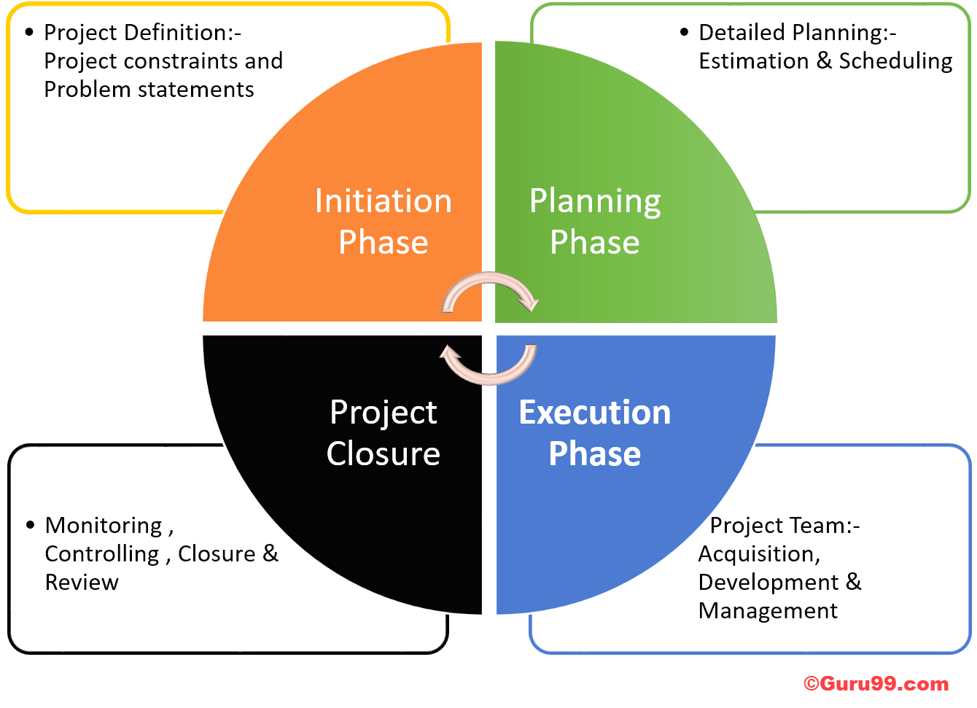

The project manager will be looking at what to put in place and how and how this will be a done, by looking at the goals and objectives and trying to achieve the deliverables in the project managers project this will be shown throughout the report in how to implement the project cycle in the report by using the different tools and techniques.

- Project initiation
The project manager will be using the 1st tool to implement the project which is the quad chart. A quad chart is a one-page summary of the project which explains what the project is all about. It is a good way of structuring the concepts and ideas of the project, so it is easily manageable before you start the project.
“A quad chart is a form of technical documentation used to briefly describe an invention or other innovation through writing, illustration and/or photographs. Such documents are described as "quad" charts because they are divided into four quadrants laid out on a landscape perspective. They are typically one-page only; their succinctness facilitates rapid decision-making.” (Wikipedia, 2019)

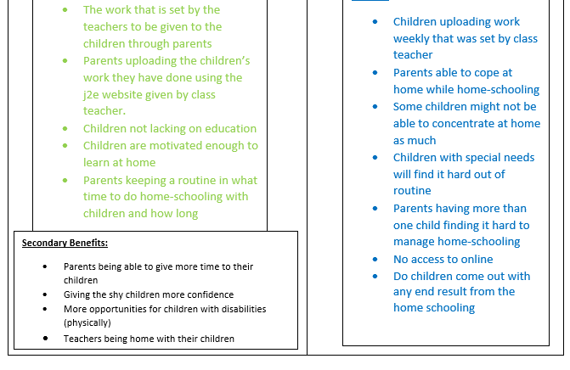
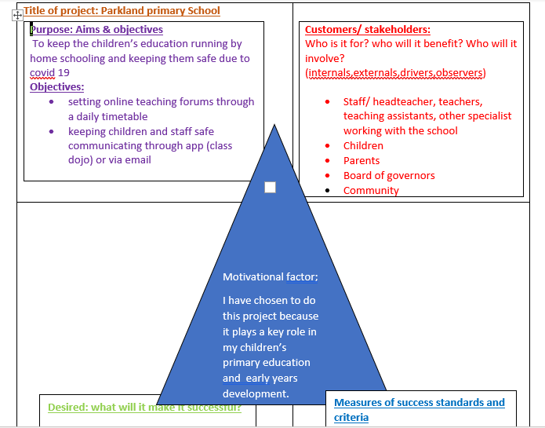
The above tool is the quad chart explaining the project and its outcomes. And how using all the deliverables the project will be started and finished.
The aims and objectives of this project is to be able to plan and deliver children work every week and parents to deliver the work to the children and then deliver back to the class teacher. There is no pressure on the children to complete work on time they can take as long as they want but over the week to complete work that has been given by class teacher. Teachers also to have a video calling session once a week with all class pupils 10 mins each to see how they are getting on and motivating the children and giving them a positive vibe as well as the parents. Parents have access to
the app dojo to message the class teachers during school hours for any questions or extra support. This project can be successful if all work given by teachers are completed weekly and parents are motivated as well as children. This is why it is important for parents to have a routine in place for home schooling. But there is no guarantee that all parents will stick to the routine and deliver work to children on time. so, this is where the project can fail from the parent (stakeholders) part. This also can fail from the children’s part as well if children are not willing to work from home not feeling motivated enough or feel like they need extra support that needs to be given by a specialist or class teacher.
Customers and stakeholders: the project will involve the above mentioned on the grid. So, the head teacher and all school staff as well as parent and children will be high priority. And board of governors are medium priority as they make the decisions for the school and pupils they will be involved int his project when a change is made and parents and teachers need to be informed via email or letter sent home by post. Lastly community is low priority making sure they are keeping the environment clean and having a friendly community makes it easy for the children to keep safe during this hard time.
Desired: this project can be successful if parents have a good routine with children keeping them motivated and dedicating a time every day at home for home-schooling. However, teachers must also have the weekly plan up every week ready for the parents to deliver to the children. Extra

resources added to the j2e website that will be useful and helpful for children completing their work.
Measures of success: this is possible when weekly work is completed by children an uploaded end of the week having feed back sessions with the class teacher. Also, could be a difficult situation for other for example children with disability, change of routine can make them distressed and not wanting to keep up with home routine. Finding it difficult to understand why they are not attending school. This can be solved if specialist contact the teachers that are working alongside disadvantage children to give them extra support online and extra video session times once a week just to make them feel and understand the situation and why they cant attend school. This also could be difficult for parents who have more than one children and finding it hard to cope so they might also need extra support from teachers, by reassuring making sure they are coping well by giving no pressure of work need to be done on time can be sent later or when suited.
Secondary benefits: working parents being able to spend time with their children at home this goes to teachers as well. Shy children opening up and enjoying home-schooling and could also be an advantage for disadvantage children as home is their comfort and will be easier from them to learn from home.

Introducing the stakeholders in the project and the stakeholder analysis:
With a stake holder analysis, the project manager can analyse problems related to the stakeholders. Which then can be identified if there are conflicts and how to solve them to ensure your project is a success or fail. (mindtools, 2020)
In this project the audiences that are involved you can see below on the table, but the three main audiences are teachers, parents, and children. They will be communicating the most in this project to make this project a successful to show that home-schooling can be done during this hard time of covid19. The table is explaining the stake holder’s perspective then the actions taken to solve any issues. The stake holder analysis tool links in with the quad chart box 1, 2 and 3, explaining how the objectives are met and which stakeholder has more priority in this project and to see if the deliverables are being met. So, as you can see from the table staff, children and parent are high priority as through them the box 1 objectives need to be met. And the actions they take in order to meet the stake holder’s perspective. However, board of governors are medium priority as they will be providing information on ay changes in the education sector. By as mentioned on the quad chart sending letters home or by via email. And the community is low priority by staying safe when outside or around children.

Priority  H/M/L | Stakeholder | Stakeholders perspective | Action
High | Staff | Providing the work and making sure parents and children are coping and being able to access the work or work out other alternatives. | Regular feedback and monitoring sessions through the Dojo app.
High | Children | Doing work within their own time to make it simpler and easy for them also be flexible as its at home  Finding the time to fit it all in, | Sending video messages to their teachers showing their work.
High | Parents | Staying motivated  keeping children motivated, interacting with the teachers when need of help or to discuss a piece of work. Making it fun and creative for the children. | Same as the children communicating with the teachers on a regular basis if your child has special needs then keeping the activities up to date for your child making sure they don’t miss out on any learning opportunities by following what is given.
Medium | Board of governors | Making the right decisions that will suit all children, parents, and the school. | Sending letters home or via email explaining what they have decided for school and pupils in how to keep them safe and educated at the same time.
low | Community | Staying safe making sure the environment is also safe. | When out and about making sure they are wearing gloves and masks as well as keeping the surroundings clean. To portray a safer environment for children.

2. project planning phase

The project manager then moves on the planning phase of the project and identifies risks and the outcomes. By using the tool risk assessment risk analysis grid.
This then links into the project management tool iron triangle which is a project scope. Project scope is a tool that provides a connection between the project goal and the work which needs to be done to achieve it. The project scope looks at the inputs and outputs of the project and how it is defined throughout. (
Meeting the specification:
Teachers making sure all parents and children have access to internet if not then to help with other alternatives.
Providing the right resources for children to complete work.
Teachers checking up on children regularly to see if they are coping ok and still engaged.

Product specification:
If the work is delivered on time and children and parents are engaged and completing work within the time set given. I feel like this project could be a successful one but on the other hand there will be a few children lacking due to English as second language or not having the right equipment or resources or parents not being able to make time for home schooling.

“Project scope is the part of project planning that involves determining and documenting a list of specific project goals, deliverables, tasks, costs and deadlines. The documentation of a project's scope, which is called a scope statement or terms of reference, explains the boundaries of the project, establishes responsibilities for each team member and sets up procedures for how completed work will be verified and approved” (Margaret. R 2007-2020)

The risk analysis grid is also a one-page tool assessment used to identify the impact, likelihood, and risks of the project, and also finding a solution which is called the mitigation action. The table below will show the risks of this project and its impacts and likelihood. (unknown, 2010)

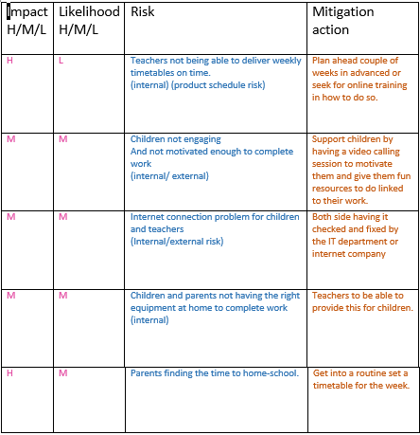
The risk analysis grid above is explain what are the risks in the project and if they are a hig or low impact and how likely this will happen and what actions could be taken to solve them. I will speak about 3 of the risks.
- Teachers not being able to deliver weekly timetables. This is a high risk because it will affect children’s home-schooling timetable will make them come out of routine if they are already in one. But this very a low likelihood and if this was the case then the actions taken will be teachers should plan ahead for couple of weeks in advance giving them selves plenty of time to be organised and taking online training sessions. Because one of the important outcomes is teachers delivering work in time for this project to run smoothly and to see a successful end result.
- Children finding it hard to engage. Parents should try all their best to motivate their children/child by making the home-schooling fun and creative and asking the teachers advice in how to do so if not able to do themselves. When teachers are having video calling sessions, they are being positive about the home-schooling process encouraging children to enjoy staying at home and learning.
- Parents finding the time to home-school. This can be shared out between both parents if they ate living in one household. So, less pressure on one parent asking for extra support from teachers. Parents not feeling pressured to complete the work on time.
The project manager can also use the tools swot and pestle analysis to measure out the strength and weaknesses of the project and measure out the outcomes.
Moving on to the next planning stage (WBS) a work breakdown structure.
“Breaking work into smaller tasks is a common productivity technique used to make the work more manageable and approachable. For projects, the Work Breakdown Structure (WBS) is the tool that utilizes this technique and is one of the most important project management documents. It singlehandedly integrates scope, cost and schedule baselines ensuring that project plans are in alignment.” (2020)
The WBs tool is a step by step puzzle broken down into order making sure the project is flowing the right direction starting off with the project title and why this project is being held. Then moving onto box 1 which is the project scope, applying who is involved in the project and how the work is going to be delivered to the children. Box 2 is the project phase box explaining how the process will work by having to do all work online through the website j2e and the dojo app. Box 3 teachers to deliver work weekly on time otherwise this can mess up children’s timetables. Teachers to be very flexible about when work is to be returned and having video sessions with the children once a week for 10 mins to keep them motivated and reassure them they are doing well, also no pressure on the parents they should also take their time in delivering and doing the work with the children. Box 4 parents to keep up with the timetable of the weekly work set but taking their time over the week to complete so no set time just to be completed end of the week and sent back to teacher for feedback. For children and parents. Box 5 making sure children are keeping positive and motivated, as well as parents. The WBS chart links in with box 3 of the quad chart desired actions. Explain how these outcomes can be met. “This is more of a scheduled event it breaks down the whole structure of the project. Defining all the phases, activities, and tasks required to deliver it. It also sets out the project scope and deliverables, resources of the project. “ (2011)

Teachers to add extra online resources for children to do or use towards their work. Also links to other educational websites for children to do in their own time.

The WBS tool also links to the Gantt chart tool which is “A Gantt chart is a graphical depiction of a project schedule. It's is a type of bar chart that shows the start and finish dates of several elements of a project that include resources, milestones, tasks, and dependencies. Henry Gantt, an American mechanical engineer, designed the Gantt chart.” (M.G 2019)
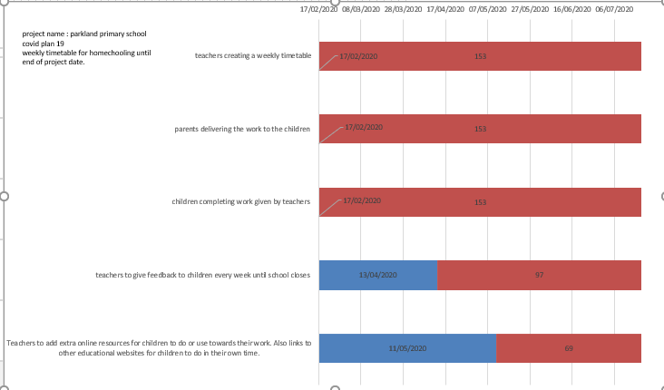

This tool shows excatly what date and time the WBS will look in a more practical way. It is a pictonial represenation of each stage of the project sharing individual tasks, according to the length of time tey will take .

The network diagram:

A network diagram is a flow chart that represents tasks, responsibilities, and workflow for a project. Most of the time the chart looks like a series of boxes an arrow. It is implemented to map out the schedule and work sequence for a project as well as track its progress through each stage up to the finish stage. The network diagram also illustrates the scope of a project. (2006-2020)

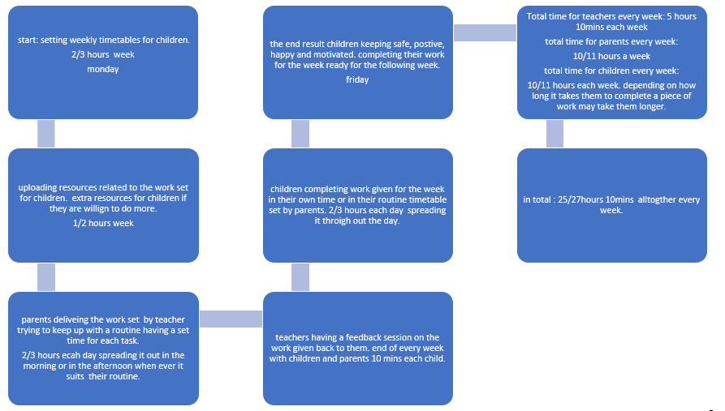

As you can see the project manager has planned out a weekly network diagram for the project parkland primary school showing how many hours each day teachers, parents and children spend doing work and communicating with one another and then how much it adds up to a weekly basis. This will be the same plan until school reopens again in mid-June.
From looking at the results the critical path from this project is children completing their work over the week in their own time and sending it when they have completed which then the teachers fall back in marking the work and giving feedback. They might not be able to mark every childs work on time and plan for the following week. So some children will get fedback the following week regarding lastweeks work.

3. project execution phase midterm evaluation

A midterm evaluation is carried out in a project to measure its success and how to better the project further and what could need improving. It’s when the project manager reflects back on the project and looking to see if it needs improvement and looking to congratulate your team members and the project manager himself-herself. For doing well in the project and keeping everyone motivated throughout. (2010)
It is also monitoring to see if the evaluation is hard or soft. Hard means is the project was successful and how successful it was. Soft evaluation is what has been useful in this project? What has motivated everyone? Has it built confidence in parents as well as children? The table below explains the monitoring and evaluation of this project.
Going back to the quad chart the project manager has tried their level best to complete the measures of parents and pupils. However, it is difficult when its only communicating through online and teachers can do so much. Therefore, there is no other alternative until school opens as everyone is still at risk due to covid19 until it’s safe to do so. The table below is explained by the project manager and how the project was evaluated.

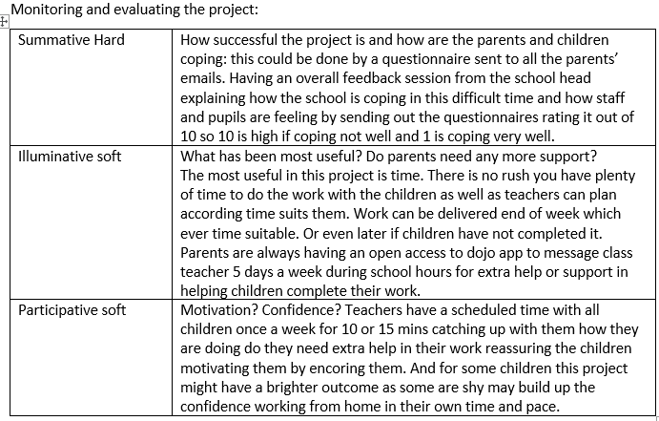
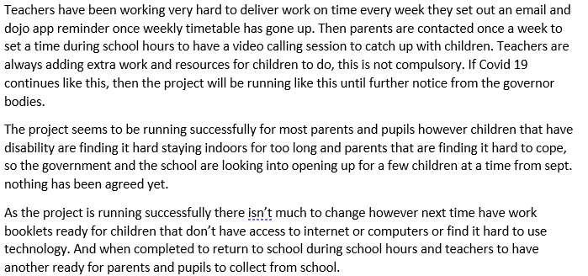
4. project closure phase
This part of the project is to see what went well and what went wrong and how things can be improved and done differently next time.
The project manger has been informed that the virus has died down to measures that school will be reopening sooner than they expected.
To reflect on the whole project the manger used the project cycle tool:
Linking the whole project back to Kolb’s reflection tool. Kolb’s experience learning cycle (1984)
“Learning is the process whereby knowledge is created through the transformation of experience” (Kolb, 1984, p. 38)
Honey and Mumford’s learn In Style (1992) is related to Kolb’s thinking.
Honey and Mumford identified that different people have different learning styles and their model is closely related to Kolb’s. (Morgan.p)
Kolb’s model is broken down into various reflective process in steps or stages. These stages are usually formed in a cycle. Which help reflection to bring better understanding and forward planning for the future. (Cottrell’s)
As you can see on my cycle, I have used it do develop my understanding of forward planning in what I lack most confidence on.
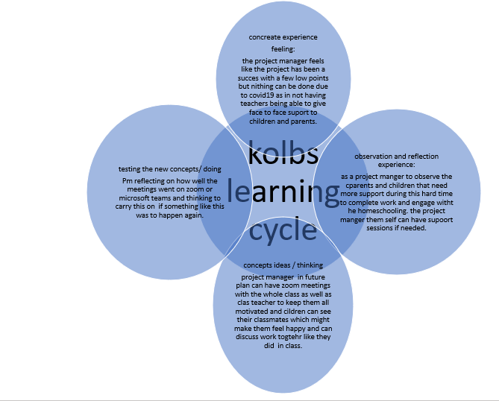
Recommendations :
The project manager can use Belbin’s team role in future to reflect on a new project. As well as the manager can always look back on this project and apply Belbin’s test results to do better for new project.

References :
Bobby M. MPH (2000) [A framework featuring steps and standards for program evaluation] vol.1 no. 3 pg. 221-228 sage publications

Cottrell s. (2003) [the study skills handbook ](second edition) New York city, Palgrave McMillan pg.31

Margaret (2007-2020) [Project scope] available at : https://searchcio.techtarget.com/definition/project-scope accessed: 24/06/2020

Mindtools (2020) [stakeholder analysis] available at : https://www.mindtools.com/pages/article/newPPM_07.htm accessed: 24/06/2020

Michelle. G (2019) [what is a Gant chart] available at: https://www.investopedia.com/terms/g/gantt-chart.asp accessed: 27/06/2020
Morgan.P (2017) [the business student’s guide to study and employability] London, sage pg.38-40
PMBOK.G (2013) [A guide to project management body of knowledge (PMBOK.guide) ] fifth edition project management institution

Unknown (2020) [Kolb’s cycle of reflective practice] available at: https://www.leedsscp.org.uk/Practitioners/Toolkit/Kolbs-Cycle-of-Reflective-Practice#:~:text=Kolb%E2%80%99s%20Cycle%20of%20Reflective%20Practice%20is%20a%20theory,as%20an%20important%20part%20of%20the%20learning%20process. Accessed: 28/06/2020

Unknown (2018) [Team building patrol.] available at : https://www.teambuildingportal.com/articles/systems-and-approaches/belbin-team-roles accessed: 28/06/2020
Unknown (2006-2020) [what is a network diagram] available at: https://www.wrike.com/project-management-guide/faq/what-is-a-network-diagram-in-project-management/#:~:text=A%20network%20diagram%20is%20a%20graphical%20representation%20of,through%20each%20stage,%20up%20to%20and%20including%20completion. Accessed: 28/06/2020

Ulaang. B (2010) [mid term evaluation of mitigation and management system in mongolio project, MON/08/305 (pahseiii)] page. 8,9
Unknown (no date) [J2e launch ] available at : https://www.j2e.com/ accessed: 28/06/2020
Unknown (2020) [what is project management?] available at: https://www.apm.org.uk/resources/what-is-project-management/ accessed: 24/06/2020

Unknown ( 2020) [what is project life cycle and its main characteristics?] available at : https://www.invensislearning.com/resources/pmp/what-is-project-life-cycle-and-its-main-characteristics accessed: 24/06/2020

Unknown (2010) [Risk Assessment Matrix - How to Use It in Risk Management]
Available at: https://www.brighthubpm.com/risk-management/88566-tool-for-assessing-project-risk/ accessed: 25/06/2020

Unknown (2011) [managing projects of all sizes] projectmanager.com

Unknown (2020) [work break down structure] available at: https://www.workbreakdownstructure.com/ accessed: 27/06/2020

Wikipedia (2019) [Quad charts] available at : https://en.wikipedia.org/wiki/Quad_chart accessed: 24/06/2020

