

Programme: BSc (Hons) Health and Social Care
Module: Independent Project
Module Code: BMHP6020
Component 1 Proposal

The Social and Health Impacts of Alcohol and Drug Consumption in the UK: A Secondary Data Analysis Study

Student’s Name: Mihaela Narcisa Sava
Student ID: 2217316

Table of Contents
1.0 Introduction 3
2.0 Research Problem 3
3.0 Rationale for the Study 3
4.0 Research Aim and Objectives 4
5.0 Research Questions 4
6.0 Outline of Methodology 4
7.0 Expected Outcomes 4
References 6

1.0 Introduction
The​‍​‌‍​‍‌​‍​‌‍​‍‌ consequences to society and the health of the community of alcohol and drug consumption are still among the most serious problems affecting the public health system of the United Kingdom (UK). Priory (2025) shows that 78.3% of people aged 15 and over have consumed alcohol in the last year. Moreover, heavy episodic drinking rates have increased, mainly among women. Drug use continues to be popular. Young adults aged 16-24 also have higher prevalence rates (Institute of Alcohol Studies, 2025). These consumption patterns are at the root of diseases, death rates and social problems, which have become widespread in the UK population. ‍ ‌ ​‍​‌‍​‍‌​‍​‌ ‌ 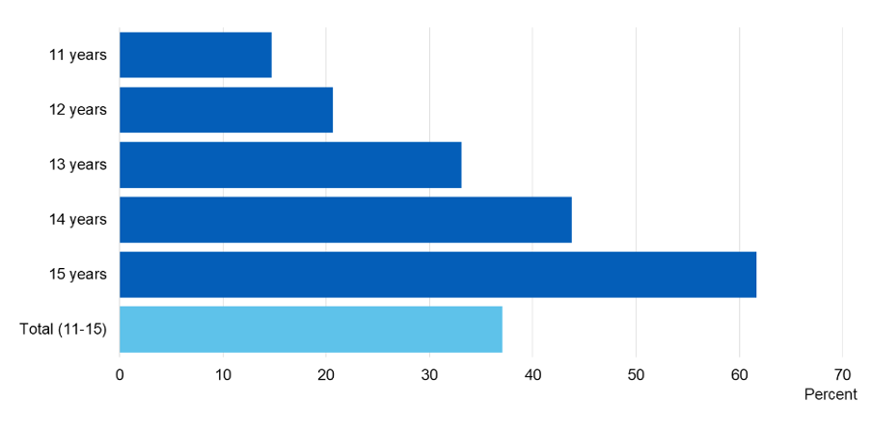
Figure 1: Alcoholic Drink Prevalence in the UK, by Age
(Source: Institute of Alcohol Studies, 2025)

2.0 Research Problem
Although​‍​‌‍​‍‌​‍​‌‍​‍‌ there are still efforts to intervene, the consumption of alcohol and drugs remains the major causes of social problems such as addiction, loss of a job, disintegration of the family and crime. Deaths from alcohol (10,048 in 2022) and drugs (5,448 in 2023) are very high and these are the reasons why responses in policy and healthcare need to be informed by ​‍​‌‍​‍‌​‍​‌‍​‍‌data, as per Crown (2025).

3.0 Rationale for the Study
This​‍​‌‍​‍‌​‍​‌‍​‍‌ analysis merges the UK epidemiological and social datasets related to alcohol and drug use. It investigates patterns, groups and the costs of society. Näher et al. (2023) stated that the use of secondary data allows for a quick and inexpensive analysis to be done, which is necessary for the coordinated use of resources and efficient prevention measures to be implemented as supported by trustworthy government and health ​‍​‌‍​‍‌​‍​‌‍​‍‌datasets.

4.0 Research Aim and Objectives
Aim:
The​‍​‌‍​‍‌​‍​‌‍​‍‌ aim is to carry out a critical assessment of the impacts on the society and the health of the UK arising from the use of alcohol and drugs.
Objectives:
- To analyse consumption patterns and demographic variations.
- To research the diseases and health problems that are linked to the use of substances.
- To examine social consequences like those resulting from addiction, the effects on the society and the economy.
- To assess the insufficiencies in the current data and the potential effects on health ​‍​‌‍​‍‌​‍​‌‍​‍‌policy.

5.0 Research Questions
- What​‍​‌‍​‍‌​‍​‌‍​‍‌ changes in alcohol and drug usage can be observed among UK demographics?
- Such consumption patterns have what kind of an impact on public health?
- What social consequences result from the use of substances and which groups of people suffer the most?
- In what way can healthcare and policy interventions use secondary ​‍​‌‍​‍‌​‍​‌‍​‍‌data?

6.0 Outline of Methodology
This​‍​‌‍​‍‌​‍​‌‍​‍‌ project only uses secondary qualitative data that are freely available in the public domain. These data have been obtained from governmental reports, public health databases, academic journals and reputable NGOs. The assessment of data will concentrate on the trustworthiness, freshness (mostly 2018-2025) and applicability of the data to the UK context (Näher et al., 2023). The analysis techniques are descriptive combined with thematic synthesis to evaluate the data ​‍​‌‍​‍‌​‍​‌‍​‍‌critically.

7.0 Expected Outcomes
This​‍​‌‍​‍‌​‍​‌‍​‍‌ research is mainly focused on explaining the health risks that come along with the use of alcohol and drugs, singling out the youth and the poor as the most vulnerable high-risk groups and stressing that the only way to have effective addiction remedies is to have the integration of social and health care policies by which prevention, treatment and support can be improved in the ​‍​‌‍​‍‌​‍​‌‍​‍‌UK (Alsuhaibani et al., 2021).

References
Alsuhaibani, R., Smith, D.C., Lowrie, R., Aljhani, S. and Paudyal, V., (2021). Scope, quality and inclusivity of international clinical guidelines on mental health and substance abuse in relation to dual diagnosis, social and community outcomes: a systematic review. BMC psychiatry, 21(1), p.209.
Crown, (2025). Collection Alcohol and drug statistics. [Online] Available at: https://www.gov.uk/government/collections/alcohol-and-drug-statistics [Accessed on 29th October 2025]
Institute of Alcohol Studies, (2025). October 2024. [Online] Available at: https://www.ias.org.uk/alcohol_alert/october-2024/ [Accessed on 29th October 2025]
Näher, A.F., Vorisek, C.N., Klopfenstein, S.A., Lehne, M., Thun, S., Alsalamah, S., Pujari, S., Heider, D., Ahrens, W., Pigeot, I. and Marckmann, G., (2023). Secondary data for global health digitalisation. The Lancet Digital Health, 5(2), pp.e93-e101.
Priory, (2025). Alcohol statistics UK 2025. [Online] Available at: https://www.priorygroup.com/addiction-treatment/alcohol-rehab/alcohol-statistics [Accessed on 29th October 2025]

