Eren Kulahlioglu (2513628)
LONDON CAMPUS
Assignment 2
Learning in the Digital Era
Video Link: https://www.youtube.com/watch?v=F28_soDmyCo

Alternative Link:
https://uowtsd-my.sharepoint.com/:v:/g/personal/2513628_student_uwtsd_ac_uk/IQCckZ_oyrfJSb2cWYvQn8K5AdzBL2VqqUTm10nZUeHYB6M?e=aVVn6A

Module Name: Learning in the Digital Era
Module Code: ACCA 4025
Student Name: Eren Kulahlioglu
Student ID: 2513628
Group: 2
Lecturer’s Name: Koushik Modak

Table of Contents
Introduction 2
Main Body 2
Conclusion 9
References 9

Introduction

This task supports both my personal and academic development and is organised into three key parts:
- Task 1: Self Evaluation
An overview of my current strengths as a learner, along with areas I aim to improve.
- Task 2: Professional Development Plan (SMART Goals)
A structed plan detailing how I will develop my skills using the SMART criteria.
- Task 3: Topic Summary “Learning to Learn”

Main Body
A brief explanation of the main ideas from Unit 4 and their importance for lifelong learning.
Aim:
To understand myself better as a learner and set achievable goals that will support my future success.

Video Link:
https://www.youtube.com/watch?v=F28_soDmyCo

Slide 1 COVER PAGE
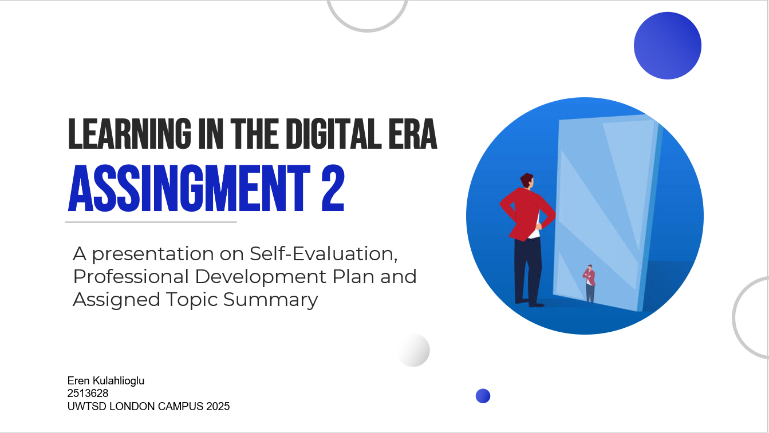

Slide 2 CONTENTS

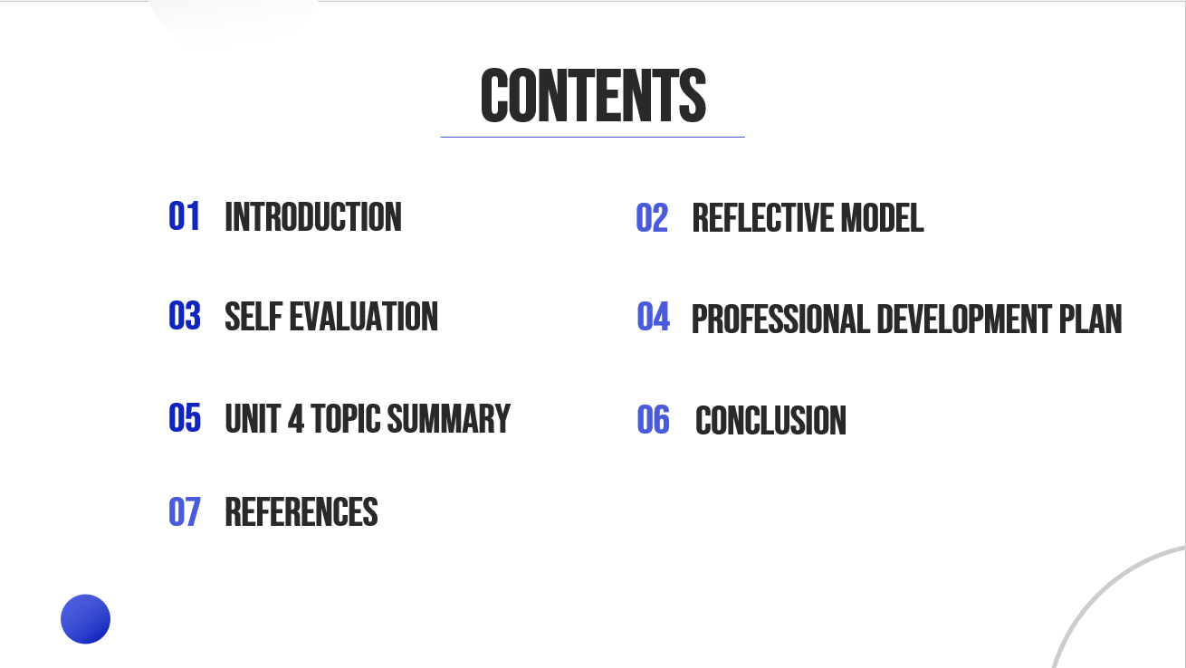

Slide 3 INTRODUCTION
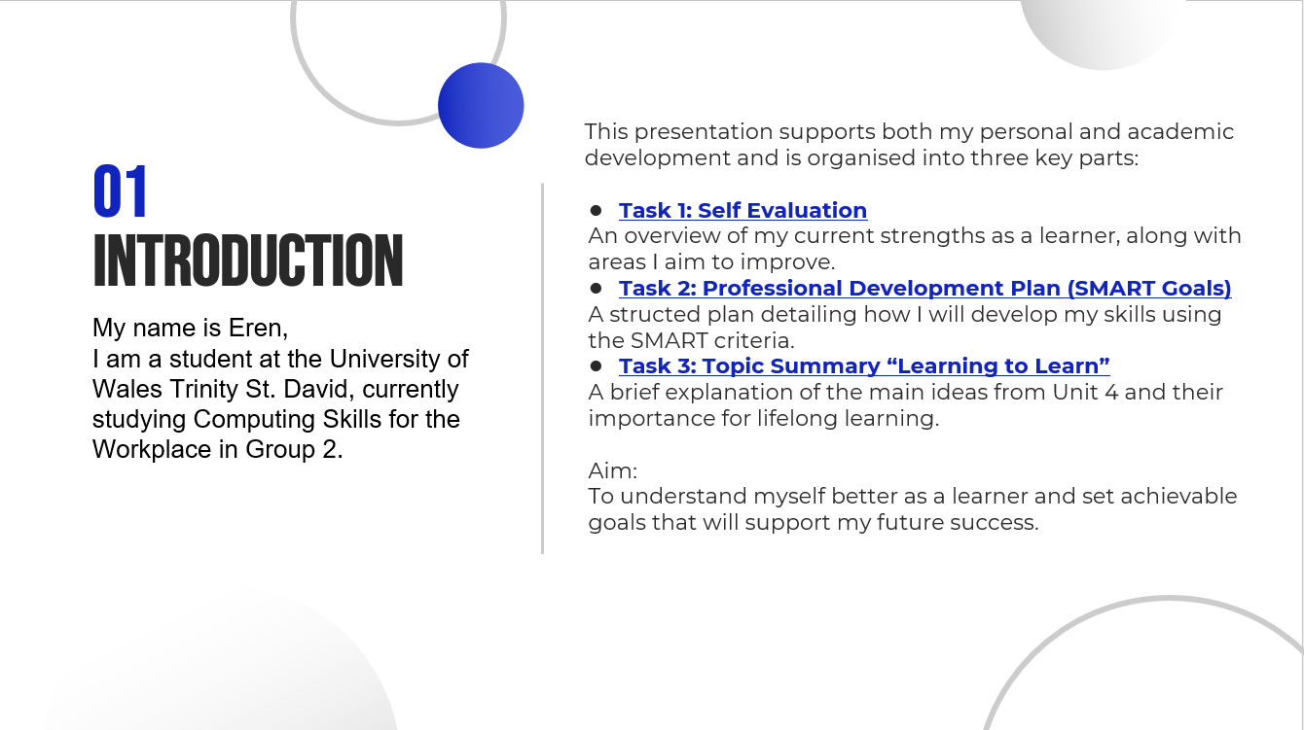

Slide 4

Slide 5 GIBB’s REFLECTIVE MODEL
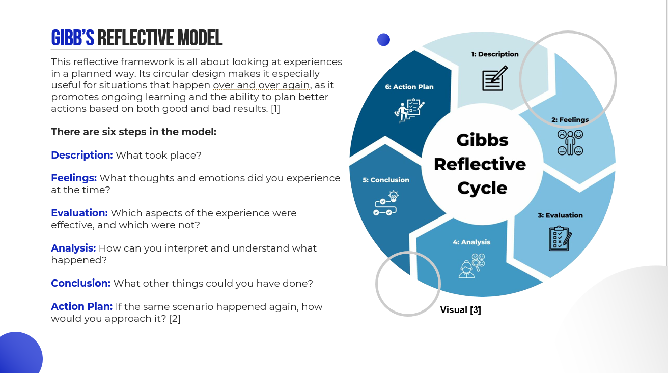

I will use Gibbs model to organise my reflection in steps for my assignment.
First, I will give a brief description of the task I did. Then, I will honestly talk about how I felt and what I thought while I was doing it. After that, I will look at what went well and what was hard for me.
During the analysis stage, I will link my experience to important ideas and talk about why some things happened when they did.
In the end, I will go over the most important things I learnt.
I will list the exact steps I will take in the action plan to get better at my schoolwork and improve my skills.

Slide 6 TASK 1: SELF EVALUATION
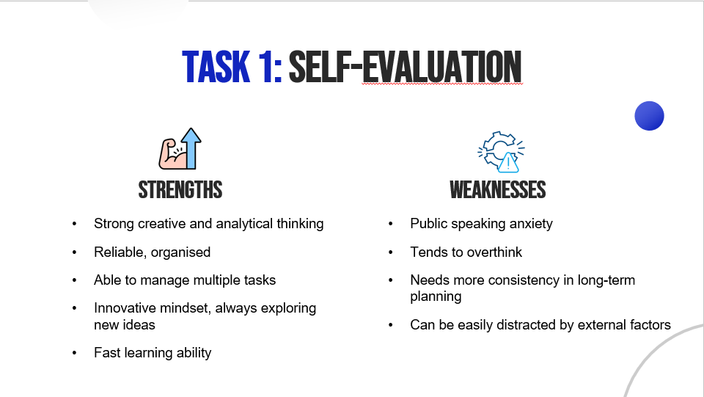

Slide 7 TRAITS GAINED FROM THE SELF EVALUATION
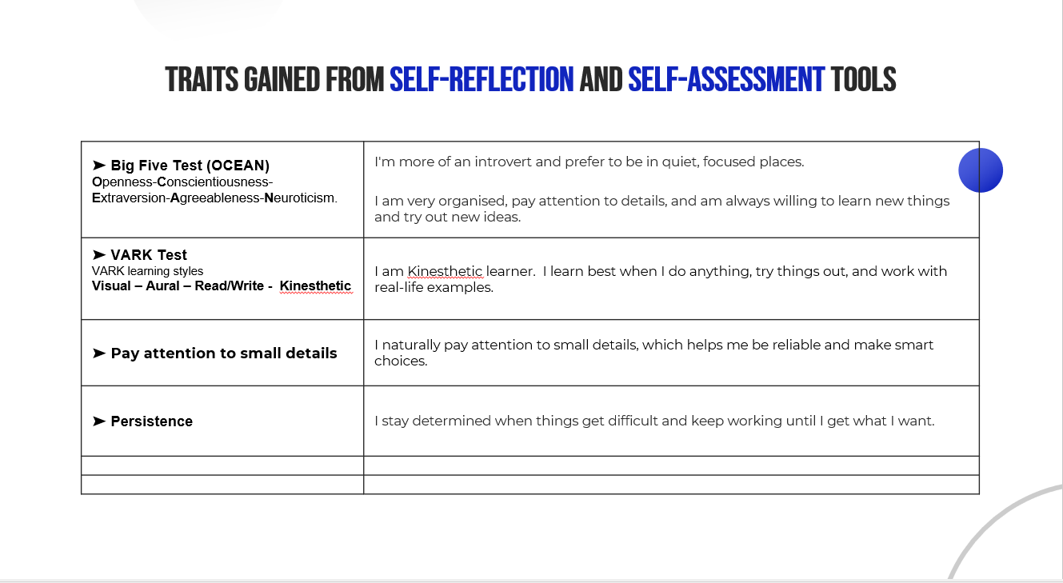

Brief explanation:
The Big Five Personality Test and the VARK learning style test helped me understand my own traits and how I like to learn better. These tests showed that I am creative, adaptable, and able to learn quicky, which helps me do better in school. They also helped me see where I needed to improve, like staying focused on tasks and being more confident in difficult situations. Overall, these tools helped me understand how I learnt and how I can keep improving my study habits.

Slide 8 PROFESSIONAL DEVELOPMENT PLAN
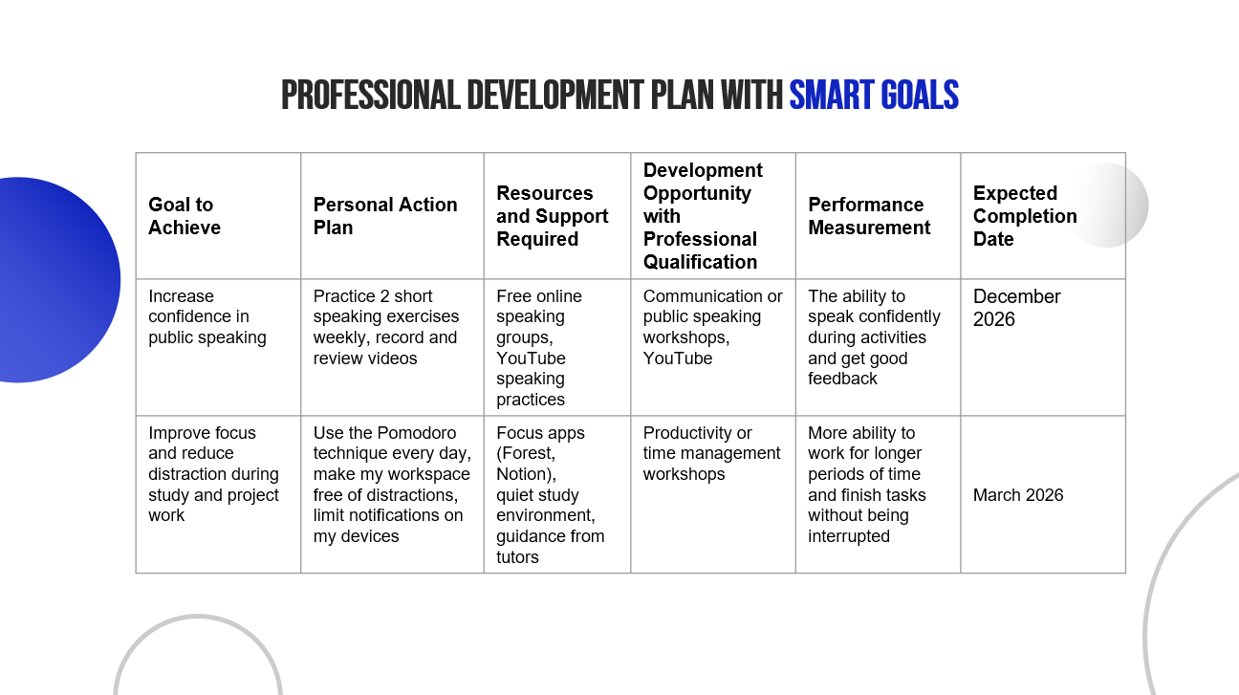
My plan for professional development is to work on the skills I found through self reflection and assessment. I set SMART goals for myself to make sure that my progress is measurable and possible. SMART goals are specific, clear goals that help me grow.
My plan has goals that focus on two main areas,
Setting structured study times and cutting down on distractions will help me stay focused and disciplined while I study.
Each goal is SMART: Specific, Measurable, Achievable, Relevant, and Time-bound. This helps me keep track of my progress and stay motivated. This plan will help me do better in professional over time.

Slide 9 UNIT 4 TOPIC SUMMARY
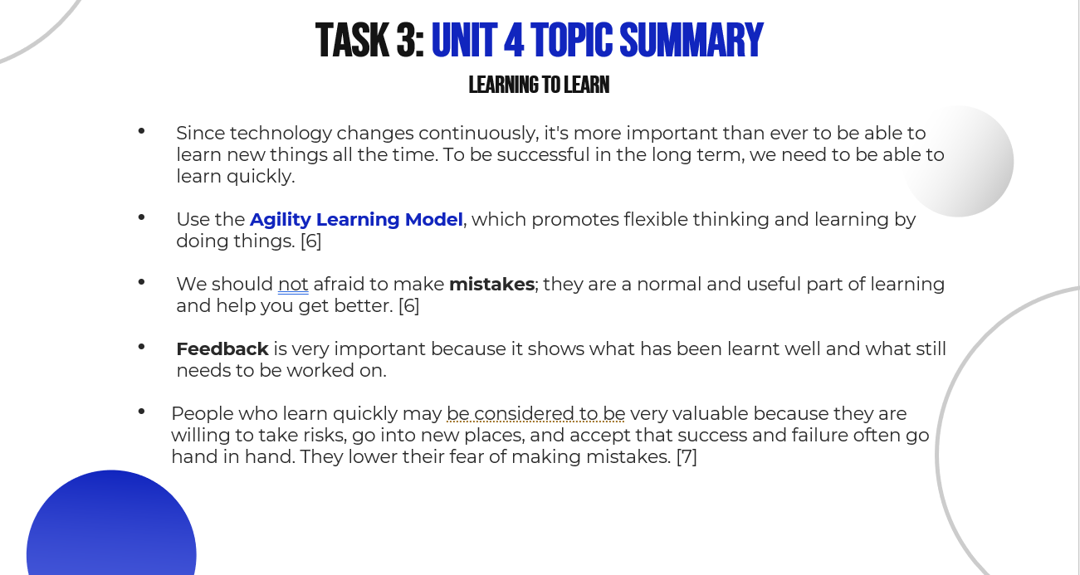
Brief explanation
- Since technology changes continuously, it's more important than ever to be able to learn new things all the time. To be successful in the long term, we need to be able to learn quickly.
- Use the Agility Learning Model, which promotes flexible thinking and learning by doing things. [6]
- We should not afraid to make mistakes; they are a normal and useful part of learning and help you get better. [6]
- Feedback is very important because it shows what has been learnt well and what still needs to be worked on.
- People who learn quickly may be considered to be very valuable because they are willing to take risks, go into new places, and accept that success and failure often go hand in hand. They lower their fear of making mistakes. [7]
The Habit Loop is a simple way to show how habits are made and kept over time. It has three parts that repeat in a loop. [8]

Why the Habit Loop is Important for Learning?
Learning about the Habit Loop can help everyone develop good study or work habits and get rid of bad ones.
It's easier to stay focused, be consistent when you know what sets you off and replace bad habits with better ones. [8]

Research show that real growth frequently occurs when people move outside their comfort zones and meet new challenges. The Learning Agility Cycle defines a four-step process that people go through to learn and improve their skills [4].

1. Seeking
Looking for new experiences and chances to learn and grow. This means being curious and willing to try new things [4].
2. Sense-Making
Thinking about what happened and why by going over the experience and looking at feedback. This stage helps learners find important information [4].
3. Internalizing
Adding new lessons to what you already know so that they become part of how you think in the long term and help you make decisions in the future [5].
4. Applying
Applying fresh knowledge and skills in practical contexts. This shows that learning has happened and can now be used to solve problems. [4].

Slide 10 CONCLUSION
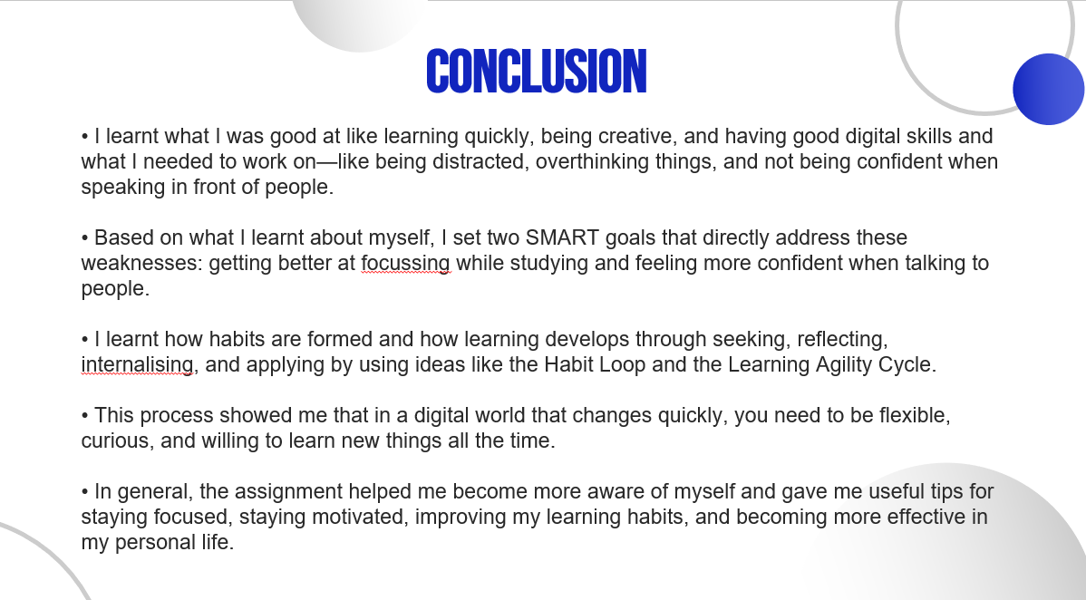

Slide 11
Conclusion
- I learnt what I was good at like learning quickly, being creative, and having good digital skills and what I needed to work on—like being distracted, overthinking things, and not being confident when speaking in front of people.
- Based on what I learnt about myself, I set two SMART goals that directly address these weaknesses: getting better at focusing while studying and feeling more confident when talking to people.
- I learnt how habits are formed and how learning develops through seeking, reflecting, internalizing, and applying by using ideas like the Habit Loop and the Learning Agility Cycle.
- This process showed me that in a digital world that changes quickly, you need to be flexible, curious, and willing to learn new things all the time.
- In general, the assignment helped me become more aware of myself and gave me useful tips for staying focused, staying motivated, improving my learning habits, and becoming more effective in my personal life.

References
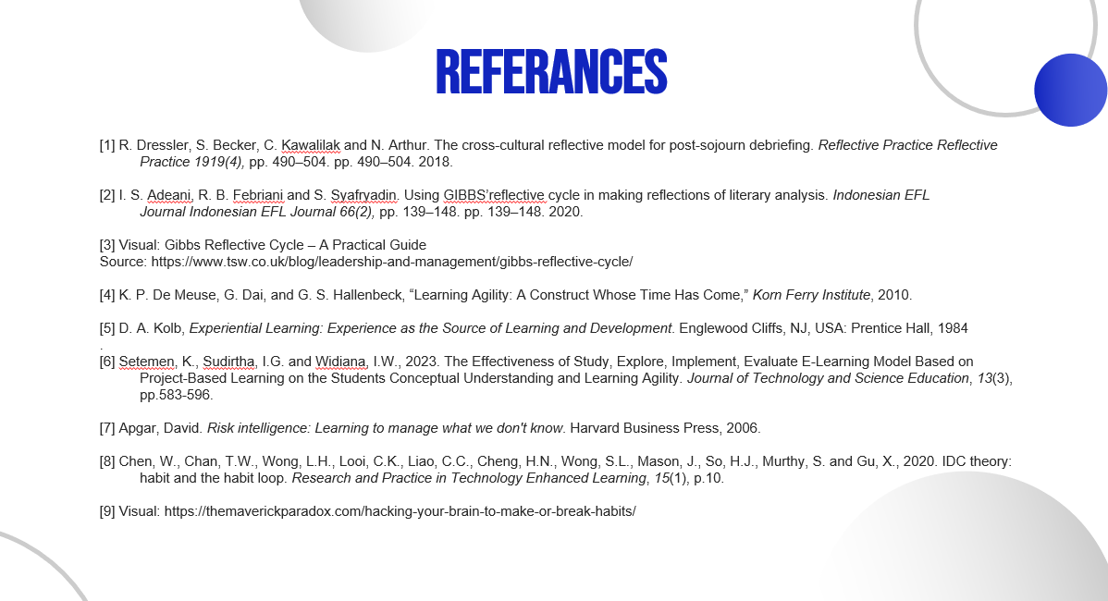

[1] R. Dressler, S. Becker, C. Kawalilak and N. Arthur. The cross-cultural reflective model for post-sojourn debriefing. Reflective Practice Reflective Practice 1919(4), pp. 490–504. pp. 490–504. 2018.
[2] I. S. Adeani, R. B. Febriani and S. Syafryadin. Using GIBBS’reflective cycle in making reflections of literary analysis. Indonesian EFL Journal Indonesian EFL Journal 66(2), pp. 139–148. pp. 139–148. 2020.
[3] Visual: Gibbs Reflective Cycle – A Practical Guide
Source: https://www.tsw.co.uk/blog/leadership-and-management/gibbs-reflective-cycle/
[4] K. P. De Meuse, G. Dai, and G. S. Hallenbeck, “Learning Agility: A Construct Whose Time Has Come,” Korn Ferry Institute, 2010.
[5] D. A. Kolb, Experiential Learning: Experience as the Source of Learning and Development. Englewood Cliffs, NJ, USA: Prentice Hall, 1984
[6] Setemen, K., Sudirtha, I.G. and Widiana, I.W., 2023. The Effectiveness of Study, Explore, Implement, Evaluate E-Learning Model Based on Project-Based Learning on the Students Conceptual Understanding and Learning Agility. Journal of Technology and Science Education, 13(3), pp.583-596.
[7] Apgar, David. Risk intelligence: Learning to manage what we don't know. Harvard Business Press, 2006.
[8] Chen, W., Chan, T.W., Wong, L.H., Looi, C.K., Liao, C.C., Cheng, H.N., Wong, S.L., Mason, J., So, H.J., Murthy, S. and Gu, X., 2020. IDC theory: habit and the habit loop. Research and Practice in Technology Enhanced Learning, 15(1), p.10.
[9] Visual: https://themaverickparadox.com/hacking-your-brain-to-make-or-break-habits/

