Natalie Jones
BA Illustration
Word Count: 2636
Lecturer: Delyth Lloyd-Evans

3 Keywords: Politics, Psychology Sociology

Proposed question for the independent project: What influence do Psychology and sociology have within editorial illustration and political art? By understanding what influences they have, can we make positive changes as activists?

In this Essay, I aim to delve deeper into the influence of specific Psychology and Sociology Theories that could affect Editorial Illustration and political art. I aspire to gain a deeper understanding of Ignacio Martin-Baro's Liberation psychology theory, which states that 'Trauma must be understood in terms of the relationship between the individual and society’, as well as Kenneth Clark’s Developmental Psychology theory, which questions ‘Who teaches a child to hate and fear a member of another race’. However, psychology is not the only possible influence of editorial illustrations and political art; sociology, such as Max Weber’s Iron Cage, which was formed during the Industrial Revolution, still affects us today and what we see from political artists.
Over the past few years, my journey has taken an unexpected turn towards politics. The catalysts for this shift were the actions of former Prime Minister Boris Johnson and former President of the United States of America Donald Trump. Their policies and rhetoric left me deeply unsettled, and I found solace in activism and art. This personal journey led me to explore the works of artists like Edel Rodriges, whose cover for Times Magazine in 2016, titled Meltdown, resonated deeply with me.

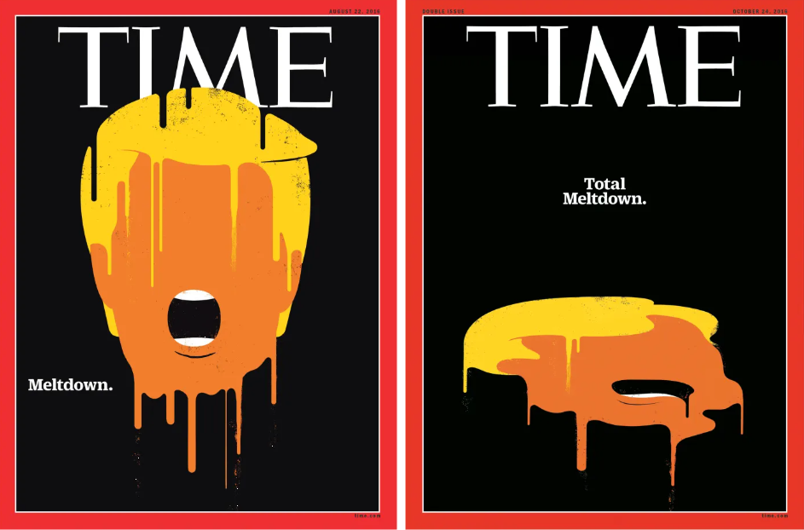

Figure 1. Edel Rodriges, Meltdown, Times Magazine, 2016. The Power of Editorial Illustration, page 34

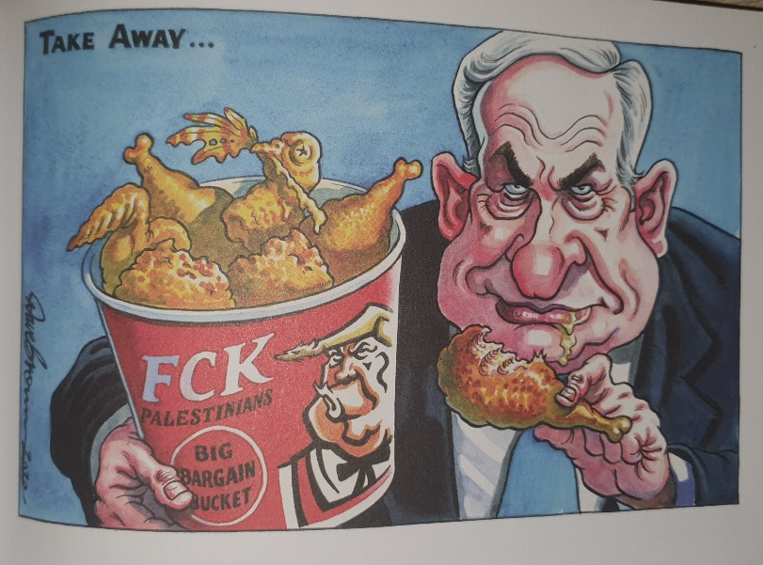
Personally, I love the style that this cover is done in, and to my understanding, it is loosely inspired by the art movement Constructivism, which was founded in 1922, five years after the Russian Revolution had taken place; this was due to artists at time embracing the new political freedom they felt from no longer being under the control of the elite members of Russian society (L.Hillegas 2019). The Russian Revolution in 1917 was primarily caused by political corruption and World War 1 – the people of Russia largely viewed their involvement negatively due to the large proportion of people who were massacred and the overall effect that losing the war had on their economy (Encyclopaedia Britannica 2024). Even though the Russian Revolution happened over 100 years ago, the themes of the revolution still resonate with a lot of people, as Government corruption and needless deaths due to war and famine are continuing in the 21st century – this can be seen within the current situation in Gaza where at least 34, 568 Palestinians were killed in Gaza and 77,765 Palestinians were injured’ (Public Health Situation Analysis 2024) this is an ongoing humanitarian crisis where not only innocent people are being ethnically cleansed but are facing a man-made famine where the ‘Gaza’s population faces “catastrophic food insecurity” and that around 70% of an estimated 300,000’ (the Economist 2024) as an activist I cannot sit by and read the news about this and not do anything, personally I have donated to gofundmes to help families in Gaza get enough money so when they can get to safety they can. In contrast to this, at the same time, this is happening in Gaza, where the Met Gala is currently taking place, raising money for the Metropolitan Museum of Art's Costume Institute. A single ticket is $75,000 (News18.com 2024), which would cover a family of 5 to be able to feel Gaza to safety.
Figure 2. Dave Brown, Independent, 2020, ink illustration, Britain’s Best Political Cartoons 2020, p79
This political illustration by Dave Brown is on the topic of the new peace plan created by Former US President Donald Trump to establish Jerusalem as Israel's undivided capital city as well as to recognise most of Israel's settlements in occupied Palestine land (T.Benson 2020) Four years later and the peace plan, in fact, didn’t work as well as wasn’t welcomed by Palestine. This Illustration by Dave Brown uses satire, which seems to be a popular theme within political art and editorial illustration. This is due to freedom of the press and freedom of speech; without these, this would be redacted and wouldn’t make it to publishing. I admire brown blending techniques as everything looks so seamless, and the contrast within this piece and the colours work well together, but the red of the chicken bucket is eye-catching and draws your eyes into that focal point.
However, political corruption doesn’t always take place in a foreign country; for example, Party Gate – which was when Former prime minister Boris Johnson misled MPs into breaking COVID-19 rules ‘which led to 126 fixed-penalty notices being issued in Whitehall and Downing Street’ (P.Walker 2023) as well as ‘Traces of cocaine found in the UK Parliament, including near Boris Johnson's office’ (J. Haltiwanger 2021) these maybe to the lesser extreme than what is currently going on within Gaza but it shows that corruption can happen anywhere.
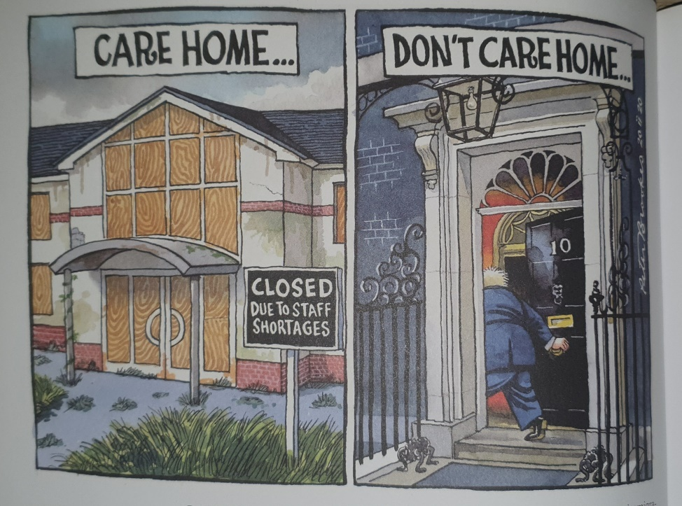
Within Psychology, there are many different approaches; the first one I will be looking into is Liberation psychology, more specifically, the work of Ignacio Martin-Baro. Martin-Baro witnessed social injustice and a violent epidemic within the bounds of El Salvador in the 1980s that caused him to abandon traditional psychology as it was impartial and didn’t consider the socio-political environment that an individual may find themselves a part of (N.Benson 2011). Martin-Baro believed that in order to treat a person’s mental health, you must address both the personal problem of the individual also take into consideration that outside circumstances may have or be the root of a person's mental health problems – this leads to change within the world and Psychology as in ‘1988 the Latin American institute of mental health and Human rights was founded’ (N.Benson 2011)
Figure 3. Peter Brookes, The Times, 2020, Britain’s best political cartoons 2020, p92
This pollical illustration by Brookes is focused on the UK government's new immigration system, which social care providers were alarmed over as there was potential to cause a Labour shortage under the new system as exceptionally few care workers would be able to enter the country which created tension due to the fact that a lot of care workers within the UK are immigrants (T.Benson 2020). Just two years after the government had made this decision, ‘ the Home Office added care workers to its shortage occupations list’ (V.Gayle 2024). This means that getting an appointment with a GP has become way more complicated than it was in previous years; this means that the elderly struggle to receive adequate care or cannot receive the care that they need; this can be said about any group of vulnerable people – this creates more problems with society and puts more pressure than ever before on care workers which has a cause ‘ more than three quarters (77 per cent)** of local authorities, mental health, stress, or work-related stress is the most common reason for sickness absence in their social care workforce’ (British Psychological Society 2023) this clearly shows what Martin-Baro was suggesting that outside factors like understaffing, underpayment and overworking a person can cause mental health problems and to help we need these people we need to provide them with the correct skills to cope but also fix the societal issues. We can see how these social problems directly influence Fig 3 and how Martin-baro's ideas are also influencing Fig 3.
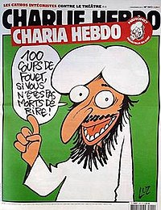
The following Psychology approach I will be looking into is Race attitudes by Kenneth Clark where Clark and his wife study the effects of racial segregation on African American school children – this experiment included both black and white-skinned dolls; the children were asked what doll they preferred, the children frequently pick the white skin doll which directly reflected the racial attitudes of the 1930s – this was interpreted as the children displaying self-hated due to their skin tone, this caused Clark to question what was teaching these children prejudices attitudes he found that an influence was the media (N.Benson 2011). This made me question what responsibilities we have as illustrators as the illustrations we create may/ can be viewed by anyone and on anything – Traditionally editor illustrations were distributed through newsstands but now they can be on subways and even airplanes (A. Selby 2022) But due to this our ideas no matter if they are based in facts or fiction can be seen by large amounts of people and like in the 1930s a lot of the time they reflect the attitudes within society at the time but due to fake news ‘The public demand more diverse content coverage, greater analysis … in the quest for knowledge, information and truth’ (A.Selby 2022) as illustrators we have a massive responsibility to the public to provide accurate and well thought out art pieces that convey the truth and that stays away from prejudiced views as Clark showed within his experiment we could be contributing to negative social opinions that can be highly damaging to the younger generation which calls into question the type of future we want for them and ourselves. That’s not to say that Prejudiced or hateful views do not exist within editorial illustration.
Figure 4. Charile hedo, Issue no.1011, 2015
Charlie Hebo is an inaccurate depiction of the Islamic prophet Muhammad, and this resulted in a terror attack on a French publishing office, which was a terrifying and awful reminder that cultural views need to be respected. This was viewed as slander of the peaceful Islamic region, but due to extremists, a horrific massacre occurred (A.Selby 2022)
This led me to lightly explore Karl Marx's sociology views on Religion and radicalism – Marx argued that religion was being used to maintain power within elite members of society as it gave hope to the working class that things would be better in the future, causing the less wealthy to find moral soles resulting in the elite capitalising off the suffering of the less wealthy and providing stabilisation within society which lessens the chance of social change. (M.Todd 2015) Radicalisation tends to be a step within extremism as people gain extreme beliefs that then turn into using violence or fear to express their beliefs. This is ultimately why Fig 4 ended within a massacre. People tend to be drawn into extremism due to personal struggles within their lives and the group gives them a lot of psychological benefits like a sense of belonging but also aids them with a feeling of community. (ACT N/A)
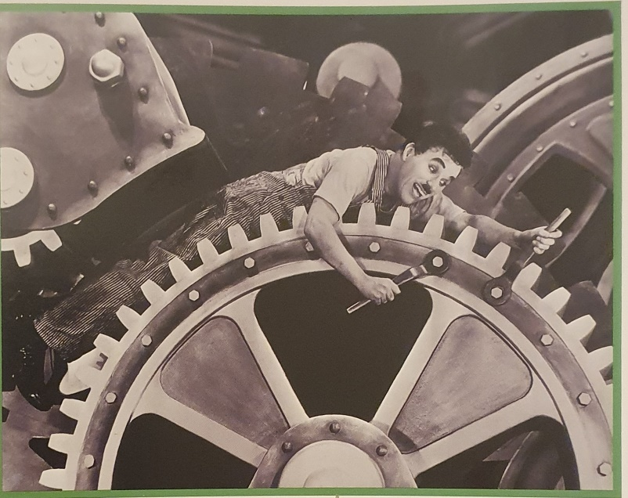
When researching Marx’s views, a name kept popping up: Max Weber. That led me to look into the sociology theory of Rational modernity where Weber came up with the idea of the metaphysical Iron cage, where modern society was changing and improving through technology pared alongside capitalism, which results in traditional values within culture being replaced with rationalisation which priorities efficacy (M. Todd 2015)
Figure 5. Modern Times, Charlie Chaplin, 1936
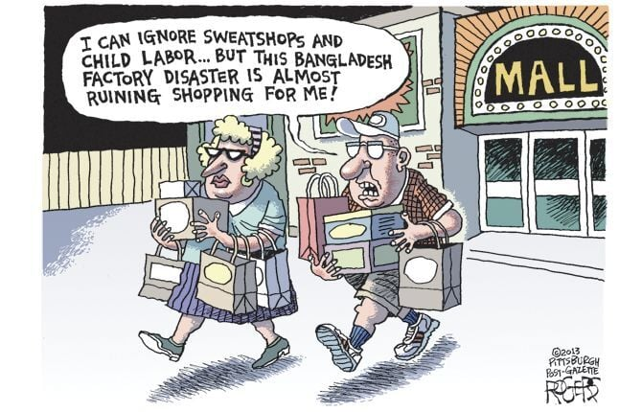
This a movie from the 1930s which shows Chaplin within cogs in a machine; even though the movie is over 80 years old, the theme is still highly relevant within today's society; when discussing this with my peers, they agreed that within their job fields at times they can feel that way however some, viewed everyone as a cog within a machine – as businesses owners are a cogs in the governmental machine. One of Weber's concerns was the effects of being a cog on individuals, which is that capitalism would lead to dehumanisation. An example of this would be the Nike Sweatshop scandal, where a report was published showing that workers were only being paid 14 cents an hour (StudySmarter N/A) – within the Western world, we want quality products for lower prices, but this leads to dehumanisation of workers overseas, where labour laws are more relaxed.
Figure 6. Columbia Gorge News, 2013
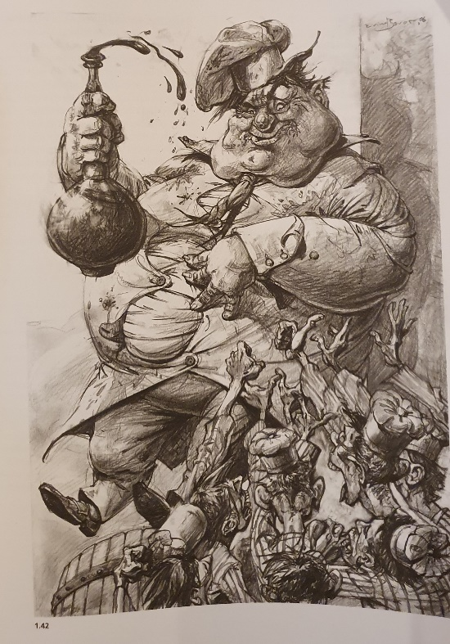
This demonstrates the dehumanisation of overseas workers by non-third world countries; there is a lack of remorse in this illustration, which also shows how fast people will bend their morals and ethics for their own personal and sometimes selfish reasons. These reasons, however, can have bases within the social class and an economic standpoint – for example, with economics, from my understanding, if you are from a lower social class, you will have less money, which will affect if you can afford sustainable items, this means that even if you are aware of the impact you are having by supporting child labour by buying a £5 t-shirt that would be considered lesser in quality and less sustainable, you have little to no choice but to buy the t-shirt because you cannot afford the sustainably sourced higher priced version. This puts activists in a difficult position as you don’t want to support the negatively impacting companies, but you have no choice due to your economic position. In my opinion, this continues the dehumanisation, one of Weber’s concerns. But it is not just up to consumers to make a difference; it is also up to big capitalist companies to be more ethical and sustainable as they have the money, power and influence to make change quickly – but due to workers being a ‘cog’ within a more giant machine, big companies tend to care less about the worker's rights and more about the bottom line of efficacy and also due to relaxed labour laws in third world countries they continue to make huge profits while exploiting human beings.
Figure 7 . Evivnd Bovor, Gormenghast , Illustration a theoretical & contextual perspective, Alan Male(2007)
To my understanding, Figure 7 comes from the resonance period. The symbolism resonates with the themes of this essay as well as the symbols I would like to explore more within my third year. The rich can afford to eat lavishly when the poor are fighting for food; it's also very reflective of the time period. However, the themes are not foreign to many people as ‘15% of UK households – equivalent to approximately 8 million adults and 3 million children’ (P.Butler 2024). This statistic led me to briefly look into Peter Townsend and Relative Poverty ‘the poor are excluded from ordinary living patterns customs and activities or life’ (M.Todd 2015). Personally, I grew up in a household that was food insecure and had little. However, my father did his best to ensure I still had things children needed. He didn’t want the lack of money to impact my childhood. Yes, we never went on holiday, but I went on holiday with the school as it was cheaper. I went on school trips, but growing up in a household with very little can exclude you from things that are considered normal within the 21st century – I have friends who are single parents using food banks because they are struggling to get jobs. This is due to late-stage capitalism and the inflation of prices with everyday objects.
Considering all of my research and the artists that I have looked into, for my 3rd year, I hope to create a series of political illustrations that reflect current and relevant social issues but also show how these social issues at the core remain the same by using symbolism inspired by the psychological and sociology theories that I have researched and more that I didn’t include within this essay. The Times Magazine very much inspires my work covers as well as Satire Spot illustrations from Magazines that showcase current issues; I would like to explore that in a more positive sense within my 3rd year using comparisons from sustainable companies and unstainable companies but also touch on the social problems that they influence- and how as activists we can help to change things for the better. This leads me to the question: What influence do Psychology and sociology have on editorial illustration and political art? By understanding what influences they have, can we make positive changes as activists?

Bibliography
Britain’s Best Political Cartoons, Tim Besnson, 2020
Boris Johnson accused of ‘shocking disrespect’ over party comments, Peter Walker, 2023, https://www.theguardian.com/uk-news/2023/dec/07/media-coverage-of-lockdown-parties-travesty-of-the-truth-johnson-says Accessed: May 2024
Constructivism Brought the Russian Revolution to the Art World, Lauran Hillegas, 2019 , https://www.artsy.net/article/artsy-editorial-constructivism-brought-russian-revolution-art Accessed: May 2024
Editorial Cartoons for May 7, Columbia Gorge News, 2013, https://www.columbiagorgenews.com/opinion/cartoons/editorial-cartoons-for-may-7/article_a495f2b8-336e-5878-ad22-ce3b6fc9f0e9.html Accessed: May 2024
Editorial illustration context content and creation, Andrew Selby, 2022
Gaza is on the brink of a man-made famine, The economist, 2024, https://www.economist.com/middle-east-and-africa/2024/03/27/gaza-is-on-the-brink-of-a-man-made-famine Accessed: May 2024
‘Health emergency’: 15% of UK households went hungry last month data shows, Patrick Butler, 2024, https://www.theguardian.com/society/2024/feb/27/health-emergency-15-of-uk-households-went-hungry-last-month-data-shows#:~:text=According%20to%20the%20Food%20Foundation,pockets%20of%20low%2Dincome%20families. Accessed: May 2024
Illustration a Theoretical & contextual Perspective, Alan Male, 2007
Met Gala 2024: Here’s how much the event raised this year, N/A 2024, https://www.cnbctv18.com/entertainment/met-gala-2024-zendaya-cardi-b-nicki-minaj-camila-cabello-how-much-the-event-raised-this-year-19410028.htm accessed: May 2024
Nike Sweatshop Scandal, Study Smart, N/A https://www.studysmarter.co.uk/explanations/business-studies/business-case-studies/nike-sweatshop-scandal/ Accessed:May 2024
One third of social care workforce sickness absence due to mental health and stress, troubling new figures reveal, The British Psychological Society, 2023, https://www.bps.org.uk/news/one-third-social-care-workforce-sickness-absence-due-mental-health-and-stress-troubling-new Accessed: May 2024
Public Health Situation Analysis (PHSA) on Hostilities in the occupied Palestinian territory (oPt) - 02 May 2024, https://reliefweb.int/report/occupied-palestinian-territory/public-health-situation-analysis-phsa-hostilities-occupied-palestinian-territory-opt-02-may-2024 Accessed: may 2014
The February Revolution, Encyclopaedia Britannica, N/a, https://www.britannica.com/biography/Alexandra-empress-consort-of-Russia Accessed: May 2024
The Psychology book, Nigel Benson, 2011
The sociology Book, Megan Todd, 2015
Traces of cocaine found in the UK Parliament, including near Boris Johnson's office: report, John Haltiwanger, 2021, https://www.businessinsider.com/cocaine-traces-found-uk-parliament-including-near-pms-office-report-2021-12 Accessed: May 2024
Why the UK needs migrant care workers, Vicky Gayle, 2024, https://www.thebureauinvestigates.com/stories/2024-03-11/why-the-uk-needs-migrant-care-workers/#:~:text=Numbers%20have%20grown%2C%20especially%20since,is%20a%20shortage%20of%20workers. Accessed: May 2024
What are the causes of extremism?, ACT, N/A, https://actearly.uk/what-are-the-causes-of-extremism/ Accessed: May 2024

