Review on Environmental Impact Assessment.
Case Study: ‘Craig y Perthi Solar’ in Newport
Kaushani Amarasena, University of Wales Trinity Saint David, United Kingdom

Abstract: Environmental Impact Assessment (EIA) is a process that is used to determine the environmental, social, and economic impacts of a project before decision-making. The EIA process comprises five key components, as per UK government legislation including screening, scoping, preparing an Environmental Statement, making a planning application or consultation and decision-making. This report focuses on the EIA process of the solar farm, battery storage and associated development project, ‘Craig y Perthi Solar’ in Newport. Even though the project would make a significant contribution to climate commitments and help to address energy crises it included several negative consequences on the environment. The project's environmental statement has separately addressed each of those consequences in detail, identifying potential mitigation measures for each of the criteria. The final project has undergone several modifications and alterations in response to recommendations made by Planning and Environment Decisions Wales (PEDW) on the project's Environmental Statement and comments received from the general public. The construction of a sustainable solar farm with minimal negative impacts on the environment as possible is the long-term objective of this EIA process.

Key Words: Environmental Impact Assessment, Solar Energy, Mitigation Measures,
Public consultation

Corresponding Author: Kaushani Amarasena University of Wales Trinity St. David, Swansea, SA1 5BD, Wales
email: 2309522@student.uwtsd.ac.uk


Environmental Planning and Policy.
Volume 1, Issue 1, 2024
Kaushani Amarasena, All Rights Reserved.

Table of Content

1.0. Introduction. 3
1.1. Environmental Impact Assessment (EIA) in General. 3
1.2. EIA Process and Stages 4
2.0. Case Study 6
2.1. Overview of the project and the location. 6
2.2. The proposed project 8
3.0. Overview of the Environmental Impact Assessment 9
3.1. EIA Scoping Summary 9
3.2. Impact Assessment Methodology 11
3.2.1. Landscape and Visual Impact Assessment (LVIA) 11
3.2.2. Biodiversity Assessment 12
3.2.3. Cultural Heritage Assessment 13
3.2.4. Hydrology and Flood Risk Assessment 14
3.3. Impact Mitigation Measures 14
3.4. Public Consultation 17
4.0. Conclusion. 18
References: 19
Appendices

Introduction.

Environmental Impact Assessment (EIA) in General.
As the impacts of human activities on the environment have become more apparent over time, many countries have implemented Environmental Impact Assessment (EIA) procedures. A typical definition of an environmental impact assessment (EIA) is an evaluation of how proposed projects will affect the environment including air, water, vegetation, and biodiversity. An EIA is a process that predicts the environmental, socioeconomic, cultural, and other effects of a proposed project in order to identify mitigation measures that would both minimize adverse effects and improve the natural environment and the general well-being. EIA strengthens the knowledge for decision-making as part of planning sustainable projects by examining the environmental effects of projects (Caro-Gonzalez et al., 2023).
The most important phase in ensuring that development projects are carried out with consideration for the requirements of local populations and the environment is the EIA process (Nisbet and Joao, 2022). EIAs are carried out in a wide variety of sectors, including agriculture, manufacturing, tourism, mining and forestry. EIA was first introduced in the United States in 1969 under the National Environmental Policy Act (NEPA) and has been used as a tool for sustainable development in almost every country (Khan et al., 2020). Almost all UN members have embedded EIAs in their national laws or have signed an international agreement mentioning EIA applications (Morgan, 2012).
After the European Council of Ministers approved Directive 85/337/EEC in June 1985, EIA was first implemented in Member States of the European Union in July 1988 (Barker and Wood, 1999). This Directive has been amended four times, with the latest amendment, the Environmental Impact Assessment (EIA) Directive (2014/52/EU) entering into force on 15 May 2014. The UK officially adopted EIA in 1988, when it was incorporated into the Environmental Assessment Regulations for Scotland and Northern Ireland and into the Town and Country Planning Regulations for England and Wales (Jha-Thakur and Fischer, 2016). Over time, the original 1988 EIA legislation revealed the requirement of certain modifications across the range of existing regulatory frameworks. Since then, there have been several revisions, renewals, and iterations to the UK's EIA legislation (Fothergill and Fischer, 2022).
In the UK, the EIA process is not governed by an exclusive set of laws that apply to all consents. Instead, EIA laws have been included within several existing development consent regimes. As a consequence, there are more than 20 sets of EIA Regulations along with multiple amendments that apply across the UK’s development consent regimes. Therefore, developers or their advisors must decide whether regulations apply to each situation individually (Fothergill, J., 2011).

EIA Process and Stages
EIA is a process for the efficient and systematic investigation of potential impacts and speed up the project authorization process, thus saving developers time and money. According to the UK government website, under the town and country planning (EIA) regulations 2017, the EIA process consists of five essential steps. These five government stages are as follows.
- Screening
- Scoping
- Preparing an Environmental Statement
- Making a planning application and consultation
- Decision making

Screening: Screening is the first stage of the EIA process, which leads to a key EIA decision on whether to conduct the assessment or not. Most countries require screening for all public and private projects that need government approval (Wilson et al., 2017). The impacts of projects are subject to change over time. Therefore, during the screening process, impacts are taken into consideration over the lifetime of the project from the beginning to operations and closure. Project proponents review their projects following a set of criteria imposed by an authorized agency to determine if an EIA is necessary. It's important that screening be completed early in the proposal's development to identify the potential EIA requirements.
Scoping: Scoping is an essential step in the EIA preparation process since it helps to identify the impacts that are likely to be most important and to remove the less important ones. This stage aims to build a scientific identification of impact and should ideally take place before, or at least throughout, project development. A high-quality scoping study minimizes the possibility of dropping out or including components that need to be addressed. Therefore, having an efficient EIA scoping process helps to achieve an efficient EIA process (Jha-Thakur and Fischer, 2016).
Preparing an Environmental Statement: An Environmental Statement is prepared by an applicant as part of an EIA in support of certain planning proposals. It provides a summary of the EIA process, which is mainly utilized for advising decision-makers on the development's potential environmental effects. The Environmental Statement organizes all the information, outlines the impacts and mitigating actions, and offers a comprehensive assessment of the scheme's positive and negative consequences. The applicant is expected to draft and submit an environmental statement if it is determined that an EIA is necessary.
Making a planning application and consultation: An Environmental Statement must be prepared and submitted by the applicant if it is determined that an EIA is necessary before a project begins. The Environmental statement is published electronically to inform the community about the project. The public and consultative bodies are allowed to thoroughly discuss and raise their thoughts regarding the proposed project.
Decision making: In this stage, all data is compiled and submitted to the Secretary of State or the local planning authority to decide whether or not to approve the project. Planning authorities consider comments on the Environmental Statement, provide opinions on the planning applications, and issue final decisions. The decision of approval or rejection of the project, together with the primary reasons for the decision is communicated to the general public.
EIA is a dynamic procedure in which there are several feedback loops. This means that even if there are generally accepted steps in the EIA procedure, each evaluation uses them differently. These feedback loops are vital components of the EIA process as they can be amended to better reflect the environmental sensitivities relevant to the proposed project. Figure 1 outlines the steps involved in the EIA process and highlights the repetitive nature of the assessment process in addition to several regulatory feedback loops (Fothergill, J., 2011).
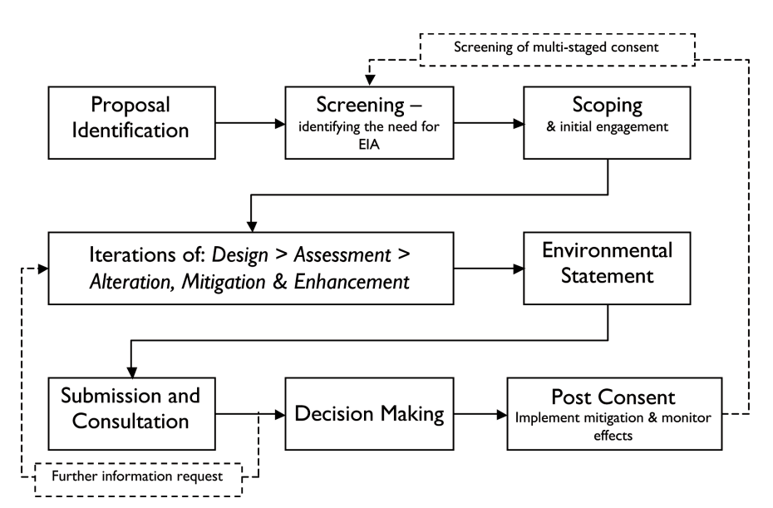
Figure 1: Classic Environmental Impact Assessment (EIA) Workflow Chart.
Sourced from: Special report of ‘The State of Environmental Impact Assessment Practice in the UK by IEMA (2011) Page Number:17.

Case Study

Overview of the project and the location.
The development project of a solar farm, battery storage and associated development, ‘Craig y Perthi Solar’ in Newport was proposed by JBM Solar Projects 25 Ltd. The Applicant is a prominent UK-based solar developer, having secured more than 1GW of solar and battery storage projects across the UK. The Proposed Development was classified as a Development of National Significance (‘DNS’) because it related to electricity generating that had an installed generating capacity of between 10 and 350 MW. Planning and Environment Decisions Wales (PEDW) made the decisions on this proposed development.

The property used for this project was close to Craig y Perthi Wood and the village of Bishton, in the east side of Newport. The site is west of the Magor Brewery, northwest of the Tesco Distribution centre, and north of Llanwern steelworks, separated by the South Wales main line. The location was utilized for agriculture as part of many pastoral and arable agricultural holdings. With cable run and wildlife enhancement zones included, it has covered over 240 hectares. Hedgerows and trees that are a component of established field borders within agricultural properties often constitute the boundaries of the site. The location of the development project is shown on Figure 2 and Figure 3.

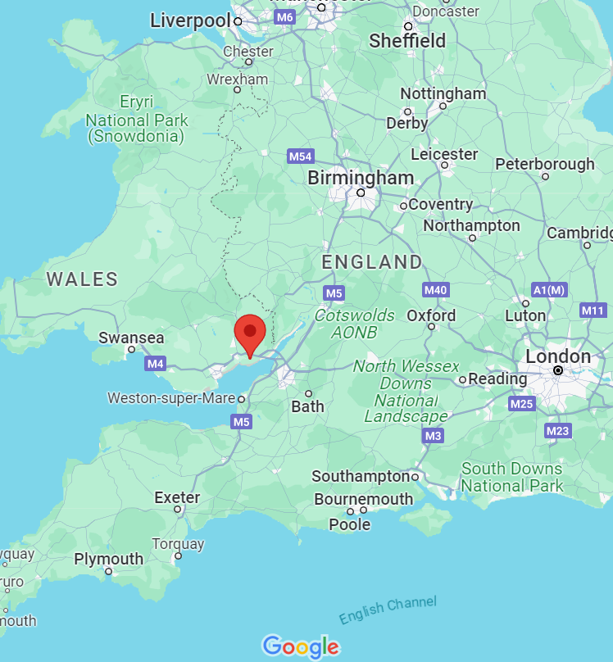
Figure 2: The location of the ‘Craig y Perthi’ Solar Farm project in village of Bishton, Newport. Map sourced from Google Map (2023.12.20)
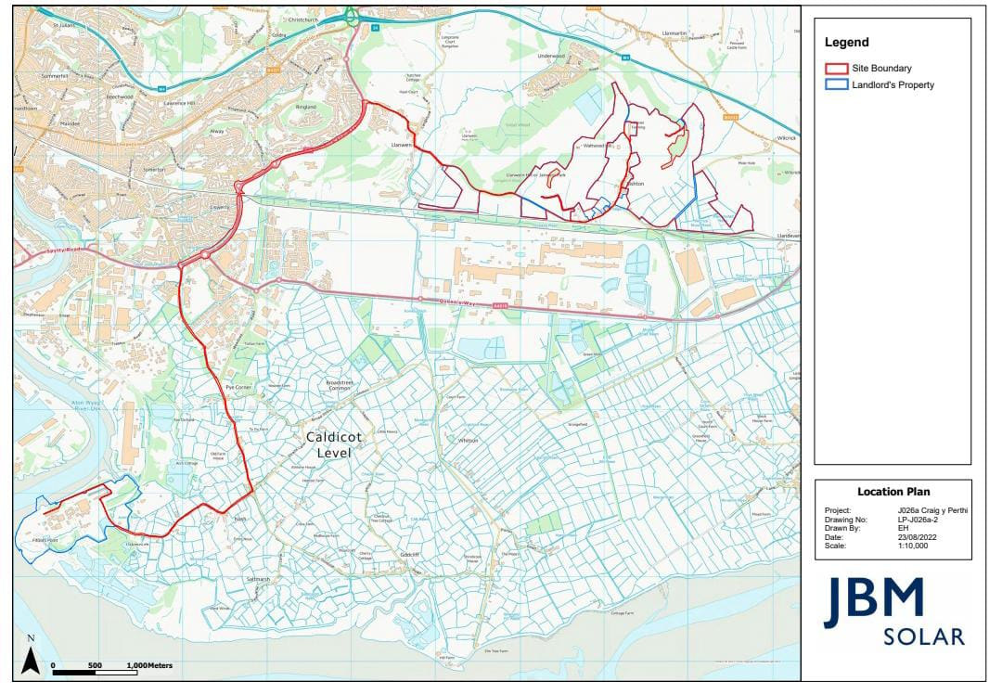
Figure 3: Site of the ‘Craig y Perthi’ Solar Farm project. Map sourced from Environmental Impact Assessment Scoping Report (2022). The red colour lines indicate the site boundaries and blue lines represent landlord’s property.

The proposed project
The proposed development included a solar photovoltaic electricity generating station with an installed capacity of around 99.9 MW, battery storage, and associated ancillary development, including a 132 kV substation. According to the report, the electricity generated here would be sufficient to provide for approximately 44,858 typical family homes and it saves more than 3,350,288 metric tons of CO₂, compared with electricity generation from fossil fuels. Batteries were planned to include for providing optimal efficiency in interacting with the electrical distribution system, allowing excess energy to be stored and supplied when required. The project was planned to interconnect with the national grid at the substation west of the Severn Power Station site in Uskmouth. Around 10.5 km of underground cable system connected the site to the substation. Figure 3 illustrates how these underground wires were planned to be contained within the existing highway border. An estimated 15 hectares to the southwest of the property are suggested as a biodiversity and wildlife improvement area. To provide effective dual use of land for agriculture and the production of green energy, this project was planned to allow sheep and poultry to graze beneath and between the rows of panels. The proposed development would be a multigenerational and reversible project with a 40-year designed lifetime.

Overview of the Environmental Impact Assessment

EIA Scoping Summary
A total of 14 topics have been discussed in this project under the EIA scoping summary. Each of these topics has mentioned whether they are to be scoped in or out of the EIA process, with supporting justification. Following table number 1 summaries those topics, their effects and scoping consideration of each focus area.
Table Number 1: Summary of proposed EIA scope
Topic | Construction and Operational effects | Scoped In  / Out
Landscape  and Visual | - Plant and the vehicles movements affect local views and residential amenity.  - Changes in landscape characters. | In
Biodiversity | - Potential foraging and breeding habitat removal of protected species.  - Potential for increased nitrogen deposition due to the presence of construction vehicles. | In
Air Quality | - Potential for dust creation due to construction activity  - No significant air pollution due to minimal traffic generation and no emissions | Out
Noise and  Vibration | - Potential impact of construction vehicles  - No significant operational effects due to minimal traffic generation | Out
Cultural  Heritage | - Potential impacts on the setting of historic designations including Llanwern Park and Bishton Castle | In
Population  and Human  Health | - No significant effects at a community level and local amenity.  - No significant realignments of Public Rights | Out
Geology  and Soils | - No impact on geological features due to limited piling into soil.  - Vehicle and worker movements impact soil characteristics | Out
Material  Assets and  Waste | - Sustainable source of construction materials promote within the supply chain  - Negligible amounts of waste produce in operation. | Out
Climate  Change | - No impacts on climate change during operation. | Out
Water  Resources | - Potential increases in surface run off from soil compaction.  - Reduced water infiltration cause potential flood risk issues. | In
Traffic and  Transport | - Negligible construction and operational traffic movements. | Out
Accidents/  Disasters | - No major accidents or disasters due to the characteristics of the site. | Out
Lighting /  glare | - Site lighting not significantly affect residential properties or sensitive species. | Out
Cumulative  effects | - Potential for an inter-project impacts  - Combination effects with other projects | In

The Environmental Statement of the project has been prepared in accordance with the Town and Country Planning Regulations, 2017. This report includes a description of the nature, extent and significance of these impacts. The report justified the reasons for scoped in and out of each aspect. The assessment considered mitigation measures that have been specifically incorporated into the development project to reduce the environmental impacts under the above each topic. Based on the information submitted to Planning and Environment Decisions Wales (PEDW) on 21 December 2022, Scoping Direction was provided under Regulation 33 of the 2017 Regulations.
This direction contains comments from council with reasonable justifications, largely agreed with the scoping decisions except for the topics ‘Geology and Soils’ and ‘Traffic and Transport’ which were required to be ‘scoped in’. Further, that includes scoping has not stated ‘Leisure and Recreation’ topic, but it should be assessed in terms of amenity and usability (Appendix 1). In response to the Scoping Direction, the applicant has submitted and published the Scoping Direction Response Schedule in July 2023 with further responses and mitigation strategies to the criteria highlighted by the PEDW. In that report, the applicant agreed with some suggestions and further modifications has been added to the project design.

Impact Assessment Methodology
The EIA Regulations do not provide exact methods to assess the significance of impacts and several methodologies are employed within EIAs. The impact assessment criteria and methodology established by relevant professional institutes need to be followed by the assessments wherever accessible and suitable. When determining the type and extent of the impact, several aspects must be taken into consideration, depending on the topic (Kassim, and Simoneit, 2005).
Based on the scope analysis of the project, this EIA has considered several impact assessments as follows.

Landscape and Visual Impact Assessment (LVIA)
According to the EIA report, a site visit was conducted to evaluate the location and surrounding area in August 2021. Understanding the location and perspectives of visual amenity receptors within the study area was made possible by this site survey. The assessment has considered 17 photographic panoramic viewpoints from publicly accessible locations within and surrounding the site. Even though the scoping report mentioned that LVIA will be carried out by experienced chartered landscape architects, PEDW EIA Scoping Direction advised that applicant should communicate directly with the council’s landscape architect to confirm whether the viewpoints are appropriate. The scoping report has not mentioned whether a Residential Visual Amenity Study (RVIA) will be undertaken along with the LVIA. Therefore, PEDW advised the applicant to liaise directly with the architects to ascertain if one is needed and the scope of any potential study.
Based on the comments on the PEDW EIA Scoping Direction, the project applicant has prepared an Environmental Statement on ‘Landscape and Visual’ and ‘Draft on Landscape and Ecology Management Plan’ (LEMP). The report on Landscape and Visual focuses on five aspects of areas for the project consideration namely, Visual and sensory, Historic landscape, Cultural landscape, Geological landscape and Landscape habitats. The proposed solar farm comprises agriculturally improved grassland and arable land managed to provide cereals, fodder, and forage for livestock.
The computer generated Zone of Theoretical Visibility (ZTV) and annotated panoramic photographic views and photomontages are used to illustrate the potential impacts from the viewpoints, immediately following construction and following the growth of the proposed landscape mitigation measures.

Biodiversity Assessment
The proposed development is 4.1km to the north of the Severn Estuary Ramsar which is of international value. Part of the proposed development is located within Gwent Levels Redwick and Llandevenny, which is of national (UK) value. Therefore, the region is regarded as a significant biological area and before beginning any development projects, it has to be carefully monitored and evaluated.
A preliminary ecological assessment of the Craig Y Perthi Solar project has been finished by Western Ecology. In this, nature conservation value of the habitat is determined within the geographic context of international importance, national importance, county importance, site importance, and negligible importance. The biodiversity assessment in the scoping report focused on how the solar farm influences on ecological receptors by considering many ecological features such as water bodies, animal and plant species (Appendix 02). The desktop survey has done to collect existing biological records. The main plant species were recorded, and broad habitat types were classified and mapped. Throughout the survey, evidences of protected species were noted, and site habitats were assessed for their potential to support notable or protected species. An assessment was made to identify how the sites may be affected by the proposal, and the species and habitat types.
The PEDW EIA Scoping Direction has commented on the above features and stated that it is unclear which species are scoped in and out and further consultation requested to ascertain this topic. Moreover, they mentioned that loss of trees or hedgerows should be clearly described and potential impacts on other receptors should be surveyed as necessary.
The Environmental Statement chapter 6 on Ecology further assessed the significant impacts from the construction, operation and decommissioning phases of the project and the mitigation measures. Along with the biodiversity assessment the applicant has completed several surveys to obtain information, assess impacts and identify mitigating actions. These include:
- Dormouse Survey
- Otter Survey
- Great Crested Newts Survey
- Water Vole Survey
- Aquatic Invertebrate Survey
- Shrill Carder Bee Survey
- National Vegetation Classification (NVC) survey
- Wintering Birds Survey
- Breeding Birds Survey

Cultural Heritage Assessment
This section of the Scoping Report addressed the specific issues relating to cultural heritage including built heritage and archaeology. The proposed site is located close to several recognized historic places including the Scheduled Monument Bishton Castle and the two listed churches. The restored wetlands and tidal mudflats of the Gwent Levels are located in the southern part of the site. Hence, the Cultural Heritage Assessment is essential for the project. According to the scoping report, the project had the potential to impact directly on buried archaeological remains and historic landscape characters. All identified assets that were situated within the project site and 1 km of its boundary were assessed in this assessment. Since the cable connection to the substation travels entirely via already-existing roadways, it was not taken into account for this evaluation.
The PEDW EIA Scoping Direction has commented that the Agricultural Land Classification assessment should be reviewed as part of the desk assessment and applicant need to consult with the Gwent Glamorgan Archaeological Trust (GGAT). Additionally, they specified that the historic assessment must take place within 3 kilometers of the proposed area. This fact was taken into consideration in the "Historic Environment Desk Based Assessment" under the Environmental Statement, and a 3 km buffer has been defined and assembled around the site. Consequently, Historic Landscape and Cultural Landscape Aspect Areas have been identified by the LANDMAP process (Landscape Assessment and Decision Making Process).

Hydrology and Flood Risk Assessment
This section provides information related to surface water (hydrology), flood risk and drainage and provides recommendations for the flood risk. South and east of the site are relatively flat, whereas the northern part of the site typically slopes steeply. This site is bounded by three major watercourses. The Monks Ditch flows the west of the site, Waltwood Brook commences at a reservoir on Waltwood Hill and flows through part of the western portion and Wilcrick Brook drain flows through the eastern portion of the site. The area is vulnerable to siltation, erosion, compaction of the soil, increased surface water runoff, and changes in water levels.
Construction of the solar project has the potential to increase downstream flood risk, erosion, and pollution of surface water bodies. In the EIA scoping report, set of threshold criteria was developed to assess the significance of the impacts on the hydrology based on the interaction between the value and sensitivity of the receptor and the magnitude of change (Appendix 04).
The PEDW EIA Scoping Direction has reviewed this section in the EIA scoping report and commented that the further appropriate construction techniques are required to prevent soil compaction. Also it mentioned that applicant should assess whether the project is required to obtain a Flood Risk Activity Permit (FRAP). Flood Consequences Assessment of the Environmental Statement has focused on the above facts and addressed them accordingly. It stated that, the site-specific modeling has been undertaken to more accurately determine the risk to the site from the several watercourses flowing through the property along with the railway line. Tuflow modeling software is used to create a 2D flood model for the design task. It was advised that solar panels and any other susceptible infrastructure be elevated above the maximum flood levels in order to reduce the danger of fluvial flooding over the development's lifetime.

Impact Mitigation Measures
Impact mitigation is the fundamental component of the whole EIA process as it requires identifying mitigation strategies for minimizing the impact that they have on the environment (Tinker et al., 2005). The Twon and Country Planning (EIA) Regulations 2017 require assessing the mitigation measures to prevent, reduce and where possible offset any significant effects on the environment. This project has several aspects of impact basically including landscape and visual impacts, ecological impacts, cultural and heritage impacts and hydrological impacts. Therefore, mitigation measures should obviously include in the EIA process. The project allowed existing farm enterprises to continue operating peacefully alongside the solar power, preserving the integrity of the farmland without removing sheep and poultry grazing from the area.
The development concept was designed to blend in with the natural landscape and incorporate the existing field layout. This landscape management plan included reinforcement of the existing vegetation with selected infill planting to retained hedgerows, extensive proposed hedgerow trees, and forest planting. The following mitigating techniques were recommended by the evaluation to prevent major negative impacts on biodiversity:
- Exclusion zones to boundary features protected by a suitable fence
- No night works
- Restoration of construction areas following completion of development
- Adoption of a ditch management plan.
- Hedgerow management in winter months.
- Creation of Shrill Carder bee habitat/ bee hotels
- Facilitate bird nesting boxes/ statutory nature conservation sites
Chapter 10 of the environmental statement mentioned that implementation of the archaeological investigation programme would reduce the magnitude of impact on buried archaeological remains by the continuous examination of the deposit sequence within the site. It has been suggested that substantial infrastructure needs to be developed, including flood barriers as the low-lying areas of the site are susceptible to flooding. Another flood mitigation measure in the report is managing rainwater at the source, allowing it to percolate into the ground within the existing site. The report highlighted two such measures: Deployment of runoff from containerized infrastructure to gravel beds and permeable access.
The danger of soil compaction, spills, and pollution accidents are planned to be controlled by using planned construction and operational practices. In order to minimize the impacts of vehicles accessing the site from local roads, two centralised main site compounds are planned to be implemented. Proper lighting was planned to be provided during construction to meet health and safety regulations and minimize effects on the surrounding area, such as glare, sky glow, and light leakage.
The proposed development will be discontinued at the end of the solar farm’s 40-year life and the site will revert to its original use as an agricultural site unless a new planning application is received.

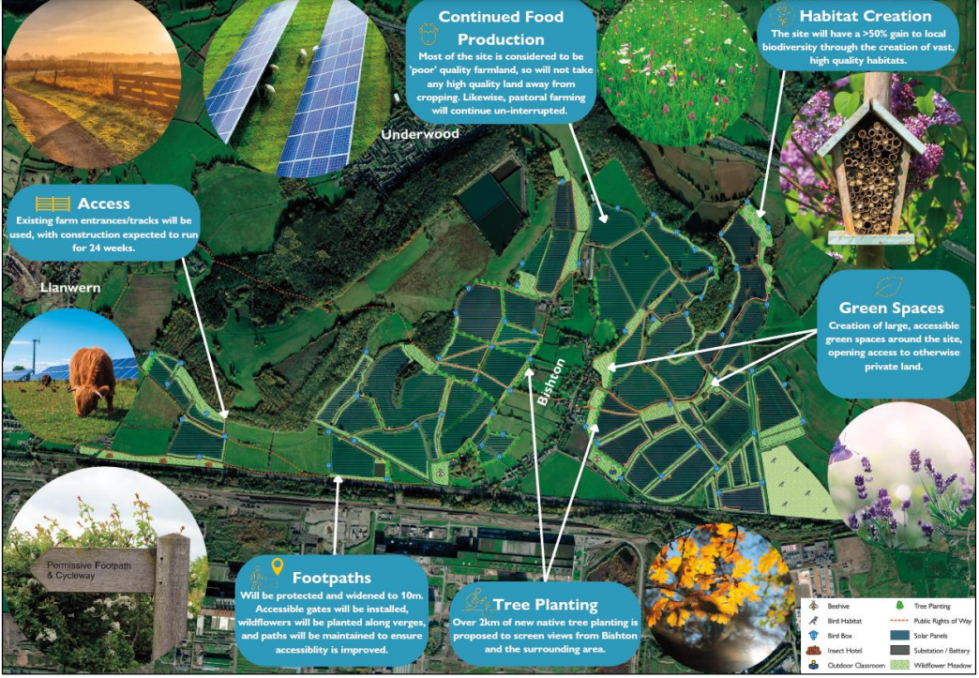
Figure 4: Concept Plan of the Solar Project, Design and Access Statement, Page No: 16
The Figure 4 illustrates the concept plan that conveys the main ideas for the proposed development which includes pastoral farming, high quality habitats, large, accessible green spaces, over 2 km of new native tree planting and protected footpaths.

Public Consultation
Public participation is important in EIA procedures and is based on the concept that people who are impacted or affected by decisions have an ethical right to participate in the decision-making process. Public participation in EIA improves the quality of the project, prevents litigation and costly delays, complies with legal requirements, improves active citizenship, strengthens democracy, protects individual rights, and creates acceptance of the project's outcome (Cuppen et al., 2012; Nadeem et al., 2014).
The EIA project applicant (JBM Solar), always attempted to gather information about the opinions of stakeholders and communities to enhance project plans. In order to get a variety of opinions on the idea, they also arranged consultation days, participated in council meetings, and interacted with local wildlife groups and educational institutions. In this particular project, they worked closely with communities to ensure that the applications include robust, effective landscaping plans. The project can be utilized to graze sheep or chickens and can help farmers in difficult times by providing ongoing assistance, so food production can continue even with panels installed. The project has planned to provide a £300,000 fund to support local projects including the rooftop solar installations for residents and schools in the area to help bring down their energy bills.
It was confirmed that every chapter of the environmental statement was available for reading on the JBM Solar website. The environmental statement was divided into ten separate chapters with appendices. The public was 90% in favor of it, according to data from 2021. But in 2022, 81% of those surveyed claimed they had no objections to a solar farm being installed in their community. Meanwhile, some villages say they are opposed and fighting a battle against plans for this solar farm around Bishton. However, following extensive public consultation held in December 2022, a series of positive changes have been incorporated into the project. These changes can be summarized as included additional landscaping and green spaces, increased community benefit fund, planned new green infrastructure, increased access to the site and wildlife improvements.

Conclusion.

According to United Kingdom (UK) government estimates, the country will require massive energy resources in the future to generate sufficient electricity to meet the demands of a fast expanding population and economy. Therefore, based on available resources, the UK is proposing a sustainable energy combination that incorporates solar energy (Drysdale et al., 2015). Solar energy is one of the fastest-growing renewable energies in the UK. The proposed ‘Craig y Perthi Solar’ project would make a meaningful contribution to both local and national climate commitments, and help to tackle energy crises. However, the development project had several negative consequences on the environment, thus an EIA was required before construction was permitted. The Environmental Statement evaluates the potential environmental impacts of the proposed project during the construction, operation and decommissioning phases. In the stage of EIA scoping, several topics have been scoped in and scoped out based on their levels of effects. Few topics those were scoped in further discussed under the different chapters to identify their impacts and mitigation measures including: landscape and visual impacts, biodiversity, cultural heritage, and hydrology and flood risk. Those reports were submitted to Planning and Environment Decisions Wales (PEDW) and then Scoping Direction was provided by them with their comments and recommendations on the project. Meanwhile, applicant published the proposed impact mitigation measures with green concept plans. Further, based on the PEDW recommendations and public comments, several modifications and improvements have included to the final project. The ultimate objective of the EIA procedure is to construct sustainable solar energy farm by minimizing the negative impacts. This EIA review indicates that the project was well-planned and possible impacts were assessed with most suitable mitigation options by following relevant policies.

References:
- Barker, A. and Wood, C., 1999. An evaluation of EIA system performance in eight EU countries. Environmental Impact Assessment Review, 19(4), pp.387-404.
Available at: https://www.sciencedirect.com/science/article/pii/S0195925599000153
Accessed on: 18.12.2023

- Bond, A.J. and Wathern, P., 1999. EIA in the European Union. Handbook of Environmental Impact Assessment. Blackwell Science, Oxford, pp.223-248.
Available at: https://www.researchgate.net/profile/Alan-Bond 3/publication/236243711_EIA_in_the_European_Union/links/0046352cc5b640d5bc000000/EIA-in-the-European-Union.pdf Accessed on: 16.12.2023

- Burnett, D., Barbour, E. and Harrison, G.P., 2014. The UK solar energy resource and the impact of climate change. Renewable Energy, 71, pp.333-343.
Available at: https://www.sciencedirect.com/science/article/pii/S0960148114002857
Accessed on: 16.12.2023

- Caro-Gonzalez, A.L., Nita, A., Toro, J. and Zamorano, M., 2023. From procedural to transformative: A review of the evolution of effectiveness in EIA. Environmental Impact Assessment Review, 103, p.107256.
Available at: https://www.sciencedirect.com/science/article/pii/S0195925523002226
Accessed on: 22.12.2023

- Cuppen, M., Broekhans, B. and Enserink, B., 2012. Public participation in EIA and attitude formation. Impact Assessment and Project Appraisal, 30(2), pp.63-74.
Available at: https://www.tandfonline.com/doi/abs/10.1080/14615517.2012.660348
Accessed on: 18.12.2023

- Craig Y Perthi Solar Farm website documents (EIA, ES)
Available at: https://craigyperthisolarfarm.co.uk/documents/
Accessed on: 18.12.2023- 05.12.2024

- Drysdale, B., Wu, J. and Jenkins, N., 2015. Flexible demand in the GB domestic electricity sector in 2030. Applied Energy, 139, pp.281-290.
Available at: https://www.sciencedirect.com/science/article/pii/S0306261914011623
Accessed on: 03.01.2024

- Environmental Impact Assessment (EIA), A handbook for scoping projects- Government of UK Available at:
https://assets.publishing.service.gov.uk/media/5a7c406eed915d7d70d1d981/geho0411btrf-e-e.pdf
Accessed on: 19.12.2024
- Fothergill, J., 2011. The state of environmental impact assessment practice in the UK. Institute of Environmental Management & Assessment.
Accessed on: 22.12.2023

- Fothergill, J. and Fischer, T.B., 2022. EIA in England. In Routledge Handbook of Environmental Impact Assessment (pp. 318-331). Routledge. Available at: https://books.google.com/books?hl=en&lr=&id=gVNhEAAAQBAJ&oi=fnd&pg=PA318&dq=+EIA+england&ots=ip2Bf_TKgB&sig=Fw8gB2wBcn-FxK_sGhzwB-FSyk4
Accessed on: 21.12.202

- Jha-Thakur, U. and Fischer, T.B., 2016. 25 years of the UK EIA system: strengths, weaknesses, opportunities and threats. Environmental Impact Assessment Review, 61, pp.19-26.
Available at: https://www.sciencedirect.com/science/article/pii/S0195925515300585
Accessed on: 28.12.2023

- Kassim, T.A. and Simoneit, B.R., 2005. Environmental impact assessment: principles, methodology and conceptual framework. Water Pollution: Environmental Impact Assessment of Recycled Wastes on Surface and Ground Waters, pp.1-57.
Available at: https://link.springer.com/chapter/10.1007/b98263
Accessed on: 28.12.2023

- Khan, M., Chaudhry, M.N., Ahmad, S.R., Saif, S. and Mehmood, A., 2020. Performance of EIA authority and effectiveness of EIA system in Pakistan. Environmental Impact Assessment Review, 81, p.106357.
Available at: https://www.sciencedirect.com/science/article/pii/S0195925518303652
Accessed on: 30.12.2023

- Morgan, R.K., 2012. Environmental impact assessment: the state of the art. Impact assessment and project appraisal, 30(1), pp.5-14.
Available at: https://www.tandfonline.com/doi/abs/10.1080/14615517.2012.661557
Accessed on: 18.12.2023

- Nadeem, O., Hameed, R. and Haydar, S., 2014. Public consultation and participation in EIA in Pakistan and lessons learnt from international practices. Pakistan Journal of Engineering and Applied Sciences.
Available at: http://111.68.102.14/ojs_old/index.php/pjeas/article/view/106
Accessed on: 26.12.2024

- Nisbet, J. and João, E., 2022. A framework for evaluating enhancement quality as part of the EIA process. Environmental Impact Assessment Review, 96, p.106806.
Available at: https://www.sciencedirect.com/science/article/pii/S0195925522000725
Accessed on: 18.12.2023
- PEDW EIA Scoping Direction Available at:
https://craigyperthisolarfarm.co.uk/wp-content/uploads/sites/10/2023/07/Appendix-2.2-PEDW-EIA-Scoping-Direction.pdf
Accessed on: 28.12.2023

- Special report of ‘The State of Environmental Impact Assessment Practice in the UK by Institute of Environmental Management and Assessment (2011).
Available at: https://www.iema.net/download-document/236676
Accessed on: 22.12.2023

- Tinker, L., Cobb, D., Bond, A. and Cashmore, M., 2005. Impact mitigation in environmental impact assessment: paper promises or the basis of consent conditions?. Impact Assessment and Project Appraisal, 23(4), pp.265-280.
Available at: https://ueaeprints.uea.ac.uk/id/eprint/27272/1/Tinker_et_al_2005.pdf
Accessed on: 22.12.2023

- Wilson, J., Hinz, S., Coston-Guarini, J., Mazé, C., Guarini, J.M. and Chauvaud, L., 2017. System-based assessments—Improving the confidence in the EIA process. Environments, 4(4), p.95.
https://www.mdpi.com/2076-3298/4/4/95
Accessed on: 28.12.2023

Figures:
Figure 01: Classic Environmental Impact Assessment (EIA) Workflow Chart. Sourced from: Special report of ‘The State of Environmental Impact Assessment Practice in the UK by Institute of Environmental Management and Assessment (2011). Page Number:17 Available at: https://www.iema.net/download-document/236676
Figure 02: The location of the ‘CRAIG Y PERTHI’ Solar Farm project in village of Bishton, Newport. Map sourced from Google Map (2023.12.20) Available at: https://www.google.com/maps/place//@51.9004399,-4.0077937,7z/data=!3m1!4b1!4m3!1m2!2m1!1sCraig+Y+Perthi+solar+farm+Wood+and+the+village+of+Bishton,+in+the+east+side+of+Newport+map?entry=ttu
Figure 03: Site of the ‘CRAIG Y PERTHI’ Solar Farm project. Map sourced from Environmental Impact Assessment Scoping Report (2022). Available at: https://craigyperthisolarfarm.co.uk/wp-content/uploads/sites/10/2023/07/Appendix-2.1-EIA-Scoping-Report.pdf
Figure 04: Concept Plan of the Solar Project, Design and Access Statement. Page No:16 Available at: https://craigyperthisolarfarm.co.uk/wp-content/uploads/sites/10/2023/07/Craig-Y-Perthi-Solar-Farm-DAS-July-2023.pdf
Appendices:
Appendix 1: EIA Scoping Consultation, Council Comments on Environmental Impact Assessment Scoping Report
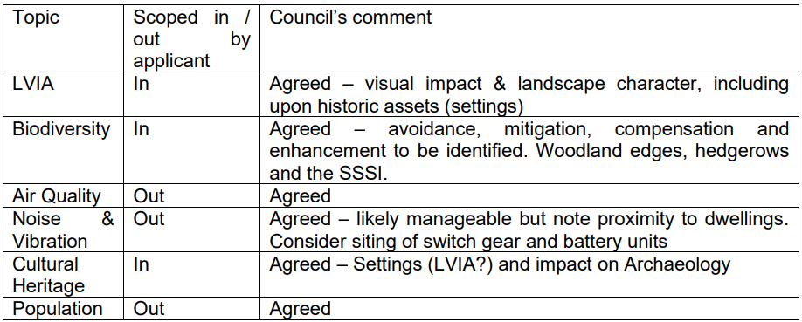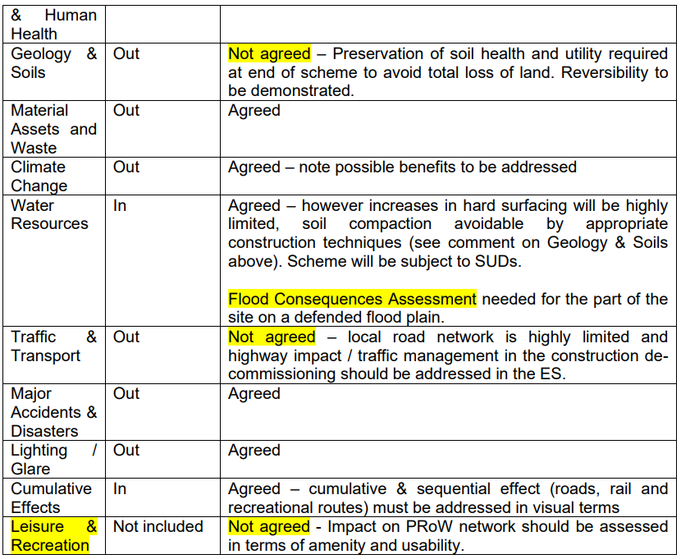

Appendix 02: Solar farm zone of influence on ecological receptors
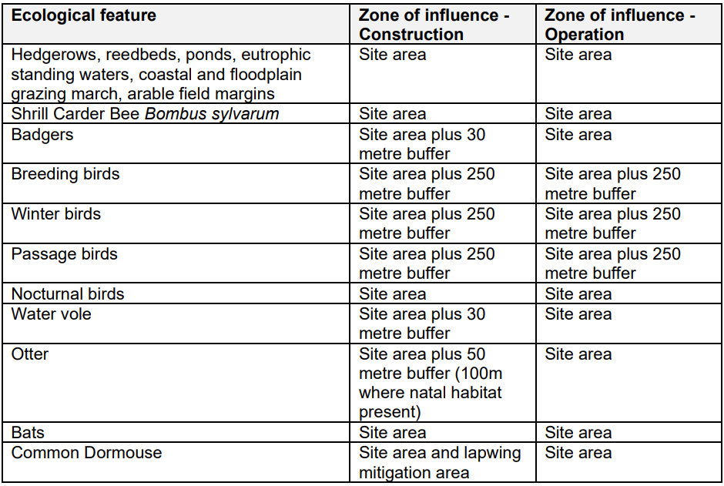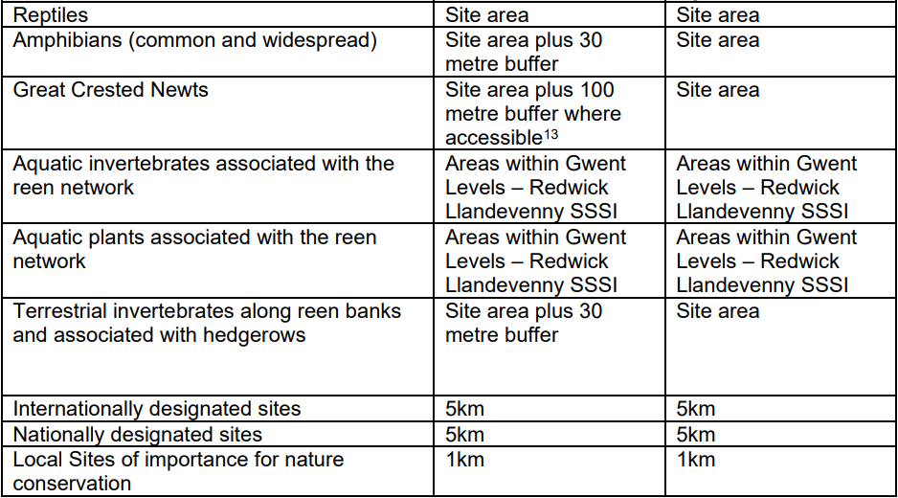

Appendix 03: Derivation of sensitivity of receptor based on criteria


