

Masters of Business Administration (MBA)
Module Title: Financial Management
Module Code: LCMB7002

Assessment Title: Financial Performance and Management Analysis
Company: Kia Corporation

Student Name -Aemanben Anwarbhai Dhanani
Student id -2525496

Lecturer Name: Isaiah Oino, Shengfeng Mei
Word Count: 5346 Words

Table of Contents
1. Financial Health Check 4
1.1 Consolidated Income Statement Highlights 4
1.2 Ratio Analysis 6
1.3 Key strengths and weaknesses 11
2. Working Capital Management Analysis 12
2.1 Assessing Cash Operating Cycle 12
2.2 Recommendations to improve liquidity through working capital reforms 13
2.3 Short Vs Long-Term Financing Options 14
3. Strategic Financial Restructuring Plan 15
3.1 Recommended options 15
3.2 Impact on Shareholder Value, Debt Structure and Operational Flexibility 16
3.3 International and Ethical Considerations 17
4. Investment Appraisal and Capital Budgeting 18
4.1 Project Cash Flow Details 19
4.2 Detailed Appraisal Using Capital Budgeting Techniques 19
4.3 Recommended project and justification 20
4.4 Capital Rationing 21
4.5 Implementation considerations and risks 22
4.6 Conclusion 22
References 24
Appendices 29
1. Kia Income Statement 2024 29
2. Kia Annual Financials Statement 2023 29
3. Kia Financial Statements 2022 30
4. Kia Income Statement 2021 31
5. Consolidated Income Statement Highlights 31
6. Consolidated Balance Sheet Excerpts 32
7. Profitability Ratios 32
8. Liquidity Ratios 33
9. Efficiency Ratios 33
10. Gearing (Leverage) Ratios 33
11. Cash Operating Cycle 34
12. Project Appraisal using Capital Budgeting Techniques 34
13. Kia balance sheet excerpts 35

1. Financial Health Check
Kia Corporation is a South Korean multinational company that makes automobiles. The company has seen major changes in the past five years by shifting toward premium SUVs and electrified vehicles. It has been through many challenges including the post-pandemic environment, supply chain disruptions and rising EV competition (Vigar, 2024). The report will analyze the company's financial statements for the last five years.

1.1 Consolidated Income Statement Highlights
Item | 2021 | 2022 | 2023 | 2024 | 2025 | CAGR (2021–2025)
Revenue | 69,862,366 | 86,559,029 | 99,808,420 | 107,448,752 | 114,140,919 | ~13.0%
Gross Profit | 12,925,201 | 18,023,019 | 22,628,847 | 24,770,771 | 22,508,077 | ~14.9%
Operating Profit | 5,066,166 | 7,233,328 | 11,610,599 | 12,667,139 | 9,078,148 | ~15.7%
Net Profit (attributable to owners) | 4,760,450 | 5,409,429 | 8,776,970 | 9,772,957 | 7,560,983 | ~12.3%

Consolidated Balance Sheet Excerpts
Item | 2021 | 2022 | 2023 | 2024 | 2025 | Trend Insight
Total Assets | 66,849,997 | 73,710,965 | 80,627,826 | 92,755,874 | 98,979,055 | Steady growth (CAGR ~10.3%)
Total Equity | 34,912,556 | 39,343,081 | 46,558,235 | 55,840,309 | 61,190,464 | Strong equity buildup via retained earnings
Current Assets | 29,205,483 | 34,147,147 | 37,466,302 | 41,797,457 | 44,425,929 | Improved liquidity base
Interest-Bearing Debt | 9,343,877 | 7,472,524 | 3,799,839 | 3,234,244 | ~2,729,000 (approx.) | Aggressive deleveraging

Global vehicle sales reached a record 3.14 million units in 2025, increasing revenue despite pressures. The CAGR was 13% over the period, showing strong volume recovery and a favorable product mix. The company also enjoyed pricing power in premium segments (Automotiveworld, 2025). The year 2025 marked normalization, with profit contraction due to U.S. tariffs and cost pressure in the EV transition.

1.2 Ratio Analysis
1. Profitability Ratios
The profits of the company expanded significantly from 2021 to 2024 due to the rise of high-margin SUVs and electrified models.
Key Margin Trends from Income Statement (%)
Margin | 2021 | 2022 | 2023 | 2024 | 2025
Gross Margin | ~18.5 | ~20.8 | ~22.7 | ~23.1 | ~19.7
Operating Margin | 7.3 | 8.4 | 11.6 | 11.8 | 8.0
Net Profit Margin | 6.8 | 6.2 | 8.8 | 9.1 | 6.6
The gross margin seen a improvement through 2024, where they provided cost efficiency with better pricing. Their Carnival Hybrid Sportage and other high-margin vehicles helped them make better margins (Furlong, 2025). Their operating margin nearly doubled by 2024 due to operational leverage and premiumization. The decline to an 8% operating margin in 2025 came from tariff-related incentives. The ROA and ROE peaked mid-period when earnings growth outpaced asset and equity expansion.
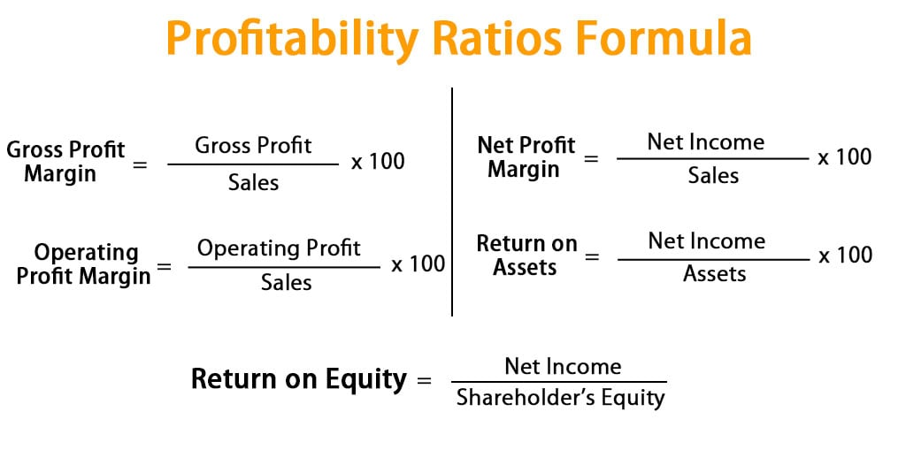
Profitability Ratios Formulas
Source: [Thakur, 2023]
The profit trends are highlighting successful strategic repositioning. The diversified global sales were strong in North America and Europe for hybrids despite the industry challenges. However, the competition has intensified in the EV segment from Chinese manufacturers and geopolitical trade barriers are major threats (Jin, 2025). Kia still maintains above-average profits and good control over costs that uplift their brand value (Lincoln, 2025).
2. Liquidity Ratios
Kia shows a solid short-term financial stability to give it a buffer against cyclical downturns in the auto sector.
Current Ratio = Current Assets / Current Liabilities
Quick Ratio = (Current Assets – Inventory) / Current Liabilities
Ratio | 2021 | 2022 | 2023 | 2024 | 2025 | Comment
Current Ratio | 1.35 | 1.35 | 1.46 | 1.55 | 1.57 | Steady improvement
Quick Ratio (Acid-Test) | 0.99 | 0.96 | 1.00 | 1.07 | 1.02 | Adequate liquid assets
The current ratio is increasing from 2021 to 2025 as the current assets grew ahead of liabilities. The quick ratio around 1.0 indicates good coverage even excluding inventory. Auto makers need to have sufficient liquid asset to manage global supply chains (Rejab, et. al., 2025).
Kia maintained a healthy cash balance with its robust operating cash flows. A disciplined working capital management was critical element behind the improved liquidity. The decision to invest in EVs reduced the risk of refinancing with ample short-term solvency. However, the inventory buildup in EVs might strain their ratios if demand reduces or battery costs rise unexpectedly (Goldstein, 2023).

3. Efficiency Ratios
Ratio | 2021 | 2022 | 2023 | 2024 | 2025 | Insight
Asset Turnover (x) | ~1.10 | ~1.20 | ~1.29 | ~1.25 | ~1.19 | Revenue growth outpaced assets
Inventory Turnover (x) | ~8.5 | ~8.0 | ~7.6 | ~7.0 | ~6.8 | Modest slowdown typical in expansion
Receivables Turnover (x) | Stable | Stable | Improving | Improving | Stable | Strong collections
The scale of Kia helped it operational efficiency but some metrics normalized during expansion into new platforms. It is shown in the above able that asset turnover was at the top in 2023 with fast revenues. The inventory turnover got reduced when they made high stocks of EV model (Szabo, et. al., 2025). A sustained low inventory turns might increase carrying costs if global demand gets low (Davies, 2025).
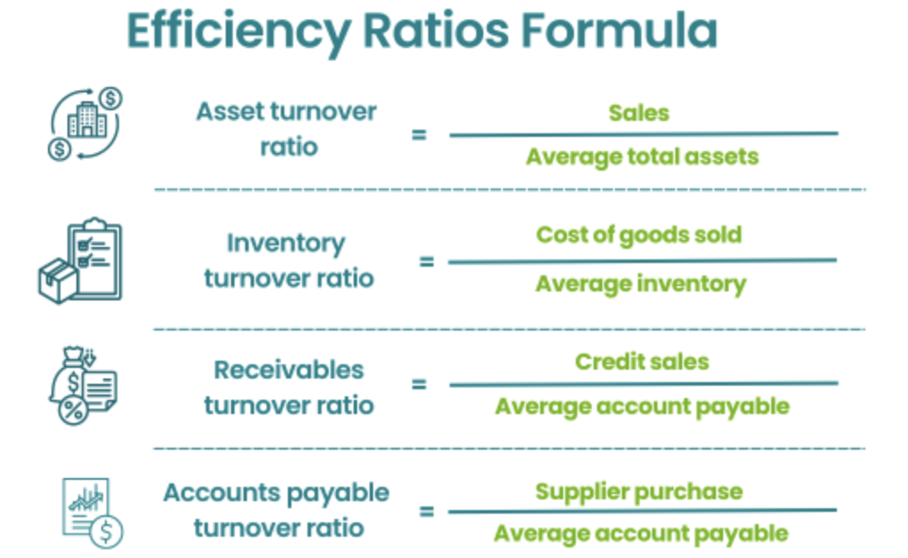
Efficiency Ratios Formula
Source: [Keni, et. al., 2019]
4. Gearing (Leverage) Ratios
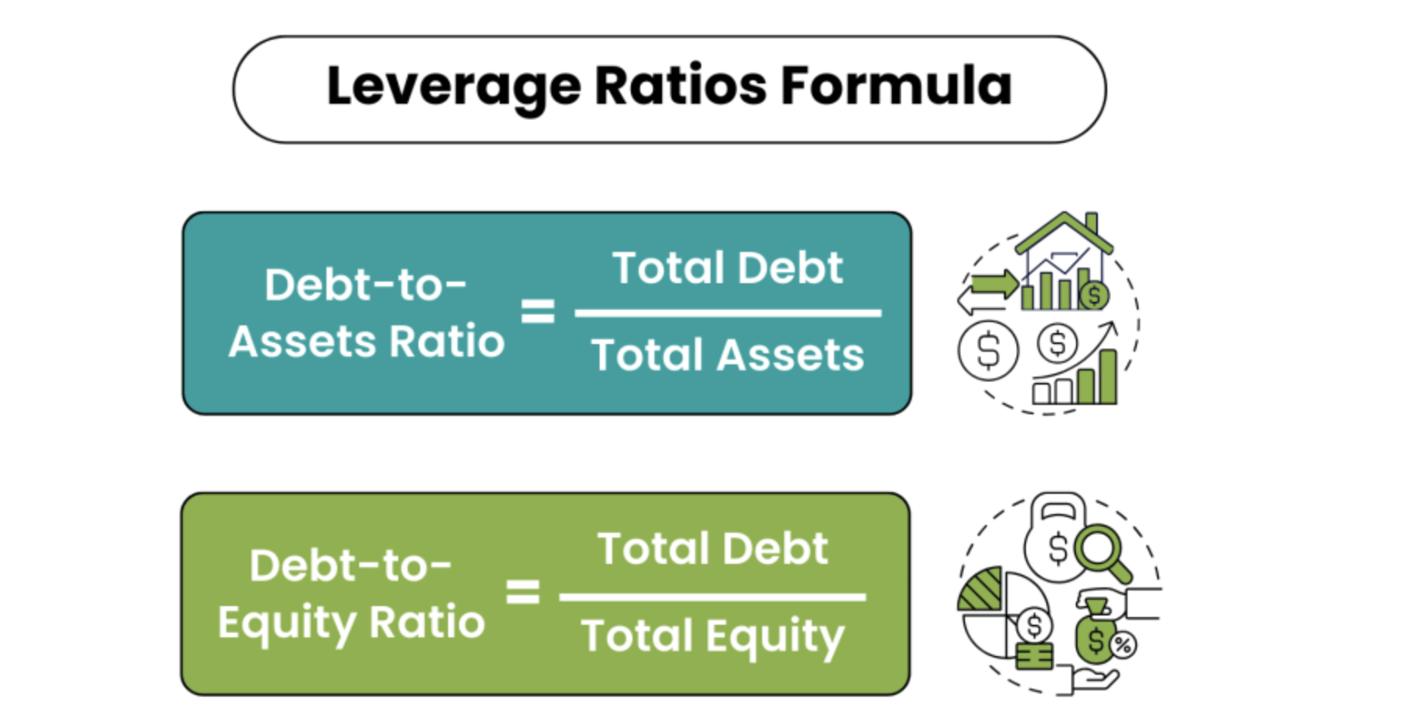
Leverage Ratios
Source: [Srivastav, 2019]
Ratio | 2021 | 2022 | 2023 | 2024 | 2025 | Trend
Debt-to-Equity (%) | 26.8 | 19.0 | 8.2 | 5.8 | ~4.5 | Sharp decline
Total Liabilities-to-Equity (%) | 91.5 | 87.4 | 73.2 | 66.1 | ~62 | Continued strengthening
Interest Coverage (x, approx.) | High | Very High | Extremely High | Extremely High | Extremely High | Low debt + solid profits
The aggressive deleveraging was one of the stand-out achievements of Kia, which created a strong low-risk balance sheet (Kenton, et. al., 2026).
The interest-bearing debt is decreasing heavily throughout the last five years. It was KRW 9.3 trillion in 2021 which got reduced to 2.73 trillion in 2025. They made repayments quickly with the strong cash flows (Badar, et. al., 2025). A company with high interest coverage usually have minimal financial risks. As a result, Kia got the flexibility to make EV investment without the pressure of interest rate hikes (Thakore, 2026).
5. Investment Ratios
Shareholder value creation was consistent, supported by earnings growth and prudent capital returns. The company maintained a shareholder friendly policy with a double EPS value in year 2024. A free cash flow was used to fund the rising dividends (Wilkins, et. al., 2025). It gets easy to make reinvestment and distributions when a firm is enjoying paced growth. The only challenge is to manage profit pressure as it might force payout adjustments.
Ratio / Metric | 2021 | 2022 | 2023 | 2024 | 2025 | Note
EPS (Basic, KRW) | 11,874 | 13,495 | 22,168 | 24,893 | 19,382 | Peaked then moderated
Dividend per Share (KRW, approx.) | Growing | Growing | Growing | ~6,000+ | 6,800+ | Sustainable payout

6. Cash Flow Analysis
Metric | 2021 | 2022 | 2023 | 2024 | 2025
Operating Cash Flow | ~7,360 | 9,333 | 11,297 | 12,564 | 9,054
Free Cash Flow (OCF – Capex) | Positive | Positive | Positive | Positive | Positive
Capex (Investing Outflows) | Rising | Rising | Rising | Significant | Significant
The cash generation was one of the main highlights as compared to their financial dimensions.
The new EV platforms have consumed significant capital expenditure but the free cash flow stayed positive. The increasing capex for battery tech and EV models can pressure ECF if marketing remain compressed (Seretidou, et. al., 2025).

1.3 Key strengths and weaknesses
Strengths | Weaknesses
- Resilient and improving profitability/margins above historical averages.  - Fortress-like balance sheet with low gearing, high liquidity and strong equity (Morris, 2026)..  - Consistent cash generation funding growth, dividends and innovation.  - Successful premiumization and electrification strategy with global diversification. | - External factors such as trade tariffs, currency volatility and raw-material costs (evident in 2025).  - High competition in EVs from low-cost Chinese players and legacy automakers accelerating battery tech (Hao and Hao, 2026).  - Rising capital expenditure needs for new platforms, supply-chain localization and R&D amid industry disruption.
This analysis highlight Kia’s transformation into a financially healthier and competitive global player. The future success hinges on balancing growth investments with margin protection (Jerab, 2023).

2. Working Capital Management Analysis

2.1 Assessing Cash Operating Cycle
The cash operating cycle (or cash conversion cycle, CCC) measures the time (in days) between cash outflows for raw materials and inflows from customer sales (CFI, 2019). It is calculated as:
CCC = DIO + DSO – DPO
where
DIO (Days Inventory Outstanding) = (Average Inventory ÷ COGS) × 365
DSO (Days Sales Outstanding) = (Average Trade Receivables ÷ Revenue) × 365
DPO (Days Payables Outstanding) = (Average Trade Payables ÷ COGS) × 365
A shorter or negative CCC indicates efficient cash generation whereas a lengthening cycle signals potential liquidity strain (Gilliam, 2025).
Year | DIO (days) | DSO (days) | DPO (days) | CCC (days) | Key Driver
2021 | ~45 | ~38 | ~79 | ~4 | Post-pandemic recovery
2022 | ~48 | ~37 | ~80 | ~5 | Supply-chain normalization
2023 | ~52 | ~35 | ~82 | ~5 | EV platform ramp-up
2024 | ~55 | ~36 | ~81 | ~10 | Global inventory build
2025 | ~58 | ~35 | ~83 | ~10–27* | EV battery & finished-goods stock
The range of CCC shows conservative DPO estimates, which might be low considering the strong supplier leverage (McKay, 2025). The DIO increased steadily from 45 days in 2021 to 58 days in 2025. It means the inventory accumulation was done intentionally for new EV platforms. It resulted in record sales but increased holding costs.
DSO remained low and stable through excellent receivables management and disciplined dealer credit terms. The DPO also stayed strong by effectively negotiating extended supplier payment terms (Weavegrid, 2025).

2.2 Recommendations to improve liquidity through working capital reforms
The company has solid liquidity, which can be further improved through debt reduction and WCM reforms. The main levers of these reforms include inventory, receivables, and payables.
Inventory Optimization
The adoption of just-in-time (JIT) manufacturing and AI-based demand forecasting are the best to produce automobiles with real-time orders (Jenkins, 2024). This works best for high-value EV components. They can also implement consignment inventory with major battery suppliers and warehousing in North America and Europe. It will help them cut safety stock while optimizing their existing inventories. It will help them release a significant cash flow in tied-up capital, which can directly mitigate obsolescence risks from rapid model refreshes.
Acceleration of Receivables
The dealers who make early payments must be provided with dynamic discounts of 1-2% for 10-day settlement. The supply chain finance platform should also be expanded for securitization of receivables. Another strategy is digital invoicing to make collections fast in emerging markets. They can also go for factoring programs for select overseas receivables to achieve immediate liquidity without balance sheet impact (Walter, 2025).
Payables extension
All non-critical suppliers must be negotiated for longer terms. On the other hand the relation with strategic partners should be preserved by volume commitments and joint R&D. Another option is the rollout of supplier financing programs using reverse factoring. This is where the strong credit rating of Kia gives suppliers access to low-cost funding. It will preserve supplier health and extend DPO without increasing costs (Snyder and Williams, 2026).

Holistic implementation and monitoring
A company-wide WCM dashboard must be integrated to track the key performance indicators of CCC with executive incentives. The cross-functional teams in areas of procurement and sales should conduct audits of suppliers and dealers. It can provide liquidity uplift while reducing interest expense from low borrowing needs. This is a reform that aligns with the new targets of Kia by converting working capital efficiency into competitive advantage (Hayes and Rosenston, 2026).

2.3 Short Vs Long-Term Financing Options
Kia's Fortress balance sheet gives flexibility in funding working capital gaps; however the choice between short- and long-term options should balance the costs, risk, and strategic fit.
Short-term financing
It has low interest rates, typically 1-3% above the benchmark in Korea. The flexibility is also high for seasonal or temporary requirements, with minimal covenant restrictions. It is ideal for bridging short CCC fluctuations or inventory spikes. However, there is a risk of tight credit environments or liquidity crunches during auto downturns (Ram, 2026).
Long-term Financing
The rates and certainty are one of the main advantages of this kind of financing, which is over 5 to 10 years. It also matches long-horizon EV KPIs as well as platform investments. Kia can use this to support credit rating stability. Moreover, it has low refinancing frequency that reduces administrative burden. The company should make sure that it does not overly rely on this financing as it can reduce agility.
Kia’s optimal approach
Kia must prioritize long-term instruments for capex needs, considering its strong internal cash generation. It can reserve short-term facilities as liquidity backstop. It can minimize interest rate and rollover risks as well.

Overall, the companies' WCM remains a major strength, with control CCC that supports cash flows and liquidity. They need to implement the recommended reforms, such as JIT inventory, strategic payable extension and receivables digitization to unlock significant cash. The long-term financing is favored when needed so Kia can maintain its low-risk profile while funding growth (Ram, 2026). A continuous WCM discipline is crucial to sustain long-term shareholder value.

3. Strategic Financial Restructuring Plan
Kia has created a strong financial position after five years of growth. Their balance sheet has low debt and healthy cash flows. The only pressures faced were from tariffs and the costly shift towards hybrid vehicles. They have new plans are around big investments of 49 KRW trillion over the next five years to expand in EVs (Do-won, 2026). This plan provides an outline for a simple financial restructuring to support the goals. It will provide long-term value without affecting their day-to-day operations.

3.1 Recommended options
There is no need for an emergency fix in the company but it can make smart changes to free up the cash and bring in new resources. These changes will help to prevent any market adversities that can impact the company’s profits in future. Following are some practical options with supporting ideas:
Selective divestiture
A divestiture is a partial or full disposal of a firm’s assets through sales or exchange. Most organizations use it during closure or bankruptcy. It is the decision of management to stop operating a business unit because it is not part of their core competence (Chen, et. al., 2025). Kia has its old internal combustion engine production lines and underused plants in less strategic locations. They can either be rented to other manufacturers or completely sold. The money obtained from the sale can be used in car-making operations. The money is also useful for new EV factories and technologies. It will help them to focus on premium SUVs and hybrids while keeping them modern in this rapid market.

Joint ventures
Kia cannot perform a full merger being a major part of Hyundai Motor Group. However, they can collaborate with battery companies and tech giants for electrification components. The firm signs an agreement to maintain a certain independence. It is mainly used to generate economies of scale and synergy by a combined facility (Navi, 2022).
Equity injection
Companies usually raise new capital by issuing shares through a rights issue to existing shareholders. The strategy provides a large cash boost for investments without adding debt (Fastercapital, 2025).
The borrower contributes his personal money within a business through a down payment or investor capital in exchange for partial ownership. The acceptable sources of the injection includes personal savings, liquid assets and documented gifts. Usually, 10-20% of the cost is required depending on the industry and cash flow. Another supportive step is the use of prudent debt refinancing. The company has the option to borrow more at low interest rate for its growth projects. These options can be combined by starting with divestiture to free cash.

3.2 Impact on Shareholder Value, Debt Structure and Operational Flexibility
The divestiture provide cash that can be returned to shareholders through high dividends or share buybacks. It focuses the business on high-margin areas like hybrids to increase profits. The injection of equity might slightly dilute ownership but funds growth for creating more value in the future. The strategic partnerships add new skills as well as markets (Theautonomous, 2021). Divestiture distribute the shares of divested unit to existing shareholders. It turn the unit into a different public company. Here, the shareholder value gets unlocked as the new firm develop independently.
The overall debt is low with the automaker compared to peers. There is no need to borrow money due to divestiture. If a firm is not meeting profit goals, the sale of non-essential segment can make the balance sheet strong. Such transactions are used to pay down debts or maintain liquidity during downturns. Even a modest new debt would be long-term and low-cost which matches investment projects. It maintains a flexible balance sheet while protecting against interest rate rises or economic slowdowns (Bernath, 2023).

3.3 International and Ethical Considerations
Taxation
Businesses need to follow a set of rules that govern how profits are taxed. If they ethically follows taxation laws smoothly, they can run their operations without affecting reputation. The sale of assets in the US or Europe might create tax bills. Here, tax-efficient structures can be used to reduce the burden. Moreover, the foreign investors can withhold the taxes (Doyle, et. al., 2022).
Currency risk
Kia makes most of its revenues in dollars and euros but reports in KWR. The major investments abroad could expose the company to exchange rate swings. This can be managed through simple hedging tools (Becker, 2024). This kind of restructuring should build in buffers and keep some cash in multiple currencies.
Inflation
The pricing of cars is rising fast along with other consumer products. As per JD power, the cars are becoming 4.2% costly year over year in 2023 (JPmorgan, 2023). High costs of raw materials are major reason behind shrunk margins for automakers. The most impacted components are batteries and steel. The company always have the option to divest old assets for efficient cost control. It is becoming unaffordable for people to buy cars and they might shift towards buying used cars. Hence, Kia needs to make sure it provide its vehicles on a low price to maintain the affordability.
CSR and ethics
The company focuses on sustainable mobility and a new structure might protect jobs where possible. The retraining for EV work is better than sudden layoffs. Diverse teachers also need fair treatment of workers. Kia is suggested to partner with ethical suppliers who meet the human rights and environmental standards. It supports the carbon emissions reduction and diversity (Chandrasekaran, 2022). The employees must be communicated clearly to avoid any reputational harm.

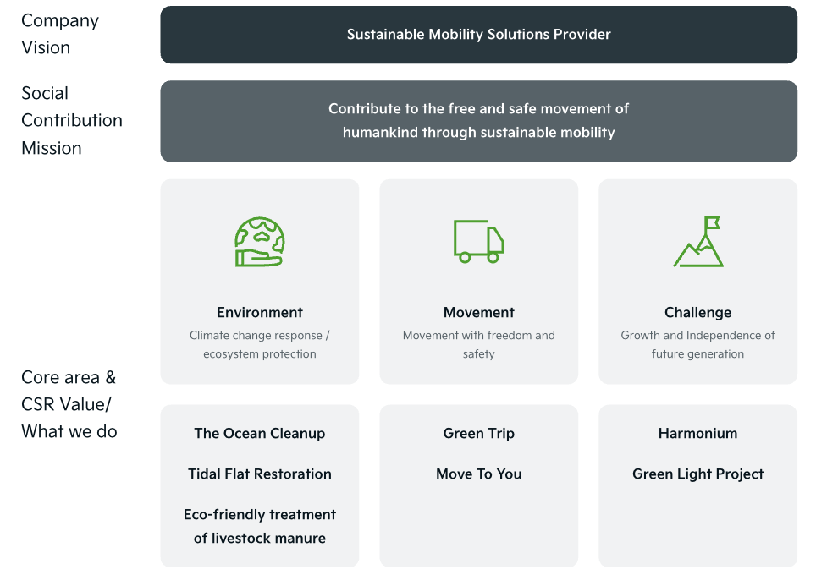
CSR and Ethics at KIA
Source: [Worldwide.kia, 2025]

4. Investment Appraisal and Capital Budgeting
The performance of Kia has been positive, with high sales and a premium product mix. Their liquidity is strong, with positive operating cash flow generation. They are actively investing in new mobility solutions to be competitive. There are three mutually exclusive investment projects under consideration that require an initial outlay of £50 million. The projects are different in their net cash inflow patterns over five years. There are five standard techniques of capital budgeting used:
Payback Period (PBP)
Accounting Rate of Return (ARR)
Net Present Value (NPV)
Profitability Index (PI)
Internal Rate of Return (IRR)
The discount rate is 10% with straight-line depreciation of £10 million per year to zero salvage value.

4.1 Project Cash Flow Details
Year | Project A (£m) | Project B (£m) | Project C (£m)
Year 1 | 10 | 11 | 5
Year 2 | 12 | 11 | 10
Year 3 | 14 | 11 | 20
Year 4 | 10 | 11 | 25
Year 5 | 8 | 11 | 5
Project A: Steady but moderate growth early, then decline.
Project B: Uniform annual cash flows.
Project C: Back-loaded with low early inflows but strong middle years.

4.2 Detailed Appraisal Using Capital Budgeting Techniques
Technique | Project A | Project B | Project C | Best Project
Payback Period (years) | 4.50 | 4.55 | 3.60 | C
Accounting Rate of Return (%) | 1.6 | 2.0 | 6.0 | C
Net Present Value (£m) | -4.54 | -4.13 | +2.82 | C
Profitability Index | 0.909 | 0.917 | 1.056 | C
Internal Rate of Return (%) | ~3% (est.) | ~3% (est.) | ~11%+ (est.) | C

The payback period calculates the time needed to recover the initial £50 million from cumulative cash inflows. Short payback periods reduce risk by returning the capital quickly. Project C is the fastest in terms of recovery, as it takes only 3.6 years. It makes it preferable in an industry that faces rapid technological change as well as uncertainty.
ARR provides a measure of average annual accounting profit as a percentage of initial investment (Gajendrakar, et. al., 2022). The project with the higher value is better in terms of average profitability. The highest ARR of 6% is provided by option C which shows strong average over the project life.
NPV discounts future cash flows at 10% while subtracting the initial investment. A positive value means it adds shareholder value to the company. The only project with a positive value is C, which creates net value. The other projects, A and B, destroy some value at the 10% hurdle rate.
Next technique is the Profitability Index which divides the initial investment by the present value of future cash inflows. This metric is above 1 which is acceptable but higher is better under capital constraints (Efinancemanagement, 2025). Similarly this project, the project C also exceeds 1 and ranks the highest among other projects.
Overall, C is the only project that outperform the others across all techniques. It gives fast recovery of capital and superior efficiency while giving the best return rate. Project B is marginally better than A due to high and BV with very stable cash flows. The lowest-ranking project is A. The back-loaded nature of the CE project suggests it involves new product development that takes time to gain traction.

4.3 Recommended project and justification
Link to Kia’s Financial Performance
Kia's profits have been resilient and its strong mid-year cash flows can boost future earnings as it expands into new segments. Project C has the shortest payback of 3.6 years, ensuring quick recovery of cash compared to others. It preserves liquidity for ongoing requirements in EV battery investment and supply chain. The strong cash generation means that the £50 million outlay can be funded internally without relying on external borrowing. The debt structure is conservative, with 5% debt to equity. The positive NPV and high PI of Project C align with Kia's low-risk approach. The equity is also growing steadily through retained earnings and provides a solid base to short-term variability in the cash flows (Morningstar, 2026).
Non-Financial Risk Consideration
Political risks are relevant as seen in the 2025 Tariff Impacts on U.S. Sales. The fast payback of Project C reduces exposure to prolonged regulatory changes. It can help manage new trade barriers or import duties as well. Quick recovery provides flexibility to adapt if the conditions are not supportive.
Another crucial element is customer loyalty as the company builds its premium brand image while transitioning to EVs. The selected project has potential for innovation and to enhance customer excitement through advanced technologies. A successful execution might provide them a better market position and repeat purchases as well (Tattam, 2023). Projects A and B offer steady but less distinctive results that might not differentiate from rivals.
Another non-financial factor is technology risk and market acceptance. There are some early-year risks in the project C due to low initial inflows; however, it can offer higher rewards if the project succeeds in growing the hybrid market. The recent experience with hybrid penetration and global sales growth shows the capability to manage such transitions.

4.4 Capital Rationing
This is a decision making process used by companies to focus their spending on main priorities to get high returns. It is not possible to have limitless funds to spend on new project. Hence, rationing helps to choose the best ideas while dropping others (Hayes and Boyle, 2026). The automaker faces capital rationing with a maximum investment budget of £100 million. Each project costs £50 million, which allows exactly two projects to be selected. The possible combinations are:
• A+B
• A+C
• B+C
The recommended product combination is project B and C, as ranked by profitability index given below:
Rank | Project | PI
1 | Project C | 1.056
2 | Project B | 0.917
3 | Project A | 0.909
The inclusion of the highest-ranked project is essential. Project B is slightly better, with slightly better PI than A and more predictable annual cash flows of £11 million. This stability complements the back-loaded profile of C and creates a balanced portfolio. The total NPV for B+C is the least negative among combinations. It minimizes value destruction and maximizes efficiency under the budget constraints (Rawell, 2022).

4.5 Implementation considerations and risks
A sensitive analysis should be conducted on cash flow variability and discount rate changes. The actual performance should be monitored against forecasts in the early years of Project C. It is suggested to be integrated with existing operations to generate additional synergies in areas of technology and supply chain. The non-financial risks are mitigated through careful project planning. A sustainable sourcing and fair labour practices can help to meet their CSR commitments (Billedaeu and Wilson, 2025).

4.6 Conclusion
The single standout project for Kia is C which excels in payback speed and return rate. The reduced political exposure further supports this choice. The 100 million capital rationing constraints make the combination of projects B and C optimal. It can help the automaker continue its successful transformation.
Hyundai’s expertise and knowledge of global markets gave Kia a competitive moat over rivals. It already had many customers around the world whose trust was directly shared with Kia as well. The financial health of the company is robust with high cash flows. The industry is now facing a shift towards battery powered vehicles where every firm needs something new and better.
This decision is built on their recent achievements in cash generation and balance sheet strength. A regular board review will be crucial for ensuring the chosen investments meet or exceed expectations. Overall, the plan’s disciplined execution will help Kia achieve long-term success in the evolving industry.

References
Automotiveworld. (2025) Kia announces 2025 second quarter business results. [Online] automotiveworld. Available at https://www.automotiveworld.com/news-releases/kia-announces-2025-second-quarter-business-results/
Badar, D. S., Nurgraha, N., Supriyatna, Y., & Purnamasari, I. (2025). The impact of financial ratios on corporate performance in Southeast Asia: A comparison of pre-and post-COVID-19 Pandemic. Jurnal Ilmiah Akuntansi Kesatuan, 13(3), 419-432.
Becker, D. (2024) Navigating raw material risks: Challenges and opportunities in the automotive industry. [Online] fastmarkets. Available at https://www.fastmarkets.com/insights/navigating-raw-material-risks-challenges-and-opportunities-in-the-automotive-industry/
Bernath, M. (2023) Debt Structuring in Project Finance: Balancing Risk and Returns for Successful Infrastructure Development. [Online] medium. Available at https://medium.com/@matthew.bernath/debt-structuring-in-project-finance-balancing-risk-and-returns-c6213c56cebf
Billedeau, D. B., and Wilson, J. (2025) Misalignment in the automotive supply Chain: Sustainability commitments of automotive manufacturing firms and their suppliers. Journal of Cleaner Production, 520, 146122.
Cbtnews. (2025) Kia hit with $842 million tariff loss as Q3 profit sinks. [Online] cbtnews. Available at https://www.cbtnews.com/kia-hit-with-842-million-tariff-loss-as-q3-profit-sinks-nearly-50/
Chandrasekaran, M. M. (2022) Does corporate social responsibility fuel firm performance? Evidence from the Asian automotive sector. Sustainability, 14(22), 15440.
Chen, J., Boyle, M. and Eichler, R. (2025) Understanding Divestiture: Definition, Reasons, and Examples. [Online] investopedia. Available at https://www.investopedia.com/terms/d/divestiture.asp
Corporatefinanceinstitute. (2019) Operating Cycle. [Online] corporatefinanceinstitute. Available at https://corporatefinanceinstitute.com/resources/accounting/operating-cycle/
Davies, J. (2026) Achieve economies to scale with lean manufacturing. [Online] winman. Available at https://www.winman.com/blog/achieve-economies-to-scale-with-lean-manufacturing
Do-wan, K. (2026) Kia Bets 49 Trillion Won on Humanoid Robots, Urban Autonomous Driving by 2029. [Online] sedaily. Available at https://en.sedaily.com/finance/2026/04/10/kia-bets-49-trillion-won-on-humanoid-robots-urban
Doyle, E., Frecknall-Hughes, J., and Summers, B. (2022) Ethical reasoning in tax practice: Law or is there more?. Journal of International Accounting, Auditing and Taxation, 48, 100483.
Efinancemanagement. (2025) Investment Appraisal Techniques. [Online] efinancemanagement. Available at https://efinancemanagement.com/investment-decisions/investment-appraisal-techniques
Fastercapital. (2025) The Importance Of Capital Injection For Business Growth. [Online] fastercapital. Available at https://fastercapital.com/topics/the-importance-of-capital-injection-for-business-growth.html/4
Furlong, K. (2025) Kia Sets Record November Sales as Carnival, Sportage, and Seltos Surge. [Online] autoblog. Available at https://www.autoblog.com/news/kia-carnival-sportage-and-seltos-november-sales-records
Gilliam, J. (2025) The cash conversion cycle: A key metric for improving your company’s financial health. [Online] billtrust. Available at https://www.billtrust.com/resources/blog/cash-conversion-cycle
Goldstein, S. (2023) Top investing picks across the EV supply chain. [Online] morningstar. Available at https://www.morningstar.com.au/stocks/top-investing-picks-across-the-ev-supply-chain
Hao, Y., and Hao, Y. (2026) The Dynamics of Competition in the Chinese Electric Vehicle Market: Insights from BYD’s Market Evolution. International Journal of Industrial Organization, 103256.
Hayes, A. and Rosenston, M. (2026) Working Capital Management: Ensuring Cash Flow & Efficiency. [Online] investopedia. Available at https://www.investopedia.com/terms/w/workingcapitalmanagement.asp
Jenkins, A. (2024) Just-in-Time (JIT) Inventory: A Definition and Comprehensive Guide. [Online] netsuite. Available at https://www.netsuite.com/portal/resource/articles/inventory-management/just-in-time-inventory.shtml
Jerab, D., & Mabrouk, T. (2023). Strategies for effective organizational restructuring: A comprehensive guide. Available at SSRN 4584665.
Jin, C. H. E. N. (2025). Growth and Competitiveness of Chinese Electric Vehicle and Electric Vehicle Battery Companies: Observation and Analysis from an Ecosystem Perspective. International Relations, 13(3), 119-133.
Keni, D., Srivastav, A. K. and Vaidya, D. (2019). Efficiency Ratios Formula. [Online] wallstreetmojo. Available at https://www.wallstreetmojo.com/efficiency-ratios-formula/
Kenton, W., Mansa, J. and Velasquez, V. (2026) Understanding Gearing Ratios: Definitions, Types, and Calculations. [Online] investopedia. Available at https://www.investopedia.com/terms/g/gearingratio.asp
McKay, T. (2025) Strategies to manage your cash conversion cycle. [Online] mercury. Available at https://mercury.com/blog/strategies-manage-cash-conversion-cycle
Morningstar. (2026) Kia and TotalEnergies Celebrate 15 Years of Global Collaboration with a Fourth Contract Renewal. [Online] morningstar. Available at https://www.morningstar.com/news/pr-newswire/20260420ny18388/kia-and-totalenergies-celebrate-15-years-of-global-collaboration-with-a-fourth-contract-renewal
Morris, C. (2026) Hyundai and Kia invest in battery software provider Qnovo. [Online] chargedevs. Available at https://chargedevs.com/newswire/hyundai-and-kia-invest-in-battery-software-provider-qnovo/
Navi. (2022) What is Joint Venture – How to Set Up and Start One? [Online] navi. Available at https://navi.com/blog/joint-venture/
Oyrer, H. (2021) New Automotive Market Realities Enhance the Need for Strategic Partnerships. [Online] the-autonomous. Available at https://www.the-autonomous.com/news/new-automotive-market-realities-enhance-the-need-for-strategic-partnerships/
Purnamasari, P., and Adriza. (2024) Capital budgeting techniques and financial performance: a comparison between SMEs and large listed firms. Cogent Economics & Finance, 12(1), 2404707.
Ram, K. (2026) Difference Between Short-Term and Long-Term Financing in the UK. [Online] legalvision. Available at https://legalvision.co.uk/corporations/term-financing/
Rawell, R. (2022) What is Capital Rationing, How is it Used? [Online] fisdom. Available at https://www.fisdom.com/what-is-capital-rationing-how-is-it-used/
Rejeb, A., Rejeb, K., and Süle, E. (2025) Key issues in electric vehicle battery supply chains based on English-language news articles: a machine learning approach. Energy Nexus, 100595.
Seretidou, D., Billios, D., & Stavropoulos, A. (2025). Integrative analysis of traditional and cash flow financial ratios: Insights from a systematic comparative review. Risks, 13(4), 62.
Szabó, T., Gáspár, S., & Hegedűs, S. (2025). Development of financial indicator set for automotive stock performance prediction using adaptive neuro-fuzzy inference system. Journal of Risk and Financial Management, 18(8), 435.
Snyder, K. (2026) What Is Just-In-Time Inventory (JIT)? [Online] forbes. Available at https://www.forbes.com/advisor/business/just-in-time-inventory/
Srivastav, A. K. (2019). Leverage Ratios Formula. [Online] wallstreetmojo. Available at https://www.wallstreetmojo.com/leverage-ratios-formula/
Tattam, D. (2023) Non-financial risk: Why the big focus? [Online] protechtgroup. Available at https://www.protechtgroup.com/en-au/blog/non-financial-risk-why-the-big-focus?utm_source=google.com&utm_medium=organic
Thakore, M. (2026) Electric vehicle and battery supply chain: 5 things to look for in 2026. [Online] woodmac. Available at https://www.woodmac.com/news/opinion/ev-and-battery-supply-chain-2026-outlook/
Thakur, M. (2023). Profitability Ratios Formula. [Online] educba. Available at https://www.educba.com/profitability-ratios-formula/
Wallstreetmojo. (2025) What is Investment Appraisal? [Online] wallstreetmojo. Available at https://www.wallstreetmojo.com/investment-appraisal-2/
Walter, J. (2025) Just In Time (JIT): Definition, Advantages and Implementation. [Online] beewatec. Available at https://www.beewatec.com/en/blog/just-in-time-definition-advantages-and-implementation
Weavegrid. (2025) WeaveGrid Secures Strategic Investment from Hyundai Motor and Kia, Reinforcing Leadership in EV Charging Management. [Online] weavegrid. Available at https://www.weavegrid.com/news/weavegrid-secures-strategic-investment-from-hyundai-and-kia
Wilkins, G., Yashina, N. and Kvilhaug, S. (2025) 6 Basic Financial Ratios and What They Reveal. [Online] investopedia. Available at https://www.investopedia.com/financial-edge/0910/6-basic-financial-ratios-and-what-they-tell-you.aspx
Worldwide.kia. (2026). Investor Relations. [Online] worldwide.kia. Available at https://worldwide.kia.com/en/company/investor-relations/financial/summary-statements
Wrightvigar. (2024) Financial Health Check for Businesses: Assessing and Improving Performance. [Online] wrightvigar. Available at https://www.wrightvigar.co.uk/news/%20Assessing-and-Improving-Performance

Appendices

1. Kia Income Statement 2024
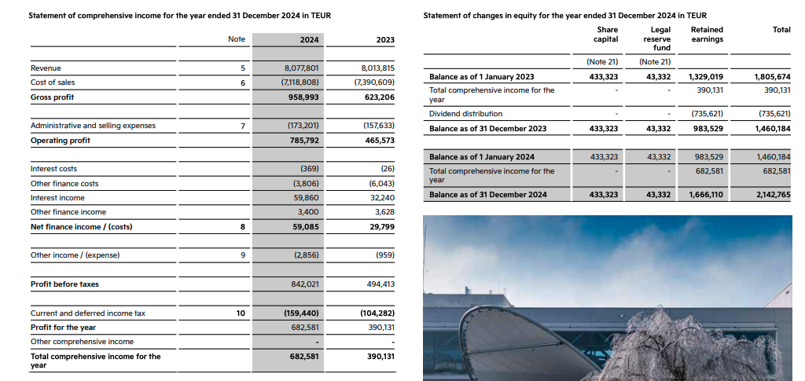

2. Kia Annual Financials Statement 2023
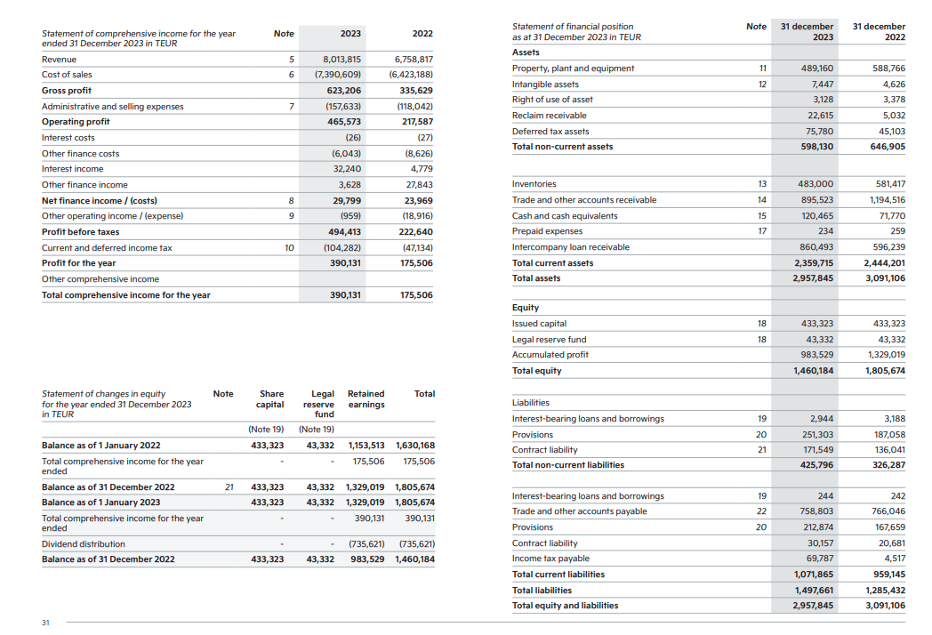

3. Kia Financial Statements 2022
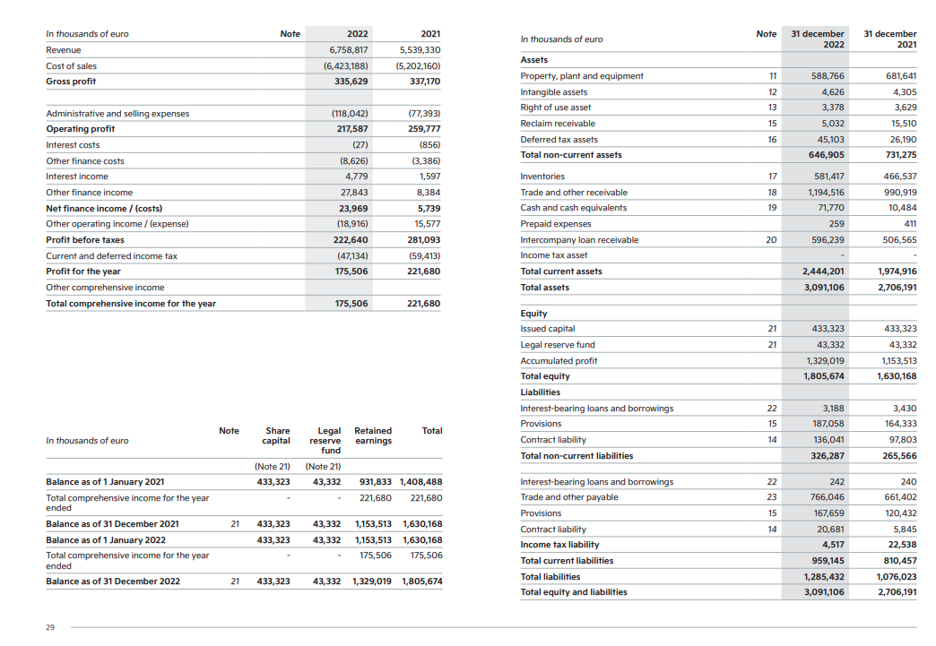

4. Kia Income Statement 2021
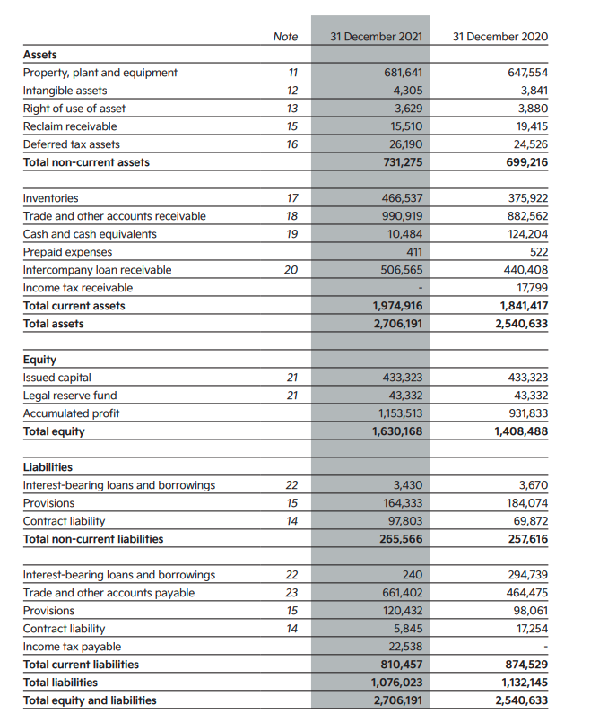

5. Consolidated Income Statement Highlights
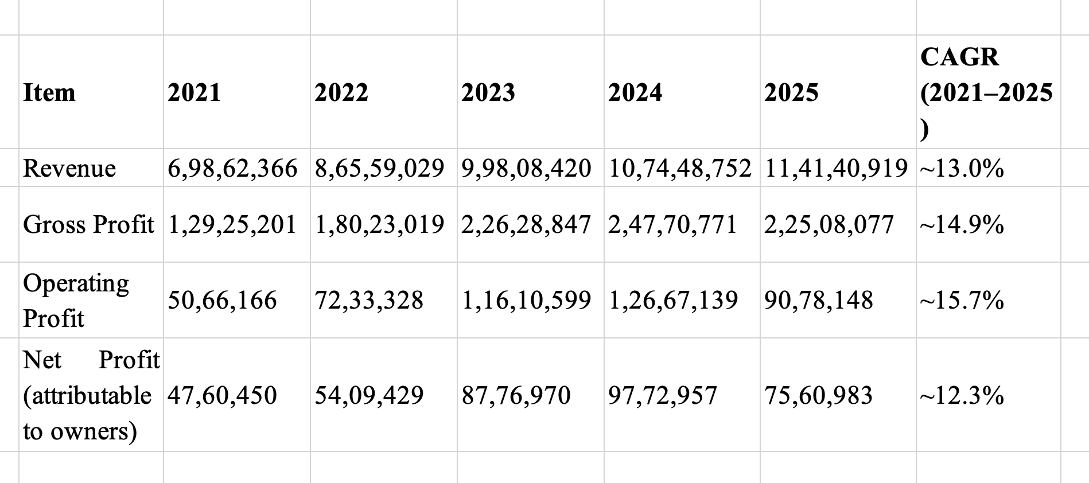

6. Consolidated Balance Sheet Excerpts
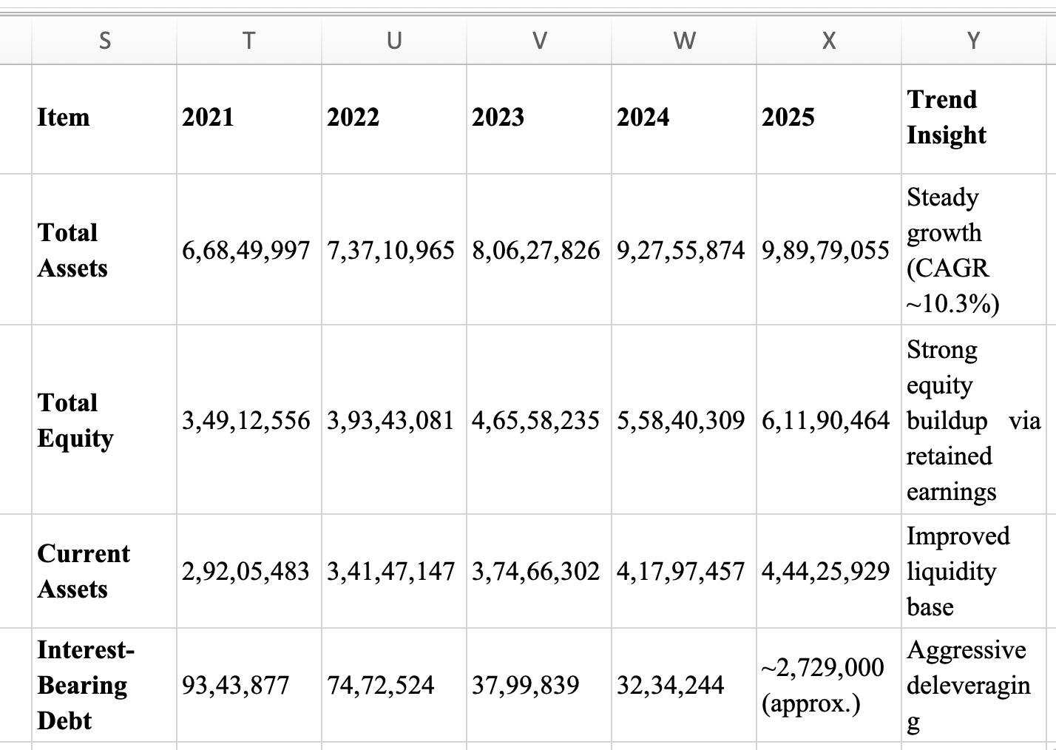

7. Profitability Ratios
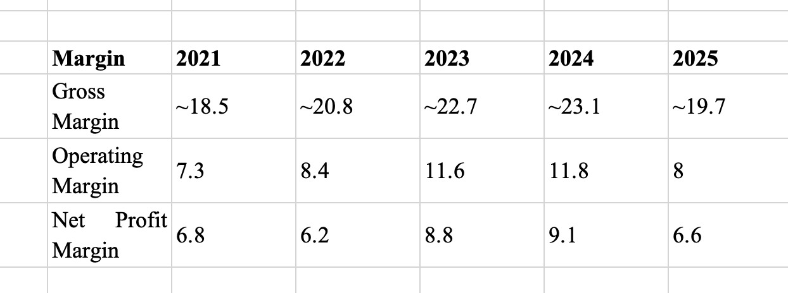

8. Liquidity Ratios
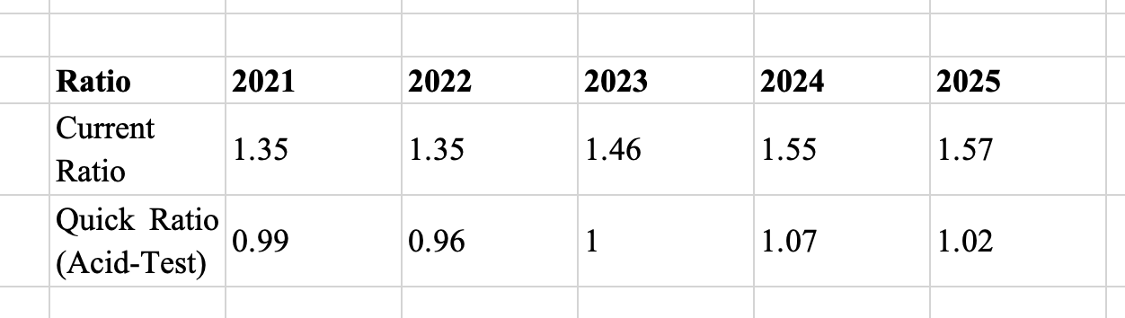

9. Efficiency Ratios
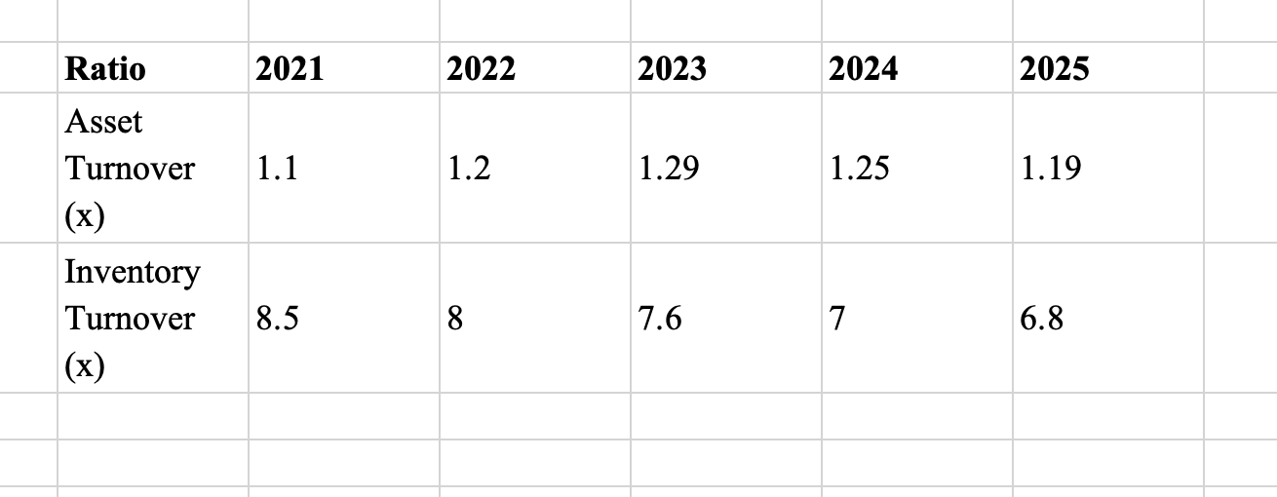

10. Gearing (Leverage) Ratios
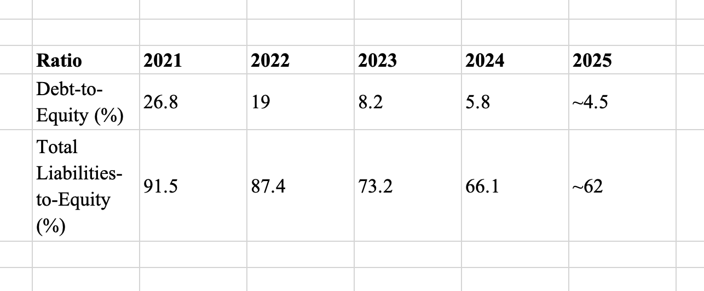

11. Cash Operating Cycle
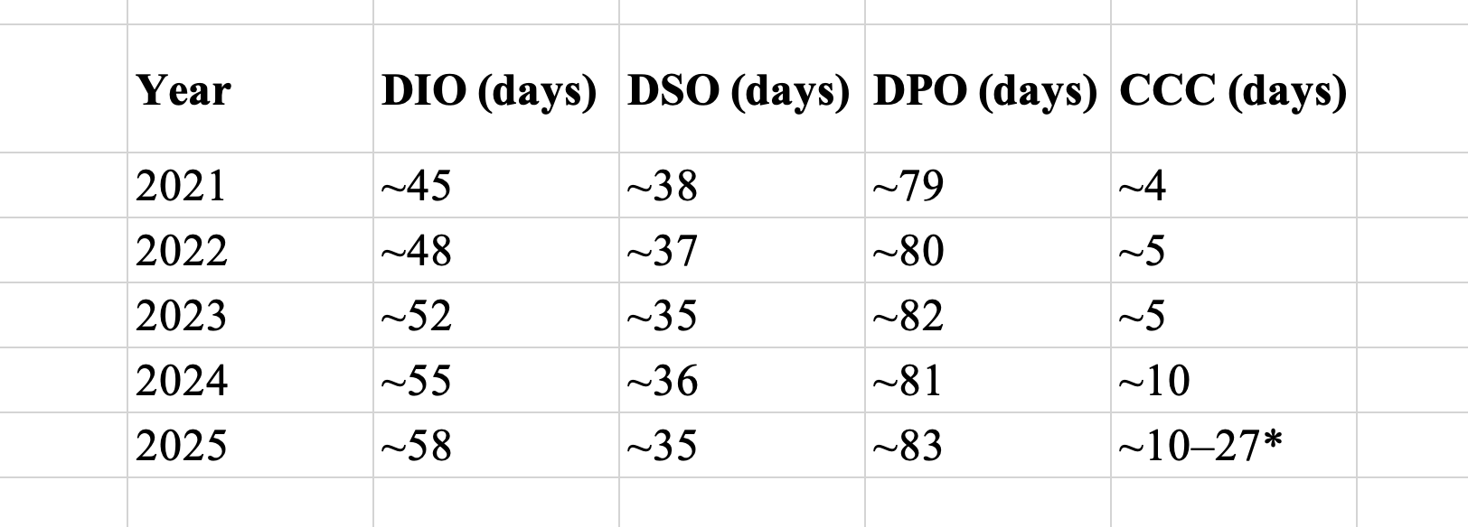

12. Project Appraisal using Capital Budgeting Techniques
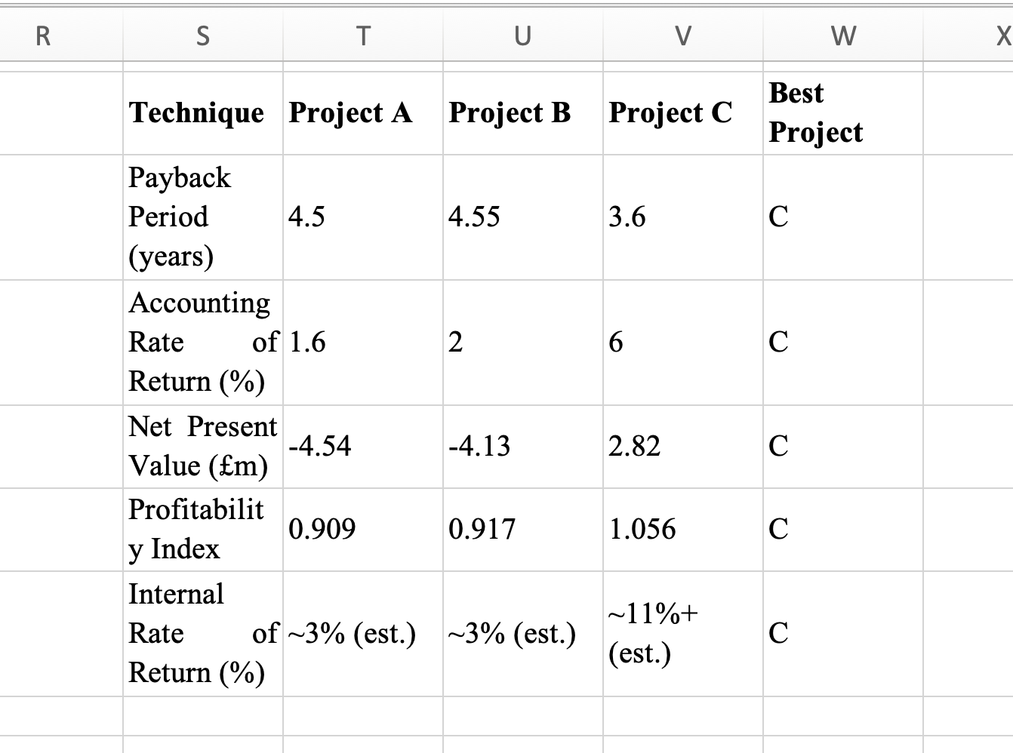

13. Kia balance sheet excerpts
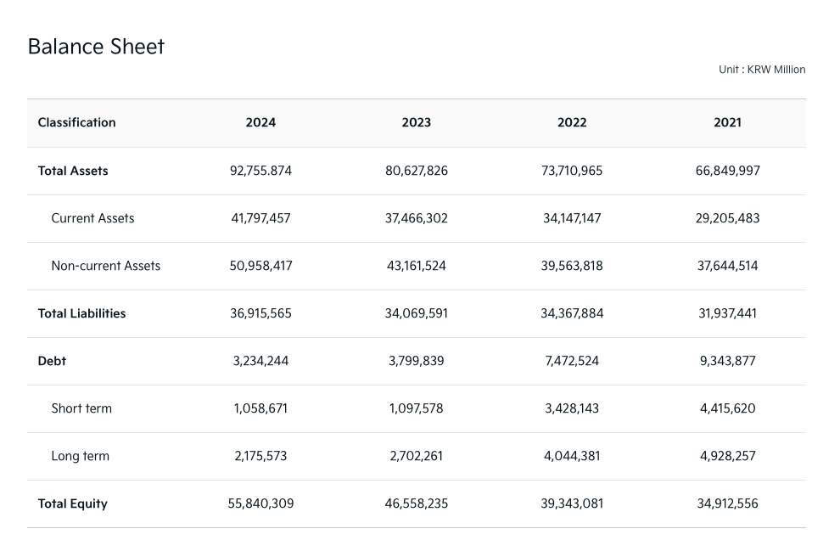
Source: [Worldwide.kia 2026]

