Business Model Canvas and Entrepreneurial Reflection

Student name: Andreea Cristina Mirica
Student ID number: 2211629
Entrepreneurship (BMIH5001)
Lecturer: Neil Dyer
Word count (reflections): 2000 words (+ - 10%).

Table of Contents

INTRODUCTION 3
PART 1- BUSINESS PROPOSAL 4
PART 2-REFLECTIVE ESSAY 8
CONCLUSION 10
REFERENCES 11
APPENDIX 14

INTRODUCTION
Entrepreneurship refers to the act of starting a business to attain a profit. There are four different forms of entrepreneurship: scalable start-up entrepreneurship, social entrepreneurship, small business entrepreneurship and large company entrepreneurship. Entrepreneurs need to create a sound business plan as it helps them to focus on all steps necessary for them to make new business ideas succeed (Terán-Yépez et.al, 2020). This essay is based on a new business idea “CareerHelp”, which is an app created to support and satisfy the learning needs of the employees working in the hospitality sector. In this essay, there will be a discussion about the hospitality business concept with the help of using the Business Model Canvas. In addition to this, there will be a discussion about the use of Gibb’s reflective cycle based on entrepreneurial tests.

PART 1- BUSINESS PROPOSAL
Entrepreneurship is a process of determining unique new ideas for exploring resources. Entrepreneurship provides proper access to products and services, promotes economic growth, and enhances living standards (Karami, and Read, 2021). The Business Model Canvas was used for developing the new business ideas “CareerHelp”, which is an app developed. To help employees in the hospitality sector. To develop their skills. By identifying their current skills, identifying their learning needs, and recommending them training sessions to work on those areas. Currently, the hospitality sector is facing one of the highest turnover rates from any other business sector. The turnover rate in the hospitality industry is of 87%, meaning that one in five employees is leaving the hospitality business in a month (GOV, 2019). One of the main causes of this high turnover rate is the lack of training and development opportunities (GOV, 2019). This app can come to support hotels and restaurants to retain employees by satisfying their learning needs in the workplace. Many hospitality businesses do not have an HR manager, prepared to identify the learning needs of employees, and develop strategies to satisfy them. In the lack of this HR resources, businesses have a higher chance of facing poor levels of job satisfaction among employees. Using this app, employers in the hospitality industry can satisfy this learning. Need of the employee with a minimum cost and with great benefits in return.
To further elaborate on the development of career help, the ESA will make use of the BMC model developed previously for this business. The BMC model includes the key partners of the business, the key activities of the business, the value proposition of the business, the customer relationship section, the channels used by the business, the target market, the cost structure, and the revenue streams of the business (Daou et.al, 2020). These elements of the business model canvas play a major role in the development of the new business idea. The key activities section of the BMC model includes the main services provided by CareerHelp. This section helps the entrepreneur to establish what the business does and what is the main competitive advantage of the business. CareerHelp will provide employee assessments to assess the learning needs of the employees, individual training sessions tailored to the individual needs of employees, recommendations for further in-house training sessions that can be done by employers if they choose so, assessments to monitor the performance of training sessions and to monitor employee satisfaction levels regarding the training session. All these services can be effective for the company in meeting the different needs and preferences of their employees and creating value for them. Also, the main aim of the new business is to create loyalty in their customers by anticipating their changing needs and preferences. The Value Proposition section of the Business Model Canvas provides a better understanding of the values which new businesses can create for the customers (Schmidt, and Scaringella, 2020). CareerHelp helps to promote the long-term development of the hospitality business by promoting a supportive learning environment with a minimum cost for businesses but with long term benefits in return. The customer relationship section of the BMC model for new business involves personal assistance, customer service, customer relationship and solving queries of customers (Migdadi, 2021). The channel element of the BMC model helps in gaining deeper insight into the way a new business can approach its target customers and attract them towards the organisation. The channels involve e-mails, phone, direct messaging applications, live chat, catboats, and social media (Facebook, Instagram, and Twitter). The use of these types of channels can allow the customer service department of the company to inform customers regarding the new offerings and allow customers to ask their queries related to the services and offers which company provides to them (Yürük-Kayapinar, and Kayapinar,2021).
In addition to this, the customer segment section of the BMC model allows new businesses to segment the customers based on age, gender, education, motivation, professional and objective. CareerHelp does not target individuals on their own, but it targets small to medium businesses in the hospitality sector which do not have sufficient financial resources to hire an HR manager to manage their workforce. The hospitality sector is formed of 145,050 small to medium enterprises, representing 68% of the total number of organisations operating in the sector (ISME, 2024). Based on these statistics, it can be said that CareerHelp has a comprehensive target market that can help satisfy the growing needs of the business venture. According to a report provided by CIPD (2015) there are 51% chances that a medium enterprise does not an appointed HR manager and there are 71% chances that a small enterprise does not have an appointed HR manager. These figures can be used to suggest the need and opportunity for CareerHelp to appear on the market. The key partners play an essential role in supporting the new business in carrying out the activities in the right and ethical manner. The key partners for the new business involves government, HR managers, technology providers and other investors that could support the long-term development of CareerHelp. Partnership with these parties allows new businesses to carry out their business function in the right and appropriate manner (Muhtadi, and Ardi, 2021). Also, the cost structure of the business determines all costs incurred to carry out the business activities in a proper manner and accomplish the goals of the organisation. The overall budget for the new business includes 30,0000 pounds which is considered as adequate amount for performing the different department's activities (Oganda et.al, 2020). The overall cost structure of the organisation is linked with the key resources, key partnerships, and key activities mentioned previously in the essay. The initial amount is distributed among different areas of the business such as insurance, capital expenditure, staff wages, app development, marketing and materials, training and development, accounting, office consumables, broadband, stock purchase and many other activities. The cost structure of the new business can help generate revenue, develop customer relationships, and create and deliver value. Additionally, the revenue streams of the BMC model allows the new businesses to analyse the various sources from which businesses can earn money (Salvador et.al, 2021). The app can be downloaded for free to identify the services provided the business. Businesses can take reach out for personalised offers depending on the number of employees they have and on the services they aim to purchase. Also, loyalty cards can allow the company to earn more revenue and make a profit in the long term (Mancha, and Gordon, 2021). In addition to this, the app can make money from advertisement of other related services.
The main competitors of the company include organisations such as CIPD and any other training providers, however, there is not such an app on the market that aims to offer what CareerHelp does. The key value proposition of the new business allows the company to differentiate itself from the available players in the market and reduce the shifting cost of customers. Apart from the core element of the business model canvas, there are other forms of factors which influence the decision-making process of the new business (Alzghoul et.al, 2022). The factors involve attitude of risks, data availability, organisational structure, external environment, and many others. Developing a good organisational structure is essential for performing the work of the business more appropriately. The business involves some employees who are highly skilled and knowledgeable. Managers and leaders of the organisation provide training and development to the workforce and support them through assigning roles and responsibilities in the right manner (Zhdanov, Bhattacharjee, and Bragin, 2022). In terms of external factors that influenced and contributed to the development of CareerHelp, the followings have been noted. Analysing social and economic trends, founders of CareerHelp identified the increased need for learning of employees in the hospitality sector and the lack of resources of hospitality businesses to satisfy those needs. Considering the Covid crisis which impacted severely the economic performance of hospitality business, many organisations are trying now to cover the losses suffered in the previous years and lack the funding for investment in employee wellbeing. The development in technology allows CareerHelp to make use of digital tools and provide this service all over the country while eliminating transportation costs, labour costs, rental costs. Also, the attitude toward risks is another factor which drives the decision-making process of CareerHelp. As CareerHelp is a start-up company, taking steps towards innovation is essential for the company to carry out the business functionalities in the right manner (Orthodoxou et.al, 2022). In addition to this, data availability and reliability can be another factor which drives the decision-making practices of the organisation. CareerHelp requires proper availability of data related to latest learning practices and training strategies. Loss of data and improper availability of the data can create problems for the company in making accurate decisions (Büyüközkan, and Tüfekçi, 2021). In addition to this, proper availability of data in the hands of the decision-makers of the new business is essential to take action and formulate strategies that support a sustainable long-term development. Therefore, the section of the Business Canvas Model plays a major role in focusing on the core business aspects.

PART 2-REFLECTIVE ESSAY
Participation in the entrepreneurial test during my academic journey was quite good and interesting for me. Involving in entrepreneurial questionnaire test and GET 2 TEST results involved positive and negative aspects. Through these tests, I was able to assess my tendency to start a new business project (García‐Gavín et.al, 2020). The adequate support and results of the test enabled me to develop a new business plan which was related to the hospitality sector. The BMC model was undertaken by me for developing the business plan as different elements of the model allowed me to focus on major aspects of the business. Also, the test enabled me to assess my areas of strengths and weaknesses in the context of the entrepreneurial area.
I got a feeling of entrepreneurship while participating in the test as I was able to assess my level of learning in context to the entrepreneurial characteristics. In starting of the test assigned by my tutor, I was unable to answer the questions due to a lack of knowledge regarding some major areas related to risks and creativity in entrepreneurship (Matsuo, and Nagata, 2020). In addition to this, some students obtained good scores in comparison to me and at that time I felt under confident. Later, adequate support and guidance from the educators allowed me to perform the test properly.
Through the test, I have evaluated that participation in the entrepreneurial-based test helps in determining own level of strengths and abilities in the context of the entrepreneurship area. Also, I evaluated that I have the potential to run the business and the skills which are necessary to become an entrepreneur as I gained 36 scores out of 48 but sometimes, I may be too cautious. Also, my overall GET score was 41% which enabled me to I can carry my own business.
I have analysed that having a proper set of required skills and knowledge related to the entrepreneurial area is important for me. Also, I have analysed that I obtained a medium score like 50% in the achievement area of the GET test, there is a need for autonomy as my score was low. In addition to this, the creative score was 42% which represented that I need to develop creative skills for better creativity skills. The risk-taking part of the test was one of the areas at which I had the lowest scores and based on the score, I have analysed that there is a need to build risk-taking ability to make business more successful (Douglas, Shepherd, and Venugopal, 2021). Lastly, I have analysed that I am self-confident, determined, and proactive following the medium score.
Therefore, involving active participation in the entrepreneurial test was a very interesting part of my academic journey and provided me with an opportunity to carry out my own business. I realised that good self-confidence and planning skills enabled me to carry out the new business plan in a proper manner (Wang, Mundorf, and Salzarulo-McGuigan, 2022). Also, I have analysed that I need to focus on improving my creativity and digital skills for better practices in my future professional career.
To overcome my poor creativity and planning skills, I will try to attend seminars and sessions to develop my planning and creativity skills. Also, I will try to take guidance and support from experts to overcome these two poor areas.

CONCLUSION
From the above essay, it has been discussed that entrepreneurship is a broad concept and there are four different forms of entrepreneurship such as scalable start-up entrepreneurship, social entrepreneurship, small business entrepreneurship and large company entrepreneurship. Also, it has been discussed that sections of the Business Canvas Model play a major role in focusing on the core business aspects. At the end of the essay, it has been discussed that an individual must perform the entrepreneurial test to assess their abilities and areas of improvement

REFERENCES

Alzghoul, A., et.al, (2022). How business intelligence capability impacts decision-making speed, comprehensiveness, and firm performance. Information Development, p.02666669221108438.
Amoussohoui, R., and et al.,. (2022). An extended Canvas business model: A tool for sustainable technology transfer and adoption. Technology in Society, 68, p.101901.
Büyüközkan, G. and Tüfekçi, G., (2021). A decision-making framework for evaluating appropriate business blockchain platforms using multiple preference formats and VIKOR. Information Sciences, 571, pp.337-357.
CIPD (2015) Research report - CIPD. Available at: https://www.cipd.org/globalassets/media/knowledge/knowledge-hub/reports/making-maximum-impact-hr-professional-sme_tcm18-8791.pdf (Accessed: 05 February 2024).
Daou, A., et.al, (2020). The Ecocanvas as a business model canvas for a circular economy. Journal of Cleaner Production, 258, p.120938.
Douglas, E.J., Shepherd, D.A. and Venugopal, V., (2021). A multi-motivational general model of entrepreneurial intention. Journal of Business Venturing, 36(4), p.106107.
García‐Gavín, J., et.al, (2020). Efficiency in patch testing: the number needed to test to get one relevant result as a new approach in the evaluation of baseline series. British Journal of Dermatology, 183(2), pp.391-393.
GOV (2019) Hospitality and Tourism Workforce Landscape - gov.uk. Available at: https://assets.publishing.service.gov.uk/media/5d67a363ed915d53b4904899/Hospitality_and_Tourism_Workforce_Landscape.pdf (Accessed: 05 February 2024).
ISME (2024) New Analysis reveals the importance of smes to the British economy , Intelligent SME.tech. Available at: https://www.intelligentsme.tech/2022/06/28/new-analysis-reveals-the-importance-of-smes-to-the-british-economy/#:~:text=Analysis%20of%20the%20industries%20revealed,%2C%20which%20equals%20roughly%2069.8%25. (Accessed: 05 February 2024).
Karami, M. and Read, S., (2021). Co-creative entrepreneurship. Journal of Business Venturing, 36(4), p.106125.
Mancha, R. and Gordon, S., (2021). Multi-sided platform strategies for organizations: transforming the business model. Journal of business strategy, 43(3), pp.175-183.
Matsuo, M. and Nagata, M., (2020). A revised model of experiential learning with a debriefing checklist. International Journal of Training and Development, 24(2), pp.144-153.
Migdadi, M.M., (2021). Knowledge management, customer relationship management and innovation capabilities. Journal of Business & Industrial Marketing, 36(1), pp.111-124.
Mosaddegh, A., et.al, (2021). Dynamics of customer segments: A predictor of customer lifetime value. Expert Systems with Applications, 172, p.114606.
Muhtadi, F. and Ardi, R., (2021), May. Critical Success Factors of a Partnership between Traditional Shop & Startup Business: A Preliminary Findings. In Proceedings of the 4th Asia Pacific Conference on Research in Industrial and Systems Engineering (pp. 188-193).
Oganda, F.P., et.al, (2020). Blockchain education smart courses of massive online open course using business model canvas. In 2020 2nd International Conference on Cybernetics and Intelligent System (ICORIS) (pp. 1-6). IEEE.
Orthodoxou, D.L., et.al, (2022). Sustainable business events: The perceptions of service providers, attendees, and stakeholders in decision-making positions. In Journal of convention & event tourism (Vol. 23, No. 2, pp. 154-178). Routledge.
Salvador, R., et.al., (2021). Key aspects for designing business models for a circular bioeconomy. Journal of Cleaner Production, 278, p.124341.
Schmidt, A.L. and Scaringella, L., (2020). Uncovering disruptors’ business model innovation activities: evidencing the relationships between dynamic capabilities and value proposition innovation. Journal of Engineering and Technology Management, 57, p.101589.
Terán-Yépez, E., et.al., (2020). Sustainable entrepreneurship: Review of its evolution and new trends. Journal of Cleaner Production, 252, p.119742.
Wang, C., Mundorf, N. and Salzarulo-McGuigan, A., (2022). Entrepreneurship education enhances entrepreneurial creativity: The mediating role of entrepreneurial inspiration. The International Journal of Management Education, 20(2), p.100570.
Yürük-Kayapinar, P. and Kayapinar, Ö., (2021). New Media Channels in Corporate Communication and Interaction with the New Consumer: Digital Marketing. In Innovative Perspectives on Corporate Communication in the Global World (pp. 1-21). IGI Global.
Zhdanov, D., Bhattacharjee, S. and Bragin, M.A., (2022). Incorporating FAT and privacy aware AI modeling approaches into business decision making frameworks. Decision Support Systems, 155, p.113715.

APPENDIX
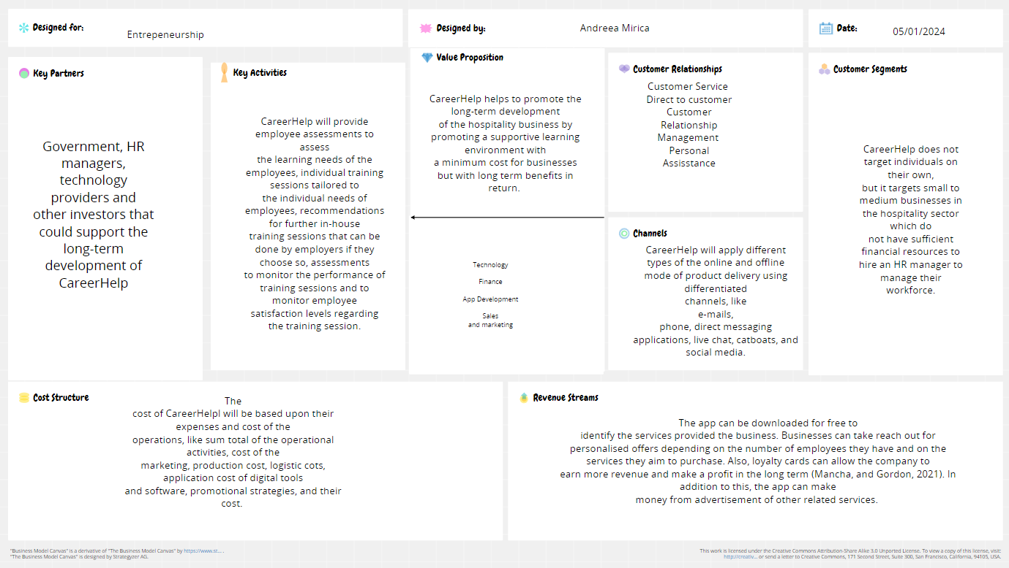

https://app.conceptboard.com/board/2ts7-rtey-nozn-crok-h1rg



