Student Name: Nicolae Mihai
Student ID: 2124103
Modul Code: BMSW4001_BIRM
January 2022 Assignment section:
Academic report: Employability Skills

Lecturer s Name: Doreen Nyaa Amundam
Table of content: task 1
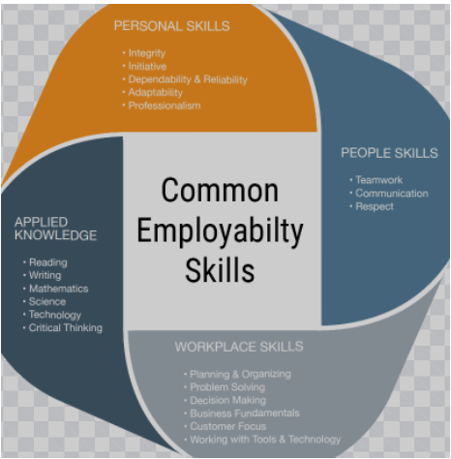

Table of Content

Pay …………………………………………………………………………………………………………………………………….1
Base pay ……………………………………………………………………………………………………………………………2
Recognition and awards……………………………………………………………………………………………………..3
Guiding principles………………………………………………………………………………………………………………4
Additional holiday ………………………………………………………………………………………………………………5
Job -based pay……………………………………………………………………………………………………………………6
Good working conditions …………………………………………………………………………………………………….7
Time rate…………………………………………………………………………………………………………………………….8

Contents

PAY
salary in a every month the money for the people to have good life and will be more important that, time you have your payment under the last day to the month you be have satisfied in uni have everything normally and if you are have good salary good money for leave and why not to make some nice beautiful holiday and be happy the last day to the month to have money to survive and to be more satisfied for your life. Marsden, D. and Richardson, R., 1994

BASE PAY

Basic pay think will be good time we start the new contract new company new job And slowly, Will it be growing up salary and why not new position and no fee good more better if you know Your salary an handle the year will be growing will be bigger and bigger and new position Will it Be better for you to satisfy your life until every month and you can choose two by Eating you your Want because you know will you be have enough money to survive due to the next payment or Your salary. Marsden, D. and Richardson, R., 1994

Recognition and awards

Time you start the new job and until the last day for the year and your manager will be happy to Have for you the nice recommendation because you are good and you do everything to be perfect You never coming delete for your programme and never to lose the time in your professional and Your job for that your manager the last day into the year you give it to you reconvention and to Gratulation you to give it to you then good feedback and two recommendation everybody you need To do what you to you and this years the best employer in the year.
Sturman, M.C. and Ford, R., 2011

Guiding principles

You need to have principles And sometime somebody to guide you like a job every job you need to Have training to explain you what you need to do example you start to new job and you need to Start to do training to know people and do you know the machine or which kind job will start Somebody need to guide you to explain you how is work in the machine and Particle system time .Will be start to know the system and slowly you be learn the system your manager will be guide you .To do the new job for your place and you'll be better the time you know everything for your job and Also you will be satisfied you know how is your job. McAleese, D. and Hargie, O., 2004.

Additional holiday

Every year you need Halliday
Every year you start you planning for holiday you planning for new country to visit something you or to visit your family Halliday is good for relaxing mind for relax your brain to be focused for new challenge new job and every year you need to find opportunity to make your holiday together with your family different place different country to visit something two don't see before like example this year 2022 two you make your holiday one country let's say German next year you plan your holiday for another country 2023 you planning to go in for Italy for two weeks but with this you need to make appointment for your next holiday to be sure you have next year nice beautiful holiday together with your family and with your friends specially the time you have family with you is beautiful and relax. Halliday McAleese, D. and Hargie, O., 2004..

Job -based pay

The family starting new company and you need to read and very good new contract for your I'm your new job to see how many days you have holiday how many days you have everything you need you need to know how much you have your based salary if your salary will be Chris or will stay normally until the finish the yeah how many months will we need to know if your salary will be basial will be will be growing up and you need to know to do the difference for the before your job and then you job to see if it's the new job is more better for your salary for the old job if you're not happy with based salary you need to have clear you're mine to find better job with based salary more better than this one and you need to cheque in your contract if it's your salary will be half they weekly or mount pay any fewer upgrade with everything you see after you can sign your new contract for you know new company. Whitaker, P., 2010

Good working conditions

Good working condition You start with the people you working with you to be nice to be friendy You need to have your place where you can change your clothes for work and also you need to have your place where you can take your lunch and after the launch you need to have no place you can stay any can be relax 30 minutes or 40 minutes after the time you finish your break you need to have clear mine and to be relax difficulty after you finish your break you need to have Good after you finish your 8 hours work you need to have your place where you can change or why not why to make one shower to be fresh in no smell that I'm going home you need to be have good position in clear .
Gorton, S., 2017.

Time rate
Employers how do you pay you for exact time That More hours all day in the year End players working take the large wage they receive after 12 months to work employers will be satisfied his salary the last day to the year will be happy to look in his account and find more money for the last year any provide more satisfied and more happiness for his life anything for new feature and why not to grow in for the next level and his job assistant manager general manager go to think in the future to open his business can you find more satisfied like before to have this money in this moment and also and the last day in the year the company working employers he have good quality and irrespect expect employers and give it some bonus like your vacation or spend money on the shop one time per year company in do one day but here party 4 thank you for welcome the new employers and for employers to working all year anyhow he started up for more than 45% will be Chris our salary any can give more money pet hours the last time am prepare for new feature in the company why not pronounce the above function. Parsons, M.B., Reid, D.H. and Crow, R.E., 2003 on
Introduction.

The aim of this task is to I have chosen this question because, it is related to my interest. In this task I will explain whether staff and students are confident in Employability Skills. To do this I will read books and use questionnaire to understand it.

Research design
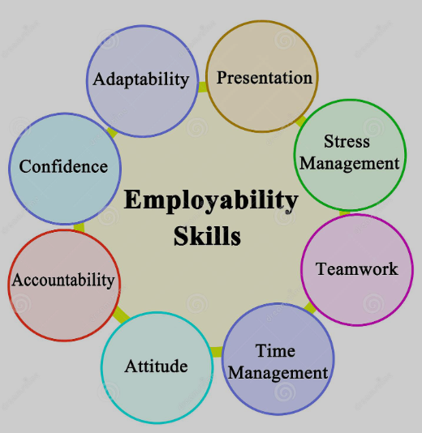

Research Question

Pay
Base pay
Recognition and awards
Guiding principles
Additional holiday
Job -based pay
Good working conditions

Time rate

Method

The method that I used was created from the chiestonar presented in class
Resultswill be

Performing for Pay? The Effects of ‘Merit Pay’ on Motivation in a Public Service - Marsden - 1994 - British Journal of Industrial Relations - Wiley Online Library

Marsden, D. and Richardson, R., 1994. Performing for pay? The effects of ‘merit pay’on motivation in a public service. British Journal of Industrial Relations, 32(2), pp.243-261.

Performing for Pay? The Effects of ‘Merit Pay’ on Motivation in a Public Service - Marsden - 1994 - British Journal of Industrial Relations - Wiley Online Library

Marsden, D. and Richardson, R., 1994. Performing for pay? The effects of ‘merit pay’on motivation in
a public service. British Journal of Industrial Relations, 32(2), pp.243-261.

Motivating Your Staff to Provide Outstanding Service (cornell.edu)
Sturman, M.C. and Ford, R., 2011. Motivating your staff to provide outstanding service.

Five guiding principles of culture management: A synthesis of best practice | Emerald Insight
McAleese, D. and Hargie, O., 2004. Five guiding principles of culture management: A synthesis of best practice. Journal of communication management.

Five guiding principles of culture management: A synthesis of best practice | Emerald Insight

McAleese, D. and Hargie, O., 2004. Five guiding principles of culture management: A synthesis of best practice. Journal of communication management.

What non-financial rewards are successful motivators? | Emerald Insight

Whitaker, P., 2010. What non-financial rewards are successful motivators?. Strategic HR review.

The budget must signal better pay is on the way - ProQuest
Gorton, S., 2017. The budget must signal better pay is on the way. Nursing Standard (2014+), 32(12),
p.29.

Working Conditions in Hospitality: Employees' Views of the Dissatisfactory Hygiene Factors: Journal of Quality Assurance in Hospitality & Tourism: Vol 10, No 1 (tandfonline.com)
Poulston, J.M., 2009. Working conditions in hospitality: Employees' views of the dissatisfactory hygiene factors. Journal of Quality Assurance in Hospitality & Tourism, 10(1), pp.23-43
Best and Worst Ways to Motivate Staff in Community Agencies: A Brief Survey of Supervisors | Intellectual and Developmental Disabilities (allenpress.com)

Parsons, M.B., Reid, D.H. and Crow, R.E., 2003. Best and worst ways to motivate staff in community agencies: A brief survey of supervisors. Mental Retardation, 41(2), pp.96-102.

Discussion
I started looking on google schogle and the library I'm looking for information by Employability Skills to get informed what in will be useful on a closer a better future
And more understood that without searching and reading you will not be able to be informed about Employability Skills and the most important result of everything I have learned in the 10 weeks I have learned how to put how properly in our school project professional (harvard ) those that I do not know knows how to put in order to be able to look professional before the 10 weeks of school

